HTTP (HyperText Transfer Protocol) is the foundation of communication

on the web. It defines how requests and responses are exchanged

between clients (like web browsers) and servers to transfer resources such as HTML pages,

images, videos, and APIs.

1. How HTTP Works

Client Makes a Request:

A client (e.g., a browser) sends an HTTP request to a server.

IMPORTANT:-The request contains information like "the requested URL, HTTP method"

(e.g., GET, POST), and "headers".

Server Processes the Request:

The server processes the request and prepares a response.

This may involve fetching data from a database, executing logic, or serving static files.

Server Sends a Response:

The server sends an HTTP response back to the client.

IMPORTANT:-The response includes a "status code, headers, and optionally a body containing the

requested resource."

Client Displays the Result:

The client renders or processes the response (e.g., displaying a webpage).

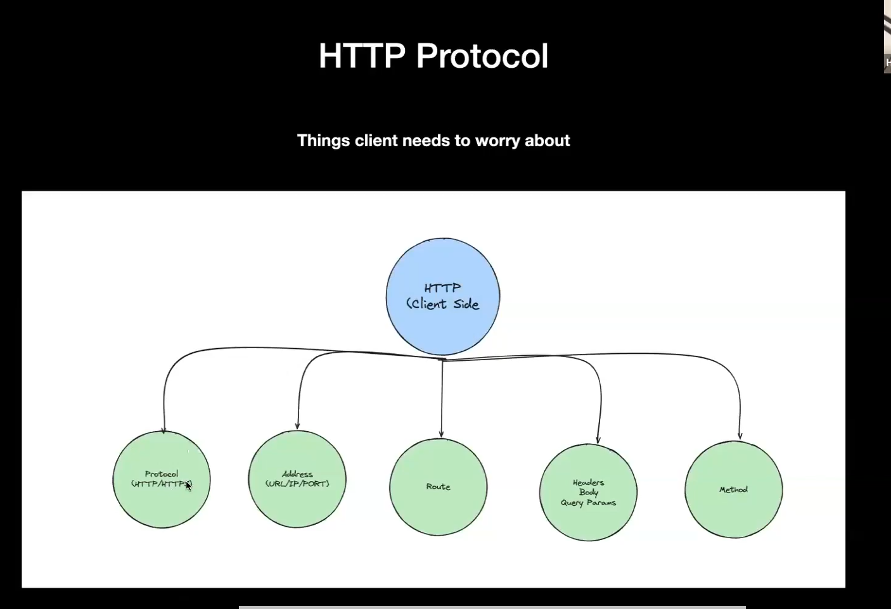

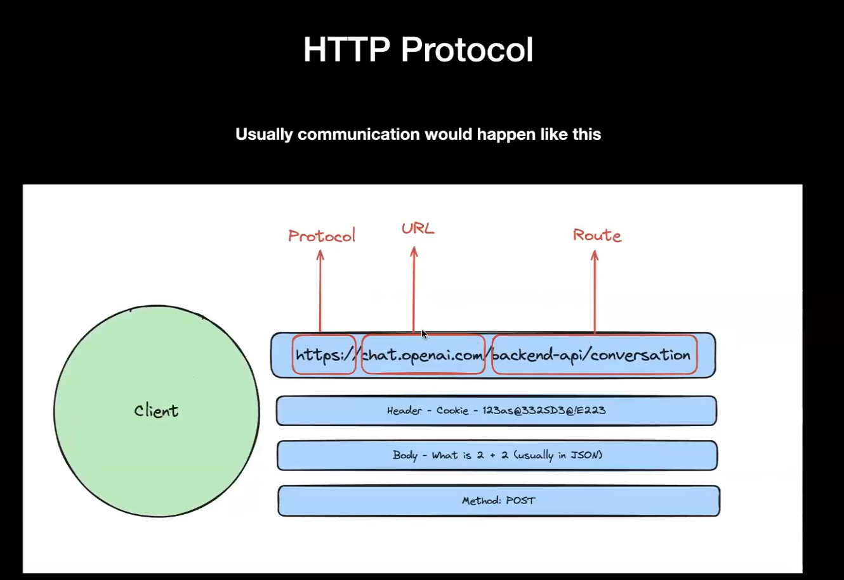

The **protocol** defines the set of rules for communication between the client and server.

**. URL**

* **What it is: The domain name or IP address of the server (chat.openai.com in this case).**
* **This represents the server the client wants to communicate with.**
* **Why it matters: The client uses the DNS to resolve the domain into an IP address to locate the server.**

**Route**

* **What it is**: The specific endpoint or resource being accessed (/backend-api/conversation in this case).
* This tells the server which part of the API or resource to handle.
* **Why it matters**: Defines the service or functionality the client is requesting.

**Header**

* **What it is**: Metadata sent with the request (e.g., cookies, authentication tokens, and content types).
* Example in the diagram: Cookie - 123as@833SD3@E223.
* **Why it matters**:
  + Contains important information such as:
    - **Authentication** (e.g., session cookies, JWT tokens).
    - **Content-Type**: Specifies the format of the request/response body (e.g., application/json).
    - **Custom Headers**: May include API-specific requirements.
  + Helps the server process the request properly.

**Body**

* **What it is**: The data sent from the client to the server, typically in JSON format for APIs.
* Example in the diagram: What is 2 + 2? (sent in JSON format).
* **Why it matters**:
  + Used in methods like **POST**, **PUT**, and **PATCH** to send data such as user inputs, form submissions, or updates.
  + Should match the format expected by the server (e.g., JSON, XML, or form data).

**HTTP Method**

* **What it is**: Defines the action the client wants the server to perform.
* Example in the diagram: POST.
* **Common methods**:
  + **GET**: Retrieve data.
  + **POST**: Send data to the server (e.g., create a resource).
  + **PUT**: Update an existing resource.
  + **DELETE**: Remove a resource.
* **Why it matters**: Helps the server determine what action to take with the request.

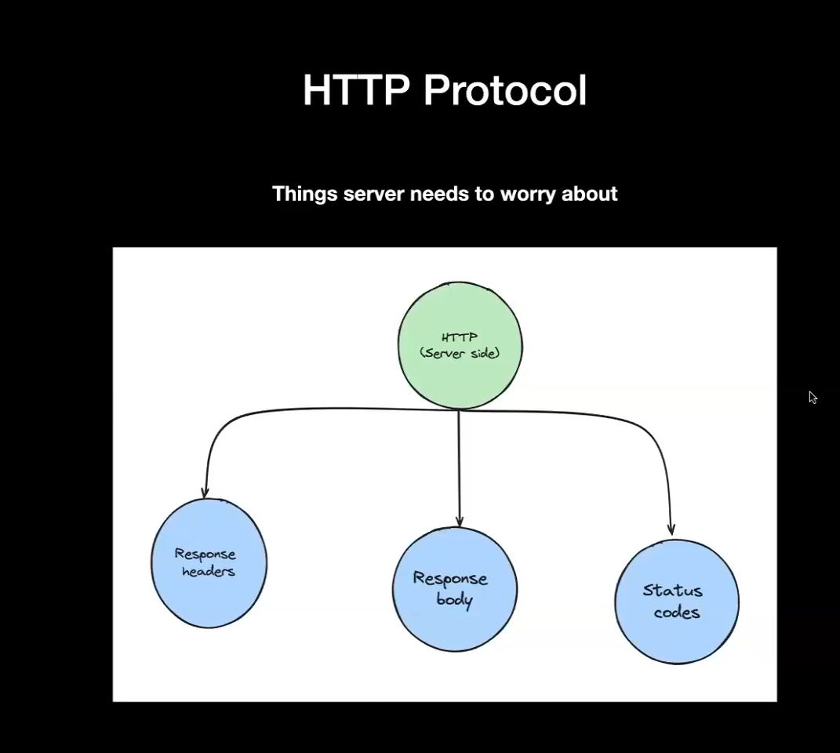

The **response header** provides metadata about the response, such as content type, length, and caching information. **It is sent by the server to the client before the actual response body.** Some common headers include:

* Content-Type: Specifies the type of content (e.g., text/html, application/json).
* Content-Length: Indicates the size of the response body in bytes.
* Server: The server software handling the request (e.g., Apache, Nginx).
* Cache-Control: Directs caching behavior (e.g., no-cache, max-age).
* Set-Cookie: Sends cookies to be stored by the client.

The **response body** contains the actual data sent from the server to the client. This can be in different formats, such as HTML, JSON, XML, or images, depending on the Content-Type header. The body is optional for some responses, such as a 204 No Content status.

The **status code** is a three-digit number that represents the outcome of the HTTP request. It indicates whether the request was successful, encountered an error, or requires further action. Status codes are grouped into five categories:

* **1xx (Informational)**: Request received, continuing process (e.g., 100 Continue).
* **2xx (Success)**: The request was successfully processed (e.g., 200 OK).
* **3xx (Redirection)**: Further action is needed to fulfill the request (e.g., 301 Moved Permanently).
* **4xx (Client Error)**: The request contains bad syntax or cannot be fulfilled (e.g., 404 Not Found).
* **5xx (Server Error)**: The server failed to fulfill a valid request (e.g., 500 Internal Server Error).

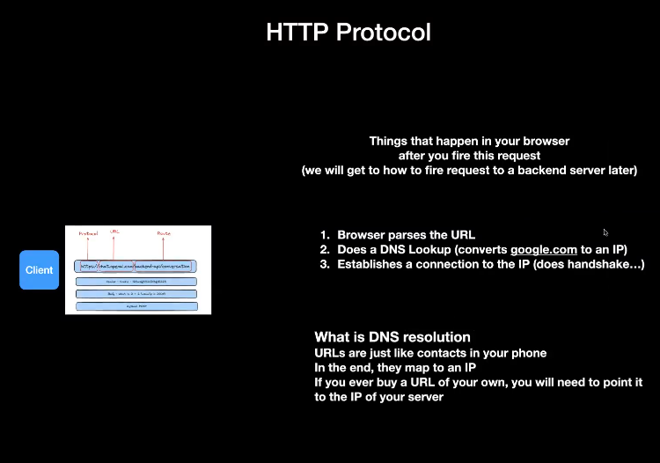

• **URL Parsing**:

* The browser first parses the URL you’ve entered (like http://example.com/path), breaking it down into several components:
  + Scheme (HTTP, HTTPS, FTP)
  + Domain name (example.com)
  + Path (/path)
  + Query parameters (e.g., ?id=1)
  + Fragment (#section)

• **DNS Lookup**:

* The browser needs to find the IP address of the domain name to make a connection. This is done via a **DNS (Domain Name System)** lookup.
* The browser first checks if the IP is cached (from previous requests).
* If it’s not cached, it queries the local DNS resolver, which eventually contacts DNS servers to resolve the domain name to an IP address.

• **Establishing a TCP Connection**:

* Once the IP address is obtained, the browser establishes a connection to the server through **TCP** (Transmission Control Protocol).
* A **TCP handshake** is performed

The browser sends a **SYN** packet to the server.

The server responds with a **SYN-ACK** packet.

The browser responds with an **ACK** packet, and the connection is established.

• **TLS Handshake (If HTTPS)**:

* If the URL uses HTTPS (secure HTTP), a **TLS handshake** takes place next to establish an encrypted connection.
* The browser and the server agree on encryption algorithms and exchange keys to ensure secure communication.

**Sending the HTTP Request**:

* The browser sends an **HTTP request** to the server. This includes the request method (GET, POST, etc.), headers (e.g., User-Agent, cookies), and possibly body data (in the case of POST requests).

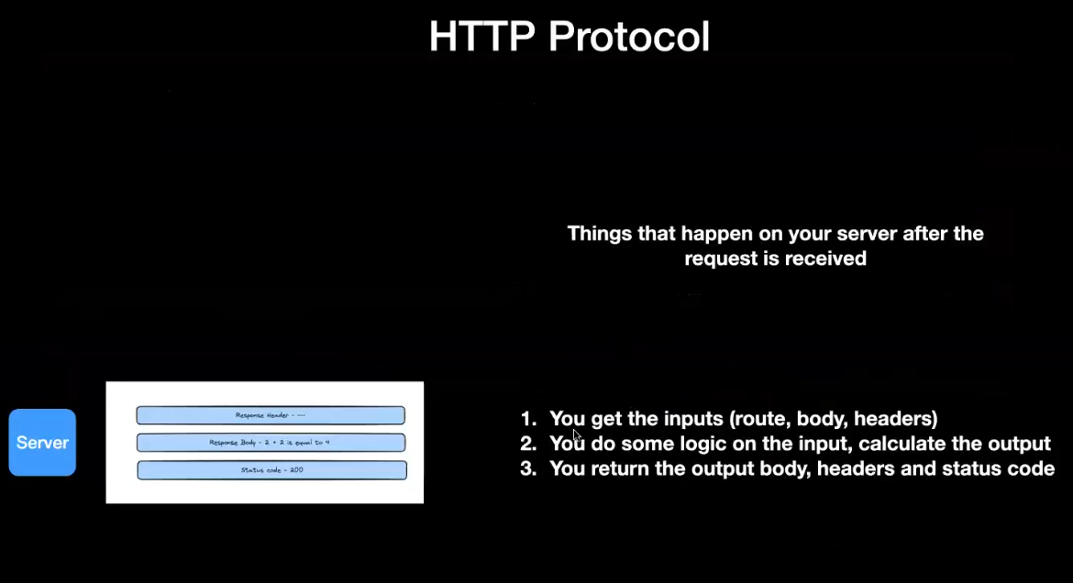

**Express** is technically a **library** (or more specifically, a **web framework**) built on top of **Node.js**. It simplifies the process of building web applications and APIs with **Node.js** by providing a set of tools and utilities.

**To clarify:**

* **Node.js** is the runtime environment for executing JavaScript on the server-side.
* **Express.js** is a framework (or a library) built on top of Node.js to streamline the development of web servers, APIs, and handling of HTTP requests and responses.

In the context of building web applications or RESTful APIs, **Express** is typically referred to as a framework due to its full suite of tools for handling common web app functionalities. So, while technically it's a **library** for Node.js, it's commonly used in the context of **framework** because it organizes the structure of your application.