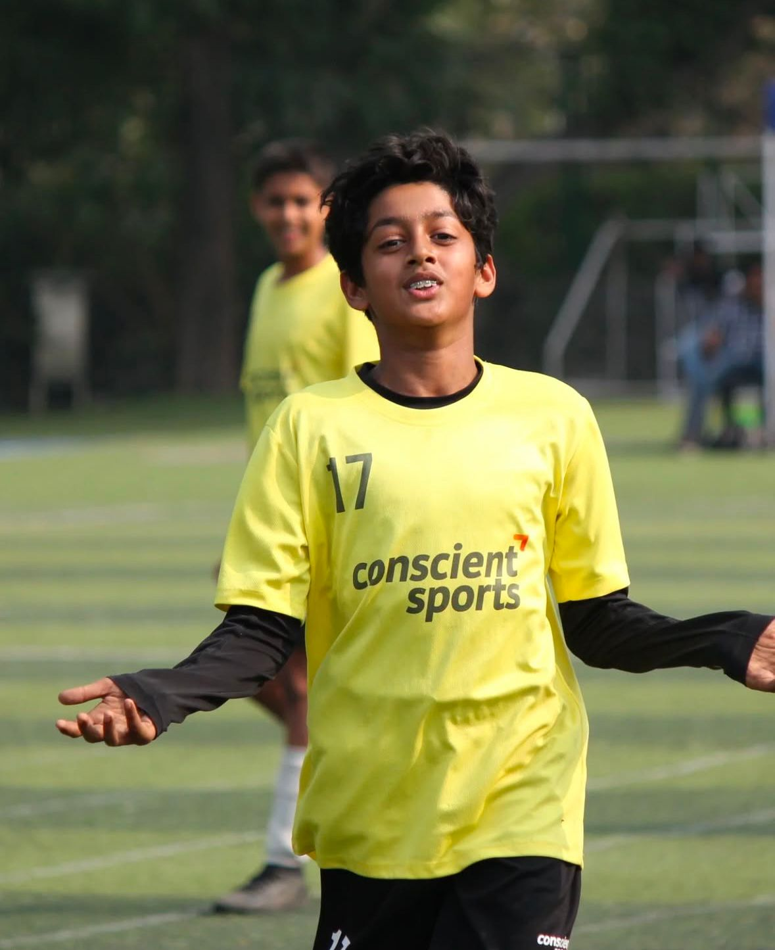 | AYAANSH MATHUR  U14 Striker / Attacking Midfielder  Age 13 | DOB: Sep 6, 2012 | Indian | Mumbai, India  Height: 162 cm | Weight: 43 kg | Right-footed | 9 Years Training

Career Snapshot: 400+ competitive matches | 540+ career goals (~1.4 goals/match) | 58 awards including Man of the Match, Golden Boot & Player of Tournament honors | 68% win rate | 25+ tournaments | Currently trialling with European academies (Spain & Italy, March-April 2026)
CAREER STATISTICS
MATCHES  400+  Since 2017 | GOALS  540+  ~1.4 per match | AWARDS  58  MOTM, Golden Boot | WIN RATE  68%  256W-76L-44D
PLAYER PROFILE
Full Name | Ayaansh Mathur
Date of Birth | September 6, 2012 (Age 13)
Nationality | Indian
Height / Weight | 162 cm / 43 kg
Preferred Foot | Right
Primary Position | Striker (Centre Forward)
Secondary Position | Attacking Midfielder (CAM)
Alternate Position | Central Defensive Midfielder
Training Experience | 9 years (since age 5)
Current Club | RMF White U14, Mumbai
Current Leagues | YPL MFA U14, Leno U14
Website | ayaansh.anmolmathur.com
KEY STRENGTHS & PLAYING STYLE
Ayaansh is a technically gifted, goal-scoring attacker who combines clinical finishing with creative playmaking. His key attributes:
- Clinical Finishing: Exceptional shot accuracy from inside and outside the box, averaging 1.4 goals per match across 400+ competitive games
- Vision & Creativity: Excellent through-ball delivery and ability to unlock defenses with incisive passes in the final third
- Game Intelligence: Mature positional awareness and decision-making beyond his years; reads the game to find space and exploit defensive gaps
- Leadership: Frequently captains his team; 96% leadership rating with strong on-field communication and ability to motivate teammates
- Versatility: Effective across multiple attacking roles (Striker, CAM, CDM), adapting his game to tactical requirements
- Work Ethic: High-intensity pressing and defensive contribution from forward positions; consistently tracks back when needed
- Composure Under Pressure: Proven big-game performer with multiple Man of the Match awards in high-stakes tournament finals

NOTABLE ACHIEVEMENTS & HONORS
YEAR | ACHIEVEMENT | CATEGORY
2026 | European Academy Trials (Spain & Italy) | International Trial
2025-26 | Real Madrid World Cup - Best Teamwork Award | International Tournament
2025 | RFYC National Camp - Top 50 in India | National Selection
2024-25 | Mumbai U13 Inter-District Champions | District Championship
2024 | WIFA Maharashtra State Championship | State Championship
2024 | Awarded Striker of the Tournament (multiple events) | Individual Award
2023 | Multiple Golden Boot awards across tournaments | Individual Award
2022-23 | Consistent Top Scorer in local and regional leagues | League Performance
2020-26 | 58 Man of the Match / Player of Tournament awards | Career Milestone
FOOTBALL JOURNEY & TRAINING HISTORY
PERIOD | CLUB / ACADEMY | HIGHLIGHTS
2025-Present | RMF White U14, Mumbai | YPL MFA U14 & Leno U14 leagues; European trials campaign
2024-2025 | Mumbai Youth Leagues | U13 Inter-District Champions; WIFA State Championship
2023-2024 | Competitive League Play | Consistent top scorer; multiple tournament MVP awards
2020-2023 | Academy & League Development | Rapid progression through age groups; early awards recognition
2017-2020 | Foundation Training | Started formal training at age 5; developed core technique
INTERNATIONAL & NATIONAL EXPOSURE
- Real Madrid World Cup (Spain, 2025-2026) - Competed against international youth talent; awarded Best Teamwork Award
- RFYC National Camp (2025) - Selected in Top 50 players from across India through Reliance Foundation Youth Champs program
- European Academy Trials (March-April 2026) - Actively trialling with top academies in Spain (Valencia, Villarreal, Sevilla, Real Betis) and Italy (Atalanta, AC Milan, Inter Milan, Juventus)
- Mumbai U13 Inter-District Champions (2024 & 2025) - Represented district in inter-district competition
- WIFA Maharashtra State Championship (2024) - Competed at state level representing Mumbai
TECHNICAL & PHYSICAL PROFILE
Technical Skills  Finishing: 95%  Dribbling: 92%  Passing: 90%  Ball Control: 95% | Physical & Mental  Speed: 88%  Agility: 85%  Leadership: 96%  Game Understanding: 95%
AVAILABILITY & TRIAL READINESS
Ayaansh and his family are travelling to Europe from March 29 to April 17, 2026, and are available for trials, assessments, and academy visits during this period.
Spain Visit | March 29 - April 10, 2026
Italy Visit | April 11 - April 17, 2026
Passport | Valid Indian passport, ready for travel
Accompanied By | Parents (Anmol Mathur & Kruti Garg)
Trial Readiness | Match-fit and actively competing in U14 leagues
CONTACT INFORMATION
Father | Anmol Mathur | +91-9867191999 | anmolm@gmail.com
Mother | Kruti Garg | +91-9967064688 | krutigarg@gmail.com
Website | ayaansh.anmolmathur.com
Video Profile | Available on request / ayaansh.anmolmathur.com

Full match footage, detailed statistics, and additional references available upon request.
Updated: March 2026

