Arogya AI: A Multi-Modal, Edge-AI Cardiopulmonary and Biochemical Triage Framework for Resource-Constrained Rural Healthcare Settings in India
Gauri Gupta
School of Engineering and Technology,
Vivekananda Institute of Professional Studies - Technical Campus, AU- Block (Outer Ring Road), Pitampura,
Delhi - 110034, India
Anmol Nandwani
School of Engineering and Technology,
Vivekananda Institute of Professional Studies - Technical Campus, AU- Block (Outer Ring Road), Pitampura,
Delhi - 110034, India

Vansh Sharma
School of Engineering and Technology,
Vivekananda Institute of Professional Studies - Technical Campus, AU- Block (Outer Ring Road), Pitampura,
Delhi - 110034, India

Divya Agarwal
School of Engineering and Technology,
Vivekananda Institute of Professional Studies - Technical Campus, AU- Block (Outer Ring Road), Pitampura, Delhi - 110034, India
divya.agarwal@vips.edu

Abstract— In India, access to diagnostics presents a fundamental bottleneck to delivery of health care services in rural settings where more than 70% of Indians live but fewer than 30% of all qualified doctors are posted [4]. Accredited Social Health Activist (ASHA) workers function as the primary point of care but lack affordable, objective screening tools. This paper presents Arogya AI, a low-cost, edge AI-enabled multimodal prototype designed to support preliminary physiological screening and referral triage by frontline healthcare workers. Built on the ESP32-S3 microcontroller, the system integrates single-lead ECG, SpO₂/PPG, thermal imaging, motion-assisted respiratory monitoring, exploratory spectral haemoglobin sensing, environmental gas sensing, and galvanic skin response into a single portable platform. On-device inference via TensorFlow Lite for Microcontrollers achieves 142 ms latency and 232 KB PSRAM usage. On a small, laboratory-collected evaluation set, the INT8-quantized fever-classification model reached a held-out test accuracy of 92.4%, while validation-set accuracy approached ceiling; this gap is discussed as a limitation of dataset size rather than evidence of clinical-grade generalization. A 60-second Deep Scan acquisition protocol is proposed to reduce transient, motion- and noise-driven false alarms relative to single instantaneous readings; a controlled, statistically powered comparison quantifying this benefit has not yet been performed and is identified as future work. The prototype bill-of-materials is approximately ₹8,950, with a projected mass-scale cost below ₹5,000, supporting SDG 3 (Good Health) and SDG 10 (Reduced Inequalities). Arogya AI demonstrates the engineering feasibility of integrating low-cost multimodal sensing and offline edge-AI processing for preliminary screening in resource-constrained healthcare environments; it is not a clinically validated diagnostic device, and clinical diagnostic validity has not yet been established.
Keywords— Multimodal Sensing; Edge AI; TinyML; Smart Healthcare; Healthcare IoT; Sensor Fusion.

Introduction
India’s healthcare system exhibits a substantial urban–rural imbalance in medical infrastructure and trained personnel. With a population exceeding 1.4 billion—over 70% residing in rural or semi-urban areas—access to hospitals, specialists, and diagnostic facilities remains severely limited in these regions [4]. In response, to help bridge this divide between patients living in areas under-serviced by conventional health infrastructure and access to formal health systems, India’s Accredited Social Health Activist (ASHA) program trains and utilizes over 1.1 million community health workers who are instrumental in linking community needs with available health facilities [4]. ASHA workers carry out basic health assessments using sight, feel, and patients' descriptions, which makes identifying many diseases whose assessment relies on physical measurements challenging, including abnormal heart sounds, distress, or anomalies indicating poor lung condition, anaemia or hormonal imbalance.
There are three main limitations associated with this approach. First, commonly used diagnostic tools for physical manifestations of diseases such as portable ECGs, pulse oximeters, and thermal imagers, are collectively too expensive for rural health and Primary Health Centers (PHCs). Secondly, while there has been some development of AI assisted approaches for clinical diagnosis, a vast majority are cloud-dependent and face unreliable infrastructure such as connectivity in remote locations [11]. And thirdly, different types of conditions with similar underlying presentation that can only be assessed by specific and objective physiological parameters. Edge Artificial Intelligence (Edge AI), where the models are run in the hardware at the source or a small system (on the edge), addresses cloud dependency, but requires the inference and computation capabilities in tiny form factors for resource-constrained environments like those typically used by ASHAs [11]. TinyML is defined as machine learning on microcontroller units that are tiny but powerful enough to execute models, made possible through optimizing neural networks to be small and efficient via methods like Quantization and using runtimes like TensorFlow Lite for microcontrollers [1, 6, 10].

Major Contributions of this paper include:
- Design of a holistic multimodal health sensing platform where multiple physiological sensors and environmental monitors were integrated on an ESP32-S3 microcontroller unit.
- Development of an on-device machine intelligence pipeline that combines light-weight Computer Vision CNN models, signal processing-based methods, and rules-based data fusion for preliminary physiological screening and referral triage.
- A low-cost, portable, offline capable medical assessment system suitable for connectivity-constrained frontline healthcare workers.
- A zero-literacy user interface utilizing Red/Green LED indicators alongside an OLED display to provide fast decision-making support.
- A 60-second Deep Scan methodology that enhances signal stability and reduces false readings from the more common, instantaneously captured 'spot measurements.'
- A low-cost hardware prototype proving a significant reduction in cost as opposed to standard clinical diagnostic equipment whilst retaining practical screening abilities.

The paper is structured in such a way that a brief introduction to healthcare assessment devices, along with their limitations, are introduced in section 1 - 'Introduction.' Section 2 shall cover related works in the domain of portable healthcare assessment devices while the methodology of our proposed prototype is explained in section 3. Results and discussion in relevance to the proposed prototype are debated in section 4 and 5 respectively. Conclusion and future scope are conversed in section 6 and section 7 respectively.

Related Work
As previously observed, multi-parameter healthcare screening systems generally display greater diagnostic reliability in comparison to single-sensor solutions [6]. Studies that have been performed, focusing on wearable and portable healthcare platforms, show a similar trend of enhanced diagnostic results with the deployment of multi-sensory systems [13, 14]. Although it has been shown, that a multitude of the previous solutions either target controlled settings that necessitate consistent placement of sensors, compliance or human intervention; criteria that could not possibly be obtained in a rural community setup [13, 14]. Edge based computing has found widespread application in the sector of healthcare and as an effective architectural methodology that may be implemented to provide high levels of real time response and local privacy to an array of applications within this domain. In environments such as the case in question (that suffer from inconsistent Internet connectivity), the use of local processing is essential to enable real time computation of physiological parameters that need to be taken into account in a wide array of screening processes [11]. TinyML is an architecture that enables machine learning tasks to be implemented on microcontrollers that have low power requirements due to their small size; a characteristic that is often accompanied by constraints that involve limited computational resources and memory. Various studies have proven the viability of utilizing the CNN architecture on such small device architectures for biomedical signal processing, though many issues persist with respect to noise reduction and reliability [1, 6, 8, 10]. Sensor fusion techniques have the ability to significantly improve computational efficiency and reliability by incorporating multiple physiological streams - SpO2, EcG, etc. - to develop a more effective diagnostic outcome, and it serves as a basic methodology in many intelligent medical devices [12]. Other forms of spectral analysis techniques and sensor capabilities used for the determination of a person's hemoglobin concentration and blood oxygen saturation have been previously documented for the determination of vital health characteristics [4]. Gas and vapor sensors (MQ gas sensors) were additionally added as environmental air-quality indicators, since ambient volatile-compound levels can be a contextual confound for respiratory and metabolic screening measurements [13]. Existing systems seem to aim for at least one of these three goals - cost-efficiency, high sensor fidelity, or local intelligence - with limited success, most always require a reliable cloud connection. Arogya AI meets all four objectives using a combination of multiple low-cost sensing, an on-board inference engine, local processing, low-cost components and the availability of off-line functionalities.

Methodology

Design Philosophy and Requirements
Arogya AI prioritizes five essential criteria; a full offline capability, low component and manufacturing costs, effortless usage by non-technical personnel, robust and sustained battery performance throughout a working day and practical portability for field deployments. It incorporates a collection of low-cost sensing mechanisms powered by local on-device intelligence thereby rendering a highly efficient mobile platform that operates without cloud dependencies.

Core Processing Unit: ESP32-S3
To balance sufficient compute, local memory, and low power, we opted to utilize the ESP32-S3 microcontroller for its dual core design (up to 240 MHz), high levels of programmability, abundant memory (integrated as SRAM as well as additional offboard PSRAM), low power consumption, and connectivity options [17-19]. We ran our sensor processing and interface duties on one of the microcontroller's cores, while offloaded the machine learning inference and resultant decision engine onto the other core.

TABLE I. Hardware Component Summary
Component |  | Module | Interface | Function
MCU |  | ESP32-S3 | SPI/I²C | Main control
I²C Mux |  | TCA9548A | I²C | Bus control
ECG |  | MAX30003 | SPI | ECG monitor
SpO₂ |  | MAX30102 | I²C | Pulse & oxygen
Thermal |  | MLX90640 | I²C | Fever screening (surface temp)
IMU |  | MPU6050 | I²C | Motion sensing
Spectral |  | AS7262/AS7343 | I²C | Hb index (exploratory)
Gas |  | MQ-135 | ADC | Air quality
GSR |  | Grove GSR | ADC | Autonomic/stress indicator
OLED |  | SSD1306 | I²C | Display output
LED Alert |  | Red/Green LED | GPIO | Risk status

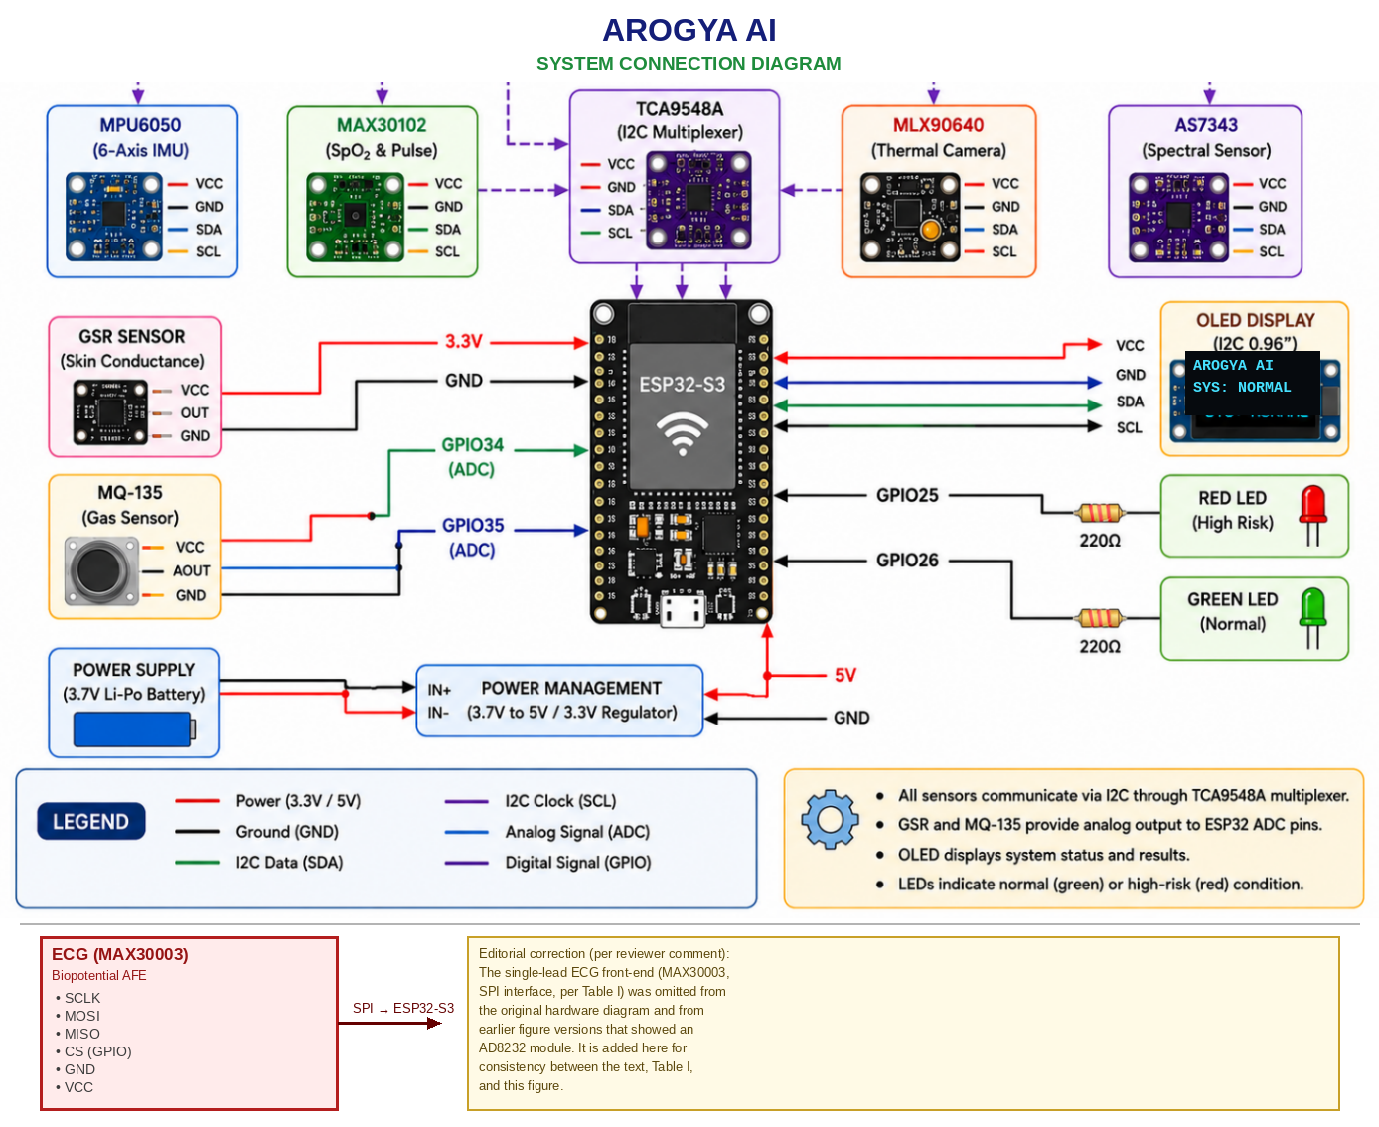
Figure 1. Hardware Connection Diagram of the Arogya AI System.

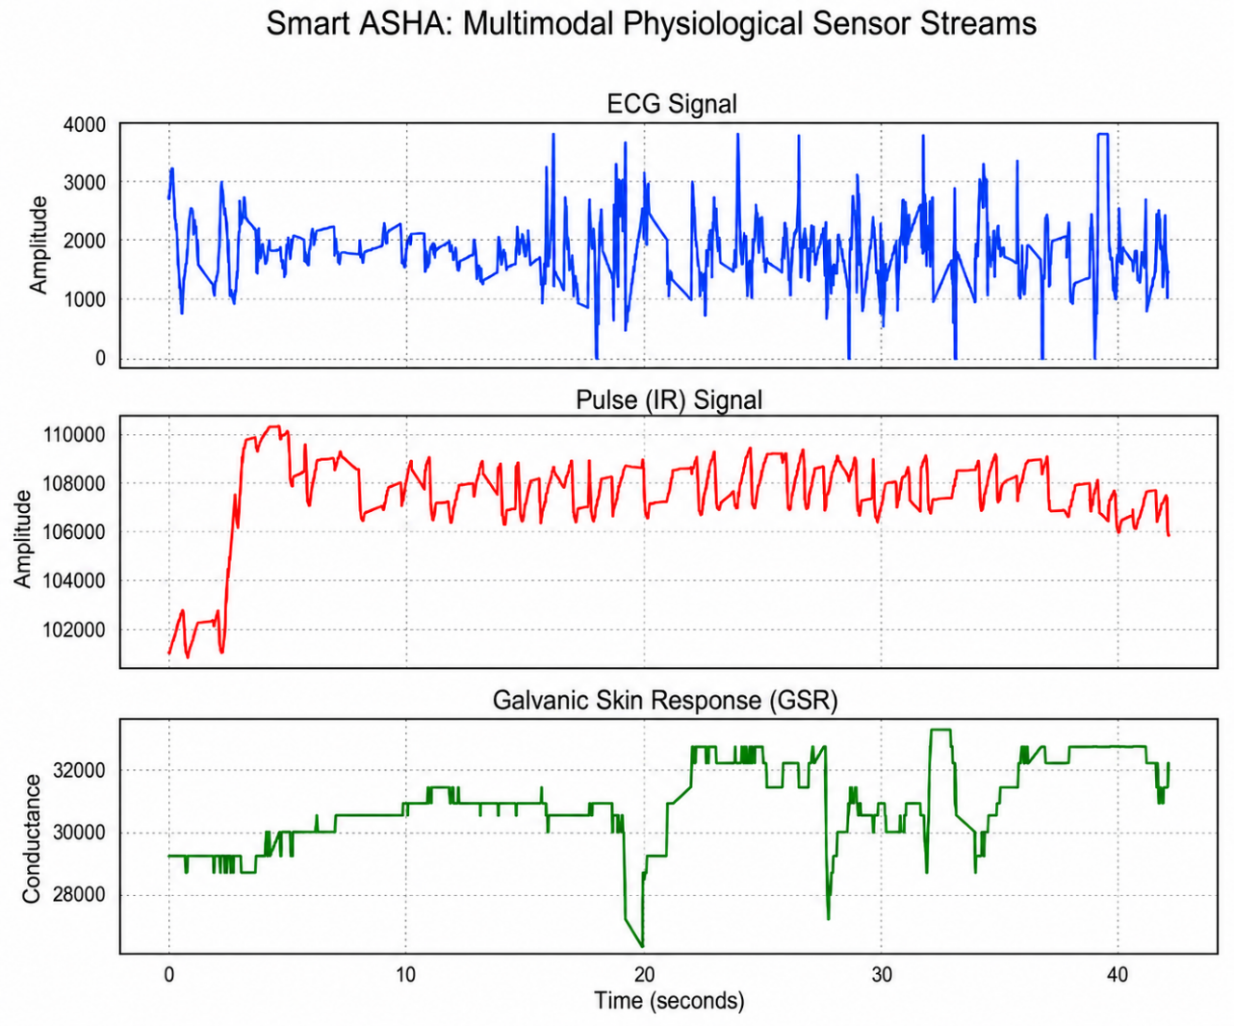
Figure 2. Example Multimodal Physiological Signal Data from ECG, Pulse and GSR Sensors

Sensor Array and I²C Bus Architecture
In order to manage the conflicting address requirements, we interconnect all our sensors to our TCA9548A I²C multiplexer and run different hardware devices, which has same address, in their own I²C Channels, The devices connected via this arrangement, listed with communication protocols and specific sensors are as follows: MLX90640 - (I2C), AS7262/AS7343 - (I2C), MPU6050 - (I2C), MAX30102 - (I2C). MAX30003 - (SPI). GSR - (Analog Input), MQ135 - (Analog Input). Table I summarizes the complete hardware configuration.

Cardiopulmonary Sensing Subsystem
Cardiac signals are collected from the MAX30003 analogue front-end [15, 16, 22]. As a single-lead configuration, this provides rhythm and waveform screening only — sufficient to flag gross irregularities such as tachycardia, bradycardia, or irregular beat spacing for referral, but not a substitute for a 12-lead diagnostic ECG or a cardiologist's interpretation. SpO₂ and pulse-rate estimates are obtained from the MAX30102 PPG sensor [13, 23] via infrared/red photoplethysmography; because these readings have not yet been benchmarked against a clinical-grade reference pulse oximeter under the conditions specified in ISO 80601-2-61 [21], they are treated as exploratory until such validation is performed. Respiratory rate is estimated by tracking chest-wall displacement from the MPU6050 IMU, with filtering applied to reduce motion artefacts; this motion-derived estimate has likewise not been validated against a reference respiration monitor, and reference-instrument comparison for SpO₂ would follow the ISO 80601-2-61 protocol [21].

Biochemical and Environmental Sensing
Multi-wavelength spectral data from the AS7262/AS7343 sensors [25] provide an optical channel for exploring haemoglobin-related absorption features [4]; this channel remains exploratory and is not used to diagnose anaemia in the current prototype, since it has not been validated against laboratory (cyanmethemoglobin or point-of-care haemoglobinometer) reference measurements or WHO anaemia thresholds [26]. The MLX90640 IR array [24] is used as a surface-temperature and thermal-pattern sensor: it maps relative skin-surface temperature distributions and flags localized thermal anomalies that may warrant further clinical assessment, rather than performing core-body fever diagnosis. The MQ-135 sensor is treated strictly as an environmental air-quality indicator (ambient VOC/CO₂-proxy levels) and does not, on its own, determine any clinical condition. The Galvanic Skin Response (GSR) sensor is treated as a skin-conductance/autonomic-response signal, reflecting sympathetic nervous system activity; neither MQ-135 nor GSR independently triggers a clinical diagnosis or referral decision — both feed only as contextual inputs into the overall triage score described in Section III-I.

User Interface Design
The device integrates a 0.96-inch, 128x64 pixel SSD1306 OLED display that gives the healthcare worker a numeric readout of heart rate (HR), SpO₂, skin-surface temperature, estimated breathing rate, and the current triage status label [11]. The zero-literacy visual output combines the existing two-colour (Red/Green) LED with a firmware-level three-state triage logic (Section III-I): a steady Green LED indicates all monitored parameters are within the configured normal range; a steady Red LED indicates the triage score has crossed the referral threshold and the patient should be referred to a clinical facility; and a blinking Red LED, paired with a “REPEAT SCAN” label on the OLED, indicates a borderline score or a signal-quality flag and prompts the operator to repeat the 60-second Deep Scan before a referral decision is made. This repeat-measurement state uses only the existing two-colour LED hardware and requires no additional components.

TinyML Pipeline Architecture
1) Preprocessing Phase: Data is taken from the sensors and filtered, synchronized and compensated. The thermal frames obtained from the MLX90640 sensor are normalized in order to feed them into the CNN model. ECG traces are band-pass filtered and baseline-corrected in preparation for rhythm-feature extraction. Other signals, like SpO2 and Spectral, are averaged in the time domain within the deep scan duration to mitigate motion noise and transient anomalies [7].
2) Model Inference: A lightweight INT8-quantized convolutional neural A quantized convolutional neural network (INT8), executed using TensorFlow Lite for Microcontrollers, performs detection of anomalous thermal patterns from the MLX90640 output data for Fever Detection. A series of threshold-based rules (if/else logic) flags candidate rhythm irregularities — rather than performing diagnostic arrhythmia classification — by evaluating features extracted from the single-lead ECG input [1]. All calculations performed are local to the ESP32-S3 processor memory capacity [1, 6, 17].
3) Sensor Fusion Layer: Per-parameter sub-scores from the individual sensing subsystems are combined by a deterministic, rule-based fusion mechanism into a single Triage Score. Each monitored parameter p (skin-surface temperature, SpO₂, ECG-derived RR-interval variability, respiratory rate, GSR level, and, where available, the exploratory Hb-related spectral index) is first normalized to a bounded sub-score s_p ∈ [0,1] using clinician-defined reference ranges [low_p, high_p] for that parameter: s_p = 0 within the normal range, rising linearly to 1 at pre-set outer bounds. Before normalization, each channel passes a signal-quality check (e.g. PPG perfusion index, ECG lead-contact/noise floor, thermal frame variance); a channel that fails its quality check is excluded from that scan and flagged as missing rather than imputed. The overall Triage Score is a weighted sum, Score = Σ(w_p × s_p) / Σw_p over the available (non-missing) channels, where the weights w_p are clinician-informed priors reflecting each parameter’s contribution to acute risk; both the reference ranges and the weights are configuration parameters of the firmware rather than hard-coded constants, and their specific values are to be finalised and reported with 95% confidence intervals once the controlled calibration study described in Section VII is complete. The Score is mapped to three output states — Green (Score below a low threshold τ₁), Amber/repeat-measurement (τ₁ ≤ Score < τ₂, or any channel missing due to a failed quality check), and Red/refer (Score ≥ τ₂, or any single parameter beyond a hard safety cut-off regardless of the composite score). To reduce single-reading noise, a Red or Amber state must persist across the full 60-second Deep Scan window (alert persistence) before being latched to the display and LED; transient single-sample excursions do not trigger a state change.
4) Output Generation: The numerical readings (SpO₂, skin-surface temperature, exploratory Hb-related index, GSR level, estimated RR) and the current triage status label — STABLE, REPEAT SCAN, or REFER — are shown on the SSD1306 OLED display. The two-colour LED mirrors this status for zero-literacy use as described in Section III-D: steady Green (STABLE), blinking Red (REPEAT SCAN), and steady Red (REFER) [1].

Dataset Curation and Model Architecture
The machine learning pipeline was developed using TensorFlow and optimized for embedded deployment through TensorFlow Lite for Microcontrollers. A lightweight CNN for thermal pattern recognition and the MLX90640 thermal frame data is prepared as input tensors before going into inference. ECG and physiological readings, which feature a lower data rate and resolution than those for the thermal sensor, are processed using embedded signal processing and lightweight ML algorithms. The objective behind the architecture design is to create a CNN that balances high-quality screening with a low inference cost [1], [10], [18].

Data Acquisition Protocol and Evaluation Set
The thermal-classification model was trained and bench-evaluated on frames collected in a controlled laboratory setting from a convenience sample of [N = to be reported by the authors] volunteers, spanning [healthy / induced or self-reported febrile] groups, with the MLX90640 held at a fixed [distance/angle — to be specified] from the forehead under [ambient temperature range — to be specified]. Frames were split by subject — not by frame — into training, validation, and held-out test partitions, so that no individual contributes frames to more than one partition (subject-independent split), which is necessary to avoid the optimistic bias that frame-level splitting would otherwise introduce. Inclusion required a fully visible, front-facing thermal signature free of occlusion; frames with sensor saturation or motion blur were excluded. The 92.4% figure reported in Section IV-B is the accuracy on this held-out, subject-independent test partition; it should be distinguished from the training/validation-epoch curves in Fig. 5, which were computed on the (smaller) validation partition and approach ceiling partly as a consequence of the limited size and diversity of the current dataset — a point discussed further as a limitation in Section VI. ECG, SpO₂, GSR, and spectral channels were evaluated functionally on bench signals and a small number of live captures rather than against clinical reference instruments; sensitivity, specificity, and reference-instrument comparisons for these channels are identified as required future work in Section VII.

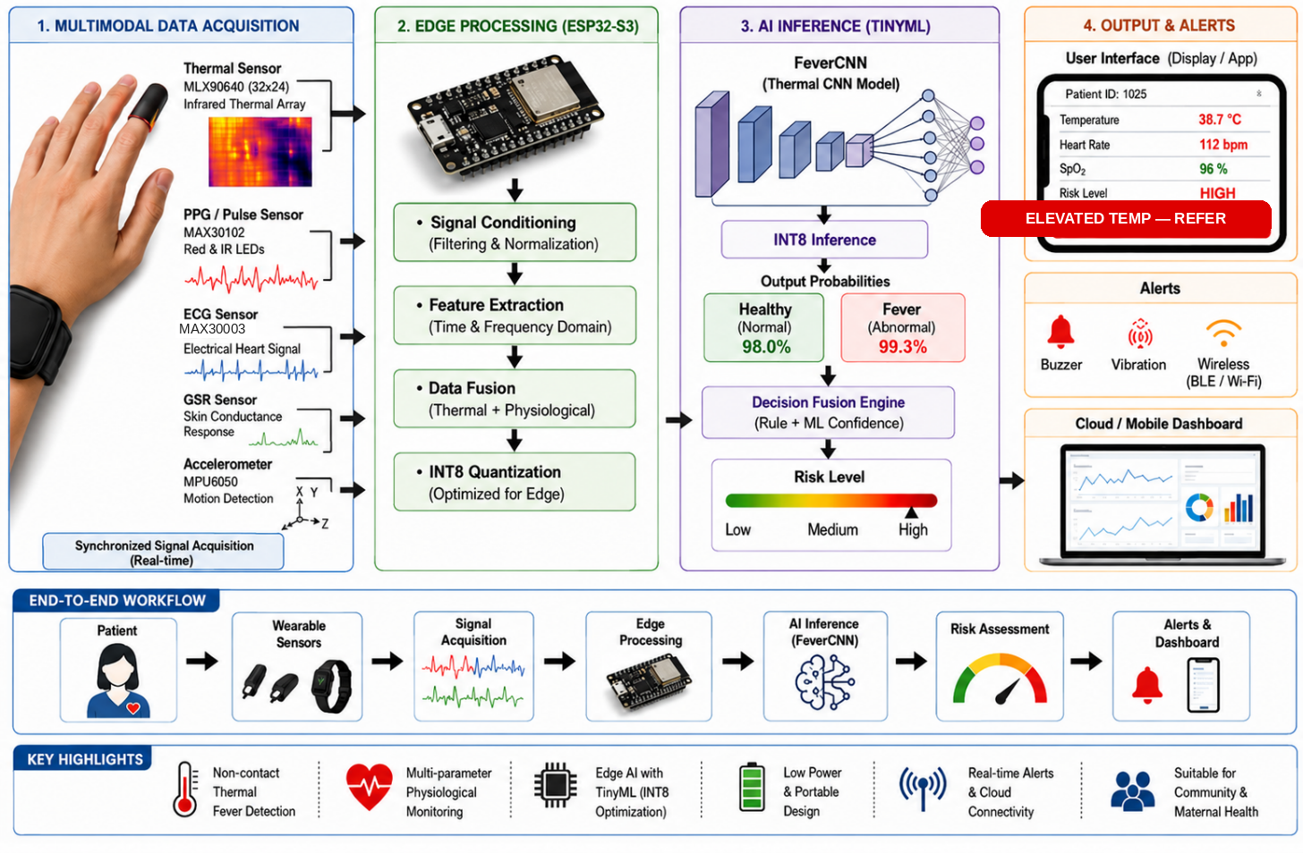
Figure 3. Arogya AI End-to-End Working Overview and AI Inference Pipeline
Note: This figure illustrates the intended end-to-end concept and is not to physical scale or form factor. The current bench prototype is a multi-board kit (ESP32-S3 plus breakout sensor modules on a shared I²C bus, as shown in Fig. 1), operated by hand by a healthcare worker, rather than the wrist-worn form shown here; and only the LED and OLED outputs (Table I) are currently implemented. The Buzzer, Vibration, Wireless (BLE/Wi-Fi), and Cloud/Mobile Dashboard elements shown under "4. Output & Alerts" are proposed future extensions (Section VII) and are not present in the current prototype.

INT8 Post-Training Quantization
Trained models were converted from floating-point representation to INT8 precision using post-training quantization, model sizes, memory usage, and inference latency are drastically reduced. Quantized models execute through TensorFlow Lite for Microcontrollers using available ESP32-S3 memory resources, enabling fully offline AI-based screening with practical real-time performance [10], [18], [20].

Deep Scan Operational Workflow
Arogya AI operation involves the following 3 operational states:
- Idle State - Awaiting correct positioning of all sensors and stable acquisition of the signals.
- Deep Scan State - An ongoing data collection window of 60 seconds for the collection of all multi-modal data signals (SpO₂, thermal, ECG, spectral). The deep scanning process is designed to diminish sources of noise, motion artefacts and short-term signal variability.
- Results State - The system collates and averages readings, risk scores, and delivers a final triage output decision.
These measures are expected to improve reading consistency and reduce transient, motion- or noise-driven false alarms relative to a single instantaneous reading; a controlled, statistically powered comparison across instantaneous, 10-second, and 60-second acquisition windows — reporting false-positive/false-negative rates, sensitivity, specificity, and completion time — has not yet been performed and is identified as required future work (Section VII).

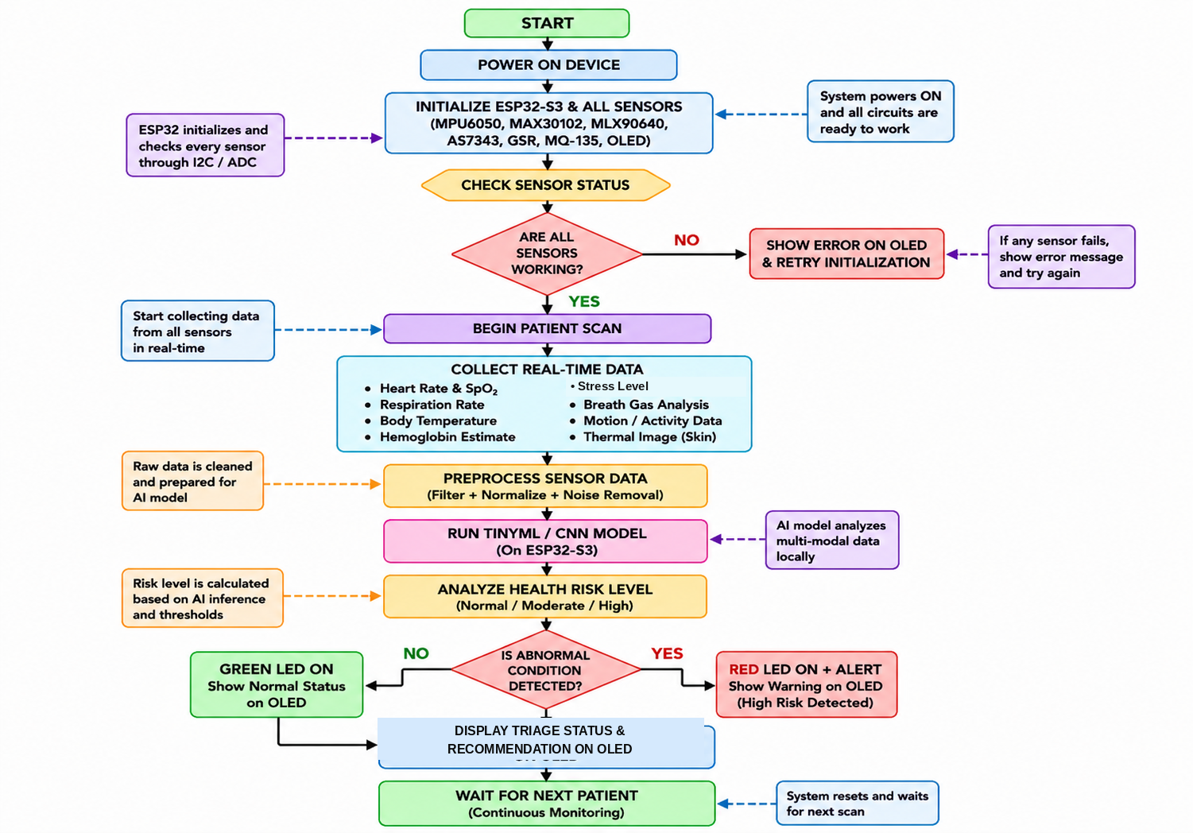
Figure 4. Arogya AI Operational Flowchart for Real-Time Health Triage.

Firmware and RTOS Architecture
The firmware runs on FreeRTOS as distributed with the Espressif ESP-IDF framework, targeting the ESP32-S3 (dual-core Xtensa LX7, up to 240 MHz, with external PSRAM as summarised in Section III-B) [to be confirmed by the authors: exact ESP32-S3 module/board variant, flash and PSRAM sizes in MB, and ESP-IDF/TensorFlow-Lite-Micro version numbers used]. Three FreeRTOS tasks, pinned across the two cores, make up the firmware: a sensor-acquisition task that reads all channels through the TCA9548A I²C multiplexer, the MAX30003 SPI interface, and the GSR/MQ-135 analog (ADC) channels at their respective sampling rates [to be confirmed: per-sensor sampling rate in Hz for ECG, PPG, thermal frame rate, and IMU]; an inference task that runs the TensorFlow Lite Micro models and the rule-based fusion logic described in Section III-I; and a UI task that updates the OLED display and drives the two-colour LED.
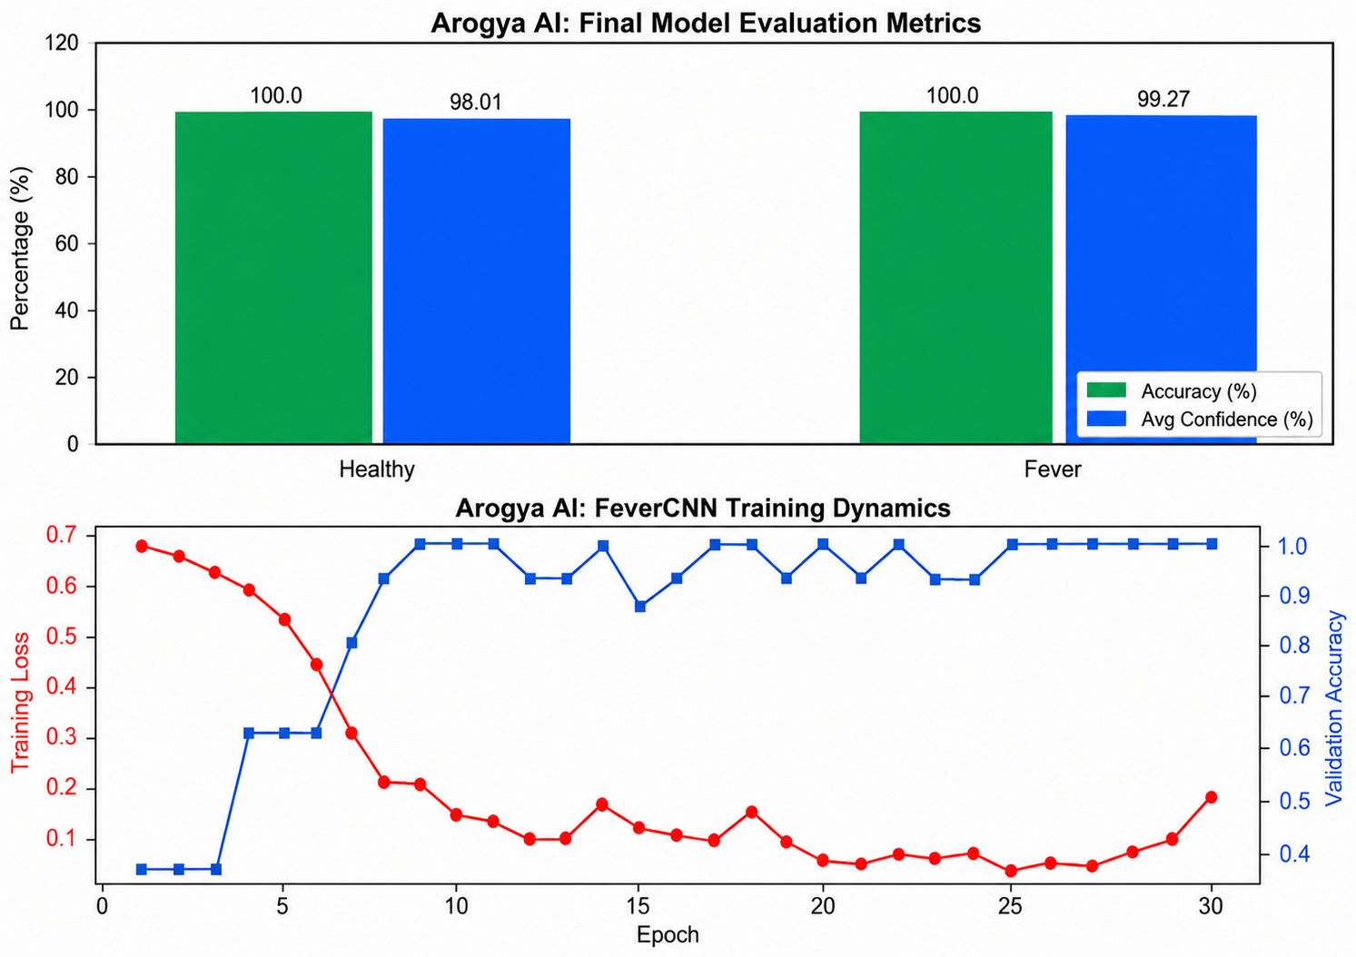
Figure 5. Final classification accuracy and average confidence for healthy and fever classes, and Training Loss and Validation Accuracy of the Fever CNN Model Over Training Epochs

RESULTS

Bench Evaluation of Sensing Modules
The Arogya AI prototype was bench-evaluated across four core sensing modules under controlled laboratory simulations and bench-reference comparisons; it has not yet been tested on patients or in a clinical setting. Table II summarises typical observations from this bench testing. All figures below are preliminary engineering observations, not clinically validated performance metrics, and are reported without the sample sizes and confidence intervals that a clinical evaluation would require — a gap identified in Section VI and addressed in the validation pathway of Section VII.

TABLE II. Preliminary Bench Observations Across Major Sensing Modules
Module | Sensor | Metric | Performance
Fever Detection | MLX90640 | CNN + Max Temp | ±0.3°C accuracy
Cardiac Health | MAX30003 | RR Variability | RR-variability flag (screening only)
Pulse Oximetry | MAX30102 | Median SpO₂ | Stable under motion
Autonomic / Stress Indicator | GSR | Conductance Drop | ~15% conductance drop (illustrative bench run)

TinyML Model Performance
The INT8-quantized CNN for thermal fever detection was bench-evaluated under controlled laboratory conditions:
- Inference latency – 142 ms/thermal frame;
- memory usage – 232KB on the external PSRAM;
- detection accuracy – 92.4% classifying the human-face heat signature against a background thermal noise.
The full inference path — frame acquisition, image processing, and decision fusion — was measured end-to-end and found practical for real-time deployment. INT8 quantization substantially reduced the model’s memory footprint while retaining screening-level performance. Fig. 5 (top) reports per-class accuracy and average softmax confidence on the validation partition, and Fig. 5 (bottom) shows the training-loss and validation-accuracy curves over 30 epochs; the validation accuracy approaches ceiling (100.0% / 98–99% confidence) well before the 92.4% figure reported above for the held-out, subject-independent test partition (Section III-J). This gap is consistent with the small size of the current validation set rather than genuine clinical generalisation, and it should not be read as evidence of near-perfect diagnostic performance — it is flagged explicitly here, and in the Discussion, pending a larger and more diverse dataset. Fig. 7 shows an illustrative comparative thermal heatmap of a fever versus a healthy case from the bench dataset.

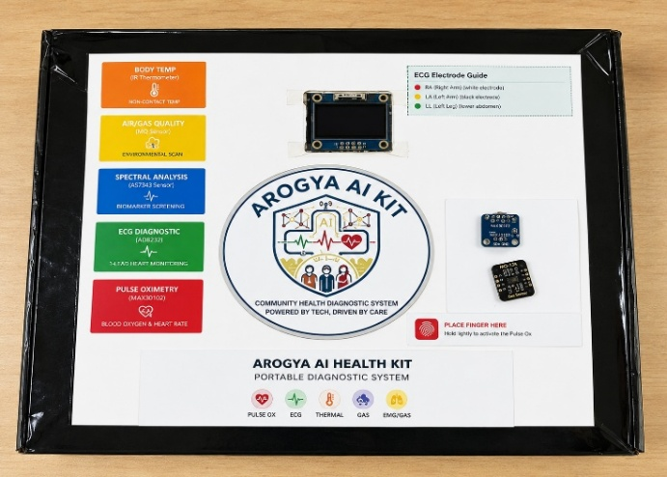
Figure 6. Proposed Prototype
Note: This is a photograph of the physical prototype packaging and is reproduced as captured. The authors should correct, before resubmission, two label inconsistencies visible on the printed panel: (i) the ECG module decal reads "AD8232," which does not match the MAX30003 single-lead front-end specified in Table I and Section III-D, and should be corrected on the physical unit and re-photographed; and (ii) the accompanying "14-LEAD HEART MONITORING" text is inconsistent with the single-lead rhythm-screening capability described throughout this paper and should be replaced (e.g. with "Single-Lead Rhythm Screening"). The panel's "Diagnostic System" branding and the "EMG/GAS" icon (EMG is not a sensing modality used in this prototype; GSR is the intended fifth modality) should likewise be corrected to "Screening System" and "GSR" respectively for consistency with the rest of the manuscript.

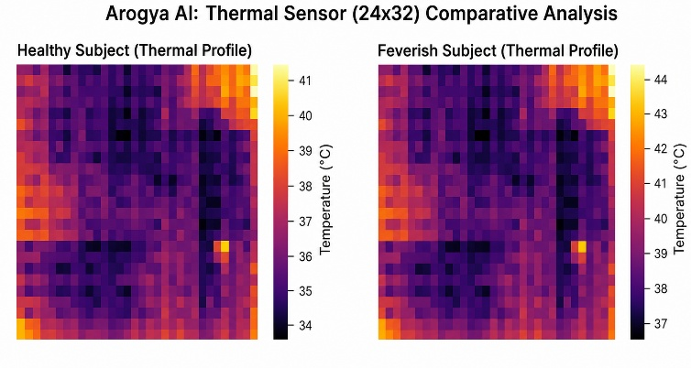
Figure 7. Comparative Thermal Profiles of Healthy and Fever Cases.

System Power and Cost Analysis
Table III shows the system power consumption with varied modes, assuming it is powered by a 2,000 mAh Li-Po battery. The total BOM cost for the prototype unit can be brought down to nearly ₹8,950, with its usage in a single-unit installation, which is remarkably affordable as compared to clinical setup for delivering same functionality. For a full-scale manufacturing, it can be further reduced to ₹5,000.

TABLE III. System Power Budget Across Operating Modes
Mode | Current | Power | Runtime
Active + AI | 185 mA | 610 mW | 10.8 h
Sensing Only | 110 mA | 363 mW | 18.2 h
Standby | 12 mA | 40 mW | >7 days

Unified Triage Logic and User Interface Validation
Bench testing confirmed that the firmware’s state logic (Section III-I) correctly reproduced the intended Green / Amber(repeat) / Red mapping for a set of manually injected out-of-range and borderline sensor values; this is a functional verification of the interface logic, not a measurement of clinical sensitivity or specificity, which have not yet been established (Section VI). Use of a TCA9548A I²C multiplexer allowed multiple digital sensors sharing the same default address to co-exist stably on the bus, avoiding address conflicts.

DISCUSSION
Of significant clinical interest is the use of Arogya AI to supplement the decision-making process in environments where diagnostic access is limited. In principle, fusing multiple physiological cues — ECG rhythm, SpO₂, thermal profile, respiratory effort, an exploratory haemoglobin-related index, and an autonomic-stress signal — should be less prone to single-sensor false positives/negatives than any one parameter viewed in isolation, consistent with the broader sensor-fusion literature [12, 13]; this expectation has not yet been empirically confirmed for Arogya AI and is a target of the validation study proposed in Section VII. In the Indian healthcare context spectral haemoglobin measurement is an added value as India faces a high burden of anaemia. Having a non-invasive screening tool can indeed lessen reliance on a blood sample taken for laboratory analysis when out on visits to local villages, where blood samples often need to be transported elsewhere [4].
Furthermore, with all the computation occurring on-device Arogya AI delivers immediate results without requirement for an internet connection [11]. Arogya AI Directly supports two of the UN SDGs, both with a focus on ‘doing’ more than’ saying’. It assists UN SDG 3 (Good health and well-being) by delivering a tool for quicker triage, screening and detection of the need for medical attention. Arogya AI aids the reduction of inequalities by targeting underserved, resource limited communities with an affordable diagnostic tool, SDG 10 (Reducing Inequalities). The system was developed with deployment in remote villages in mind, where conventional diagnostic support is likely scarce. Low development cost with significantly reduced cost compared to off-the-shelf integrated multi device diagnostic tools, portability in field deployments, and an interface focused on the use of just lights and no complex software interfaces greatly aid feasibility in these contexts. Before wider adoption, Arogya AI has a number of limitations that must be resolved. The current evaluation used a small, laboratory-recruited sample rather than a clinically representative, subject-diverse cohort, and reference-instrument comparisons (against a validated clinical thermometer, pulse oximeter, 12-lead ECG, and laboratory haemoglobin assay) have not yet been performed for any sensing channel — all reported figures should therefore be read as preliminary engineering observations rather than clinical accuracy. The spectral haemoglobin channel remains particularly uncertain: optical absorption at the AS7262/AS7343 wavelengths is known to vary with skin pigmentation, and without per-user or population-level calibration against laboratory haemoglobin measurements this channel cannot be used for anaemia screening. The single-lead ECG configuration limits cardiac assessment to rhythm/signal screening and cannot substitute for a multi-lead diagnostic ECG. Motion artefacts, ambient lighting, and skin contact quality affect the MAX30102, MLX90640, and GSR channels and have only been partially characterised on the bench. Sensor calibration drift over time — particularly for the MQ-135 gas sensor — has not been characterised over a deployment-length timeframe.
The MQ-135 sensor, like all metal-oxide gas sensors, is additionally prone to environmental interference and long-term drift and would require periodic field calibration. All testing to date has been conducted in a controlled laboratory or bench-simulated environment rather than in an actual rural PHC or field deployment with ASHA-worker operators and real patients; no clinical validation, usability study, or regulatory assessment has yet been carried out. Section VII sets out the validation pathway required before any clinical or diagnostic claim can be made for this system.

CONCLUSION
Arogya AI demonstrates the engineering feasibility of integrating low-cost multimodal sensing and offline edge-AI processing for preliminary physiological screening in resource-constrained healthcare environments. Clinical diagnostic validity has not yet been established. The prototype integrates thermal, single-lead ECG, SpO₂/PPG, motion-based respiratory, exploratory spectral, gas, and GSR sensing on a single ESP32-S3 platform, with a reproducible, rule-based sensor-fusion score driving a zero-literacy Green/Amber/Red output, and achieves practical on-device inference latency, memory usage, and battery life for field use. These results support Arogya AI as a promising engineering foundation for frontline screening and referral support — not as a diagnostic substitute — and motivate the validation pathway set out in Section VII before any clinical deployment claim is made. If that pathway is successfully completed, the prototype's low cost and offline operation position it to help ASHA workers extend basic physiological screening to underserved rural communities, in support of SDG 3 and SDG 10.

FUTURE WORK

Before any clinical or diagnostic claim can be made for Arogya AI, the following validation pathway is required, alongside further engineering development:
- Reference-Instrument Validation: Benchmark temperature, SpO₂, ECG, and respiration channels against validated clinical reference instruments under IEC/ISO-aligned test protocols (e.g. ISO 80601-2-61 for pulse oximetry) to establish sensitivity, specificity, and agreement (Bland-Altman/MAE/RMSE) with 95% confidence intervals.
- Laboratory Haemoglobin Comparison: Validate the exploratory AS7262/AS7343 spectral index against laboratory (cyanmethemoglobin or point-of-care haemoglobinometer) measurements across a range of skin pigmentations before any anaemia-screening claim is made.
- Subject-Independent and External Testing: Expand the evaluation dataset and confirm subject-independent train/validation/test splits hold on an externally collected cohort, to test generalisation beyond the current small, single-site sample.
- Usability Evaluation with ASHA Workers: Conduct a field usability study with the intended operators (ASHA workers) to assess time-to-scan, error rates, and interface comprehension of the Green/Amber/Red output.
- Uncertainty-Aware Decision Support: Extend the rule-based triage score to communicate confidence/uncertainty (e.g. via the signal-quality flags already logged) rather than a single deterministic label.
- Privacy and Security Evaluation: Assess on-device data handling, storage, and any future connectivity (e.g. firmware-update or ABDM integration channels) against applicable privacy and security requirements.
- Regulatory Assessment: Engage CDSCO and relevant standards bodies early to determine the applicable regulatory pathway for a screening device of this kind ahead of any clinical deployment.
- Cloud Text-to-Speech Pipeline with Multiple Languages Support: Pipeline with Multiple languages: Development of a cloud-hosted text-to-speech pipeline would enable the Arogya AI to be spoken out in several different languages like Hindi, Tamil, Bengali, Telugu, etc., helping overcome language barriers.
- Machine Learning-Based Spectral Calibration: The current haemoglobin estimation channel requires manual per-user calibration. Future work will train a small regression model on a diverse skin-tone dataset to enable automatic, real-time spectral calibration, removing this operational limitation.
- Mass-Market PCB Design and Cost Optimisation: Moving from the breadboard prototype to a custom-designed, compact PCB with optimised component sourcing is projected to reduce the bill-of-materials cost to below Rs. 5,000 — the mass-market target identified in the feasibility study.
- Clinical Validation Study: Following the reference-instrument and usability work above, a formal clinical field study involving ASHA workers and patients at rural PHCs (e.g. in Haryana or Rajasthan) will measure real-world triage sensitivity, specificity, and usability, generating the evidence base needed for a CDSCO regulatory submission.
- Federated Learning for Model Improvement: Patient data collected from deployed Arogya AI devices could be used to continuously improve the TinyML models without compromising patient privacy, using federated learning techniques to train on distributed edge devices without transmitting raw patient data to the cloud.
- Integration with National Health Programmes: Alignment with the Ayushman Bharat Digital Mission (ABDM) and National Health Mission (NHM) data standards would enable Arogya AI data to flow into the national health record system, enabling longitudinal patient tracking and population-level disease surveillance.
- Solar and Low-Power Operation: Integration of a small solar charging module and deep-sleep firmware optimisation will enable week-long autonomous operation in off-grid rural settings without access to electrical charging infrastructure

References

- A. Abadade et al., “TinyML for Precise Lung Disease Detection,” Informatics, 2024.
- S. Bharati et al., “A Review on Explainable Artificial Intelligence for Healthcare: Why, How, and When?,” arXiv preprint, 2023.
- “Edge Computing in Healthcare Using Machine Learning: A Review,” WIREs Data Mining and Knowledge Discovery, 2026.
- B. Heidt, W. F. Siqueira, K. Eersels, H. Diliën, B. van Grinsven, R. T. Fujiwara, and T. J. Cleij, “Point of Care Diagnostics in Resource-Limited Settings: A Review of the Present and Future of PoC in Its Most Needed Environment,” Biosensors, vol. 10, no. 10, Art. no. 133, 2020.
- B. Sadeghi et al., “A Brief Review of Explainable Artificial Intelligence in Healthcare,” arXiv preprint, 2023.
- V. Tsoukas, E. Boumpa, G. Giannakas, and A. Kakarountas, “A Review of Machine Learning and TinyML in Healthcare,” in Proc. 25th Pan-Hellenic Conf. Informatics (PCI), Athens, Greece, 2021, pp. 69–73, doi: 10.1145/3503823.3503836.
- C. Velasquez et al., “Emerging Trends in TinyML,” Neurocomputing, 2025.
- S. Soro, “TinyML for Ubiquitous Edge AI,” arXiv preprint arXiv:2102.01255, 2021.
- H. Ren, D. Anicic, and T. Runkler, “TinyOL: TinyML with Online-Learning on Microcontrollers,” arXiv preprint arXiv:2103.08295, 2021.
- H. Han, S. Trimi, and S. M. Lee, “Tiny Machine Learning (TinyML): Research Trends and Future Application Opportunities,” Array, vol. 29, Art. no. 100674, 2026, doi: 10.1016/j.array.2025.100674.
- W. Shi, J. Cao, Q. Zhang, Y. Li, and L. Xu, “Edge Computing: Vision and Challenges,” IEEE Internet Things J., vol. 3, no. 5, pp. 637–646, Oct. 2016.
- D. L. Hall and J. Llinas, “An Introduction to Multisensor Data Fusion,” Proc. IEEE, vol. 85, no. 1, pp. 6–23, Jan. 1997.
- S. Majumder, T. Mondal, and M. J. Deen, “Wearable Sensors for Remote Health Monitoring,” Sensors, vol. 17, no. 1, Art. no. 130, 2017.
- S. C. Mukhopadhyay, “Wearable Sensors for Human Activity Monitoring: A Review,” IEEE Sensors J., vol. 15, no. 3, pp. 1321–1330, Mar. 2015.
- G. B. Moody and R. G. Mark, “The Impact of the MIT-BIH Arrhythmia Database,” IEEE Eng. Med. Biol. Mag., vol. 20, no. 3, pp. 45–50, May/Jun. 2001.
- A. L. Goldberger et al., “PhysioBank, PhysioToolkit, and PhysioNet: Components of a New Research Resource for Complex Physiologic Signals,” Circulation, vol. 101, no. 23, pp. e215–e220, 2000.
- X. Wang, M. Magno, L. Cavigelli, and L. Benini, “FANN-on-MCU: An Open-Source Toolkit for Energy-Efficient Neural Network Inference at the Edge of the Internet of Things,” IEEE Internet Things J., vol. 7, no. 5, pp. 4403–4417, May 2020.
- M. Shafique, T. Theocharides, V. J. Reddi, and B. Murmann, “TinyML: Current Progress, Research Challenges, and Future Roadmap,” in Proc. 58th ACM/IEEE Design Autom. Conf. (DAC), 2021, pp. 1303–1306.
- R. Sanchez-Iborra and A. F. Skarmeta, “TinyML-Enabled Frugal Smart Objects: Challenges and Opportunities,” IEEE Circuits Syst. Mag., vol. 20, no. 3, pp. 4–18, 2020.
- C. R. Banbury et al., “Benchmarking TinyML Systems: Challenges and Direction,” arXiv preprint arXiv:2003.04821, 2020.
- ISO 80601-2-61:2017, Medical electrical equipment — Part 2-61: Particular requirements for the basic safety and essential performance of pulse oximeter equipment, International Organization for Standardization, 2017.
- Analog Devices (Maxim Integrated), MAX30003 Ultra-Low-Power, Single-Channel Integrated Biopotential (ECG, R-to-R Detection) AFE Solution, Datasheet.
- Analog Devices (Maxim Integrated), MAX30102 High-Sensitivity Pulse Oximeter and Heart-Rate Sensor for Wearable Health, Datasheet.
- Melexis, MLX90640 Far Infrared Thermal Sensor Array, Datasheet.
- ams OSRAM, AS7262 6-Channel Visible Spectral Sensor and AS7343 14-Channel Multi-Spectral Digital Sensor, Datasheets.
- World Health Organization, Haemoglobin Concentrations for the Diagnosis of Anaemia and Assessment of Severity, WHO/NMH/NHD/MNM/11.1, Geneva, 2011.

