**Steps to start the profile summary api locally**

1. 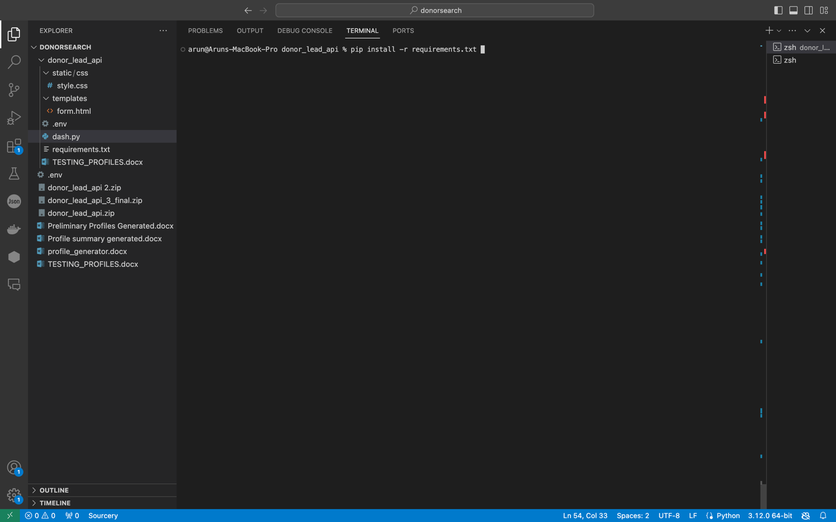Install packages required using the command shown below.
2. Python command to run the api file and click on the link generated by the api

1. Press control and click on <http://127.0.0.1:5000> and the below webpage will open.
2. A screenshot of a computer

   Description automatically generatedClick generate after filling the form and wait for the application to return with the different summaries intended in json format ready to be used in the user interface.
   1. “chatgpt_summary” - summary generated by chatgpt
   2. “donorsearch_context_summary” – summary generated using context from donorsearch api
   3. “less_likely_summary” – summary of less likely matches in the donorsearch api.

