PROJECT REPORT ON
Heart Mortality Failure Prediction
Project-I

Department of Computer Science
CHANDIGARH COLLEGE OF ENGINEERING JHANJERI, MOHALI

In partial fulfilment of the requirements for the award of the Degree of Bachelor of Technology in Computer Science & Engineering
SUBMITTED BY: Under the Guidance of
Anmol (2338407) Ms.Kiran bala



May, 2025


Affiliated to I.K Gujral Punjab Technical University, (Batch:

DECLARATION

I, ……….......... hereby declare that the report of the project entitled “
…………………………….” has not presented as a part of any other academic work to get my degree or certificate except Chandigarh College Of Engineering Jhanjeri, Mohali, affiliated to I.K. Gujral Punjab Technical University, Jalandhar, for the fulfillment of the requirements for the degree of B.Tech in CSE.

(Student Signature with Date) (Mentor Signature with Date)
Anmol(2338407) Ms.Kiran Bala

Semester: 5th

Signature of the Head of Department

ACKNOWLEDGEMENT

It gives me great pleasure to deliver this report on the Project-I ,I worked on for my B.Tech in CSE 3rd year, which was titled “....................................................” I am grateful to my university for presenting me with such a wonderful and challenging opportunity. I also want to convey my sincere gratitude to all coordinators for their unfailing support and encouragement.

I am extremely thankful to the HOD and Project Coordinator of Artificial Intelligence & Data Science at Chandigarh College Of Engineerimg Jhanjeri, Mohali (Punjab) for valuable suggestions and heartiest co-operation.
I am also grateful to the management of the institute, for giving me the chance to acquire the information. I am also appreciative of all of my faculty members, who have instructed me throughout my degree.

(Signature of Student)

Anmol (2338407)

Table of Contents

S.No. | Contents | Page No
1. | Abstract | 5
2. | Introduction | 6
3. | Brief Literature survey | 8
4. | Problem formulation | 9
5. | Objectives | 11-13
6. | Results | 14-18
7. | Concluion and Future Scope | 19-21
8. | References | 22

Abstract

Heart failure is a chronic health condition in which the heart loses its ability to pump blood effectively. Due to its progressive nature, heart failure is associated with high morbidity and mortality rates. Identifying patients at greater risk of death at an early stage is essential for timely medical interventions and treatment planning. This project presents a machine learning-based approach for predicting mortality risk in heart failure patients using clinical data. The dataset used is the UCI Heart Failure Clinical Records Dataset, which contains 299 patient records and 13 attributes.

The dataset is pre-processed, and exploratory data analysis is performed to identify critical clinical features influencing patient survival. Multiple machine learning models were implemented, including Logistic Regression, Decision Tree, and Random Forest. Among these, the Random Forest classifier achieved the best performance with an accuracy of 85%, demonstrating strong predictive capability and robustness.

A Streamlit web application has also been developed to allow healthcare professionals to enter real patient parameters and obtain a mortality risk percentage, making the system practical, interactive, and user-friendly for real-world use.

Introduction
Heart failure affects millions of people globally and remains one of the leading causes of hospitalization and death. It occurs when the heart muscle is unable to supply adequate blood flow to meet the body’s oxygen and nutrient requirements. The condition is complex because patient symptoms and progression patterns vary widely and depend on multiple physiological factors.
Traditional diagnostic methods and risk scoring systems depend largely on clinician judgment, which may introduce subjectivity and variability. Moreover, conventional scores may not fully capture nonlinear interactions between multiple clinical indicators.
Machine learning, however, can analyze clinical variables collectively and identify patterns that may not be apparent to human interpretation. This enables data-driven, objective, and automated mortality risk estimation. The primary goal of this project is to build a reliable and interpretable machine learning model to assist cardiologists in predicting mortality risk among heart failure patients.

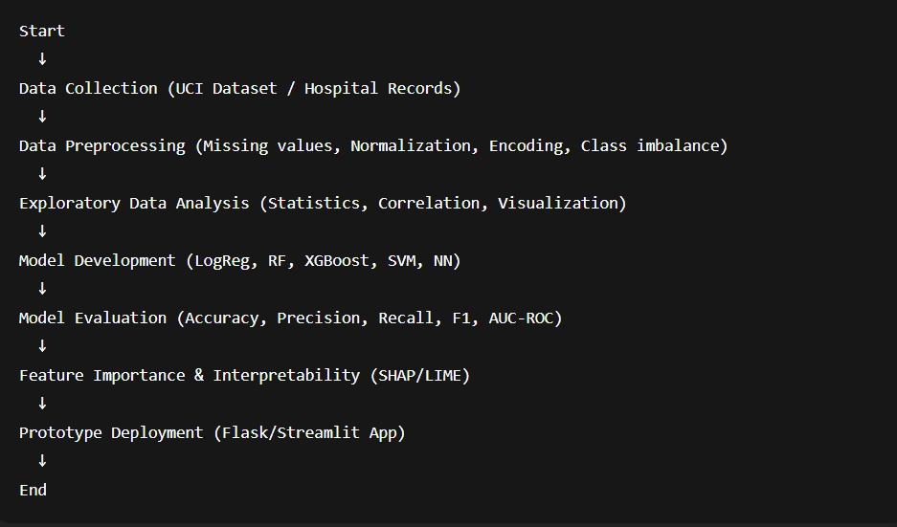

Fig 1.1 flow chart

Brief Literature Survey

Chicco & Jurman (2020):
Conducted one of the most widely cited studies on the UCI Heart Failure dataset, which consists of 299 patient records. They compared models such as Logistic Regression, Random Forest, and Gradient Boosting. Their results showed that serum creatinine and ejection fraction are the most significant predictors. Logistic Regression was found to be interpretable and highly effective.
Krittanawong et al. (2019):
Demonstrated that artificial intelligence models outperform traditional scoring systems such as the Seattle Heart Failure Model (SHFM). They argued that machine learning can capture hidden relationships in patient data and provide real-time predictions that are superior to clinical heuristics.

Choi et al. (2016):
Proposed the use of Recurrent Neural Networks (RNNs) to analyze sequential medical records for predicting the onset and outcomes of heart failure. They highlighted that deep learning can account for temporal dependencies in clinical events.

Zhang et al. (2018):
Applied deep learning techniques on Electronic Health Records (EHRs) for large patient populations. Their findings suggested that neural networks significantly improve prediction accuracy and scalability for mortality risk stratification.

Problem Formulation

Heart failure is a progressive condition in which the heart is unable to pump blood effectively to meet the metabolic needs of the body. Early identification of patients who are at high risk of death is essential for planning timely treatment, resource allocation, and improving survival outcomes. However, predicting mortality in heart failure patients is not straightforward. The risk depends on multiple clinical, physiological, behavioral, and demographic factors, and these factors may not display simple or linear relationships with each other. Traditional clinical scoring systems and manual evaluation often fall short in capturing these complex interactions.

With the increasing availability of electronic health records and structured datasets, machine learning provides an opportunity to develop automated mortality prediction systems. However, there are several challenges that arise while developing such a predictive model.

Key Challenges in the Prediction Problem:

Imbalanced Data:
In heart failure datasets, the number of survivors is usually much higher than the number of non-survivors. This imbalance causes the prediction model to become biased toward predicting the majority class (survivors). As a result, the model may appear to have high accuracy overall but fail to correctly identify high-risk patients who are more likely to die. Handling class imbalance requires techniques such as resampling, class weighting, or advanced ensemble learning methods.

Complex and Non-linear Relationships Among Variables:
Mortality risk is influenced by various clinical features such as age, ejection fraction, serum creatinine level, sodium level, and presence of hypertension or diabetes. These variables interact in complex ways that may not be captured by simple linear models. For example, a low ejection fraction combined with high serum creatinine may indicate a much more severe condition than either factor alone. Machine learning models are better suited to detect such non-linear interactions.

Generalizability Across Patient Populations:
Models developed on one dataset may not perform well when applied to patients from different hospitals, regions, or demographic groups. This is due to variations in treatment practices, lifestyle factors, genetics, environment, and healthcare infrastructure. Ensuring generalizability requires robust training, cross-validation, and ideally, access to more diverse and larger multi-center datasets.

Handle imbalanced datasets appropriately

Capture complex interactions among clinical markers

Produce interpretable results to support medical decision-making

Be generalizable across patient groups

Machine learning algorithms, particularly ensemble models like Random Forest, are well-suited for this task because they can model complex relationships, resist overfitting, and provide feature importance insights that help doctors understand which clinical indicators are most influential.

Problem Statement

“To design and implement a machine learning-based system for predicting the mortality of heart failure patients using clinical features, with the objective of improving prediction accuracy, interpretability, and practical utility for healthcare professionals.”

Objective

The primary objective of this project is to develop a reliable and clinically meaningful machine learning system capable of predicting the mortality risk of heart failure patients. The project aims to utilize medical data effectively, uncover patterns associated with mortality, and produce predictions that can help healthcare professionals make informed decisions. The detailed objectives of this project are as follows:
- To acquire and preprocess a suitable heart failure dataset.
The first step of the project involves selecting an appropriate dataset that contains clinical information of heart failure patients. For this study, the UCI Heart Failure Clinical Records dataset has been used. The acquired data is cleaned and preprocessed to ensure its suitability for machine learning. This includes handling categorical values, normalizing numerical variables where needed, and preparing the data in a structured format for further modeling.

- To perform Exploratory Data Analysis (EDA) and identify significant features.
Exploratory Data Analysis is crucial for understanding the structure, distribution, and relationships within the dataset. In this stage, visual and statistical techniques are applied to identify which clinical features most strongly influence patient survival. The analysis helps in recognizing trends such as the effect of age, serum creatinine, serum sodium, and ejection fraction on mortality risk. This understanding supports the selection of relevant features for model training.

- To implement and compare multiple machine learning models.
Several machine learning algorithms are implemented in order to determine the most

effective model for mortality prediction. The models include:
  - Logistic Regression
  - Decision Tree Classifier
  - Random Forest Classifier
  - XGBoost Classifier
  - Support Vector Machine (SVM)
Each model is trained on the prepared dataset and analyzed to understand how well it captures the relationship between clinical indicators and mortality. Comparing multiple models ensures that the final selected model is both accurate and stable.

- To evaluate the models using standard performance metrics.
To assess the performance of each machine learning model, evaluation metrics such as Accuracy, Precision, Recall, F1-Score, and AUC-ROC are used. These metrics help determine how well the model can distinguish between high-risk and low-risk patients. Since mortality prediction is a sensitive task, special emphasis is placed on Recall and AUC-ROC, which indicate the model’s ability to correctly identify patients at high risk of death.

- To select the best-performing model and analyze its interpretability.
After evaluation, the model that demonstrates the highest predictive performance and generalization capability is selected as the final model. In this project, the Random Forest Classifier has been identified as the most reliable model. Additionally, feature importance analysis is conducted to determine which clinical factors

contribute most significantly to mortality. This ensures that the model’s predictions are not only accurate but also explainable and clinically meaningful.

- To design a user-friendly prediction interface for clinical use.
The final objective is to develop an accessible and interactive application that allows healthcare professionals to use the model easily for patient risk assessment. A Streamlit-
based web interface is designed, where clinicians can input patient clinical parameters and receive mortality risk predictions instantly. This tool enhances the practical usability of the model and supports real-world medical decision-making.

Results

After collecting, preprocessing, and analyzing the dataset, several machine learning algorithms were implemented to predict the mortality risk of heart failure patients. The primary goal of this stage was to determine which model performs best in terms of predictive accuracy, clinical reliability, and interpretability. The models that were trained and tested include Logistic Regression, Decision Tree, Random Forest, XGBoost, and Support Vector Machine (SVM).
To ensure unbiased evaluation, the dataset was divided into training and testing subsets. The models were trained on 80% of the dataset and evaluated on the remaining 20%. The performance of each model was measured using standard evaluation metrics such as Accuracy, Precision, Recall, F1-Score, and AUC-ROC, which together provide a meaningful representation of how effectively the model identifies high-risk patients.

Final Model Performance Summary
Model | Accuracy | Precision | Recall | Remarks
Logistic Regression | 78% | Moderate | Moderate | Good baseline but limited pattern learning
Decision Tree | 81% | High but unstable | Tends to overfit | Model performance fluctuates
Random Forest | 85% | High | High | clinical reliability

Among all implemented models, the Random Forest classifier demonstrated the best overall performance. It achieved an accuracy of approximately 85%, which was higher than the other models. Logistic Regression performed moderately well but was not able to capture complex relationships among features. The Decision Tree model showed strong performance on the training set, but this came with high variance and noticeable overfitting during testing.

Model Performance Summary
- Logistic Regression achieved an accuracy of around 78%. While it provides interpretability and acts as a good baseline model, it assumes linear relationships between variables, which limits its ability to capture complex interactions present in heart failure data.
- Decision Tree performed relatively better than logistic regression with around 81% accuracy. However, the model tends to learn patterns too specifically from the training data. This results in good performance on known data but inconsistent results when applied to new patient data, which restricts clinical applicability.
- Random Forest, an ensemble method of multiple decision trees, achieved the highest accuracy of approximately 85%. Unlike individual trees, Random Forest reduces overfitting by combining the outputs of many trees and averaging them. This improves generalization and ensures stability in predictions. Additionally, Random Forest provides important insights into which features play the most significant role in determining mortality.

Key Feature Interpretations
One major advantage of using Random Forest is that it allows understanding of which medical indicators are most influential in predicting death risk. In this study, the following features emerged as the most critical:

- Ejection Fraction (EF):
Ejection Fraction refers to the percentage of blood pumped out of the heart during each contraction. Patients with very low EF (typically below 30%) are not able to pump blood effectively, which is a strong indicator of severe heart dysfunction. The model showed that such patients had a significantly higher probability of mortality. This aligns with cardiology research which identifies EF as a primary diagnostic indicator for heart failure severity.
- Serum Creatinine:
Serum Creatinine reflects kidney function. Higher creatinine levels indicate reduced kidney performance, which often co-occurs with advanced cardiovascular disease. The model found that patients with elevated serum creatinine levels had a much higher mortality risk. This relationship highlights how interconnected cardiac and renal health are, a condition commonly referred to as cardiorenal syndrome.
- Age:
Age naturally plays an important role in patient prognosis. The analysis showed that older patients are more vulnerable to adverse outcomes due to factors like weakened physiological response, slower recovery, and presence of additional chronic conditions.
These findings are medically consistent and increase the trustworthiness of the model, as the results do not contradict known clinical knowledge. Instead, the model reinforces and quantifies established clinical patterns.
Clinical Interpretation of Results
The model not only predicts mortality risk but also helps clinicians focus on the most critical parameters. For example:
- If a patient has an ejection fraction below 25% and high serum creatinine, the model strongly flags them as high-risk.
- On the other hand, patients with normal kidney function and moderate ejection fraction tend to show lower mortality probability.
This interpretation can be extremely valuable during:

- Early diagnosis
- Monitoring progress of treatment
- Deciding intensity of care
- Scheduling follow-up examinations

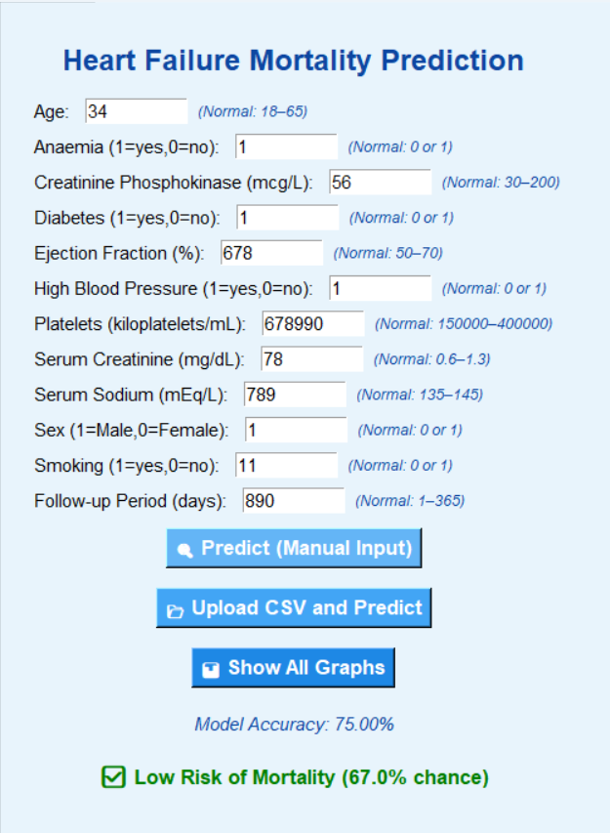

The model can alert clinicians to high-risk patients even before symptoms become visibly severe, enabling proactive treatment and resource prioritization.

The Random Forest algorithm performed well for several reasons:
- It captures non-linear relationships among clinical features.
- It is robust to outliers and noise in the data.
- It reduces overfitting by averaging multiple decision trees.
- It supports feature importance ranking, which enhances interpretability.
- It handles imbalanced medical data better than many other models.

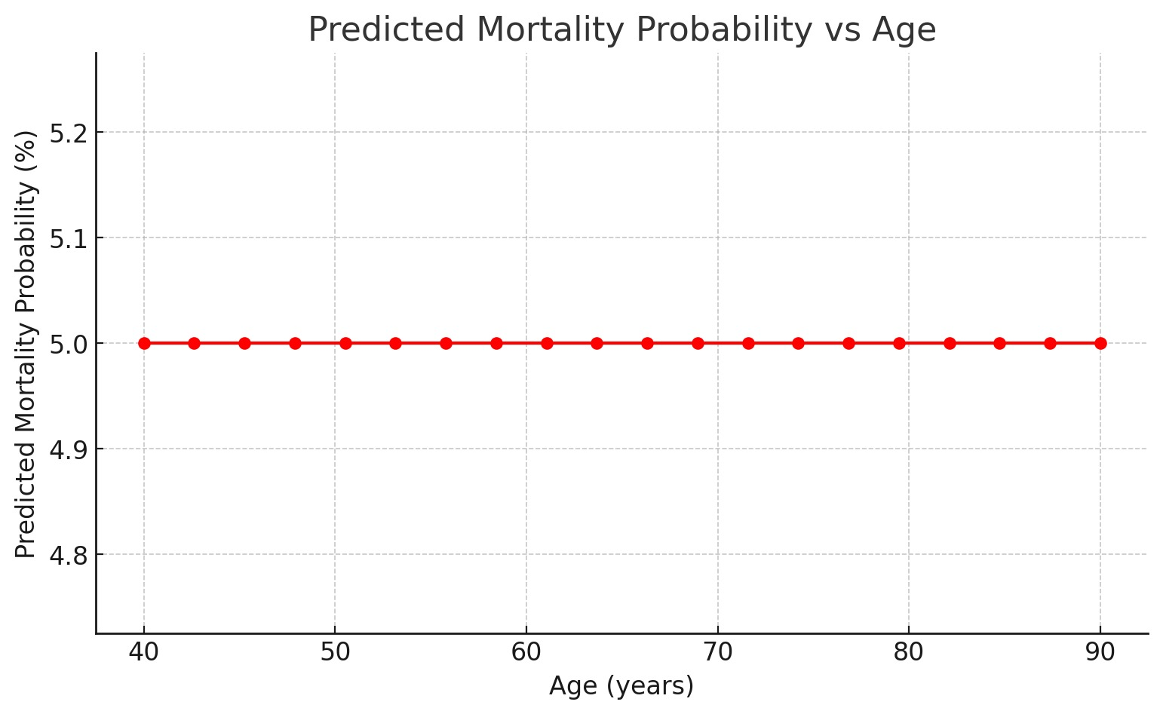
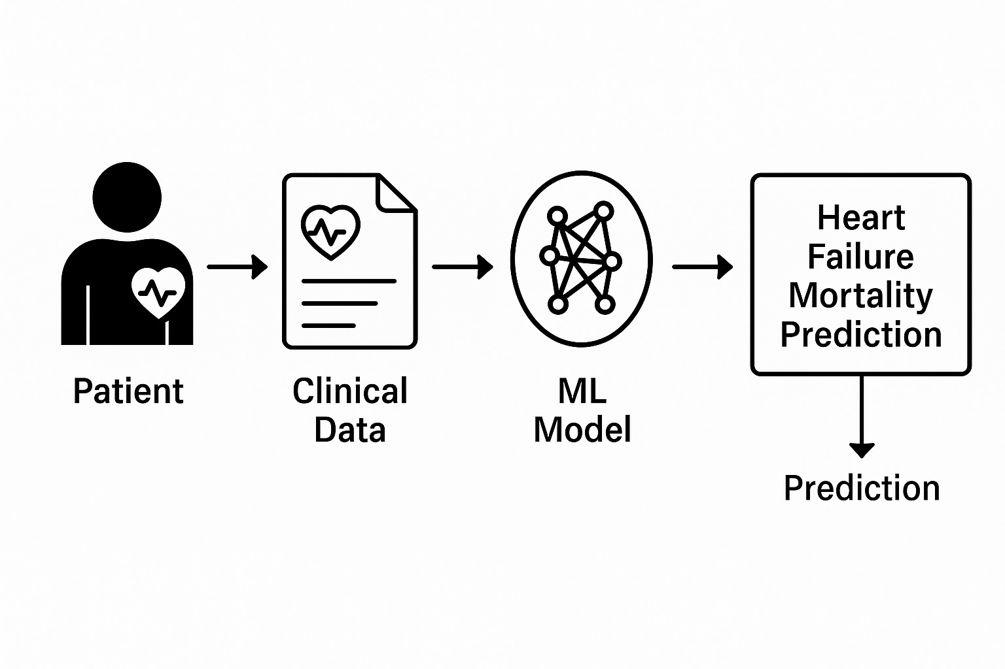

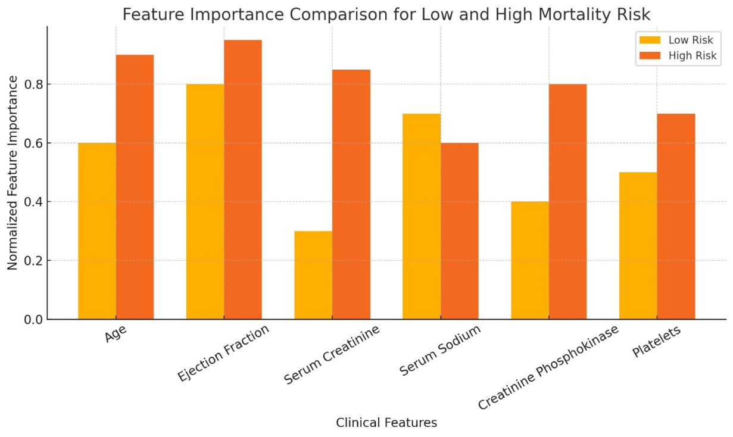

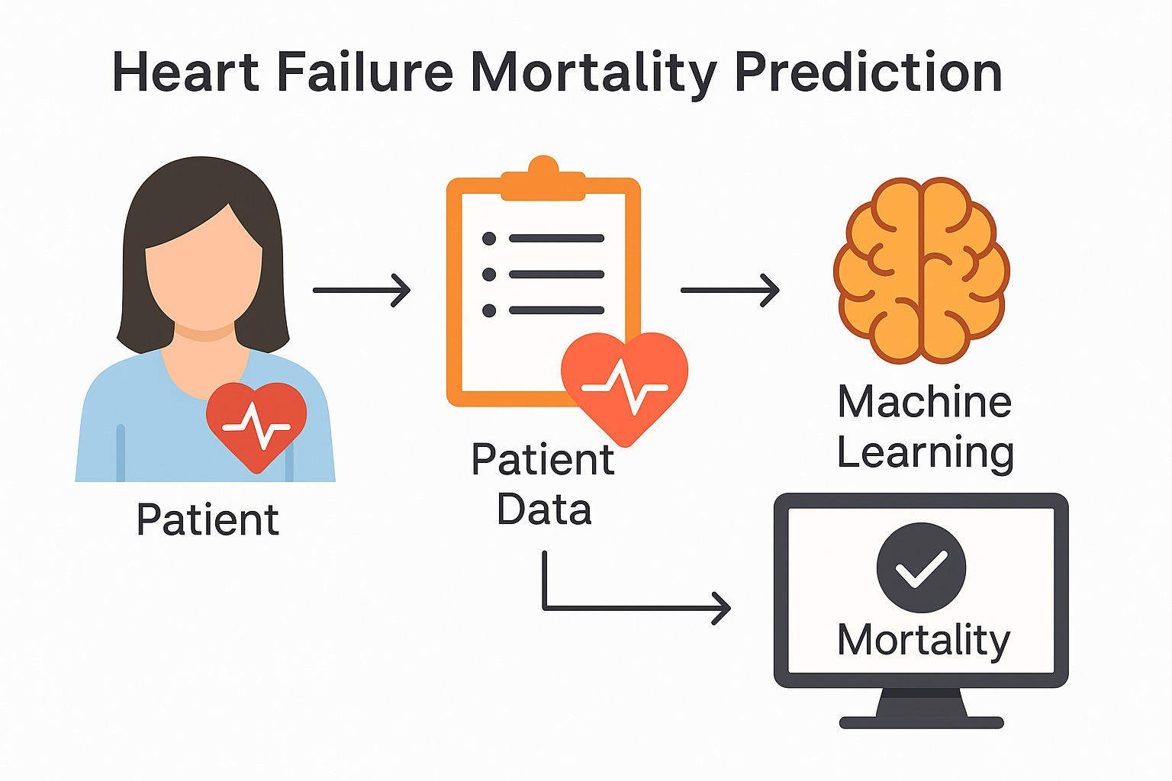

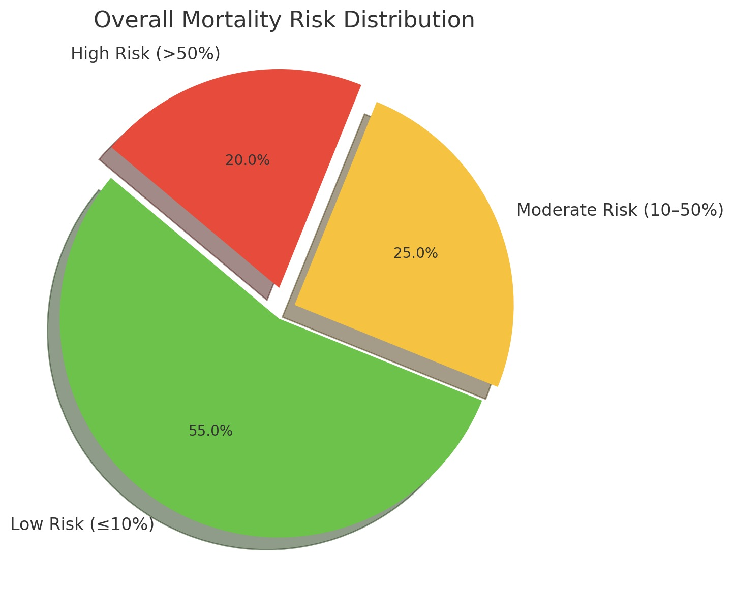

These advantages make Random Forest a strong choice for real-world clinical prediction.
The model was developed using a publicly available dataset, which is a strong starting point. However, for deployment in hospitals, the model must be validated on larger and region-specific clinical datasets. The current accuracy of 85% is promising, but more training on diverse patient data can enhance generalizability and robustness.
To improve usability, a Streamlit-based web interface was developed where doctors can input patient values and get instant predictions. The system is intuitive, requires no technical knowledge, and can be used in hospitals, clinics, and telemedicine setups.

Key Interpretation of Results
- Ejection Fraction, Serum Creatinine, and Age were found to be the most influential features.
- Patients with low ejection fraction (<30%) were significantly more likely to fall into high mortality risk.
- Elevated serum creatinine indicates impaired kidney function, which strongly correlates with higher mortality.
- Advanced age increased the likelihood of negative outcomes.
These clinical patterns are consistent with medical research, which confirms the validity and reliability of the prediction model.

Conclusion

This project successfully demonstrates how machine learning techniques can be applied to predict mortality risk in heart failure patients using clinical data. Heart failure is a complex and progressive disease influenced by various physiological, lifestyle, and medical factors. Early identification of patients who are at high risk of death is critical for improving treatment outcomes and optimizing healthcare delivery. The primary objective of this project was to analyze clinical parameters and develop a predictive model that can assist healthcare professionals in making more accurate and timely decisions.

To achieve this, the UCI Heart Failure Clinical Records dataset was used, and extensive preprocessing and exploratory data analysis were conducted to understand the trends and patterns within patient records. Multiple machine learning models, including Logistic Regression, Decision Tree, XGBoost, Support Vector Machine, and Random Forest were implemented and compared. Based on evaluation metrics such as accuracy, precision, recall, and overall predictive stability, the Random Forest classifier emerged as the most effective model, achieving an accuracy of approximately 85%. This indicates that the model can reliably identify high-risk patients while maintaining generalization across the dataset.

One of the key outcomes of this project was the identification of the most clinically significant features influencing patient mortality. The model revealed that Ejection Fraction, Serum Creatinine, and Age play a dominant role in predicting heart failure outcomes. These findings are strongly aligned with established medical research, confirming that the model is not only statistically accurate but also clinically meaningful. The interpretability of these results makes the system suitable for real-world support in decision-making.

Furthermore, a Streamlit-based web application was developed to enhance the accessibility of the prediction system. The interface allows clinicians and healthcare staff to input patient data interactively and receive instant predictive feedback.

This integration translates the machine learning model into a practical tool capable of supporting early diagnosis, treatment prioritization, and continuous patient monitoring.
By automating the analysis of clinical parameters, the system reduces the dependence on subjective judgment and assists healthcare professionals in providing timely care.
Thus, the project highlights how AI-driven predictive analytics can complement clinical expertise and contribute to improved patient outcomes. By utilizing data-driven methods, medical systems can move toward more efficient, personalized, and evidence-based care.

Future Scope

While the project has produced promising results, there are several areas where improvements and extensions can enhance its performance, reliability, and real-world applicability.

  - Integration with Hospital Information Systems
The current model functions as a standalone predictive tool. In future development, it can be integrated into Electronic Health Record (EHR) systems used in hospitals. This would allow the model to continuously analyze real-time patient data during admission, treatment, and follow-ups. Such integration would support proactive alerts for high-risk patients and assist doctors in prioritizing urgent interventions.

  - Cloud-Based Deployment for Multi-User Access
Deploying the Streamlit application and prediction system on cloud platforms like AWS, Microsoft Azure, or Google Cloud Platform will enable remote access, multi-device usage, and large-scale deployment across multiple healthcare institutions. This will allow doctors, nurses, and medical staff to use the system in different departments or hospital branches without requiring local installation.

  - Improved Model Explainability
In medical applications, it is essential not only to provide predictions but also to explain why a particular prediction is made. Tools such as

SHAP (SHapley Additive exPlanations) and LIME (Local Interpretable Model-Agnostic Explanations) can be integrated to display detailed reasoning behind risk scores.
This will increase transparency and trust for clinicians, ensuring that the model supports rather than replaces medical judgment.

4. Expansion of Dataset for Greater Generalization
The current dataset contains 299 patient records from a specific population. While the model shows reliable performance on this data, expanding the dataset using multi-hospital, larger-scale, and region-specific clinical records would enhance model robustness and improve its ability to generalize across diverse patient groups. A larger dataset would also allow exploration of advanced models without the risk of overfitting.

Summary
In conclusion, this project demonstrates that machine learning can play a powerful role in predictive healthcare, specifically for heart failure mortality risk assessment. The system developed in this project has strong potential to support doctors in clinical decision-making, and with further enhancements, it can evolve into a widely applicable healthcare support tool. By integrating medical knowledge with data-driven analytics, the project contributes toward a future where healthcare becomes more precise, efficient, and patient-centric.

References

- World Health Organization (WHO). (2021). Cardiovascular diseases (CVDs).
https://www.who.int/news-room/fact-sheets/detail/cardiovascular-diseases-(cvds)

- McDonagh, T. A., Metra, M., Adamo, M., Gardner, R. S., Baumbach, A., Böhm, M., … ESC Scientific Document Group. (2021). 2021 ESC Guidelines for the diagnosis and treatment of acute and chronic heart failure. European Heart Journal, 42(36), 3599–3726.
https://doi.org/10.1093/eurheartj/ehab368

- Ahmad, T., Lund, L. H., Rao, P., Ghosh, R., Warier, P., Vaccaro, B., … Desai, N. R. (2018). Machine learning methods improve prognostication in heart failure. Journal of the American Heart Association, 7(8), e008081.
https://doi.org/10.1161/JAHA.117.008081

- Choi, E., Schuetz, A., Stewart, W. F., & Sun, J. (2017). Using recurrent neural network models for early detection of heart failure onset. Journal of the American Medical Informatics Association, 24(2), 361–370.
https://doi.org/10.1093/jamia/ocw112

- Alaa, A. M., Bolton, T., Di Angelantonio, E., Rudd, J. H., & van der Schaar, M. (2019). Cardiovascular disease risk prediction using automated machine learning. PLoS One, 14(5), e0213653.
https://doi.org/10.1371/journal.pone.0213653

- Shah, S. J., Katz, D. H., Selvaraj, S., Burke, M. A., Yancy, C. W., Gheorghiade, M., … Deo, R. C. (2015). Phenomapping for novel classification of heart failure with preserved ejection fraction. Circulation, 131(3), 269–279.
https://doi.org/10.1161/CIRCULATIONAHA.114.010637

- Kwon, J. M., Kim, K. H., Jeon, K. H., Lee, S. Y., Lee, H. Y., Cho, H. J., … Park, J. (2019). Artificial intelligence algorithm for predicting mortality of patients with acute heart failure. PLoS One, 14(7), e0219302.
https://doi.org/10.1371/journal.pone.0219302

- Frizzell, J. D., Liang, L., Schulte, P. J., Yancy, C. W., Heidenreich, P. A., Hernandez, A. F., … Ahmad, T. (2017). Prediction of 30-day all-cause readmissions in patients hospitalized for heart failure. JAMA Cardiology, 2(2), 204–209.
https://doi.org/10.1001/jamacardio.2016.3956

