**DESIGN DOCUMENT SPECIFICATIONS**

**FOR**

**DOCTOR APPOINTMENT SYSTEM**

**BY**

**Anmol Sahu**

**INDEX**

| 1.1 | CLASS DIAGRAMS |  |
| --- | --- | --- |
| 1.2 | ACTIVITY FLOW DIAGRAM |  |
| 1.3 | DATABASE DESIGN WITH THEIR STRUCTURE |  |
| 1.4 | FUNCTIONALITY OF INDIVIDUAL MODULES WITH THEIR FLOW DIAGRAM |  |
| 1.5 | STRUCTURE Of SOURCE CODE LIKE METHODS, CLASSES AND THEIR IMPLEMENTATION DETAILS |  |
|  |  |  |

**1.2 CLASS DIAGRAMS**

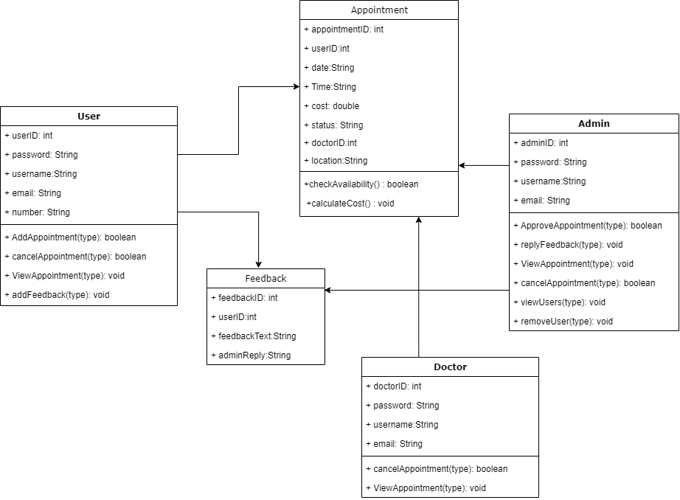

**1.1 Activity Flow Diagram**

**1. Patient**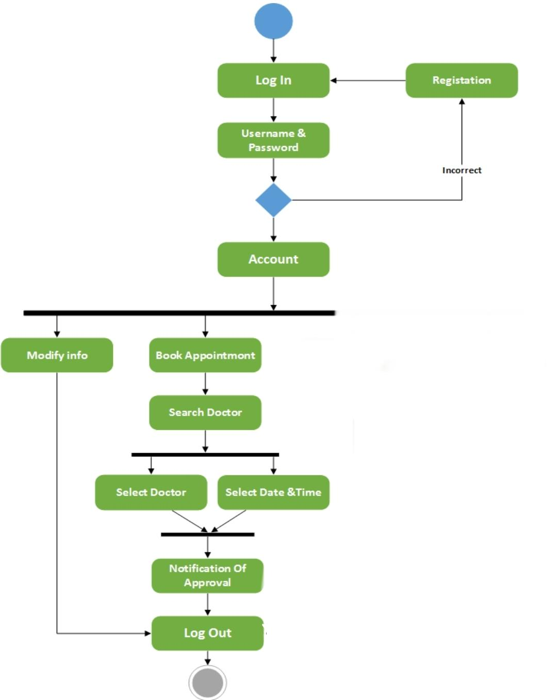

**2. Doctor**

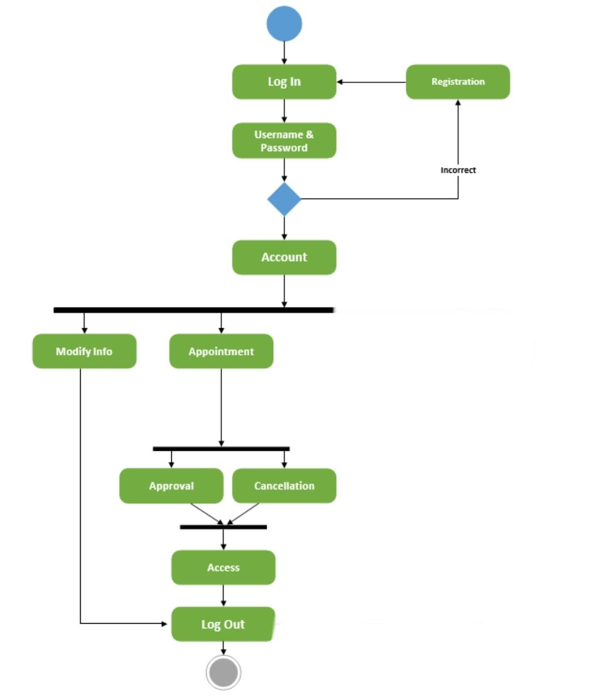

**3. Admin**

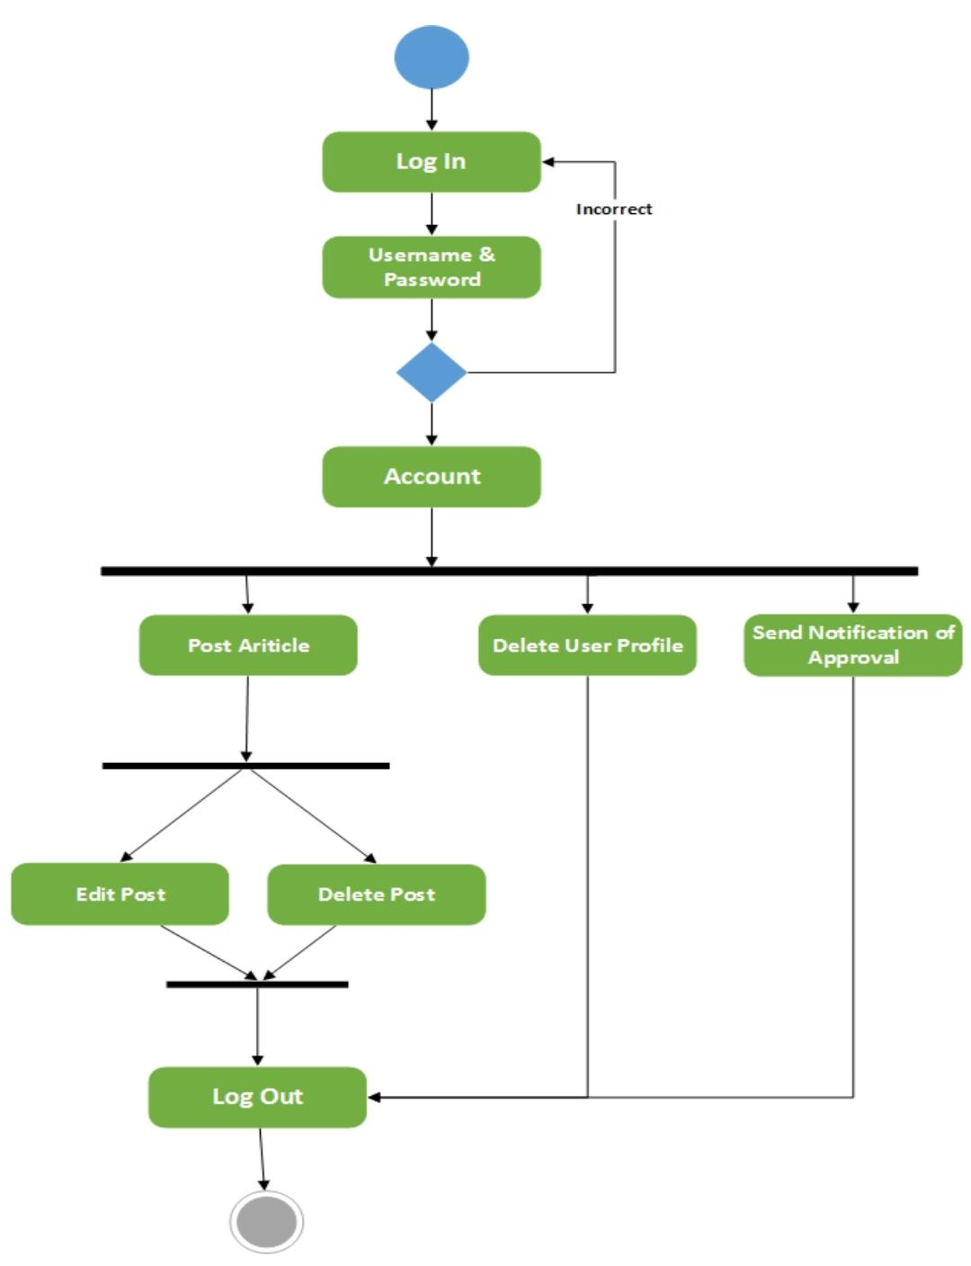

**1.3 DATABASE DESIGN WITH THEIR STRUCTURE**

1. **Table: Admin**

| **FieldName** | **FieldType** | **Data size** | **Constraint** | **Description** |
| --- | --- | --- | --- | --- |
| adminID | Integer | 10 | Primary Key, Auto Increment | Unique identifier for admin |
| username | Varchar | 50 | NOT NULL | Admin's login username |
| password | Varchar | 100 | NOT NULL | Admin's login password |
| email | varchar | 100 | NOT NULL | Admin's email address |

**2.Table: Users**

| **FieldName** | **FieldType** | **Data size** | **Constraint** | **Description** |
| --- | --- | --- | --- | --- |
| userID | Integer | 10 | Primary Key, Auto Increment | Unique identifier for user |
| username | Varchar | 50 | NOT NULL | User's login username |
| password | Varchar | 100 | NOT NULL | user's login password |
| email | varchar | 100 | NOT NULL | user's email address |
| phoneNumber | varchar | 10 | NOT NULL | phone number of user/patient |

**3. Table : Appointments**

| **FieldName** | **FieldType** | **Data size** | **Constraint** | **Description** |
| --- | --- | --- | --- | --- |
| appointmentID | Integer | 10 | Primary Key, Auto Increment | Unique identifier for appointments |
| userID | Integer | 10 | Foreign Key,References Users(userID) | ID of the user who booked the appointment |
| location | varchar | 30 | NOT NULL | user preferred location from given options |
| date | Date |  | NOT NULL | Date of the appointment |
| timeSlot | varchar | 50 | NOT NULL | Time slot of the appointment |
| totalCost | Decimal |  | NOT NULL | Total cost of the appointment |
| status | varchar | 50 | NOT NULL | Status of the appointment (e.g., booked, canceled, completed) |
| doctorID | Integer | 10 | Foreign Key, References Users(UserID) | ID of the doctor who is Appointed |

**4. Table: Feedback**

| **FieldName** | **FieldType** | **Data size** | **Constraint** | **Description** |
| --- | --- | --- | --- | --- |
| feedbackID | Integer | 10 | Primary Key, Auto Increment | Unique identifier for feedback |
| userID | Integer | 10 | Foreign Key, References Users(UserID) | ID of the user who provided feedback |
| feedbackText | text | 100 | NOT NULL | Feedback message from the user |
| adminReply | text |  |  | Admin's reply to the feedback |

**5. Table : Doctor**

| **FieldName** | **FieldType** | **Data size** | **Constraint** | **Description** |
| --- | --- | --- | --- | --- |
| doctorID | Integer | 10 | Primary Key, Auto Increment | Unique identifier for doctor |
| username | Varchar | 50 | NOT NULL | User's login doctorName |
| password | Varchar | 100 | NOT NULL | doctor's login password |
| email | varchar | 100 | NOT NULL | doctor's email address |

**1.5 STRUCTURE OF SOURCE CODE LIKE METHODS, CLASSES AND THEIR IMPLEMENTATION DETAILS**

**1. Class: UserController**

Method: registerUser()

Method: loginUser()

Method: bookAppointment()

Method: cancelAppointment()

Method: viewReceipt()

Method: submitFeedback()

Method: rechargeAccount()

**2. Class: AdminController**

Method: adminLogin()

Method: administerBookedAppointments()

Method: cancelUserAppointment()

Method: viewUserData()

Method: viewFeedback()

Method: replyToFeedback()

**3. Class: AppointmentService**

Method: checkAppointmentAvailability()

Method: calculateAppointmentCost()

Method: sendAppointmentConfirmationEmail()

**4. Class: UserService**

Method: registerUser()

Method: loginUser()

Method: bookAppointment()

Method: cancelAppointment()

Method: viewReceipt()

Method: submitFeedback()

Method: rechargeAccount()

**5. Class: AdminService**

Method: adminLogin()

Method: administerBookedAppointments()

Method: cancelUserAppointment()

Method: viewUserData()

Method: viewFeedback()

Method: replyToFeedback()

**6. Class: UserRepository**

Method: saveUser()

Method: findUserByUsername()

Method: deleteUser()

Method: findUserById()

**7. Class: AppointmentRepository**

Method: saveAppointment()

Method: findAppointmentById()

Method: deleteAppointment()

**8. Class: FeedbackRepository**

Method: saveFeedback()

Method: findAllFeedback()

Method: findFeedbackById()

**9. Class: DoctorRepository**

Method: cancelAppointment()

Method: findAppointmentByDoctorID()

**10. Class: Appointment**

Properties: appointmentId, user, date, time, cost, status

**11. Class: User**

Properties: userId, username, password, email

**12. Class: Feedback**

Properties: feedbackId, user, message, reply (nullable)

**13. Class: Doctor**

Properties: doctorId, name,username, password, email