Eye of Agamotto: Complete Design Document
Team Vortex, WEBSTER 2026, Problem Statement 08. This document describes the design of the whole project: the visual system, navigation, every screen, the user flow of all 29 features, and how the system parts connect. Screens shown are wireframes, not final visuals. Names and layouts are proposals for the team to confirm.

1. Design goals
The product has one job: help a developer go from noticing a problem to understanding its cause quickly. The design follows from that.
- Speed to insight: the common path (notice, locate, diagnose) takes the fewest clicks.
- Trust: every AI statement links to real telemetry, and guesses are labelled as guesses.
- Context never lost: time range, filters and selection travel across every view.
- Calm density: a lot of data, but clear hierarchy so problems stand out.
- Team-ready: organizations, groups and permissions are part of the experience from the start.
- Demo-ready: one click starts a working demo with a built-in fault story.

2. Users and the main journey
User | Goal | Main areas
Developer / on-call engineer | Find and fix the cause of a slow or failing request | Overview, Traces, Logs, Topology, Errors, AI drawer
Team admin / owner | Set up the organization, control who sees and does what, manage the plan | Settings (Members, Groups, Billing, Integrations), Deployments
Evaluator / judge | See the whole product working in a few minutes | Demo controls, Overview, AI drawer, Setup

The investigation journey
- Detect: the Overview banner, an alert or an error group shows something is wrong.
- Locate: the topology map and service list show which service is unhealthy.
- Diagnose: a slow trace shows the critical path, its logs show the error, comparison shows what changed.
- Explain: the AI drawer summarises with evidence the user can click and verify.
- Share: a link hands the exact view to a teammate.

3. System design at a glance
Telemetry enters through the ingestion gateway, tagged to an organization by its ingest key, and is written by one store service. The dashboard reads from the store service. The AI service reads through read-only MCP tools, calls the LLM and validates the evidence. The support API and MongoDB hold organizations, groups, plans and saved items.
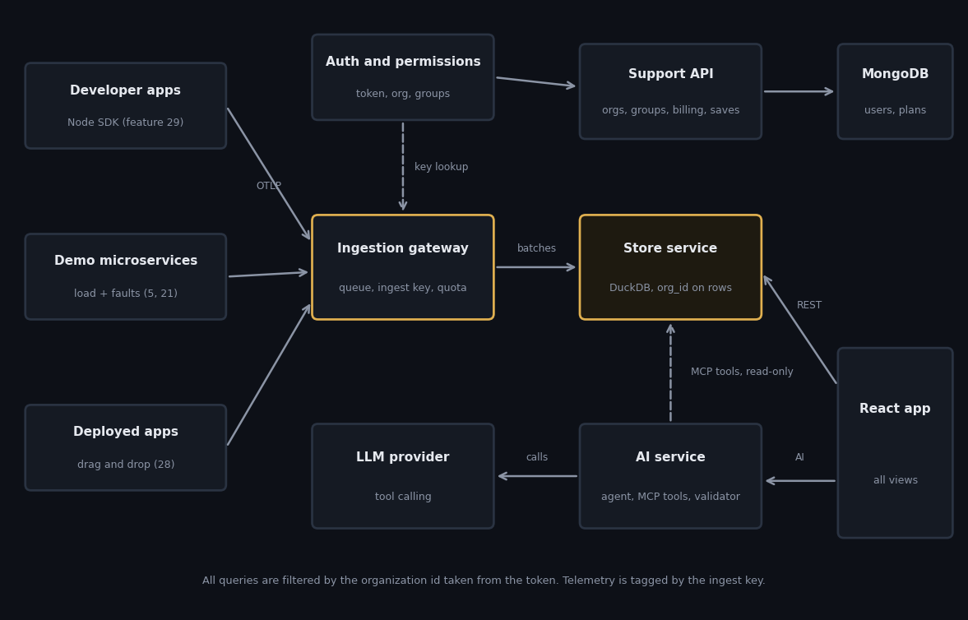
Figure 1. System architecture. Dashed lines are read-only or lookup paths.
Tenant isolation: every row has an org_id, and every query uses the org_id from the signed-in user's token, never from a request parameter.
Overload: the gateway queues and batches, and answers 429 when full so senders retry instead of the system crashing.
Why one store service: DuckDB allows one writer process, so one service owns the database file and everything else goes through its API.

4. Navigation and information architecture
Page | Purpose | Features | Needs permission
Overview | Health at a glance, anomaly banner, charts | 7, 10, 15, 17 | traces:read
Traces and trace detail | List and inspect requests | 2, 13, 14, 16 | traces:read
Logs | Search and filter logs | 3, 14, 20, 26 | logs:read
Topology | Service dependencies and health | 4 | traces:read
Errors | Grouped errors | 15 | logs:read
Alerts | Rules and firing alerts | 23 | alerts:manage to edit
Deployments | Drag-and-drop deploy and status | 28 | deploy:run
Setup | Endpoint, ingest key, SDK, demo | 1, 5, 21, 29 | any member
Settings | Members, Groups, Billing, Integrations, Data | 6, 8, 11, 27 | members:manage, billing:manage
AI drawer, command palette, top bar | Available on every page | 9, 18, 19, 25 | ai:use for AI
Layout: a top bar (logo, time range, service filter, live toggle, search, Ask AI, account) and a left sidebar. The sidebar shows only pages the user may open; individual actions the user lacks are shown locked with a reason.

5. Visual design system

5.1 Color
A dark theme suits long investigation sessions and fits the Eye of Agamotto theme. The values below are suggested starting points.
Role | Value | Use
Background | #0D1017 | Page
Surface | #151A23 | Cards and panels
Border | #2A3342 | Dividers and outlines
Text | #E6E9EF | Main text
Muted text | #8B94A5 | Labels and secondary information
Accent (gold) | #E0B050 | Selection, key actions, critical path, event markers
OK | #3FB68B | Healthy
Slow / warning | #E5A63D | Above baseline
Error | #E5534B | Failed spans, error logs

5.2 Typography and spacing
- One clean sans-serif for interface text and a monospace font for trace IDs, span IDs and log lines.
- Sizes: page title, section title, body and small label, using only these four steps.
- Spacing on an 8 px grid with 4 px for tight spots. Corner radius is consistent for cards, buttons and chips.

5.3 Components
Component | Rules
Buttons | One primary (gold) per area. Secondary buttons are outlined. Destructive actions use the error color and ask for confirmation.
Chips | Used for filters (removable), evidence (clickable) and plan or status labels.
Status badge | Color plus icon plus word, so color is never the only signal.
Tables | Compact rows, sticky header, sortable columns, row click opens detail.
Cards | Surface color with a border, no shadow. Whole card is a link when it navigates.
Drawers | The AI drawer and anomaly panel open on the right and leave the main view visible.
Locked state | Lock icon with a short reason on hover (ask an admin, or upgrade).
Toasts and banners | Short toasts for saves. Banners for anomalies, limits and insufficient AI evidence.

5.4 Motion and accessibility
- Motion is short and only explains change: drawers slide in, new live rows fade in. Respect the reduced-motion setting.
- All actions work by keyboard, focus is always visible, and the command palette is fully operable without a mouse.
- Text and status colors meet contrast needs on the dark surface; charts use differing line styles or labels, not color alone.
- Waterfall and topology have text alternatives: the trace list and the service table carry the same information.

6. Screen designs

6.1 Overview
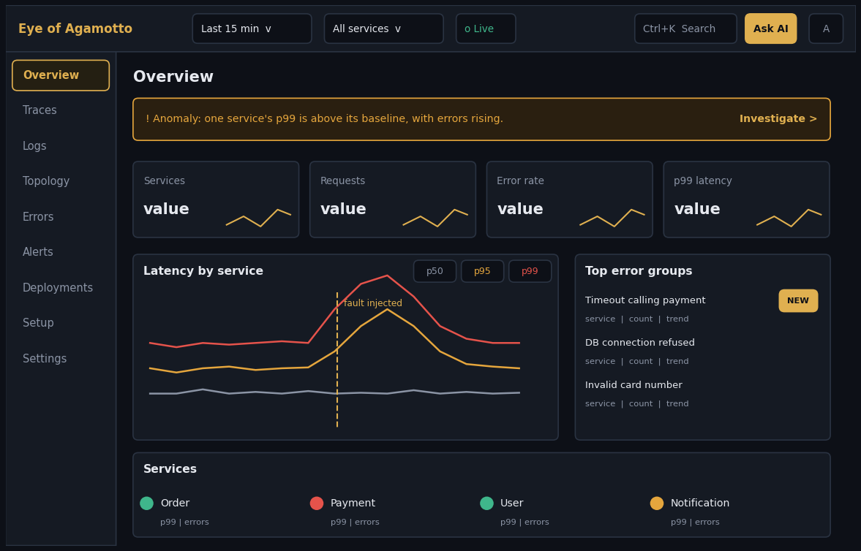
Figure 2. Overview wireframe.
- Layout: anomaly banner on top, four health cards with small trend lines, the latency chart with p50, p95, p99 toggles and an event marker, top error groups, and the services list.
- Interactions: every card and row is a link; the banner opens the anomaly panel; chart cells open trace lists.
- States: loading skeleton, empty (with a Start demo hint), error with retry.

6.2 Trace detail
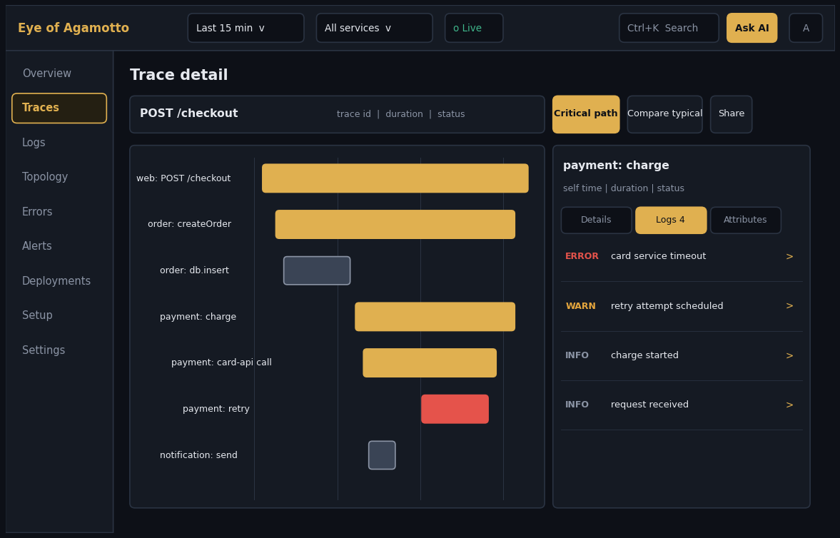
Figure 3. Trace detail wireframe. Gold bars are the critical path.
- Layout: header with operation, ID, duration and status, with toolbar buttons Critical path, Compare typical and Share. Waterfall on the left, span side panel on the right with Details, Logs and Attributes tabs.
- Interactions: hover tooltip, click to select, collapse subtrees, drag the ruler to zoom, keyboard arrows.
- States: very large traces load progressively; a failed trace load keeps the header and shows retry.

6.3 Log explorer
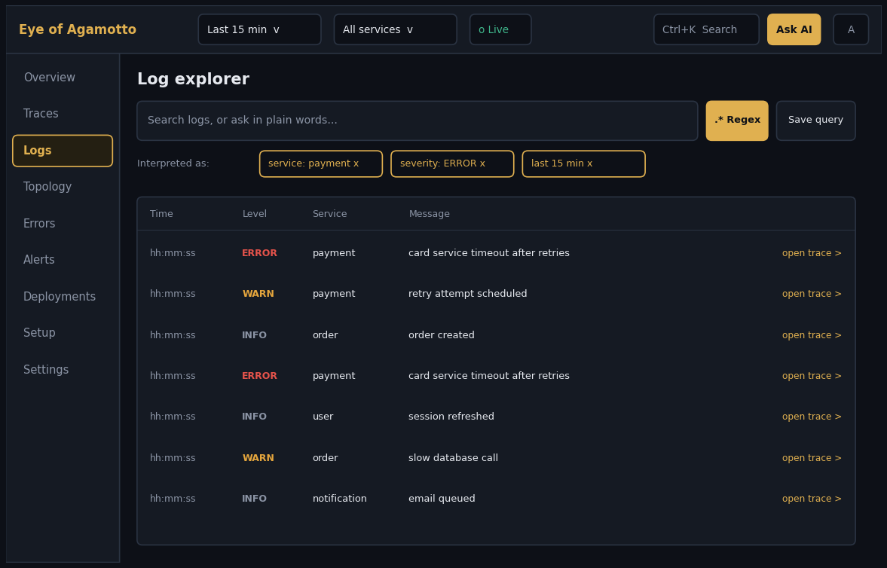
Figure 4. Log explorer wireframe.
- Layout: one search bar with a Regex toggle and Save query, an Interpreted as row of chips, then a virtualized table.
- Interactions: type text or a sentence in plain words, edit chips, click a row for details, open trace from a row.
- States: live mode appends rows without moving the one being read; invalid regex shows an inline message.

6.4 Service topology
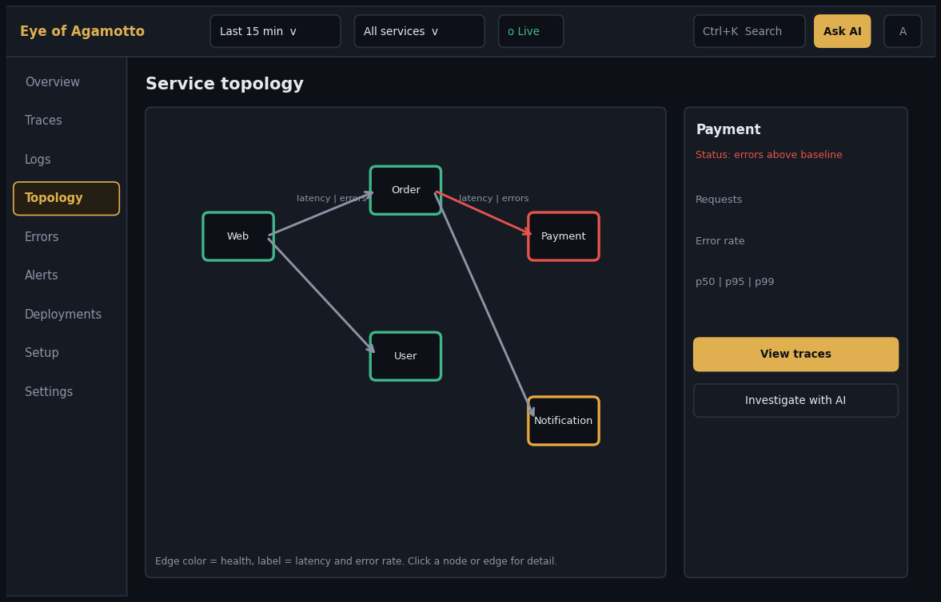
Figure 5. Topology wireframe.
- Layout: graph on the left, detail panel on the right.
- Interactions: click a node or edge, View traces, Investigate with AI.
- States: layout stays stable on refresh; an empty map explains that calls between services appear once traces arrive.

6.5 AI investigation drawer
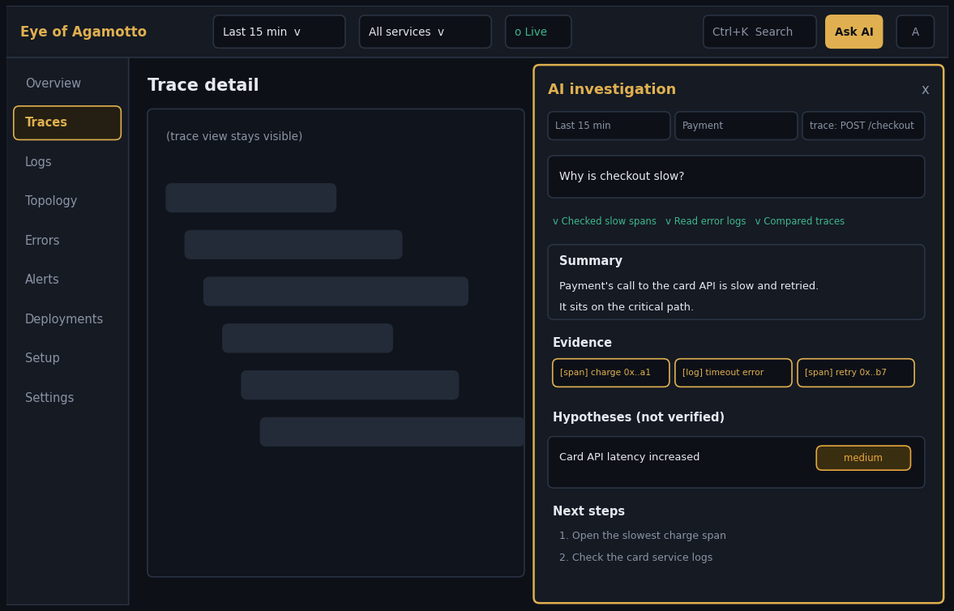
Figure 6. AI drawer over the trace page.
- Layout: context chips, the question, tool progress, then Summary, Evidence chips, Hypotheses with a confidence label, and Next steps.
- Interactions: click an evidence chip to open the span or log beside the drawer; Share saves the answer and copies a link.
- States: streaming progress while working; an Insufficient evidence banner replaces the conclusion when the data does not support one.

6.6 Organization settings
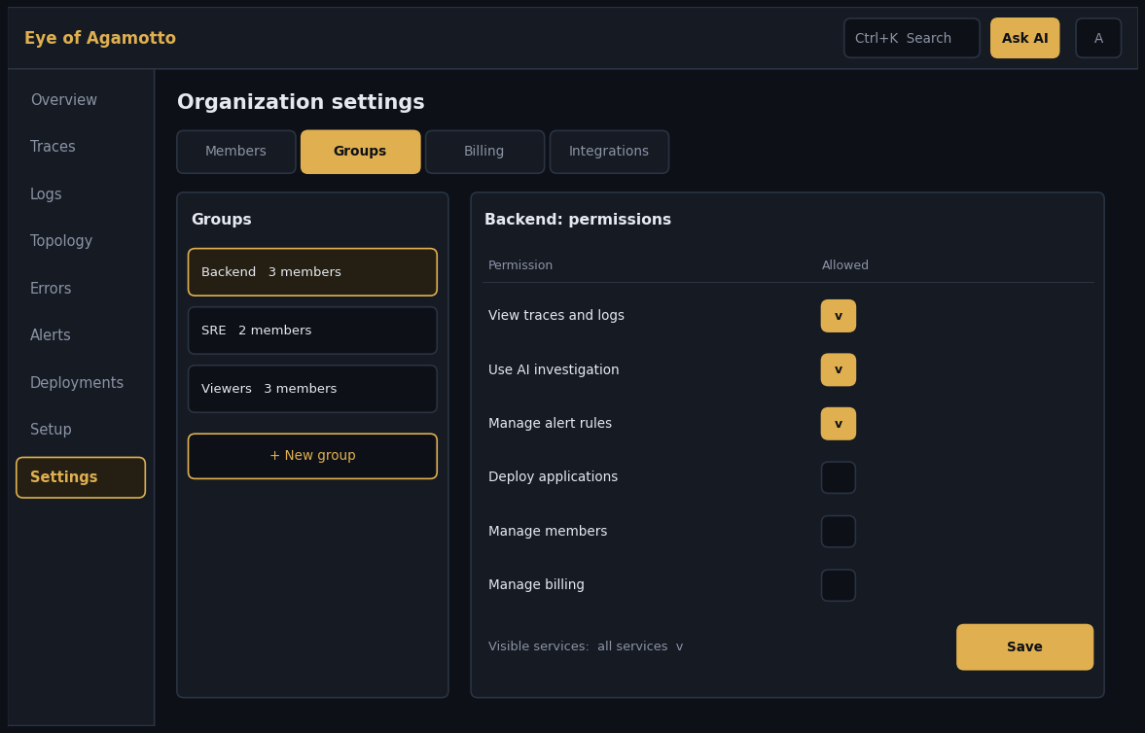
Figure 7. Groups and permissions wireframe.
- Layout: tabs Members, Groups, Billing, Integrations. In Groups, a list of groups on the left and a permission matrix with a visible-services selector on the right.
- Interactions: tick permissions, choose services, Save; invite and assign members from the Members tab.
- States: unsaved changes are marked; a plan limit shows a locked state with Upgrade.

6.7 Deployments
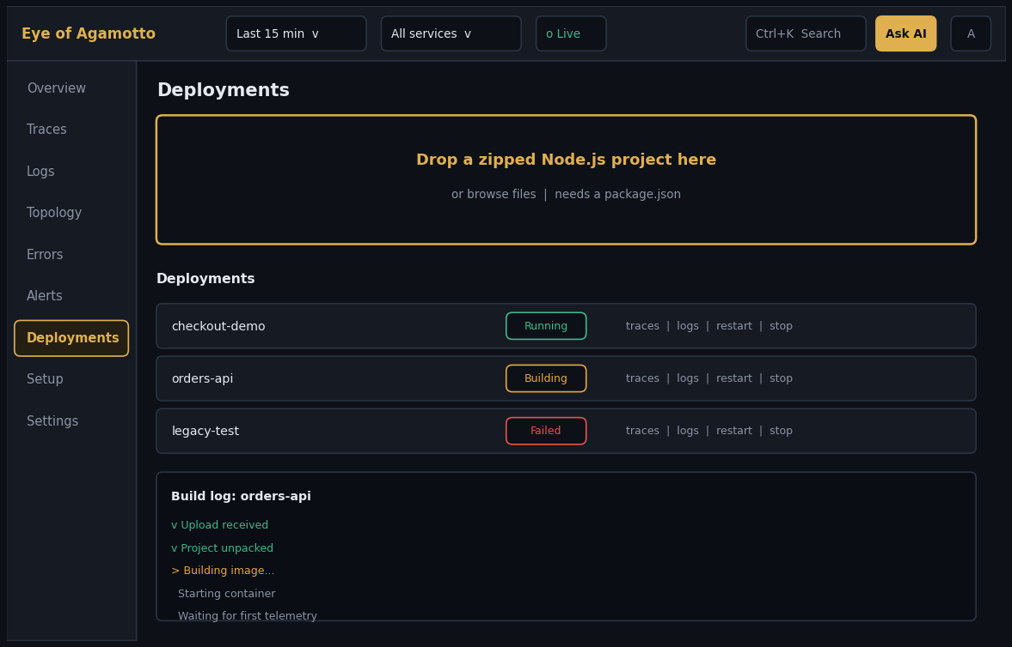
Figure 8. Drag-and-drop deployment wireframe.
- Layout: large drop area, the deployments list with status badges and row actions, and a streaming build log for the selected deployment.
- Interactions: drop a zip, fill name and environment, Deploy; stop, restart, redeploy, delete from the row.
- States: invalid or oversized file rejected before upload; failed builds show the failing stage and the last log lines.

6.8 Account, onboarding and remaining pages
- Sign up, log in and invite accept: simple single-column forms; the invite link opens with the organization name shown.
- First-run flow: create organization, then the Setup page with the endpoint, ingest key, SDK snippet and a Start demo button, so the first data appears within minutes.
- Errors, Alerts and Billing pages follow the same table-and-detail pattern as the screens above.

7. Design flow of every feature
Each entry gives where the user starts, the steps in order, and the design notes. Feature 12 (optional extras) was replaced by features 27 and 28.

1. OpenTelemetry ingestion gateway
Entry point: Setup page
Flow:
- Developer opens Setup
- Copies the endpoint and ingest key snippet
- Runs the app
- The page changes from "Waiting for data" to "Receiving data" with the services seen and the time of the last data
Design notes: The first-data moment is the key onboarding success state. Show clear hints for a rejected key or a reached limit (429).

2. Distributed trace waterfall
Entry point: Traces list, an error group, an AI evidence chip or a shared link
Flow:
- Open the trace list and pick a trace (root operation, duration, status, number of services)
- The trace page shows a header (ID, total duration, status) and the waterfall
- Hover a span for a tooltip, click it to open the side panel
- Collapse a subtree, or drag on the time ruler to zoom
Design notes: Rows are compact, indented by depth, colored by status. Arrow keys move the selection. Failed spans are visible without scrolling.

3. Live log explorer
Entry point: Logs page, a span panel, an error group
Flow:
- Type text or switch on regex
- Add filters (service, severity, time) shown as removable chips
- Results appear in a virtualized list; live mode appends new rows
- Click a row for its full message and attributes
Design notes: Severity is shown by color and a label. Matches are highlighted. An invalid regex shows an inline message, not an empty list.

4. Service topology map
Entry point: Topology page, Overview service list
Flow:
- The graph appears with services as nodes and calls as edges
- Node border color shows health, edge label shows latency and error rate
- Click a node to see stats, View traces and Investigate with AI
- Click an edge to see the calls between the two services
Design notes: Layout is stable between refreshes so the map does not jump. Unhealthy nodes are visually strongest.

5. Synthetic load generator and benchmark
Entry point: Setup page or Demo controls
Flow:
- Click Start demo
- Fake services start and traffic flows
- Dashboard fills with live data within seconds
- Click Stop demo to end traffic
Design notes: Gives every evaluator the same working demo with one click and no setup.

6. Columnar analytical storage
Entry point: Settings > Data (admin)
Flow:
- Open the Data panel
- See stored row counts, the oldest data kept and ingest status
- Admins see the retention setting of the plan
Design notes: Mostly invisible to developers. Surface only health information that explains empty or slow views.

7. Automated root-cause correlation
Entry point: Overview banner, Alerts, topology
Flow:
- A banner appears on Overview when a service is above its baseline with errors rising
- Click Investigate to open the anomaly panel: service, time window, flagged spans ranked by self time
- Choose Open slowest trace or Investigate with AI
Design notes: The banner states the finding in one sentence and disappears when the anomaly ends.

8. MCP server
Entry point: Settings > Integrations
Flow:
- Open Integrations
- Copy the MCP endpoint and connection snippet
- See the list of tools with a one-line description each
- Admins can switch individual tools off
Design notes: Make it clear the tools are read-only and which data they can see (the organization's data only).

9. AI investigation assistant
Entry point: Ask AI button, Ctrl+K, Investigate buttons
Flow:
- The drawer opens with context chips (time range, service, trace)
- Type a question or pick a suggested one
- Progress shows tool steps as they run
- The answer shows Summary, Evidence chips, Hypotheses with confidence, Next steps
- Share creates a link to the saved answer
Design notes: Hypotheses are labelled as not verified. If the data is not enough, a banner says so instead of a guess. The trace view stays visible beside the drawer.

10. Dashboard shell and overview
Entry point: Home page
Flow:
- Overview opens with the anomaly banner if any, four health cards, the latency chart, top error groups and the services list
- Clicking any card or row goes to the matching detail view
Design notes: Answer first, detail on demand. Every card is a link.

11. Supporting backend services
Entry point: Settings pages
Flow:
- Saved items, alert rules and settings appear in their own sections
- Edits save immediately with a short confirmation
Design notes: No separate screen of its own. It supports features 22, 23, 26 and 27.

13. Critical path highlighting
Entry point: Trace detail toolbar
Flow:
- Toggle Critical path in the toolbar
- Spans on the path get a gold outline and others dim
- A Self time column appears
- Tooltip explains why the span is on the path
Design notes: Default off for very small traces, on when a trace has more than a few spans.

14. Click-through correlation
Entry point: Span panel and log rows
Flow:
- Select a span and open its Logs tab (the tab shows a count)
- Click a log to jump to its trace with the span selected
- Use the breadcrumb or browser back to return
Design notes: Every ID is a link. Back navigation restores scroll and selection.

15. Error grouping
Entry point: Errors page, Overview preview
Flow:
- The page lists groups: message pattern, service, count, trend, first and last seen
- New groups carry a NEW badge
- Click a group to see sample traces and logs
Design notes: Sorted by impact. Show the pattern with placeholders so grouped values are understandable.

16. Trace comparison
Entry point: Trace detail > Compare typical
Flow:
- Click Compare typical (the median trace for that operation is chosen)
- A split view shows both waterfalls aligned, with a delta column
- Spans only in one trace are labelled Added or Missing
- Change the baseline with a picker
Design notes: Differences are highlighted, same spans stay quiet.

17. Latency heatmap and percentile charts
Entry point: Overview chart
Flow:
- Choose p50, p95, p99 toggles or the Heatmap tab
- Hover for values
- Click a heatmap cell to list the traces inside it
Design notes: Chart choices stay in the URL. Percentile colors are consistent across the app.

18. Global time range and service filter
Entry point: Top bar
Flow:
- Pick a preset or custom range
- Pick services
- Toggle Live
- All views update together and the URL reflects the choice
Design notes: The filter is always visible. Changing it never resets the selected trace.

19. Clickable evidence in AI answers
Entry point: AI drawer
Flow:
- Evidence appears as chips with an icon (span or log) and a short label
- Hover shows a small preview
- Click opens the span or log beside the drawer
Design notes: Only evidence confirmed to exist is shown, so no chip ever leads to a missing item.

20. Natural-language search
Entry point: Search bars in Logs and Traces
Flow:
- Type a sentence in plain words
- An Interpreted as row shows the filters as chips
- Edit or remove chips and results update
Design notes: The user always sees and can fix the interpretation.

21. Fault injection
Entry point: Demo controls panel
Flow:
- Pick a service
- Set extra latency or an error rate
- Click Apply, an event marker appears on charts
- Reset all returns to normal
Design notes: Visible only while the demo is running and for permitted users.

22. Shareable investigation links
Entry point: Share button
Flow:
- Click Share
- A dialog lists what is included: range, filters, selection, optional AI answer
- Copy link
Design notes: Opening the link restores the exact view. Access still follows the viewer's permissions.

23. Alert rules with a baseline
Entry point: Alerts page
Flow:
- Click New rule
- Choose service, metric (p99 or error rate), how far above baseline and for how long
- Save
- Firing rules appear in a list with a link to investigate
Design notes: Plain-language rule summary under the form, for example when p99 is above twice normal for 5 minutes.

24. Event markers on charts
Entry point: Charts
Flow:
- Events (faults, deploys) appear as dashed gold vertical lines with a label
- Hover for details
- A toggle hides them
Design notes: Markers never cover data lines.

25. Command palette and shortcuts
Entry point: Ctrl+K anywhere
Flow:
- Press Ctrl+K
- Type to find pages, services, saved queries or paste a trace ID
- Choose Ask AI to send the text to the assistant
Design notes: Fully keyboard operable with visible focus.

26. Saved queries
Entry point: Next to filters
Flow:
- Click Save query
- Name it
- Reopen later from the Saved menu
Design notes: Saved queries respect permissions on reopen.

27. Organizations, groups, permissions and paid tier
Entry point: Sign up, Settings
Flow:
- Sign up and verify email
- Create an organization
- Invite members by email
- Create groups and tick permissions in a matrix, choose visible services
- Assign members to groups
- When a limit is reached a banner offers Upgrade, leading to a plan comparison and checkout
- Plan changes show immediately after payment
Design notes: Actions the user cannot take show as locked with a short reason (ask an admin or upgrade) instead of disappearing. Owner is the only role that can delete the organization.

28. Drag-and-drop deployment
Entry point: Deployments page
Flow:
- Drag a zip onto the drop area
- The app checks for a package.json and shows a name and environment fields
- Click Deploy
- A build log streams with stages (Upload, Unpack, Build, Start, First data)
- The deployment shows Running and links to its traces and logs
- Stop, restart, redeploy and delete are in a row menu
Design notes: Failed builds show the failing stage and the last log lines. Large or invalid files are rejected before upload with a clear message.

29. Node SDK plugin
Entry point: Setup page and documentation
Flow:
- Choose the Code or Preload tab
- Copy the snippet with the real key already filled in
- Click Test connection
- A success message shows once the first span arrives
Design notes: Snippets are short enough to copy in one go. Errors point to the likely cause (wrong key, blocked port).

8. Cross-cutting states and rules
Topic | Rule
Loading | Skeletons that match the final layout, never a blank page.
Empty | Say why it is empty and offer the next action (Start demo, Setup, widen the time range).
Error | Plain message, what to try, and a Retry button.
Permissions | Hide whole pages the user cannot open; show locked actions with a reason on pages they can open.
Limits and plans | Warn before a limit is hit when possible; at the limit show a banner with Upgrade.
Live data | Never move the row or span the user is reading; show a New data button if needed.
Responsiveness | Designed for desktop first. On narrow screens the sidebar collapses, drawers become full screen and the waterfall scrolls horizontally.
Sharing | Links restore the view, but access follows the viewer's permissions.

9. Demo flow
- Open Setup and click Start demo. Services start and the dashboard fills.
- Show Overview, then the topology map.
- Open Demo controls and slow down one service. An event marker appears on the chart.
- The anomaly banner appears. Click Investigate.
- Open the slowest trace, switch on Critical path, read its logs.
- Ask AI. Click evidence chips to verify each claim.
- Share the link. Then show Settings: groups, permissions and the plan.
- Optionally drag a zipped app onto Deployments and watch telemetry arrive.

10. Open design decisions
- Who builds the ingestion gateway and the store service.
- DuckDB or ClickHouse, decided by the benchmark.
- Whether organizations are built from the start, since they add org_id to every table and query.
- What drag-and-drop deployment deploys. This document assumes a zipped Node.js app.
- Which payment provider to use for the paid tier, in test mode for the hackathon.
- Final visual style: the wireframes show structure, and colors and typography still need a visual pass.

