FINAL MAJOR PROJECT

## Part 1: Project Proposal

Step 1: Your Taxi is web based project final major project in ASP.NET

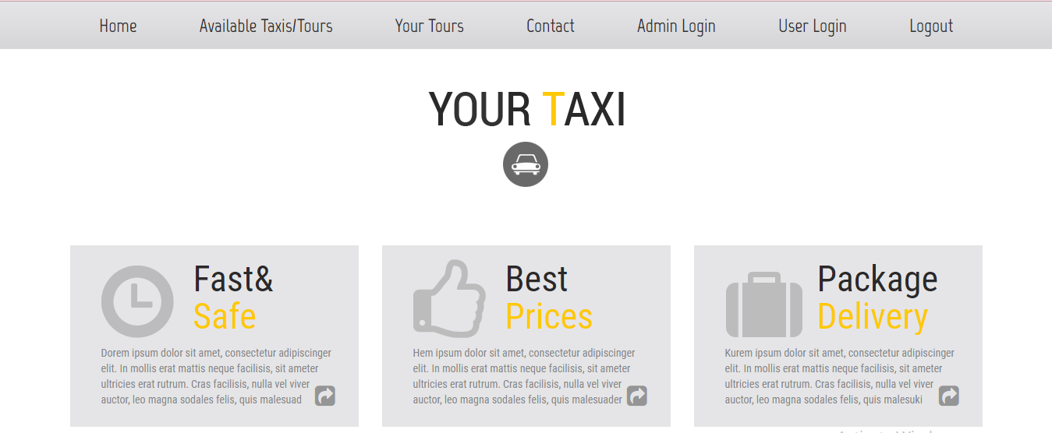

**Systems Analysis –** This platform was built with ASP.NET. The key feature is about booking a car for a tour and admin can add car for a tour and route there is different working for both so that website should be common to all.

The project team assessed the project's scope and devised a timetable and resource allocation strategy based on their findings.

**Systems design** – This is a high-level description of how a computer-based system would satisfy the requirements; it is expected to be a single-user system that does not rely on data connection for the primary facility.

**Systems Specifications**

OS -Windows 10

IDE- Visual Studio

**Programming** – ASP.NET and C# was used for functionality completed as a working system in an MVC model.

Step 2***:*** Produced a project proposal contained that includes home page, Tour details, add tours from admin side and contact page and user can login register

Project Goal – Build a platform to book a taxi

Project Objectives – The main objectives of the project was to enable that users can book a tour what admin puts on the website through admin login

Project Scope – A full-fledge website develop 5 page website development

1. Context – A Admin Login Facility
2. ASP.NET language platform
3. Stakeholders of the product: People who want to book tour
4. Backend or API integration

Project Deliverables –

1. Analysis documentation
2. Design documentation
3. Executable program
4. User documentation

|  |  |  |
| --- | --- | --- |
| **Milestone** | **Time taken** | **Finalized** |
| Designing | 2 Days | Yes |
| Programming | 2 Days | Yes |
| Documentation | 2 days | Yes |

Resources

|  |  |
| --- | --- |
| Processor | 1 GHz |
| RAM | 512 MB |
| Disk space (minimum) |  |
| 32-bit | 4.5 GB |
| 64-bit | 4.5 GB |

ProjectMilestones

|  |  |  |
| --- | --- | --- |
| **Milestone** | **Time taken** | **Finalized** |
| Designing | 2 Days | Yes |
| Programming | 2 Days | Yes |
| Documentation | 2 days | Yes |

ProjectSchedule

1. The conclusion of the preliminary inquiry

2. Drafted design

3. Approval of the design

4. The prototype programme has been finished.

5. Signed-off stages of programme refinement

6. The programme has been completed.

7. The programme was put to the test

8. Completed system documentation

9. The user acceptance process has been finished.

10. Completion of the user report on system acceptability

Project Assumptions

1. Users are available during the project to provide information and software is available at the client site.

**Design**: Home Page or Landing Page of the Website

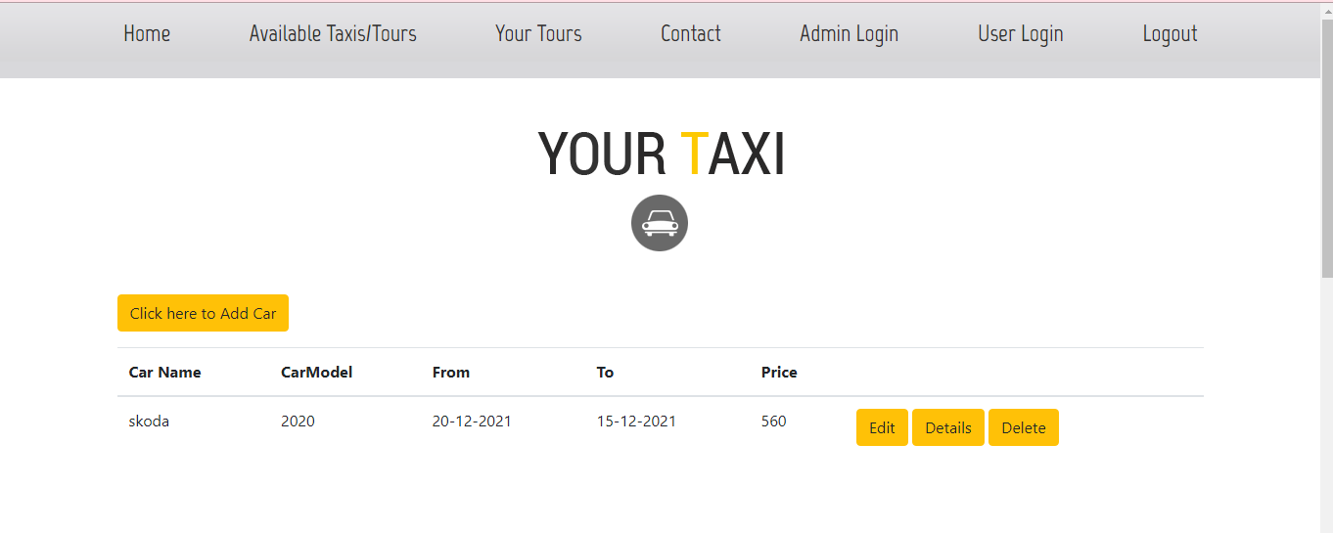When Admin is Login we get option to add a new tour car

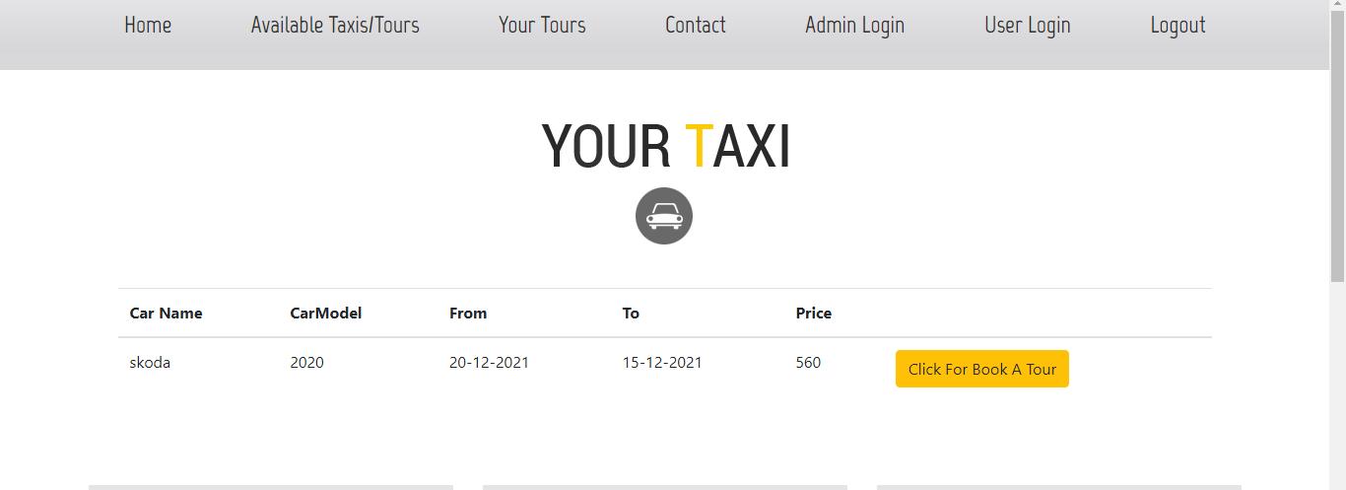When user is Login we get option to book a car

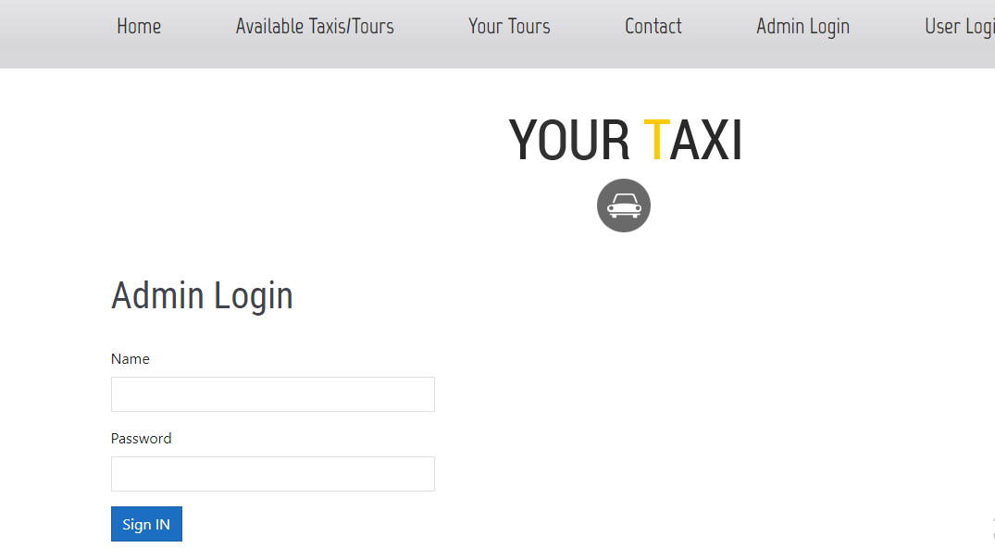Admin Login

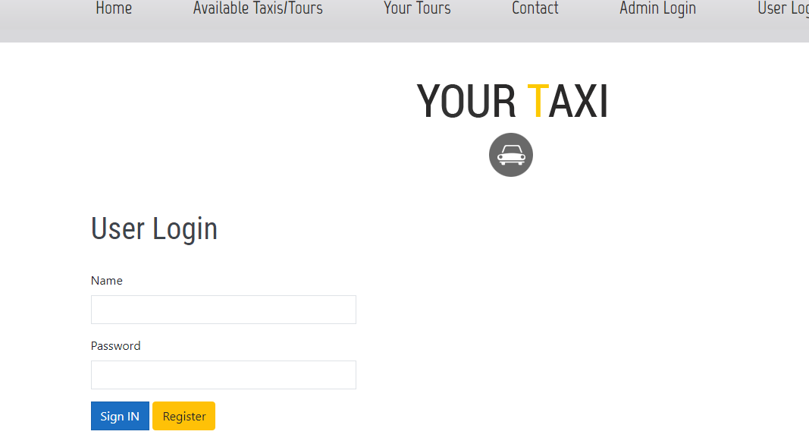

User Login

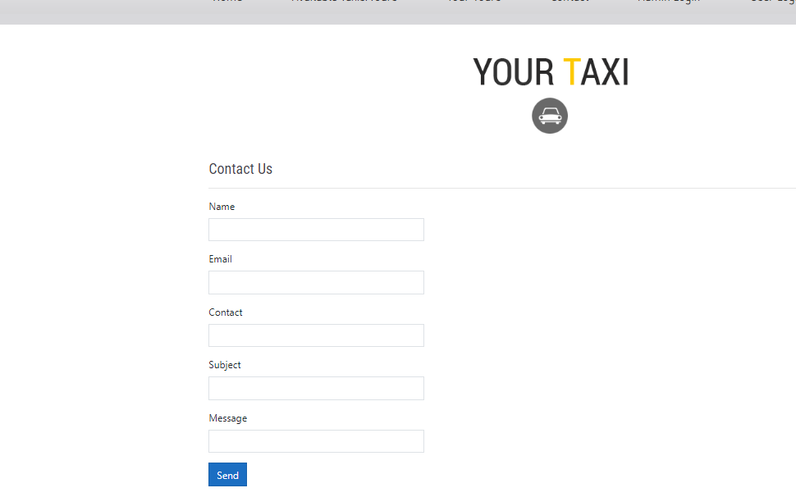Contact Page

# **Part 2: Review your project**

Step 1: Final Product/Outcome - a platform to Book a Car for Tour