

# Module: CST1340-Information In Organisations

**2020 September Intake**

# Student Name:

# Niven Poovanen Coonjamalay & Anmol Vishvas

# Student Number:

# M00775724 & M00734701

# LW 21 – XML: Introduction

## G21.1: Design the data schema

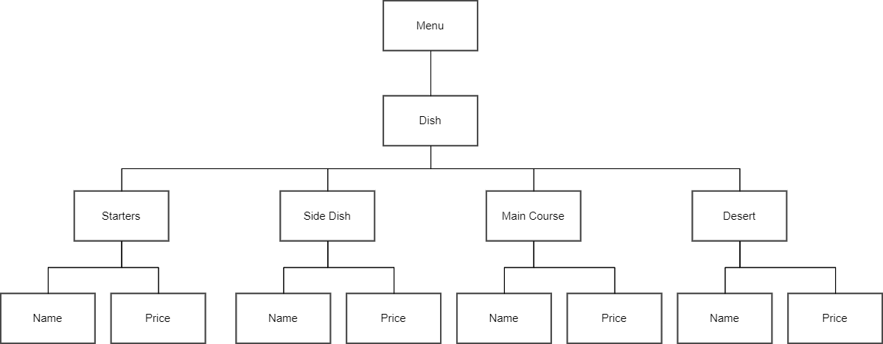

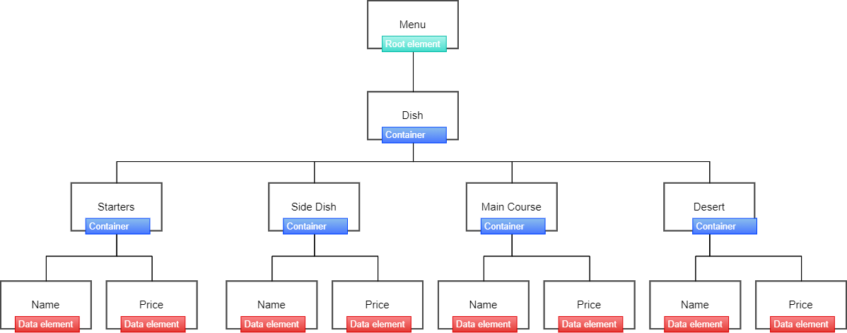

## G21.2: Generate the XML file

|  |
| --- |
| <?xml version="1.0" encoding="UTF-8"?>  <Menu>  <Dish>  <Starters>  <Name>Crispy Samosas</Name>  <Price>15 Rs</Price>  </Starters>    <Starters>  <Name>Gateau Piment</Name>  <Price>10 Rs</Price>  </Starters>    <Side_Dish>  <Name>Garlic Bread</Name>  <Price>20 Rs</Price>  </Side_Dish>    <Side_Dish>  <Name>Potato Wedges</Name>  <Price>18 Rs</Price>  </Side_Dish>    <Main_Course>  <Name>Butter Chicken</Name>  <Price>150 Rs</Price>  </Main_Course>    <Main_Course>  <Name>Prawn Rougaille</Name>  <Price>175 Rs</Price>  </Main_Course>    <Desert>  <Name>Macaron Orange</Name>  <Price>45 Rs</Price>  </Desert>    <Desert>  <Name>Tiramisu</Name>  <Price>80 Rs</Price>  </Desert>  </Dish>  </Menu> |

## G21.3: Explain the container element

A **container element** has multiple elements as child elements. Using the data schema designed in G21.1, we can observe that we have 1 container element, which is ‘**Dish’** that contains other 4 container elements, which are **‘Starters’**, ‘**Side Dish’**, **‘Main Course’**, and **‘Desert’**. To sum up, we create a new element that contains some of the multiple child elements, which is called **‘container element’**.

## G21.4: Explain the data element

**Data elements** contains only sub elements. Using the data schema designed in G21.1, we can observe that **‘name’** and **‘price’** are the data elements of each container elements (are **‘Starters’**, ‘**Side Dish’**, **‘Main Course’**, and **‘Desert’**).

# LW 22 – XML: DTD and Namespaces

## G22.1: DTD file

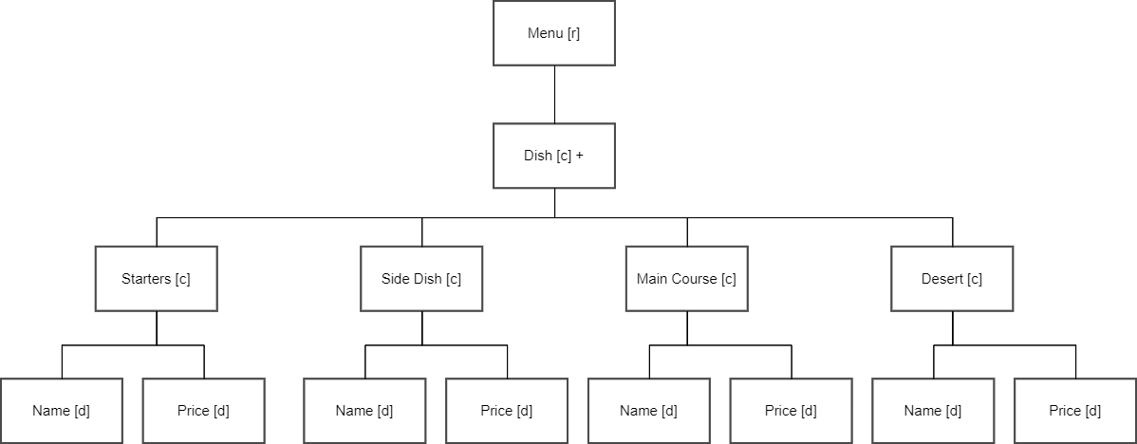

## G22.2: Validate the data

|  |  |
| --- | --- |
| **DTD file** | **DTD linked with XML file** |
| <?xml version="1.0" encoding="UTF-8"?>  <!DOCTYPE Menu [  <!ELEMENT Menu (Dish+)>  <!ELEMENT Dish (Starters, Side_Dish, Main_Course, Desert)>  <!ELEMENT Starters (Name, Price)>  <!ELEMENT Side_Dish (Name, Price)>  <!ELEMENT Main_Course (Name, Price)>  <!ELEMENT Desert (Name, Price)>  <!ELEMENT Name (#PCDATA)>  <!ELEMENT Price (#PCDATA)>  ]> | <?xml version="1.0" encoding="UTF-8"?>  <!DOCTYPE Menu SYSTEM "Week22- G22.2 (DTD).dtd">  <Menu>  <Dish>  <Starters>  <Name>Crispy Samosas</Name>  <Price>15 Rs</Price>  </Starters>    <Starters>  <Name>Gateau Piment</Name>  <Price>10 Rs</Price>  </Starters>    <Side_Dish>  <Name>Garlic Bread</Name>  <Price>20 Rs</Price>  </Side_Dish>    <Side_Dish>  <Name>Potato Wedges</Name>  <Price>18 Rs</Price>  </Side_Dish>    <Main_Course>  <Name>Butter Chicken</Name>  <Price>150 Rs</Price>  </Main_Course>    <Main_Course>  <Name>Prawn Rougaille</Name>  <Price>175 Rs</Price>  </Main_Course>    <Desert>  <Name>Macaron Orange</Name>  <Price>45 Rs</Price>  </Desert>    <Desert>  <Name>Tiramisu</Name>  <Price>80 Rs</Price>  </Desert>  </Dish>  </Menu> |

## G22.3: Explain relationships

In the DTD designed in G22.1, the relationships used are “**one to many relation”** as we can see on the screenshot below, because the record can be associated with one or more child records.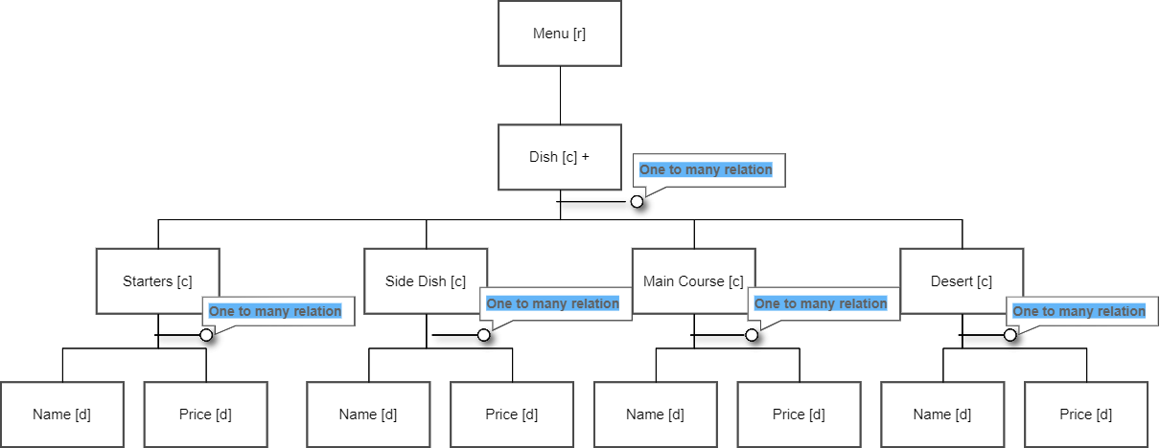

## G22.4: Explain attributes

DTD attributes gives more information about an element, instead of having a child element, we can define attributes of an element to store information. An example from our XML file, we have:

**<Starters>**

**<Name>Cripsy Samosas</Name>**

**</Starters>**

Where **‘Name’** is an element. It can also be written **<Starters Name='Crispy Samosas'>**, where, **‘Name’** will be.3

an attribute

# LW 23 – XML: Transformation and Selection

## G 23.1: XSL file

(file menu.xml)