1.

Basis:

P(1): If we sum 1/(i*(i+1)) from 1 to 1 then sum 1/(i(i+1)) = 1-(1/(i+1))

Proof:

1-(1/(1+1)) = ½

½ = 1/(1*(1+1))

1/(1*(1+1)) = sum(i=1 to 1) 1/(1*(1+1))

Inductive Hypothesis:

P(k): If we sum 1/(i*(i+1)) from 1 to k then sum 1/(i(i+1)) = 1-(1/(i+1))

Assume P(k)

Proof:

2.

|  |  |  |
| --- | --- | --- |
| Expression | Dominant Term(s) | O(...) |
| 5 + 0.001n^3 + 0.025n | 0.001n^3 | O(n^3) |
| 500n + 100n^1.5 + 50n*log10(n) | 100n^1.5 | O(n^(1.5)) |
| 0.3n + 5n^1.5+2.5n^1.75 | n^1.75 | O(n^(1.75)) |
| n^2*log2(n)+n(log2(n))^2 | n^2 * log2(n) | O(n^2 * logn) |
| n*log3(n) + n*log2(n) | n * log2(n), n * log3(n) | O(n * logn), O(n * logn) |
| 3*log8(n)+log2(log2(log2(n))) | 3log8(n) | O(log(n)) |
| 100n+0.01n^2 | 100n^2 | O(n^2) |
| 0.01n+100n^2 | .01n^2 | O(n^2) |
| 2n+n^(.5) + .5n^(1.25) | 0.5n^1.25 | O(n^1.25) |
| .01n*log2(n) + n(log2(n))^2 | 0.01n*log2(n) | O(n*log2(n)) |
| 100n*log3(n) + n^3 + 100n | n^3 | O(n^3) |
| 0.003*log4(n) + log2(log2(n)) | 0.003log4(n) | O(logn) |

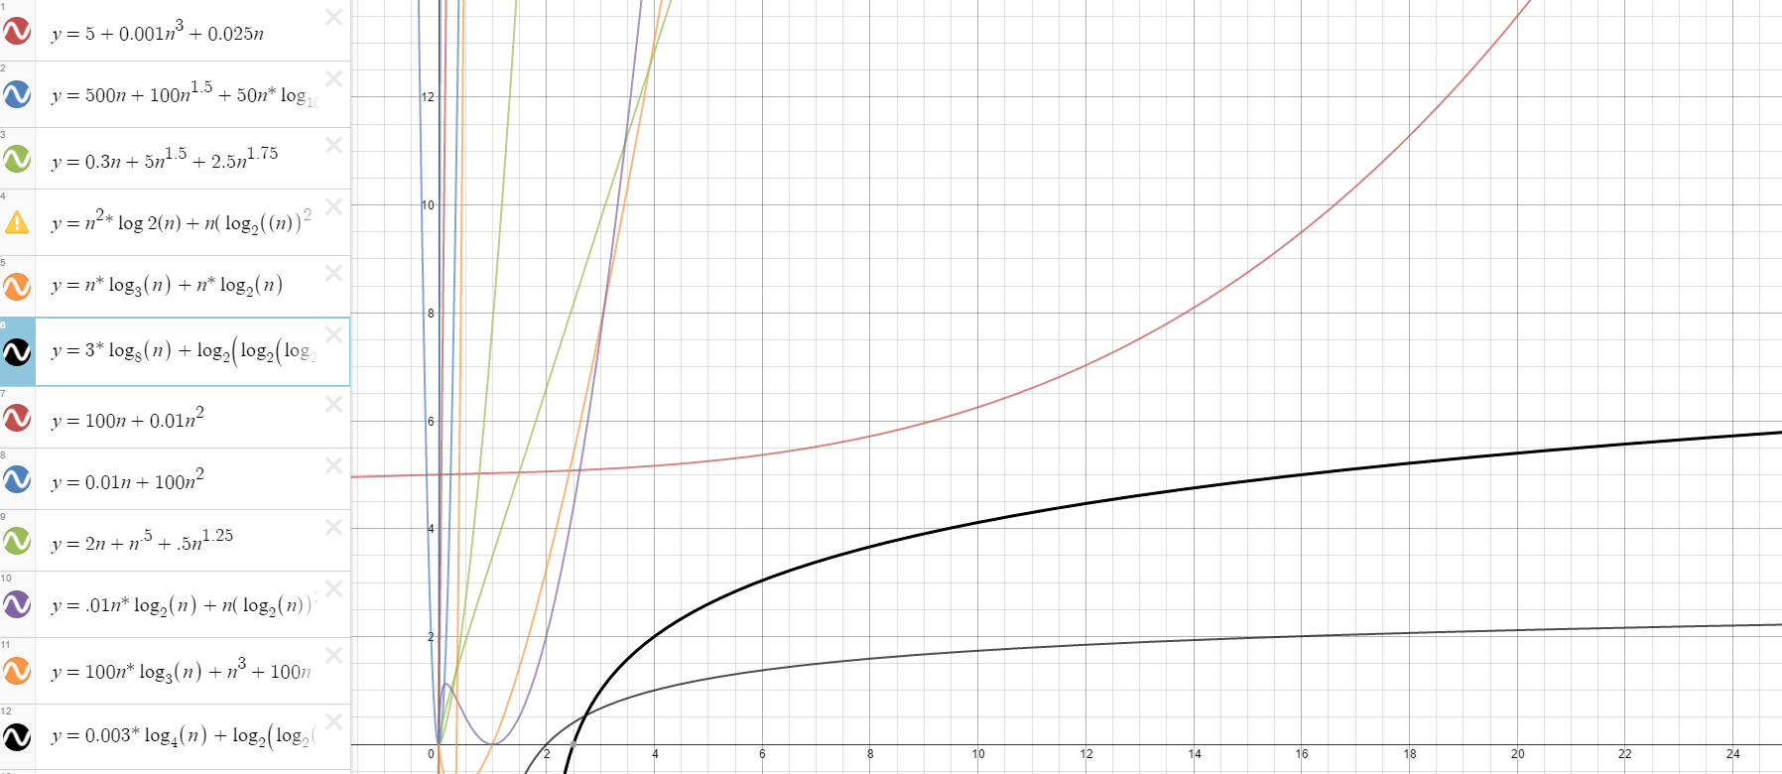

3.

Included

4.

