1.

|  |  |  |
| --- | --- | --- |
| Round | Ending Amount | # of Games Played |
| 1 | 1100 | 10 |
| 2 | 1300 | 10 |
| 3 | 1500 | 10 |
| 4 | 0 | 6 |
| 5 | 1300 | 10 |
| 6 | 0 | 4 |
| 7 | 0 | 5 |
| 8 | 900 | 10 |
| 9 | 0 | 8 |
| 10 | 1400 | 10 |

It helps in the short term on most games but it hurts you in the long run. After 10 games, you would have lost quite a bit of money.

2.

a.

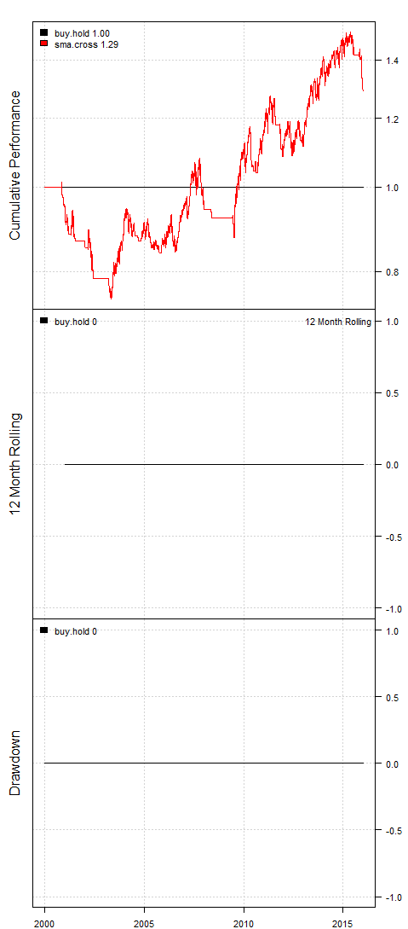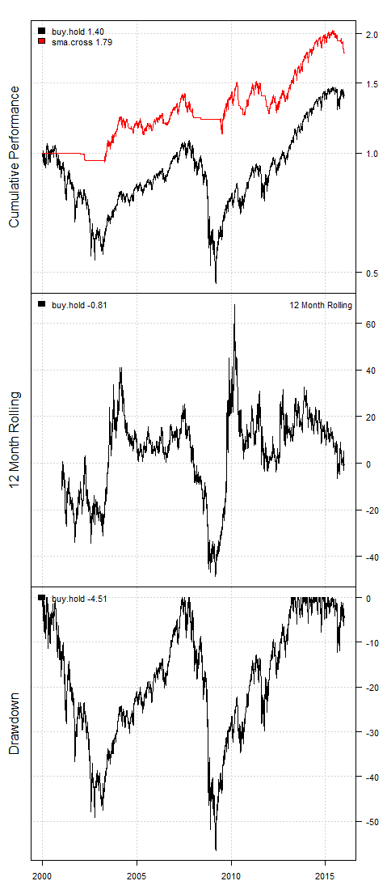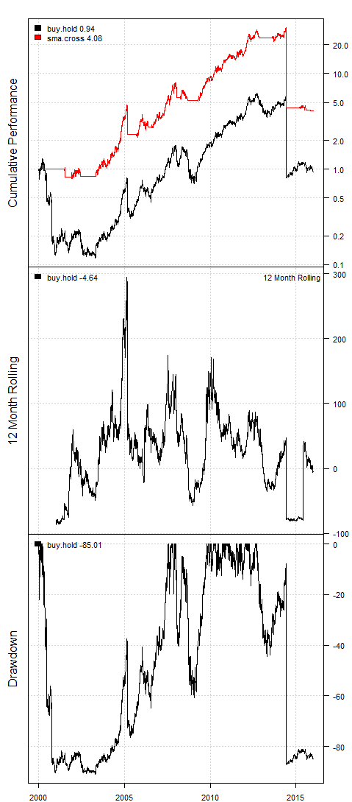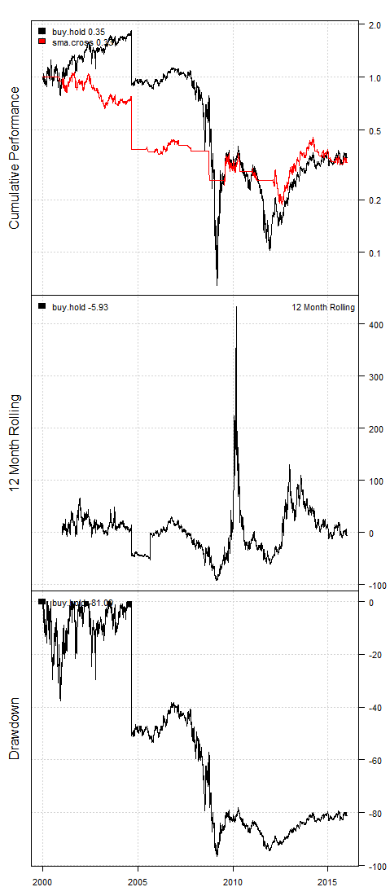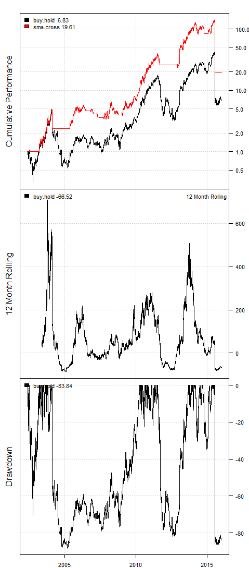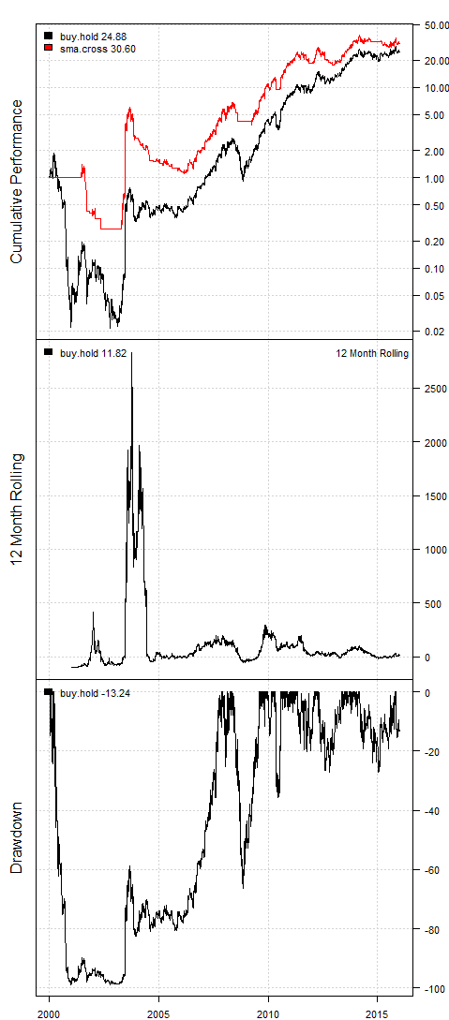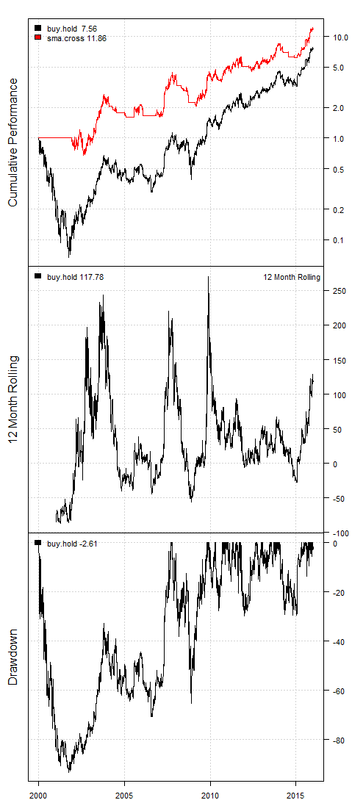

b.

|  |  |  |  |  |
| --- | --- | --- | --- | --- |
| Stock | Buy and Hold | | SMA Crossover | |
| CAGR | Performance | CAGR | Performance |
| DJIA | 0 | 1 | 1.6 | 1.29 |
| SPY | 2.1 | 1.40 | 3.7 | 1.79 |
| AAPL | -0.4 | 0.94 | 9.2 | 4.08 |
| BAC | -6.4 | 0.35 | -6.8 | .33 |
| NFLX | 15.2 | 6.83 | 24.4 | 19.61 |
| PCLN | 22.2 | 24.88 | 23.8 | 30.60 |
| AMZN | 13.5 | 7.56 | 16.7 | 11.86 |

c.

I would choose the SMA Crossover method. While the buy and hold method may be safer, this method has better performance for these stocks. This can be seen with the much higher performance on the majority of the stocks (assuming I am correctly reading the CAGR and performance values). This would allow for a better return on investment.