Quiz I – CE 5972 Optimisation Techniques in Transportation Engineering

Name: Roll No.:
IndiGo - a low-cost Indian airline company wants to introduce business class service on its domestic flight between Delhi and Mumbai. IndiGo's operations research team predicts passenger demand (per trip) to follow a normal distribution with a mean of 10.04 and 150.6 passengers for business and economy class, respectively; and likewise, a standard deviation of 1 and 15 passengers for business and economy class, respectively. Notably, a row of business class includes 4 seats, wherein each seat takes up 5400cm², costs ₹15,000 to install, and earns a revenue of ₹20,000 per trip. On the other hand, a row of economy class includes 6 seats, wherein each seat takes up 3200cm², costs ₹5000 to install, and earns a revenue of ₹8000 per trip. To provide sufficient leg space, the total area covered by all seats should not exceed 72m². How many rows of business class (x₁) and economy class (x₂) should IndiGo configure in its Airbus A321neo airplane to ensure 95% service level, given that this airplane will make 6 trips per day between Delhi and Mumbai, every day for next 5 years? Assume a discount rate of 3%, and ignore all operational costs. (z_{0.95} = 1.96)

- Objective Function

  - Formulate net present value of IndiGo's daily revenue (report the outcome in ₹abcd.e cr) (2)

  - Formulate IndiGo's fixed cost. (1)

  - Using above formulations, formulate IndiGo's daily profit. (1)

- Constraints

  - Formulate all the technical constraints. (3)

  - Formulate all the domain constraints. (1)

- Formulation

  - Formulate the problem as a standard linear programming model. (5)

  - Categorise the problem based on its functional, temporal, and certainty form. (3)

  - State the necessary assumptions pertaining to the formulation. (2)

- Graphical Solution Method

  - Draw the feasible region. (4)
(Label each constraint and clearly indicate the region that represents the feasible region)

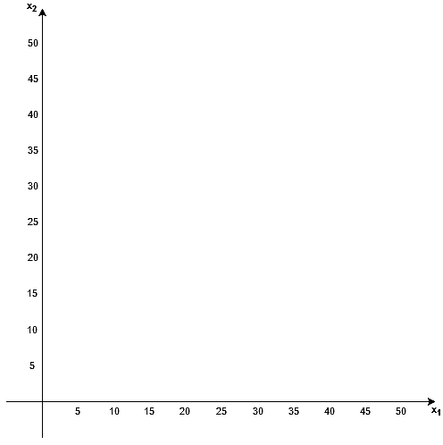

  - Draw the iso-cost lines through each corner points of the feasible region. (3)
(Redraw the feasible region and then draw the iso-cost lines; Label each constraint as well as the iso-cost lines).



  - Report the optimal solution for the standardised linear programming model. (1)

  - Classify each technical constraint as binding/non-binding. (1)

- Solution Inference

  - How many rows of business and economy class seats should IndiGo configure? (1)

  - What conditions could lead to multiple optimal solutions? (1)

  - Under such conditions, how would you advise IndiGo to configure seating arrangement? (1)

