Program No: 01 | Date: 05/12/2025
Program Title: Design a responsive webpage using HTML5 semantic elements and CSS.

<!-- Responsive webpage
@Ann Jo Mathew
Roll No: 12
05/12/2025 -->

<!DOCTYPE html>
<html lang="en">
<head>
<meta charset="UTF-8">
<title>Responsive Semantic Webpage</title>
<meta name="viewport" content="width=device-width, initial-scale=1.0">

<style>
* {
margin: 0;
padding: 0;
box-sizing: border-box;
}

html, body {
height: 100%;
}

body {
font-family: Arial, sans-serif;
line-height: 1.6;
display: flex;
flex-direction: column;
}

header {
background: #333;
color: white;
padding: 20px;
text-align: center;
}

nav {
background: #444;
display: flex;
justify-content: center;
flex-wrap: wrap;
}

nav a {
color: white;
padding: 10px 15px;
text-decoration: none;
}

nav a:hover {
background: #555;
}

main {
display: flex;
padding: 20px;
gap: 20px;
flex: 1;
}

article {
flex: 3;
background: #f4f4f4;
padding: 15px;
}

aside {
flex: 1;
background: #ddd;
padding: 15px;
}

footer {
background: #333;
color: white;
text-align: center;
padding: 10px;
margin-top: auto;
}

@media (max-width: 768px) {
main {
flex-direction: column;
}
}
</style>
</head>
<body>

<header>
<h1>My Responsive Webpage</h1>
<p>Using HTML5 Semantic Elements</p>
</header>

<nav>
<a href="#">Home</a>
<a href="#">About</a>
<a href="#">Services</a>
<a href="#">Contact</a>
</nav>

<main>
<article>
<h2>Main Article</h2>
<p>
This is the main content section of the webpage. It uses semantic
HTML5 elements like header, nav, main, article, aside, and footer.
</p>
<p>
Resize the browser window to see the responsive effect.
</p>
</article>

<aside>
<h3>Sidebar</h3>
<p>This is the sidebar content.</p>
</aside>
</main>

<footer>
<p>&copy; 2026 Simple Responsive Page</p>
</footer>

</body>
</html>

Output
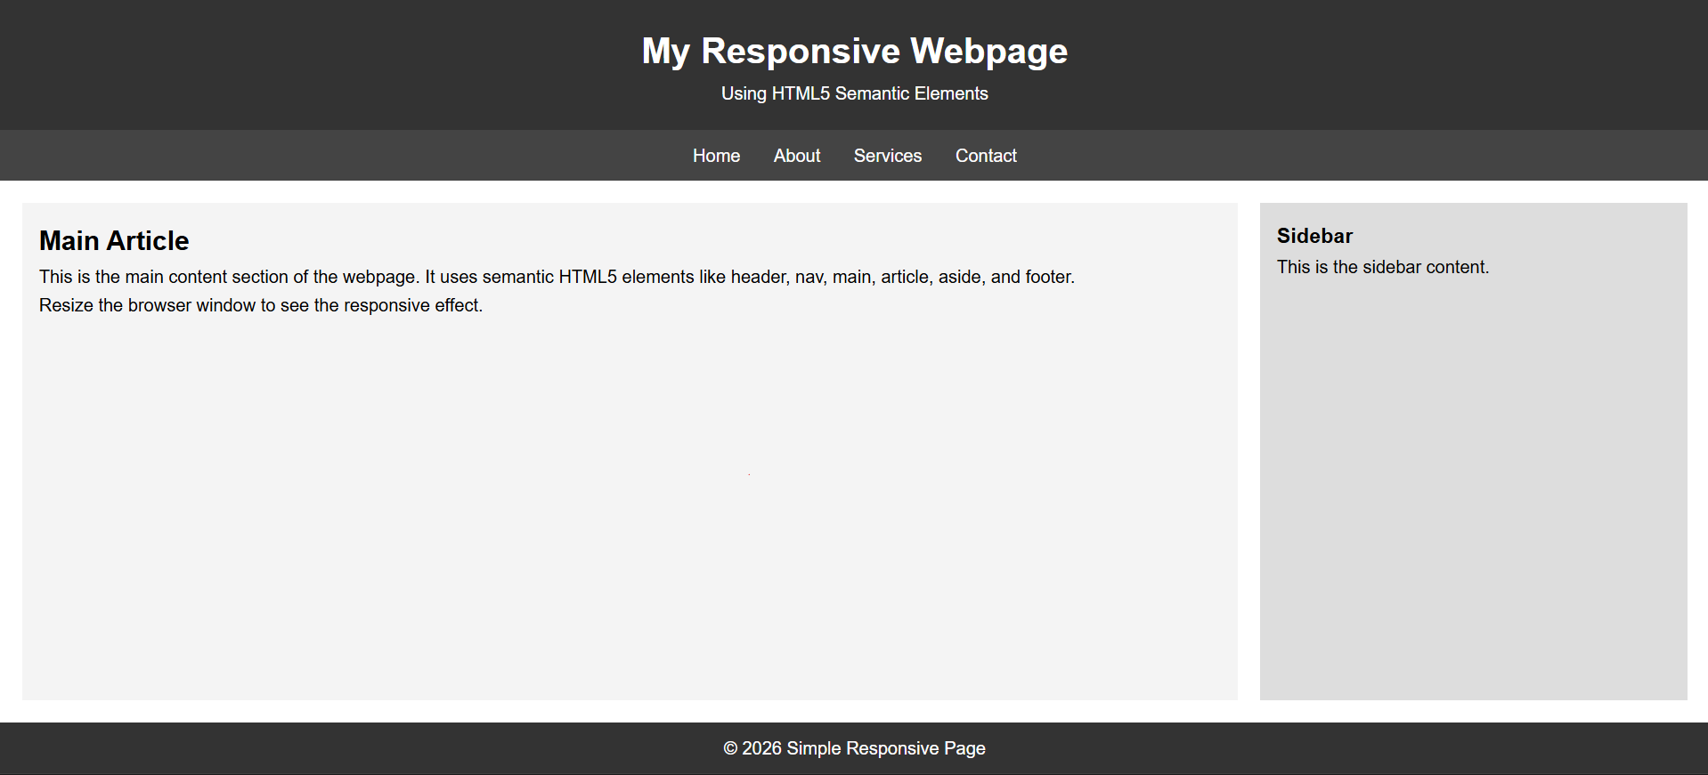

Program No: 02 | Date: 05/12/2025
Program Title: Implement CSS animations and transitions on webpage elements
<!-- Animations and transitions on webpage elements
@Ann Jo Mathew
Roll No: 12
07/12/2025 -->

<!DOCTYPE html>
<html lang="en">
<head>
<meta charset="UTF-8">
<title>CSS Animations & Transitions</title>
<meta name="viewport" content="width=device-width, initial-scale=1.0">

<style>
body {
font-family: Arial, sans-serif;
background: #f4f6f8;
text-align: center;
padding: 40px;
}

h1 {
margin-bottom: 30px;
}
.card {
width: 250px;
margin: 20px auto;
padding: 20px;
background: white;
border-radius: 10px;
box-shadow: 0 5px 15px rgba(0,0,0,0.1);
transition: transform 0.4s ease, box-shadow 0.4s ease;
}

.card:hover {
transform: translateY(-10px);
box-shadow: 0 10px 25px rgba(0,0,0,0.2);
}
button {
padding: 12px 25px;
border: none;
background: #4f46e5;
color: white;
border-radius: 25px;
cursor: pointer;
font-size: 16px;
transition: background 0.3s ease, transform 0.3s ease;
}

button:hover {
background: #3730a3;
transform: scale(1.05);
}
.circle {
width: 80px;
height: 80px;
background: #22c55e;
border-radius: 50%;
margin: 40px auto;

animation: bounce 2s infinite;
}
@keyframes bounce {
0% {
transform: translateY(0);
}
50% {
transform: translateY(-30px);
}
100% {
transform: translateY(0);
}
}
</style>
</head>
<body>
<h1>CSS Animations & Transitions</h1>
<div class="card">
<h3>Hover Card</h3>
<p>Moves up smoothly when hovered.</p>
</div>
<button>Hover Me</button>
<div class="circle"></div>
</body>
</html>

Output
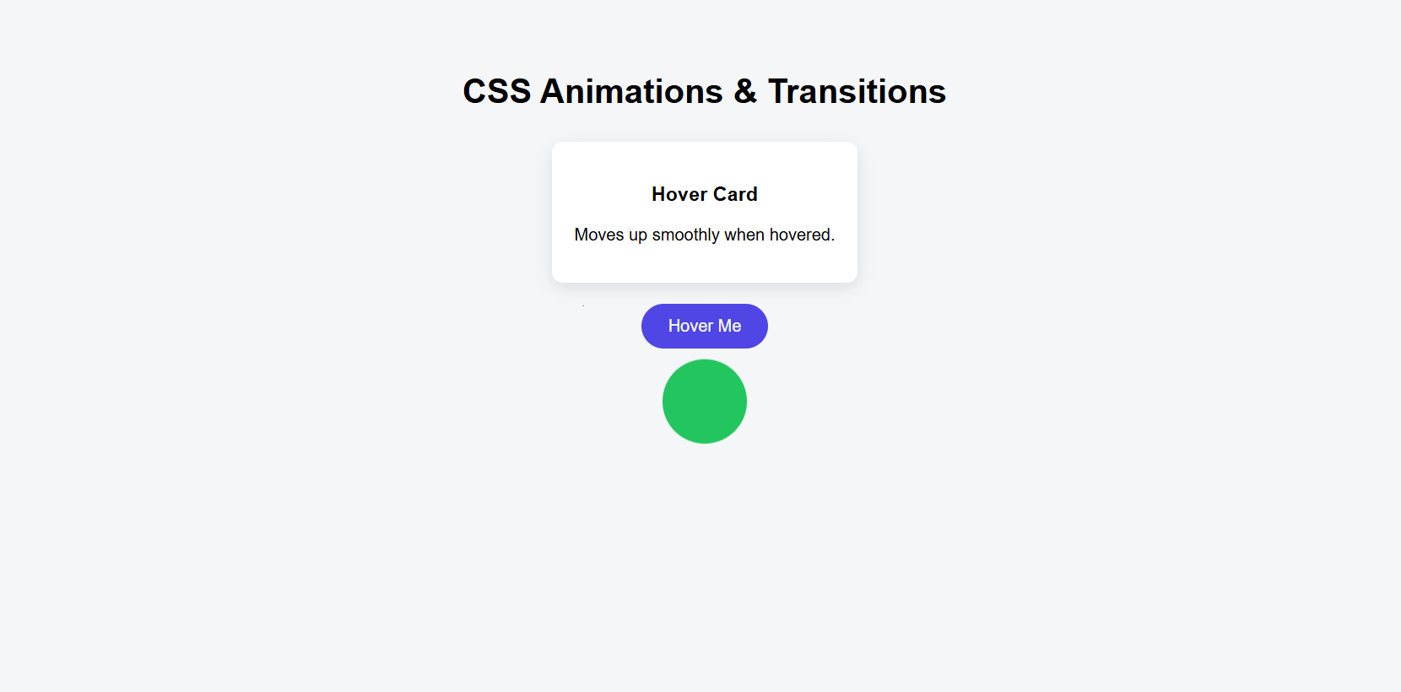

Program No: 03 | Date: 05/12/2025
Program Title: Create a webpage demonstrating CSS Flexbox layouts.
<!-- CSS Flexbox layouts
@Ann Jo Mathew
Roll No: 12
Date: 07/12/2025 -->

<!DOCTYPE html>
<html lang="en">
<head>
<meta charset="UTF-8">
<title>CSS Flexbox Example</title>
<meta name="viewport" content="width=device-width, initial-scale=1.0">

<style>
body {
font-family: Arial, sans-serif;
background: #f1f5f9;
padding: 20px;
}

h1 {
text-align: center;
margin-bottom: 30px;
}

.flex-container {
display: flex;
justify-content: space-between;
align-items: center;
gap: 15px;
flex-wrap: wrap;
}

.box {
flex: 1;
min-width: 200px;
background: #6366f1;
color: white;
padding: 30px;
text-align: center;
border-radius: 8px;
}
</style>
</head>
<body>
<h1>CSS Flexbox Layout</h1>
<div class="flex-container">
<div class="box">Box 1</div>
<div class="box">Box 2</div>
<div class="box">Box 3</div>
</div>
</body>
</html>

Output
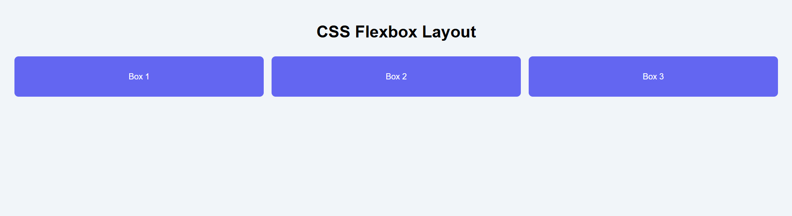

Program No: 04 | Date: 05/12/2025
Program Title: Design a pricing table layout using HTML and CSS.
<!-- Pricing table layout
@Ann Jo Mathew
Roll No: 12
08/12/2025 -->

<!DOCTYPE html>
<html lang="en">
<head>
<meta charset="UTF-8">
<title>Pricing Table</title>
<meta name="viewport" content="width=device-width, initial-scale=1.0">

<style>
body {
font-family: Arial, sans-serif;
background: #f4f6f8;
text-align: center;
padding: 40px;
}

h1 {
margin-bottom: 40px;
}

.pricing-container {
display: flex;
justify-content: center;
gap: 20px;
flex-wrap: wrap;
}

.pricing-card {
background: white;
padding: 25px;
width: 250px;
border-radius: 10px;
box-shadow: 0 5px 15px rgba(0,0,0,0.1);
transition: transform 0.3s ease;
}

.pricing-card:hover {
transform: translateY(-10px);
}

.price {
font-size: 28px;
margin: 15px 0;
color: #4f46e5;
}

ul {
list-style: none;
padding: 0;
margin: 20px 0;
}

ul li {
margin: 8px 0;
}

button {
padding: 10px 20px;
border: none;
background: #4f46e5;
color: white;
border-radius: 20px;
cursor: pointer;
}

button:hover {
background: #3730a3;
}

.popular {
border: 2px solid #4f46e5;
}

</style>
</head>
<body>
<h1>Pricing Plans</h1>
<div class="pricing-container">
<div class="pricing-card">
<h2>Basic</h2>
<p class="price">$10 / month</p>
<ul>
<li>1 User</li>
<li>5GB Storage</li>
<li>Email Support</li>
</ul>
<button>Choose Plan</button>
</div>
<div class="pricing-card popular">
<h2>Standard</h2>
<p class="price">$20 / month</p>
<ul>
<li>5 Users</li>
<li>50GB Storage</li>
<li>Priority Support</li>
</ul>
<button>Choose Plan</button>
</div>
<div class="pricing-card">
<h2>Premium</h2>
<p class="price">$40 / month</p>
<ul>
<li>Unlimited Users</li>
<li>200GB Storage</li>
<li>24/7 Support</li>
</ul>
<button>Choose Plan</button>
</div>
</div>
</body>
</html>
Output
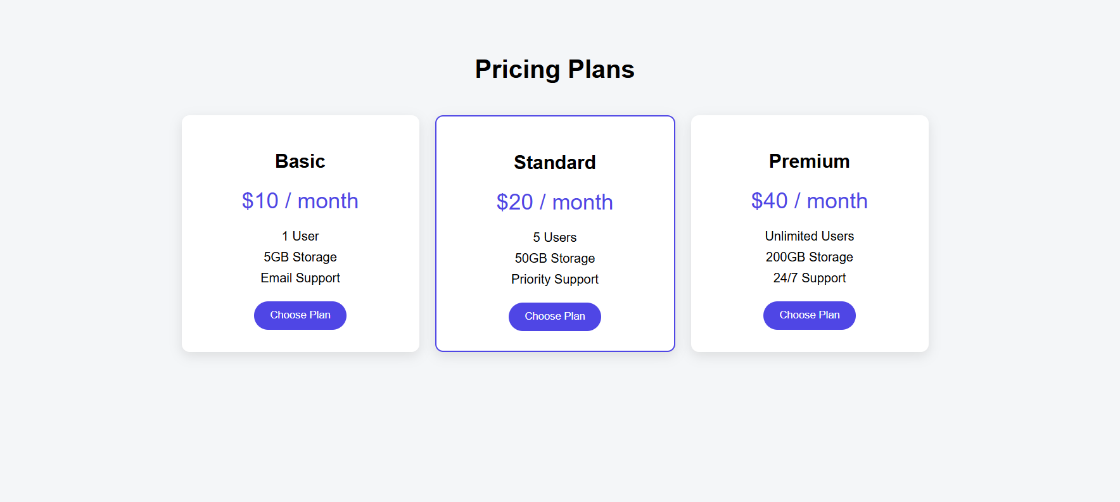

Program No: 05 | Date: 12/12/2025
Program Title: Design a multi-section landing page using HTML and CSS.
<!-- Multi-section landing page
@Ann Jo Mathew
Roll No: 12
14/12/2025 -->

<!DOCTYPE html>
<html lang="en">
<head>
<meta charset="UTF-8">
<title>Landing Page</title>
<meta name="viewport" content="width=device-width, initial-scale=1.0">
<style>
* {
margin: 0;
padding: 0;
box-sizing: border-box;
}
body {
font-family: Arial, sans-serif;
line-height: 1.6;
}
header {
background: #4f46e5;
color: white;
padding: 20px;
text-align: center;
}
nav {
margin-top: 10px;
}
nav a {
color: white;
margin: 0 10px;
text-decoration: none;
font-weight: bold;
}
.hero {
background: #eef2ff;
padding: 60px 20px;
text-align: center;
}
.hero h1 {
margin-bottom: 15px;
}
.hero button {
padding: 12px 25px;
border: none;
background: #4f46e5;
color: white;
border-radius: 5px;
cursor: pointer;
}
.features {
padding: 40px 20px;
text-align: center;
}
.feature-box {
display: flex;
gap: 20px;
justify-content: center;
flex-wrap: wrap;
margin-top: 20px;
}
.feature {
background: #f4f4f4;
padding: 20px;
width: 250px;
border-radius: 8px;
}
.about {
padding: 40px 20px;
background: #f8fafc;
text-align: center;
}
.contact {
padding: 40px 20px;
text-align: center;
}
input, textarea {
width: 250px;
padding: 10px;
margin: 8px 0;
}
footer {
background: #1f2937;
color: white;
text-align: center;
padding: 15px;
}
@media (max-width: 768px) {
nav {
display: flex;
flex-direction: column;
}
}
</style>
</head>
<body>
<header>
<h1>My Landing Page</h1>
<nav>
<a href="#">Home</a>
<a href="#">Features</a>
<a href="#">About</a>
<a href="#">Contact</a>
</nav>
</header>
<section class="hero">
<h1>Welcome to Our Website</h1>
<p>Simple landing page using HTML and CSS</p>
<button>Get Started</button>
</section>
<section class="features">
<h2>Features</h2>
<div class="feature-box">
<div class="feature">Fast</div>
<div class="feature">Responsive</div>
<div class="feature">Easy to Use</div>
</div>
</section>
<section class="about">
<h2>About Us</h2>
<p>
We create simple and beginner-friendly web designs using
HTML and CSS.
</p>
</section>
<section class="contact">
<h2>Contact Us</h2>
<form>
<input type="text" placeholder="Your Name"><br>
<input type="email" placeholder="Your Email"><br>
<textarea placeholder="Message"></textarea><br>
<button>Send</button>
</form>
</section>
<footer>
<p>&copy; 2026 Landing Page</p>
</footer>
</body>
</html>
Output
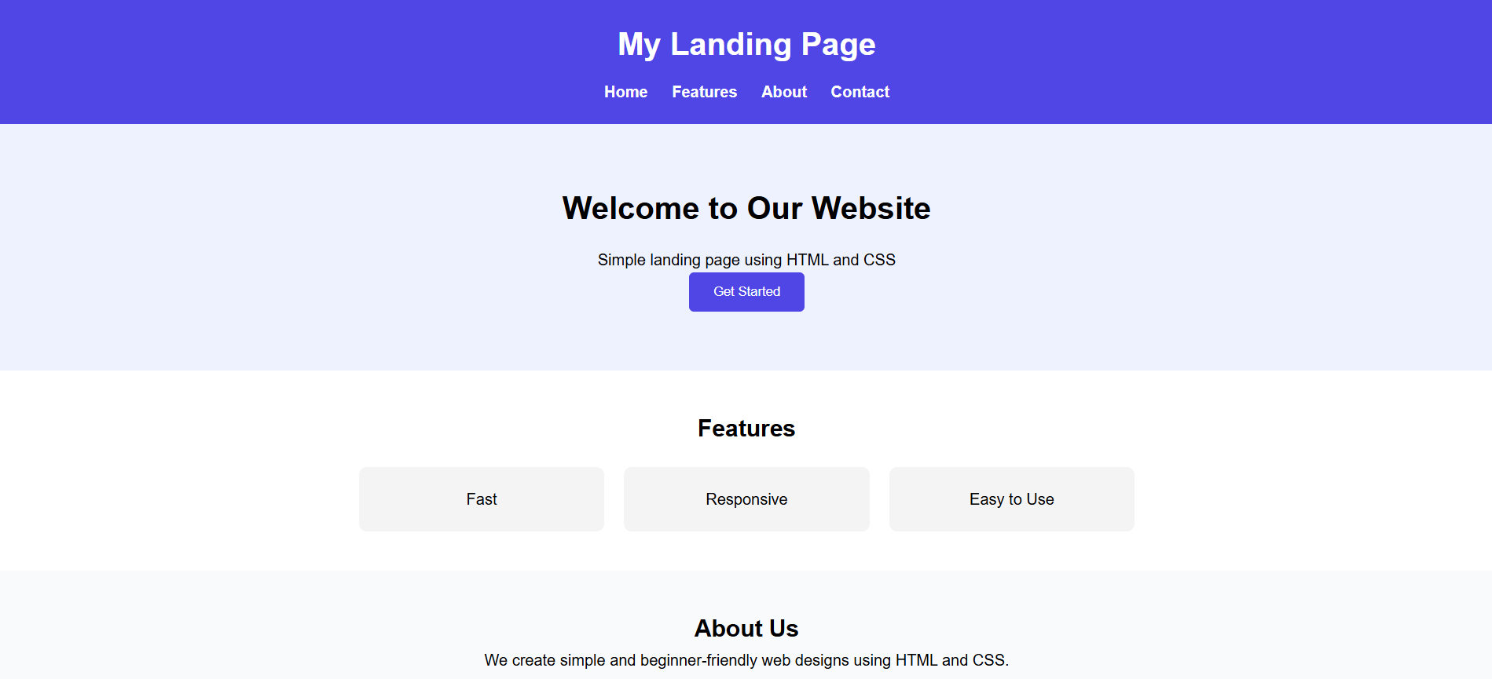


Program No: 06 | Date: 12/12/2025
Program Title: Write a JavaScript program to validate a registration form.
<!-- Registration form
@Ann Jo Mathew
Roll No: 12
16/12/2025 -->

<!DOCTYPE html>
<html lang="en">
<head>
<meta charset="UTF-8">
<title>Form Validation</title>
<meta name="viewport" content="width=device-width, initial-scale=1.0">
<style>
body {
font-family: Arial, sans-serif;
padding: 30px;
text-align:center ;
}
form {
max-width: 300px;
margin: auto;
}
input {
width: 100%;
padding: 8px;
margin: 8px 0;
}
button {
width: 100%;
padding: 10px;
}
</style>
<script>
function validateForm() {
let name = document.getElementById("name").value;
let email = document.getElementById("email").value;
let password = document.getElementById("password").value;
let confirmPassword = document.getElementById("confirm").value;
if (name === "") {
alert("Name is required");
return false;
}
if (email === "") {
alert("Email is required");
return false;
}
if (password.length < 6) {
alert("Password must be at least 6 characters");
return false;
}
if (password !== confirmPassword) {
alert("Passwords do not match");
return false;
}
alert("Registration successful!");
return true;
}
</script>
</head>
<body>
<h2>Registration Form</h2>
<form onsubmit="return validateForm()">
<input type="text" id="name" placeholder="Name">
<input type="email" id="email" placeholder="Email">
<input type="password" id="password" placeholder="Password">
<input type="password" id="confirm" placeholder="Confirm Password">
<button type="submit">Register</button>
</form>
</body>
</html>
Output
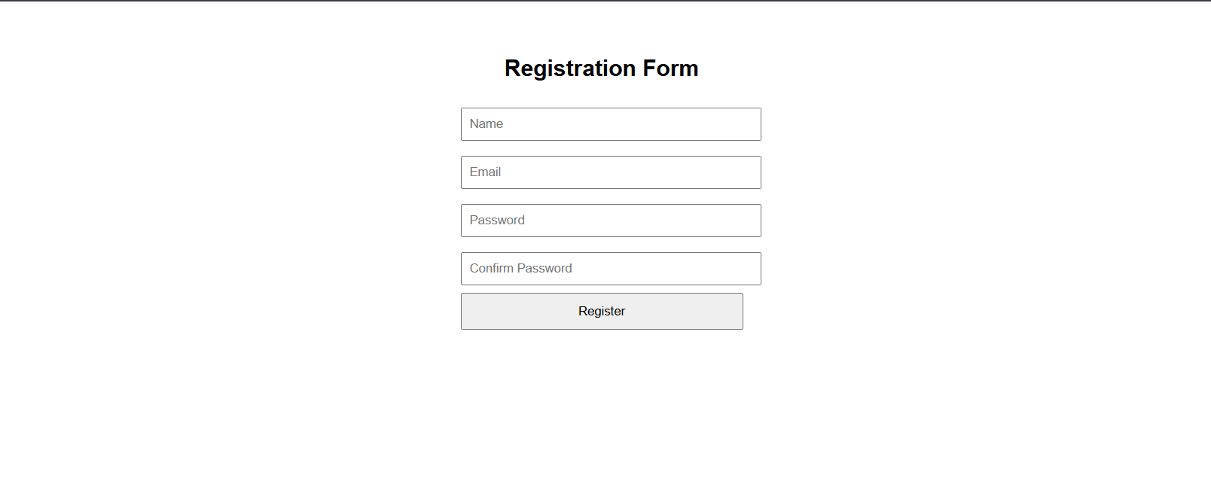

Program No: 07 | Date: 12/12/2025
Program Title: Write a JavaScript program to filter and search data dynamically.
<!-- Filter and search data dynamically
@Ann Jo Mathew
Roll No: 12
16/12/2025 -->

<!DOCTYPE html>
<html>
<head>
<meta charset="UTF-8">
<title>Search and Filter</title>

<style>
body {
font-family: Arial;
padding: 30px;
}

input, select {
padding: 8px;
margin-right: 10px;
margin-bottom: 15px;
}

.item {
padding: 8px;
background: #f4f4f4;
margin-bottom: 5px;
border-radius: 4px;
}
</style>

<script>
function filterData() {
let searchText = document.getElementById("search").value.toLowerCase();
let category = document.getElementById("category").value;
let items = document.getElementsByClassName("item");

for (let i = 0; i < items.length; i++) {
let name = items[i].getAttribute("data-name").toLowerCase();
let type = items[i].getAttribute("data-category");

let matchSearch = name.includes(searchText);
let matchCategory = (category === "all" || type === category);

if (matchSearch && matchCategory) {
items[i].style.display = "block";
} else {
items[i].style.display = "none";
}
}
}
</script>

</head>
<body>
<h2>Search and Filter Products</h2>
<input type="text" id="search" placeholder="Search..." onkeyup="filterData()">
<select id="category" onchange="filterData()">
<option value="all">All</option>
<option value="electronics">Electronics</option>
<option value="accessories">Accessories</option>
</select>
<div class="item" data-name="Laptop" data-category="electronics">Laptop</div>
<div class="item" data-name="Mobile" data-category="electronics">Mobile</div>
<div class="item" data-name="Keyboard" data-category="accessories">Keyboard</div>
<div class="item" data-name="Mouse" data-category="accessories">Mouse</div>
</body>
</html>
Output
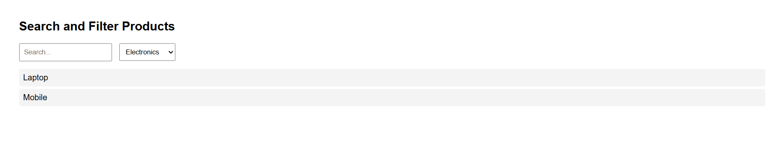

Program No: 08 | Date: 12/12/2025
Program Title: Implement image slideshow using JavaScript and CSS Grid.
<!-- Image slideshow using JavaScript and CSS Grid
@Ann Jo Mathew
Roll No: 12
19/12/2025 -->

<!DOCTYPE html>
<html lang="en">
<head>
<meta charset="UTF-8">
<title>Image Slideshow</title>
<meta name="viewport" content="width=device-width, initial-scale=1.0">
<style>
body {
font-family: Arial, sans-serif;
background: #f4f6f8;
display: flex;
justify-content: center;
align-items: center;
height: 100vh;
}

.slideshow {
display: grid;
grid-template-rows: auto 50px;
width: 400px;
background: white;
padding: 15px;
border-radius: 10px;
box-shadow: 0 5px 15px rgba(0,0,0,0.2);
}

img {
width: 100%;
height: 250px;
object-fit: cover;
border-radius: 8px;
}

.controls {
display: grid;
grid-template-columns: 1fr 1fr;
gap: 10px;
margin-top: 10px;
}

button {
padding: 10px;
border: none;
background: #4f46e5;
color: white;
border-radius: 5px;
cursor: pointer;
}

button:hover {
background: #3730a3;
}
</style>
</head>
<body>
<div class="slideshow">
<img id="slide" src="https://via.placeholder.com/400x250?text=Image+1">
<div class="controls">
<button onclick="prevSlide()">Previous</button>
<button onclick="nextSlide()">Next</button>
</div>
</div>
<script>
let images = [
"https://images.pexels.com/photos/1108099/pexels-photo-1108099.jpeg",
"https://images.pexels.com/photos/4587993/pexels-photo-4587993.jpeg",
"https://images.pexels.com/photos/1805164/pexels-photo-1805164.jpeg",
"https://images.pexels.com/photos/4587991/pexels-photo-4587991.jpeg",
"https://images.pexels.com/photos/4587999/pexels-photo-4587999.jpeg",
"https://images.pexels.com/photos/4588002/pexels-photo-4588002.jpeg"
];
let index = 0;
function nextSlide() {
index = (index + 1) % images.length;
document.getElementById("slide").src = images[index];
}
function prevSlide() {
index = (index - 1 + images.length) % images.length;
document.getElementById("slide").src = images[index];
}
</script>
</body>
</html>
Output
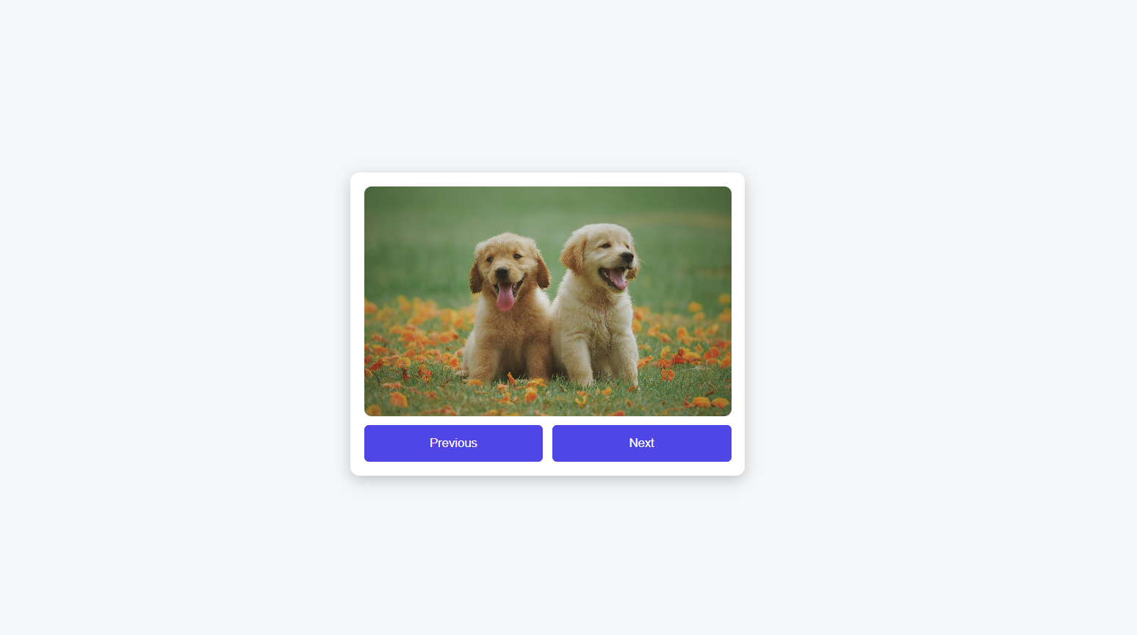

Program No: 09 | Date: 19/12/2025
Program Title: Create a real-time digital clock using JavaScript.

<!-- Real-time digital clock using JavaScript
@Ann Jo Mathew
Roll No: 12
19/12/2025 -->

<!DOCTYPE html>
<html lang="en">
<head>
<meta charset="UTF-8">
<title>Digital Clock</title>
<meta name="viewport" content="width=device-width, initial-scale=1.0">
<style>
body {
height: 100vh;
display: flex;
justify-content: center;
align-items: center;
background: #111827;
font-family: Arial, sans-serif;
}

.clock {
font-size: 50px;
color: #22d3ee;
background: #1f2937;
padding: 20px 40px;
border-radius: 10px;
letter-spacing: 3px;
}
</style>
</head>
<body>
<div class="clock" id="clock"></div>
<script>
function updateClock() {
let now = new Date();
let hours = now.getHours();
let minutes = now.getMinutes();
let seconds = now.getSeconds();
hours = hours < 10 ? "0" + hours : hours;
minutes = minutes < 10 ? "0" + minutes : minutes;
seconds = seconds < 10 ? "0" + seconds : seconds;
let time = hours + ":" + minutes + ":" + seconds;
document.getElementById("clock").innerHTML = time;
}
setInterval(updateClock, 1000);
updateClock();
</script>
</body>
</html>
Output


Program No: 10 | Date: 19/12/2025
Program Title: Implement dropdown-based content rendering using JavaScript.
<!-- Dropdown-based content rendering using JavaScript
@Ann Jo Mathew
Roll No: 12
21/12/2025 -->

<!DOCTYPE html>
<html lang="en">
<head>
<meta charset="UTF-8">
<title>Dropdown Content Rendering</title>
<meta name="viewport" content="width=device-width, initial-scale=1.0">
<style>
body {
font-family: Arial, sans-serif;
padding: 40px;
text-align: center;
}

select {
padding: 8px;
margin-bottom: 20px;
}

.content-box {
width: 300px;
margin: auto;
padding: 20px;
background: #f4f4f4;
border-radius: 8px;
}
</style>
</head>
<body>
<h2>Select a Course</h2>
<select id="course" onchange="showContent()">
<option value="">-- Select Course --</option>
<option value="html">HTML</option>
<option value="css">CSS</option>
<option value="js">JavaScript</option>
</select>
<div class="content-box" id="content">
Please select a course to see details.
</div>
<script>
function showContent() {
let value = document.getElementById("course").value;
let contentBox = document.getElementById("content");
if (value === "html") {
contentBox.innerHTML = "HTML is used to structure web pages.";
}
else if (value === "css") {
contentBox.innerHTML = "CSS is used to style web pages.";
}
else if (value === "js") {
contentBox.innerHTML = "JavaScript is used to make web pages interactive.";
}
else {
contentBox.innerHTML = "Please select a course to see details.";
}
}
</script>
</body>
</html>
Output


Program No: 11 | Date: 19/12/2025
Program Title: Write a program to display student details (name, age, grade) using JSON.
<!-- student details using JSON
@Ann Jo Mathew
Roll No: 12
21/12/2025 -->

<!DOCTYPE html>
<html>
<head>
<title>Student Details (JSON)</title>
<style>
body {
font-family: Arial;
text-align: center;
padding: 40px;
}
</style>
</head>
<body>
<h2>Student Details</h2>
<div id="output"></div>
<script>
let studentJSON = `{
"name": "Ann Jo Mathew",
"age": 22,
"grade": "A"
}`;
let student = JSON.parse(studentJSON);
document.getElementById("output").innerHTML =
"Name: " + student.name + "<br>" +
"Age: " + student.age + "<br>" +
"Grade: " + student.grade;
</script>
</body>
</html>
Output


