Program No: 01 | Date: 17/11/2025
Program Title: Program to display two numbers using command line arguments, add those numbers, and display the result.

/* Inputting two numbers using command line arguments and displaying their sum
@Ann Jo Mathew
Roll No: 12
17/11/2025 */

import java.io.*;
class CLA1{
public static void main(String args[]){
if(args.length!=2){
System.out.println("Error: Need Exactly 2 argumnets");
return;
}
int n1,n2,sum;
n1=Integer.parseInt(args[0]);
n2=Integer.parseInt(args[1]);
System.out.println("The two numbers are: "+n1+" and "+n2);
sum=n1+n2;
System.out.println("Sum="+sum);

}
}
Output
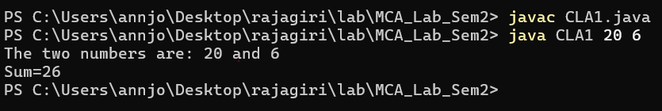

Program No: 02 | Date: 17/11/2025
Program Title: Program to demonstrate arithmetic operation using command line arguments
/* Arithmetic operation using Command Line Arguments
@Ann Jo Mathew
Roll No: 12
19/11/2025 */

import java.io.*;
class ClaArithmeticOp{
public static void main(String args[]){
if(args.length!=3){
System.out.println("Error: Need exactly 3 arguments: operand1 operand2 choice");
return;
}

int n1,n2,ch,r;
n1=Integer.parseInt(args[0]);
n2=Integer.parseInt(args[1]);
ch=Integer.parseInt(args[2]);

switch(ch){
case 0:
r=n1+n2;
System.out.println("Sum= "+r);
break;
case 1:
r=n1-n2;
System.out.println("Difference= "+r);
break;
case 2:
r=n1*n2;
System.out.println("Product= "+r);
break;
case 3:
if(n2==0)
System.out.println("Error: Division by zero is not allowed");
else{
r=n1/n2;
System.out.println("Quotient= "+r);
}
break;

default:
System.out.println("Invalid choice! Choices are: 0 for Addition, 1 for Subtraction, 2 for multiplication, 3 for Division.");
}
}
}
Output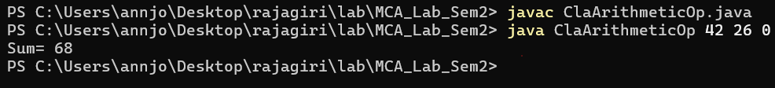

Program No: 03 | Date: 29/11/2025
Program Title: Keep a secret number between 20 and 30 in your program. Ask the user to
predict a number between 20 and 30. Use a do-while loop until the user predicts
your secret number and displays the count of attempts.
/* Secret number guess
@Ann Jo Mathew
Roll No: 12
Date: 29/11/2025 */

import java.io.*;
class Guess{
public static void main(String args[]){
DataInputStream d=new DataInputStream(System.in);
try{
int secret=27;
int g=0,count=0;
do{
System.out.println("Enter a number between 20 and 30:");
g=Integer.parseInt(d.readLine());
count++;
}while(g!=secret);
System.out.println("Your guess is Correct\nAttempts = "+count);
}
catch(Exception e){
System.out.println("Error: "+e);
}
}
}

Output
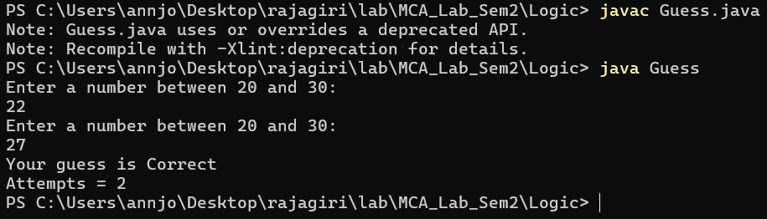

Program No: 04 | Date: 29/11/2025
Program Title: Implement searching and sorting elements in an Array
/* Search and sort elements in array
@Ann Jo Mathew
Roll No: 12
29/11/2025 */

import java.util.*;
class SortSearchArray{
public static void main(String args[]){
int a[],i,n,j,e;
Scanner sc=new Scanner(System.in);
System.out.print("Enter the array size: ");
n=sc.nextInt();
a=new int[n];
System.out.print("Enter the array elements: ");
for(i=0;i<n;i++)
a[i]=sc.nextInt();
System.out.println("Sorted elements are: ");
for(i=0;i<n;i++){
for(j=0;j<n-i-1;j++){
if(a[j]>a[j+1]){
int temp=a[j];
a[j]=a[j+1];
a[j+1]=temp;
}
}
}
for(i=0;i<n;i++)
System.out.print(a[i]+"\t");
System.out.println();
System.out.print("Enter an element to search: ");
e=sc.nextInt();
int mid,h,l;
h=n-1; //using Binary Search since elements are sorted
l=0;
mid=(l+h)/2;
while(l<=h){
mid=(l+h)/2;
if(a[mid]==e){
System.out.println("Element "+a[mid]+" found at position "+mid);
return ;
}
else if(e<a[mid])
h=mid-1;
else
l=mid+1;
}
if(l>=h)
System.out.println("Element not found");
}
}

Output
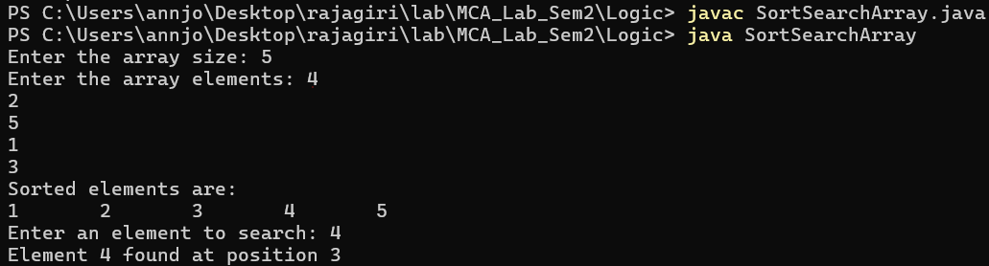

Program No: 05 | Date: 29/11/2025
Program Title: Implement a Java program to pass an array in different ways.
/* Passing array in different ways
@Ann Jo Mathew
Roll No: 12
30/11/2025 */

import java.util.*;
class ArrayPass{
void printArray(int arr[]) { //Passing array as a parameter
System.out.println("Array elements:");
for (int x : arr) {
System.out.print(x + " ");
}
System.out.println();
}
int[] createArray() {
Scanner sc = new Scanner(System.in);
System.out.print("Enter size: ");
int n = sc.nextInt();
int a[] = new int[n];
System.out.println("Enter elements:");
for (int i = 0; i < n; i++) {
a[i] = sc.nextInt();
}
return a;
}
}
class ArrayConstructor { //Passing array to constructor
int arr[];
ArrayConstructor(int a[]) {
arr = a;
}
void show() {
System.out.println("Array from constructor:");
for (int x : arr) {
System.out.print(x + " ");
}
}
}
public class Pgm5{
public static void main(String[] args) {
ArrayPass obj = new ArrayPass();
int data[] = obj.createArray();
obj.printArray(data);
ArrayConstructor ac = new ArrayConstructor(data);
ac.show();
}
}

Output
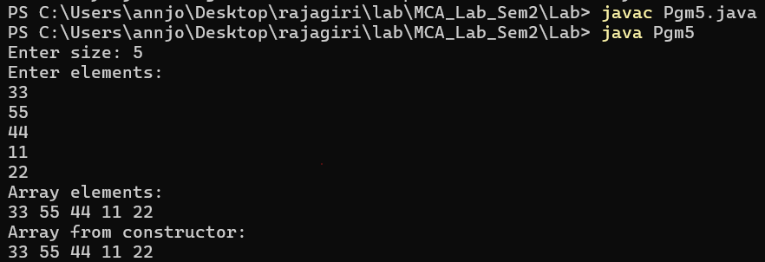

Program No: 06 | Date: 1/12/2025
Program Title: Write a Java program to add and multiply two matrices
/* Matrix multiplication and addition
@Ann Jo Mathew
Roll No: 12
01/12/2025 */

import java.util.*;
class MatrixAddMulti{
public static void main(String args[]){
int a[][],r1,c1,r2,c2,i,j,k;
Scanner s=new Scanner(System.in);
System.out.println("Enter the no. of r and c");
r=s.nextInt();
c=s.nextInt();
a=new int[r][c];
System.out.println("Enter elements of matrix A");
for(i=0;i<r;i++){
for(j=0;j<c;j++){
System.out.println("Enter a["+i+"]["+j+"]");
a[i][j]=s.nextInt();
}
}
System.out.println("Enter elements of matrix B");
int b[][]=new int[r][c];
for(i=0;i<r;i++){
for(j=0;j<c;j++){
System.out.println("Enter b["+i+"]["+j+"]");
b[i][j]=s.nextInt();
}
}
if(r1==r2 && c1==c2){
System.out.println("Sum of Matrices:");
int sum[][]=new int[r][c];
for(i=0;i<r;i++){
for(j=0;j<c;j++)
sum[i][j]=a[i][j]+b[i][j];
}
for(i=0;i<r;i++){
for(j=0;j<c;j++)
System.out.print(sum[i][j]+"\t");
System.out.println("");
}
}
else{
System.out.println("Addition not possible");
}
if(r2==c1){
int r[][]=new int[r1][c2];
for(i=0;i<r1;i++){
for(j=0;j<c2;j++)
r[i][j]=0;
}
for(i=0;i<r1;i++){
for(j=0;j<c2;j++){
for(k=0;k<c1;k++)
r[i][j]=r[i][j]+a[i][k]*b[k][j];
}
}
System.out.println("Product of Matrices:");
for(i=0;i<r1;i++){
for(j=0;j<c2;j++)
System.out.print(r[i][j]+"\t");
System.out.println("");
}
}
else
System.out.println("Multiplication not possible");
}
}
Output
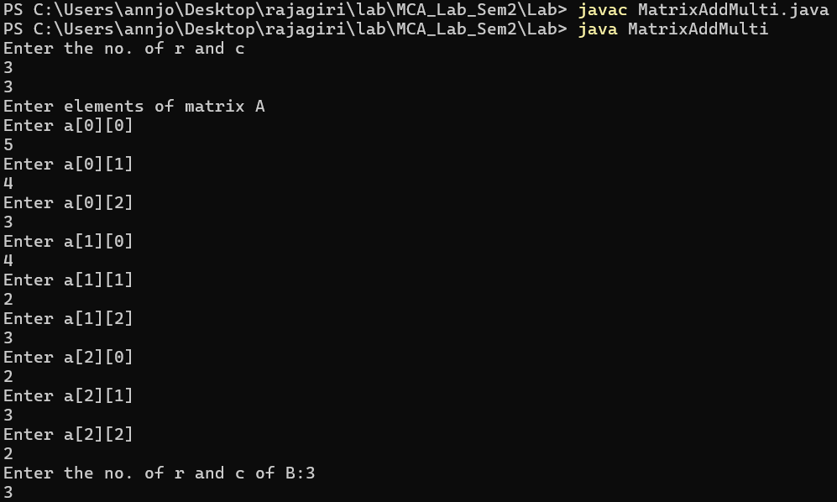
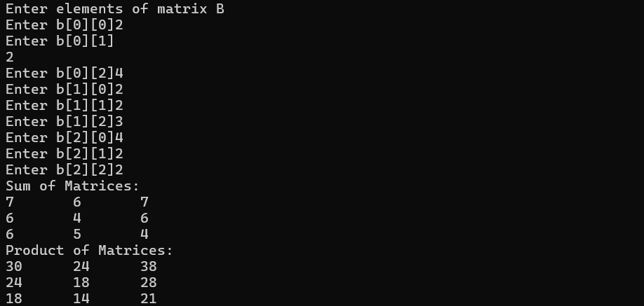

Program No: 07 | Date: 1/12/2025
Program Title: A function takes two integer arguments and returns the maximum. Use this function to find the maximum of three numbers
/* Max of three numbers
@Ann Jo Mathew
Roll No: 12
01/12/2025 */

import java.util.*;
class Pgm7{
public int max(int x,int y){
if(x>y)
return x;
else
return y;
}
public static void main(String args[]){
int a,b,c,m;
Pgm7 obj=new Pgm7();
Scanner sc=new Scanner(System.in);
System.out.println("Enter three numbers: ");
a=sc.nextInt();
b=sc.nextInt();
c=sc.nextInt();
m=obj.max(a,b);
m=obj.max(m,c);
System.out.println("Max= "+m);
}
}

Output
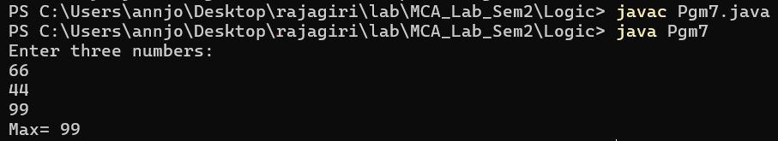

Program No: 08 | Date: 1/12/2025
Program Title: A function takes an integer argument and returns the reverse of the same. Another function takes an integer argument and returns true or false if the number is a palindrome, using the above function.
/* Paliandrome or not
@Ann Jo Mathew
Roll No: 12
01/12/2025 */

import java.io.*;
import java.util.*;
class Reverse{
public int reverse(int n){
int p=0;
while(n>0){
int r=n%10;
p=p*10+r;
n=n/10;
}
return p;
}
public void palindrome(int n){
int temp=n;
n=reverse(n);
if(temp==n)
System.out.println("The number is a Palindrome Number");
else
System.out.println("The number is not palindrome");
}
public int read(){
Scanner sc=new Scanner(System.in);
System.out.print("Enter a number: ");
int n=sc.nextInt();
return n;
}
}
class Pgm8{
public static void main(String args[]){
int a,r;
Reverse obj=new Reverse();
a=obj.read();
r=obj.reverse(a);
System.out.println("Reverse: "+r);
obj.palindrome(a);
}
}
Output
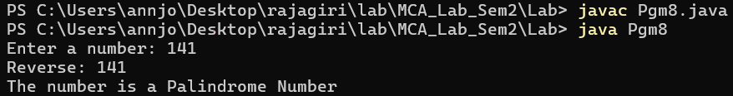

Program No: 09 | Date: 3/12/2025
Program Title: The 15-puzzle (also known as the sliding puzzle) consists of a 4×4 grid containing 15 numbered tiles (from 1 to 15) and one empty space. The objective is to rearrange the tiles by sliding them horizontally or vertically into the empty space to achieve the correct ascending order, as shown below: [Experiential Learning]
1 2 3 4
5 6 7 8
9 10 11 12
13 14 15 _
/* Puzzle
@Ann Jo Mathew
Roll No: 12
07/12/2025 */

import java.io.*;
import java.util.*;
class Puzzle{
int a[][],i,j,m,mr,mc,zr,zc; //size is 4x4
void checkMove(){
int c=0;
//a=new int[][]{1,2,3,4,5,6,7,8,9,10,11,0,13,14,15,12};
a=new int[][]{{1,2,3,4},{5,6,7,8},{9,10,11,12},{13,14,0,15}};
System.out.println("Solve the puzzle");
display(c);
Scanner sc=new Scanner(System.in);
while(true){
System.out.println();
System.out.print("Enter the value that you want to Move: ");
m=sc.nextInt();
if(m<0 || m>15){
System.out.println("Invalid Input");
continue;
}
for(i=0;i<4;i++){
for(j=0;j<4;j++){
if(a[i][j]==m){
mr=i;
mc=j;
}
if(a[i][j]==0){
zr=i;
zc=j;
}
}
}
if((zr==mr)&&(zc==mc-1||zc==mc+1)) {
swap(zr,zc,mr,mc);
}
else if((zr==mr-1||zr==mr+1)&&(zc==mc)){
swap(zr,zc,mr,mc);
}
else{
System.out.println("Invalid Move");
continue;
}
c++;
display(c);
if(checkWin()){
System.exit(0);
}
}
}
boolean checkWin(){
int fin[][]=new int[][]{{1,2,3,4},{5,6,7,8},{9,10,11,12},{13,14,15,0}};
int f=0;
for(i=0;i<4;i++){
for(j=0;j<4;j++){
if(a[i][j]!=fin[i][j]){
f++;
}
}
}
if(f>0){
return false;
}
else{
System.out.println("Congratulations! You have solved the puzzle.");
return true;
}
}
void swap(int i,int j,int m,int n){
int temp=a[i][j];
a[i][j]=a[m][n];
a[m][n]=temp;
}
void display(int c){
for(i=0;i<4;i++){
for(j=0;j<4;j++){
System.out.print(a[i][j]+" ");
}
System.out.println();
}
System.out.println("Number of moves: "+c);
}
}
public class PuzzlePgm9{
public static void main(String args[]){
Puzzle p=new Puzzle();
p.checkMove();
}
}

Output
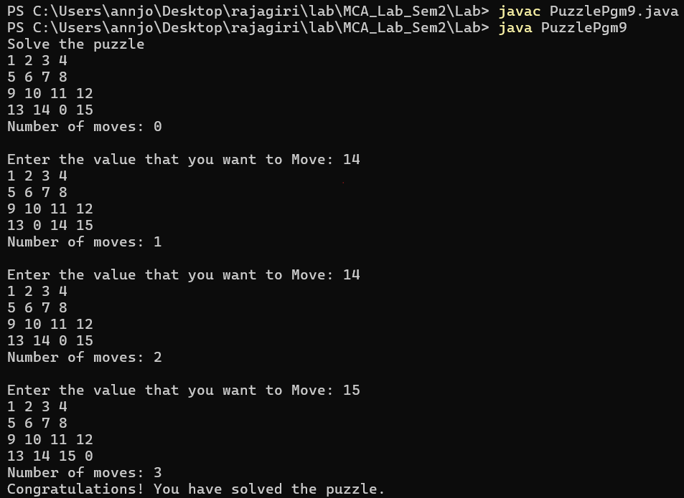

Program No: 10 | Date: 3/12/2025
Program Title: Display from n - 1 and 1-n using recursive functions.
/* Ascending, Descending using recursion
@Ann Jo Mathew
Roll No: 12
04/12/2025 */

import java.util.*;
class Recursion{
public void printDesc(int n) { // Print from n to 1
if(n==0) return;
System.out.print(n+" ");
printDesc(n-1);
}
public void printAsc(int n) { // Print from 1 to n
if(n==0) return;
printAsc(n-1);
System.out.print(n+" ");
}
}
class RecursivePgm10{
public static void main(String args[]) {
Scanner sc = new Scanner(System.in);
System.out.print("Enter n: ");
int n = sc.nextInt();
Recursion obj = new Recursion();
System.out.println("Descending (n to 1):");
obj.printDesc(n);
System.out.println("\nAscending (1 to n):");
obj.printAsc(n);
}
}
Output
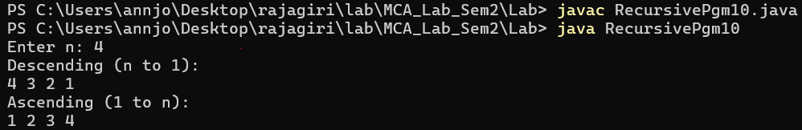

Program No: 11 | Date: 3/12/2025
Program Title: Create a program for adding, subtracting, multiplying and dividing two numbers using object-oriented concepts
/* Arithmetic operation
@Ann Jo Mathew
Roll No: 12
04/12/2025 */

import java.util.*;
class Calculator {
int add(int a, int b) { // Addition
return a + b;
}
int subtract(int a, int b) { // Subtraction
return a - b;
}
int multiply(int a, int b) { // Multiplication
return a * b;
}
float divide(int a, int b) { // Division
if(b == 0) {
System.out.println("Cannot divide by zero.");
return 0;
}
return (float)a / b;
}

}
public class CalculatorPgm11{
public static void main(String args[]) {
Scanner sc = new Scanner(System.in);
Calculator c = new Calculator();
System.out.print("Enter first number: ");
int n1 = sc.nextInt();
System.out.print("Enter second number: ");
int n2 = sc.nextInt();
System.out.println("Addition: " + c.add(n1, n2));
System.out.println("Subtraction: " + c.subtract(n1, n2));
System.out.println("Multiplication: " + c.multiply(n1, n2));
System.out.println("Division: " + c.divide(n1, n2));
}

}

Output
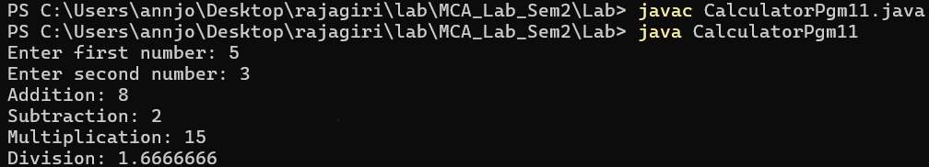

Program No: 12 | Date: 06/12/2025
Program Title: Create a class complex having real and imaginary as data members and provide function for read, display, add and multiply.
/*Addition, Multiplication of Complex numbers
@Ann Jo Mathew
Roll No: 12
06/12/2025 */

import java.util.*;
class Complex {
int r,i;
void read() {
Scanner sc=new Scanner(System.in);
System.out.print("Enter real part: ");
r=sc.nextInt();
System.out.print("Enter imaginary part: ");
i=sc.nextInt();
}
void display() {
if(i>=0)
System.out.println(r+"+"+i+"i");
else
System.out.println(r+"-"+(-i)+"i");
}
Complex add(Complex c) {
Complex obj=new Complex();
obj.r=r+c.r;
obj.i=i+c.i;
return obj;
}
Complex multiply(Complex c) {
Complex obj=new Complex();
obj.r=(r*c.r)-(i*c.i);
obj.i=(r*c.i)+(i*c.r);
return obj;
}
}
public class ComplexPgm12{
public static void main(String args[]) {
Complex c1=new Complex();
Complex c2=new Complex();
System.out.println("Enter first complex number:");
c1.read();
System.out.println("Enter second complex number:");
c2.read();
Complex sum=c1.add(c2);
Complex product=c1.multiply(c2);
System.out.println("\nFirst number:");
c1.display();
System.out.println("Second number:");
c2.display();
System.out.println("\nSum:");
sum.display();
System.out.println("Product:");
product.display();
}
}

Output
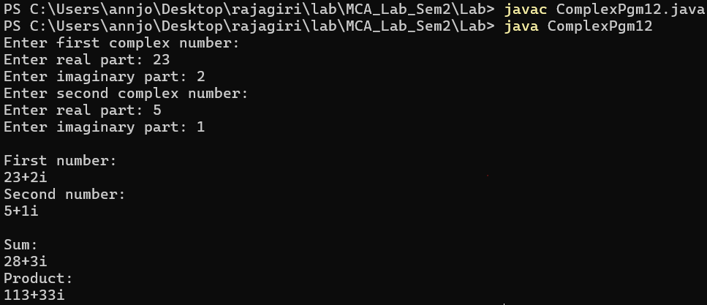

Program No: 13 | Date: 06/12/2025
Program Title: Create a class for CString having a string data member and provide functions for read, display, compare(return Boolean value),add and concatenate.
/*String program
@Ann Jo Mathew
Roll No: 12
06/12/2025 */

import java.util.*;
class CString {
String s;
void read() {
Scanner sc=new Scanner(System.in);
System.out.print("Enter string: ");
s=sc.nextLine();
}
void display() {
System.out.println(s);
}
boolean compare(CString c) { // returns true/false
return s.equals(c.s);
}
CString add(CString c) { // "add" = string addition (concatenation)
CString r=new CString();
r.s=s+c.s;
return r;
}
CString concatenate(CString c) { // same as add but kept separate because question asked
CString r=new CString();
r.s=s+c.s;
return r;
}
}
public class StringPgm13{
public static void main(String args[]) {
CString c1=new CString();
CString c2=new CString();
System.out.println("Enter first string:");
c1.read();
System.out.println("Enter second string:");
c2.read();
boolean eq=c1.compare(c2);
CString added=c1.add(c2);
CString conc=c1.concatenate(c2);
System.out.println("\nFirst string:");
c1.display();
System.out.println("Second string:");
c2.display();
System.out.println("\nStrings equal? "+eq);
System.out.println("Added:");
added.display();
System.out.println("Concatenated:");
conc.display();
}
}

Output
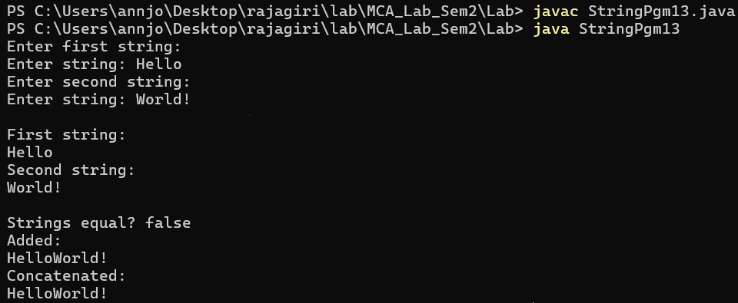

Program No: 14 | Date: 06/12/2025
Program Title: Create a class for a student having (sno, sname, sprogram) [example sno-1,sname-sanjay,sprogram-MCA]. Provide functions for reading and displaying the same information. Also provide a function for comparing two student objects for equality.
/*Student Detail program
@Ann Jo Mathew
Roll No: 12
06/12/2025 */

import java.util.*;
class Student {
int sno;
String sname, sprogram;
void read() {
Scanner sc=new Scanner(System.in);
System.out.print("Enter student number: ");
sno=sc.nextInt();
sc.nextLine();
System.out.print("Enter student name: ");
sname=sc.nextLine();
System.out.print("Enter program: ");
sprogram=sc.nextLine();
}
void display() {
System.out.println(sno+" "+sname+" "+sprogram);
}
boolean compare(Student s) {
return sno==s.sno && sname.equals(s.sname) && sprogram.equals(s.sprogram);
}
}
public class Pgm14 {
public static void main(String args[]) {
Student s1=new Student();
Student s2=new Student();
System.out.println("Enter first student details:");
s1.read();
System.out.println("Enter second student details:");
s2.read();
boolean same=s1.compare(s2);
System.out.println("\nFirst student:");
s1.display();
System.out.println("Second student:");
s2.display();
System.out.println("\nStudents equal? "+same);
}
}
Output
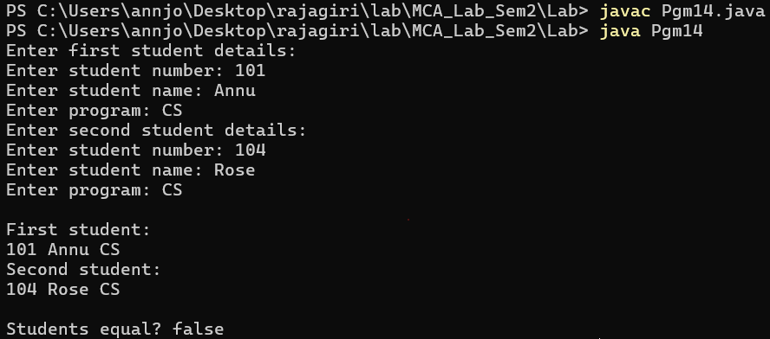

Program No: 15 | Date: 08/12/2025
Program Title: Program to implement the ISA and HASA relationship.
/* ISA and HASA
@Ann Jo Mathew
Roll No: 12
Date: 08/12/2025 */

import java.util.*;
class Person{ // Base class
String name;
Aadhaar a=new Aadhaar();
public Person(String name,int n){
this.name=name;
a.id=n;
}
public Person(String name){
this.name=name;
}
void dispP(){
System.out.println("Name: "+name);
a.dispA();
}
}
class Student extends Person{ // Student ISA Person
int rollNo;
public Student(String name, int rollNo,int id) {
super(name,id);
this.rollNo=rollNo;
}
void dispS() {
dispP();
System.out.println("Roll No: "+rollNo);
}
}
class Aadhaar{ // Person HASA Aadhaar
int id;
void dispA() {
System.out.println("Aadhaar no: "+id);
}
}
public class IsaHasaRelation {
public static void main(String args[]) {
Scanner sc=new Scanner(System.in);

System.out.println("ISA Relationship:");
System.out.println("Enter the name: ");
String a=sc.nextLine();
System.out.print("Enter Roll no: ");
int rn=sc.nextInt();
System.out.print("Enter Aadhaar no: ");
int id=sc.nextInt();
Student s=new Student(a,rn,id);
s.dispS();
System.out.println();
sc.nextLine();

System.out.println("HASA Relationship:");
System.out.print("Enter the name: ");
String b=sc.nextLine();
System.out.print("Enter Aadhaar no: ");
int n=sc.nextInt();
Person p = new Person(b,n);
p.dispP();
}
}
Output
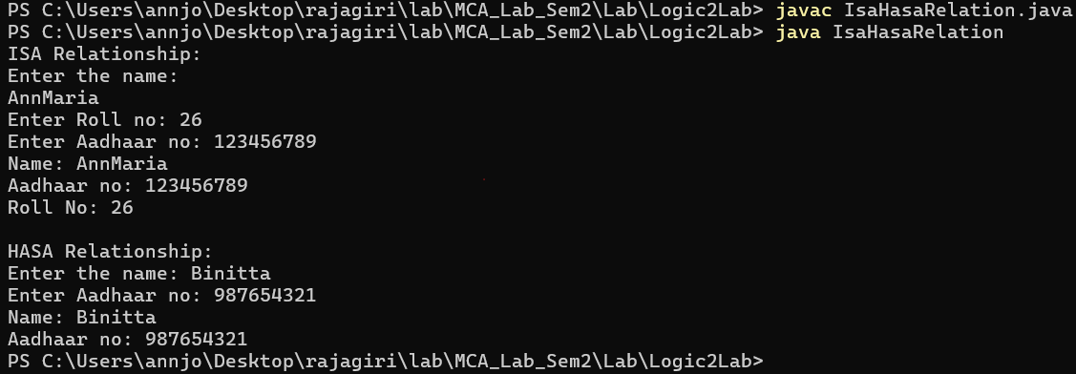

Program No: 16 | Date: 08/12/2025
Program Title: Program to overcome function overriding in Java.
/* Function Overriding
@Ann Jo Mathew
Roll No: 12
Date: 08/12/2025 */

import java.util.*;
class Person{
int age;
String name;
public void read(){
Scanner sc=new Scanner(System.in);
System.out.print("Enter name: ");
name=sc.nextLine();
System.out.print("Enter age: ");
age=sc.nextInt();
}
public void disp(){
System.out.println("Name: "+name);
System.out.println("Age: "+age);
}
}
class Teacher extends Person{
String subject;
public void read(){
super.read();
Scanner sc=new Scanner(System.in);
System.out.print("Enter subject: ");
subject=sc.nextLine();
}
public void disp(){
super.disp();
System.out.println("Subject: "+subject);
}
}
class Pgm2FunOverriding{
public static void main(String args[]){
Person p=new Person();
Teacher t=new Teacher();
System.out.println("Enter Person details:");
p.read();
System.out.println("Person details:");
p.disp();
System.out.println();
System.out.println("\nEnter Teacher details:");
t.read();
System.out.println("Teacher details:");
t.disp();
}
}

Output
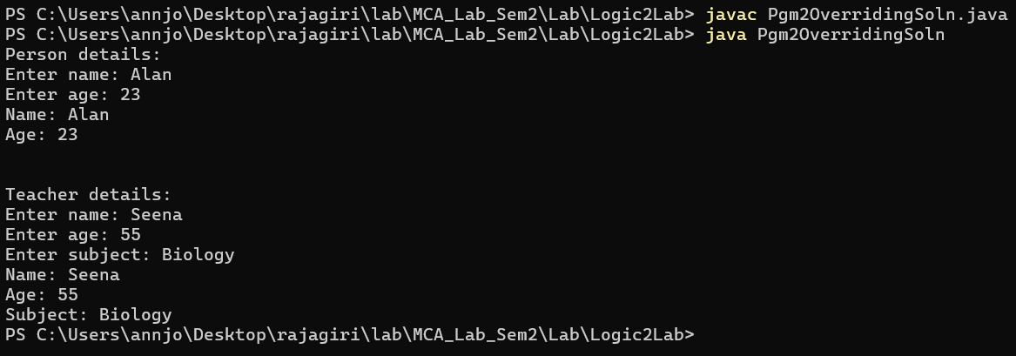

Program No: 17 | Date: 08/12/2025
Program Title: Demonstrate the use of a super keyword
a. To overcome function overriding
b. Passing arguments to the base class constructor

/* Super keyword
@Ann Jo Mathew
Roll No: 12
09/12/2025 */

import java.util.*;
class Person {
int age;
String name;

Person(String name,int age) {
this.name=name;
this.age=age;
}

void display() {
System.out.println("Name:"+name);
System.out.println("Age:"+age);
}
}
class Teacher extends Person {
String subject;

Teacher(String name,int age,String subject) {
super(name,age); //passing arguments to base class constructor
this.subject=subject;
}

void display() {
super.display(); //base class method overriden in derived class
System.out.println("Subject:"+subject);
}
}
class Pgm3Super{
public static void main(String args[]) {
Scanner sc=new Scanner(System.in);
System.out.print("Enter teacher name:");
String name=sc.nextLine();
System.out.print("Enter teacher age:");
int age=sc.nextInt();
sc.nextLine();
System.out.print("Enter subject:");
String subject=sc.nextLine();
Teacher t=new Teacher(name,age,subject);
System.out.println("\nTeacher Details:");
t.display();
}
}
Output
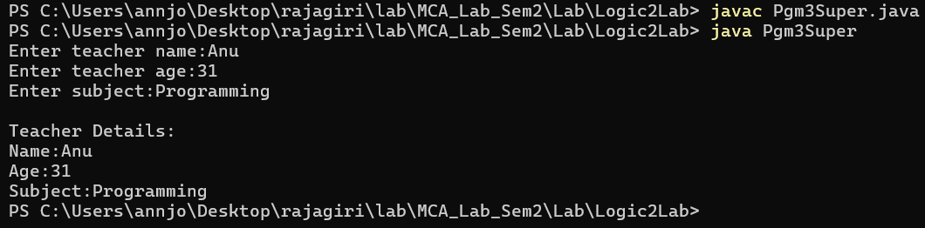

Program No: 18 | Date: 08/12/2025
Program Title: Create a class for an employee having eno, ename and esal as data members. Provide functions for reading, displaying, and comparing by eno. Accept n employees' information in the main function, display the same, and search for an employee whose eno is given.
/* Array of Objects
@Ann Jo Mathew
Roll No: 12
09/12/2025 */

import java.util.*;
class Employee {
int eno;
String ename;
double esal;
void read() {
Scanner sc=new Scanner(System.in);
System.out.print("Enter Employee Number: ");
eno=sc.nextInt();
sc.nextLine(); // consume newline
System.out.print("Enter Employee Name: ");
ename=sc.nextLine();
System.out.print("Enter Employee Salary: ");
esal=sc.nextDouble();
}
void display() {
System.out.println("Employee Number:"+eno);
System.out.println("Employee Name:"+ename);
System.out.println("Employee Salary:"+esal);
}
boolean compareEno(int no) {
if(eno==no)
return true;
else
return false;
}
}
class Pgm4Employee{
public static void main(String args[]) {
Scanner sc=new Scanner(System.in);
System.out.print("Enter total number of employees: ");
int n=sc.nextInt();
Employee e[]=new Employee[n]; //array created of employee data type(AOO)
for(int i=0;i<n;i++) {
e[i]=new Employee(); //object creation
System.out.println("\nEnter details of employee "+(i+1));
e[i].read();
}
System.out.println("\nEmployee Details:");
for(int i=0;i<n;i++) {
e[i].display();
System.out.println();
}System.out.print("Enter employee number to search: ");
int s=sc.nextInt();
boolean found=false;
for(int i=0;i<n;i++) {
if(e[i].compareEno(s)==true) {
System.out.println("\nEmployee Found:");
e[i].display();
found=true;
break;
}
}
if(found==false)
System.out.println("\nEmployee with number "+s+" not found.");
}
}
Output
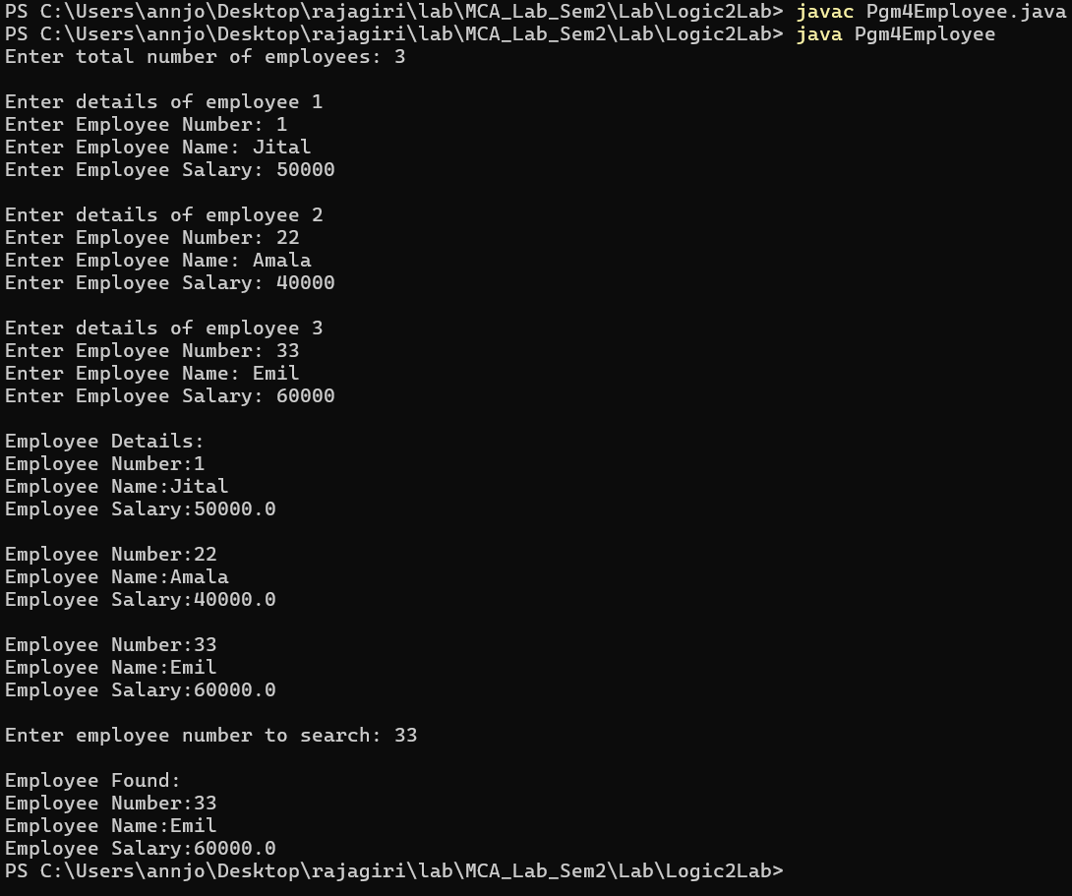

Program No: 19 | Date: 10/12/2025
Program Title: Program to implement run-time polymorphism in Java(interface).
/* Run time polymorphism
@Ann Jo Mathew
Roll No: 12
Date: 11/12/2025 */

import java.util.*;
interface Shape {
void disp();
}
class Circle implements Shape {
public void disp() {
System.out.println("Circle");
}
}
class Rectangle implements Shape {
public void disp() {
System.out.println("Rectangle");
}
}
class Pgm5RuntimePoly{
public static void main(String args[]) {
Shape s1=new Circle();
s1.disp();
Shape s2=new Rectangle();
s2.disp();
}
}

Output

Program No: 20 | Date: 10/12/2025
Program Title: Create an interface ishape having two prototypes draw and mov, create two classes circle and rectangle which implements the above interface. In the main function only a reference object of ishape is created, depends on the choice entered by the user , it points to the respective memory location.
/* Interface
@Ann Jo Mathew
Roll No: 12
11/12/2025 */

import java.util.*;
interface IShape {
void draw();
void mov();
}
class Circle implements IShape {
public void draw() {
System.out.println("Drawing Circle");
}
public void mov() {
System.out.println("Moving Circle");
}
}
class Rectangle implements IShape {
public void draw() {
System.out.println("Drawing Rectangle");
}
public void mov() {
System.out.println("Moving Rectangle");
}
}
class Pgm6Interface{
public static void main(String args[]) {
Scanner sc=new Scanner(System.in);
IShape obj;
System.out.print("1 - Circle \n2 - Rectangle\nEnter choice: ");
int ch=sc.nextInt();
if(ch==1) {
obj=new Circle();
}
else if(ch==2) {
obj=new Rectangle();
}
else {
System.out.println("Invalid choice");
return;
}
obj.draw();
obj.mov();
}
}
Output
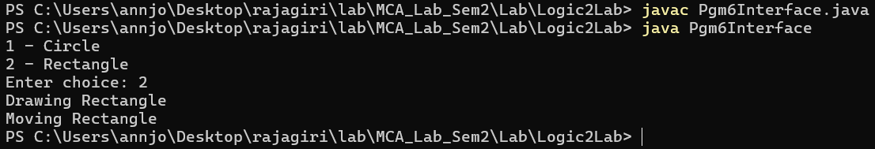

Program No: 21 | Date: 10/12/2025
Program Title: Write a program using multiple catch statements / predefined Exceptions.
/* Predefined Exceptions(MultiCatch)
@Ann Jo Mathew
Roll No: 12
14/12/2025 */

import java.util.*;
class Pgm7MultiCatch{
public static void main(String args[]) {
Scanner sc=new Scanner(System.in);
try {
System.out.print("Enter first number:");
int a=sc.nextInt();
System.out.print("Enter second number:");
int b=sc.nextInt();
int c=a/b;
System.out.println("Result:"+c);
}
catch(ArithmeticException e) {
System.out.println("Arithmetic Exception:"+e);
}
catch(InputMismatchException e) {
System.out.println("Input Mismatch Exception:"+e);
}
catch(Exception e) {
System.out.println("General Exception:"+e);
}
}
}
Output
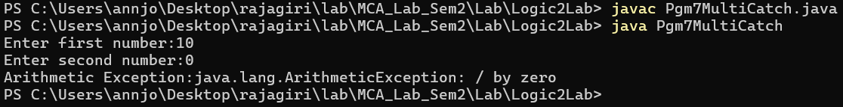

Program No: 22 | Date: 15/12/2025
Program Title: Write a program to implement a user-defined Exception.
/* user-defined Exception
@Ann Jo Mathew
Roll No: 12
15/12/2025 */

import java.util.*;
class UDE extends Exception{
String strError;
public UDE(){ //constructor
strError="Unknown Error";
}
public UDE(String s){ //constructor with argument
strError=s;
}
public String showError(){ //method to return error
return strError;
}
}
class Pgm8UserException{ //throw
public static void main(String args[]){
int a,b,c;
Scanner sc=new Scanner(System.in);
System.out.print("Enter numerator:");
a=sc.nextInt();
System.out.print("Enter dinominator:");
b=sc.nextInt();
try{
if(b==0)
throw new UDE("Dinominator is ZERO"); //here 2nd consructor is invoked
c=a/b;
System.out.println(c);
}
catch(UDE e){
System.out.println(e.showError());
}
}
}
Output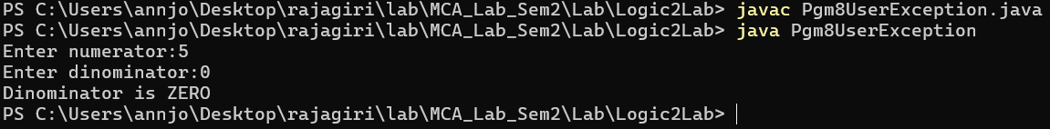

Program No: 23 | Date: 15/12/2025
Program Title: Write a program to implement re-throw and finally.
/* re-throw , finally Exceptions
@Ann Jo Mathew
Roll No: 12
16/12/2025 */

import java.util.*;
class RethrowFinally {
void divide(int a,int b) {
try {
int c=a/b;
System.out.println("Result:"+c);
}
catch(ArithmeticException e) {
System.out.println("Exception caught in divide()");
throw e; // re-throwing the exception
}
finally {
System.out.println("Finally block in divide()");
}
}
}
class Pgm9RethrowFinally {
public static void main(String args[]) {
Scanner sc=new Scanner(System.in);
RethrowFinally obj=new RethrowFinally();
System.out.print("Enter numerator:");
int a=sc.nextInt();
System.out.print("Enter denominator:");
int b=sc.nextInt();
try {
obj.divide(a,b);
}
catch(ArithmeticException e) {
System.out.println("Exception caught in main()");
}
finally { // finally block
System.out.println("Finally block in main()");
}
}
}

Output
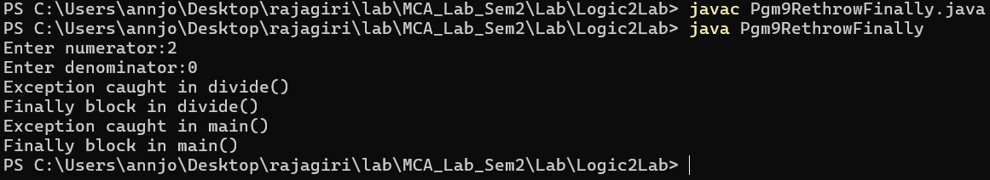

Program No: 24 | Date: 15/12/2025
Program Title: Create a user defined exception class for handling different types of errors. Create another class for reading and validating a password based on certain condition
a. password should be an alphaneumaric
b. atleast 1 lowercase letter
c. atleast 1 uppercase letter
d. special characters allowed are @,*,!,{,},(,),[,],&,=(at least 1 special character)
e. there should not be any consecutive repetitions of characters
f. minimum length must be 8
/* Password validation check using exception
@Ann Jo Mathew
Roll No: 12
16/12/2025 */

import java.util.*;
class PwdCheck extends Exception{
String strError;
public PwdCheck(){
System.out.println("Unknown Error");
}
public PwdCheck(String s){
strError=s;
}
public String showError(){
return strError;
}

}
class Pgm10Pwd{
public static void main(String args[]){
String p;
Scanner sc=new Scanner(System.in);
while(true){
int lcount=0,ucount=0,spcount=0;
System.out.print("Password: ");
try{
p=sc.nextLine();
if(p.length()<8){
throw new PwdCheck("Length must be atleast 8");
}String l=p.toLowerCase();
String u=p.toUpperCase();

for(int i=0;i<p.length()-1;i++){
if(p.charAt(i)==p.charAt(i+1))
throw new PwdCheck("Cannot have any
concecutive repetition ");
}
for(int i=0;i<p.length();i++){
if(p.charAt(i)==l.charAt(i))
lcount++;
if(p.charAt(i)==u.charAt(i))
ucount++;
if((p.charAt(i)>='a'&&p.charAt(i)<='z')||(p.charAt(i)>
='A'&&p.charAt(i)<='Z')||(p.charAt(i)>='0'&&p.charAt(i)<='9')){
}
else if(p.charAt(i)=='@'||p.charAt(i)=='*'||p.charAt(i)=='!'||p.charAt(i)=='{'||p.charAt(i)=='}'||p.charAt(i)=='('||p.charAt(i)==')'||p.charAt(i)=='['||p.charAt(i)==']'||p.charAt(i)=='&'||p.charAt(i)=='=')
spcount++;
else
throw new PwdCheck("Password can only
have alphanumeric characters and special characters @,*,!,{,},(,),[,],& and = ");
}
if(lcount==0)
throw new PwdCheck("Password must have at least
1 lowercase character");
if(ucount==0)
throw new PwdCheck("Password must have at least
1 uppercase character ");
if(spcount==0)
throw new PwdCheck("Password must have at least
1 special case character ");
System.out.println("Password is valid");
break;
}
catch(PwdCheck e){
System.out.println(e.showError());
}
}
}
}

Output
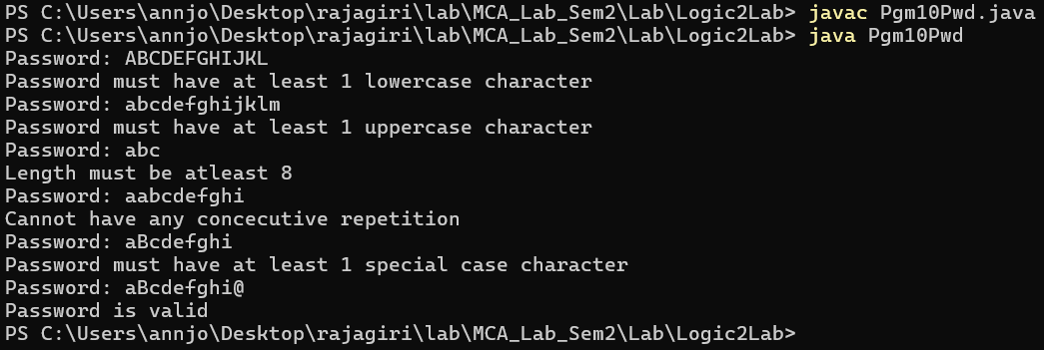

Program No: 25 | Date: 17/12/2025
Program Title: Implement threading by inheriting Thread class.
/* Thread
@Ann Jo Mathew
Roll No: 12
17/12/2025 */

class CThread extends Thread {
int n;
public CThread(int a) {
n=a;
}
public void run() {
int i;
for(i=1;i<=n;i++)
System.out.println("i="+i+"\t");
}
}
class TP1Inherit{
public static void main(String args[]) {
CThread t1,t2;
t1=new CThread(200);
t2=new CThread(250);
System.out.println("Be for Thread");
t1.start();
System.out.println("Between Thread");
t2.start();
System.out.println("Finished");
}
}
Output
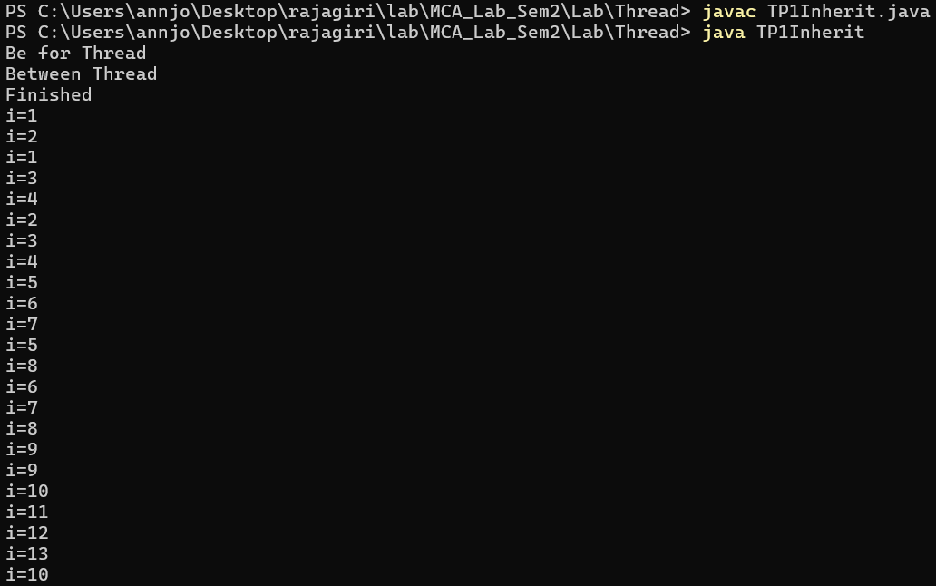

Program No: 26 | Date: 17/12/2025
Program Title: Write a Java program to create threads using the Runnable interface.
/* Thread by implementing Runnable interface
@Ann Jo Mathew
Roll No: 12
17/12/2025 */

class CIThread implements Runnable {
int n;
public CIThread(int a) {
n=a;
}
public void run() {
int i;
for(i=1;i<=n;i++) {
System.out.println("i="+i+"\t");
}
}
}
class TP2RunnableImp{
public static void main(String args[]) {
CIThread p,q;
p=new CIThread(200);
q=new CIThread(250);
Thread t1,t2;
t1=new Thread(p);
t2=new Thread(q);
System.out.println("Before Thread");
t1.start();
System.out.println("Between Thread");
t2.start();
System.out.println("Finished");
}
}
Output
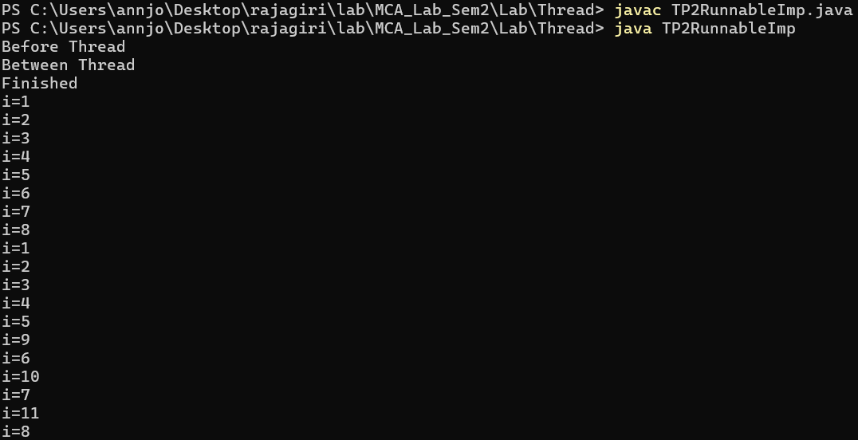

Program No: 27 | Date: 17/12/2025
Program Title: Write a Java program to create two threads, one to display odd numbers and another to display even numbers up to N.
/* Print Odd and Even Numbers using Thread
@Ann Jo Mathew
Roll No: 12
19/12/2025 */

import java.util.*;
class NumThread implements Runnable{
int n;
String type;

NumThread(int n,String type){
this.n=n;
this.type=type;
}

public void run(){
if(type.equals("Odd")){
for(int i=1;i<=n;i+=2)
System.out.println("Odd: "+i);
}
else if(type.equals("Even")){
for(int i=2;i<=n;i+=2)
System.out.println("Even: "+i);
}
}
}

class TP3OddEven{
public static void main(String args[]){
Scanner sc=new Scanner(System.in);
System.out.print("Enter N:");
int n=sc.nextInt();

NumThread o=new NumThread(n,"Odd");
NumThread e=new NumThread(n,"Even");

Thread t1=new Thread(o);
Thread t2=new Thread(e);
t1.start();
t2.start();
}
}

Output
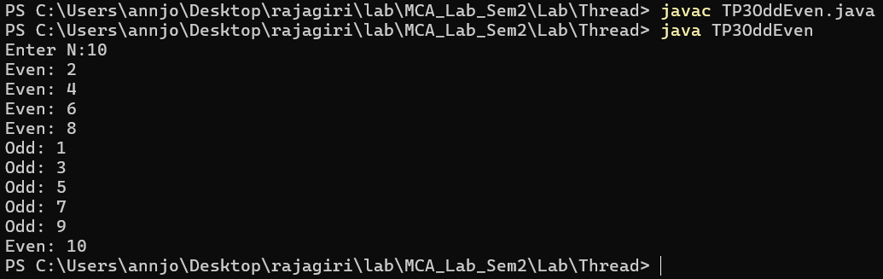

Program No: 28 | Date: 20/12/2025
Program Title: Search for a given element using n/5 threads.
/*Multi Thread
@Ann Jo Mathew
Roll No: 12
20/12/2025 */

import java.util.*;
class MultiThread extends Thread{
int a[],s,e,k;
public MultiThread(int a[],int s,int e,int key){
this.a=a;
this.s=s;
this.e=e;
k=key;
}
public void run(){
for(int i=s;i<=e;i++){ //starts at 0
if(a[i]==k)
System.out.println("Elemnt found at index "+i);
}
}
}
class TP4Nby5{
public static void main(String args[]){
int key,a[],n,s,e;
MultiThread t[];
Scanner sc=new Scanner(System.in);
System.out.print("Enter the size: ");
n=sc.nextInt();
a=new int[n];
t=new MultiThread[n/5]; //should be (n+4)/5
System.out.println("Enter the elements: ");
for(int i=0;i<n;i++){
a[i]=sc.nextInt();
}
System.out.print("Enter the element to search: ");
key=sc.nextInt();
for(int i=0;i<n/5;i++){
System.out.println("Thread "+i);
s=i*5;
e=s+4;
if(e>=n)
e=n-1;
t[i]=new MultiThread(a,s,e,key);
t[i].start();
}
}
}
Output
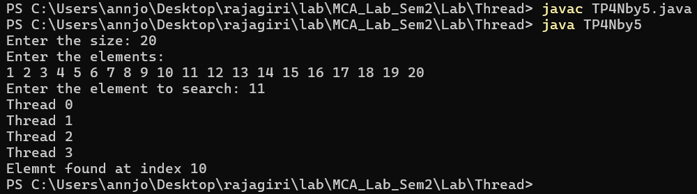

Program No: 29 | Date: 20/12/2025
Program Title: Develop a program to compute square and cube of a given number using two separate threads.
/*Square and cube computation using Thread
@Ann Jo Mathew
Roll No: 12
20/12/2025 */

import java.util.*;
class SquareThread extends Thread{
int n;
SquareThread(int n){
this.n=n;
}
public void run(){
System.out.println("Square: "+(n*n));
}
}
class CubeThread extends Thread{
int n;
CubeThread(int n){
this.n=n;
}
public void run(){
System.out.println("Cube: "+(n*n*n));
}
}
class TP5CubeSquare{
public static void main(String args[]){
Scanner sc=new Scanner(System.in);
System.out.print("Enter a number: ");
int n=sc.nextInt();
SquareThread t1=new SquareThread(n);
CubeThread t2=new CubeThread(n);
t1.start();
t2.start();
}
}
Output

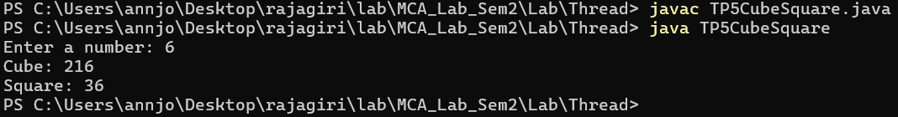

Program No: 30 | Date: 20/12/2025
Program Title: Implement Printer Queue Simulation without synchronization but using multiple threads.
/*Printer Simulation using multi Thread , without synchronization
@Ann Jo Mathew
Roll No: 12
21/12/2025 */

class CPrintPbm{
public void print(String s){
System.out.println("Printing...[");
System.out.println(s);
System.out.println("]");
}
}
class PrintThreadPbm extends Thread{
CPrintPbm p;
String str;
public PrintThreadPbm(CPrintPbm p,String s){
this.p=p;
str=s;
}public void run(){
p.print(str);
}
}
class TP6PrinterPbm{
public static void main(String args[]){
CPrintPbm p=new CPrintPbm();
PrintThreadPbm t1,t2,t3;
t1=new PrintThreadPbm(p,"Hello");
t2=new PrintThreadPbm(p,"World");
t3=new PrintThreadPbm(p,"Good");
t1.start();
t2.start();
t3.start();
}
}
Output
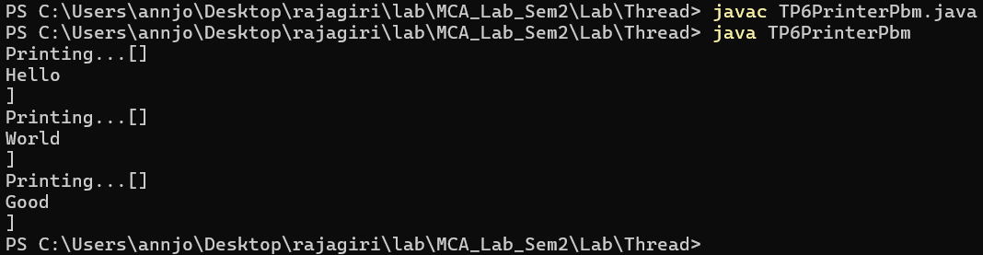

Program No: 31 | Date: 22/12/2025
Program Title: Implement Printer Queue simulation using multithreading and synchronization
/* Printer using Multithreading and synchronization
@Ann Jo Mathew
Roll No: 12
Date: 22/12/2025 */

class CPrint{
public synchronized void print(String s){
System.out.println("Printing...[");
System.out.println(s);
System.out.println("]");
}
}
class PrintThread extends Thread{
CPrint p;
String str;
public PrintThread(CPrint p,String s){
this.p=p;
str=s;
}
public void run(){
p.print(str);
}
}
class TP7PrinterSoln{
public static void main(String args[]){
CPrint p=new CPrint();
PrintThread t1,t2,t3;
t1=new PrintThread(p,"Hello");
t2=new PrintThread(p,"World");
t3=new PrintThread(p,"Good");
t1.start();
t2.start();
t3.start();
}
}

Output
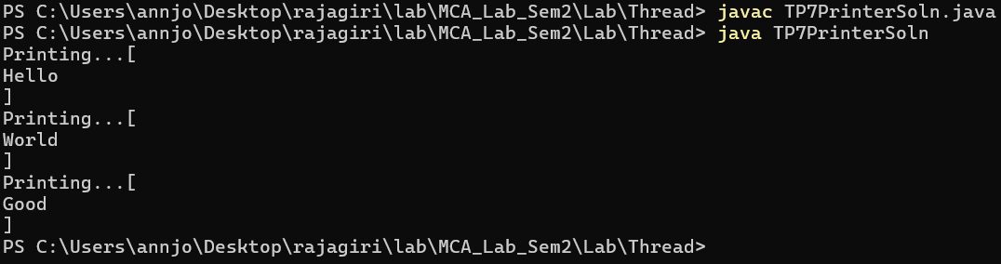

Program No: 32 | Date: 22/12/2025
Program Title: Write a Java program to demonstrate inter-thread communication using wait(), notify(), and notifyAll()by implementing
a. Producer consumer problem
b. Readers writer’s problem
/* inter-thread communication
@Ann Jo Mathew
Roll No: 12
23/12/2025 */

class SM{
int data;
boolean f=false;
int readCount=0;
public synchronized void put(int a){ //PRODUCER CONSUMER
try{
if(f==true)
wait();
data=a;
System.out.println("PUT:"+data);
f=true;
notify();
}
catch(InterruptedException e){
System.out.println(e);
}
}
public synchronized void get(){
try{
if(f==false)
wait();
System.out.println("GET:"+data);
f=false;
notify();
}
catch(InterruptedException e){
System.out.println(e);
}
}
public synchronized void startRead(){ //READERS WRITERS
try{
while(f==true)
wait();
readCount++;
System.out.println("Reader starts reading, count="+readCount);
}
catch(InterruptedException e){
System.out.println(e);
}
}
public synchronized void endRead(){
readCount--;
System.out.println("Reader stops reading, count="+readCount);
if(readCount==0)
notifyAll();
}
public synchronized void write(int a){
try{
while(readCount>0 || f==true)
wait();
f=true;
data=a;
System.out.println("Writer writes:"+data);
f=false;
notifyAll();
}
catch(InterruptedException e){
System.out.println(e);
}
}
}
class Producer extends Thread{ //PRODUCER
SM q;
public Producer(SM q){
this.q=q;
}
public void run(){
int i=1;
while(i<=5){
q.put(i);
i++;
}
}
}
class Consumer extends Thread{ //CONSUMER
SM q;
public Consumer(SM q){
this.q=q;
}
public void run(){
int i=1;
while(i<=5){
q.get();
i++;
}
}
}
class Reader extends Thread{ //READER
SM q;
public Reader(SM q){
this.q=q;
}
public void run(){
q.startRead();
System.out.println("Reading data");
q.endRead();
}
}
class Writer extends Thread{ //WRITER
SM q;
public Writer(SM q){
this.q=q;
}
public void run(){
q.write(100);
}
}
class TP8InterThread{
public static void main(String args[]){
SM q=new SM();
Producer p=new Producer(q); //Producer Consumer
Consumer c=new Consumer(q);
p.start();
c.start();
try{
Thread.sleep(1000);
}catch(Exception e){
}
Reader r1=new Reader(q); //Readers Writers
Reader r2=new Reader(q);
Writer w=new Writer(q);
r1.start();
r2.start();
w.start();
}
}

Output
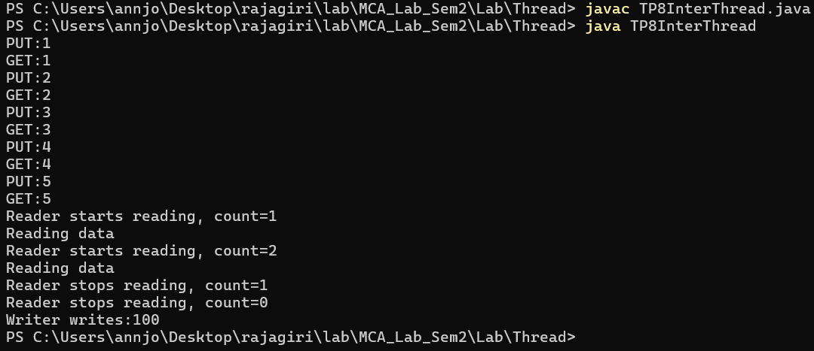

Program No: 33 | Date: 22/12/2025
Program Title: Write a Java program to simulate bank deposit and withdrawal using threads for a single account without synchronization.

/* Bank using thread without synchronization
@Ann Jo Mathew
Roll No: 12
23/12/2025 */

import java.util.*;
class Bank{
int bal=0;
void deposit(int amt){
bal=bal+amt;
System.out.println("Deposited:"+amt+" Balance:"+bal);
}
void withdraw(int amt){
bal=bal-amt;
System.out.println("Withdrawn:"+amt+" Balance:"+bal);
}
}
class DepositThread extends Thread{
Bank b;
int amt;
DepositThread(Bank b,int amt){
this.b=b;
this.amt=amt;
}
public void run(){
b.deposit(amt);
}
}
class WithdrawThread extends Thread{
Bank b;
int amt;
WithdrawThread(Bank b,int amt){
this.b=b;
this.amt=amt;
}
public void run(){
b.withdraw(amt);
}
}
class TP9Bank{
public static void main(String args[]){
Scanner sc=new Scanner(System.in);
Bank b=new Bank();
System.out.print("Enter deposit amount:");
int d=sc.nextInt();
System.out.print("Enter withdraw amount:");
int w=sc.nextInt();
DepositThread t1=new DepositThread(b,d);
WithdrawThread t2=new WithdrawThread(b,w);
t1.start();
t2.start();
}
}
Output
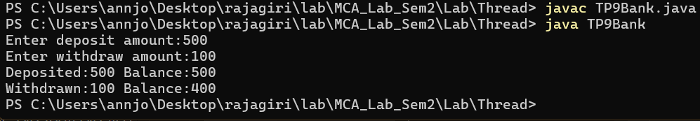

Program No: 34 | Date: 24/12/2025
Program Title: Implement thread priority.

/* Thread Priority
@Ann Jo Mathew
Roll No: 12
24/12/2025*/

class PThread extends Thread{
String name;
PThread(String n){
name=n;
}
public void run(){
for(int i=1;i<=5;i++){
System.out.println(name+" running");
}
}
}
class TP10Priority{
public static void main(String args[]){
PThread t1=new PThread("Low Priority Thread");
PThread t2=new PThread("Medium Priority Thread");
PThread t3=new PThread("High Priority Thread");
t1.setPriority(Thread.MIN_PRIORITY);
t2.setPriority(Thread.NORM_PRIORITY);
t3.setPriority(Thread.MAX_PRIORITY);
t1.start();
t2.start();
t3.start();
}
}
Output
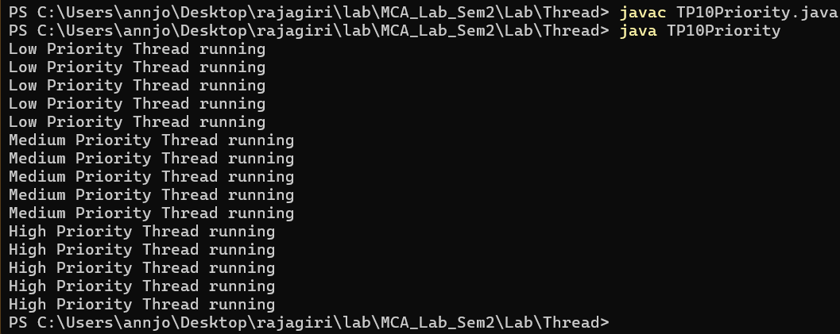

Program No: 35 | Date: 24/12/2025
Program Title: Develop a Java program to simulate ATM operations with multiple users accessing the same account [Develop a program to prevent race condition in banking transactions using synchronized methods.]

/* ATM using Synchronized methods
@Ann Jo Mathew
Roll No: 12
25/12/2025*/

class Account{
int balance=0;
public synchronized void deposit(int amt){
System.out.println(Thread.currentThread().getName()+" depositing "+amt);
balance=balance+amt;
System.out.println("Balance:"+balance);
}
public synchronized void withdraw(int amt){
System.out.println(Thread.currentThread().getName()+" withdrawing "+amt);
if(balance>=amt){
balance=balance-amt;
System.out.println("Balance:"+balance);
}
else{
System.out.println("Insufficient balance");
}
}
}
class ATMUser extends Thread{
Account a;
int amt;
String type;
ATMUser(Account a,int amt,String type,String name){
this.a=a;
this.amt=amt;
this.type=type;
setName(name);
}
public void run(){
if(type.equals("deposit"))
a.deposit(amt);
else
a.withdraw(amt);
}
}
class TP11ATM{
public static void main(String args[]){
Account a=new Account();
ATMUser u1=new ATMUser(a,1000,"deposit","User1");
ATMUser u2=new ATMUser(a,500,"withdraw","User2");
ATMUser u3=new ATMUser(a,700,"withdraw","User3");
u1.start();
u2.start();
u3.start();
}
}
Output
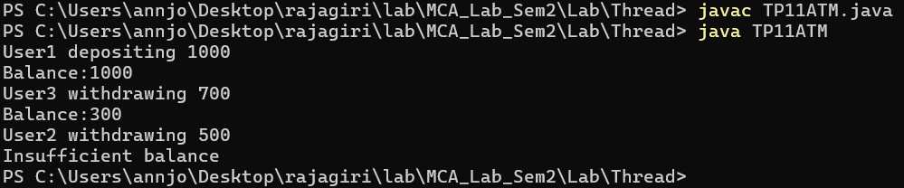

Program No: 36 | Date: 5/1/2026
Program Title: Write a program to implement a Generic method.

/* Generic method
@Ann Jo Mathew
Roll No: 12
5/1/2026 */

class GM
{
public static < E > void printArray( E[] e ) {
for(int i = 0; i < e.length;i++)
{
System.out.println(e[i]);
}
}
public static void main(String args[]) {
Integer[] intArray = { 1, 2, 3, 4, 5 }; //5 val stored as object
Double[] doubleArray = { 1.1, 2.2, 3.3, 4.4 };
Character[] charArray = { 'H', 'E', 'L', 'L', 'O' };
System.out.println("Array integerArray contains:");
printArray(intArray);
System.out.println("\nArray doubleArray contains:");
printArray(doubleArray);
System.out.println("\nArray characterArray contains:");
printArray(charArray);
}
}
Output
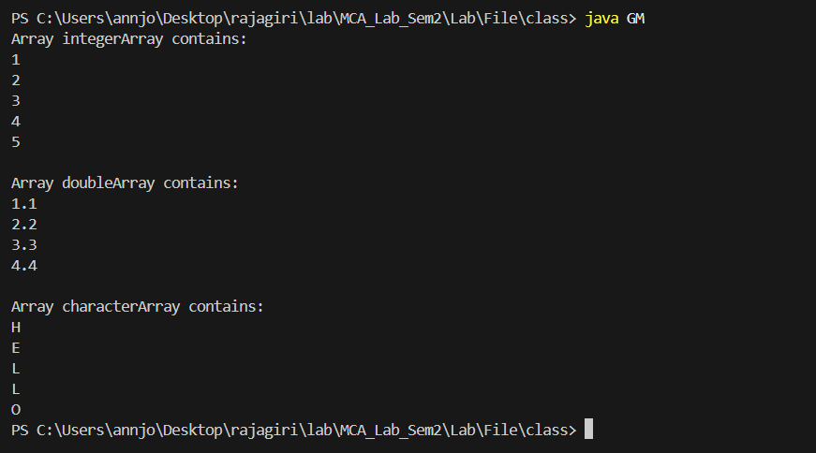

Program No: 37 | Date: 5/1/2026
Program Title: Write a program to implement a Generic class.
/* Generic class
@Ann Jo Mathew
Roll No: 12
5/1/2026 */

import java.util.*;
import java.io.*;
class GenStack <T>
{
ArrayList <T> stack = new ArrayList<T>(); //T given
int top = -1;
public void push(T d)
{
stack.add(d);
top++;
}
public void pop()
{
if(top == -1)
{
System.out.println("Empty..");
}
else
{
System.out.println(stack.remove(top--));
}
}
}
class MGenStack
{
public static void main(String args[])
{
GenStack <Integer> is = new GenStack<Integer>();
GenStack <String> ss = new GenStack<String>();
is.push(12);
is.push(30);
ss.push("Test");
ss.push("two");
ss.pop();
ss.pop();
is.pop();
is.pop();
}
}

Output
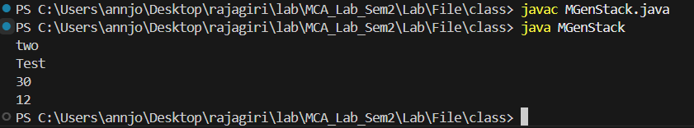

Program No: 38 | Date: 5/1/2026
Program Title: Write a program to create a menu driven program for performing the following operations.
a. Length of a given string
b. Compare for equality
c. Extract a substring from a string.
d. Convert to uppercase and lowercase
e. Reverse a string
/* Menu Driven program for String functions
@Ann Jo Mathew
Roll No: 12
Date: 5/1/2026*/

import java.util.*;
class Pgm38StringMenu{
public static void main(String args[]){
Scanner sc=new Scanner(System.in);
System.out.print("Enter a string: ");
String s=sc.nextLine();
int ch;
do{
System.out.println("\n--- String Menu ---");
System.out.println("1. Length of string");
System.out.println("2. Compare for equality");
System.out.println("3. Extract substring");
System.out.println("4. Convert to uppercase and lowercase");
System.out.println("5. Reverse a string");
System.out.println("6. Exit");
System.out.print("Enter choice: ");
ch=sc.nextInt();
sc.nextLine();
switch(ch){
case 1:
System.out.println("Length: "+s.length());
break;
case 2:
System.out.print("Enter string to compare: ");
String s2=sc.nextLine();
if(s.equals(s2))
System.out.println("Strings are equal");
else
System.out.println("Strings are not equal");
break;
case 3:
System.out.print("Enter start index: ");
int si=sc.nextInt();
System.out.print("Enter end index: ");
int ei=sc.nextInt();
System.out.println("Substring: "+s.substring(si,ei));
break;
case 4:
System.out.println("Uppercase: "+s.toUpperCase());
System.out.println("Lowercase: "+s.toLowerCase());
break;
case 5:
String rev="";
for(int i=s.length()-1;i>=0;i--)
rev+=s.charAt(i);
System.out.println("Reversed: "+rev);
break;
case 6:
System.out.println("Exiting...");
break;
default:
System.out.println("Invalid choice");
}
}while(ch!=6);
}
}
Output

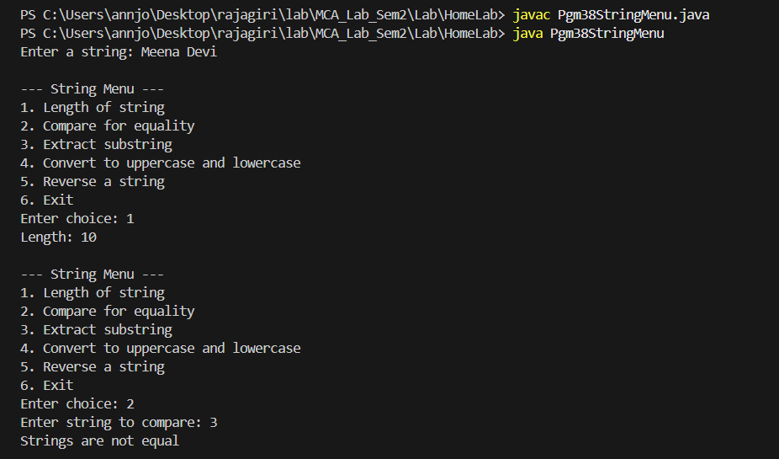

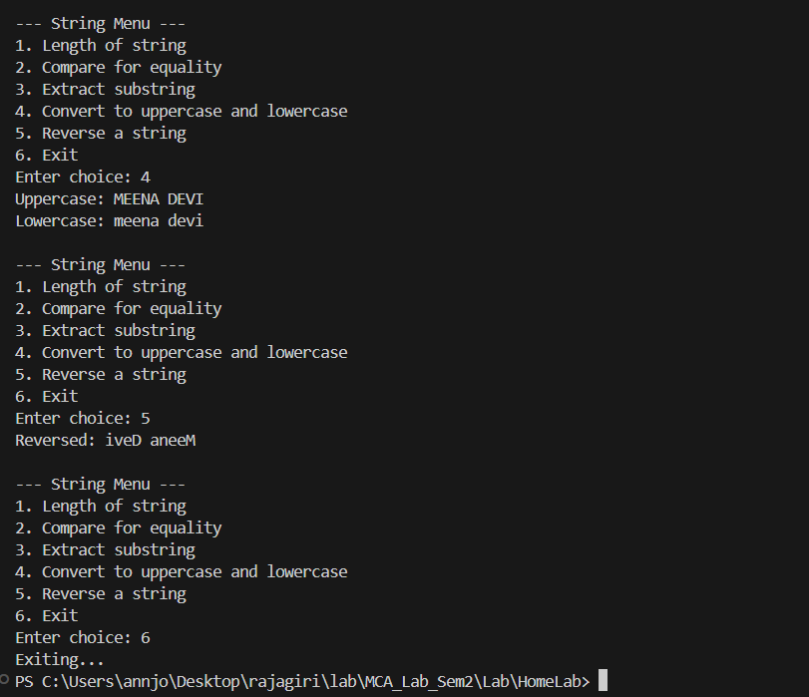

Program No: 39 | Date: 12/1/2026
Program Title: Program to implement StringBuffer class.
/* StringBuffer
@Ann Jo Mathew
Roll No: 12
12/1/2026*/

import java.util.*;
class Pgm39StringBuffer{
public static void main(String args[]){
StringBuffer sb=new StringBuffer("Hello World");
System.out.println("Original: "+sb);
sb.append(" Java");
System.out.println("After append: "+sb);
sb.insert(5," Beautiful");
System.out.println("After insert: "+sb);
sb.delete(5,15);
System.out.println("After delete: "+s
sb.reverse();
System.out.println("After reverse: "+sb);
sb.reverse();
System.out.println("After reverse back: "+sb);
sb.replace(0,5,"Hi");
System.out.println("After replace: "+sb);
System.out.println("Length: "+sb.length());
System.out.println("Capacity: "+sb.capacity());
System.out.println("Char at index 0: "+sb.charAt(0));
System.out.println("Substring(0,2): "+sb.substring(0,2));
}
}
Output
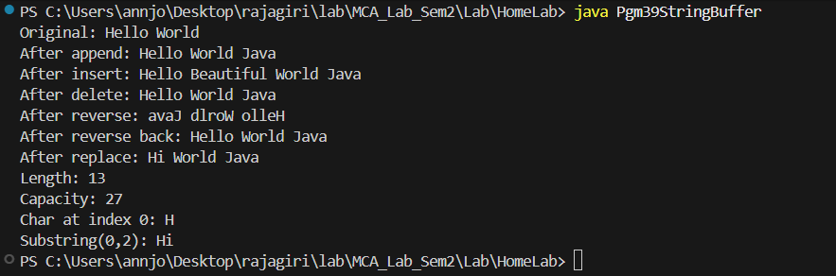

Program No: 40 | Date: 12/1/2026
Program Title: Program to implement server client communication.
/* Server client communication
@Ann Jo Mathew
Roll No: 12
13/1/2026*/

// server side
import java.io.*;
import java.net.*;
class Server{
public static void main(String args[]){
try{
ServerSocket ss=new ServerSocket(1234);
System.out.println("Server Listening....");
Socket cs=ss.accept(); //recieves the socket from the client through listening socket
System.out.println("Cleint socket recieved...");
DataInputStream sin=new DataInputStream(cs.getInputStream());
DataOutputStream sout=new DataOutputStream(cs.getOutputStream());
String str="Welcome";
sout.writeUTF(str);
str=sin.readUTF();
System.out.println("Client: "+str);
}
catch(Exception e){
System.out.println("Error: "+e);
}

}
}

// client side
import java.net.*;
import java.io.*;
class Client{
public static void main(String args[]){
try{
Socket ss=new Socket("localhost",1234);
DataInputStream sin= new DataInputStream(ss.getInputStream());
DataOutputStream sout=new DataOutputStream(ss.getOutputStream());
String str=sin.readUTF();
System.out.println("Server: "+str);
str="Hello";
sout.writeUTF(str);
}
catch(Exception e){
e.printStackTrace();
}
}
}
Output
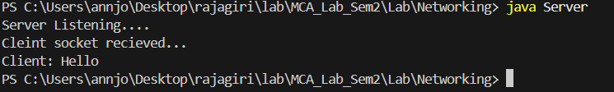

Program No: 41 | Date: 12/1/2026
Program Title: Program to implement one-one chatting.
/* one-one chatting.
@Ann Jo Mathew
Roll No: 12
16/1/2026*/

import java.net.*;
import java.io.*;
class MsgServer{
public static void main(String args[]){
try{
ServerSocket ss=new ServerSocket(1234);
System.out.println("Waiting for a client...");
Socket cs=ss.accept();
DataInputStream sin=new DataInputStream(cs.getInputStream());
DataOutputStream sout=new DataOutputStream(cs.getOutputStream());
DataInputStream kin=new DataInputStream(System.in);
String str;
while(true){
System.out.print("*Enter Message/type q to quit: ");
str=kin.readLine();
sout.writeUTF(str);
if(str.equals("q"))
break;
str=sin.readUTF();
System.out.println("Client: "+str);
if(str.equals("q"))
break;
}
}
catch(Exception e){
e.printStackTrace();
}
}
}

import java.net.*;
import java.io.*;
class MsgClient{
public static void main(String args[]){
try{
Socket cs=new Socket("localhost",1234);
DataInputStream sin=new DataInputStream(cs.getInputStream());
DataOutputStream sout=new DataOutputStream(cs.getOutputStream());
DataInputStream kin=new DataInputStream(System.in);
String str;
while(true){
str=sin.readUTF();
if(str.equals("q"))
break;
System.out.println("Server: "+str);
System.out.print("Enter message/ q to quit: ");
str=kin.readLine();
sout.writeUTF(str);
if(str.equals("q"))
break;
}
}
catch(Exception e){
e.printStackTrace();
}
}
}
Output
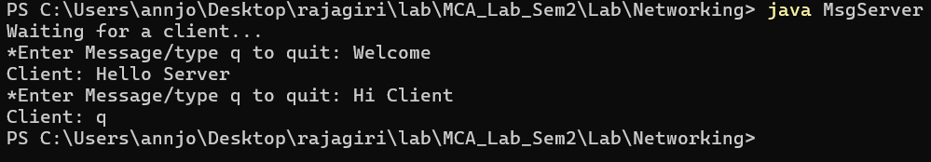

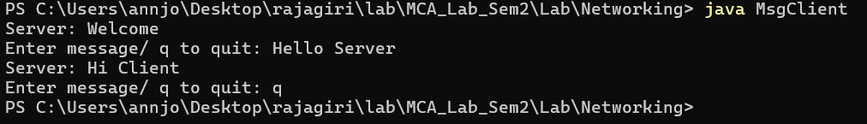

Program No: 42 | Date: 17/1/2026
Program Title: A file name is given in the client, download the content from the server
/* File download from server
@Ann Jo Mathew
Roll No: 12
17/1/2026*/

// clients file upload download server

import java.io.*; import java.net.*;
public class DownloadServer {
public static void main(String[] args) {
try (ServerSocket serverSocket = new ServerSocket(7000)) { System.out.println("Download Server listening on port 7000..."); while (true) {
try (Socket socket = serverSocket.accept()) { System.out.println("Client connected.");
DataInputStream in = new DataInputStream(socket.getInputStream()); String fileName = in.readUTF();
System.out.println("Client requested file: " + fileName);

File file = new File(fileName);
DataOutputStream out = new DataOutputStream(socket.getOutputStream());
if (file.exists() && !file.isDirectory()) { out.writeUTF("FOUND"); out.writeLong(file.length());
FileInputStream fis = new FileInputStream(file); byte[] buffer = new byte[4096];
int bytesRead;
while ((bytesRead = fis.read(buffer)) != -1) { out.write(buffer, 0, bytesRead);
}
fis.close();
System.out.println("File sent successfully.");
} else {
out.writeUTF("NOT_FOUND"); System.out.println("File not found.");
}
}
}
} catch (IOException e) { e.printStackTrace();
}
}
}
/*
A file name is given in the client, download the content from the server. Client side for requesting and saving file content.
@Viswas B Kurian roll no: 59 28 February 2026
*/
import java.io.*; import java.net.*;
import java.util.Scanner;
public class DownloadClient {
public static void main(String[] args) { Scanner scanner = new Scanner(System.in);
System.out.print("Enter file name to download from server: "); String fileName = scanner.nextLine();
try (Socket socket = new Socket("localhost", 7000)) {
DataOutputStream outRequest = new DataOutputStream(socket.getOutputStream()); outRequest.writeUTF(fileName);
DataInputStream in = new DataInputStream(socket.getInputStream()); String response = in.readUTF();

if (response.equals("FOUND")) { long fileSize = in.readLong();
FileOutputStream fos = new FileOutputStream("downloaded_" + fileName); byte[] buffer = new byte[4096];
int bytesRead; long totalRead = 0;
while (totalRead < fileSize && (bytesRead = in.read(buffer, 0, (int)Math.min(buffer.length, fileSize - totalRead))) != -1) {
fos.write(buffer, 0, bytesRead); totalRead += bytesRead;
}
fos.close();
System.out.println("File " + fileName + " downloaded as 'downloaded_" + fileName + "' (" + totalRead + " bytes)");
} else {
System.out.println("Server says: File not found.");
}
} catch (IOException e) { e.printStackTrace();
} finally { scanner.close();
}
}
}

Output
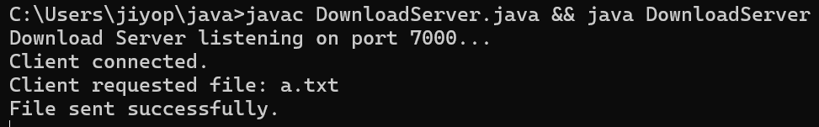

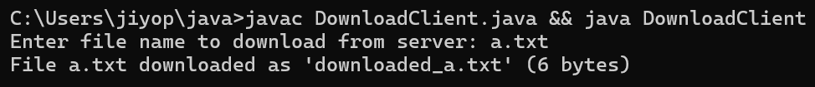

Program No: 43 | Date: 17/1/2026
Program Title: Upload the content from client to server.
/* Upload content to server
@Ann Jo Mathew
Roll No: 12
17/1/2026*/

import java.io.*;
import java.net.*;
class UploadServer{
public static void main(String args[]){
try{
ServerSocket ss=new ServerSocket(1234);
System.out.println("Server waiting for client...");
Socket cs=ss.accept();
System.out.println("Client connected");
DataInputStream sin=new DataInputStream(cs.getInputStream());
DataOutputStream sout=new DataOutputStream(cs.getOutputStream());
String fileName=sin.readUTF();
System.out.println("Receiving file: "+fileName);
FileOutputStream fout=new FileOutputStream("uploaded_"+fileName);
String content=sin.readUTF();
fout.write(content.getBytes());
fout.close();
System.out.println("File received and saved as: uploaded_"+fileName);
sout.writeUTF("File uploaded successfully");
cs.close();
ss.close();
}
catch(Exception e){
System.out.println("Error: "+e);
}
}
}

import java.io.*;
import java.net.*;
class UploadClient{
public static void main(String args[]){
try{
Socket cs=new Socket("localhost",1234);
DataInputStream sin=new DataInputStream(cs.getInputStream());
DataOutputStream sout=new DataOutputStream(cs.getOutputStream());
DataInputStream kin=new DataInputStream(System.in);
System.out.print("Enter file name to upload: ");
String fileName=kin.readLine();
sout.writeUTF(fileName);
FileInputStream fin=new FileInputStream(fileName);
byte[] data=new byte[fin.available()];
fin.read(data);
fin.close();
sout.writeUTF(new String(data));
String reply=sin.readUTF();
System.out.println("Server: "+reply);
cs.close();
}
catch(Exception e){
System.out.println("Error: "+e);
}
}
}
Output

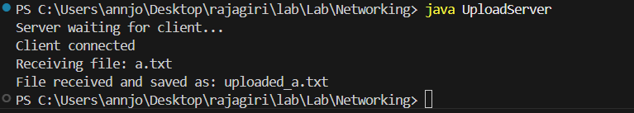

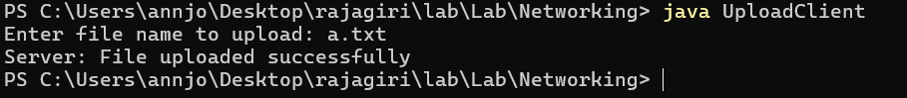

Program No: 44 | Date: 17/1/2026
Program Title: Program to implement public chatting.

/* public chatting
@Ann Jo Mathew
Roll No: 12
17/1/2026*/

import java.net.*;
import java.io.*;
class ChatRoom {
Socket cs[] = new Socket[50];
DataOutputStream sout[] = new DataOutputStream[50];//broadcast purpose
int count = 0;//count no. of clinets
public synchronized void add(Socket s) throws Exception {
cs[count] = s;
sout[count] = new DataOutputStream(s.getOutputStream());//creates an output stream for each clinet
count++;
System.out.println("Client connected. Total: " + count);
}
public synchronized void broadcast(String msg) throws Exception {
for (int i = 0; i < count; i++) {
sout[i].writeUTF(msg);//all msges in the server send to all clinets
}
}
}
class ClientThread extends Thread {
Socket s;
DataInputStream sin;
ChatRoom room;
ClientThread(Socket s, ChatRoom room) throws Exception {
this.s = s;
this.room = room;
sin = new DataInputStream(s.getInputStream());
}
public void run() {
try {
while (true) {
String msg = sin.readUTF(); //receive msg
if (msg.equals("q"))
break;
room.broadcast(msg);//send the msg frm a client to every other client
}
}
catch (Exception e) {}
}
}
class TCPPublicServer {
public static void main(String args[]) throws Exception {
ServerSocket ss = new ServerSocket(9000);
System.out.println("Public Chat Server Started on 9000...");
ChatRoom room = new ChatRoom(); // ONE shared object (like CPrint p)
while (true) {
Socket s = ss.accept();
room.add(s);
ClientThread t = new ClientThread(s, room);
t.start();
}
}
}

import java.net.*;
import java.io.*;
class ReadThread extends Thread { //class responsible for displaying all the chats thats been broadcasted
DataInputStream sin;
ReadThread(DataInputStream sin) {
this.sin = sin;
}
public void run() {
try {
while (true) {
System.out.println(sin.readUTF());
}
}
catch (Exception e) {}
}
}
class TCPPublicClient {
public static void main(String args[]) throws Exception {
Socket ss = new Socket("localhost", 9000);
DataInputStream sin = new DataInputStream(ss.getInputStream());
DataOutputStream sout = new DataOutputStream(ss.getOutputStream());
DataInputStream kin = new DataInputStream(System.in);
new ReadThread(sin).start();
System.out.println("Type message. Type q to quit.");
while (true) {
String msg = kin.readLine();
sout.writeUTF(msg);
if (msg.equals("q"))
break;
}
ss.close();
}
}
Output
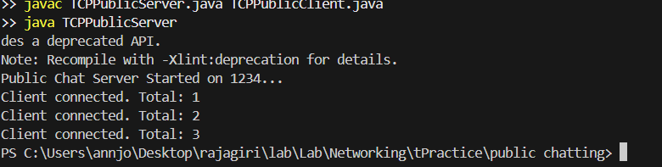

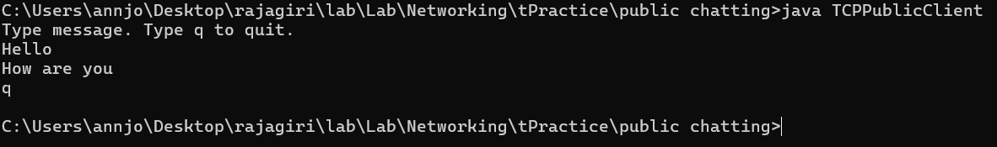

Program No: 45 | Date: 19/1/2026
Program Title: Program to implement connection less communication.

/* Connectionless communication
@Ann Jo Mathew
Roll No: 12
19/1/2026*/

import java.net.*;
import java.io.*;
class UDPS{
public static void main(String args[]){
DatagramSocket ds=null;
DatagramPacket dp=null,reply; //reply is a datagram packet
try{
ds=new DatagramSocket(1234);
byte[] buffer=new byte[1000];
dp=new DatagramPacket(buffer,buffer.length);
ds.receive(dp);
System.out.println("From client: "+(new String(dp.getData())).trim());
System.out.println("Client port:"+dp.getPort());
reply=new DatagramPacket("From Server:".getBytes(),"From Server".length(),dp.getAddress(),dp.getPort());
ds.send(reply);
}
catch(Exception e){
System.out.println("Error:"+e);
}
}
}

import java.net.*;
import java.io.*;
class UDPC{
public static void main(String args[]){
DatagramSocket ds=null;
InetAddress shost=null;
DatagramPacket dp=null,reply=null;
try{
ds=new DatagramSocket();
byte[] m="Bye".getBytes();
shost=InetAddress.getByName("localhost");
//shost=InetAddress.getByName("192.168.17.46");
//shost=InetAddress.getLocalHost();
dp=new DatagramPacket(m,3,shost,1234); //3-length of bye
ds.send(dp);
byte[] buffer=new byte[1000];
reply=new DatagramPacket(buffer,buffer.length);
ds.receive(reply);
System.out.println("Reply: "+(new String(reply.getData())).trim());
}
catch(Exception e){
System.out.println("Error: "+e);
}
}
}
Output

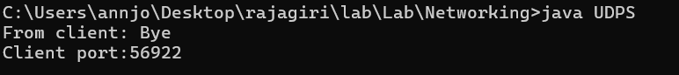

Program No: 46 | Date: 19/1/2026
Program Title: Program to get protocol, file name, host, path and port of a given URL
/* URL program
@Ann Jo Mathew
Roll No: 12
19/1/2026*/

import java.net.*;
class Pgm46URL{
public static void main(String args[]){
try{
URL url=new URL("https://www.example.com:8080/docs/index.html?name=java#section1");
System.out.println("Protocol: "+url.getProtocol());
System.out.println("Host: "+url.getHost());
System.out.println("Port: "+url.getPort());
System.out.println("Path: "+url.getPath());
System.out.println("File: "+url.getFile());
System.out.println("Query: "+url.getQuery());
System.out.println("Ref: "+url.getRef());
System.out.println("Authority: "+url.getAuthority());
System.out.println("Default Port: "+url.getDefaultPort());
}
catch(Exception e){
System.out.println("Error: "+e);
}
}
}
Output
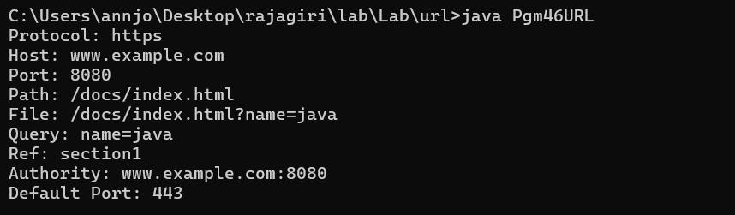

Program No: 47 | Date: 19/1/2026
Program Title: Program to download a file from given URL.

/* Download file from URL
@Ann Jo Mathew
Roll No: 12
Date: 19/1/2026*/

import java.net.*;
import java.io.*;
import java.util.Date;
class CDownload extends Thread{
public void run(){
try{
URL u=new URL("https://beej.us/guide/bgnet/pdf/bgnet_a4_c_1.pdf");
URLConnection uc=u.openConnection();
int len=uc.getContentLength();
FileOutputStream fout=new FileOutputStream("a.pdf");
if(len>0){
InputStream input=uc.getInputStream();
int c,i=0;
while(((c=input.read())!=-1)&&(i<len)){
fout.write((char)c);
i++;
}
input.close();
}
else{
System.out.println("Not available");
}
}

catch(Exception e){
e.printStackTrace();
}

}

}
class CUD{
public static void main(String args[]){
CDownload cd=new CDownload();
cd.start();
}
}

Output
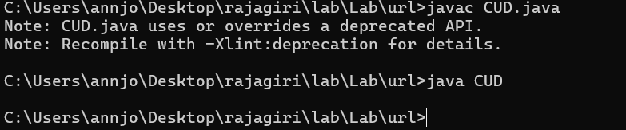

Program No: 48 | Date: 31/1/2026
Program Title: Program to display the content of a webpage
/* Display content webpage
@Ann Jo Mathew
Roll No: 12
31/1/2026*/

import java.net.*;
import java.io.*;
class CUWeb{
public static void main(String args[]) throws Exception{
URL url=new URL("https://www.google.com");
BufferedReader reader=new BufferedReader(new InputStreamReader(url.openStream()));
BufferedWriter writer=new BufferedWriter(new FileWriter("index.html"));
String line;
while((line=reader.readLine())!=null){
System.out.println(line);
writer.write(line);
writer.newLine();
}
reader.close();
writer.close();
}
}
Output

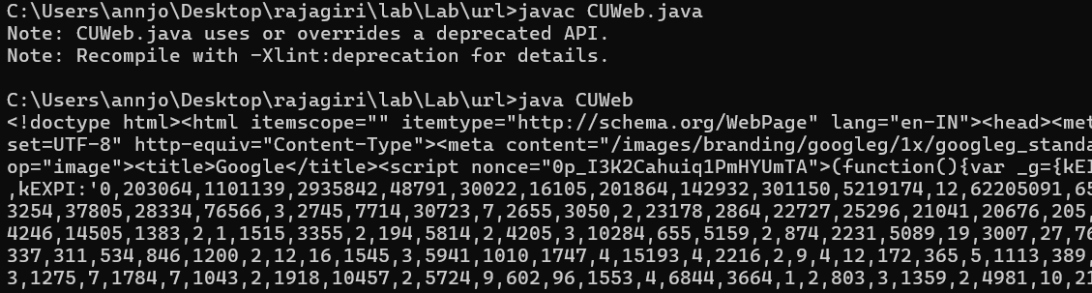

Program No: 49 | Date: 31/1/2026
Program Title: Program to insert values into a table.
/* Insert values into tables
@Ann Jo Mathew
Roll No: 12
31/1/2026*/

import java.sql.*;
import java.util.*;
public class Connect{
public static void main(String args[]){
try{
String no,na,sal,sql;
Scanner s=new Scanner(System.in);
Class.forName("oracle.jdbc.OracleDriver");
Connection con=DriverManager.getConnection("jdbc:oracle:thin:1521:oracl","mca","mca");
System.out.println("Connected.."+con);
Statement st=con.createStatement();
System.out.println("Enter the no,name and salary");
no=s.nextLine();
na=s.nextLine();
sal=s.nextLine();
sql="insert into empp values("+no+",'"+na+"',"+sal+")";
st.executeUpdate(sql);
ResultSet rs = st.executeQuery("select * from empp");
while(rs.next())
{
System.out.println(rs.getString(1) + " " + rs.getString(2)+" "+rs.getString(3));
}
} catch (ClassNotFoundException e) {
// TODO Auto-generated catch block
e.printStackTrace();
} catch (SQLException e) {
// TODO Auto-generated catch block
e.printStackTrace();
}
}
}
Output
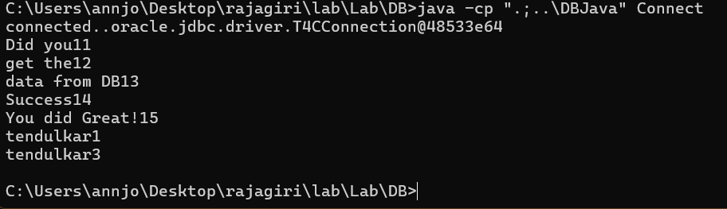
Program No: 50 |  | Date: 31/1/2026
Program Title: Assume that login is a table which has Uname, Upass and some records. Check whether the record is present or not.
/* Login validation
@Ann Jo Mathew
Roll No: 12
31/1/2026*/

import java.sql.*;
import java.util.*;
public class Pgm50Login{
public static void main(String args[]){
try{
Scanner s=new Scanner(System.in);
Class.forName("oracle.jdbc.OracleDriver");
Connection con=DriverManager.getConnection("jdbc:oracle:thin:@//localhost:1521/XE","ann","1234");
System.out.println("Connected.."+con);
System.out.print("Enter Username: ");
String uname=s.nextLine();
System.out.print("Enter Password: ");
String upass=s.nextLine();
PreparedStatement pst=con.prepareStatement("select * from login where Uname=? and Upass=?");
pst.setString(1,uname);
pst.setString(2,upass);
ResultSet rs=pst.executeQuery();
if(rs.next()){
System.out.println("Login Successful!");
System.out.println("Welcome, "+rs.getString("Uname"));
}
else{
System.out.println("Invalid Username or Password");
}
con.close();
}
catch(ClassNotFoundException e){
e.printStackTrace();
}
catch(SQLException e){
e.printStackTrace();
}
}
}

Output
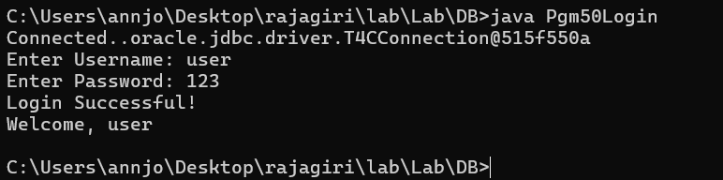

Program No: 51 |  | Date: 2/2/2026
Program Title: Department is table having dno, dname, dloc. Emp is table having eno, ename, esal and dno. Write a program for displaying the information in the following order:
eno ename esal dname dloc
1 abc 10,000 MCA MB
2 bcd 20,000 MSW OB
/* Display information from a table
@Ann Jo Mathew
Roll No: 12
2/2/2026*/

import java.sql.*;
public class Pgm51DeptEmp{
public static void main(String args[]){
try{
Class.forName("oracle.jdbc.OracleDriver");
Connection con=DriverManager.getConnection("jdbc:oracle:thin:@//localhost:1521/XE","ann","1234");
System.out.println("Connected.."+con);
Statement st=con.createStatement();
String sql="select e.eno,e.ename,e.esal,d.dname,d.dloc from Emp e,Department d where e.dno=d.dno";
ResultSet rs=st.executeQuery(sql);
System.out.println("eno\tename\tesal\tdname\tdloc");
System.out.println("----\t-----\t----\t-----\t----");
while(rs.next()){
System.out.println(rs.getInt(1)+"\t"+rs.getString(2)+"\t"+rs.getFloat(3)+"\t"+rs.getString(4)+"\t"+rs.getString(5));
}
con.close();
}
catch(ClassNotFoundException e){
e.printStackTrace();
}
catch(SQLException e){
e.printStackTrace();
}
}
}
Output
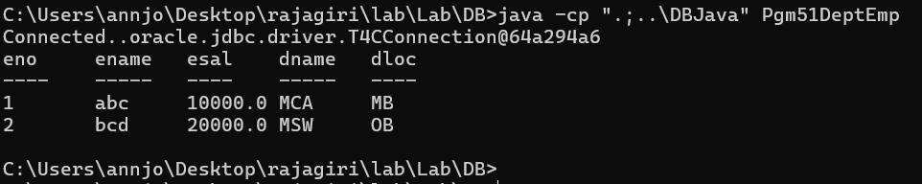
Program No: 52 | Date: 2/2/2026
Program Title: Write a database program including
a. callable statement
b. prepared statement
/* Callable statement and prepared statement
@Ann Jo Mathew
Roll No: 12
2/2/2026*/

//prepared statements
import java.sql.*;
import java.util.*;
public class ConnectP{
public static void main(String args[]){
try{
String no,na,sal,sql;
Scanner s=new Scanner(System.in);
Class.forName("oracle.jdbc.OracleDriver");
Connection con=DriverManager.getConnection("jdbc:oracle:thin:1521:oracl","mca","mca");
System.out.println("Connected.."+con);
Statement st=con.createStatement();
PreparedStatement pst=con.prepareStatement("insert into empp values(?,?,?)");
System.out.println("Enter the no,name and salary");
no=s.nextLine();
na=s.nextLine();
sal=s.nextLine();
pst.setInt(1,Integer.parseInt(no));
pst.setString(2,na);
pst.setFloat(3,Float.parseFloat(sal));
pst.executeUpdate();
ResultSet rs = st.executeQuery("select * from empp");
while(rs.next())
{
System.out.println(rs.getString(1) + " " + rs.getString(2)+" "+rs.getString(3));
}
} catch (ClassNotFoundException e) {
// TODO Auto-generated catch block
e.printStackTrace();
} catch (SQLException e) {
// TODO Auto-generated catch block
e.printStackTrace();
}

}

}

//proccedure callable statements
import java.sql.*;
import java.util.*;
public class ConnectC{
public static void main(String args[]){
try{
String no,na,sal,sql;
Scanner s=new Scanner(System.in);
Class.forName("oracle.jdbc.OracleDriver");
Connection con=DriverManager.getConnection("jdbc:oracle:thin:1521:oracl","mca","mca");
System.out.println("Connected.."+con);
Statement st=con.createStatement();
CallableStatement pst=con.prepareCall("{call empinsert(?,?,?)}");
System.out.println("Enter the no,name and salary");
no=s.nextLine();
na=s.nextLine();
sal=s.nextLine();
pst.setInt(1,Integer.parseInt(no));
pst.setString(2,na);
pst.setFloat(3,Float.parseFloat(sal));
pst.execute();
ResultSet rs = st.executeQuery("select * from empp");
while(rs.next())
{
System.out.println(rs.getString(1) + " " + rs.getString(2)+" "+rs.getString(3));
}
} catch (ClassNotFoundException e) {
// TODO Auto-generated catch block
e.printStackTrace();
} catch (SQLException e) {
// TODO Auto-generated catch block
e.printStackTrace();
}

}

}
Output
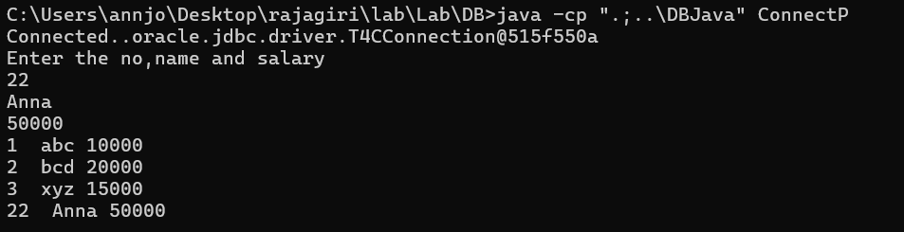

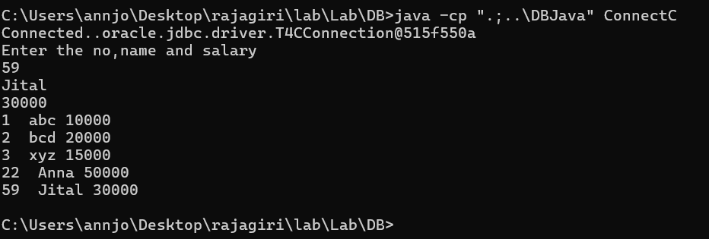

Program No: 53 | Date: 2/2/2026
Program Title: Program to implement
a. Transaction.
b. Batch processing
/* Transaction and batch processing
@Ann Jo Mathew
Roll No: 12
2/2/2026*/

import java.sql.*;
import java.util.*;
public class Pgm53TransBatch{
public static void main(String args[]){
try{
Class.forName("oracle.jdbc.OracleDriver");
Connection con=DriverManager.getConnection("jdbc:oracle:thin:@//localhost:1521/XE","ann","1234");
System.out.println("Connected.."+con);
// Transaction
System.out.println("\n--- Transaction Demo ---");
con.setAutoCommit(false);
Statement st=con.createStatement();
try{
st.executeUpdate("insert into empp values(101,'Ajay',25000)");
st.executeUpdate("insert into empp values(102,'Bindu',30000)");
con.commit();
System.out.println("Transaction committed successfully");
}
catch(SQLException e){
con.rollback();
System.out.println("Transaction rolled back due to error: "+e);
}
// Batch Processing
System.out.println("\n--- Batch Processing Demo ---");
Statement bst=con.createStatement();
bst.addBatch("insert into empp values(103,'Cathy',28000)");
bst.addBatch("insert into empp values(104,'David',35000)");
bst.addBatch("insert into empp values(105,'Elsa',32000)");
int result[]=bst.executeBatch();
con.commit();
System.out.println("Batch executed. Rows affected: "+result.length);
// Display all records
ResultSet rs=st.executeQuery("select * from empp");
System.out.println("\nAll Records:");
while(rs.next()){
System.out.println(rs.getString(1)+" "+rs.getString(2)+" "+rs.getString(3));
}
con.close();
}
catch(ClassNotFoundException e){
e.printStackTrace();
}
catch(SQLException e){
e.printStackTrace();
}
}
}
Output
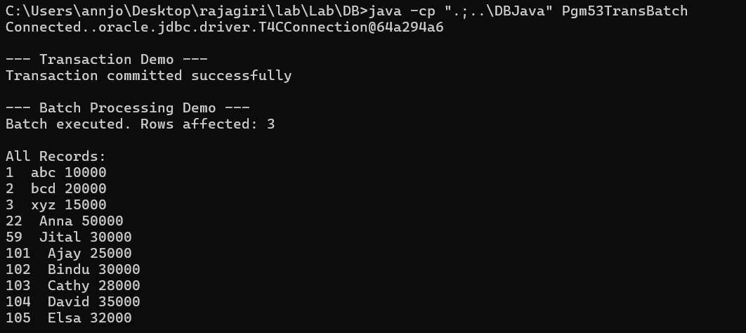

Program No: 54 | Date: 7/2/2026
Program Title: Program to implement Serialization and De-Serialization.

/* Serialization and deserialization
@Ann Jo Mathew
Roll No: 12
7/2/2026*/

import java.io.Serializable;
public class Student implements Serializable{
private int id;
private String name;
public Student(int id, String name) {
this.id = id;
this.name = name;
}
public void disp(){
System.out.println("id: "+id+" name: "+name);
}
}

import java.io.*;
class Serialization{
public static void main(String args[])throws Exception{
Student s1=new Student(01,"Amala");
FileOutputStream fout=new FileOutputStream("f1.txt");
ObjectOutputStream out=new ObjectOutputStream(fout);
out.writeObject(s1);
out.flush();
}

}

import java.io.*;
class Deserialization{
public static void main(String args[])throws Exception{
FileInputStream fin=new FileInputStream("f1.txt");
ObjectInputStream in=new ObjectInputStream(fin);
Student s=(Student)in.readObject();
s.disp();
}
}
Output
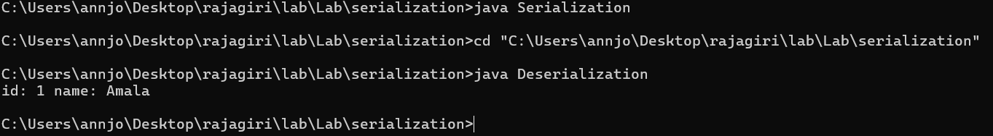

Program No: 55 | Date: 7/2/2026
Program Title: Program to implement IS A Serialization and De-Serialization.
/* IS A Serialization and De-Serialization
@Ann Jo Mathew
Roll No: 12
7/2/2026*/

import java.io.*;

class Person55 implements Serializable{
String name;
int age;
Person55(String name,int age){
this.name=name;
this.age=age;
}
}

class Student55 extends Person55{
int rollNo;
String course;
Student55(String name,int age,int rollNo,String course){
super(name,age);
this.rollNo=rollNo;
this.course=course;
}
}

class Pgm55ISASerialization{
public static void main(String args[])throws Exception{
// Serialization
Student55 s=new Student55("Ann",22,12,"MCA");
FileOutputStream fout=new FileOutputStream("isa.txt");
ObjectOutputStream out=new ObjectOutputStream(fout);
out.writeObject(s);
out.flush();
out.close();
System.out.println("Object serialized successfully");

// De-Serialization
FileInputStream fin=new FileInputStream("isa.txt");
ObjectInputStream in=new ObjectInputStream(fin);
Student55 s2=(Student55)in.readObject();
in.close();
System.out.println("Object de-serialized successfully");
System.out.println("Name: "+s2.name);
System.out.println("Age: "+s2.age);
System.out.println("Roll No: "+s2.rollNo);
System.out.println("Course: "+s2.course);
}
}
Output
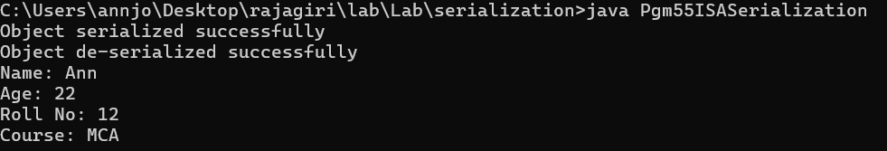

Program No: 56 | Date: 7/2/2026
Program Title: Program to implement HAS A Serialization and De-Serialization.

/* HAS A Serialization and De-Serialization
@Ann Jo Mathew
Roll No: 12
Date: 7/2/2026*/

import java.io.*;

class Address56 implements Serializable{
String city;
String state;
Address56(String city,String state){
this.city=city;
this.state=state;
}
}

class Employee56 implements Serializable{
int eno;
String ename;
Address56 addr; // HAS A relationship
Employee56(int eno,String ename,Address56 addr){
this.eno=eno;
this.ename=ename;
this.addr=addr;
}
}

class Pgm56HASASerialization{
public static void main(String args[])throws Exception{
// Serialization
Address56 a=new Address56("Kochi","Kerala");
Employee56 e=new Employee56(1,"Ann",a);
FileOutputStream fout=new FileOutputStream("hasa.txt");
ObjectOutputStream out=new ObjectOutputStream(fout);
out.writeObject(e);
out.flush();
out.close();
System.out.println("Object serialized successfully");

// De-Serialization
FileInputStream fin=new FileInputStream("hasa.txt");
ObjectInputStream in=new ObjectInputStream(fin);
Employee56 e2=(Employee56)in.readObject();
in.close();
System.out.println("Object de-serialized successfully");
System.out.println("Eno: "+e2.eno);
System.out.println("Ename: "+e2.ename);
System.out.println("City: "+e2.addr.city);
System.out.println("State: "+e2.addr.state);
}
}
Output
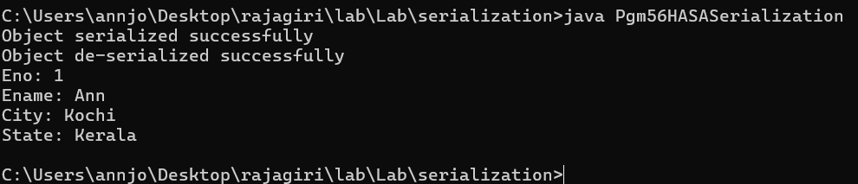

Program No: 57 | Date: 9/2/2026
Program Title: Program to De-Serialize selected attributes of an object using Transient keyword.
/* Transient keyword.
@Ann Jo Mathew
Roll No: 12
9/2/2026*/

import java.io.*;

class Employee57 implements Serializable{
int eno;
String ename;
transient double esal; // will not be serialized
transient String password; // will not be serialized
Employee57(int eno,String ename,double esal,String password){
this.eno=eno;
this.ename=ename;
this.esal=esal;
this.password=password;
}
}

class Pgm57Transient{
public static void main(String args[])throws Exception{
// Serialization
Employee57 e=new Employee57(1,"Ann",50000,"secret123");
System.out.println("Before Serialization:");
System.out.println("Eno: "+e.eno);
System.out.println("Ename: "+e.ename);
System.out.println("Esal: "+e.esal);
System.out.println("Password: "+e.password);

FileOutputStream fout=new FileOutputStream("transient.txt");
ObjectOutputStream out=new ObjectOutputStream(fout);
out.writeObject(e);
out.flush();
out.close();
System.out.println("\nObject serialized successfully");

// De-Serialization
FileInputStream fin=new FileInputStream("transient.txt");
ObjectInputStream in=new ObjectInputStream(fin);
Employee57 e2=(Employee57)in.readObject();
in.close();
System.out.println("Object de-serialized successfully");
System.out.println("\nAfter De-Serialization:");
System.out.println("Eno: "+e2.eno);
System.out.println("Ename: "+e2.ename);
System.out.println("Esal: "+e2.esal+" (transient - default value)");
System.out.println("Password: "+e2.password+" (transient - default value)");
}
}
Output
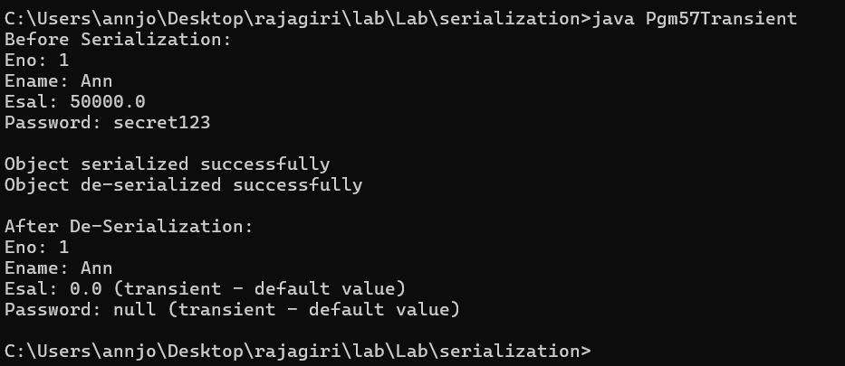

Program No: 58 | Date: 9/2/2026
Program Title: Find the maximum of three numbers using AWT
/* Max of three numbers using AWT
@Ann Jo Mathew
Roll No: 12
9/2/2026*/

import java.awt.*;
import java.awt.event.*;
class Pgm58MaxAWT extends Frame implements ActionListener{
TextField t1,t2,t3;
Label l1,l2,l3,lresult;
Button bmax;

public Pgm58MaxAWT(){
super("Max of Three Numbers");
l1=new Label("Number 1:");
l2=new Label("Number 2:");
l3=new Label("Number 3:");
lresult=new Label("Result: ");
t1=new TextField(10);
t2=new TextField(10);
t3=new TextField(10);
bmax=new Button("Find Max");

setLayout(new FlowLayout());
add(l1); add(t1);
add(l2); add(t2);
add(l3); add(t3);
add(bmax);
add(lresult);

bmax.addActionListener(this);
setSize(300,200);
setVisible(true);

addWindowListener(new WindowAdapter(){
public void windowClosing(WindowEvent we){
System.exit(0);
}
});
}

public void actionPerformed(ActionEvent ae){
int a=Integer.parseInt(t1.getText());
int b=Integer.parseInt(t2.getText());
int c=Integer.parseInt(t3.getText());
int max=a;
if(b>max) max=b;
if(c>max) max=c;
lresult.setText("Result: Maximum is "+max);
}

public static void main(String args[]){
new Pgm58MaxAWT();
}
}
Output
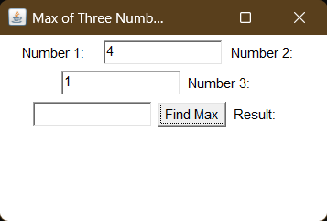

Program No: 59 | Date: 9/2/2026
Program Title: Implement all the functionality of LIST control.
/* LIST control
@Ann Jo Mathew
Roll No: 12
9/2/2026*/

import java.awt.*;
import java.awt.event.*;
class CList extends Frame implements ActionListener{
List l1,l2;
TextField t1;
Button badd, bright,bleft;
public CList(){
super("List Content Transfer");
l1=new List(5);
l2=new List(5);
t1=new TextField(20);
badd=new Button("Add");
bright=new Button(">>");
bleft=new Button("<<");
setLayout(new FlowLayout());
add(l1);
add(bright);
add(bleft);
add(l2);
add(t1);
add(badd);
badd.addActionListener(this);
bright.addActionListener(this);
bleft.addActionListener(this);
setSize(700,700);
setVisible(true);
}
public void actionPerformed(ActionEvent ae){
if(ae.getSource()==badd){
String s=t1.getText();
l1.add(s);
t1.setText("");
}
else if(ae.getSource()==bright){
int p=l1.getSelectedIndex();
if(p>=0){
String s=l1.getSelectedItem();
l2.add(s);
l1.remove(p);
}
}
else if(ae.getSource()==bleft){
int p=l2.getSelectedIndex();
if(p>=0){
String s=l2.getSelectedItem();
l1.add(s);
l2.remove(p);
}
}
}
public static void main(String args[]){
new CList();
}
}
Output
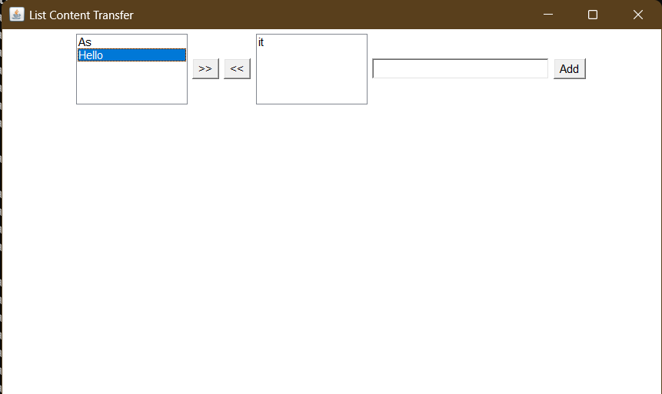

Program No: 60 | Date: 16/2/2026
Program Title: Implement Check box and radio button in AWT
/* Check box and radio button
@Ann Jo Mathew
Roll No: 12
16/2/2026*/

import java.awt.*;
import java.awt.event.*;
class Pgm60CheckRadio extends Frame implements ItemListener{
Checkbox c1,c2,c3;
Checkbox r1,r2,r3;
CheckboxGroup cbg;
Label lcb,lrb,lresult;

public Pgm60CheckRadio(){
super("Checkbox and Radio Button");
lcb=new Label("Select Hobbies (Checkbox):");
c1=new Checkbox("Reading");
c2=new Checkbox("Gaming");
c3=new Checkbox("Sports");

lrb=new Label("Select Gender (Radio):");
cbg=new CheckboxGroup();
r1=new Checkbox("Male",cbg,false);
r2=new Checkbox("Female",cbg,false);
r3=new Checkbox("Other",cbg,false);

lresult=new Label("Selection: ");

setLayout(new FlowLayout());
add(lcb); add(c1); add(c2); add(c3);
add(lrb); add(r1); add(r2); add(r3);
add(lresult);

c1.addItemListener(this);
c2.addItemListener(this);
c3.addItemListener(this);
r1.addItemListener(this);
r2.addItemListener(this);
r3.addItemListener(this);

setSize(400,200);
setVisible(true);

addWindowListener(new WindowAdapter(){
public void windowClosing(WindowEvent we){
System.exit(0);
}
});
}

public void itemStateChanged(ItemEvent ie){
String hobbies="";
if(c1.getState()) hobbies+="Reading ";
if(c2.getState()) hobbies+="Gaming ";
if(c3.getState()) hobbies+="Sports ";
String gender="";
Checkbox sel=cbg.getSelectedCheckbox();
if(sel!=null) gender=sel.getLabel();
lresult.setText("Hobbies: "+hobbies+" | Gender: "+gender);
}

public static void main(String args[]){
new Pgm60CheckRadio();
}
}
Output
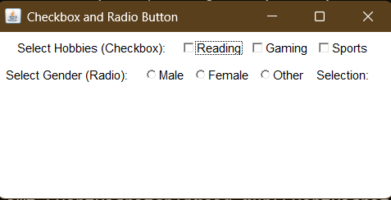

Program No: 61 | Date: 16/2/2026
Program Title: Demo of menus using AWT
/* Menus using AWT
@Ann Jo Mathew
Roll No: 12
16/2/2026*/

import java.awt.*;
import java.awt.event.*;
class Pgm61Menu extends Frame implements ActionListener{
MenuBar mb;
Menu file,edit,help;
MenuItem mnew,mopen,msave,mexit;
MenuItem mcut,mcopy,mpaste;
MenuItem mabout;
Label lresult;

public Pgm61Menu(){
super("Menu Demo");
mb=new MenuBar();

file=new Menu("File");
mnew=new MenuItem("New");
mopen=new MenuItem("Open");
msave=new MenuItem("Save");
mexit=new MenuItem("Exit");
file.add(mnew);
file.add(mopen);
file.add(msave);
file.addSeparator();
file.add(mexit);

edit=new Menu("Edit");
mcut=new MenuItem("Cut");
mcopy=new MenuItem("Copy");
mpaste=new MenuItem("Paste");
edit.add(mcut);
edit.add(mcopy);
edit.add(mpaste);

help=new Menu("Help");
mabout=new MenuItem("About");
help.add(mabout);

mb.add(file);
mb.add(edit);
mb.add(help);
setMenuBar(mb);

lresult=new Label("Click a menu item...");
add(lresult);

mnew.addActionListener(this);
mopen.addActionListener(this);
msave.addActionListener(this);
mexit.addActionListener(this);
mcut.addActionListener(this);
mcopy.addActionListener(this);
mpaste.addActionListener(this);
mabout.addActionListener(this);

setSize(400,300);
setVisible(true);

addWindowListener(new WindowAdapter(){
public void windowClosing(WindowEvent we){
System.exit(0);
}
});
}

public void actionPerformed(ActionEvent ae){
String cmd=ae.getActionCommand();
if(cmd.equals("Exit"))
System.exit(0);
lresult.setText("You clicked: "+cmd);
}

public static void main(String args[]){
new Pgm61Menu();
}
}
Output
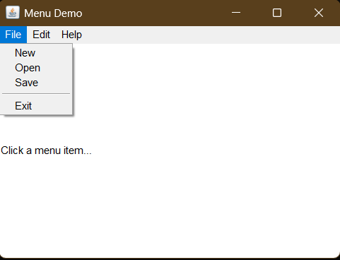

Program No: 62 | Date: 2/3/2026
Program Title: Project
/* Student Leave Approval System
@Ann Jo Mathew
Roll No: 12
2/3/2026*/

/* The Student Leave Management System is a desktop-based application developed using Java Swing for the graphical user interface and Oracle Database for data storage. The system is designed to automate the process of applying, approving, and managing student leave requests in an educational institution.*/

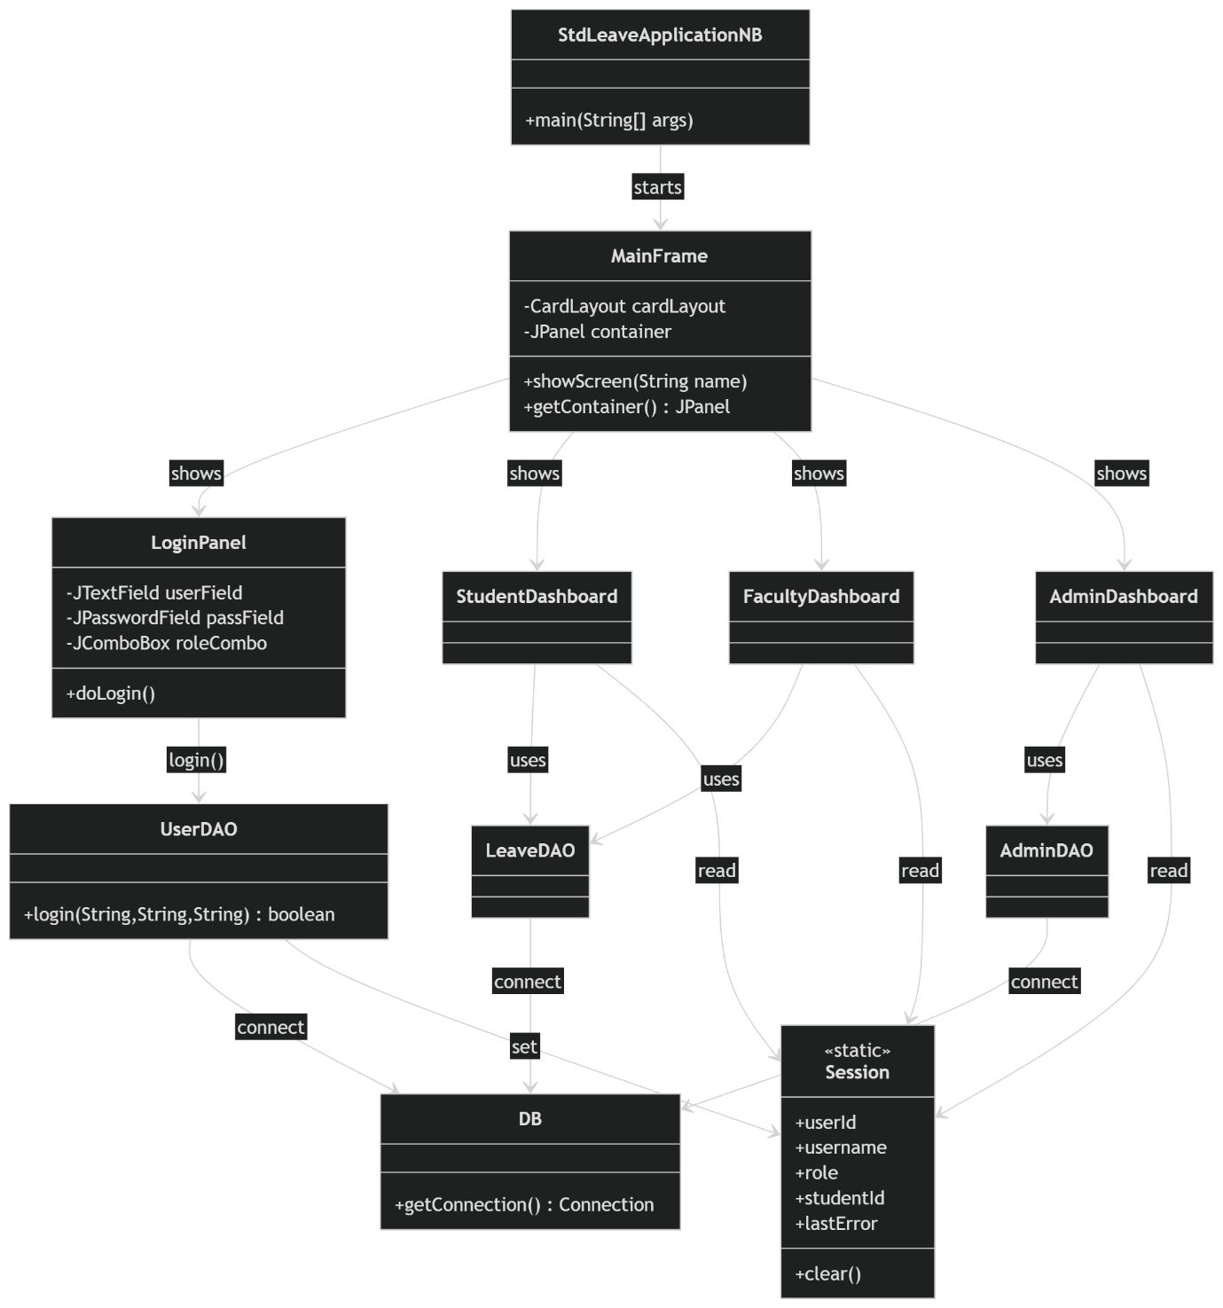

package db;

import java.sql.Connection;
import java.sql.DriverManager;
import java.sql.SQLException;

public class DB {
private static final String URL = "jdbc:oracle:thin:@//localhost:1521/XE";
private static final String USER = "leave_portal";
private static final String PASS = "123";

public static Connection getConnection() throws SQLException {
try {
Class.forName("oracle.jdbc.OracleDriver");
} catch (ClassNotFoundException e) {
throw new SQLException("Oracle JDBC driver not found.", e);
}
return DriverManager.getConnection(URL, USER, PASS);
}
}

package dao;

import db.DB;
import java.sql.*;
import session.Session;

public class UserDAO {

// returns true if login success (Session filled)
public static boolean login(String username, String password, String role) {
Session.clear();

String sql = "SELECT USER_ID, USERNAME, ROLE FROM USERS "
+ "WHERE UPPER(USERNAME)=UPPER(?) AND PASSWORD=? AND UPPER(ROLE)=UPPER(?)";

try (Connection con = DB.getConnection()) {
try (PreparedStatement ps = con.prepareStatement(sql)) {
ps.setString(1, username);
ps.setString(2, password);
ps.setString(3, role);

try (ResultSet rs = ps.executeQuery()) {
if (!rs.next()) {
Session.lastError = "Invalid username, password, or role.";
return false;
}

Session.userId = rs.getString("USER_ID");
Session.username = rs.getString("USERNAME");
Session.role = rs.getString("ROLE");

if ("STUDENT".equalsIgnoreCase(Session.role)) {
fetchStudentId(con);
}
return true;
}
}
} catch (SQLException e) {
if (e.getErrorCode() == 942) {
Session.lastError = "Table USERS not found. Create USERS table in schema ANN.";
return false;
}
Session.lastError = "Database error (" + e.getErrorCode() + "): " + e.getMessage();
return false;
} catch (Exception e) {
Session.lastError = "Connection Error: " + e.getMessage();
return false;
}
}

private static void fetchStudentId(Connection con) {
String sql = "SELECT STUDENT_ID FROM STUDENTS WHERE USER_ID=?";
try (PreparedStatement ps = con.prepareStatement(sql)) {
ps.setString(1, Session.userId);
ResultSet rs = ps.executeQuery();
if (rs.next()) Session.studentId = rs.getString("STUDENT_ID");
} catch (Exception e) {
System.err.println("Could not fetch Student ID: " + e.getMessage());
}
}
}

package stdleaveapplicationnb;

import javax.swing.SwingUtilities;
import ui.MainFrame;

public class StdLeaveApplicationNB {
public static void main(String[] args) {
SwingUtilities.invokeLater(() -> new MainFrame().setVisible(true));
}
}

package ui;

import javax.swing.*;
import java.awt.*;

public class LoginPanel extends JPanel {
private MainFrame frame;

private JTextField userField = new JTextField();
private JPasswordField passField = new JPasswordField();
private JComboBox<String> roleCombo = new JComboBox<>(new String[]{"ADMIN", "FACULTY", "STUDENT"});
private JButton loginBtn = new JButton("Login");

public LoginPanel(MainFrame frame) {
this.frame = frame;
setLayout(new BorderLayout());
setBackground(Theme.APP_BG);

// Left branding
JPanel left = new JPanel(new BorderLayout());
left.setPreferredSize(new Dimension(420, 650));
left.setBackground(Theme.SIDEBAR_BG);
left.setBorder(BorderFactory.createEmptyBorder(40, 30, 40, 30));

JLabel appTitle = new JLabel("<html><div style='font-size:26px;'>Student Leave<br>Management</div></html>");
appTitle.setForeground(Theme.TEXT_WHITE);
appTitle.setFont(new Font("Segoe UI", Font.BOLD, 26));

JLabel subtitle = new JLabel("<html><div style='font-size:14px;'>Login to continue</div></html>");
subtitle.setForeground(new Color(220, 220, 220));
subtitle.setFont(Theme.FONT_NORMAL);

JPanel leftText = new JPanel();
leftText.setOpaque(false);
leftText.setLayout(new BoxLayout(leftText, BoxLayout.Y_AXIS));
leftText.add(appTitle);
leftText.add(Box.createVerticalStrut(10));
leftText.add(subtitle);

left.add(leftText, BorderLayout.NORTH);

// Right card
JPanel right = new JPanel(new GridBagLayout());
right.setBackground(Theme.APP_BG);

JPanel card = new JPanel();
card.setBackground(Theme.CONTENT_BG);
card.setLayout(new GridLayout(6, 1, 10, 10)); // Increased rows to 6
card.setBorder(BorderFactory.createCompoundBorder(
BorderFactory.createLineBorder(new Color(230, 230, 230)),
BorderFactory.createEmptyBorder(30, 35, 30, 35)
));
card.setPreferredSize(new Dimension(420, 450)); // Increased height to 450

JLabel loginTitle = new JLabel("Login");
loginTitle.setFont(new Font("Segoe UI", Font.BOLD, 22));
loginTitle.setForeground(Theme.TEXT_DARK);

styleField(userField);
styleField(passField);
styleField(roleCombo);
styleButton(loginBtn);

card.add(loginTitle);
card.add(labeled("Username", userField));
card.add(labeled("Password", passField));
card.add(labeled("Role", roleCombo));
card.add(new JLabel("")); // spacer
card.add(loginBtn);

right.add(card);

add(left, BorderLayout.WEST);
add(right, BorderLayout.CENTER);

loginBtn.addActionListener(e -> doLogin());
}

private JPanel labeled(String label, JComponent field) {
JPanel p = new JPanel(new BorderLayout());
p.setOpaque(false);

JLabel l = new JLabel(label);
l.setFont(Theme.FONT_NORMAL);
l.setForeground(Theme.TEXT_DARK);

p.add(l, BorderLayout.NORTH);
p.add(field, BorderLayout.CENTER);
return p;
}

private void styleField(JComponent f) {
f.setFont(Theme.FONT_NORMAL);
f.setBorder(BorderFactory.createCompoundBorder(
BorderFactory.createLineBorder(new Color(200, 200, 200)),
BorderFactory.createEmptyBorder(5, 12, 5, 12) // Reduced vertical padding to 5
));
}

private void styleButton(JButton b) {
b.setFont(new Font("Segoe UI", Font.BOLD, 14));
b.setBackground(Theme.SIDEBAR_BTN_ACTIVE);
b.setForeground(Color.WHITE);
b.setFocusPainted(false);
b.setBorderPainted(false);
b.setCursor(new Cursor(Cursor.HAND_CURSOR));
}

private void doLogin() {
String username = userField.getText().trim();
String password = new String(passField.getPassword());
String role = (String) roleCombo.getSelectedItem();

boolean ok = dao.UserDAO.login(username, password, role);

if (!ok) {
String msg = (session.Session.lastError != null) ? session.Session.lastError : "Invalid username/password";
JOptionPane.showMessageDialog(this,
"Login Failed!\n\nDetails: " + msg,
"Login Error", JOptionPane.ERROR_MESSAGE);
return;
}

String userRole = session.Session.role.toUpperCase();

if (userRole.equals("ADMIN")) frame.showScreen("admin");
else if (userRole.equals("FACULTY")) frame.showScreen("faculty");
else if (userRole.equals("STUDENT")) frame.showScreen("student");
}
}

Output

