Program No: 01 | Date: 17/11/2025
Program Title: Program to display two numbers using command line arguments, add those numbers, and display the result.

/* Inputting two numbers using command line arguments and displaying their sum
@Ann Jo Mathew
Roll No: 12
17/11/2025 */

import java.io.*;
class CLA1{
public static void main(String args[]){
if(args.length!=2){
System.out.println("Error: Need Exactly 2 argumnets");
return;
}
int n1,n2,sum;
n1=Integer.parseInt(args[0]);
n2=Integer.parseInt(args[1]);
System.out.println("The two numbers are: "+n1+" and "+n2);
sum=n1+n2;
System.out.println("Sum="+sum);

}
}
Output
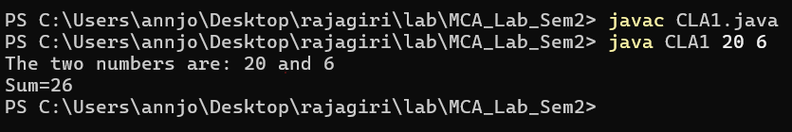

Program No: 02 | Date: 17/11/2025
Program Title: Program to demonstrate arithmetic operation using command line arguments
/* Arithmetic operation using Command Line Arguments
@Ann Jo Mathew
Roll No: 12
19/11/2025 */

import java.io.*;
class ClaArithmeticOp{
public static void main(String args[]){
if(args.length!=3){
System.out.println("Error: Need exactly 3 arguments: operand1 operand2 choice");
return;
}

int n1,n2,ch,r;
n1=Integer.parseInt(args[0]);
n2=Integer.parseInt(args[1]);
ch=Integer.parseInt(args[2]);

switch(ch){
case 0:
r=n1+n2;
System.out.println("Sum= "+r);
break;
case 1:
r=n1-n2;
System.out.println("Difference= "+r);
break;
case 2:
r=n1*n2;
System.out.println("Product= "+r);
break;
case 3:
if(n2==0)
System.out.println("Error: Division by zero is not allowed");
else{
r=n1/n2;
System.out.println("Quotient= "+r);
}
break;

default:
System.out.println("Invalid choice! Choices are: 0 for Addition, 1 for Subtraction, 2 for multiplication, 3 for Division.");
}
}
}
Output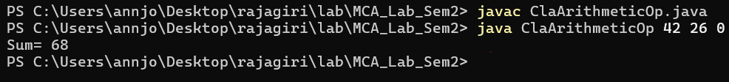

Program No: 03 | Date: 29/11/2025
Program Title: Keep a secret number between 20 and 30 in your program. Ask the user to
predict a number between 20 and 30. Use a do-while loop until the user predicts
your secret number and displays the count of attempts.
/* Secret number guess
@Ann Jo Mathew
Roll No: 12
Date: 29/11/2025 */

import java.io.*;
class Guess{
public static void main(String args[]){
DataInputStream d=new DataInputStream(System.in);
try{
int secret=27;
int g=0,count=0;
do{
System.out.println("Enter a number between 20 and 30:");
g=Integer.parseInt(d.readLine());
count++;
}while(g!=secret);
System.out.println("Your guess is Correct\nAttempts = "+count);
}
catch(Exception e){
System.out.println("Error: "+e);
}
}
}

Output
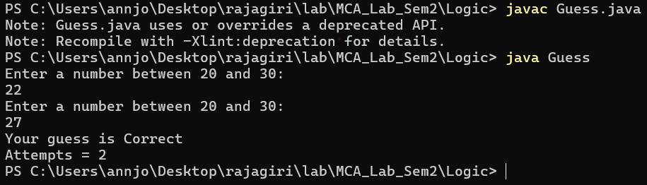

Program No: 04 | Date: 29/11/2025
Program Title: Implement searching and sorting elements in an Array
/* Search and sort elements in array
@Ann Jo Mathew
Roll No: 12
29/11/2025 */

import java.util.*;
class SortSearchArray{
public static void main(String args[]){
int a[],i,n,j,e;
Scanner sc=new Scanner(System.in);
System.out.print("Enter the array size: ");
n=sc.nextInt();
a=new int[n];
System.out.print("Enter the array elements: ");
for(i=0;i<n;i++)
a[i]=sc.nextInt();
System.out.println("Sorted elements are: ");
for(i=0;i<n;i++){
for(j=0;j<n-i-1;j++){
if(a[j]>a[j+1]){
int temp=a[j];
a[j]=a[j+1];
a[j+1]=temp;
}
}
}
for(i=0;i<n;i++)
System.out.print(a[i]+"\t");
System.out.println();
System.out.print("Enter an element to search: ");
e=sc.nextInt();
int mid,h,l;
h=n-1; //using Binary Search since elements are sorted
l=0;
mid=(l+h)/2;
while(l<=h){
mid=(l+h)/2;
if(a[mid]==e){
System.out.println("Element "+a[mid]+" found at position "+mid);
return ;
}
else if(e<a[mid])
h=mid-1;
else
l=mid+1;
}
if(l>=h)
System.out.println("Element not found");
}
}

Output
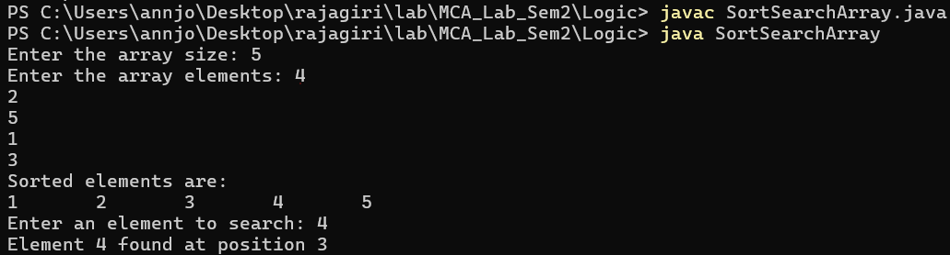

Program No: 05 | Date: 29/11/2025
Program Title: Implement a Java program to pass an array in different ways.
/* Passing array in different ways
@Ann Jo Mathew
Roll No: 12
30/11/2025 */

import java.util.*;
class ArrayPass{
void printArray(int arr[]) { //Passing array as a parameter
System.out.println("Array elements:");
for (int x : arr) {
System.out.print(x + " ");
}
System.out.println();
}
int[] createArray() {
Scanner sc = new Scanner(System.in);
System.out.print("Enter size: ");
int n = sc.nextInt();
int a[] = new int[n];
System.out.println("Enter elements:");
for (int i = 0; i < n; i++) {
a[i] = sc.nextInt();
}
return a;
}
}
class ArrayConstructor { //Passing array to constructor
int arr[];
ArrayConstructor(int a[]) {
arr = a;
}
void show() {
System.out.println("Array from constructor:");
for (int x : arr) {
System.out.print(x + " ");
}
}
}
public class Pgm5{
public static void main(String[] args) {
ArrayPass obj = new ArrayPass();
int data[] = obj.createArray();
obj.printArray(data);
ArrayConstructor ac = new ArrayConstructor(data);
ac.show();
}
}

Output
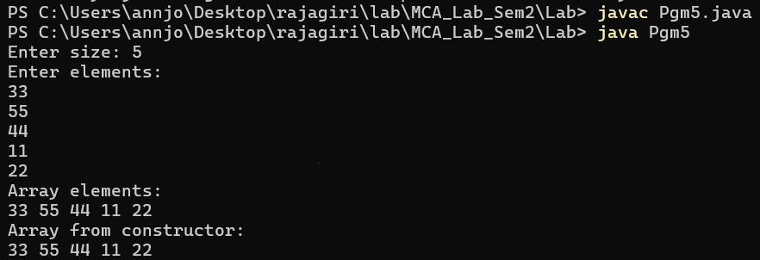

Program No: 06 | Date: 1/12/2025
Program Title: Write a Java program to add and multiply two matrices
/* Matrix multiplication and addition
@Ann Jo Mathew
Roll No: 12
01/12/2025 */

import java.util.*;
class MatrixAddMulti{
public static void main(String args[]){
int a[][],r1,c1,r2,c2,i,j,k;
Scanner s=new Scanner(System.in);
System.out.println("Enter the no. of r and c");
r=s.nextInt();
c=s.nextInt();
a=new int[r][c];
System.out.println("Enter elements of matrix A");
for(i=0;i<r;i++){
for(j=0;j<c;j++){
System.out.println("Enter a["+i+"]["+j+"]");
a[i][j]=s.nextInt();
}
}
System.out.println("Enter elements of matrix B");
int b[][]=new int[r][c];
for(i=0;i<r;i++){
for(j=0;j<c;j++){
System.out.println("Enter b["+i+"]["+j+"]");
b[i][j]=s.nextInt();
}
}
if(r1==r2 && c1==c2){
System.out.println("Sum of Matrices:");
int sum[][]=new int[r][c];
for(i=0;i<r;i++){
for(j=0;j<c;j++)
sum[i][j]=a[i][j]+b[i][j];
}
for(i=0;i<r;i++){
for(j=0;j<c;j++)
System.out.print(sum[i][j]+"\t");
System.out.println("");
}
}
else{
System.out.println("Addition not possible");
}
if(r2==c1){
int r[][]=new int[r1][c2];
for(i=0;i<r1;i++){
for(j=0;j<c2;j++)
r[i][j]=0;
}
for(i=0;i<r1;i++){
for(j=0;j<c2;j++){
for(k=0;k<c1;k++)
r[i][j]=r[i][j]+a[i][k]*b[k][j];
}
}
System.out.println("Product of Matrices:");
for(i=0;i<r1;i++){
for(j=0;j<c2;j++)
System.out.print(r[i][j]+"\t");
System.out.println("");
}
}
else
System.out.println("Multiplication not possible");
}
}
Output
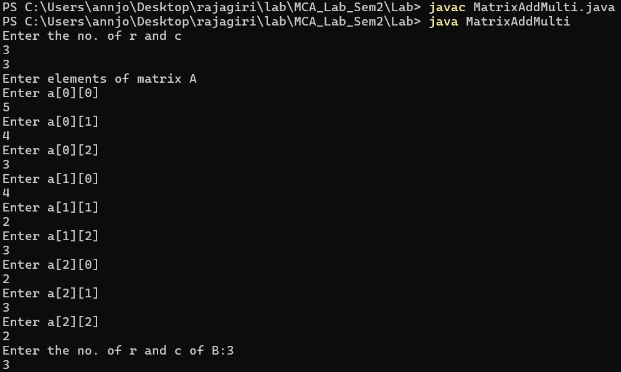
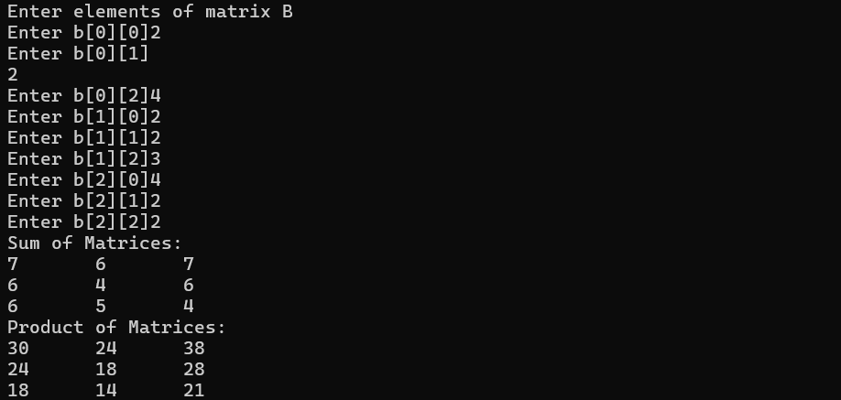

Program No: 07 | Date: 1/12/2025
Program Title: A function takes two integer arguments and returns the maximum. Use this function to find the maximum of three numbers
/* Max of three numbers
@Ann Jo Mathew
Roll No: 12
01/12/2025 */

import java.util.*;
class Pgm7{
public int max(int x,int y){
if(x>y)
return x;
else
return y;
}
public static void main(String args[]){
int a,b,c,m;
Pgm7 obj=new Pgm7();
Scanner sc=new Scanner(System.in);
System.out.println("Enter three numbers: ");
a=sc.nextInt();
b=sc.nextInt();
c=sc.nextInt();
m=obj.max(a,b);
m=obj.max(m,c);
System.out.println("Max= "+m);
}
}

Output
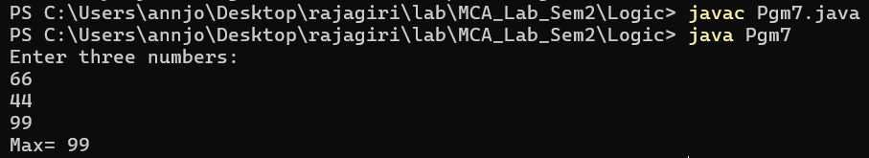

Program No: 08 | Date: 1/12/2025
Program Title: A function takes an integer argument and returns the reverse of the same. Another function takes an integer argument and returns true or false if the number is a palindrome, using the above function.
/* Paliandrome or not
@Ann Jo Mathew
Roll No: 12
01/12/2025 */

import java.io.*;
import java.util.*;
class Reverse{
public int reverse(int n){
int p=0;
while(n>0){
int r=n%10;
p=p*10+r;
n=n/10;
}
return p;
}
public void palindrome(int n){
int temp=n;
n=reverse(n);
if(temp==n)
System.out.println("The number is a Palindrome Number");
else
System.out.println("The number is not palindrome");
}
public int read(){
Scanner sc=new Scanner(System.in);
System.out.print("Enter a number: ");
int n=sc.nextInt();
return n;
}
}
class Pgm8{
public static void main(String args[]){
int a,r;
Reverse obj=new Reverse();
a=obj.read();
r=obj.reverse(a);
System.out.println("Reverse: "+r);
obj.palindrome(a);
}
}
Output
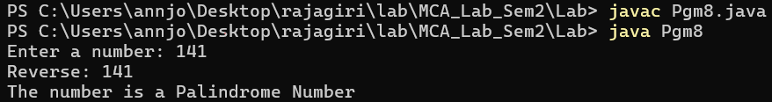

Program No: 09 | Date: 3/12/2025
Program Title: The 15-puzzle (also known as the sliding puzzle) consists of a 4×4 grid containing 15 numbered tiles (from 1 to 15) and one empty space. The objective is to rearrange the tiles by sliding them horizontally or vertically into the empty space to achieve the correct ascending order, as shown below: [Experiential Learning]
1 2 3 4
5 6 7 8
9 10 11 12
13 14 15 _
/* Puzzle
@Ann Jo Mathew
Roll No: 12
07/12/2025 */

import java.io.*;
import java.util.*;
class Puzzle{
int a[][],i,j,m,mr,mc,zr,zc; //size is 4x4
void checkMove(){
int c=0;
//a=new int[][]{1,2,3,4,5,6,7,8,9,10,11,0,13,14,15,12};
a=new int[][]{{1,2,3,4},{5,6,7,8},{9,10,11,12},{13,14,0,15}};
System.out.println("Solve the puzzle");
display(c);
Scanner sc=new Scanner(System.in);
while(true){
System.out.println();
System.out.print("Enter the value that you want to Move: ");
m=sc.nextInt();
if(m<0 || m>15){
System.out.println("Invalid Input");
continue;
}
for(i=0;i<4;i++){
for(j=0;j<4;j++){
if(a[i][j]==m){
mr=i;
mc=j;
}
if(a[i][j]==0){
zr=i;
zc=j;
}
}
}
if((zr==mr)&&(zc==mc-1||zc==mc+1)) {
swap(zr,zc,mr,mc);
}
else if((zr==mr-1||zr==mr+1)&&(zc==mc)){
swap(zr,zc,mr,mc);
}
else{
System.out.println("Invalid Move");
continue;
}
c++;
display(c);
if(checkWin()){
System.exit(0);
}
}
}
boolean checkWin(){
int fin[][]=new int[][]{{1,2,3,4},{5,6,7,8},{9,10,11,12},{13,14,15,0}};
int f=0;
for(i=0;i<4;i++){
for(j=0;j<4;j++){
if(a[i][j]!=fin[i][j]){
f++;
}
}
}
if(f>0){
return false;
}
else{
System.out.println("Congratulations! You have solved the puzzle.");
return true;
}
}
void swap(int i,int j,int m,int n){
int temp=a[i][j];
a[i][j]=a[m][n];
a[m][n]=temp;
}
void display(int c){
for(i=0;i<4;i++){
for(j=0;j<4;j++){
System.out.print(a[i][j]+" ");
}
System.out.println();
}
System.out.println("Number of moves: "+c);
}
}
public class PuzzlePgm9{
public static void main(String args[]){
Puzzle p=new Puzzle();
p.checkMove();
}
}

Output
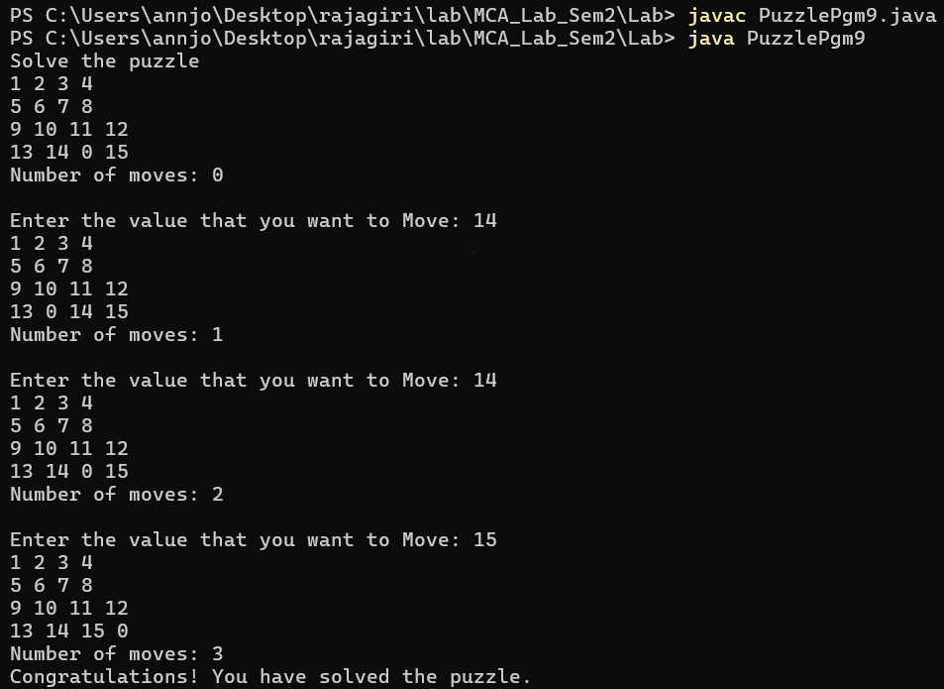

Program No: 10 | Date: 3/12/2025
Program Title: Display from n - 1 and 1-n using recursive functions.
/* Ascending, Descending using recursion
@Ann Jo Mathew
Roll No: 12
04/12/2025 */

import java.util.*;
class Recursion{
public void printDesc(int n) { // Print from n to 1
if(n==0) return;
System.out.print(n+" ");
printDesc(n-1);
}
public void printAsc(int n) { // Print from 1 to n
if(n==0) return;
printAsc(n-1);
System.out.print(n+" ");
}
}
class RecursivePgm10{
public static void main(String args[]) {
Scanner sc = new Scanner(System.in);
System.out.print("Enter n: ");
int n = sc.nextInt();
Recursion obj = new Recursion();
System.out.println("Descending (n to 1):");
obj.printDesc(n);
System.out.println("\nAscending (1 to n):");
obj.printAsc(n);
}
}
Output
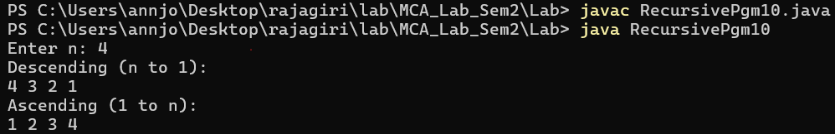

Program No: 11 | Date: 3/12/2025
Program Title: Create a program for adding, subtracting, multiplying and dividing two numbers using object-oriented concepts
/* Arithmetic operation
@Ann Jo Mathew
Roll No: 12
04/12/2025 */

import java.util.*;
class Calculator {
int add(int a, int b) { // Addition
return a + b;
}
int subtract(int a, int b) { // Subtraction
return a - b;
}
int multiply(int a, int b) { // Multiplication
return a * b;
}
float divide(int a, int b) { // Division
if(b == 0) {
System.out.println("Cannot divide by zero.");
return 0;
}
return (float)a / b;
}

}
public class CalculatorPgm11{
public static void main(String args[]) {
Scanner sc = new Scanner(System.in);
Calculator c = new Calculator();
System.out.print("Enter first number: ");
int n1 = sc.nextInt();
System.out.print("Enter second number: ");
int n2 = sc.nextInt();
System.out.println("Addition: " + c.add(n1, n2));
System.out.println("Subtraction: " + c.subtract(n1, n2));
System.out.println("Multiplication: " + c.multiply(n1, n2));
System.out.println("Division: " + c.divide(n1, n2));
}

}

Output
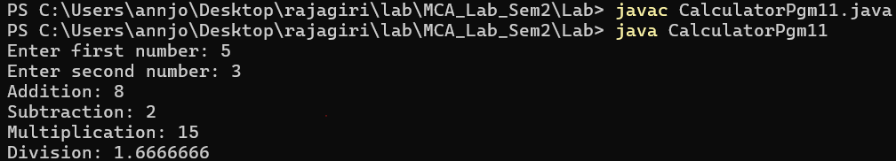

Program No: 12 | Date: 06/12/2025
Program Title: Create a class complex having real and imaginary as data members and provide function for read, display, add and multiply.
/*Addition, Multiplication of Complex numbers
@Ann Jo Mathew
Roll No: 12
06/12/2025 */

import java.util.*;
class Complex {
int r,i;
void read() {
Scanner sc=new Scanner(System.in);
System.out.print("Enter real part: ");
r=sc.nextInt();
System.out.print("Enter imaginary part: ");
i=sc.nextInt();
}
void display() {
if(i>=0)
System.out.println(r+"+"+i+"i");
else
System.out.println(r+"-"+(-i)+"i");
}
Complex add(Complex c) {
Complex obj=new Complex();
obj.r=r+c.r;
obj.i=i+c.i;
return obj;
}
Complex multiply(Complex c) {
Complex obj=new Complex();
obj.r=(r*c.r)-(i*c.i);
obj.i=(r*c.i)+(i*c.r);
return obj;
}
}
public class ComplexPgm12{
public static void main(String args[]) {
Complex c1=new Complex();
Complex c2=new Complex();
System.out.println("Enter first complex number:");
c1.read();
System.out.println("Enter second complex number:");
c2.read();
Complex sum=c1.add(c2);
Complex product=c1.multiply(c2);
System.out.println("\nFirst number:");
c1.display();
System.out.println("Second number:");
c2.display();
System.out.println("\nSum:");
sum.display();
System.out.println("Product:");
product.display();
}
}

Output
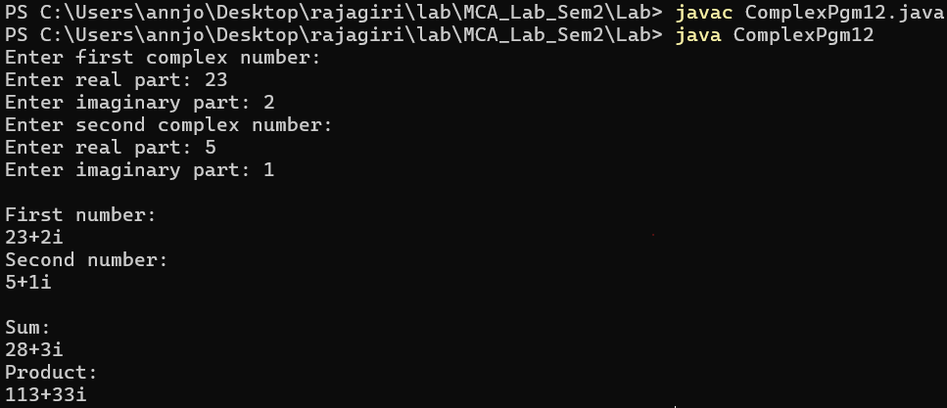

Program No: 13 | Date: 06/12/2025
Program Title: Create a class for CString having a string data member and provide functions for read, display, compare(return Boolean value),add and concatenate.
/*String program
@Ann Jo Mathew
Roll No: 12
06/12/2025 */

import java.util.*;
class CString {
String s;
void read() {
Scanner sc=new Scanner(System.in);
System.out.print("Enter string: ");
s=sc.nextLine();
}
void display() {
System.out.println(s);
}
boolean compare(CString c) { // returns true/false
return s.equals(c.s);
}
CString add(CString c) { // "add" = string addition (concatenation)
CString r=new CString();
r.s=s+c.s;
return r;
}
CString concatenate(CString c) { // same as add but kept separate because question asked
CString r=new CString();
r.s=s+c.s;
return r;
}
}
public class StringPgm13{
public static void main(String args[]) {
CString c1=new CString();
CString c2=new CString();
System.out.println("Enter first string:");
c1.read();
System.out.println("Enter second string:");
c2.read();
boolean eq=c1.compare(c2);
CString added=c1.add(c2);
CString conc=c1.concatenate(c2);
System.out.println("\nFirst string:");
c1.display();
System.out.println("Second string:");
c2.display();
System.out.println("\nStrings equal? "+eq);
System.out.println("Added:");
added.display();
System.out.println("Concatenated:");
conc.display();
}
}

Output
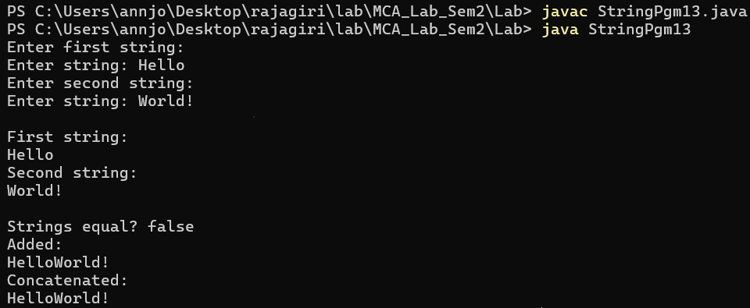

Program No: 14 | Date: 06/12/2025
Program Title: Create a class for a student having (sno, sname, sprogram) [example sno-1,sname-sanjay,sprogram-MCA]. Provide functions for reading and displaying the same information. Also provide a function for comparing two student objects for equality.
/*Student Detail program
@Ann Jo Mathew
Roll No: 12
06/12/2025 */

import java.util.*;
class Student {
int sno;
String sname, sprogram;
void read() {
Scanner sc=new Scanner(System.in);
System.out.print("Enter student number: ");
sno=sc.nextInt();
sc.nextLine();
System.out.print("Enter student name: ");
sname=sc.nextLine();
System.out.print("Enter program: ");
sprogram=sc.nextLine();
}
void display() {
System.out.println(sno+" "+sname+" "+sprogram);
}
boolean compare(Student s) {
return sno==s.sno && sname.equals(s.sname) && sprogram.equals(s.sprogram);
}
}
public class Pgm14 {
public static void main(String args[]) {
Student s1=new Student();
Student s2=new Student();
System.out.println("Enter first student details:");
s1.read();
System.out.println("Enter second student details:");
s2.read();
boolean same=s1.compare(s2);
System.out.println("\nFirst student:");
s1.display();
System.out.println("Second student:");
s2.display();
System.out.println("\nStudents equal? "+same);
}
}
Output
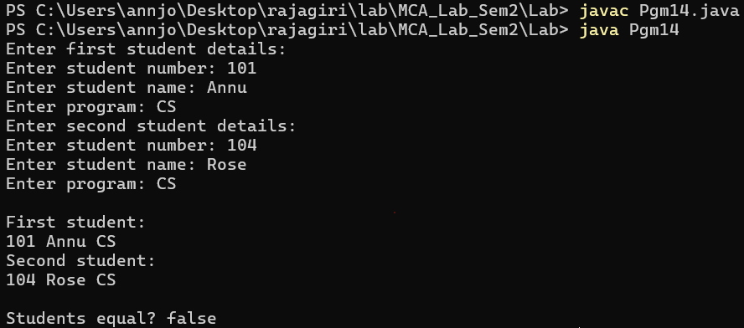

Program No: 15 | Date: 08/12/2025
Program Title: Program to implement the ISA and HASA relationship.
/* ISA and HASA
@Ann Jo Mathew
Roll No: 12
Date: 08/12/2025 */

import java.util.*;
class Person{ // Base class
String name;
Aadhaar a=new Aadhaar();
public Person(String name,int n){
this.name=name;
a.id=n;
}
public Person(String name){
this.name=name;
}
void dispP(){
System.out.println("Name: "+name);
a.dispA();
}
}
class Student extends Person{ // Student ISA Person
int rollNo;
public Student(String name, int rollNo,int id) {
super(name,id);
this.rollNo=rollNo;
}
void dispS() {
dispP();
System.out.println("Roll No: "+rollNo);
}
}
class Aadhaar{ // Person HASA Aadhaar
int id;
void dispA() {
System.out.println("Aadhaar no: "+id);
}
}
public class IsaHasaRelation {
public static void main(String args[]) {
Scanner sc=new Scanner(System.in);

System.out.println("ISA Relationship:");
System.out.println("Enter the name: ");
String a=sc.nextLine();
System.out.print("Enter Roll no: ");
int rn=sc.nextInt();
System.out.print("Enter Aadhaar no: ");
int id=sc.nextInt();
Student s=new Student(a,rn,id);
s.dispS();
System.out.println();
sc.nextLine();

System.out.println("HASA Relationship:");
System.out.print("Enter the name: ");
String b=sc.nextLine();
System.out.print("Enter Aadhaar no: ");
int n=sc.nextInt();
Person p = new Person(b,n);
p.dispP();
}
}
Output
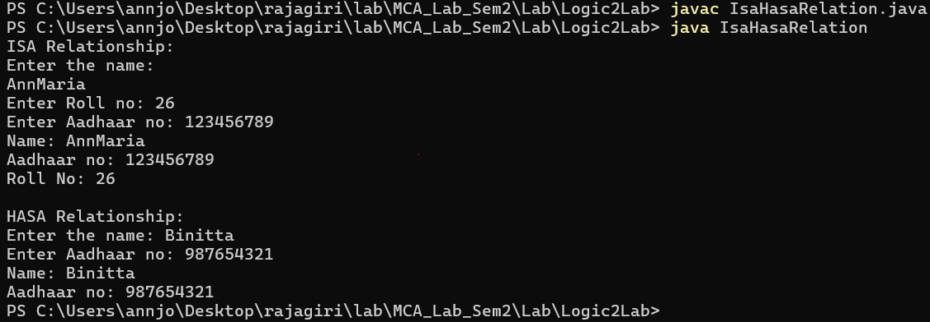

Program No: 16 | Date: 08/12/2025
Program Title: Program to overcome function overriding in Java.
/* Function Overriding
@Ann Jo Mathew
Roll No: 12
Date: 08/12/2025 */

import java.util.*;
class Person{
int age;
String name;
public void read(){
Scanner sc=new Scanner(System.in);
System.out.print("Enter name: ");
name=sc.nextLine();
System.out.print("Enter age: ");
age=sc.nextInt();
}
public void disp(){
System.out.println("Name: "+name);
System.out.println("Age: "+age);
}
}
class Teacher extends Person{
String subject;
public void read(){
super.read();
Scanner sc=new Scanner(System.in);
System.out.print("Enter subject: ");
subject=sc.nextLine();
}
public void disp(){
super.disp();
System.out.println("Subject: "+subject);
}
}
class Pgm2FunOverriding{
public static void main(String args[]){
Person p=new Person();
Teacher t=new Teacher();
System.out.println("Enter Person details:");
p.read();
System.out.println("Person details:");
p.disp();
System.out.println();
System.out.println("\nEnter Teacher details:");
t.read();
System.out.println("Teacher details:");
t.disp();
}
}

Output
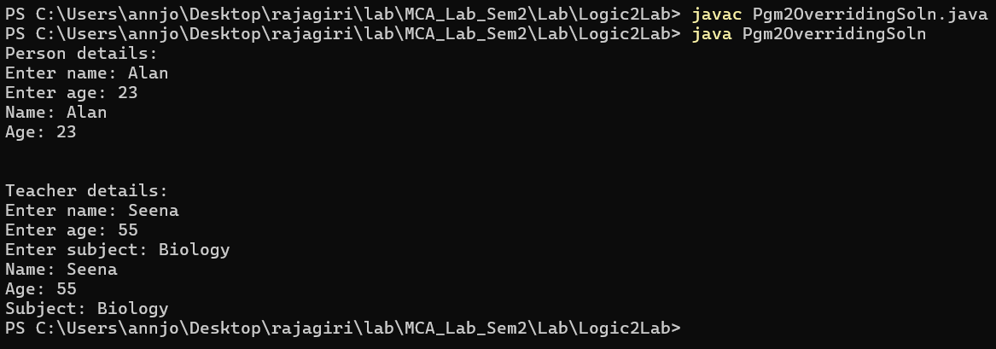

Program No: 17 | Date: 08/12/2025
Program Title: Demonstrate the use of a super keyword
a. To overcome function overriding
b. Passing arguments to the base class constructor

/* Super keyword
@Ann Jo Mathew
Roll No: 12
09/12/2025 */

import java.util.*;
class Person {
int age;
String name;

Person(String name,int age) {
this.name=name;
this.age=age;
}

void display() {
System.out.println("Name:"+name);
System.out.println("Age:"+age);
}
}
class Teacher extends Person {
String subject;

Teacher(String name,int age,String subject) {
super(name,age); //passing arguments to base class constructor
this.subject=subject;
}

void display() {
super.display(); //base class method overriden in derived class
System.out.println("Subject:"+subject);
}
}
class Pgm3Super{
public static void main(String args[]) {
Scanner sc=new Scanner(System.in);
System.out.print("Enter teacher name:");
String name=sc.nextLine();
System.out.print("Enter teacher age:");
int age=sc.nextInt();
sc.nextLine();
System.out.print("Enter subject:");
String subject=sc.nextLine();
Teacher t=new Teacher(name,age,subject);
System.out.println("\nTeacher Details:");
t.display();
}
}
Output
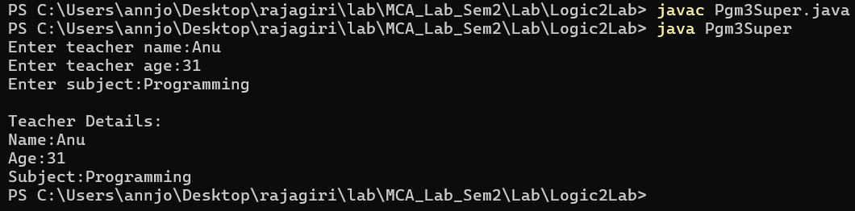

Program No: 18 | Date: 08/12/2025
Program Title: Create a class for an employee having eno, ename and esal as data members. Provide functions for reading, displaying, and comparing by eno. Accept n employees' information in the main function, display the same, and search for an employee whose eno is given.
/* Array of Objects
@Ann Jo Mathew
Roll No: 12
09/12/2025 */

import java.util.*;
class Employee {
int eno;
String ename;
double esal;
void read() {
Scanner sc=new Scanner(System.in);
System.out.print("Enter Employee Number: ");
eno=sc.nextInt();
sc.nextLine(); // consume newline
System.out.print("Enter Employee Name: ");
ename=sc.nextLine();
System.out.print("Enter Employee Salary: ");
esal=sc.nextDouble();
}
void display() {
System.out.println("Employee Number:"+eno);
System.out.println("Employee Name:"+ename);
System.out.println("Employee Salary:"+esal);
}
boolean compareEno(int no) {
if(eno==no)
return true;
else
return false;
}
}
class Pgm4Employee{
public static void main(String args[]) {
Scanner sc=new Scanner(System.in);
System.out.print("Enter total number of employees: ");
int n=sc.nextInt();
Employee e[]=new Employee[n]; //array created of employee data type(AOO)
for(int i=0;i<n;i++) {
e[i]=new Employee(); //object creation
System.out.println("\nEnter details of employee "+(i+1));
e[i].read();
}
System.out.println("\nEmployee Details:");
for(int i=0;i<n;i++) {
e[i].display();
System.out.println();
}System.out.print("Enter employee number to search: ");
int s=sc.nextInt();
boolean found=false;
for(int i=0;i<n;i++) {
if(e[i].compareEno(s)==true) {
System.out.println("\nEmployee Found:");
e[i].display();
found=true;
break;
}
}
if(found==false)
System.out.println("\nEmployee with number "+s+" not found.");
}
}
Output
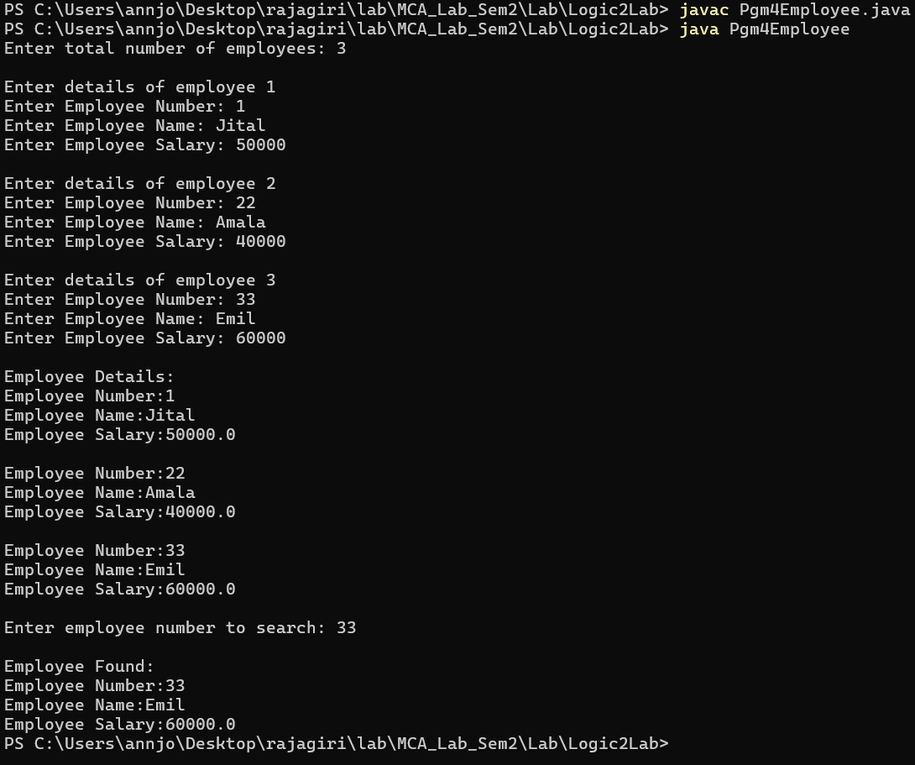

Program No: 19 | Date: 10/12/2025
Program Title: Program to implement run-time polymorphism in Java(interface).
/* Run time polymorphism
@Ann Jo Mathew
Roll No: 12
Date: 11/12/2025 */

import java.util.*;
interface Shape {
void disp();
}
class Circle implements Shape {
public void disp() {
System.out.println("Circle");
}
}
class Rectangle implements Shape {
public void disp() {
System.out.println("Rectangle");
}
}
class Pgm5RuntimePoly{
public static void main(String args[]) {
Shape s1=new Circle();
s1.disp();
Shape s2=new Rectangle();
s2.disp();
}
}

Output

Program No: 20 | Date: 10/12/2025
Program Title: Create an interface ishape having two prototypes draw and mov, create two classes circle and rectangle which implements the above interface. In the main function only a reference object of ishape is created, depends on the choice entered by the user , it points to the respective memory location.
/* Interface
@Ann Jo Mathew
Roll No: 12
11/12/2025 */

import java.util.*;
interface IShape {
void draw();
void mov();
}
class Circle implements IShape {
public void draw() {
System.out.println("Drawing Circle");
}
public void mov() {
System.out.println("Moving Circle");
}
}
class Rectangle implements IShape {
public void draw() {
System.out.println("Drawing Rectangle");
}
public void mov() {
System.out.println("Moving Rectangle");
}
}
class Pgm6Interface{
public static void main(String args[]) {
Scanner sc=new Scanner(System.in);
IShape obj;
System.out.print("1 - Circle \n2 - Rectangle\nEnter choice: ");
int ch=sc.nextInt();
if(ch==1) {
obj=new Circle();
}
else if(ch==2) {
obj=new Rectangle();
}
else {
System.out.println("Invalid choice");
return;
}
obj.draw();
obj.mov();
}
}
Output
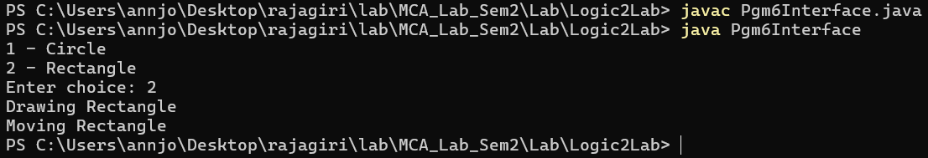

Program No: 21 | Date: 10/12/2025
Program Title: Write a program using multiple catch statements / predefined Exceptions.
/* Predefined Exceptions(MultiCatch)
@Ann Jo Mathew
Roll No: 12
14/12/2025 */

import java.util.*;
class Pgm7MultiCatch{
public static void main(String args[]) {
Scanner sc=new Scanner(System.in);
try {
System.out.print("Enter first number:");
int a=sc.nextInt();
System.out.print("Enter second number:");
int b=sc.nextInt();
int c=a/b;
System.out.println("Result:"+c);
}
catch(ArithmeticException e) {
System.out.println("Arithmetic Exception:"+e);
}
catch(InputMismatchException e) {
System.out.println("Input Mismatch Exception:"+e);
}
catch(Exception e) {
System.out.println("General Exception:"+e);
}
}
}
Output
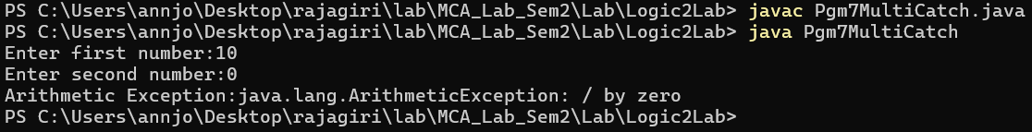

Program No: 22 | Date: 15/12/2025
Program Title: Write a program to implement a user-defined Exception.
/* user-defined Exception
@Ann Jo Mathew
Roll No: 12
15/12/2025 */

import java.util.*;
class UDE extends Exception{
String strError;
public UDE(){ //constructor
strError="Unknown Error";
}
public UDE(String s){ //constructor with argument
strError=s;
}
public String showError(){ //method to return error
return strError;
}
}
class Pgm8UserException{ //throw
public static void main(String args[]){
int a,b,c;
Scanner sc=new Scanner(System.in);
System.out.print("Enter numerator:");
a=sc.nextInt();
System.out.print("Enter dinominator:");
b=sc.nextInt();
try{
if(b==0)
throw new UDE("Dinominator is ZERO"); //here 2nd consructor is invoked
c=a/b;
System.out.println(c);
}
catch(UDE e){
System.out.println(e.showError());
}
}
}
Output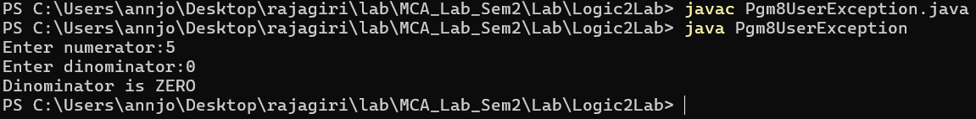

Program No: 23 | Date: 15/12/2025
Program Title: Write a program to implement re-throw and finally.
/* re-throw , finally Exceptions
@Ann Jo Mathew
Roll No: 12
16/12/2025 */

import java.util.*;
class RethrowFinally {
void divide(int a,int b) {
try {
int c=a/b;
System.out.println("Result:"+c);
}
catch(ArithmeticException e) {
System.out.println("Exception caught in divide()");
throw e; // re-throwing the exception
}
finally {
System.out.println("Finally block in divide()");
}
}
}
class Pgm9RethrowFinally {
public static void main(String args[]) {
Scanner sc=new Scanner(System.in);
RethrowFinally obj=new RethrowFinally();
System.out.print("Enter numerator:");
int a=sc.nextInt();
System.out.print("Enter denominator:");
int b=sc.nextInt();
try {
obj.divide(a,b);
}
catch(ArithmeticException e) {
System.out.println("Exception caught in main()");
}
finally { // finally block
System.out.println("Finally block in main()");
}
}
}

Output
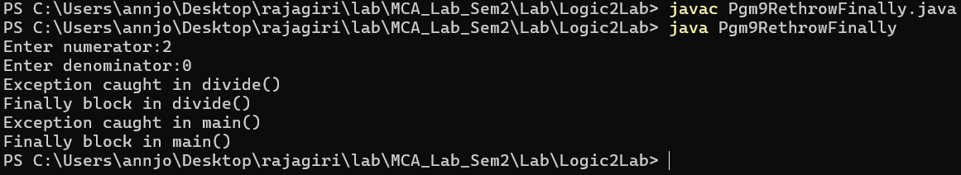

Program No: 24 | Date: 15/12/2025
Program Title:
/* Password validation check using exception
@Ann Jo Mathew
Roll No: 12
16/12/2025 */

import java.util.*;
class PwdCheck extends Exception{
String strError;
public PwdCheck(){
System.out.println("Unknown Error");
}
public PwdCheck(String s){
strError=s;
}
public String showError(){
return strError;
}

}
class Pgm10Pwd{
public static void main(String args[]){
String p;
Scanner sc=new Scanner(System.in);
while(true){
int lcount=0,ucount=0,spcount=0;
System.out.print("Password: ");
try{
p=sc.nextLine();
if(p.length()<8){
throw new PwdCheck("Length must be atleast 8");
}String l=p.toLowerCase();
String u=p.toUpperCase();

for(int i=0;i<p.length()-1;i++){
if(p.charAt(i)==p.charAt(i+1))
throw new PwdCheck("Cannot have any
concecutive repetition ");
}
for(int i=0;i<p.length();i++){
if(p.charAt(i)==l.charAt(i))
lcount++;
if(p.charAt(i)==u.charAt(i))
ucount++;
if((p.charAt(i)>='a'&&p.charAt(i)<='z')||(p.charAt(i)>
='A'&&p.charAt(i)<='Z')||(p.charAt(i)>='0'&&p.charAt(i)<='9')){
}
else if(p.charAt(i)=='@'||p.charAt(i)=='*'||p.charAt(i)=='!'||p.charAt(i)=='{'||p.charAt(i)=='}'||p.charAt(i)=='('||p.charAt(i)==')'||p.charAt(i)=='['||p.charAt(i)==']'||p.charAt(i)=='&'||p.charAt(i)=='=')
spcount++;
else
throw new PwdCheck("Password can only
have alphanumeric characters and special characters @,*,!,{,},(,),[,],& and = ");
}
if(lcount==0)
throw new PwdCheck("Password must have at least
1 lowercase character");
if(ucount==0)
throw new PwdCheck("Password must have at least
1 uppercase character ");
if(spcount==0)
throw new PwdCheck("Password must have at least
1 special case character ");
System.out.println("Password is valid");
break;
}
catch(PwdCheck e){
System.out.println(e.showError());
}
}
}
}
Output
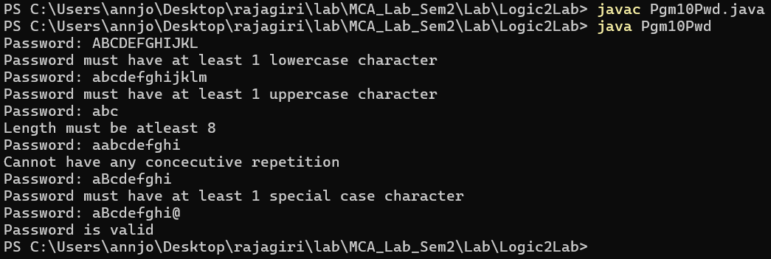

Program No: 25 | Date: 17/12/2025
Program Title: Implement threading by inheriting Thread class.
/* Thread
@Ann Jo Mathew
Roll No: 12
17/12/2025 */

class CThread extends Thread {
int n;
public CThread(int a) {
n=a;
}
public void run() {
int i;
for(i=1;i<=n;i++)
System.out.println("i="+i+"\t");
}
}
class TP1Inherit{
public static void main(String args[]) {
CThread t1,t2;
t1=new CThread(200);
t2=new CThread(250);
System.out.println("Be for Thread");
t1.start();
System.out.println("Between Thread");
t2.start();
System.out.println("Finished");
}
}
Output
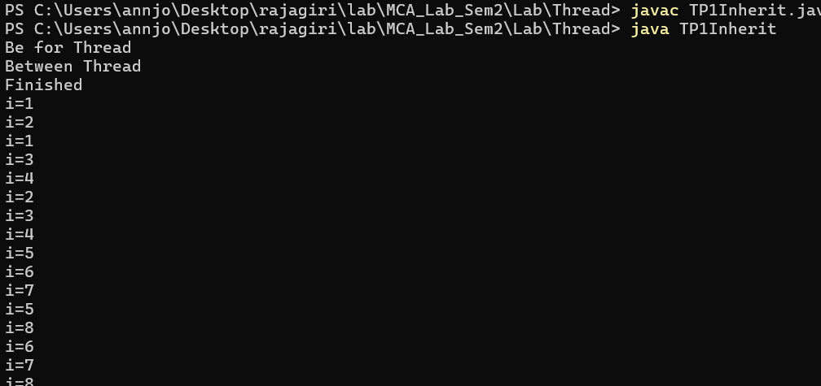

Program No: 26 | Date: 17/12/2025
Program Title: Write a Java program to create threads using the Runnable interface.
/* Thread by implementing Runnable interface
@Ann Jo Mathew
Roll No: 12
17/12/2025 */

class CIThread implements Runnable {
int n;
public CIThread(int a) {
n=a;
}
public void run() {
int i;
for(i=1;i<=n;i++) {
System.out.println("i="+i+"\t");
}
}
}
class TP2RunnableImp{
public static void main(String args[]) {
CIThread p,q;
p=new CIThread(200);
q=new CIThread(250);
Thread t1,t2;
t1=new Thread(p);
t2=new Thread(q);
System.out.println("Before Thread");
t1.start();
System.out.println("Between Thread");
t2.start();
System.out.println("Finished");
}
}
Output
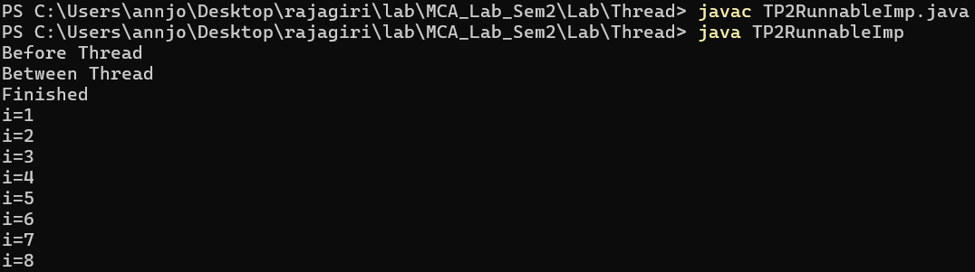

Program No: 27 | Date: 17/12/2025
Program Title: Write a Java program to create two threads, one to display odd numbers and another to display even numbers up to N.
/* Print Odd and Even Numbers using Thread
@Ann Jo Mathew
Roll No: 12
19/12/2025 */

import java.util.*;
class NumThread implements Runnable{
int n;
String type;

NumThread(int n,String type){
this.n=n;
this.type=type;
}

public void run(){
if(type.equals("Odd")){
for(int i=1;i<=n;i+=2)
System.out.println("Odd: "+i);
}
else if(type.equals("Even")){
for(int i=2;i<=n;i+=2)
System.out.println("Even: "+i);
}
}
}

class TP3OddEven{
public static void main(String args[]){
Scanner sc=new Scanner(System.in);
System.out.print("Enter N:");
int n=sc.nextInt();

NumThread o=new NumThread(n,"Odd");
NumThread e=new NumThread(n,"Even");

Thread t1=new Thread(o);
Thread t2=new Thread(e);
t1.start();
t2.start();
}
}

Output
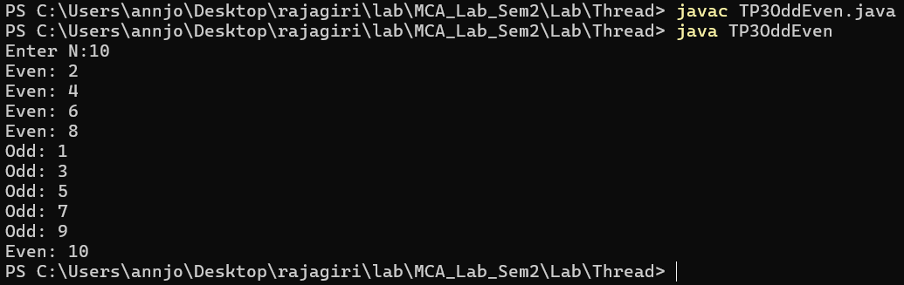

Program No: 28 | Date: 27/11/2025
Program Title: Create a class complex having real and imaginary as data members and provide function for read, display, add and multiply.
/*Addition, Multiplication of Complex numbers
@Ann Jo Mathew
Roll No: 12
05/07/2025 */

import java.util.*;
class Complex {
int r,i;
void read() {
Scanner sc=new Scanner(System.in);
System.out.print("Enter real part: ");
r=sc.nextInt();
System.out.print("Enter imaginary part: ");
i=sc.nextInt();
}
void display() {
if(i>=0)
System.out.println(r+"+"+i+"i");
else
System.out.println(r+"-"+(-i)+"i");
}
Complex add(Complex c) {
Complex obj=new Complex();
obj.r=r+c.r;
obj.i=i+c.i;
return obj;
}
Complex multiply(Complex c) {
Complex obj=new Complex();
obj.r=(r*c.r)-(i*c.i);
obj.i=(r*c.i)+(i*c.r);
return obj;
}
}
public class ComplexPgm12{
public static void main(String args[]) {
Complex c1=new Complex();
Complex c2=new Complex();
System.out.println("Enter first complex number:");
c1.read();
System.out.println("Enter second complex number:");
c2.read();
Complex sum=c1.add(c2);
Complex product=c1.multiply(c2);
System.out.println("\nFirst number:");
c1.display();
System.out.println("Second number:");
c2.display();
System.out.println("\nSum:");
sum.display();
System.out.println("Product:");
product.display();
}
}

Output

Program No: 13 | Date: 27/11/2025
Program Title: Create a class for CString having a string data member and provide functions for read, display, compare(return Boolean value),add and concatenate.
/*String program
@Ann Jo Mathew
Roll No: 12
05/07/2025 */

import java.util.*;
class CString {
String s;
void read() {
Scanner sc=new Scanner(System.in);
System.out.print("Enter string: ");
s=sc.nextLine();
}
void display() {
System.out.println(s);
}
boolean compare(CString c) { // returns true/false
return s.equals(c.s);
}
CString add(CString c) { // "add" = string addition (concatenation)
CString r=new CString();
r.s=s+c.s;
return r;
}
CString concatenate(CString c) { // same as add but kept separate because question asked
CString r=new CString();
r.s=s+c.s;
return r;
}
}
public class StringPgm13{
public static void main(String args[]) {
CString c1=new CString();
CString c2=new CString();
System.out.println("Enter first string:");
c1.read();
System.out.println("Enter second string:");
c2.read();
boolean eq=c1.compare(c2);
CString added=c1.add(c2);
CString conc=c1.concatenate(c2);
System.out.println("\nFirst string:");
c1.display();
System.out.println("Second string:");
c2.display();
System.out.println("\nStrings equal? "+eq);
System.out.println("Added:");
added.display();
System.out.println("Concatenated:");
conc.display();
}
}

Output

Program No: 14 | Date: 27/11/2025
Program Title: Create a class for a student having (sno, sname, sprogram) [example sno-1,sname-sanjay,sprogram-MCA]. Provide functions for reading and displaying the same information. Also provide a function for comparing two student objects for equality.
/*Student Detail program
@Ann Jo Mathew
Roll No: 12
06/07/2025 */

import java.util.*;
class Student {
int sno;
String sname, sprogram;
void read() {
Scanner sc=new Scanner(System.in);
System.out.print("Enter student number: ");
sno=sc.nextInt();
sc.nextLine();
System.out.print("Enter student name: ");
sname=sc.nextLine();
System.out.print("Enter program: ");
sprogram=sc.nextLine();
}
void display() {
System.out.println(sno+" "+sname+" "+sprogram);
}
boolean compare(Student s) {
return sno==s.sno && sname.equals(s.sname) && sprogram.equals(s.sprogram);
}
}
public class Pgm14 {
public static void main(String args[]) {
Student s1=new Student();
Student s2=new Student();
System.out.println("Enter first student details:");
s1.read();
System.out.println("Enter second student details:");
s2.read();
boolean same=s1.compare(s2);
System.out.println("\nFirst student:");
s1.display();
System.out.println("Second student:");
s2.display();
System.out.println("\nStudents equal? "+same);
}
}
Output

Program No: 15 | Date: 23/07/2025
Program Title: Program to implement the ISA and HASA relationship.
/* Read n Strings and display them in ascending order
@Ann Jo Mathew
Roll No: 12)
Date: 28/07/2025 */

#include<stdio.h>
#include<string.h>
int inputStr(char s[20][50]){
int n,i;
printf("Enter the number of words you are going to input: ");
scanf("%d",&n);
printf("Enter %d strings: ",n);
for(i=0;i<n;i++){
scanf("%s",s[i]); //reads string as words
}
return n;
}

void sortStr(char s[20][50],int n){
int i,j;
char temp[50]; //temp stores a whole string for swapping
for(i=0;i<n-1;i++){ //swapping strings
for(j=i+1;j<n;j++){
if(strcmp(s[i],s[j])>0){
strcpy(temp,s[i]);
strcpy(s[i],s[j]);
strcpy(s[j],temp);
}
}
}
}

void dispStr(char s[20][50],int n){ //function for displaying the strings
int i;
printf("Strings are: \n");
for(i=0;i<n;i++){
printf("%d. %s\n",i+1,s[i]);
}
}

int main(){
char s[20][50]; //char 2d array s stores each words in rows as characters
int n;
n=inputStr(s);
printf("***Strings before sorting***\n");
dispStr(s,n);
sortStr(s,n);
printf("***Strings after sorting***\n");
dispStr(s,n);
return 0;
}

Output

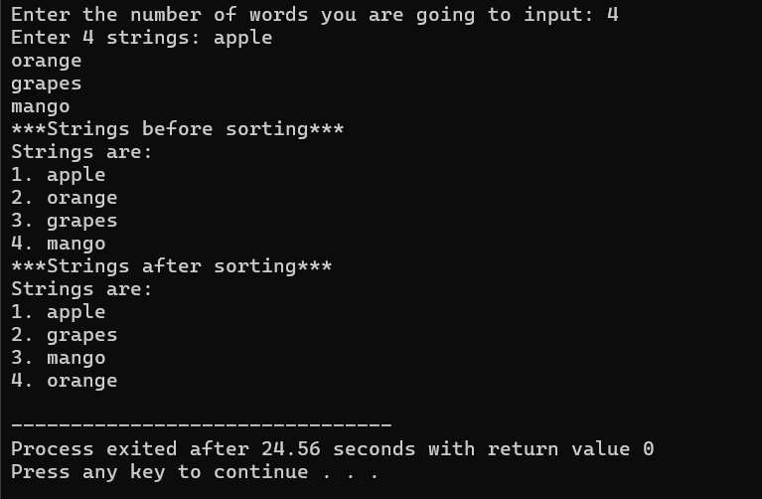

Program No: 16 | Date: 23/07/2025
Program Title: Reverse a string using Stack.
/* Reverse a string using Stack
@Ann Jo Mathew
Roll No: 12
Date: 31/07/2025 */

#include<stdio.h>
#define s 10 // Maximum size 10
char stack[5];
int top=-1; // Top pointer initialized to -1 (empty stack)
void push(char ch){ // Function to push a character onto the stack
if(top+1==5)
printf("error:stack is full");
else{
stack[++top]=ch; //inserting character at top
}
}

char pop(){ // Function to pop a character from the stack
if(top==-1){
printf("error:stack empty");
return '\0';
}
else{
return stack[top--];
}
}
int main(){ //main function
char a[s];
int i;
printf("enter a string: ");
scanf("%s",a);
for(i=0;a[i]!='\0';i++){ //push each character into string
push (a[i]);
}
while(top!=-1){ //pop the characters and print them to get reverse
printf("%c",pop());
}
return 0;
}

Output

