SKIN LESION CLASSIFICATION USING EXPLAINABLE AI

A Minor Project Report submitted to
Manipal Academy of Higher Education
in partial fulfilment of the requirement for the award of the degree of

BACHELOR OF TECHNOLOGY
in
Computer Science and Engineering

Submitted by

ANN SHAM DANIEL
235805100

Under the guidance of

Dr. Mahadevi S
Assistant Professor
Department of Computer Science and Engineering
Manipal Institute of Technology


DEPARTMENT OF COMPUTER SCIENCE AND ENGINEERING
May 2026

DEPARTMENT OF COMPUTER SCIENCE AND ENGINEERING

Bengaluru
26/05/2026

CERTIFICATE

This is to certify that the minor project titled SKIN LESION CLASSIFICATION USING EXPLAINABLE AI is a record of the bonafide work done by ANN SHAM DANIEL (Reg. No. 235805100) and AKHIL GIRISH (Reg. No. 235805272), submitted in partial fulfilment of the requirements for the award of the Degree of Bachelor of Technology (B.Tech.) in COMPUTER SCIENCE AND ENGINEERING of Manipal Institute of Technology Bengaluru, Karnataka, (A Constituent Institute of Manipal Academy of Higher Education), during the academic year 2025-2026.

Dr. Mahadevi S  Assistant Professor  CSE Dept. M.I.T, BENGALURU | Dr. Jayita Saha  HOD, CSE Dept.  M.I.T, BENGALURU

ACKNOWLEDGEMENTS

We would like to express our sincere gratitude to Dr. Mahadevi S, Department of Computer Science and Engineering, Manipal Institute of Technology Bengaluru, for her invaluable guidance, continuous support, and encouragement throughout the course of this minor project. Her insightful suggestions and constructive feedback greatly contributed to the successful completion of this work.

We are also grateful to the Head of Department, Dr. Jayita Saha, and the entire faculty of the Department of Computer Science and Engineering for providing us with the necessary resources and infrastructure to carry out this project.

We extend our thanks to Manipal Academy of Higher Education for the opportunity to undertake this project as part of our curriculum. We also acknowledge the open-source communities behind TensorFlow, Keras, and other tools used in this project.

Finally, we thank our families and friends for their constant motivation and support.

ABSTRACT

Skin lesion classification is a critical application of Artificial Intelligence in the healthcare domain. This project proposes a deep learning-based system that uses Convolutional Neural Networks (CNNs) to classify dermatoscopic skin lesion images into multiple diagnostic categories. The system is trained and evaluated on the HAM10000 dataset, a widely used benchmark containing over 10,000 labelled skin lesion images. To address the interpretability limitations of conventional black-box deep learning models, the system integrates Explainable AI (XAI) techniques — specifically Gradient-weighted Class Activation Mapping (Grad-CAM) — which generates visual heatmaps highlighting the image regions most influential in the model's prediction. This enhances transparency, clinical trustworthiness, and the overall utility of the system for assisting healthcare professionals in skin disease analysis. The proposed approach combines state-of-the-art deep learning with explainability, contributing toward more reliable AI-assisted diagnostic tools in dermatology.

TABLE OF CONTENTS

 | Page No
Acknowledgement | iii
Abstract | iv
List of Figures | vi
Chapter 1 — Introduction | 7
Chapter 2 — Literature Review | 9
Chapter 3 — Objectives | 11
Chapter 4 — Methodology | 12
Chapter 5 — Conclusion | 14
References | 16

LIST OF FIGURES

Figure No | Figure Title | Page No
4.1 | System Architecture / Workflow Diagram | 12

CHAPTER 1
INTRODUCTION

1.1 General Overview
Artificial Intelligence (AI) has made remarkable strides in healthcare, particularly in the domain of medical image analysis. Dermatology, the branch of medicine dealing with skin disorders, is one of the most promising areas for AI-assisted diagnosis. Skin diseases affect millions of people worldwide, and early and accurate detection is critical for effective treatment and improved patient outcomes.

Among the various dermatological conditions, skin lesions — including melanoma, melanocytic nevi, and benign keratosis — represent a diverse range of conditions that require expert visual examination for diagnosis. Traditional diagnosis relies heavily on the expertise and subjective judgment of trained dermatologists, which can introduce variability and is often time-consuming.

1.2 Present-Day Scenario
With the advancement of deep learning, particularly Convolutional Neural Networks (CNNs), automated classification of medical images has achieved accuracy levels comparable to expert clinicians. However, a major challenge with deep learning models in medical settings is their lack of interpretability. Known as 'black-box' models, these systems provide predictions without clear explanations of the underlying reasoning, which limits their clinical adoption.

Explainable AI (XAI) has emerged as a solution to this problem, aiming to make AI predictions transparent and understandable. Techniques like Grad-CAM (Gradient-weighted Class Activation Mapping) enable visual explanation of CNN decisions, making AI-assisted diagnosis more trustworthy and clinically actionable.

1.3 Project Work Schedule
This project was carried out in two phases. Phase 1 involved literature review, problem definition, dataset exploration, and preliminary model design. Phase 2 (planned) will involve model training, Grad-CAM integration, evaluation, and deployment via a Streamlit web application.

1.4 Organisation of the Report
Chapter 2 provides a literature review of existing methods and identifies research gaps. Chapter 3 states the specific objectives. Chapter 4 describes the methodology, system architecture, and tools used. Chapter 5 presents the conclusion and future directions. References are listed at the end.

CHAPTER 2
LITERATURE REVIEW

2.1 Introduction to the Project Area
Skin lesion classification using deep learning has been an active research domain for over a decade. The availability of large-scale dermatoscopic datasets such as HAM10000 and the ISIC Archive has significantly accelerated progress in this area. Research has demonstrated that CNNs, particularly architectures such as ResNet, VGG, and InceptionNet, can achieve performance at par with board-certified dermatologists on specific classification tasks.

2.2 Existing Solutions and Research Background
Several notable works have shaped the current landscape of skin lesion classification:

- Esteva et al. (2017) demonstrated that a CNN trained on a large dataset of clinical images could classify skin cancer with accuracy comparable to dermatologists. This landmark paper highlighted the potential of deep learning in dermatology.
- Codella et al. demonstrated high performance on the ISIC challenge benchmark using ensemble methods combining CNNs with traditional feature extraction.
- Transfer learning approaches, where models pre-trained on large datasets (e.g., ImageNet) are fine-tuned on medical images, have become a standard technique to overcome the challenge of limited labelled medical data.
- The HAM10000 dataset, introduced by Tschandl et al., provides over 10,000 dermatoscopic images across seven diagnostic categories, becoming a widely adopted benchmark.

2.3 Gaps Identified in Current Methods
Despite the progress, several important gaps remain in existing literature:

- Lack of Explainability: The majority of high-performing models are black-box in nature. Clinicians require explanations for AI-driven predictions before trusting and adopting them in clinical workflows.
- Limited Trust and Transparency: Without visual or textual explanations, medical professionals are reluctant to rely on AI recommendations, especially in high-stakes decisions.
- Computational Cost: Many high-accuracy models involve complex architectures requiring significant computational resources, limiting deployment in resource-constrained settings.
- Generalisation: Models trained on specific datasets may not generalise well to images from different hospitals or imaging devices.

2.4 Summarised Outcome of the Literature Review
The literature review establishes that while deep learning has demonstrated strong performance in skin lesion classification, the integration of explainability mechanisms remains an open and important challenge. This project addresses this gap by combining CNN-based classification with Grad-CAM-based explainability, producing a system that is both accurate and interpretable.

CHAPTER 3
OBJECTIVES

The specific objectives of this project are as follows:

- To classify skin lesion images into multiple diagnostic categories using deep learning techniques, specifically Convolutional Neural Networks (CNNs).
- To improve prediction accuracy by designing and training an effective CNN model on the HAM10000 dataset.
- To implement Explainable AI (XAI) for transparent and interpretable predictions, enabling healthcare professionals to understand the model's reasoning.
- To generate Grad-CAM heatmaps that visually highlight the important regions within skin lesion images that influence the model's classification decision.
- To assist healthcare professionals in skin disease analysis by providing a tool that combines high classification performance with clinical interpretability.
- To deploy the system as a user-friendly web application using Streamlit, allowing easy access for end users.

CHAPTER 4
METHODOLOGY

4.1 Proposed Approach
The proposed system follows a pipeline that begins with preprocessing raw skin lesion images, passes them through a trained CNN model for classification, and then applies Grad-CAM to generate visual explanations. The complete architecture is shown in Figure 4.1.

4.2 System Architecture / Workflow
The system architecture consists of the following stages:
- Input Image: A dermatoscopic image of a skin lesion is provided as input.
- Preprocessing: The image is resized, normalised, and augmented (during training) to improve model generalisation.
- CNN Model: The preprocessed image is fed into a Convolutional Neural Network that extracts hierarchical visual features (texture, colour, shape) relevant to classification.
- Classification: The CNN outputs a probability distribution over the diagnostic categories, and the class with the highest probability is assigned as the prediction.
- Grad-CAM: The Grad-CAM algorithm computes gradients of the predicted class score with respect to the last convolutional layer's feature maps, producing a heatmap.
- Result: The final output includes the predicted category and the Grad-CAM heatmap overlaid on the original image.

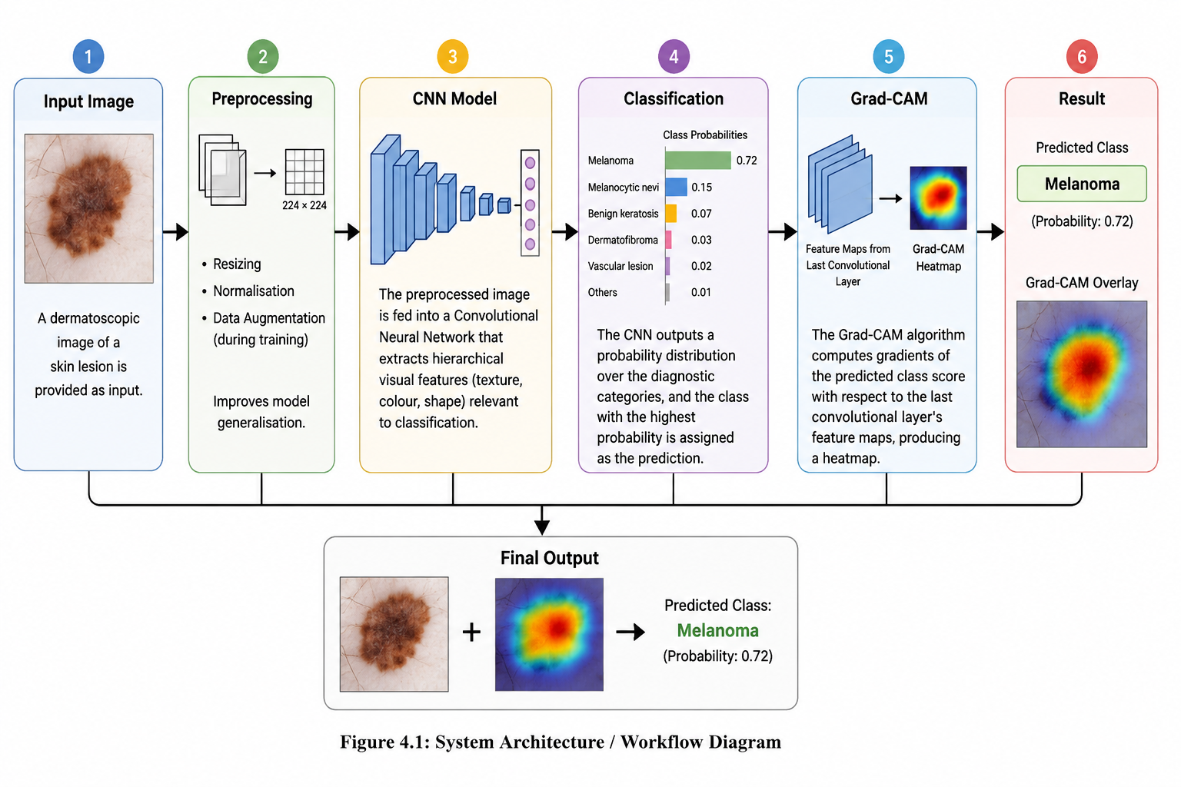
[Figure 4.1: System Architecture / Workflow Diagram]

4.3 Dataset
The project uses the HAM10000 (Human Against Machine with 10000 Training Images) dataset. Key characteristics of the dataset include:

- Contains 10,015 dermatoscopic images of pigmented skin lesions across seven diagnostic categories: Melanocytic nevi, Melanoma, Benign keratosis, Basal cell carcinoma, Actinic keratoses, Vascular lesions, and Dermatofibroma.
- Images are collected from two different sources (Vienna and Queensland) and are provided with ground truth labels confirmed by histopathology, follow-up, expert consensus, or in-vivo confocal microscopy.
- The dataset is publicly available on Kaggle and is a standard benchmark for medical image classification research.

4.4 Tools and Technologies
The following tools and frameworks are used in this project:

- Python: Primary programming language for model development and data processing.
- TensorFlow / Keras: Deep learning framework used to build, train, and evaluate the CNN model.
- CNN (Convolutional Neural Network): Core model architecture for image feature extraction and classification.
- Grad-CAM: Explainability technique used to generate class activation heatmaps.
- OpenCV: Image processing library used for heatmap generation and visualisation.
- Streamlit: Web application framework used for deploying the model as an interactive interface.

4.5 Assumptions
- Input images are assumed to be dermatoscopic images of sufficient resolution for meaningful feature extraction.
- The HAM10000 dataset is assumed to be representative of real-world skin lesion distributions for training purposes.
- Ground truth labels provided in the dataset are treated as reliable.

CHAPTER 5
CONCLUSION

5.1 Summary of Work
This project proposes and designs a skin lesion classification system that integrates CNN-based deep learning with Explainable AI techniques. The system uses the HAM10000 dermatoscopic dataset and applies Grad-CAM to generate visual heatmaps, providing transparent and interpretable predictions that are clinically useful.

5.2 Problem Statement and Objective (Brief)
Traditional skin disease diagnosis is dependent on expert visual examination and is inherently subjective and time-consuming. Existing AI solutions, while accurate, operate as black-box models that do not provide clinical explanations. This project addresses both the accuracy and explainability challenges by combining CNNs with Grad-CAM-based visualisation.

5.3 Methodology Planned
The methodology follows a structured pipeline: image preprocessing, CNN-based feature extraction and classification, and Grad-CAM-based heatmap generation. The system is built using Python, TensorFlow/Keras, and OpenCV, and is designed to be deployed as a Streamlit web application for accessibility.

5.4 General Conclusion
The project successfully combines state-of-the-art deep learning with Explainable AI techniques to address a critical need in dermatological diagnosis. Key contributions include:

- A CNN-based model capable of multi-class skin lesion classification with improved accuracy.
- Grad-CAM integration that improves transparency by highlighting the image regions most relevant to each prediction.
- A clinically interpretable system that builds trust in AI-assisted diagnosis and reduces the black-box nature of traditional deep learning models.
- A user-friendly deployment framework via Streamlit that enables broad access to the tool.

Future work will focus on improving model accuracy through advanced architectures (e.g., EfficientNet, Vision Transformers), expanding explainability to additional XAI methods (LIME, SHAP), and validating the system on clinical data from multiple sources.

REFERENCES

[1] A. Esteva et al., "Dermatologist-level classification of skin cancer with deep neural networks," Nature, vol. 542, pp. 115–118, 2017.

[2] N. C. F. Codella et al., "Skin lesion analysis toward melanoma detection: ISIC 2017 challenge, data set, and baseline results," in Proc. IEEE Int. Symp. Biomed. Imaging (ISBI), 2018.

[3] P. Tschandl, C. Rosendahl, and H. Kittler, "The HAM10000 dataset, a large collection of multi-source dermatoscopic images of common pigmented skin lesions," Scientific Data, vol. 5, 2018.

[4] R. R. Selvaraju et al., "Grad-CAM: Visual Explanations from Deep Networks via Gradient-Based Localization," in Proc. IEEE Int. Conf. Comput. Vis. (ICCV), 2017, pp. 618–626.

[5] "Explainable Artificial Intelligence for Medical Imaging," Springer Nature, 2022.

[6] "Skin Cancer Classification Using Deep CNNs," IEEE Transactions on Medical Imaging, vol. 39, 2020.

[7] HAM10000 Dataset, Kaggle, [Online]. Available: https://www.kaggle.com/kmader/skin-lesion-analysis-toward-melanoma-detection

[8] TensorFlow Documentation, Google, [Online]. Available: https://www.tensorflow.org

PROJECT DETAILS

Student Details
Student Names | Ann Sham Daniel
Register Numbers | 235805100
Department | Computer Science and Engineering, MIT
Project Details
Project Title | Skin Lesion Classification Using Explainable AI
Guide Details
Faculty Name | Dr. Mahadevi S
Contact Address | Dept of Computer Science & Engg, Manipal Institute of Technology, Bengaluru – 560064 (Karnataka State), INDIA

