MongoDB CRUD Checkpoint Report

# Step 1: Create Database

Screenshot: __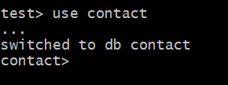______________________________

# Step 2: Create Collection and Insert Documents

Screenshot: ____ 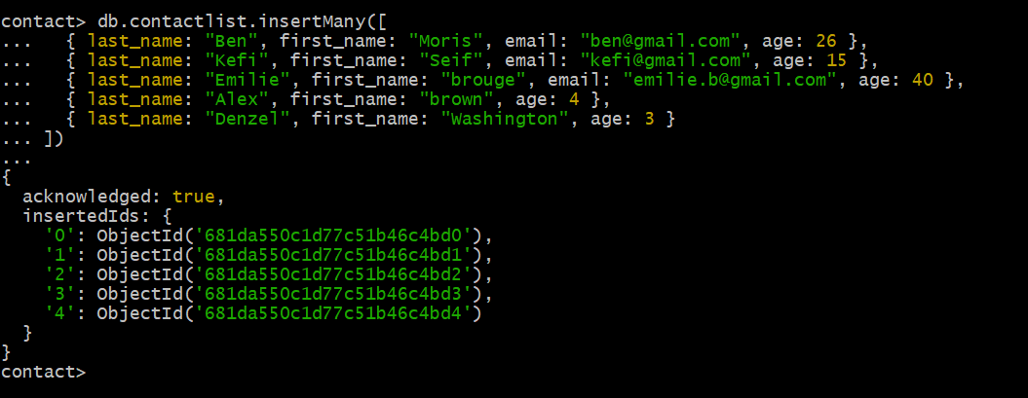____________________________

# Step 3: Display All Contacts

Screenshot: _______ 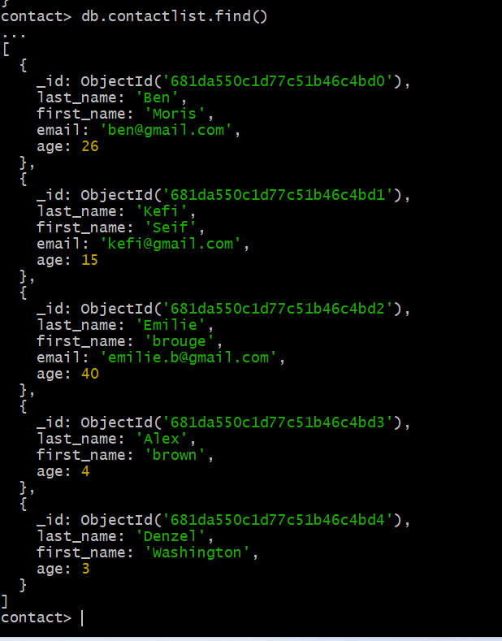_________________________

# Step 4: Display One Contact by ID

Screenshot: _____ 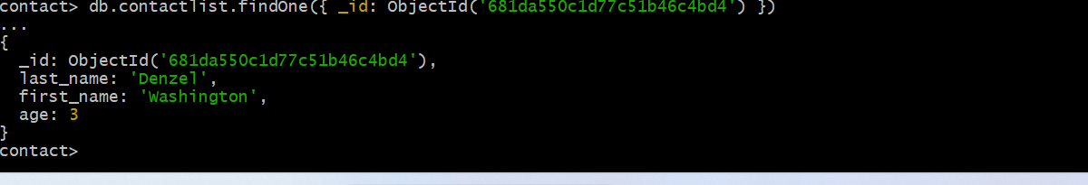___________________________

# Step 5: Display Contacts with Age > 18

Screenshot: ______ 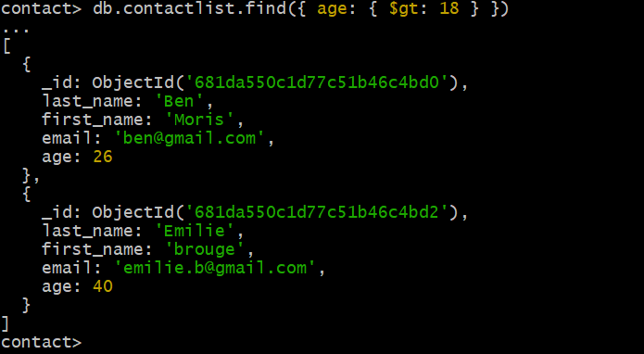__________________________

# Step 6: Display Contacts with Age > 18 and Name Containing 'ah'

Screenshot: _____ ___________________________

# Step 7: Update First Name from 'Kefi Seif' to 'Kefi Anis'

Screenshot: ____ 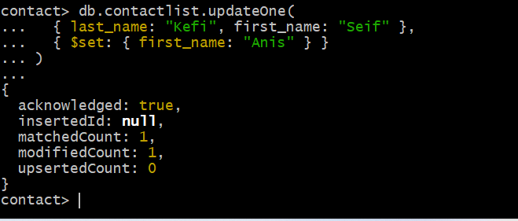____________________________

# Step 8: Delete Contacts with Age < 5

Screenshot: ______ __________________________

# Step 9: Display Updated Contact List

Screenshot: ___ 