2. b and c)
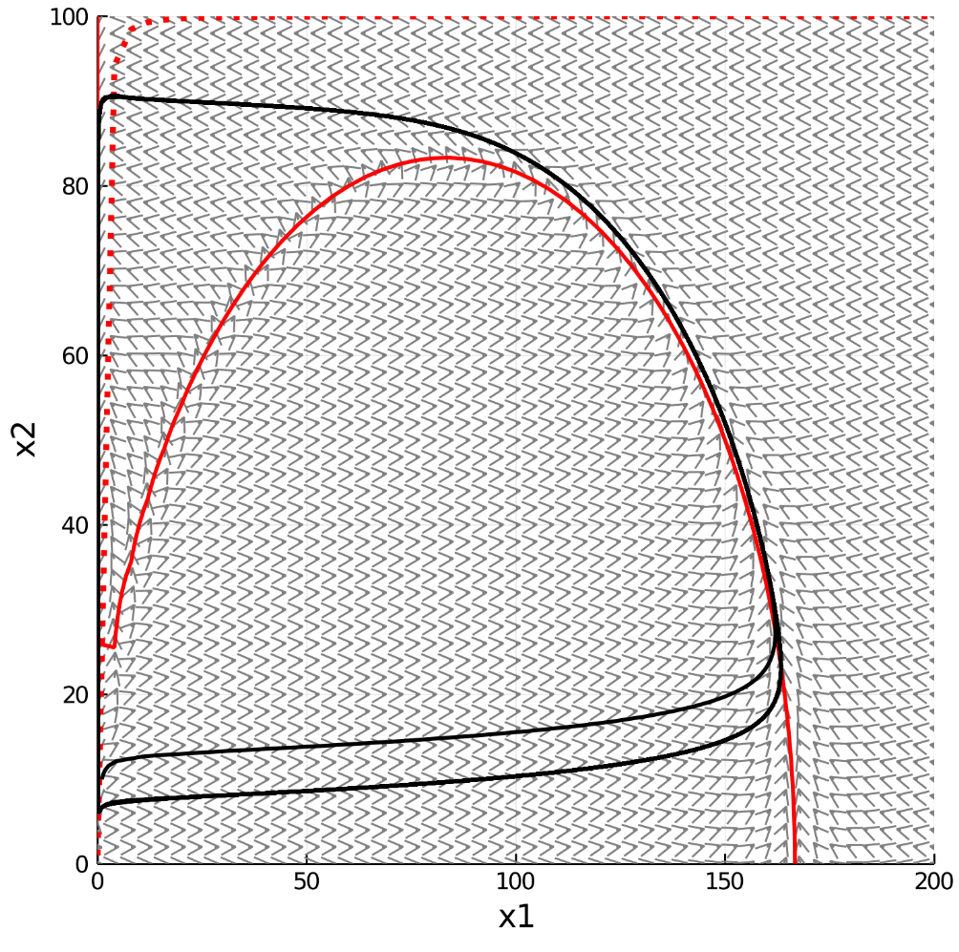
Phase portrait plot
Fixed point, where nullclines intersect
Unstable
Legend:
x1 = c_{a}
x2 = c_{r}
red-dotted line = c_{r} nullcline
red solid line = c_{a} nullcline
black solid line = representative solution when c_{ao} = 1 and c_{ro} = 10

e)
3. b and c)
n = 1 plot has one steady-state solution, which is stable. n = 2 plot has three steady-state solutions. The center steady state is unstable while the other two steady states are stable. As the degree of cooperativity increases, the center steady state shifts to lower concentrations, moving the nullclines with it (and vice versa). Cooperativities higher than 1 will have multiple steady states. The steady states are circled.
3 e – bonus) (attempt) a_{crit} is about 1.5385

