20/4/16
- Nothing
- Read specification
Means of communication set up
- To decide on meeting times

21/4/16 - 25/4/16
Nothing

26/4/16
- Nothing
- Meeting time decided – to meet every week on tuesdays 12-2pm
- First meeting

27/4/16
- Meeting time decided
- First meeting (minutes by Peter)
Basis of project:
- easy, intermediate, expert
- solvable
- obstacles
- power up

Scrum roles:
- Scrum master = Kayleen
- Product owner = Blake
- Developer = Ben, Anna
- Tester = Peter
3. Maze representation
Classes → UML diagram

3/5/16
- UML diagram draft complete
- Second meeting
Produce backlog :
- Generating a maze
- Displaying a maze
- Using arrows to navigate a path through the maze with current position being represented by marker
- Congratulated on completion
- Menu screen before start of game
- Able to exit and restart
- Timer which determines score
- Music and ability to turn on/off

First sprint to be completed by next Tuesday, before the lab review
- Peter = Maze, Player
- Blake = AMazingGame
- Ben = AMazingGame
- Anna = Maze, Player
- Kaylen = UML, Tile
3. Agree on UML diagram and complete class stub

8/5/16
- Nothing
- Using Prim's algorithm or depth first search with backtracking to generate maze.
Draft UML
- Concrete design on how to represent the points in the maze and the edges associated with them
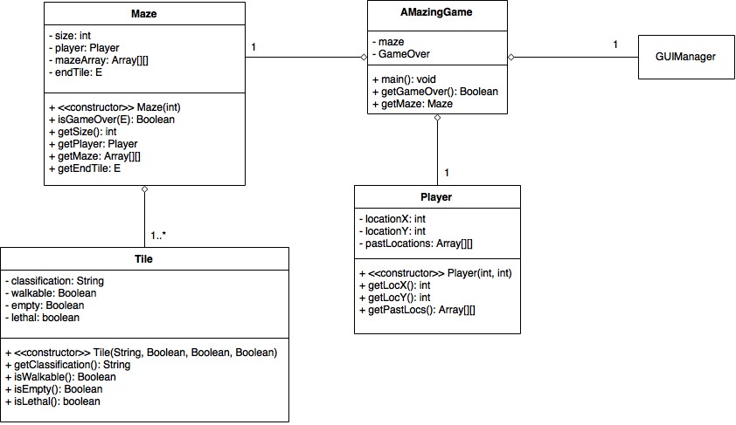
9/5/16
- Deciding the algorithm to use to generate the map
Draft UML
- If each point in the maze was a tile of some classfication (i.e. path, lava), then the walls, or lack of wall, would be represented by an array of edges, in the order north, east, south and west. Each edge is a boolean to state whether there is a wall there or not.
Third meeting:
Discussion on implementation of methods in maze and player.
Should have a maze generated and displayed (with ascii for now) for the sprint review on Wednesday.
- Implementing depth first search
Gantt chart

10/5/16
- Representing the points on the maze as tiles with edges
Gantt chart
- Depth first search implemented by recursive backtracking:
Have list of tiles needed to be visited.
Make the initial cell current cell and remove from toVisit.
While the toVisit is not empty, if the current cell has neighbours that have not been visited, then choose a random unvisited neighbour and push the current cell to the stack. Remove the wall between the current and the chosen neighboutr and make the chosen the current and remove from toVisit. Else if the stack is not empty, pop cell from stack and make it current.
- Finish the generator

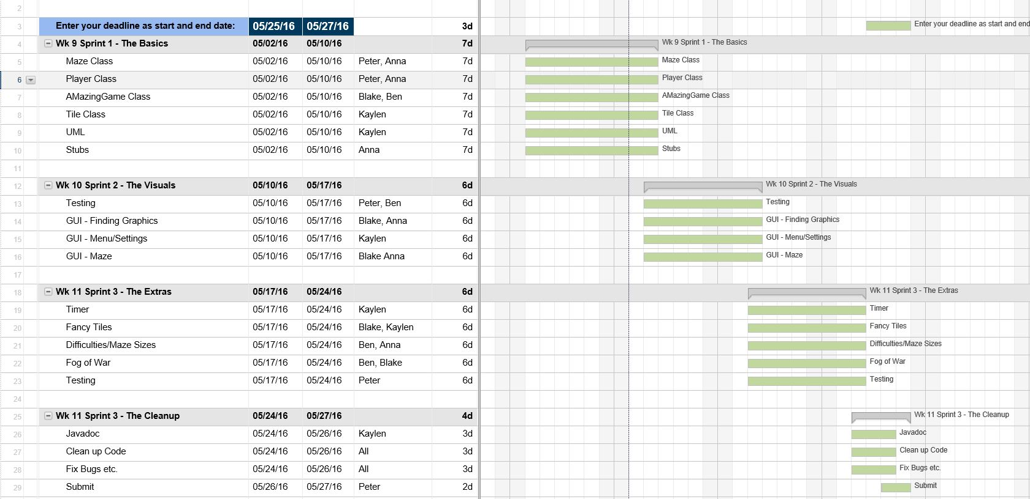

14/5/16
- Nothing
- Working on generating mazes based on Prim's algorithm. This will produce mazes which have less long corridors with more deadends (so harder). Steps:
Start with grid of walls
Pick a cell (starting cell on top left corner) and make it part of maze. Add walls of the cell to wall list to check.
While there are walls in the list, pick a random wall from the list. This wall will either have one unvisited cell on one side of it or both will already have been visited. If it is the former, remove the wall and make the cell on the other side of the wall part of the maze. Add the walls of that cell to the walls list. Then remove the wall from the list.
This is identical to Kruskal's, being a minimal spanning tree algorithm, as it is choosing random cells.
- Finish implementation

15/5/16
- Working on Prim's algorithm
- Prim's algorithm working
Change to the maze: the input number that is given to generate a maze is the number of paths in the maze. As there is a wall between each path as well as the border of the maze itself, the input must be multiplied by 2 plus 1, giving the actual tile dimensions of the maze grid.
- Design of GUI

16/5/16
- Finished Prim's algorithm
- Mazes can now be generated according to the level of difficulty chosen, being either depth-first or Prim's. GUI should be done, however the people in charge of this section have not completed a working graphical representation of the current work done in the backend.
- Concrete idea on theme of game

17/5/16
- Maze generation based on level selected, altering the size and algorithm used
- For the GUI, it has been decided that a card layout will be used. Currently, the maze is displayed with placeholder images. The sprites to be used for the final product will be from kennley, who provides free use of his art. To make the game more interesting, the game will no longer be a traditional top-down view maze but a platformer where the player can jump and walk along the platforms (walls). The start point will now be at the bottom right corner and the end on the top left. For jumping, he will have a jetpack to allow for jumps of all sizes to be made, as the generation of the maze is random and so the lengths of walls will be unknown for a set jump height to be implemented. There are also various images for enemies, powerups and pickups that can be incorporated. As a base, the player can only pick up coins (or some other thing) that will increase points (which for now is based on the time taken to complete the maze). But the addition of the following things is desired:
    - suns are stationary and will inflict burn damage
    - storm clouds will be following the player and does damage
    - lightning will randomly appear and inflict damage
    - for harder levels, invisibility potion will give the player 3 secs to move anywhere
    - have a key somewhere in the maze that has to be collected before the end can be unlocked
    - wings will randomly appear every 15 secs somewhere in the maze. They will give increased speed in movement
- Have a player be able to move around in the maze

21/5/16
- Nothing
- Realised that everything was wrong. The game was not running, it was just being repainted after each key press which is so wrong. Realised that in the beginning, running the game was going to be based on input which is no. So massive overhaul, major redesigns. Implementation of maze and player is still correct though. To finalise the deisgn by tomorrow.
- Pretty much start over

22/5/16
- Regrets
- The redesign: the panel holding the game no longer contains the game but a gameState. The gameState contains the maze and all the elements inside it including players, enemies and items which individually must be able to update based on input and draw themselves based on the update. So the gamePanel calls the gameState to update and draw, which in turn calls the maze and all its elements to update and draw. The updating and drawing is occuring in a thread which is running in a loop. This is done by having gamePanel implement Runnable.
- Add enemies and pickups.

23/5/16
- Redesigned the way the game is being implemented.
- The player has health except no HUD and does not die when it reaches 0. Enemies (currently there is only an evil sun) do damage when they are touching the player.
- Jumping

24/5/16
- There is an enemy but it really does nothing
- The implementation of jumping and falling when not on the ground sort of works. But because it is still moving in terms of tiles, the jumping does not seem very smooth. I have also added the beginnings of animation, which every Entity and Item can have. Each of the objects will have an Animation object which contains an array of images that it cycles through.
- Fix the animation so that movement is different for when idle, walking and jumping (right now it is walking on the spot everywhere). Also:
    - when the game begins, a random character can be chosen (so that each time they are different colour)
    - the pickups should be more to the theme of the game (being in the sky). Right now there are only coins but this should be replaced with something else as well as something for health, a weapon to shoot an enemy, an invisibility cloak/bubble, keys to unlock pathways or to finish (the pathways thing will require the key and locked pathway to spawn correctly so that the key is not beyond the pathway)
    - enemies currently move randomly as well as the evil lightning which appears randomly. But for land enemies, they should only move on the platforms.

26/5/16
- Jumping
- The end is nearing at last. POWERUPS. Now it really doesn't make sense because the player is jumping everywhere but I chose one attack and one defence item to add. I would like to add more like invisibility cloak but time is pressing. The weapon of choice is a flail just cause it looks cool. And the defence was a bubble but due to inability to see it against the background, a shield will be used. The player can only have one powerup at any one time so if they touch another one, it will override the one they already had.
- FIX LITTLE ERRORS THAT HAVE MULTIPLIED IN THE CODE (no there are actually only a few)

27/5/16
- Powerups
- Today was the day of hand-in. I was doing most of the bug fixing because I wrote majority of the code including maze generation, running of the game, key input, items, enemies, hud, drawing and updating of the visuals while my teammates had taken 2 weeks to complete a menu screen and difficulty screen, both of which had 3 buttons???????? But they played it and said it was cool, not realising that it had taken me all week, after I found out the person in charge of the maze gui hadn't done anything and this was MONDAY. And the others apparently had assignments and stuff (but so did I) and couldn't do it. When I asked them to help me for parts, they said what I already had was fine. But it was things we needed to improve. So they didn't help me and I improved it. So all in all, I felt this project was done by me until the last day where we met up to finish off the project, they worked on background images and the menu and difficulty screen (cause at this point they still were not finished). And someone else fixed the weirdness of player movement.
- Sleep until I don't feel dead.

