* Images same size so it’ll look cleaner.
* LOFI HIP HOP RADIO, not relevant (Not my channel)
* Many viewers and subscribers  
  Our channel has over 50K subscribers,   
  and over 13 million viewers. (Already said in the text before = 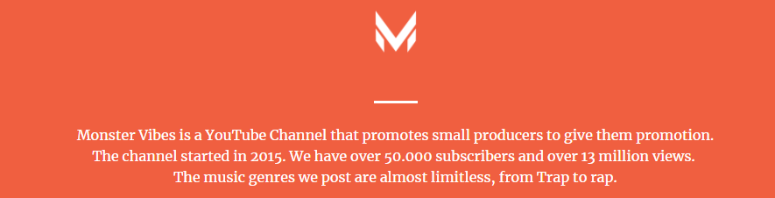

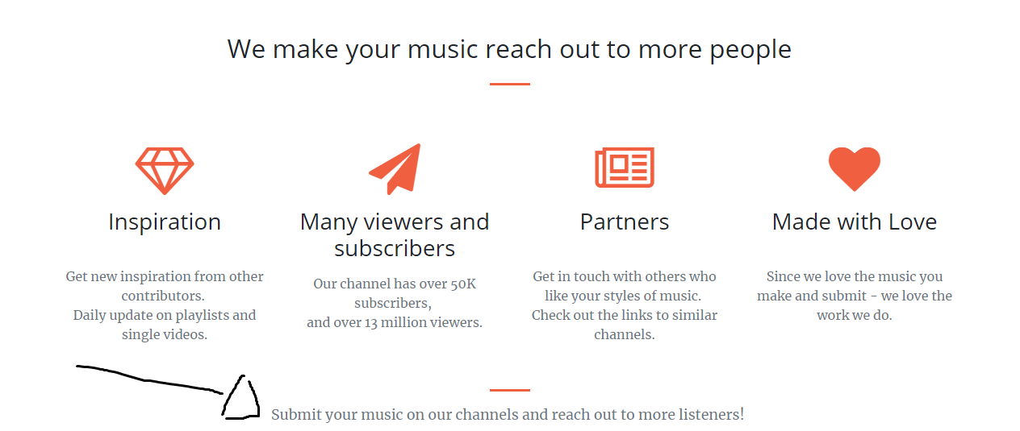

Add a hyperlink to the submission form