Blei “Latent Dirichlet Allocation” (LDA)

Motivation
I am fascinated with the phenomenon of language – how we can evoke such a detailed, specific experience in another person just sending an audio signal.
Example of importance: for like a hundred years there were conflicting theories about what were the basic types of human personality. There seemed to be no objective way to test these theories. Finally, researchers performed statistical factor analysis on the adjectives used to describe people. This led to a widely recognized model that there were five basic traits: extroversion, agreeableness, conscientiousness, neuroticism and openness.
I bring this up to show that NLP is more than just a technology, it will provide data for science.

What is LDA
Topic modeling is unsupervised ML to:
- “Discover the thematic structure”
- “Annotate the documents”
- “Use the annotations to visualize, organize, summary.”
(Probabilistic Topic Models and User Behavior YouTube, 2017)
Balance two conflicting requirements – small number of topics per document, small number of words per topic.
LDA is a topic modeling technique based on a probabilistic generative model. Mixed membership model: instead of one pdf you have a mix of many pdf’s, each with its own probability. It uses an iterative numerical calculation to estimate which distribution maximizes the likelihood of the documents.
Application very broad (genetics – classify individuals by genotype and define populations).

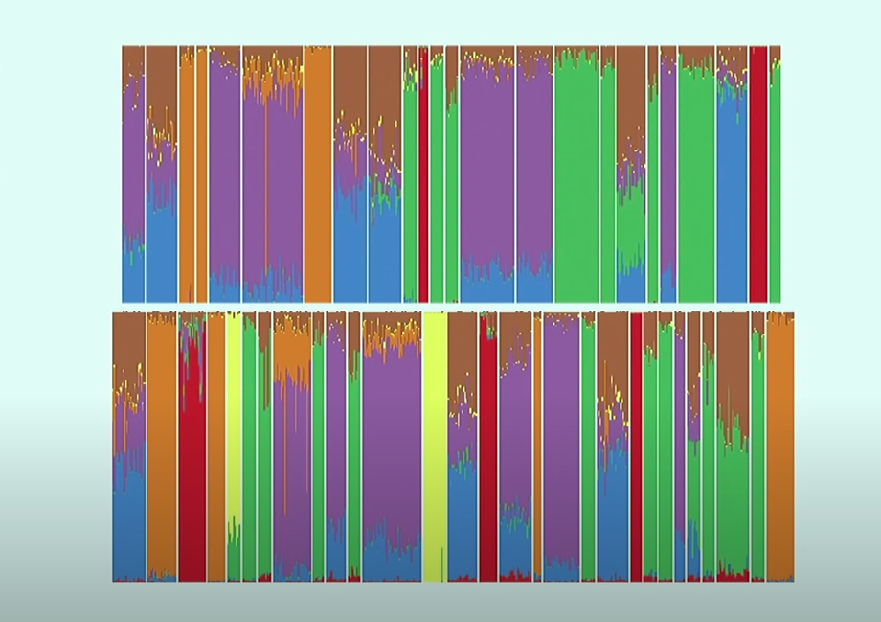

LDA vs. K-Means Clustering
K is hyperparameter in both cases but in LDA the assignment to categories is probabilistic (soft). LDA provides more meta-data: topic definitions, document topic mixes

LDA vs. Latent Semantic Indexing
LSI is deterministic – you count word frequencies, form a matrix representing the corpus and factor that matrix, selecting the components associated with the largest eigenvalues. There is no probability.

Overview
Mixed membership – the mixture components are topics and the weighting of the components varies from document to document. Bag of words – order doesn’t matter. The topics are vectors of probabilities of words and the mix in a vector of probabilities of topics. These are hidden (latent) variables and we have to infer them using Bayesian statistics.
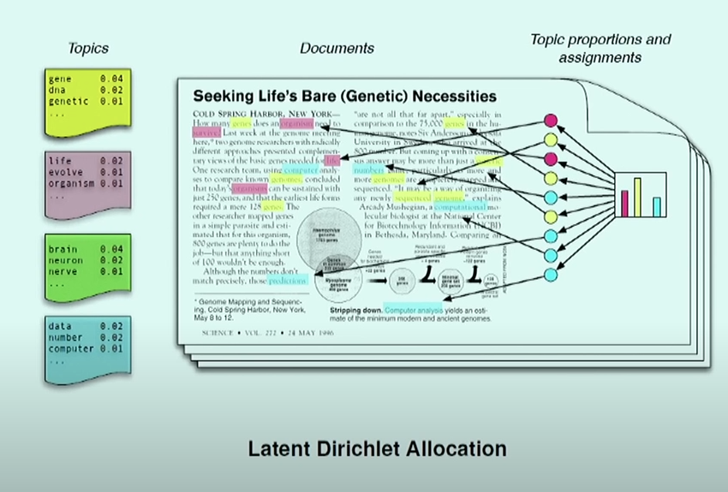

From Wikipedia, “...de Finetti's theorem states that exchangeable observations are conditionally independent relative to some latent variable.” The observations are the words of the document and the latent variables are the topics and topic mixtures.
Blei says “by taking the de Finetti theorem seriously, we can capture significant intra-document statistical structure via the mixing distribution.”
“We wish to find a probabilistic model of a corpus that not only assigns high probability to members of the corpus, but also assigns high probability to other “similar” documents.”

Generative Process

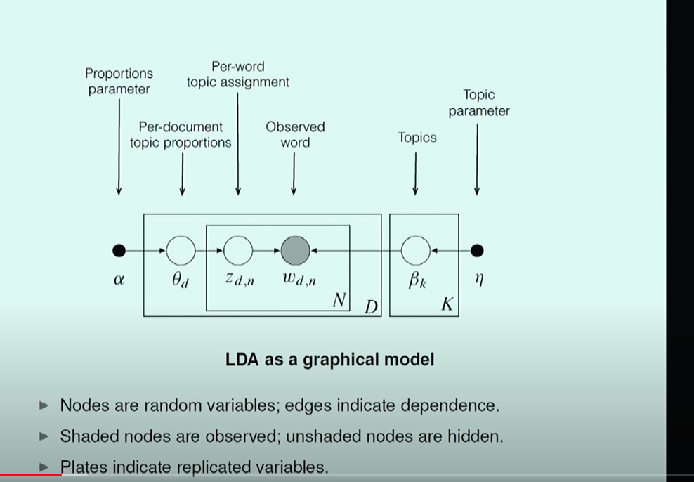

Nodes are random variables; edges indicate dependence. Shaded nodes are observed; unshaded notes are hidden. The plates (rectangles) indicate replicated variables.

The generation of documents is a random process where the underlying distribution depends on the following parameters:
- 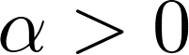, the parameter of the Dirichlet distribution of topic mixtures
- k the assumed number of topics and
- β, a matrix with one row for each topic and one column for each word in the vocabulary. β represents the probabilities of words for each topic, so the rows of β sum to one.

In the training phase, k will be set as a hyperparameter and the remaining parameters will be estimated. As each document is generated, it will give rise to the following random variables:
- 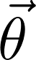, a vector of non-negative real numbers summing to one and representing the topic mix. θ is drawn from the Dirichlet distribution. It is constant for a given document and independent across documents.
- 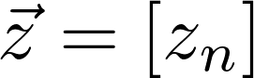, a sequence of integers identifying the topics for the n words of the document. The 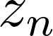 for a given document are independent of one another
- 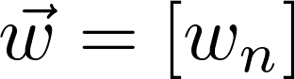, the words of the document. The 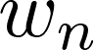 for a given document are independent of the the for the next document.
The topics and the words are not independent of one another.

The document is treated as a bag of words in no particular order drawn from topics in nor particular order. This means that the joint pdf 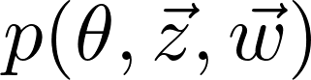 doesn’t change if the words or topics are permuted.

Repeat the following steps M times:
- Choose the document length 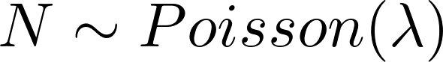.
- Choose a topic mix 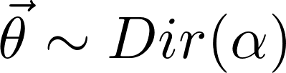
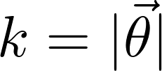 is the number of topics, a hyperparameter.
- Repeat the following steps N times
a. Choose a topic 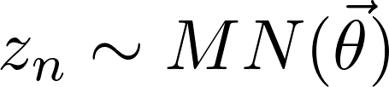. MN is the multinomial distribution.
c. selects the column from β that defines the word probabilities for the topic . Call that column 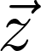. 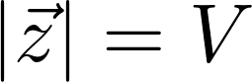, the number of distinct words in the corpus. β will be fit to the corpus during the estimation process. Choose a word .

Joint Distribution
The joint pdf of the random variables produced during document generation can be written as the product of the pdf’s of the the random vector and the dyad 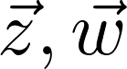
Equation 2
The second of these can likewise be written as a product over the words of the document:
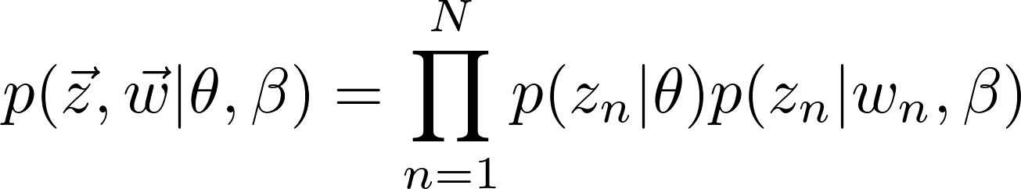:
Substituting gives
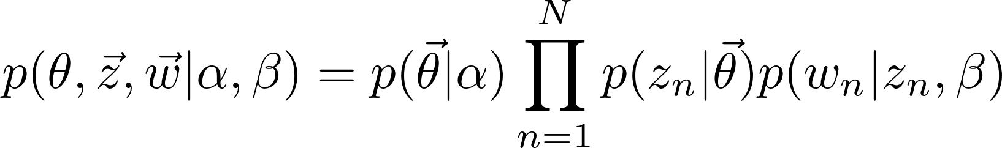

Marginal Distribution
A word can come from any topic, so the probability that the word is 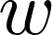 is weighted by the topic mix.
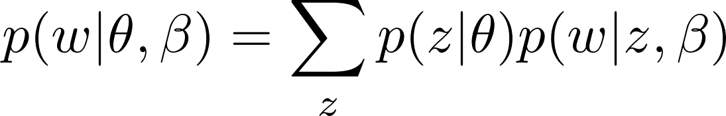
The words are not independent random variables unless conditioned on θ because if a given word is generated, that conveys information about the likelihood of the various possible values for the topic mix, which in turn conveys information about the probability distribution of the next word. Therefore the probability of a document cannot be written as the product of the probabilities of the various words:
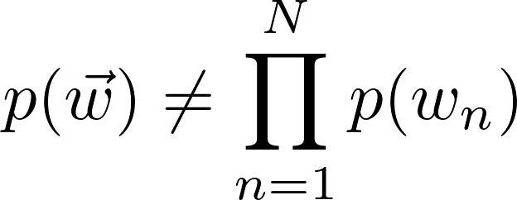
Instead, the probability distribution of the document is a mix of the document probability distributions associated with the various possible topic mixtures:
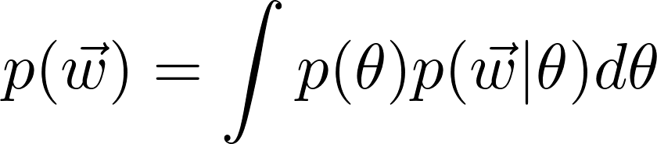
The pdf of the topic mix θ depends on the Dirichlet parameter α and the pdf of the word depends on the both the topic chosen for the word and the word mix for that topic.
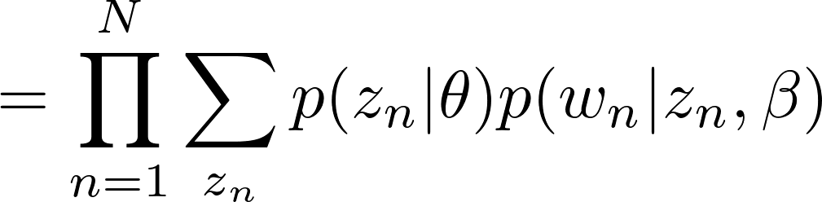
Equation 3
So the pdf of the document is written: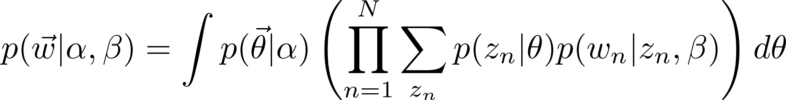
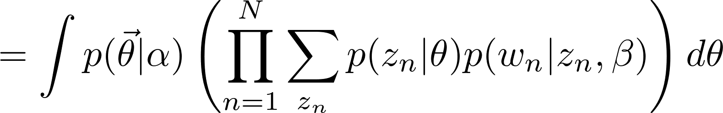

Probability of a Corpus
The corpus itself is a random variable. Since the documents are independent, the pdf can be written as the product of the pdf’s for the individual documents.
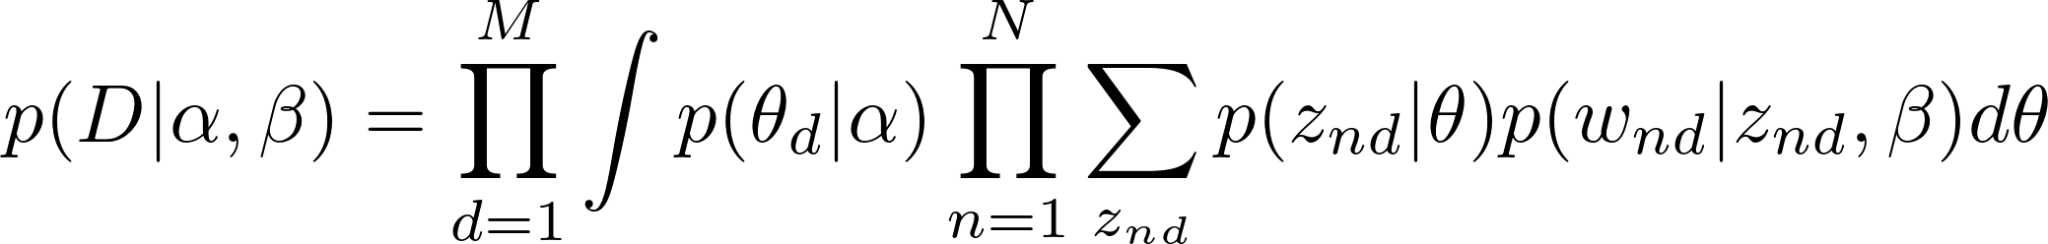

Latent Topic
The documents are interchangeable and the words are also interchangeable. De Finetti’s theorem implies that their pdf’s are independent when conditioned on the latent variable, the topic mix θ. Therefore, the conditional pdf of the document is the product of the conditional pdf’s of the words. Likewise, the conditional pdf of the topics for the document is the product of the conditional pdf’s of the topics for the individual documents.
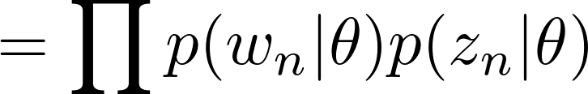
The marginal pdf is obtained by integrating out the dependence on the topic mix:
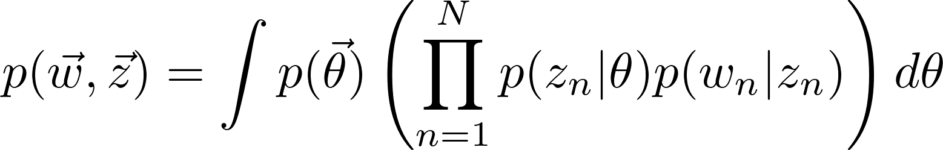
If the topics are interchanged, the factors occur in a different order but their product is the same. Likewise, if the words are interchanged, the product of their pdf’s is unchanged, in accordance with De Finetti’s theorem.

Marginal Distribution of Documents
Equation 3 can be obtained by marginalizing out the topic variables, that is, summing over topics:
Equation a.
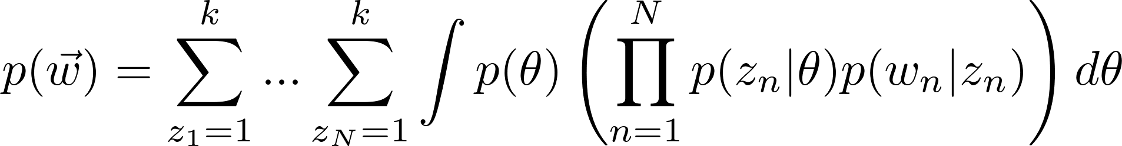
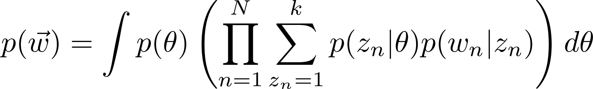
Blei writes the sum in equation a as a sum over topic vectors:
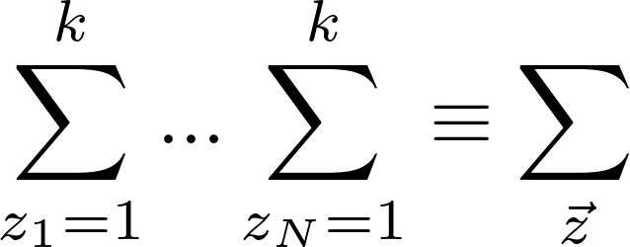
The conditional distribution of the random words is therefore:
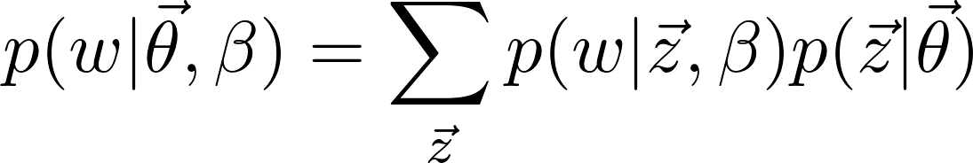
The document generation process implied by this formula is:
- Choose 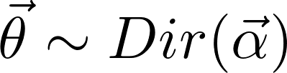
- For each of the N words :
a. Choose a word from 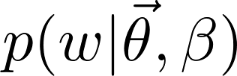
Because each word depends only on the topic , the documents are distributed in proportion to the distribution of the topics. Blei expresses this by saying that the marginal distribution of a document is a “mixture distribution”:
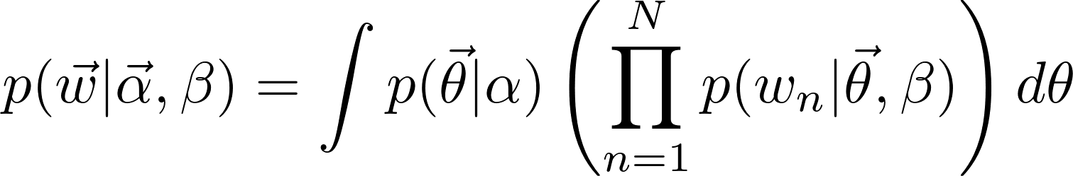
The mixture components are and the mixture weights are 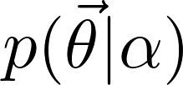
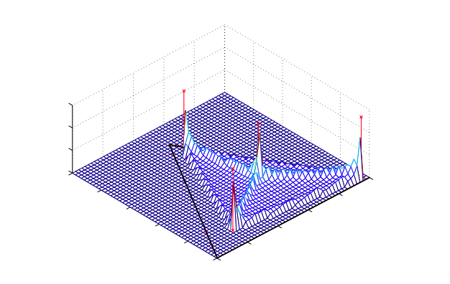
In the figure there are three words in the vocabulary, for example “dog”, “cat” and “hamster.” A topic is a random combination of dogs, cats and hamsters. Every point within the triangle represents a topic. The vertices of the triangle represent the three “pure” topics: 100% dog, 100% cat and 100% hamster. The midpoints of the triangle edges represent three mixed topics. One is 50% cat and 50% dog. Another is 50% cat and 50% hamster and the third is 50% dog and 50% hamster. The centroid of the triangle represents an equally mixed topic: 33% dog, 33% cat and 33% hamster. The points directly below points marked with an x represent four mixed topics. The z axis might represent 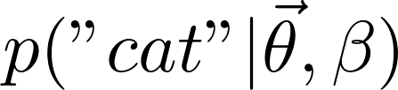, the probability of a word in a document being “cat” for a given β. Apparently, β will be such that the peaks can be in the interior of the triangle rather than being confined to one corner.
Ask the group how this can be!

Inference and Parameter Estimation
The words sequence of a document determines, in principle, the posterior probability density as a function of the topic variables θ and . The goal is to identify the values of these variables that have maximum probability.
Bayes’ Rule says the pdf is given by
Equation 3, restated is
The likelihoods 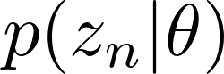 and 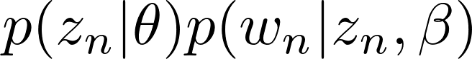 associated with the multinomial distributes are just products of powers of the underlying parameters θ and β, resulting in
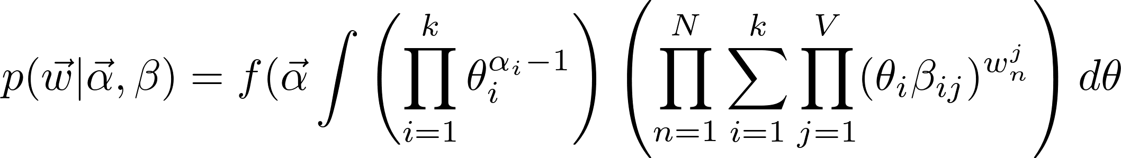
The way that 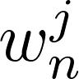works is by one-hot coding For example, if the vocabulary were “cat”, “dog”,”armadillo”, “hamster”, then “dog” would be encoded as
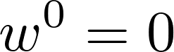
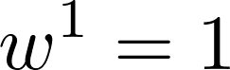
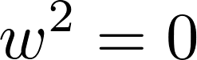
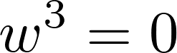
Thus the product over words in the vocabulary only gets a factor different from one for the particular word, getting a single θ.
The expression involving β is matrix multiplication. β is a k by V matrix representing the probabilities of particular word/topic combinations. There is one row for each topic and one column for each word in the vocabulary. The exponent selects one column, that is one word in the vocabulary.

The discussion seems to imply that the numerator 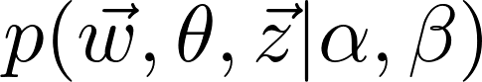 can be calculated. The likelihood 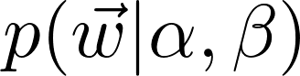 must be approximated by variational methods. The authors provide at least two methods:

Kullback-Leibler Divergence
This method computes a lower bound.

The Kullback-Leibler (KL) divergence from one probability distribution to another, a.k.a. the cross-entropy, is a measure of the how the second distribution differs from the first. It indicates the gain or loss of information when substituting the second distribution for the first. In the appendix, the authors show that the optimum is achieved when the KL divergence between the approximate posterior distribution and the true posterior distribution is minimized. The approximate posterior is parameterized by γ and φ. Their optimum values are:

where D is the divergence, q is the approximate distribution, φ is the probability of a topic for a word and γ is the parameter of the posterior distribution.

This is solved iteratively. The authors provide the following pseudo-code:

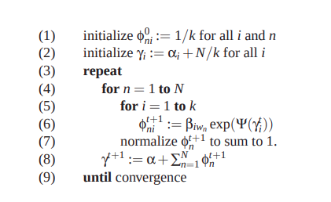

Bayesian – Expectation Maximization
Dempster et al. - Maximum Likelihood from Incomplete Data via the EM Algorithm
Five kinds of animal, we only know the total of the first two kinds
Problem is to estimate π
Initial guess 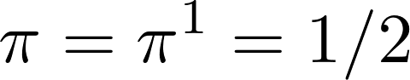
Exponential family canonical form of pdf:
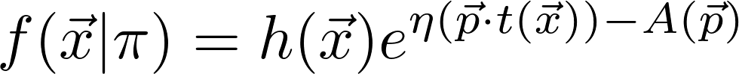
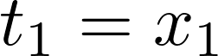
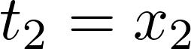

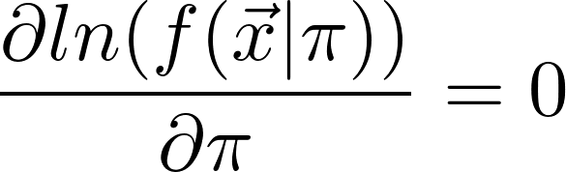
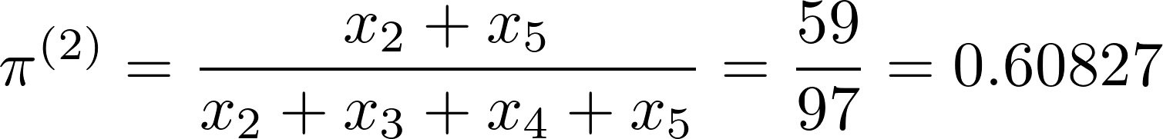

Topics for Discussion
- How to improve on this method: we might relax the bag-of-words assumption by assuming partial exchangeability or Markovianity of word sequences.
- What has happened since: modeling user behavior
- Compare equations
- Limitations
- Where does it work well
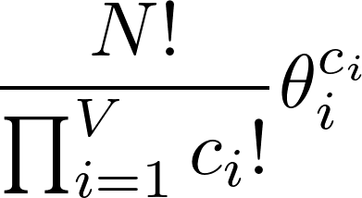
The words can be one-hot coded. For example, if the vocabulary were “cat”, “dog”,”armadillo”, “hamster”, then “dog” would be encoded as
In that case, the probability that probability that the n-th word is 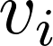 is can be written
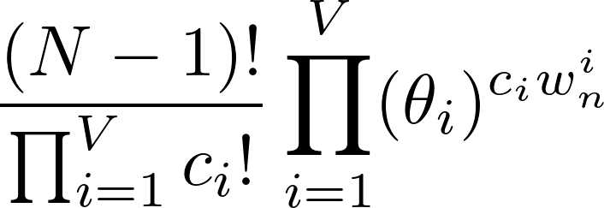

Distribution of Topics for a Document
The probability that topic i is included 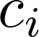 times in a document is

Multinomial Distribution
The pdf of the multinomial distribution is 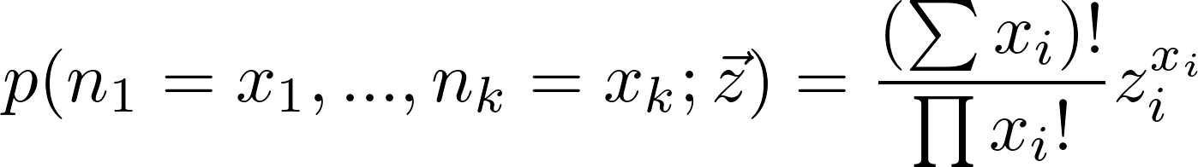

Sufficient Statistic
If t is a function of a statistic x (apparently a statistic is a series of values for a given random variable) and
Then t is a sufficient statistic. For a Bernoulli distribution, the likelihood only depends on the number of positive outcomes n and the likelihood is maximum when
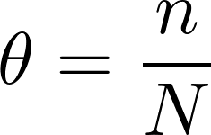

Jensen’s Inequality
If f is convex and X is a random variable, E(f(X))>=f(E(x))

Dirichlet Distribution

The Dirichlet distribution is written as a conditional: 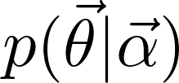 and the multinomial distribution that follows it satisfies a chain rule 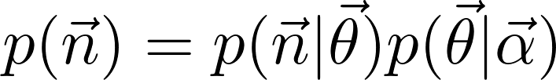 You might have some counts and a known vector of alphas and want to estimate the thetas. The way you would express that is
, 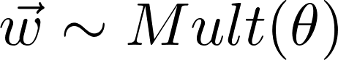 and 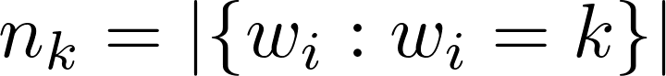
The expression for their pdf would be 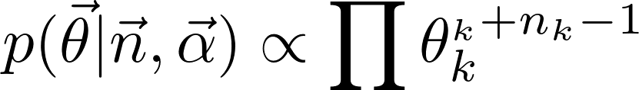
The fact that the probability of the sample from the Dirichlet distribution, conditioned on the counts and the parameters of the distribution, is itself a Dirichlet distribution is expressed by saying that the posterior has the same form as the prior, it just looks like you are adding counts, and there is conjugacy.

Mixing
Mixing is related to De Finetti’s theorem
An example of mixing: Three coins. Coin 1 is unbiased, coin 2 has a probability of .9 coming up heads and coin 3 has a probability of .7 of coming up heads. First, coin 1 is tossed. If it comes up heads then all further trials are done with coin 2. If coin 1 comes up tails, then all further trials are done with coin 3. In N trials, on the average coin 2 will be used N/2 times and there will be .45N heads and .05 tails. Coin 3 will be used N/2 times and there will be .35N heads and .15N tails.
 | Toss 2 |  | Toss 3
Coin 1 | N(H) | N(T) | N(H) | N(T)
H | .45N | .05N | .9*.45 | .1*.5
T | .35N | .15N

The probability of heads on the second coin is .7, so the
The probability that coin 1 came up heads given that the other coin came up heads is .45N/(.45N+.35N)=90/160.
The probability that coin 1 came up tails given that the other coin came up heads is .35/(.45+.35)=70/160.
These add up to one.
The probability that coin 1 came up heads given that the other coin came up tails is .05N/(.05N+.15N)=10/40.
The probability that coin 1 came up tails given that the other coin came up tails is .15/(.05+.15)=120/160.
These add up to one.

Coin 1 | Coin 2 | Coin 3 | Number of events
H | H | H | .5*.9*.9=.405
H | H | T | .5*.9*.1=.045
H | T | H | .5*.1*.9=.045
H | T | T | .5*.1*.1=.005
T | H | H | .5*.7*.7=.245
T | H | T | .5*.7*.3=.105
T | T | H | .5*.3*.7=.105
T | T | T | .5*.3*.3=.045
Total |  |  | 1.0

The probability of coin 3 being heads is.
If coin 2 is heads then the probability of coin 3 being heads is (.405+.245)/(.405+.045+.245+.105)=

References
Probabilistic Topic Models and User Behavior YouTube, 2017

