* Bell’s inequality
* Photons and photon polarization
* Proof of entanglement
* Large-scale entanglement
* Quantum repeaters – code
* Quantum repeaters – physical/engineering realization

Quantum entanglement is one way that quantum states, particles or bits communicate information. It is an active area of physics research and, although the phenomenon is not well understood, it is clear that is is fundamental to quantum computing and quantum information. For example, the repeaters that will power the backbone of the Quantum Internet will depend on entanglement.

A paper published by Albert Einstein and two other physicists in the 1930s kicked off the controversy by arguing that relativity prevents instantaneous communication at a distance and therefore entanglement is impossible. They insisted on the existence of auxiliary information, supplemental to the quantum state, called “hidden variables.” Decades later, John Bell defined a way to prove experimentally that hidden variables do not exist. This statistical basis of this result is called “Bell’s inequality” and I will explain it now.

# Bell’s Inequality

Consider a room full of computers. Some are laptops and some are desktops. Some run the Mac OS operating system and some run Linux. Some are fast and some are not fast. Let “A” stand for “laptop”, “B” stand for “Mac OS” and “C” stand for “fast.” A simplified version of Bell’s inequality, proven in the following figure, states that the number of laptops that do not run Mac OS, plus the number of Mac machines that are not fast not fast, is greater than or equal to the number of laptops that are not fast.

1 + 4 is laptops that run Linux (A and not B) and 2+3 is Macs that are not fast (B and not C). 1 + 2 is laptops that are not fast (A and not C). So the number of Linux laptops plus the number of slow Macs is greater than or equal to the number of slow laptops.

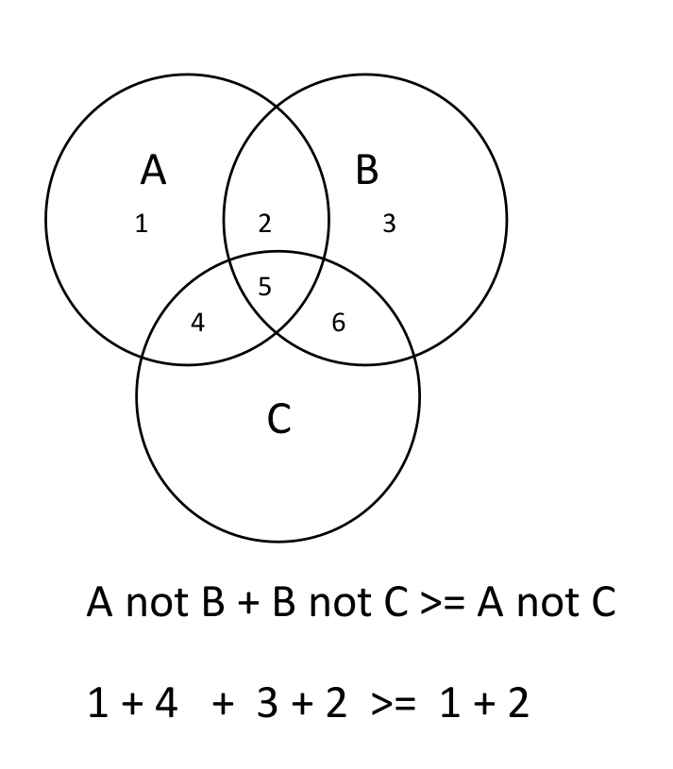

# Photons and Photon Polarization

What does this have to do with physics and quantum computing? The Quantum Internet will almost certainly use photons as the transmission medium, so we need to look at the properties of photons. Every photon as an attribute called “polarization,” which is the direction of its electric field. It is a quantum bit; a qubit. If the polarization is vertical then the qubit is in the zero state; if the polarization is horizontal then the qubit is on the one state. A photon can exist in a superposition of one and zero, just as any qubit can. For example, the photon may be halfway between horizontal and vertical, with polarization at a 45 degree angle.

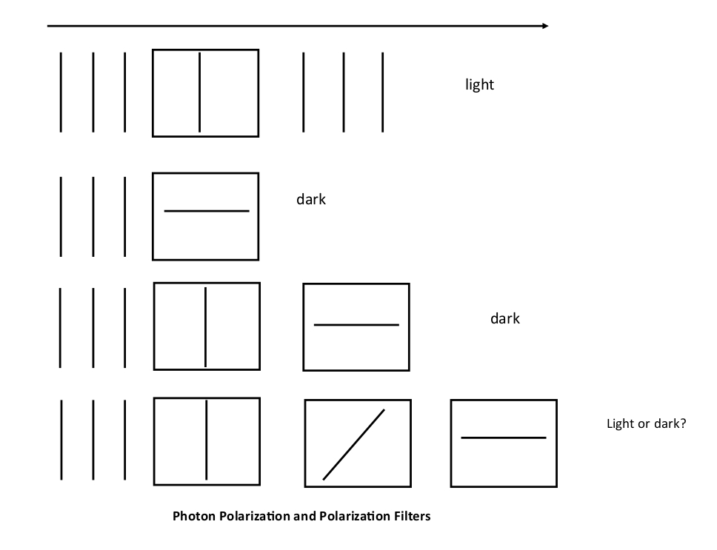The photons are coming in from the left. The vertical lines indicate that they are vertically polarized. The box with the vertical line in it is a polarization filter oriented so that it allows vertically polarized photons to pass.

In the second row we again have vertically polarized photons but the filter is oriented horizontally, so the photons are blocked.

In the third row we have two filters – one vertical and one horizontal. Nothing gets through.

The fourth row is meant to puzzle you. There are three polarization filters, one vertical, then one diagonal and finally one horizontally. Nothing gets through, right? Are you sure?

# Do the Photons Know What They Will Do?

Einstein advocated “hidden variables.” In this case, it means that when a photon is produced, it has attached to it information which indicates whether or not it will pass through horizontal and vertical polarization filters. There is an experimental test for this based on Bell’s inequality.

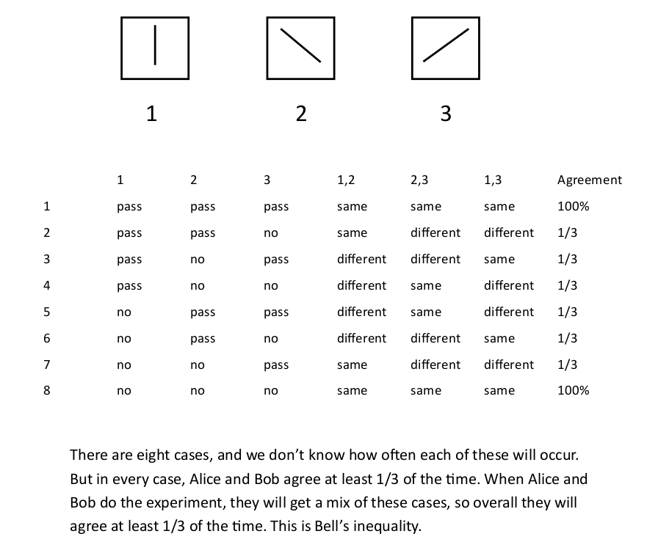

In this experiment, a phenomenon called “spontaneous down-conversion” is used to produce pairs of entangled photons where the polarization of the first photon is identical to the polarization of the second photon.

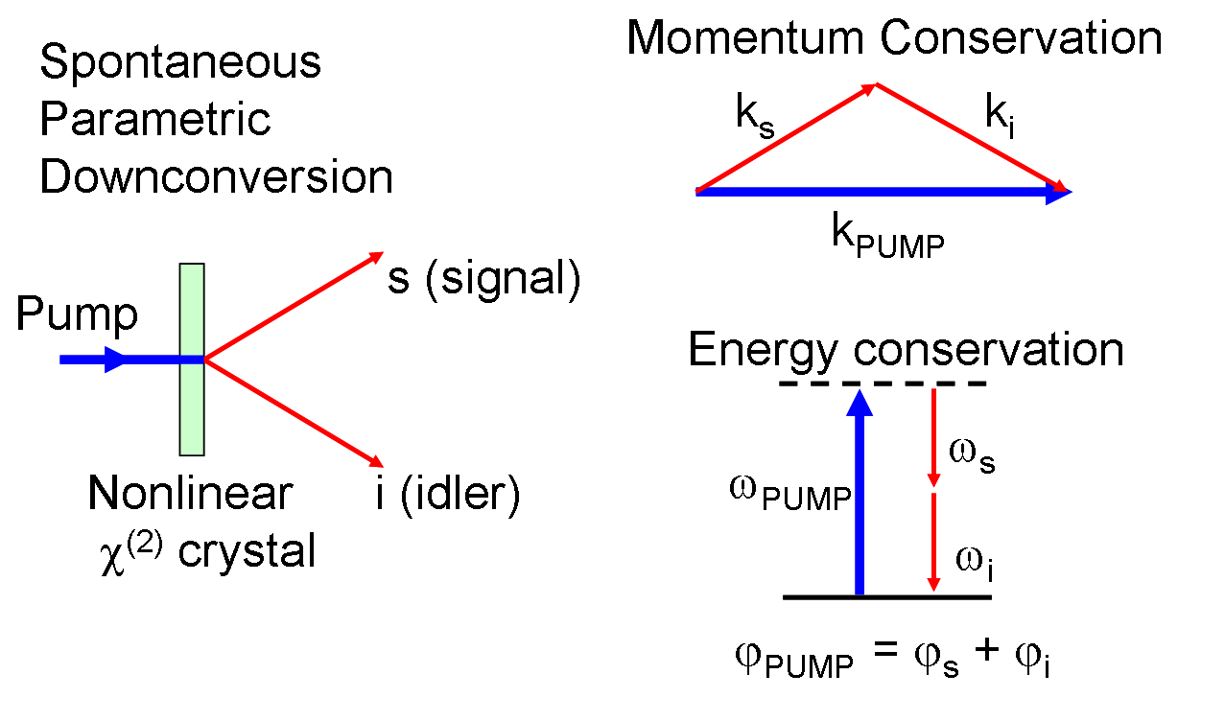

Alice will measure one and Bob will measure the other. There are three polarizers oriented at different angles. Alice will choose one of these and Bob will choose another. Let’s suppose that each photon carries with it a property that tells which filters it can get through. The first row in the table represents photons that “know” they can get through any polarizer. Maybe there are no such photons or maybe there are a few. In the second row we have photons that will get through a polarizers one and two but not polarizer three.

As you can see, there are eight possibilities for the photons. We don’t know how many photons there are for each possilbility.

Alice picks one of the three polarizers and so does Bob. They are counting how often they agree – that is, either a photon gets through for Both Alice and Bob or it gets through for neither Alice and Bob. The fifth column tells whether or not Alice and Bob agree when Alice chooses the first polarizer and Bob chooses the second. The sixth column is for the case where Alice chooses the second polarizer and Bob chooses the third. The seventh column is for the case where Alice chooses the first polarizer and Bob chooses the third..

The last column tells how often Alice and Bob agree. You can see that for all rows, there is agreement in at least 1/3 of the cases. This is basically Bell’s inequality. The implication of this is that when the experiment is done, the overall agreement will be greater than or equal to one out of three. This is based on the assumption that when a photon is created, it carries with it a “tag” that tells which filters it can pass through. Do you believe it?

Experiments with photons and other particles have been done and actually ***you get agreement only one quarter of the time,*** as predicted by quantum mechanics. So Bell’s inequality is violated and, the implication is that when the photons are created they do not “know” which filters they can pass through. There are no “hidden variables.”

However, there have been loopholes in these experiments. For example, the two photons could be communicating with one another somehow so that Alice’s measurement affects Bob’s measurement. This seems ridiculous and, if Alice and Bob are far enough apart such instantaneous communication is incompatible with Einstein’s special theory of relativity. Experiments have been done that make it very unlikely that this is happening.

# Macroscopic (Large Scale) Entanglement

Entanglement is not restricted to tiny particles like photons; this year, a team with the National Institute of Standards and Technology (NIST) in Boulder, Colorado, achieved mechanical entanglement between two vibrating drum heads whose diameter is approximately the thickness of a human hair (0.1 mm). Microwave pulses were used to create and measure the entanglement.

# Quantum Repeaters

Because photons tend to get lost in length fiber optic cables, the Quantum Internet will require repeaters (devices that receive a photon and transmit an identical photon downstream). Of necessity, the incoming photon is destroyed. Here is what it looks like:

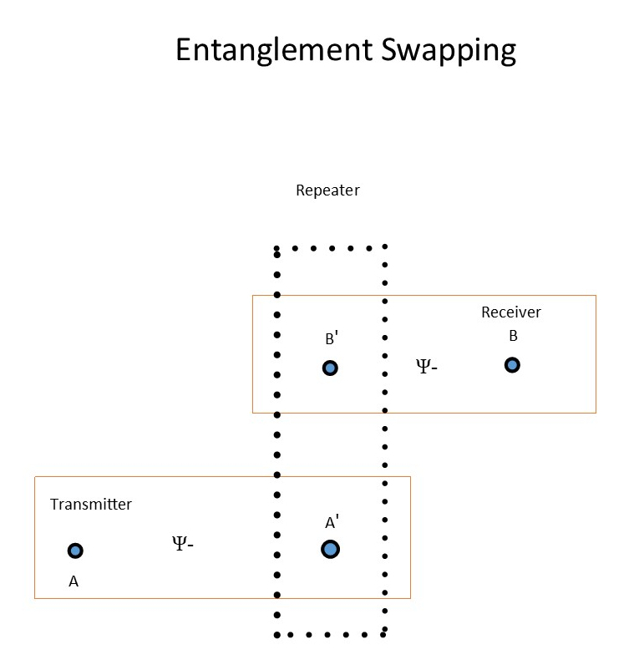

There are five qubits: the transmitted data, three link qubits and the received data. The process takes place as follows:

1. Qubits A and A` are entangled in the Bell singlet state known as Phi +
2. B’ and B are similarly entangled
3. The repeater measures the combined state of the data and qubit A
4. The combined state of qubit A’ and B’ is measured
5. The repeater transmits the results of its measurement – a pair of classical bits (one or zero) – to the receiver
6. The receiver uses the measurement results to choose one of four gates to apply to its qubit to reconstruct the data.

I simulated the process using the basic formulas of quantum computing. Here is the code:

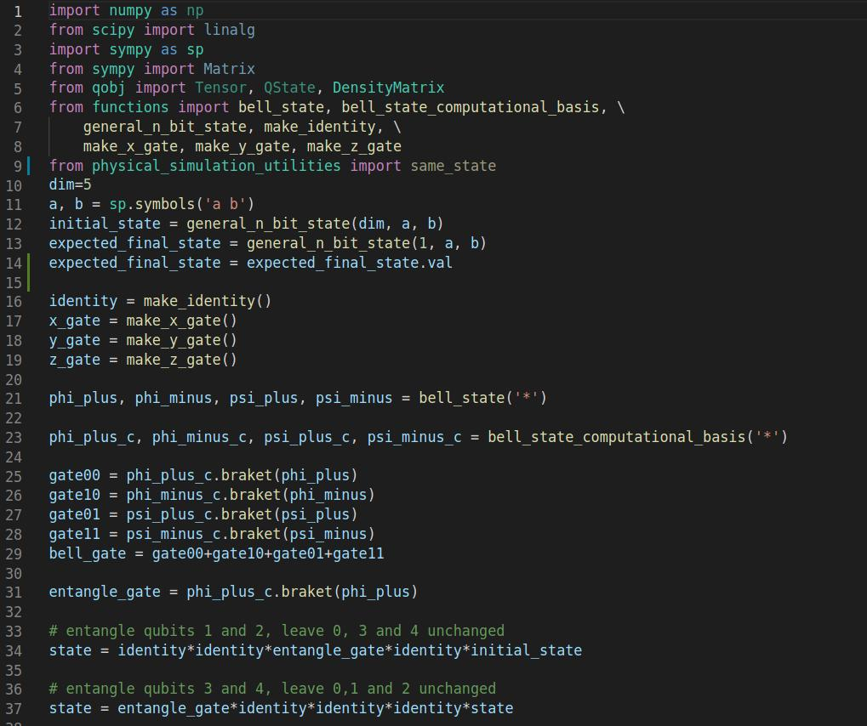https://meet.google.com/sgy-xbrk-nbo

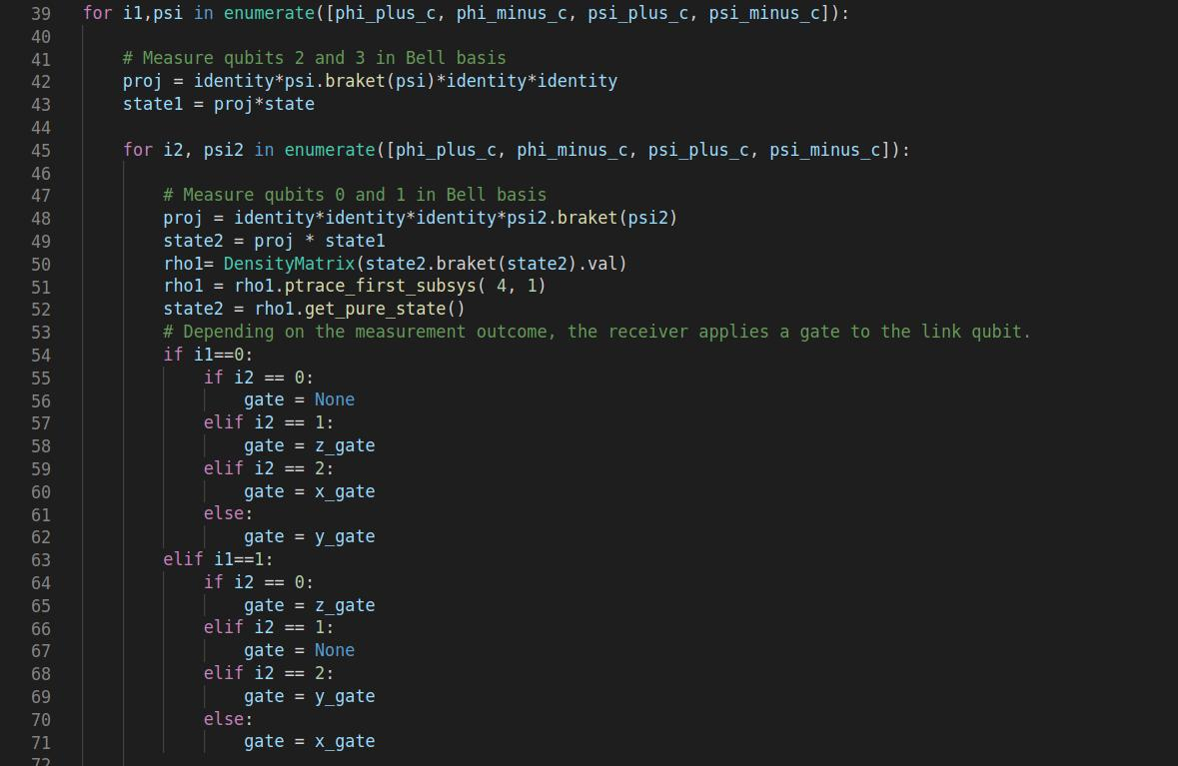

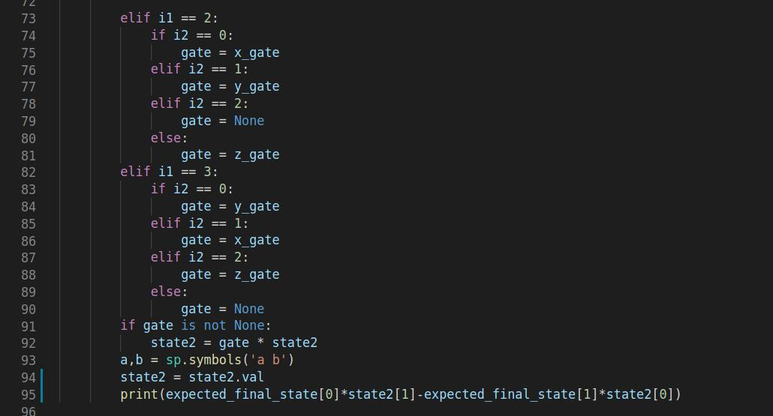

|  |  |
| --- | --- |
| **Lines** | **Function/remarks** |
| 12-14 | Set up initial states |
| 16-19 | Quantum gates |
| 21-37 | Set up entanglement and measurement |
| 38-49 | Measurements |
| 50-52 | Receiving station examines received qubit |
| 54-90 | Choosing gate based on measurement results |
| 91-92 | Transform received qubit |
| 95 | Perform cross product to check if transmitted qubit and final received qubit are parallel (same state) |

As you can see, the reconstructed data matches the transmitted data – the states are parallel. This depends on the code in lines 54-90 that chooses a gate based on the measurement results. Where did this code come from? It was a bit of algebra:

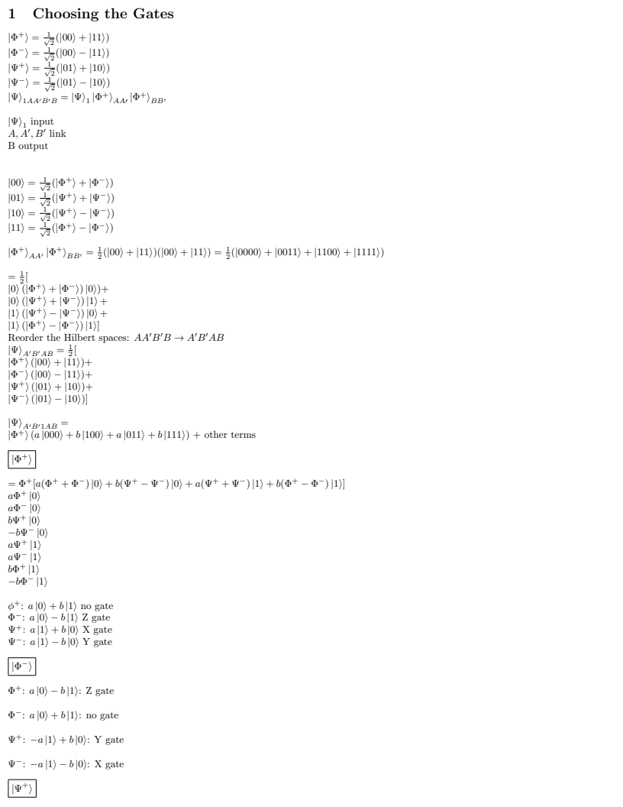I will post a link to this derivation in the comments for the event.

# Physical Realization of Quantum Repeaters

How does this look like in terms of practical, physical devices? It is based on optical devices called Bell state analyzers. Here is what a Bell state analyzer looks like:

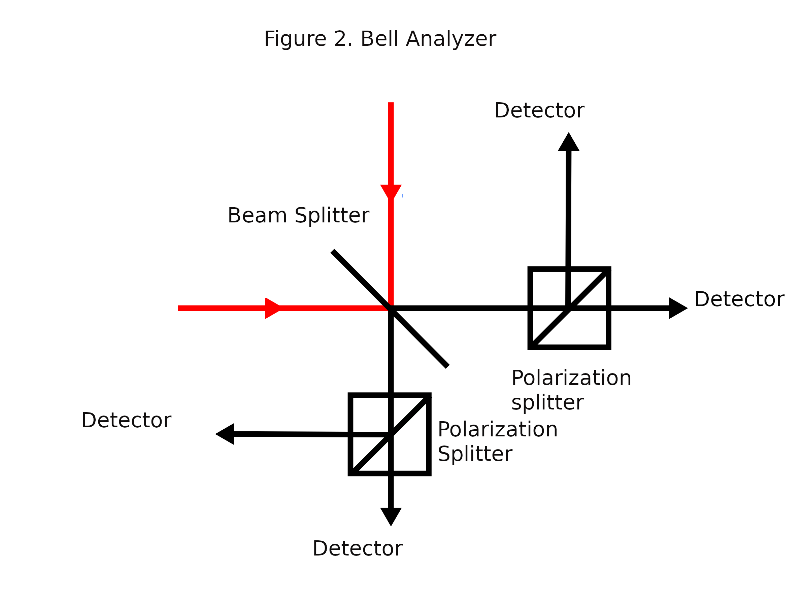 The photons come in on the red beams and strike the beam splitter. Each photons takes a superposition of two paths: straight ahead towards a detector or reflected 90 degrees towards another detector. The boxes are polarization splitters. Each photon takes a superposition of two paths – the horizontally polarized part goes straight ahead and the vertically polarized part goes off in another direction towards the other detector.

In this communication protocol, the receiving station needs to know measurement results to decide what gate to apply to the received qubit. The measurement results come from the four detectors.

In practice, the engineering has not been worked out. Some sources say that this apparatus can only perform a partial measurement, detecting some Bell states but not distinguishing others.