Chuckle Factory

Export of [**https://partyrock.aws/u/anya-d-r/WLk-So1k7/Chuckle-Factory**](https://partyrock.aws/u/anya-d-r/WLk-So1k7/Chuckle-Factory)

# App Description

Welcome to the Joke-and-Image Generator! This app creates hilarious jokes and generates funny images to match. Each time you refresh, you'll get a new joke and image. Enjoy the laughter!

# Random Seed

school

# Joke Generator

Here's a short, funny, and unexpected joke inspired by the random seed 'school':

Setup: Why did the math book look so sad?

Punchline: Because it had too many problems!

This joke is family-friendly and suitable for all ages, playing on the double meaning of "problems" in mathematics and in life.

# Joke Illustration

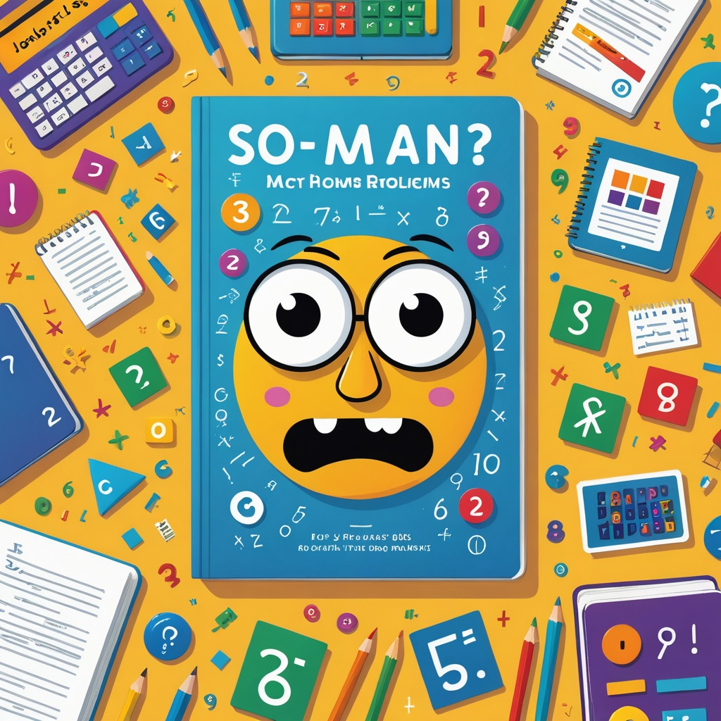

# Joke Discussion

**Human**: Here's a joke for you: [Joke Generator]. What do you think? Can you explain why it's funny or generate a new one?

**Assistant**: That's a great joke! I'd be happy to discuss it or generate a new one for you. What would you like to do?