SMART RIDER SAFETY AND ENFORCEMENT SYSTEM
ANNA POORANI C , ASLIN JERSHIA A, AKSHAYA S M, S.S. DEEPA DHARSHINI, DEPARTMENT OF INFORMATION TECHNOLOGY, ARUNACHALA COLLEGE OF ENGINEERING FOR WOMEN

ABSTRACT
Road safety for two-wheeler riders continues to be a major concern due to accidents caused by helmet negligence, alcohol-impaired riding, and mobile phone usage while driving. Traditional traffic enforcement relies on manual inspection, making it difficult to ensure continuous rider compliance. This paper proposes the Smart Rider Safety and Enforcement System (SRSES), an IOT-based intelligent safety solution designed to enhance rider protection and reduce road accidents. The system integrates a helmet detection module, an alcohol detection sensor, and a mobile phone usage detection module to continuously monitor rider behavior before and during vehicle operation. The motorcycle ignition is enabled only when the rider wears a helmet and passes the alcohol test. If alcohol consumption or mobile phone usage is detected, the system immediately activates an audible alarm, displays warning messages, and can restrict vehicle operation based on predefined safety conditions. An ESP32 microcontroller serves as the central processing unit, while IOT connectivity enables real-time monitoring, data logging, and emergency notifications through a mobile application or cloud platform. Experimental evaluation demonstrates that the proposed system provides reliable detection, rapid response, and effective enforcement of safety regulations. The SRSES offers a cost-effective, scalable, and intelligent solution that can significantly improve two-wheeler rider safety and support the development of smarter transportation systems.
Key Words: Smart Rider Safety , IOT, ESP32, Helmet detection , Alcohol detection , Mobile phones usage detection , Ignition Control , Rider Monitoring , Road Safety , Accident Prevention

INTRODUCTION
The rapid growth of Internet of Things (IOT) technology has transformed conventional transportation systems into intelligent and connected systems. IOT enables sensors, microcontrollers, and communication networks to exchange real-time information, allowing continuous monitoring and automatic decision-making. In road transportation, IOT plays a significant role in improving vehicle safety, traffic management, and rider protection.Two-wheelers are one of the most commonly used modes of transportation because they are affordable, fuel-efficient, and convenient. However, riders are highly vulnerable to accidents due to unsafe riding practices such as not wearing a helmet, riding under the influence of alcohol, and using mobile phones while driving. These behaviors increase the risk of severe injuries and fatalities.Although traffic authorities enforce road safety rules, manual monitoring cannot continuously observe every rider. This limitation creates a need for an automated system capable of monitoring rider behavior in real time and enforcing safety regulations without human intervention.The proposed Smart Rider Safety and Enforcement System (SRSES) addresses these challenges by integrating IOT technology with intelligent sensing modules. The system uses helmet detection, alcohol detection, and mobile phone usage detection to evaluate rider safety before and during vehicle operation. An ESP32 microcontroller processes sensor data and makes decisions based on predefined safety conditions. If all conditions are satisfied, the motorcycle ignition is enabled; otherwise, the system activates warning alerts and restricts vehicle operation. In addition, IOT connectivity supports real-time monitoring, data logging, and remote notifications, making the proposed system suitable for modern smart transportation applications.The Internet of Things (IOT) is a modern technology that enables physical devices, sensors, and embedded systems to communicate with each other through the internet. IOT allows devices to collect, process, and exchange real-time data automatically without requiring continuous human intervention. This technology improves automation, remote monitoring, intelligent decision-making, and efficient system management.
A typical IOT system consists of four major components: sensors, processing unit, communication network, and cloud platform. Sensors collect information from the environment, while the processing unit, such as the ESP32 microcontroller, analyzes the collected data. The communication network, mainly Wi-Fi, transfers the processed information to a cloud platform or mobile application for real-time monitoring and data storage. Users can access this information remotely and receive instant notifications whenever necessary.IOT technology is widely used in various fields, including smart homes, healthcare, agriculture, industrial automation, environmental monitoring, and intelligent transportation systems. In the transportation sector, IOT improves vehicle safety by continuously monitoring vehicle conditions and rider behavior. It also supports accident prevention, traffic management, and remote vehicle monitoring.In the proposed Smart Rider Safety and Enforcement System (SRSES), IOT plays a vital role in enhancing rider safety. The ESP32 microcontroller receives data from the helmet detection module, MQ-3 alcohol sensor, and mobile phone usage detection module. Based on the received information, the ESP32 verifies whether the rider satisfies all safety conditions. If the rider wears a helmet, no alcohol is detected, and no unsafe mobile phone usage is identified, the motorcycle ignition is enabled through the relay module. Otherwise, the system activates warning alerts and keeps the ignition disabled. The collected safety data can also be transmitted through IOT for real-time monitoring, data logging, and future analysis. Therefore, IOT provides an intelligent, reliable, and efficient platform for improving two-wheeler rider safety and supporting modern smart transportation systemRoad accidents involving two-wheelers continue to increase due to unsafe riding practices such as not wearing a helmet, riding under the influence of alcohol, and using mobile phones while driving. These behaviors significantly increase the risk of serious injuries and fatalities. Although traffic authorities enforce road safety regulations, manual monitoring cannot continuously observe every rider or prevent unsafe actions in real time. Most existing safety systems focus on only one safety feature and do not provide a complete solution. Therefore, there is a need for an intelligent IOT-based system that can automatically monitor multiple safety conditions, control motorcycle ignition, and improve overall rider safety.The main objectives of the proposed Smart Rider Safety and Enforcement System (SRSES) are: To ensure that the motorcycle starts only when the rider is wearing a helmet. To detect alcohol consumption before vehicle operation and prevent unsafe riding .To identify mobile phone usage while riding and generate warning alerts . To process sensor data using the ESP32 microcontroller for intelligent decision-making . To control motorcycle ignition automatically based on predefined safety conditions. To provide real-time monitoring and data logging through IOT connectivity. To reduce road accidents and improve the overall safety of two-wheeler riders , To develop a reliable, low-cost, and intelligent rider safety system.
PROPOSED SYSTEM
The proposed Smart Rider Safety and Enforcement System (SRSES) is an Internet of Things (IoT)-based intelligent safety solution designed to improve the safety of two-wheeler riders and reduce road accidents. The system integrates multiple safety features, including helmet detection, alcohol detection, mobile phone usage detection, ESP32 microcontroller, relay module, buzzer alerts, and IOT connectivity, into a single platform. The system begins by checking whether the rider is wearing a helmet using the helmet detection module. If the helmet is not detected, the motorcycle ignition remains disabled and the system activates a warning buzzer. Once the helmet is detected, the MQ-3 alcohol sensor measures the rider’s alcohol level. If alcohol is detected above the predefined threshold, the system prevents the motorcycle from starting and alerts the rider. After successfully passing the alcohol test, the mobile phone usage detection module continuously monitors whether the rider is using a mobile phone while riding. If unsafe phone usage is detected, the system generates an audible warning and records the event for monitoring purposes. The ESP32 microcontroller acts as the central processing unit by collecting and analyzing data from all sensors. Based on predefined safety conditions, it controls the relay module to either enable or disable the motorcycle ignition. The system also utilizes IOT connectivity to transmit rider safety information to a cloud platform or mobile application for real-time monitoring, data logging, and remote notifications. The proposed System provides an intelligent ,reliable, and cost-effective , solution by integrating multiple safety mechanism into a single platform This approach enhances rider safety, minimizes human intervention, and contributes to the development of smarter and safer transportation systems. The Smart Rider Safety and Enforcement System (SRSES) is designed using an ESP32 microcontroller as the central processing unit. The system integrates a helmet detection module, MQ-3 alcohol sensor, mobile phone usage detection module, relay module, buzzer, and IOT communication to ensure rider safety.Initially, the helmet detection module checks whether the rider is wearing a helmet. If the helmet is not detected, the ESP32 keeps the motorcycle ignition OFF and activates the buzzer to alert the rider. If the helmet is detected, the system proceeds to the alcohol detection process.The MQ-3 alcohol sensor measures the rider’s alcohol level. If alcohol is detected above the predefined threshold, the ESP32 disables the ignition system and generates an audible warning. If no alcohol is detected, the system continues to monitor mobile phone usage. The mobile phone usage detection module identifies whether the rider is using a mobile phone while riding. If unsafe phone usage is detected, the system activates a warning alert and records the event for monitoring.
After verifying all safety conditions, the ESP32 microcontroller processes the collected sensor data and sends a control signal to the relay module. If all conditions are satisfied, the relay enables the motorcycle ignition. Otherwise, the ignition remains disabled.
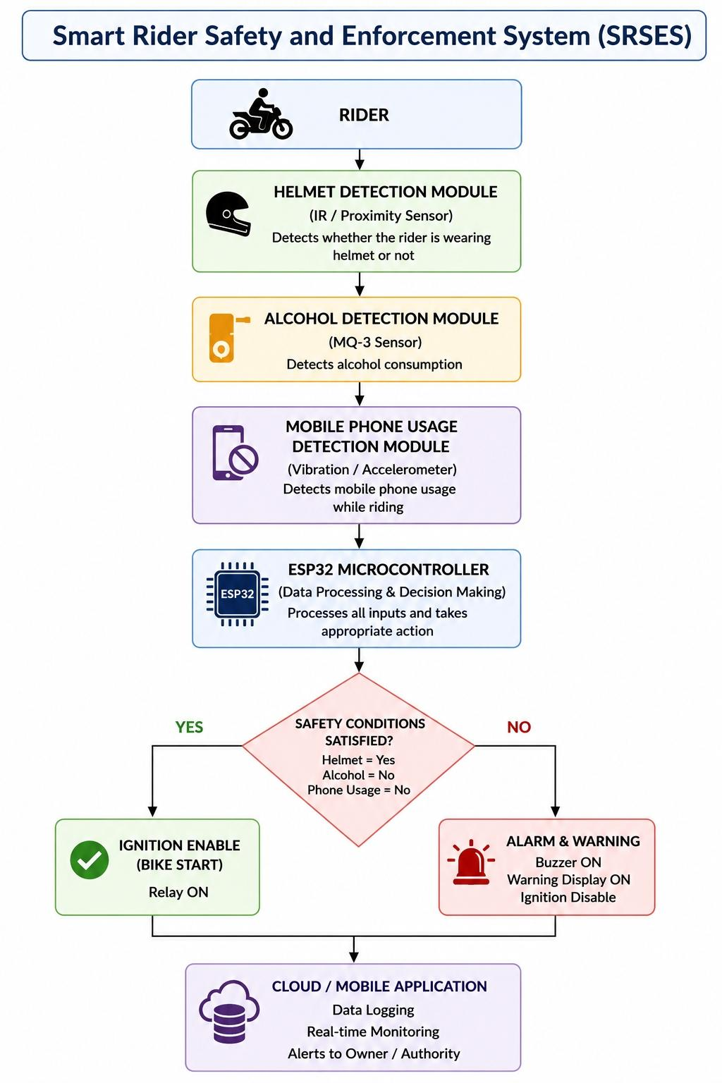
The system also supports IOT connectivity through the ESP32’s built-in Wi-Fi module. Safety information, warning alerts, and rider status are transmitted to a cloud platform or mobile application for real-time monitoring, data logging, and remote notifications. This architecture provides an intelligent, automated, and reliable solution for improving two-wheeler rider safety.The proposed Smart Rider Safety and Enforcement System (SRSES) consists of the following hardware components: The ESP32 is the main controller of the system. It receives data from all sensors, processes the information, controls the relay module, and enables IOT communication through its built-in Wi-Fi capability. The helmet detection module verifies whether the rider is wearing a helmet. The motorcycle ignition is enabled only when the helmet is properly detected. The MQ-3 sensor detects the presence of alcohol in the rider’s breath. If the alcohol level exceeds the predefined threshold, the system prevents the motorcycle from starting and generates a warning alert. This module detects mobile phone usage while riding. When unsafe phone usage is identified, the system activates a warning alert and records the event for monitoring.The relay module controls the motorcycle ignition. Based on the decision made by the ESP32, it either enables or disables the ignition system.The buzzer provides an audible warning whenever an unsafe riding condition such as helmet absence, alcohol detection, or mobile phone usage is detected.The display shows system status, warning messages, and rider safety information for easy monitoring.The power supply provides the required electrical energy for operating the ESP32, sensors, relay module, buzzer, and other electronic components.The proposed Smart Rider Safety and Enforcement System (SRSES) requires appropriate software tools for programming, communication, and system monitoring. The software components are described below.
Arduino IDE: Arduino IDE is used to develop, compile, and upload the program to the ESP32 microcontroller. It provides a simple environment for writing Embedded C/C++ code and testing the system.
Embedded C/C++: Embedded C/C++ is the programming language used to implement the system logic. It controls sensor operation, processes input data, makes safety decisions, and manages the motorcycle ignition system.
ESP32 Board Package: The ESP32 board package is installed in the Arduino IDE to support programming and uploading code to the ESP32 microcontroller.
IOT Platform: An IOT platform such as Blynk, Firebase, or MQTT can be used for real-time monitoring, data logging, and remote notifications. It enables users to monitor rider safety information through a mobile application or cloud platform.
ESP32 Libraries: Required software libraries are used for interfacing the helmet detection module, MQ-3 alcohol sensor, mobile phone detection module, Wi-Fi communication, and other hardware components.
Operating System: A computer running Windows, Linux, or macOS is used for program development, compilation, and uploading the firmware to the ESP32.
METHODOLOGY
The proposed Smart Rider Safety and Enforcement System (SRSES) operates by continuously monitoring the rider’s safety conditions before and during motorcycle operation. The overall working procedure is described as follows: The system is powered ON, and the ESP32 microcontroller initializes all connected sensors and modules. The helmet detection module checks whether the rider is wearing a helmet. If the helmet is not detected, the motorcycle ignition remains OFF, and the buzzer generates a warning alert. If the helmet is detected, the MQ-3 alcohol sensor measures the rider’s alcohol level. If alcohol is detected above the predefined threshold, the ignition remains disabled, and a warning alert is activated. If the rider passes the alcohol test, the mobile phone usage detection module continuously monitors whether the rider is using a mobile phone while riding. The ESP32 microcontroller receives and processes data from all connected sensors. It compares the received data with the predefined safety conditions. If all safety conditions are satisfied, the ESP32 sends a control signal to the relay module, enabling the motorcycle ignition. If any unsafe condition is detected during operation, the system immediately activates the buzzer, displays a warning message (if a display is available), and records the event. Through IOT connectivity, rider safety information, warning events, and system status are transmitted to a cloud platform or mobile application for real-time monitoring, data logging, and remote notifications. The system continuously repeats the monitoring process until the motorcycle is switched OFF, ensuring continuous rider safety throughout the journey.
CONCLUSION
The Smart Rider Safety and Enforcement System (SRSES) presents an intelligent and IOT-based approach to improve the safety of two-wheeler riders. The system integrates multiple safety features, including helmet detection, alcohol detection, mobile phone usage detection, ignition control, warning alerts, and real-time IoT monitoring, into a single platform. By continuously monitoring the rider’s safety conditions, the system helps reduce unsafe riding practices and supports automatic enforcement of essential road safety measures. The ESP32 microcontroller serves as the central processing unit by collecting data from all sensing modules and making intelligent decisions based on predefined safety conditions. The motorcycle ignition is enabled only when the rider satisfies all required safety conditions. If any unsafe condition is detected, the system immediately activates warning alerts and restricts vehicle operation. In addition, IOT connectivity enables real-time monitoring, data logging, and remote access to rider safety information, making the system suitable for modern intelligent transportation applications. The proposed system offers a cost-effective, reliable, scalable, and user-friendly solution that can contribute to reducing road accidents caused by helmet negligence, alcohol-impaired riding, and mobile phone usage while riding. Although the current system focuses on these essential safety features, it provides a strong foundation for future enhancements such as GPS tracking, accident detection, face recognition, artificial intelligence, and cloud-based analytics. In conclusion, the Smart Rider Safety and Enforcement System (SRSES) demonstrates the potential of IOT technology in improving rider safety and promoting responsible riding behavior. With further development, practical implementation, and real-world testing, the proposed system can become an effective smart transportation solution that supports safer roads and helps save lives.

REFERENCE
1. P. R. Rajarapollu, N. V. Bansode, and P. P. Mane, “A novel two-wheeler security system based on embedded systems,” IEEE Transactions on Advances in Computing, Communication, Automation (ICACCA), pp. 1–5, 2016.
2. S. Tapadar, S. Ray, H. N. Saha, A. K. Saha, and R. Karlose, “Accident and alcohol detection in Bluetooth-enabled smart helmets for motorbikes,” Computing and Communication Workshop and Conference (CCWC), pp. 584–590, 2018.
3. M. Abirami and J. Asha, “Embedded system-based smart bike,” Artificial Intelligent Systems and Machine Learning, pp. 258–260, 2016.
4. M. M. Rahman, J. R. Mou, K. Tara, and M. I. Sarkar, “Real-time Google map and Arduino-based vehicle tracking system,” IEEE Transactions on Electrical, Computer Telecommunication Engineering (ICECTE), pp. 1–4, 2016.
5. J.-H. Choi and J.-H. Chang, “Dual-microphone voice activity detection technique based on two-step power level difference ratio,” IEEE Transactions on Audio, Speech, and Language Processing, vol. 22, pp. 1069–1081, 2014.
6. S. Vijayan, V. T. Govind, M. Mathews, S. Surendran, and M. S. ME, “Alcohol Detection using Smart Helmet System,” International Journal of Emerging Technology in Computer Science Electronics, vol. 8, pp. 190–195, 2014.
7. N. Agarwal, A. K. Singh, P. P. Singh, and R. Sahani, “Smart helmet,” International Research Journal of Engineering and Technology, pp. 25–36, 2015.

