**Network Communication**

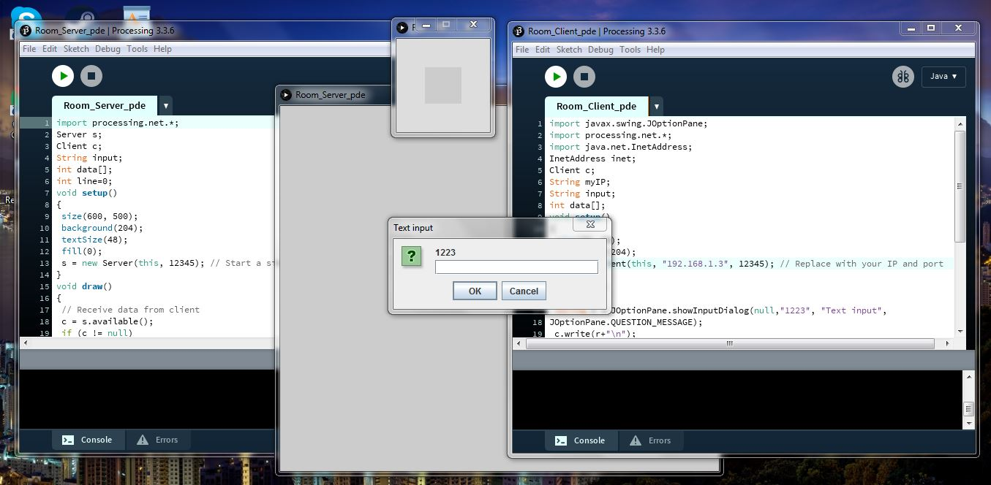

**Server code:** import processing.net.*;

Server s;

Client c;

String input;

int data[];

int line=0;

void setup()

{

size(600, 500);

background(204);

textSize(48);

fill(0);

s = new Server(this, 12345); // Start a simple server on a port 12345

}

void draw()

{

// Receive data from client

c = s.available();

if (c != null)

{

input = c.readString();

input = input.substring(0, input.indexOf("\n")); // Only up to the newline

text(input,10,48+48*(line));

line++;

if(line==10) {line=0; background(204);}

}

}

**Client code:** import javax.swing.JOptionPane;

import processing.net.*;

import java.net.InetAddress;

InetAddress inet;

Client c;

String myIP;

String input;

int data[];

void setup()

{

size(50, 50);

background(204);

c = new Client(this, "192.168.1.3", 12345); // Replace with your IP and port

}

void draw()

{

String r = JOptionPane.showInputDialog(null,"1223", "Text input",

JOptionPane.QUESTION_MESSAGE);

c.write(r+"\n");

try {

inet = InetAddress.getLocalHost();

myIP = inet.getHostAddress();

}

catch (Exception e) {

e.printStackTrace();

myIP = "couldnt get IP";

}

println(myIP);

}