**PLOT OF COSINE() VS SINE() PRODUCING A CIRCLE:**



**GRAFICA USED TO PLOT RATE OF POPULATION CHANGE IN IRELAND:**

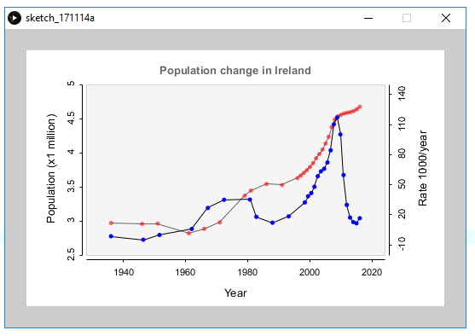

**IRISH BIRTH AND DEATH RATE:**

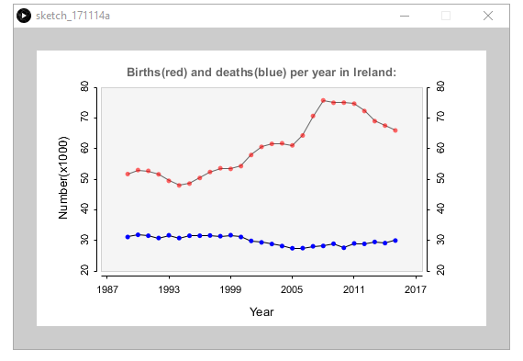

**LOGISTIC MAP:**

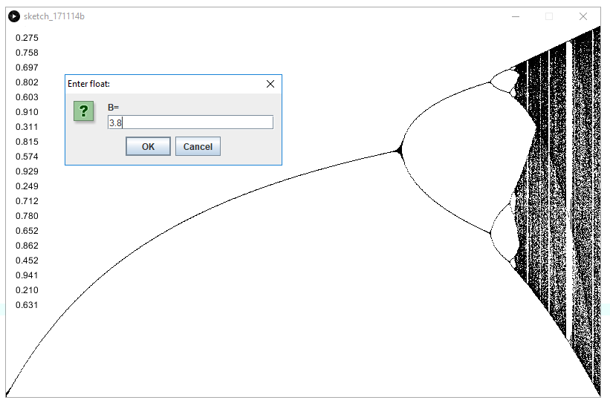

**ATTRACTOR I LIKED:**

