**Human visual search behaviour is far from ideal**

Anna Nowakowska

Alasdair D.F. Clarke

Amelia R. Hunt

**University of Aberdeen**

Corresponding Author:

Anna Nowakowska

Address and email for reader correspondence: Room T32, William Guild Building, King’s College, University of Aberdeen, a.nowakowska@abdn.ac.uk

Running Head: Human visual search behaviour is far from ideal

Author note:

Anna Nowakowska, Department of Psychology, University of Aberdeen

Alasdair D.F. Clarke, Department of Psychology, University of Aberdeen

Amelia R. Hunt, Department of Psychology, University of Aberdeen

**Human visual search behaviour is far from ideal**

**Abstract**

*We tested the efficiency of eye movements during visual search using homogeneous and heterogeneous arrays of line segments. The target is visible in the periphery on the homogeneous array, but requires central vision to be detected on the heterogeneous array. For a compound search array* that is heterogeneous on one side and homogeneous on the other*, eye movements should be directed only to the heterogeneous side. Instead, p*articipants made many fixations on the homogeneous side. By comparing search of compound arrays to an estimate of search performance based on uniform arrays, we isolate two contributions to search inefficiency. First, participants make superfluous fixations, sacrificing speed for a perceived (but not actual) gain in response certainty. *Second, participants* fixate the homogeneous side even more frequently than predicted by inefficient search of uniform arrays, suggesting they also *fail to* direct fixations to locations that yield the most new information.

Imagine that you are searching for a red pen, and you know it could be on either of two desks. The top of one desk is clean, while the other desk is cluttered with papers, other pens, books and coffee cups. What is the most effective way to find the red pen? Common sense suggests that a glance at the empty desk should be enough to detect the target if it is present, and the observer should spend the rest, or all, of their time searching the cluttered desk. An efficient visual system would not waste any time on the clean desk.

Several studies have suggested our visual system is able to sample information efficiently by directing eye movements to locations that yield the maximum possible information or reward (Ma, Navalpakkam, Beck, Van den Berg, & Pouget, 2011; Navalpakkam, Koch, Rangel, & Perona, 2010). In one influential model of visual search, Najemnik and Geisler(2005, 2008) demonstrated that eye movements are well-described by an optimal strategy, in which each saccade during search is directed to the location that will maximise the probability of detecting a target. A few recent studies, however, contradict key assumptions of the optimal search model. Notably, observers appear to be unable to adapt their fixation strategies on a trial-by-trial basis to changes in target frequency (Verghese, 2012), or to changes in the expected difficulty of detecting the target in the periphery(Morvan & Maloney, 2012; Clarke & Hunt 2016). This failure to adapt strategy to changing task demands leads to search performance that is considerably less efficient than would be predicted by an optimal model.

Here we examine whether optimal fixation strategies can be employed under even simpler conditions, in which the task does not change on a trial-by-trial basis. We test a straightforward prediction of an optimal search model: when faced with the search array depicted in Figure 1, and instructed to search for a line oriented 45˚ to the right, observers should only make fixations to the more heterogeneous half of the array. If the target were on the more homogeneous side of the array, it would be easily detected using peripheral vision, making fixations to that side superfluous (details of a pilot study checking the suitability of our stimuli are given in the Supplementary Materials). If search is optimal, the proportion of fixations directed to the heterogeneous side on any given trial should be 1, because inspection of the homogeneous side will provide no additional information about the target location. This prediction is tested in Experiment 1.

Experiment 1

## **Methods**

*Participants.* Fourteen participants (females=10; age range =20-38; mean age=25.12) completed the experiment. Previous seminal experiments on this topic had a very small numbers of participants (e.g. N=2 in Najemnik and Geisler, 2005; N=4 in Morvan and Maloney, 2012) but report results from individuals separately rather than averaging them. Our sample is larger, but we maintain the approach of reporting individual differences (as in Clarke and Hunt, 2016), making a very large sample impractical and unnecessary.

*Apparatus.* The display was presented on a 17inch CRT monitor with a resolution of 1024x768. Stimulus generation, presentation and data collection were controlled by Matlab and psychophysics toolbox (Brainard, 1997; Pelli, 1997) run on a Powermac. The position of the dominant eye was recorded using a desktop-mounted EyeLink 1000 eye tracker (SR Research, Canada) sampling eye position at 1000Hz.

*Stimuli.* The line segments were aligned in 22 columns and 16 rows on a uniform grey background. The target line was always tilted 45 degrees to the right. The mean distractor angle was perpendicular to the target angle. Search difficulty was manipulated by sampling from either a narrow 30˚ range of distractor line orientations (“homogeneous”) or a wide 106˚ range (“heterogeneous”). One half of each search array consisted of line segments with a homogeneous orientation, while the other half was heterogeneous (see Figure 1 for an example). There were 160 trials in total, half of which contained a target. The side of the target relative to the search difficulty was counterbalanced. The target could be located in any of the possible locations apart from the middle four vertical columns.

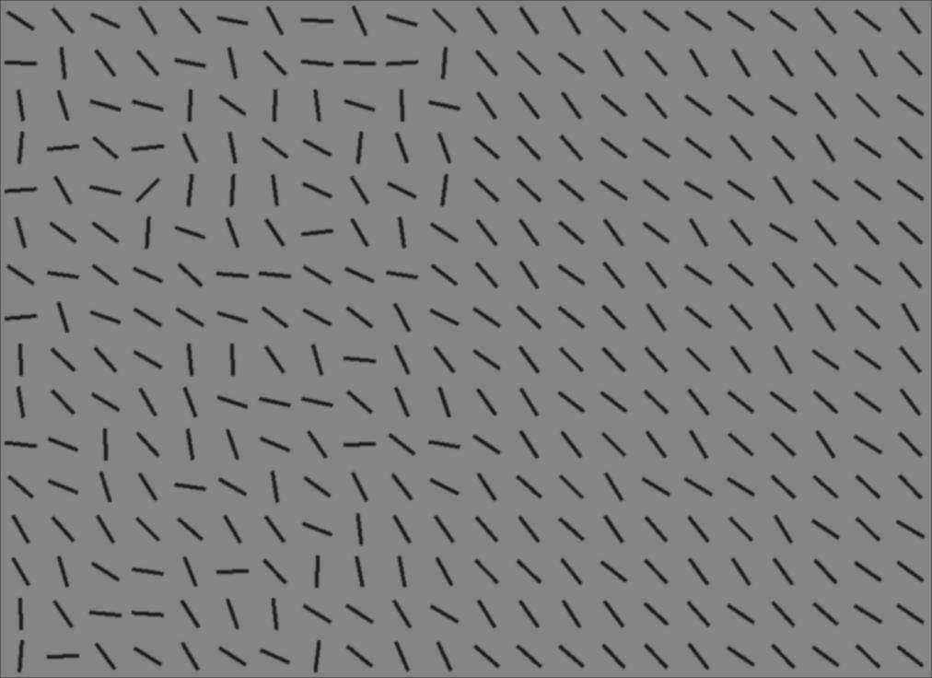

Figure 1. Example of a compound search array. The target is a line oriented 45˚ to the right. The target is present on the heterogeneous side in this example. The heterogeneous half of the array is shown on the left side.

*Procedure.* On arrival at the laboratory each participant was asked to read and sign a consent form and was seated alone in a low-lit room. Participants were told they would see line segments on the screen, and their task was to determine whether a line tilted 45° to the right was present among other lines. Participants were asked to respond as quickly and accurately as possible. Each trial consisted of a black fixation point (letter x) subtending 1.5x2.5cm (1.9°x3.1°), presented at the centre of the computer screen. On the press of a space bar, the stimulus was displayed until the participant made a response (or timed out after 60 seconds). Participants had to press either the left (present) or right (absent) arrow key. Auditory feedback in the form of a beep immediately followed incorrect key presses. Before the start of the experiment participants underwent a nine-point calibration sequence and a block of 10 practice trials.

## **Results**

Reaction times for targets on the homogeneous side of the search array were faster than for targets on the heterogeneous side (as shown in Figure 2). Mean accuracy for target absent trials was ≈100%. For target present, participants were more accurate when the target was located on the homogeneous side of the display, 98.4%, than the heterogeneous side, 72.8% (*t*(13)=6.7, *p*<0.001).



Figure 2: distribution of reaction times across conditions.

Figure 3 shows the proportion of fixations each observer made on the heterogeneous side of the display. The strictest criteria of optimal strategy in this experiment is not to look to the homogeneous side at all. (The pilot study demonstrates it can be easily ascertained whether the target is present on this side or not from the central fixation point.) Fixations on this side will provide no new information on the target’s location, so participants should direct all fixations to the heterogeneous side. As we can see in Figure 3 only Participant 11 is close to executing the optimal strategy. In aggregate, our participants spend more time fixating the heterogeneous than the homogeneous side (Figure 4), but for the majority of participants a large proportion of fixations are made to the homogenous side.

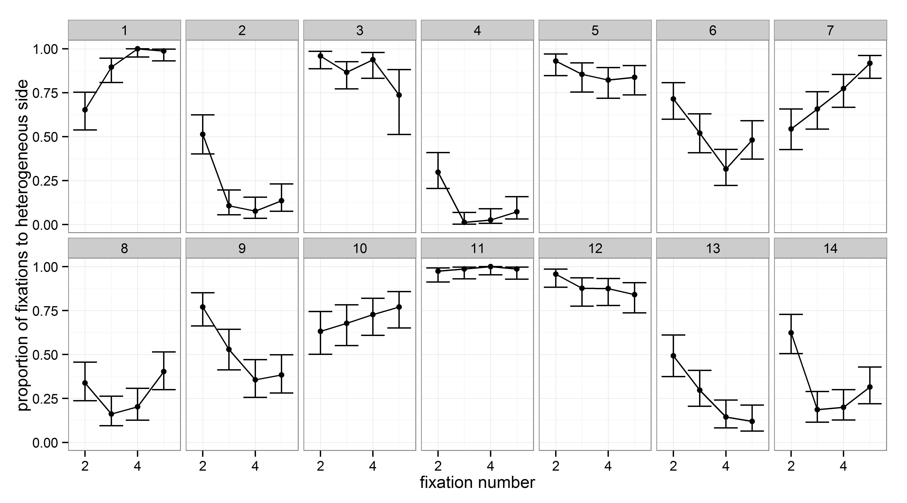

Figure 3. Proportion of the first five fixations on the homogeneous side for each observer. Only target absent trials are shown here. Fixations in the central region (1 degree to the left and right of the centre of the screen) have been excluded.

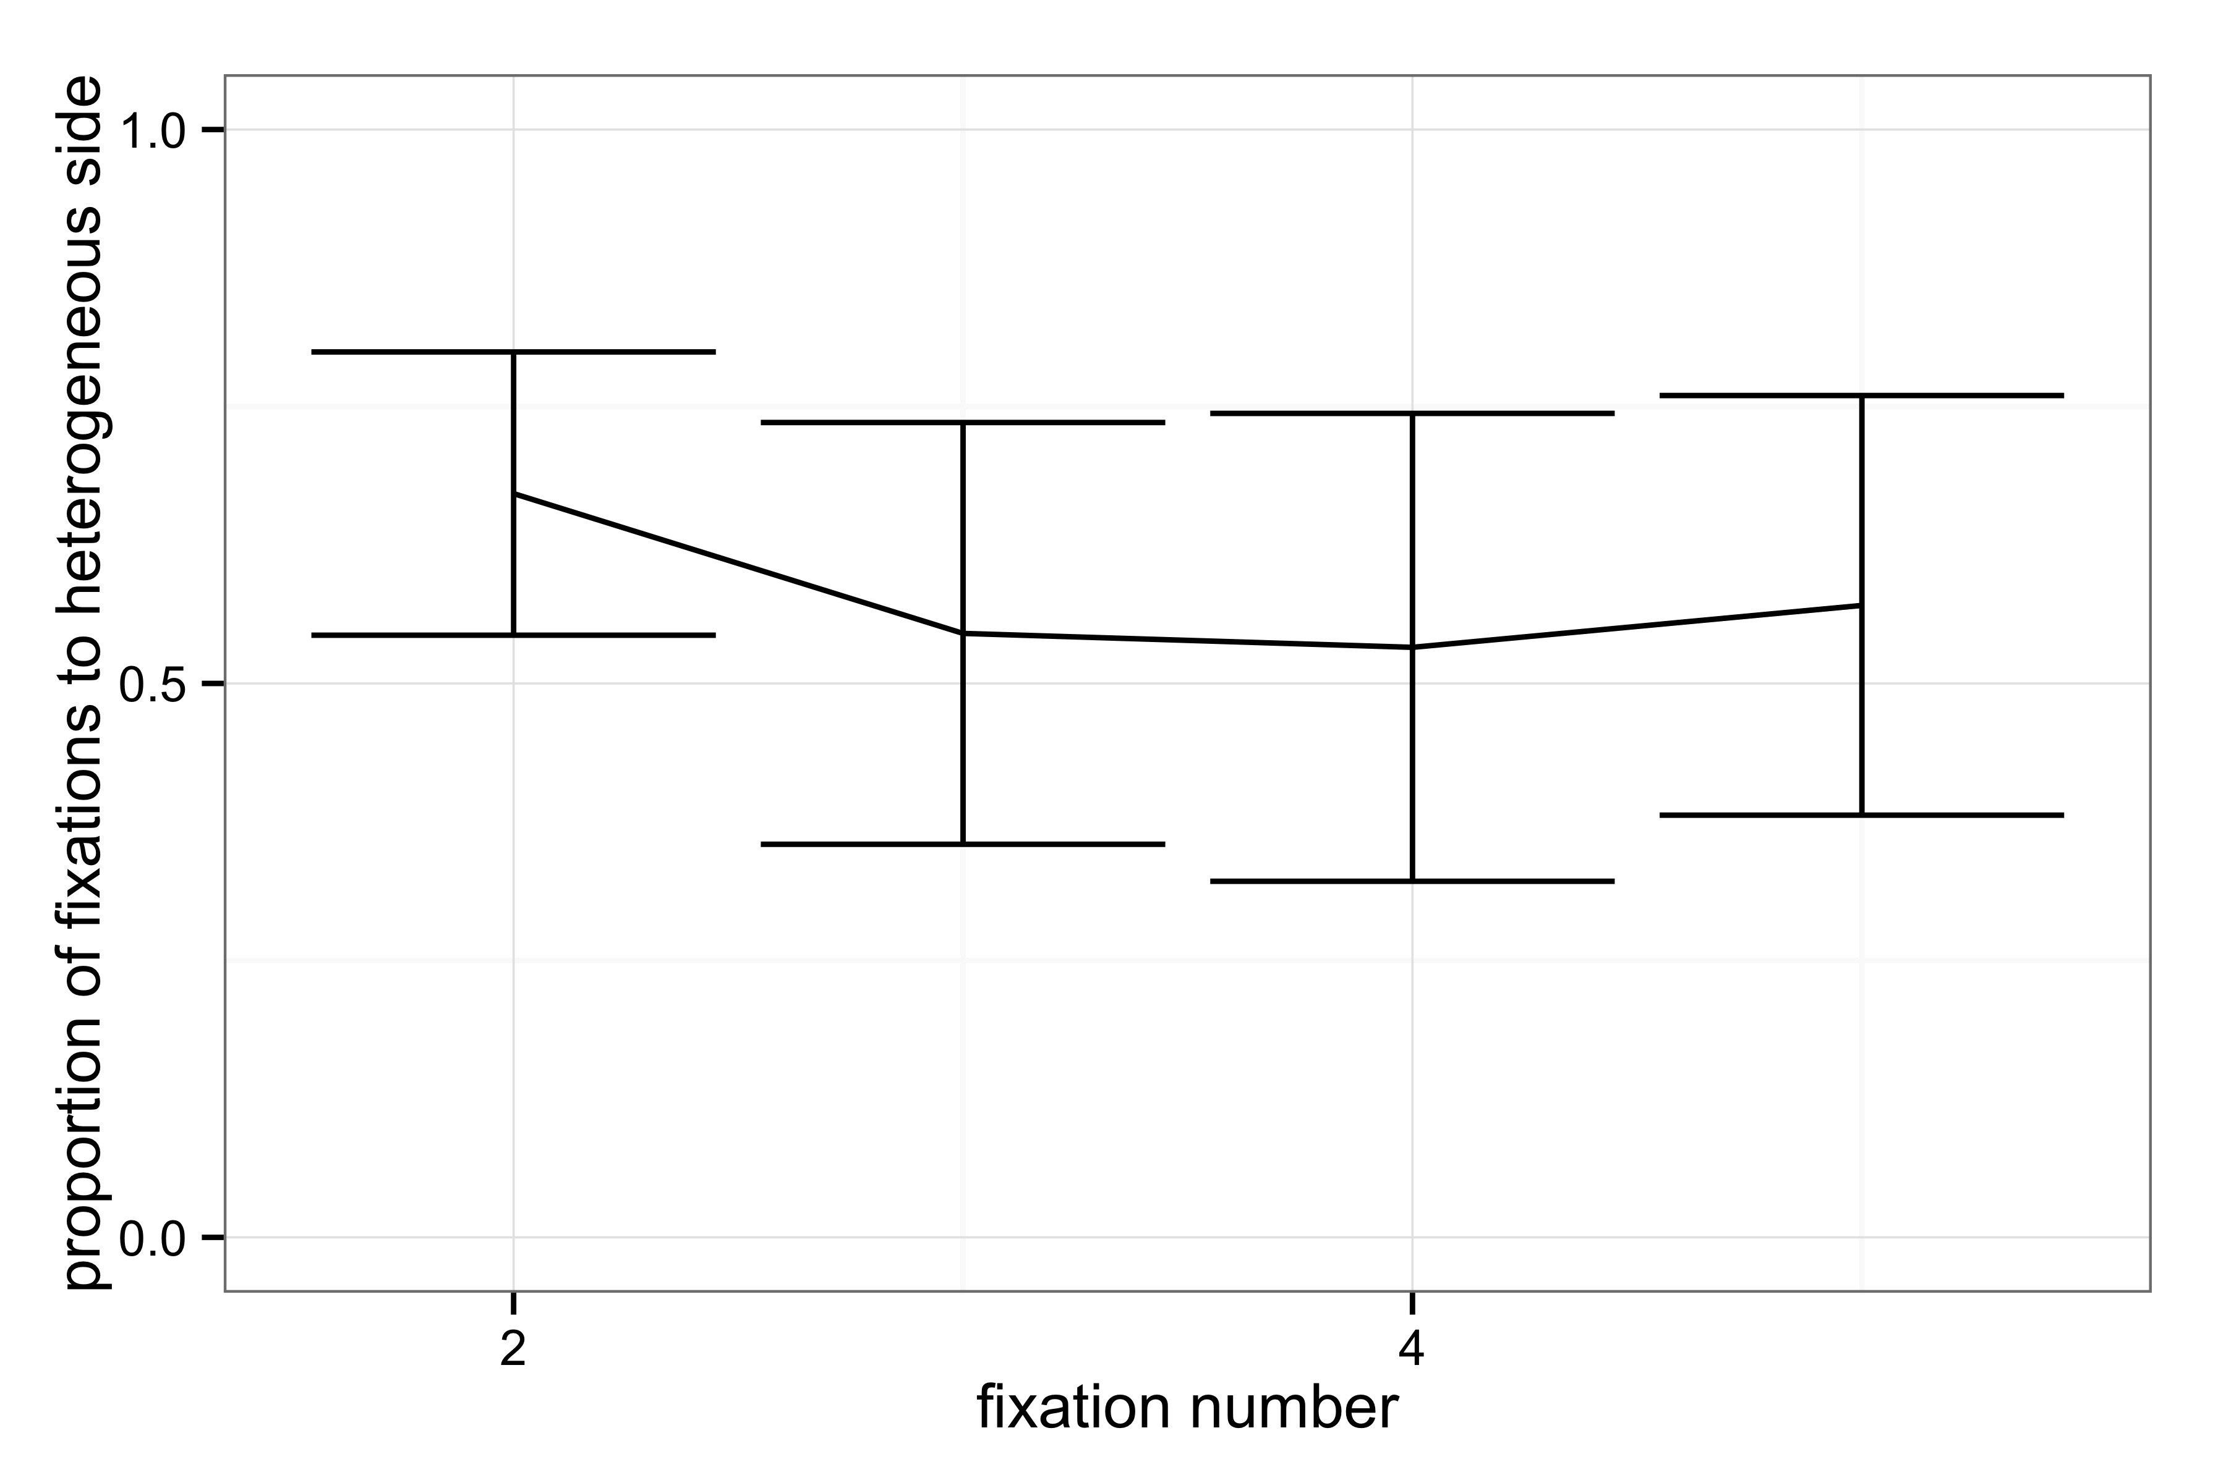

Figure 4. Mean proportion of saccades directed towards the heterogeneous side of the search array on target absent trials. Only fixations that are further than 1˚ to the left or right of the center of the display have been included in this analysis.

Next we measured the effect of this fixation inefficiency on the search performance of each participant. Inefficiency was defined as the proportion of the first five fixations made during target absent trials that were directed to the homogeneous side of the display. This measure was significantly correlated (see Figure 5A) with the median reaction time on target present trials, both when the target was located on the heterogeneous half of the display (r=0.93, p<0.001) and on the homogeneous side (r=0.81, p=0.002). These correlations are also significant when taking the proportion of the first 10 fixations (heterogeneous r=0.89, p<0.001; homogeneous r=0.71, p=0.01).

We also quantified the effect of fixation inefficiency on search time using a linear mixed-effect model (using the **lme4** (version 1.1.8, Bates, Maechler, Bolker, & Walker, 2015) package for **R** (version 3.2.1, *R* Core Team, 2015) with random intercepts and slopes. We were specifically interested in the effect of the number of homogeneous fixations on any given trial on the reaction time to find the target (including participant as a random factor). For target absent trials, we find an additional 357ms (bootstrapped 95% confidence interval: 196-516ms) in reaction times for every fixation made to the homogeneous side of the array (see Figure 5B). When the target is present on the heterogeneous side, each fixation on the homogeneous side slows reaction time by 547ms. Homogenous fixations even slow reaction time to find the target when it is present on the homogeneous side (by 159ms), consistent with the conclusions from our pilot study (see Supplementary Information) that these fixations are not necessary to find the target.

|  |  |
| --- | --- |
|  |  |
| Figure 5. A. Mean reaction time on trials where the target was present on the heterogeneous side for each observer is highly correlated with the mean proportion of the first five fixations directed to the homogenous side of the display on target absent trials. B. Reaction time on each target absent trial as a function of how many fixations were made on the homogeneous side of the display. For every homogeneous-side fixation, reaction time increases by 360ms. | |

Discussion.

Most participants over-fixate the homogeneous half of the display at the cost of increased reaction times. There are two possible (non-conflicting) explanations for this search inefficiency. First, it could reflect a failure to direct fixations in a manner that maximizes information gain, which would present a direct challenge to the optimal search model of Najemnik and Geisler (2005). Second, participants may make unnecessary confirmatory fixations on both sides of the display. Although we demonstrated in the pilot experiment that the peripheral information is sufficient to decide the target is present or absent, observers may be driven to verify their peripheral estimate based on the clearer, higher-resolution visual information that can be obtained by bringing that image onto the fovea, even though this verification comes at great cost to speed. The inefficiency of search in the compound display may therefore simply reflect an additive combination of how efficiently participants search these two types of displays alone, rather than a failure to distribute fixations optimally across the two types of search arrays. To separate these two plausible contributions to search inefficiency, we ran a second experiment, using a mix of uniform homogeneous, uniform heterogeneous, and compound arrays like those in Experiment 1.

*Experiment 2*

Methods.

Fourteen new participants (females=7; age range =20-62; mean age=25.5) completed Experiment 2. The stimuli, procedures and methods were the same as Experiment 1, except the stimuli consisted of 80 homogeneous arrays, 80 heterogeneous arrays and 80 split screen arrays. There were 240 trials in total, half of which contained a target. All the stimuli were displayed until the participant made a response (or timed out after 60 seconds).

Results.

Mean accuracy on the homogeneous trials was 98% (range: 91-100%), on heterogeneous 74% (55-88%), on compound trials 87% (79-96%). The mean of the observers’ median reaction times was 2.15 s (range: 1.69-2.91 s) for homogeneous trials, 5.76 s (2.82-15.15 s) for heterogonous trials, and 4.30 s (2.41-10.12 s) for the compound trials. The mean number of fixations over participants was 4 for uniform homogeneous (range: 2.5-5.0), 6.4 (3.9-13.7) for heterogeneous and 16.9 (8.7-37.8) for target absent.

Participants made, on average, four eye movements in the uniform homogenous display before making a response. Each of these fixations can be considered unnecessary, given that participants in the pilot experiment were close to 100% correct with no eye movements at all. If search on compound trials is simply an (optimal) combination of suboptimal search behaviour on the two types of uniform trials, then RT on the compound trials should equal the average of RT on the uniform homogeneous and uniform heterogeneous trials. If equal, this would suggest our participants simply sacrifice efficiency to satisfy an overly conservative certainty criteria. To the extent that search is slower on compound trials compared to the average of the two types of uniform trials, an inflated certainty criterion alone does not explain poor search behaviour.

Figure 6 shows predicted and actual RT for each participant on the target absent trials. All participants lie above the red line (although three are very close). This indicates that participants are taking longer than predicted from the uniform trials. To quantify the size of the difference, we calculated the ratio of split versus predicted RT for each participant. If participants’ behaviour on the compound trials matches an average of the behaviour they exhibit on the uniform trials, the ratio should be around 1. The mean ratio was 1.21(± .15), significantly higher than 1 (*t*(13)=30.95, *p*<.001). This additional slowing of reaction time in the compound trials can be attributed specifically to an inefficiency in allocating fixations to locations that yield the most information.

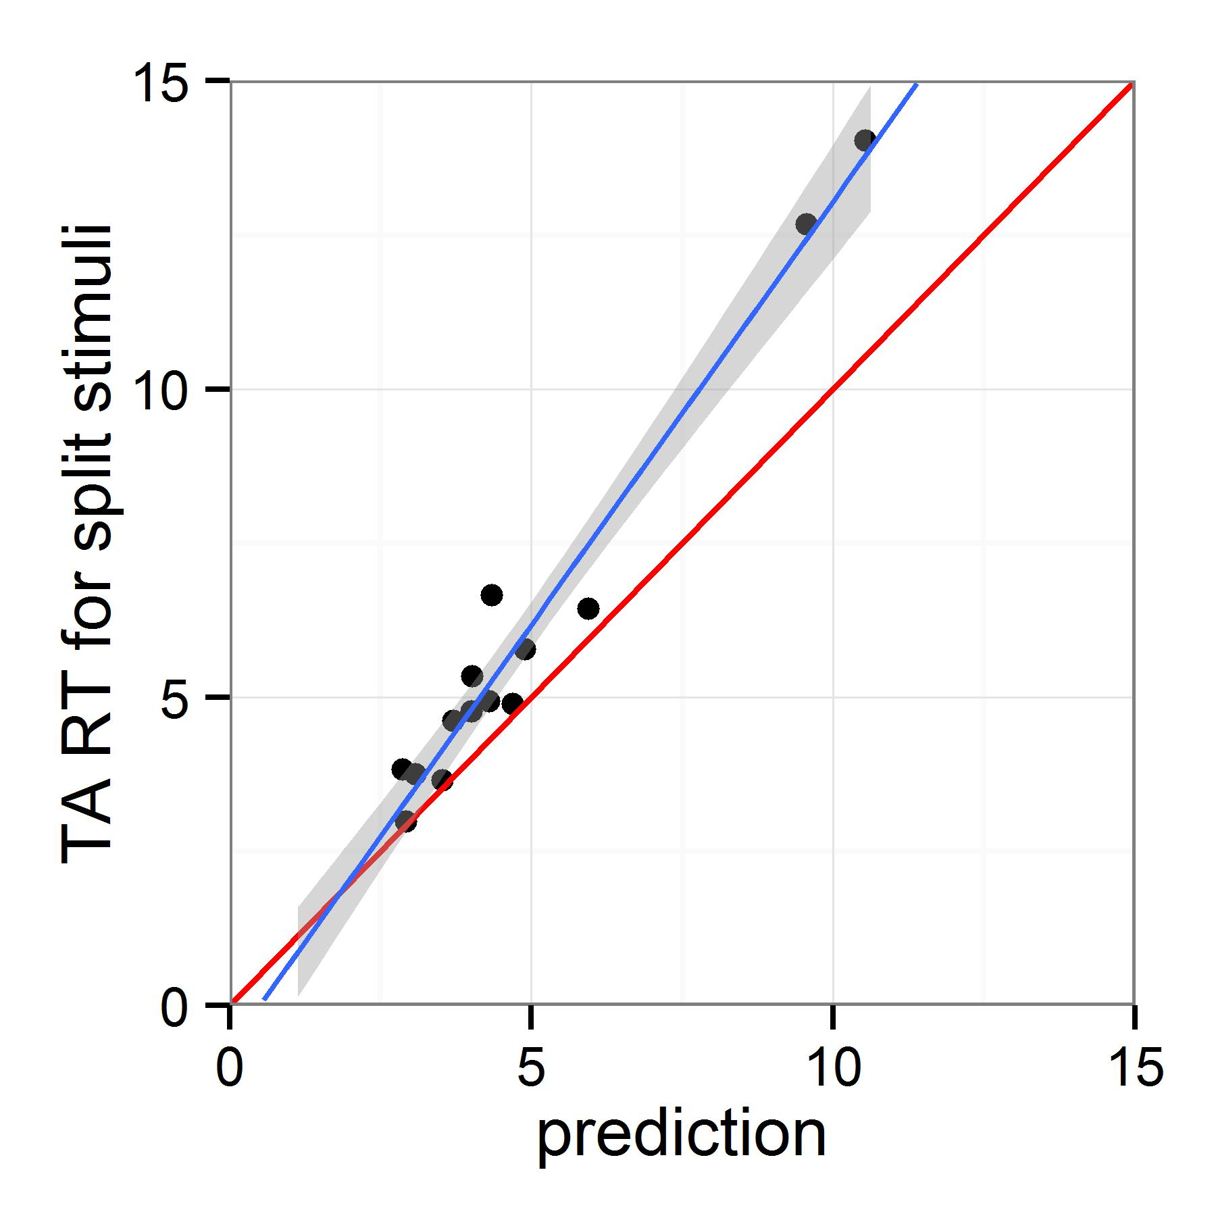

Figure 6. The red line represents predicted RT on target absent trials (mean homogeneous and mean heterogeneous RT averaged together). The blue line represents the actual RT on the split screen trials. Most points are above the line, suggesting participants take longer on the split screen trials than predicted from their behaviour on the full screen trials.

**General Discussion**

Our participants consistently failed to adopt an optimal strategy for searching a compound array with easy search on one side and difficult search on the other. In the first experiment, a large number of saccades were directed to the easy side of the display, on which the target would be clearly visible from the central fixation point. Each one of these unnecessary fixations slows search substantially. In the second experiment, we demonstrated that participants also search uniform displays inefficiently, generally making many more fixations than is necessary to find the target. Importantly, the inefficiency of search in the compound display reflects more than an additive combination of how inefficiently participants search the two types of displays alone. The additional inefficiency associated with the more complex array can be attributed to a failure to direct saccades to locations that can easily be estimated to provide the most information.

Taken together, these experiments clearly demonstrate that a large proportion of fixations made during visual search are not guided by the principles behind the optimal search model (Najemnik & Geisler, 2005; 2008). Not only do observers demonstrate a preference for making far more fixations than is required – presumably to increase their perceived certainty – but even taking these sub-optimal fixations into account, fixations in the compound array are not directed to locations that yield the most information. A viable alternative to the optimal search model has recently been proposed by Clarke, Green, Chantler & Hunt (submitted), who showed that a scan-paths during visual search can be modelled using a random walk. The current results are consistent with the notion that the processes underlying fixation selection during visual search may be more random and less efficient than current popular models suggest.

## **References**

Bates, D., Maechler, M., Bolker, B., & Walker, S. (2015). Package ‘lme4’. *Journal of Statistical Software,* 67(1), 1-48, [doi:10.18637/jss.v067.i01](http://dx.doi.org/10.18637/jss.v067.i01).

Brainard, D.H. (1997). The psychophysics toolbox. *Spatial Vision,* 10, 433-436.

Clarke, A.D.F. & Hunt, A.R. (2016). Failure of intuition when choosing whether to invest in a single goal or split resources between two goals. *Psychological Science,* 27(1), 64-74.

Goeree, J.K., Holt, C.A. & Palfrey, T.R. (2003). Risk averse behaviour in generalized matching pennies game. *Games and Economic Behaviour,* 45,97-113.

Ma, W.J., Navalpakkam, V., Beck, J.M., Van den Berg, R. & Pouget, A. (2011). Behaviour and neural basis of near-optimal visual search. *Nature Neuroscince,* 14, 783–790*.*

Morvan, C. & Maloney, L.T. (2012). Human visual search does not maximise the post-saccadic probability of identifying targets. *PLoS Computational Biology,*8, e1002342. Najemnik, J., & Geisler, W.S. (2005). Optimal eye movement strategies in visual search. *Nature,* 434, 387-391.

Najemnik, J., & Geisler, W.S. (2008). Eye movement statistics in humans are consistent with an optimal search strategy. *Journal of Vision,* 8(3):4.

Navalpakkam, V., Koch,C., Rangel, A., & Perona,P. (2010). Optimal reward harvesting in complex perceptual environments. *Proceedings of the National Academy of Sciences of the United States of America,* 107, 5232-5237.

Pelli, D.G. (1997). The VideoToolbox software for visual psychophysics: Transforming numbers into movies. *Spatial Vision,* 10, 437-442.

*R Core Team. R Foundation for Statistical Computing, Vienna, Austria (2015), URL https://www.R-project.org/.*

Shafir, S., Reich, T., Tsur, E., Erev I. & Lotem, A. (2008). Perceptual accuracy and conflicting effects of certainty on risk-taking behaviour. *Nature,*  453, 917-920.

**Volume:**

Pages:

Year published:

Verghese, P.(2012). Active search for multiple targets is inefficient. *Vision Research,* 74, 61-71.

## **Supplementary Materials - Pilot Experiment**

**Method**

*Participants.* Ten participants (females=8; age range=21-30; mean age=25) with normal or corrected to normal vision completed the experiment.

*Apparatus.* The display was presented on a 17inch CRT monitor with a resolution of 1024x768. Stimulus generation, presentation and data collection were controlled by Matlab and psychophysics toolbox (Brainard, 1997; Pelli, 1997) run on a Powermac. The position of the dominant eye was recorded using a desktop-mounted EyeLink 1000 eye tracker (SR Research, Canada) sampling eye position at 1000Hz.

*Stimuli and procedure.* Search arrays of line segments are illustrated in Figure 1. The line segments were aligned in 22 columns and 16 rows on a uniform grey background. The target line was always tilted 45 degrees to the right. The mean distractor angle was perpendicular to the target angle. Search difficulty was manipulated by sampling from either a narrow 30˚ range of distractor line orientations (“homogeneous”) or a wide 106˚ range (“heterogeneous”). The side of the target was counterbalanced. The target could be located in any of the possible locations apart from the middle four vertical columns. There were 80 trials, half of which contained a target.

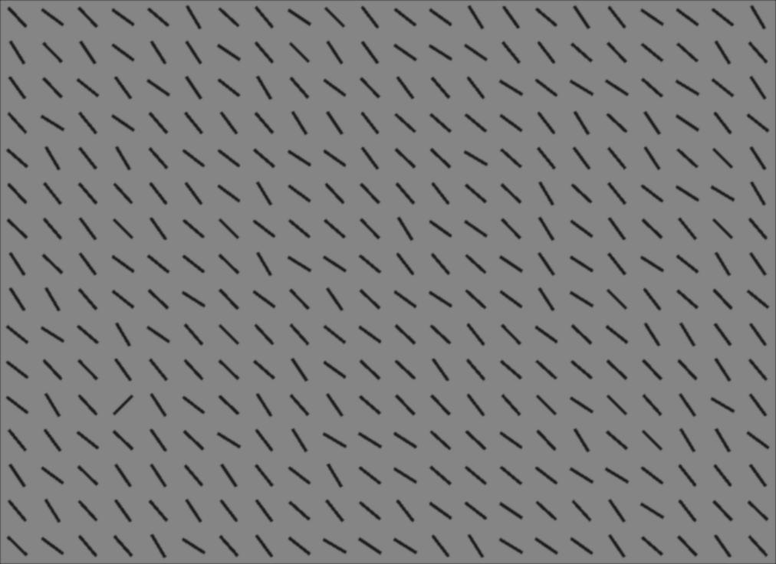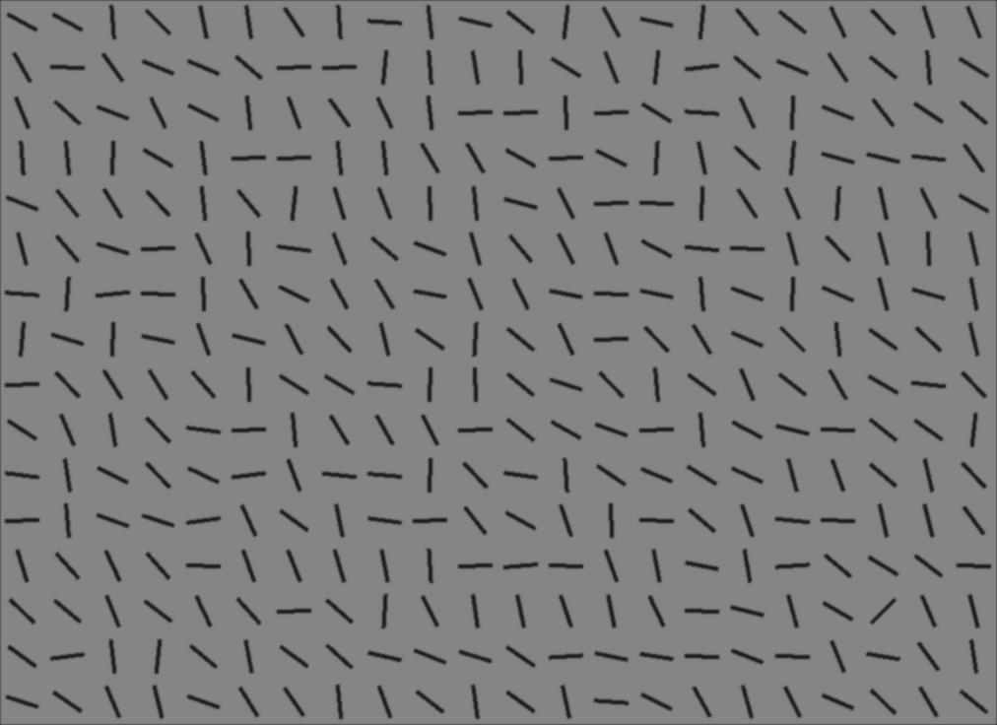

Figure 1: Example stimuli.

On arrival at the laboratory each participant was asked to read and sign a consent form and was seated alone in a low-lit room. Participants were told they would see line segments on the screen for a very short time, and their task was to determine whether a line tilted 45° to the right was present among other lines. Participants were asked to respond as accurately as possible.

Each trial consisted of a black fixation point (letter x) subtending 1.5x2.5cm (1.9°x3.1°), presented at the centre of the computer screen. On the press of a space bar, the stimulus was displayed for 200ms follow by a blank screen. Participants had to press either the left (present) or right (absent) arrow key. Auditory feedback in the form of a beep immediately followed incorrect key presses. Before the start of the experiment participants underwent a five-point calibration sequence and a block of 10 practice trials.

**Results**

Mean accuracy for the homogeneous stimuli was close to 100% (96 ± 5 % for target present, 89 ± 13% for target absent), while accuracy for the heterogeneous line segments was close to chance (61 ± 13% for target present, 57 ± 17% for target absent). When viewed from a central point, our observers were close to 100% correct to detect the target in the homogeneous array and close to chance in the heterogeneous array.