Alasdair’s Notes on Anna’s Study

Are we going to use “serial” and “parallel,” or “heterogeneous” and “homogeneous” ?

# Results

## 200ms Target DEtection

People get better between Monday and Friday

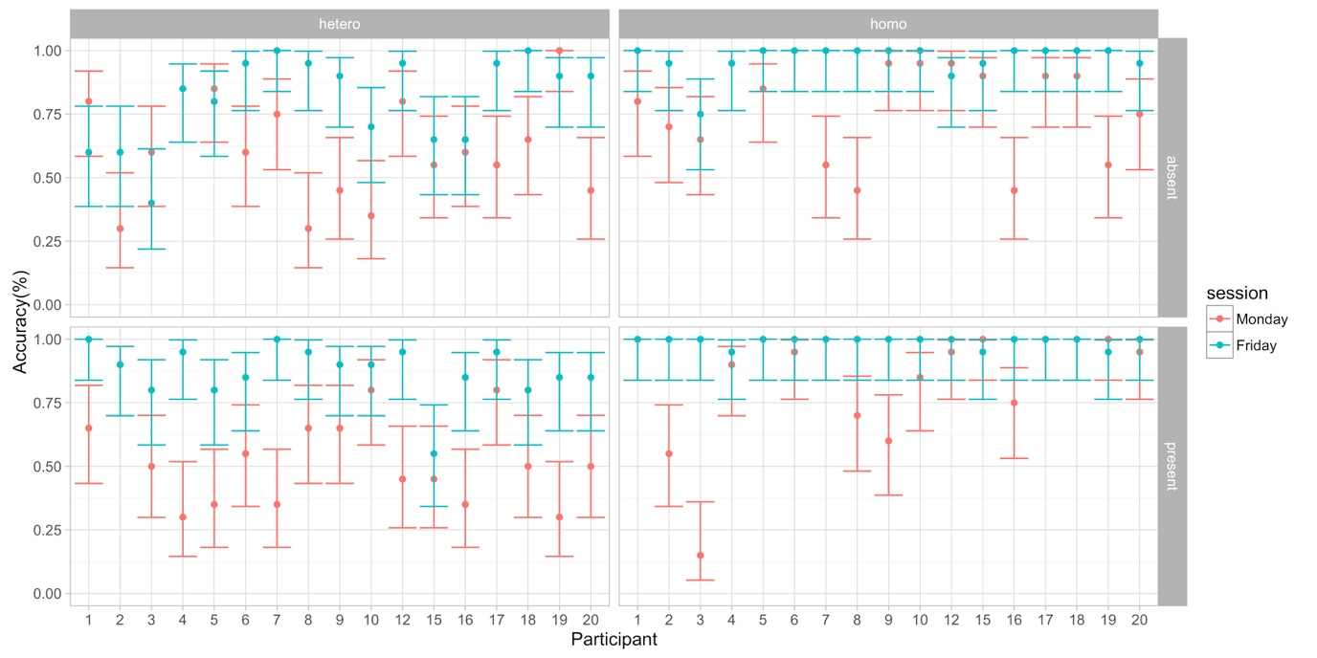

How would we like to analyse this? If I run a general linear effects model (which I think is kind of overkill), we find that people are significantly more accurate on Friday compared to Monday, and there’s an interaction in that they’re even better for the target present trials, no doubt in part due to a ceiling effect. And other uninteresting interactions with hetero/homogeneous. Maybe the best (simplest!) way to analyse over this is to just collapse over conditions (except for session) and calculate the 95% CI on how much people tend to improve by.

Here’s the plot collapsing over people:

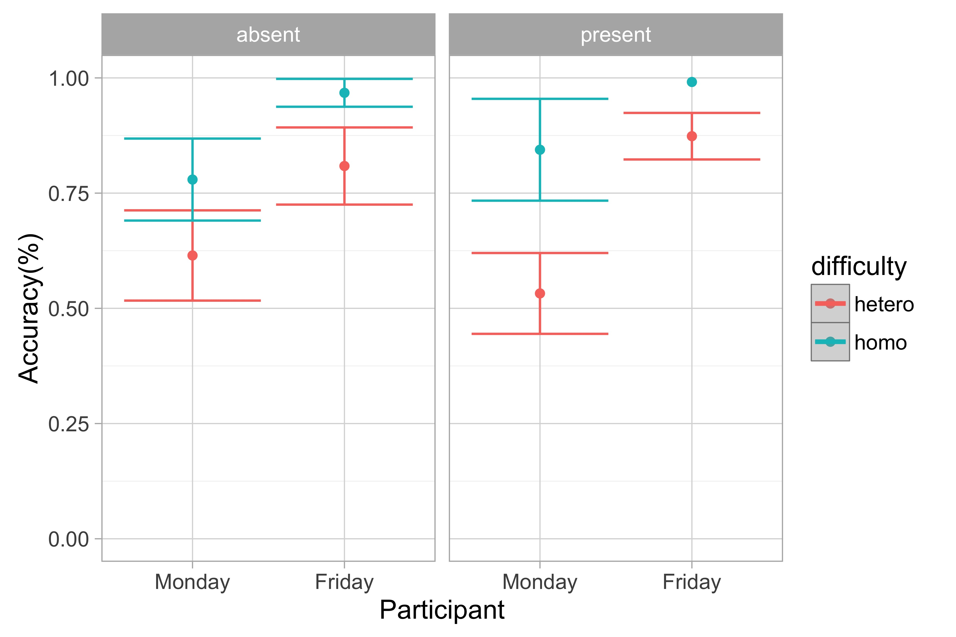

## The Five Search Sessions

### Accuracy

Macintosh HD:Users:alasdairclarke:Documents:HemianopiaTraining:plots:accuracy.pdf

We can clearly see that people get better over sessions. Lines indicate model fits that just pool all data over participants. I ran a glmer and we, unsurprisingly get the following results:

Analysis of Deviance Table (Type II Wald chisquare tests)

# Response: acc

# Chisq Df Pr(>Chisq)

# session 50.9665 1 9.395e-13 ***

# trialType 46.8036 2 6.866e-11 ***

# targSide 32.7537 2 7.720e-08 ***

# var 42.8988 1 5.765e-11 ***

# session:trialType 0.1983 2 0.9055885

# session:targSide 21.6161 2 2.024e-05 ***

# trialType:targSide 26.7011 4 2.285e-05 ***

# session:var 5.4585 1 0.0194736 *

# trialType:var 2.8877 2 0.2360211

# targSide:var 2.6804 2 0.2617981

# session:trialType:var 3.2985 2 0.1921973

# trialType:targSide:var 19.2913 4 0.0006888 ***

### Reaction Times

Macintosh HD:Users:alasdairclarke:Documents:HemianopiaTraining:plots:RTserial.pdf

Less of an obvious effect, but a linear mixed effect model using log(rt) suggests that nearly everything and its interaction is statistically significant.

Analysis of Deviance Table (Type II Wald chisquare tests)

Response: scale(log(RT))

Chisq Df Pr(>Chisq)

session 16.5595 1 4.715e-05 ***

targSide 220.7999 2 < 2.2e-16 ***

trialType 63.2704 1 1.802e-15 ***

var 68.9636 1 < 2.2e-16 ***

session:targSide 71.0196 2 3.787e-16 ***

session:trialType 22.4830 1 2.120e-06 ***

targSide:trialType 637.6169 2 < 2.2e-16 ***

session:var 0.6997 1 0.40288

targSide:var 1689.5594 2 < 2.2e-16 ***

trialType:var 0.3992 1 0.52748

session:targSide:trialType 0.7676 2 0.68128

session:targSide:var 74.3003 2 < 2.2e-16 ***

session:trialType:var 29.7427 1 4.934e-08 ***

targSide:trialType:var 110.1097 2 < 2.2e-16 ***

session:targSide:trialType:var 8.0889 2 0.01752 *

I think the a good (simple) way to analysis this may be to simply run a nested model comparison, to show that a model that includes session as a fixed effect explains statistically significantly more variance than one that doesn’t include session as a fixed effect. (This should avoid us having to run a gazillion pointless post-hocs). We could do the same for Accuracy above. If we do this, we get the following:

anova(m1,m2)

refitting model(s) with ML (instead of REML)

Data: rtdat

Models:

m2: scale(log(RT)) ~ targSide * trialType * var + (session + targSide + trialType + var | subjN)

m1: scale(log(RT)) ~ session * targSide * trialType * var + (session + targSide + trialType + var | subjN)

Df AIC BIC logLik deviance Chisq Chi Df Pr(>Chisq)

m2 34 30385 30651 -15159 30317

m1 46 30190 30550 -15049 30098 218.66 12 < 2.2e-16 ***

### Scan path Metrics

Scan-path metrics are a little trickier, as it’s harder to pin down what the dependent variables should be.

Macintosh HD:Users:alasdairclarke:Documents:HemianopiaTraining:LeftVrightFixationsParallel.pdf

In this plot above, I have just looked at the homogeneous (parallel) target absent trials. Each subplot is a different person, and we’re looking at the proportion of times (over trials) fixations are on one side or another. I think we have things set up so that the hemianopia side is always coded as being on the left, but I have to double check this. Regardless, there appears to be systematic pattern with session number.

If we look at saccadic amplitude, we get the following:plots/saccAmpBySession.pdf

### Individual differences?

I wonder if there correlation between how much people improve in this task, compared to the 200ms task?