28-06

- do the frequency code
- [plot graphs of frequency → (did it on pycharm)]
- make it a map
- check year that brown corpus was created
- was created in 1961
- look if this year shows more frequency?

- check if frequency “goes up” at the time of the corpus… could demonstrate language change (corpus is a snapshot in time)

- “low numbers”. Under ten maybe?
- ADD THE YEARS TO X-AXIS – IMPORTANT!
- look into syntax
verbs?
look into parsing (trees)
- look at 0s relative to text length?: 0 proportion
- email self all the daily tasks (so for the w/e can check what to do)

notes from today:

- looked at frequency patterns
- plotted graphs of all words / the less frequent ones. Nothing dramatic to note
- ‘0-proportion’… looking at proportion of text occupied by infrequent words (rated 0 frequency in brown corpus)… again there is no decrease in this
- plotted a graph of zeros… if anything, looks like it could have very slightly gone up. This could reflect language change (brown corpus is from the 60s)
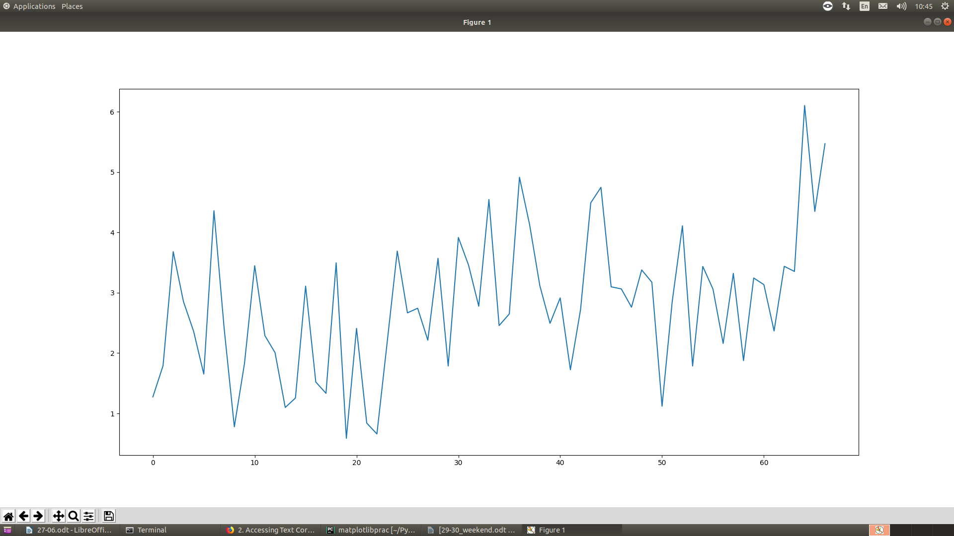
[look into newer ones?]

image below: zero plot

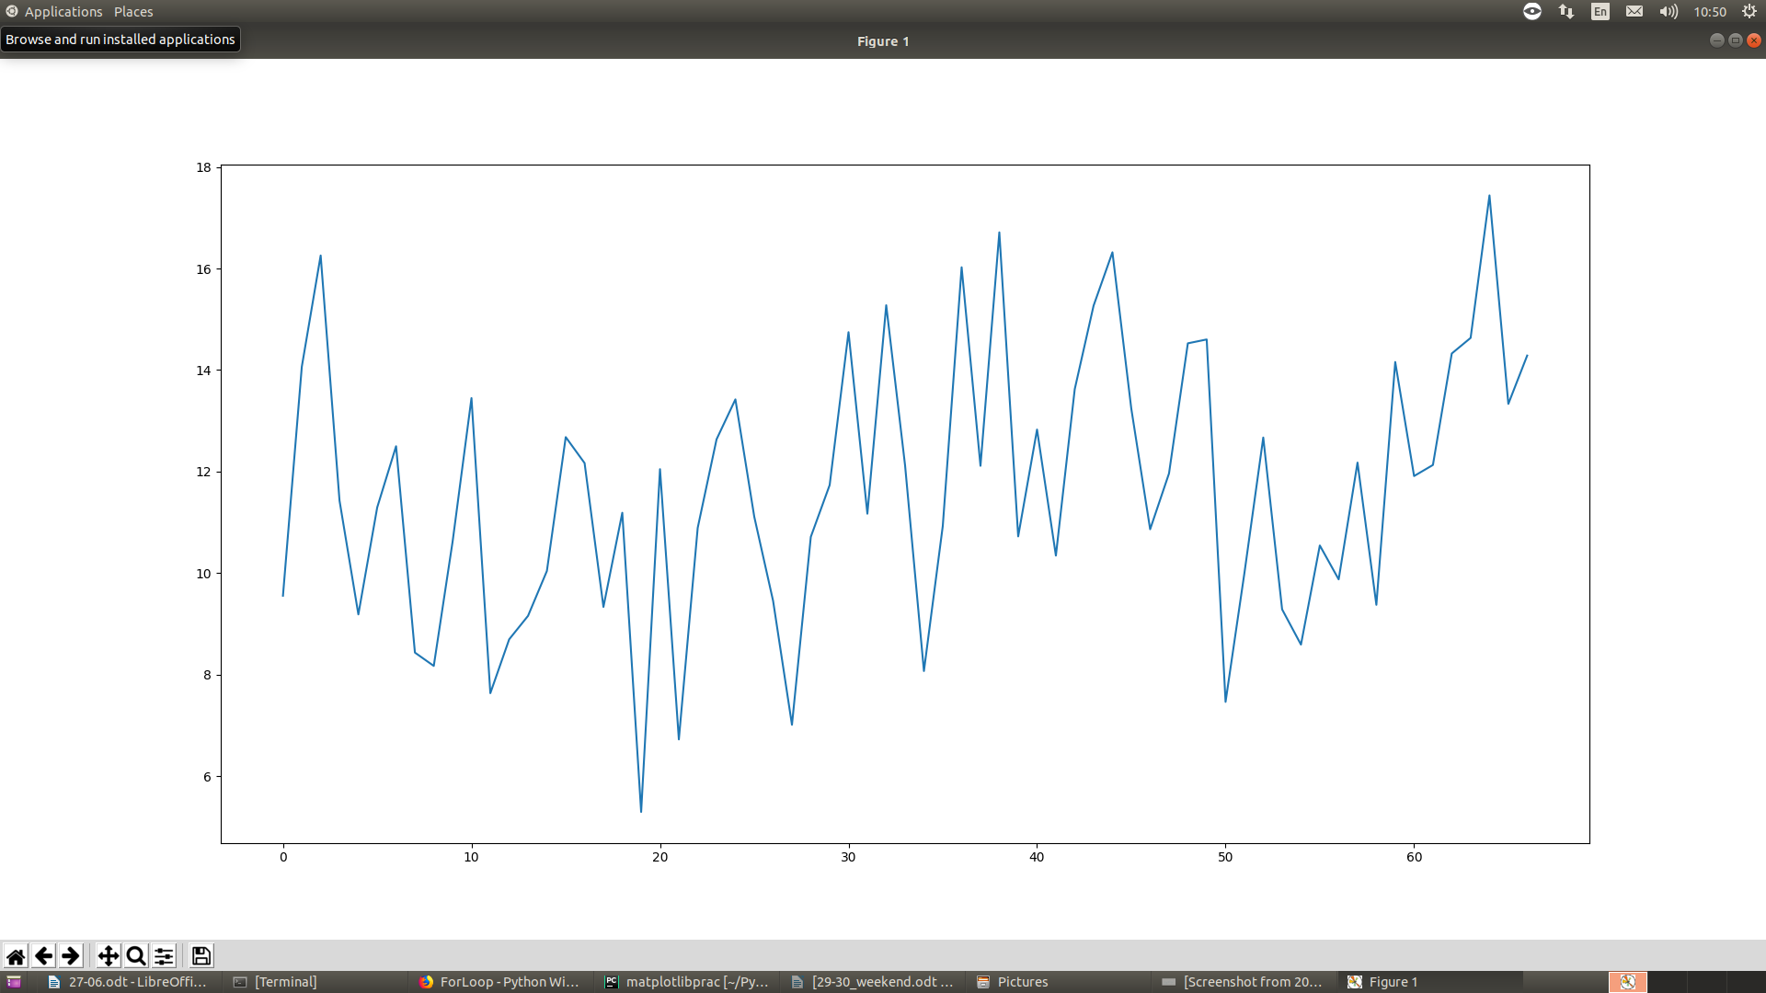
image below 0-10 plot (dip in the 60s?)
CHECK
[possible interpretation: queen follows the trends, reflected by plot]
THOSE DIPS COULD BE FREAK SPEECHES – REMOVE THEM

re-ran without the unconventional years (short-statements etc):
//same shape. Main dips etc not a result of this

YEARS ADDED:

0-plot again
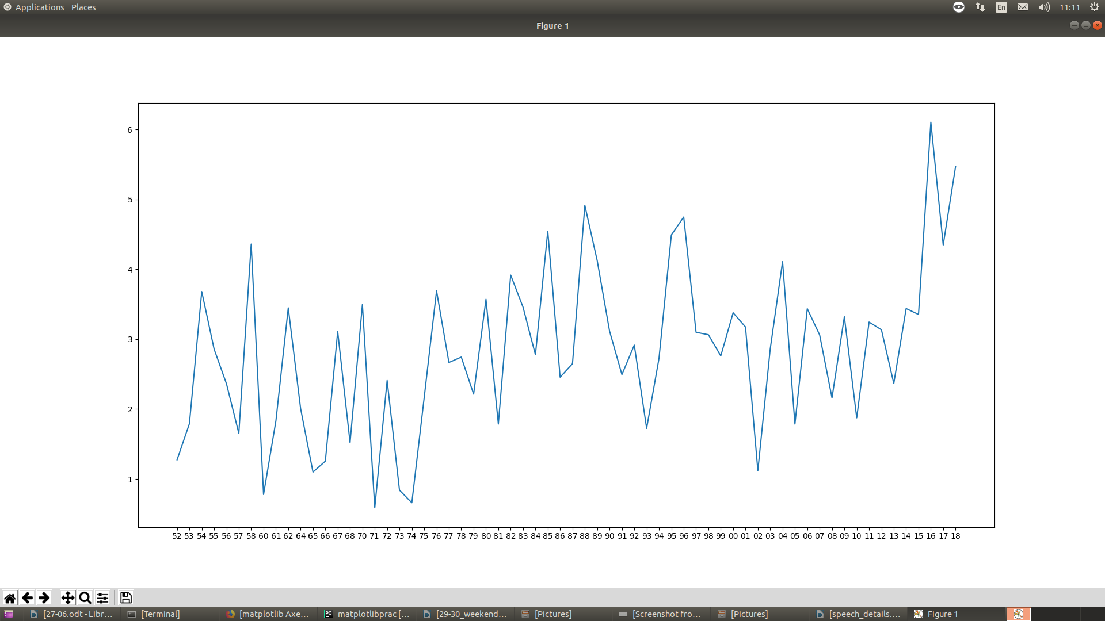

0-10 plot again

