NVDA Sentiment to Volume Data Platform
Azure Data Engineering and Machine Learning Project Report
Purpose Interview preparation and portfolio documentation
Platform Azure Data Factory, Azure Functions, ADLS Gen2, Synapse Analytics, Synapse Spark, Synapse SQL, and Power BI
Evidence base Version-controlled project artifacts and source code in the nvda-azure-pipeline repository
Report date September 18 2026
This report describes the implemented system and the engineering decisions visible in the repository. It does not claim production scale, financial forecasting accuracy, or measured cost savings where the project does not contain supporting evidence.

Executive Summary
This project implements an Azure data platform that combines X or Twitter activity with NVDA market data to predict the next available trading session's volume. It covers historical ingestion, daily micro-batch inference, Spark feature engineering, model training and evaluation, post-market label backfill, conditional retraining, Gold-layer aggregation, dimensional modeling, and Power BI serving.
The system separates historical processing from the daily inference path. Azure Data Factory ingests and transforms historical tweet data through Bronze and Silver layers. Synapse Spark combines the cleaned social data with Yahoo Finance market history, generates Gold features, and trains a Random Forest regression model. Azure Functions handles the daily tweet window. Synapse Pipelines coordinate prediction at 6:00 AM Eastern Time and the 6:30 PM backfill and warehouse refresh workflow.
The strongest engineering aspects are the explicit data layers, trading-session-aware labels, chronological model validation, post-market actual-volume backfill, idempotent overwrite patterns, managed identity, and automated SQL pool pause and resume. The main limitations are the small educational workload, dependence on external APIs, a sensitive one percent retraining threshold, limited automated data-quality enforcement, and the absence of recorded production performance metrics.

Project Scope and Business Question
The project asks whether social sentiment and engagement signals available before a trading session can contribute to an estimate of NVDA volume for the next available market session. The target is volume rather than price direction. This distinction matters because the repository creates the label `next_available_volume`, evaluates prediction error, and stores both predicted and actual volume in the serving layer.
The project is designed as a data engineering portfolio system. Model quality matters, but the implementation gives equal attention to ingestion, data contracts, transformation, orchestration, operational recovery, and analytical serving.
Objective | Implementation evidence
Ingest external data | RapidAPI tweet ingestion through ADF and Azure Functions; Yahoo Finance market ingestion in Synapse notebooks
Create reusable data layers | ADLS Gen2 Bronze, Silver Parquet, and Gold Parquet paths
Build predictive features | Sentiment, engagement, account, calendar, and market-session features in PySpark
Operationalize inference | Scheduled Azure Function and Synapse triggers for prediction and backfill
Serve analytics | External tables, dimensional warehouse tables, stored procedure refresh, and Power BI

System Architecture
The architecture uses two connected paths. The historical path produces training data and analytical aggregates. The daily path produces a prediction before the market session and attaches the actual label after market data becomes available.
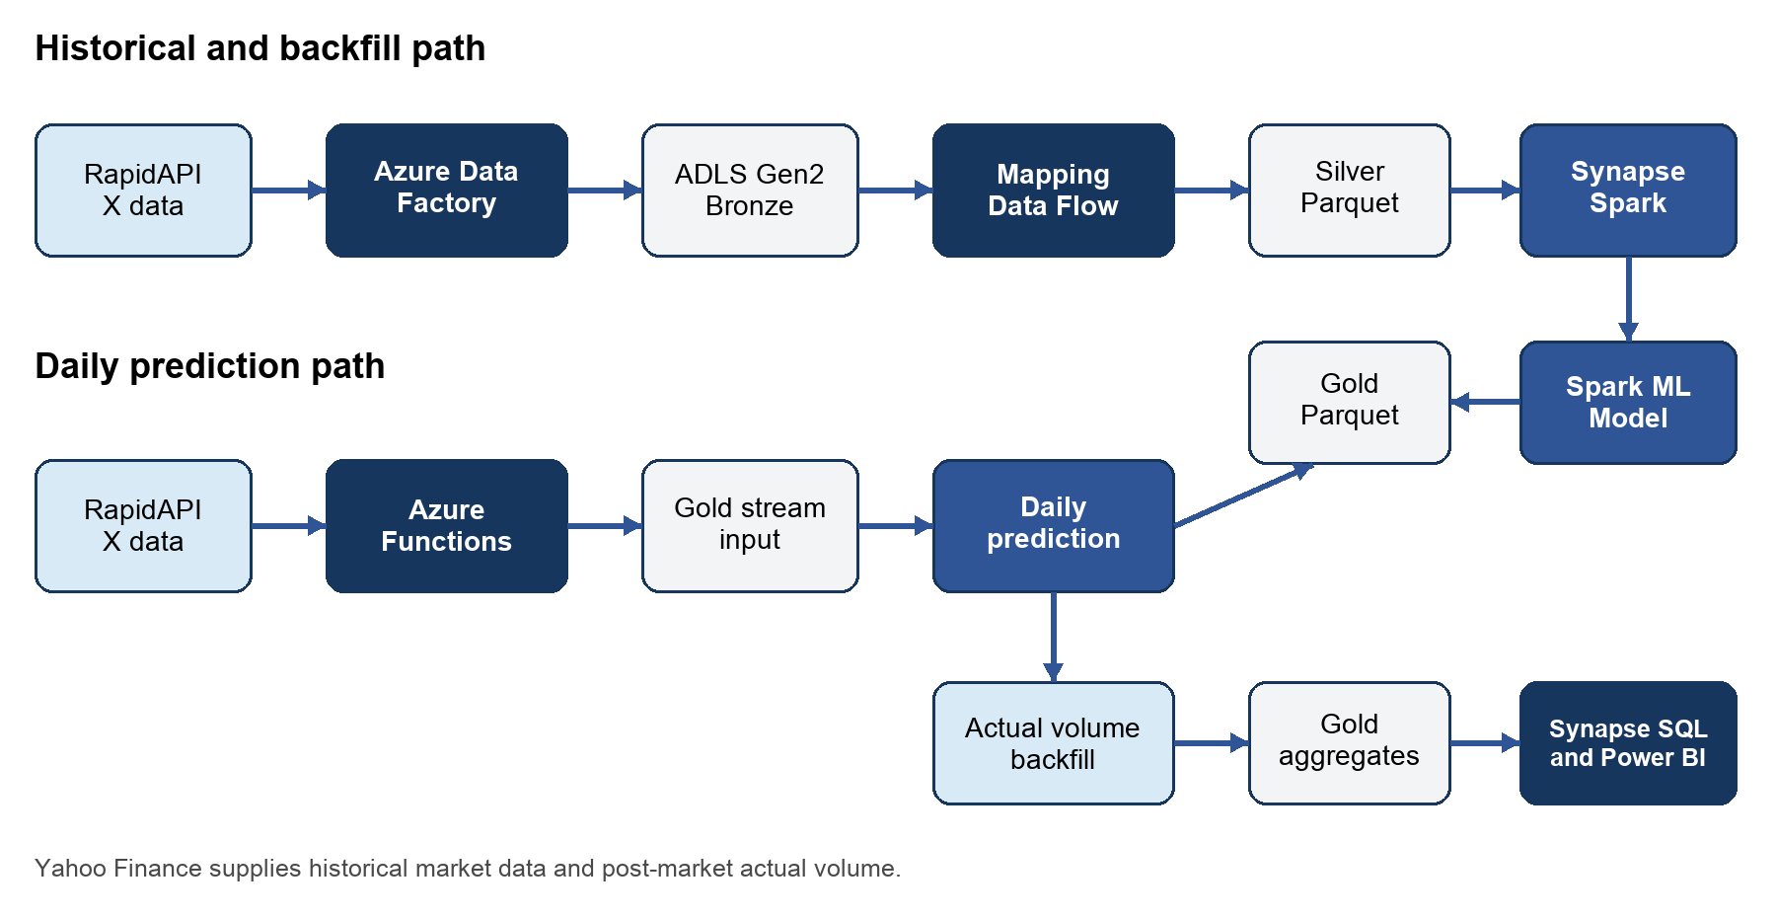
Figure 1 Implemented Azure data platform and daily prediction path

Service Responsibilities
Service | Responsibility | Why it exists
Azure Data Factory | Historical ingestion, backfill, and Bronze-to-Silver Mapping Data Flows | Managed connectors, parameters, and batch transformation
Azure Functions | Scheduled and HTTP-triggered daily tweet ingestion | Serverless micro-batch execution
ADLS Gen2 | Bronze, Silver, Gold, model, prediction, and aggregate storage | Durable storage separated from compute
Synapse Spark | Market processing, feature engineering, ML, and aggregation | Distributed Python and Spark ML execution
Synapse Pipelines | Dependencies, notebook execution, SQL lifecycle, and refresh | Cross-service orchestration and failure paths
Dedicated SQL Pool | Dimensional serving tables for BI | Supports relational analytics and predictable BI access patterns
Power BI | Dashboard consumption | Presents sentiment, market, user, and prediction measures

Data Ingestion

Historical Tweet Processing
ADF pipeline `PL_Tweet_Bronze_Backfill` iterates across dates for historical ingestion. `PL_Tweet_Bronze_Test` uses a Copy activity to call the RapidAPI endpoint and write JSON to ADLS. The historical Silver pipeline runs `DF_Tweets_Bronze_to_Silver_Historical`, which flattens nested entries, maps tweet fields, removes null rows, derives timestamps and weekend flags, and deduplicates tweets before writing Parquet.

Daily Tweet Processing
The Python Function App queries a recent RapidAPI window, extracts tweet and user structures, cleans text, computes VADER sentiment, derives engagement fields, assigns a candidate prediction session, and writes a compact JSON payload to the configured Gold stream location. Configuration values such as `RAPIDAPI_KEY` and `STORAGE_ACCOUNT_NAME` come from environment variables.
The timer uses two UTC schedules to cover daylight-saving changes. An `America/New_York` guard allows execution only during the 5:00 AM Eastern hour. The HTTP endpoint supports controlled manual testing without changing the scheduled function.

Market Data
Synapse notebooks use `yfinance` for historical NVDA prices and volume and for the post-market actual-volume backfill. Bronze preserves the downloaded market records, Silver applies types and cleanup, and Gold joins trading-session labels to tweet-level features.

Medallion Architecture
Layer | Stored data | Format and purpose | Representative controls
Bronze | Raw API responses and market extracts | JSON or CSV retained for replay and debugging | Date parameters and source-preserving ingestion
Silver | Flattened tweets, typed market history | Parquet optimized for analytical reads | Null filtering, type conversion, derived timestamps, and deduplication
Gold | Model features, predictions, evaluation records, and BI aggregates | Parquet aligned to ML and serving use cases | Trading-session mapping, overwrite-by-output dataset, and post-write read checks

The layers represent data quality and purpose, not merely storage folders. Bronze retains source fidelity, Silver creates reusable typed entities, and Gold encodes business and model semantics. Because compute is separated from storage, failed transformations can be replayed from an earlier durable layer.

Feature Engineering and Label Design
The project maps tweets to a `prediction_session_date` and derives `next_available_volume` from the next eligible trading session. This prevents a simple calendar-date join from assigning weekend or holiday data to a nonexistent market session. The label design also reduces leakage by separating information available before prediction from volume observed after the market session.
Feature group | Implemented examples
Sentiment | VADER compound sentiment score
Engagement | Interaction score, favorite ratio, reply ratio, viral flag
User profile | Follower and friend counts, media count, account age, credibility score
User classification | Blue verification, new-account flag, influencer flag
Calendar | Day of week and weekend flag
Target | Next available trading-session volume

The feature pipeline coerces numeric and Boolean values, fills missing feature values, indexes and one-hot encodes day of week, assembles the feature vector, and applies standard scaling. The same transformation sequence is reused during training and retraining through a Spark ML Pipeline.

Machine Learning Workflow

Training and Validation
`PredictionML_Historical` trains a Spark ML `RandomForestRegressor`. The implementation separates train and test data by `prediction_session_date` and asserts that the two session sets do not overlap. This chronological separation is more appropriate than a random row split because tweets from the same market session share the same volume label.
The selected model configuration uses 50 trees, maximum depth 5, and a minimum of 5 instances per node. The notebook evaluates RMSE, MAE, and R squared at both tweet level and session level. Session-level evaluation averages tweet predictions within a prediction session before comparing the result with actual volume.

Daily Prediction and Backfill
`BlobStreamPredict` loads the daily stream input and persisted model, applies the training feature pipeline, aggregates predictions by session, and writes prediction history. `BackfillRetrain` later retrieves the actual market volume, updates previously unlabeled Gold rows, calculates prediction error, and evaluates whether retraining is required.

Conditional Retraining
The implemented trigger retrains when a newly evaluated prediction has relative error greater than 1 percent. When triggered, the notebook rebuilds the Random Forest pipeline with the same 50-tree, depth-5 configuration and writes a replacement model artifact.
Interview assessment: the mechanism demonstrates closed-loop model operations, but a one percent threshold is likely too sensitive for stock-volume forecasts. A production design should calibrate the threshold against a rolling error baseline, minimum sample count, model age, data drift, and the cost of retraining.

Daily Orchestration
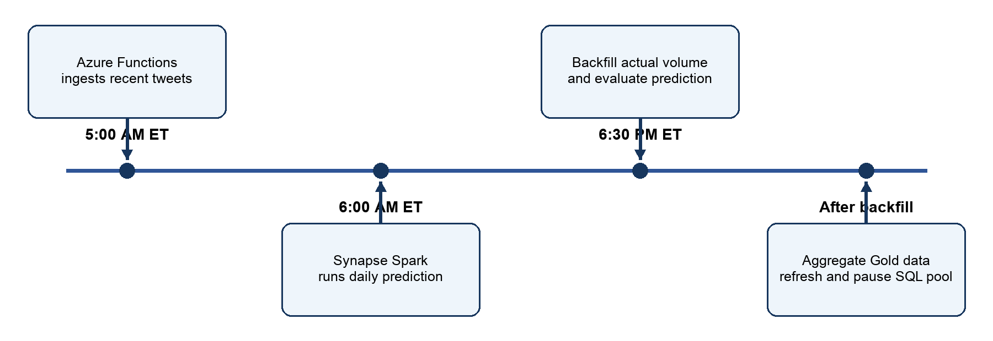
Figure 2 Daily schedule in Eastern Time
`TR_DailyPrediction_6AM_ET` starts `PL_DailyPrediction`, which runs the prediction notebook. `TR_BackfillRetrain_630PM_ET` starts the larger post-market workflow. That pipeline runs backfill and conditional retraining, rebuilds Gold aggregates, resumes the SQL pool through a management API, polls for readiness, executes `dbo.sp_DailyRefresh`, and pauses the pool after the refresh. A separate failure branch pauses the pool if it does not become ready.
Time | Task | Output or control
5:00 AM ET | Azure Function ingestion | Inference-ready recent tweet payload
6:00 AM ET | Synapse daily prediction | Predicted next-session volume
6:30 PM ET | Backfill and evaluation | Actual volume, error, and retraining decision
After backfill | Gold aggregation and warehouse refresh | Updated BI tables followed by SQL pool pause

Analytical Serving Model
Gold Parquet datasets are exposed through Synapse external tables and loaded into a dimensional warehouse by `sp_DailyRefresh`. Small descriptive dimensions use replicated distribution, while the fact tables use round-robin distribution in this educational workload. The SQL scripts use heaps rather than clustered columnstore indexes, which keeps setup simple but should be revisited for a larger warehouse.
Object | Representative grain or purpose
DimDate | One row per calendar date
DimUser | One row per social-media user
FactDailyTweet | Daily tweet and sentiment summary
FactMarketSummaryPerDay | One market summary per date
FactViralTweetLog | One row per viral tweet
FactUserTypeDistribution | One user-type distribution per day
FactTopUsersByTweetCount | User-level tweet ranking
FactTopUsersByViralTweets | User-level viral-tweet ranking
FactInfluencerMonthlyEngagement | Monthly influencer engagement summary
FactPrediction | One prediction and evaluation record per target session

Security and Configuration
- Azure Functions uses `DefaultAzureCredential` for storage access instead of embedding a storage key.
- ADF and Synapse use managed identity credentials for platform-to-storage access.
- RapidAPI credentials are read from environment variables; the repository contains placeholders only.
- Local settings, environment files, private keys, and generated dependency folders are excluded from Git.
- The public repository preserves non-secret resource identifiers and endpoints in native deployment artifacts. A new environment must replace or parameterize them.
A production extension should store the external API credential in Azure Key Vault and grant the Function App access through managed identity. It should also separate development and production factories and deploy higher environments through CI and CD rather than direct Git authoring.

Reliability and Cost Controls
Concern | Implemented control | Recommended extension
Duplicate historical ingestion | Historical tweet deduplication and date-parameterized backfill | Persist source request IDs and enforce a deterministic object key contract
Partial workflow failure | Pipeline dependencies, readiness polling, and SQL pool failure branch | Add alerting, dead-letter handling, and explicit recovery runbooks
Schema change | Typed Silver transformations | Add schema contracts, quarantine paths, and compatibility tests
Data quality | Null checks, post-write reads, and model-label availability checks | Add formal expectations for uniqueness, freshness, completeness, and ranges
Compute cost | Dedicated SQL pool resume and pause around refresh | Track runtime and cost by workload tag and enforce maximum run duration
Model drift | Prediction backfill and relative-error trigger | Use rolling metrics, minimum sample counts, and feature-drift monitoring

Design Tradeoffs and Limitations
- The daily path is scheduled micro-batch processing. It should not be described as true continuous streaming.
- The external APIs can change schemas, enforce rate limits, or provide incomplete historical coverage. The pipeline needs explicit retry and schema-quarantine behavior for production use.
- The repository documents evaluation methods but does not provide stable production accuracy metrics. Resume and interview claims should not invent RMSE, MAE, or R squared results.
- The retraining threshold is implemented as a fixed one percent relative error. It demonstrates branching but needs empirical calibration.
- Round-robin heaps are reasonable for a small educational warehouse but may be inefficient at scale. Distribution keys and columnstore indexes should be chosen from query and load patterns.
- Power BI artifacts are not included in the current repository, so dashboard visuals and refresh configuration are described only at the serving-layer level.

Azure to AWS Rebuild Plan
The AWS rebuild should preserve capabilities and data contracts rather than copy Azure service names one for one. S3 replaces the storage foundation, but ingestion, cataloging, compute, query, orchestration, and security remain separate architectural responsibilities.
Capability | Azure implementation | AWS target
Object storage | ADLS Gen2 | Amazon S3
Serverless ingestion | Azure Functions | AWS Lambda
Batch transformation | ADF Mapping Data Flow and Synapse Spark | AWS Glue Spark or Amazon EMR
Metadata catalog | Synapse and workspace metadata | AWS Glue Data Catalog
Lake query | Synapse external tables | Amazon Athena or Redshift Spectrum
Warehouse | Synapse Dedicated SQL Pool | Amazon Redshift
Orchestration | Synapse Pipelines | Apache Airflow or Amazon MWAA
Secrets and identity | Managed Identity and environment configuration | IAM Roles and AWS Secrets Manager
Monitoring | Azure Monitor and pipeline run history | Amazon CloudWatch

Interview Preparation

Sixty Second Project Summary
I built an end-to-end Azure data platform that combines X sentiment with Yahoo Finance market data to predict NVDA trading volume. ADF handles historical ingestion and Bronze-to-Silver transformation, while Synapse Spark creates Gold features, trains a Random Forest model, and runs daily inference. After market close, the pipeline backfills actual volume, evaluates the prediction, conditionally retrains the model, rebuilds Gold aggregates, resumes the Synapse SQL pool, refreshes a dimensional warehouse, and pauses the pool to control cost. I designed the workflow around explicit data layers, trading-session-aware labels, chronological validation, managed identity, and replayable storage.

Questions to Expect
Question | Answer framework
Why use Bronze, Silver, and Gold? | To separate source preservation, reusable typed data, and business or model semantics. The separation supports replay, debugging, and independent downstream consumers.
Why Parquet in Silver and Gold? | Parquet is typed and columnar, which reduces analytical scan volume and preserves schema better than JSON or CSV.
How did you avoid model leakage? | The split uses prediction sessions instead of random tweet rows, and the target comes from the next eligible trading session.
Why is Airflow or MWAA useful in the AWS version? | It coordinates Lambda, Glue, quality checks, backfills, branching, and Redshift refreshes. It is the orchestrator, not the transformation engine.
How is the pipeline idempotent? | Historical processing uses date parameters and deduplication; Gold aggregates use deterministic output paths and overwrite semantics. Production hardening would add run manifests and source request IDs.
What would you change for production? | Add formal data-quality gates, Key Vault, CI and CD, schema quarantine, drift monitoring, calibrated retraining, and workload-specific warehouse distribution and indexing.

Resume Ready Description
- Designed an end-to-end Azure data platform using a Bronze, Silver, and Gold medallion architecture, ingesting X and Yahoo Finance data through Azure Data Factory and Azure Functions and transforming raw JSON and CSV into typed, deduplicated Parquet datasets.
- Developed PySpark feature engineering and Random Forest regression workflows in Azure Synapse to combine sentiment, engagement, account, calendar, and market features for NVDA trading-volume prediction, with RMSE, MAE, and R squared evaluation.
- Orchestrated daily prediction, actual-volume backfill, Gold aggregation, conditional retraining, and dimensional-warehouse refresh; automated Synapse SQL pool resume, readiness checks, refresh, and pause operations to limit idle compute.

Repository Evidence Map
Area | Repository path
ADF ingestion and transformation | adf/pipeline, adf/dataflow, adf/dataset, adf/linkedService
Azure Functions | function-app/function_app.py and function-app/host.json
Spark processing and ML | synapse/notebook
Daily orchestration | synapse/pipeline and synapse/trigger
Warehouse DDL and refresh | sql/01_external_objects.sql through sql/04_sp_daily_refresh.sql
Native Synapse artifacts | synapse/credential, synapse/linkedService, and synapse/sqlscript

The report reflects the repository state reviewed on September 18 2026. It should be updated when the AWS rebuild, Power BI artifact, automated quality framework, or measured model results are added.

