**IBS ⟶ DEP**

**IBS ⟶ DED**

**DEP ⟶ IBS**

**DED ⟶ IBS**

**DED ⟶ DEP**

**DEP ⟶ DED**

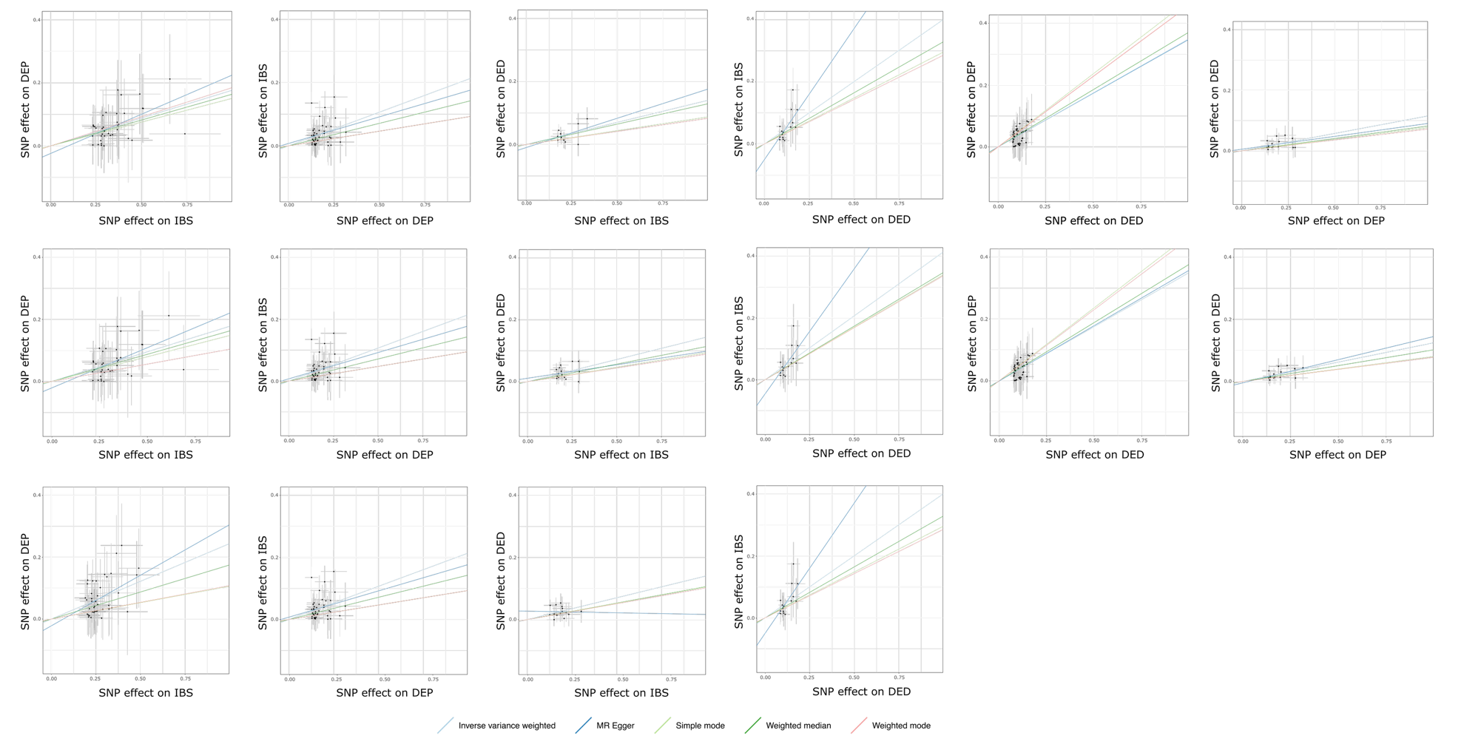

**GWAS**

**COJO**

**SAIGE**

Figure 2. Scatter plots of the one-sample Mendelian randomization analysis. GWAS: genome-wide association study; COJO: conditional and joint association analysis; IBS, inflammatory bowel disease; DEP, depression; DED, dry eye disease. * SAIGE was only applied in the IBS to DEP, DEP to IBS, IBS to DED, and DED to IBS experiments.

**IBS ⟶ DEP**

**IBS ⟶ DED**

**DEP ⟶ IBS**

**DED ⟶ IBS**

**DED ⟶ DEP**

**DEP ⟶ DED**

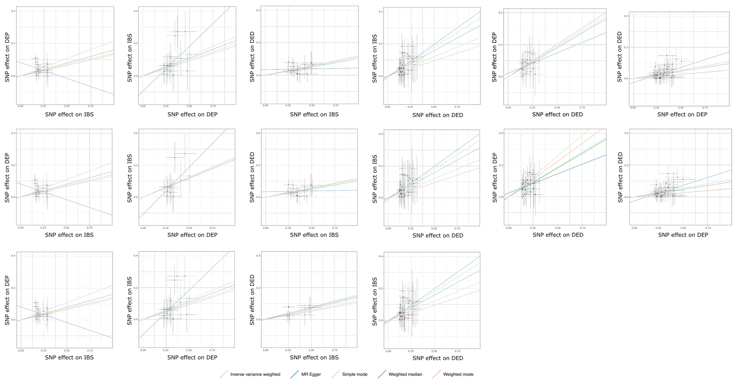

**GWAS**

**COJO**

**SAIGE**

Figure 3. Scatter plots of the two-sample Mendelian randomization analysis. GWAS: genome-wide association study; COJO: conditional and joint association analysis; IBS, inflammatory bowel disease; DEP, depression; DED, dry eye disease. * SAIGE was only applied in the IBS to DEP, DEP to IBS, IBS to DED, and DED to IBS experiments.

**GWAS**

**COJO**

**SAIGE**

**DEP ⟶ DED**

**DED ⟶ DEP**

**DED ⟶ IBS**

**DEP ⟶ IBS**

**IBS ⟶ DED**

**IBS ⟶ DEP**

Figure 3. Effect size (beta) of leave-one-out (LOO) approach for heterogeneity analysis of one-sample Mendelian randomization (OSMR) using the inverse-variance weighted (IVW) method. LOO omits instrumental single-nucleotide polymorphisms (SNPs) one by one to explore whether the MR estimates were disproportionately influenced by certain SNPs. GWAS: genome-wide association study; COJO: conditional and joint association analysis; IBS, inflammatory bowel disease; DEP, depression; DED, dry eye disease. * SAIGE was only applied in the IBS to DEP, DEP to IBS, IBS to DED, and DED to IBS groups due to the low case‒control ratio.

**GWAS**

**COJO**

**SAIGE**

**IBS ⟶ DEP**

**IBS ⟶ DED**

**DEP ⟶ IBS**

**DED ⟶ IBS**

**DED ⟶ DEP**

**DEP ⟶ DED**

Figure 4. Effect size (beta) of leave-one-out (LOO) approach for heterogeneity analysis of two-sample Mendelian randomization (TSMR) using the inverse-variance weighted (IVW) method. LOO omits instrumental single-nucleotide polymorphisms (SNPs) one by one to explore whether the MR estimates were disproportionately influenced by certain SNPs. GWAS: genome-wide association study; COJO: conditional and joint association analysis; IBS, inflammatory bowel disease; DEP, depression; DED, dry eye disease. * SAIGE was only applied in the IBS to DEP, DEP to IBS, IBS to DED, and DED to IBS groups due to the low case‒control ratio.