Paper Title
Subtitle (if needed)

Author 1 Name¹, Author 2 Name², Author 3 Name²
¹ Line 1 (of affiliation): dept. name of organization, organization name, City, Country
Line 2: e-mail address if desired
² Line 1 (of affiliation): dept. name of organization, organization name, City, Country
Line 2: e-mail address if desired

Accepted on mmmmm dd, yyyy
Approved on mmmmm dd, yyyy

Abstract—This electronic document is a “live” template which you can use on preparing your Ultima Computing paper. Use this document as a template if you are using Microsoft Word 2007 or later. Otherwise, use this document as an instruction set. Do not use symbol, special characters, or Math in Paper Title and Abstract. Do not cite references in the abstract.
Index Terms—enter key words or phrases in alphabetical order, separated by semicolon ( ; )

Introduction
This template, modified in MS Word 2007 and saved as a Word 97-2003 document, provides authors with most of the formatting specifications needed for preparing electronic versions of their papers. Margins, column widths, line spacing, and type styles are built-in here. The authors must make sure that their paper has fulfilled all the formatting stated here.
Introduction commonly contains the background, purpose of the research, problem identification, and research methodology conducted by the authors which been describe implicitly. Except for Introduction and Conclusion, other chapter’s title must be explicitly represent the content of the chapter.

Ease of Use

Selecting a Template
First, confirm that you have the correct template for your paper size. This template is for Ultima Computing. It has been tailored for output on the A4 paper size.

Maintaining the Integrity of the Specifications
The template is used to format your paper and style the text. All margins, column widths, line spaces, and text fonts are prescribed; please do not alter them.

Prepare Your Paper Before Styling
Before you begin to format your paper, first write and save the content as a separate text file. Keep your text and graphic files separate until after the text has been formatted and styled. Do not add any kind of pagination anywhere in the paper. Please take note of the following items when proofreading spelling and grammar.

Abbreviations and Acronyms
Define abbreviations and acronyms the first time they are used in the text, even after they have been defined in the abstract. Abbreviations such as IEEE, SI, MKS, CGS, sc, dc, and rms do not have to be defined. Abbreviations that incorporate periods should not have spaces: write “C.N.R.S.,” not “C. N. R. S.” Do not use abbreviations in the title or heads unless they are unavoidable.

Units
- Use either SI (MKS) or CGS as primary units (SI units are encouraged).
- Do not mix complete spellings and abbreviations of units: “Wb/m2” or “webers per square meter,” not “webers/m2.” Spell units when they appear in text: “...a few henries,” not “...a few H.”
- Use a zero before decimal points: “0.25,” not “.25.”

Equations
The equations are an exception to the prescribed specifications of this template. You will need to determine whether or not your equation should be typed using either the Times New Roman or the Symbol font (please no other font). To create multileveled equations, it may be necessary to treat the equation as a graphic and insert it into the text after your paper is styled.
Number the equations consecutively. Equation numbers, within parentheses, are to position flush right, as in (1), using a right tab stop.
(1)
Note that the equation is centered using a center tab stop. Be sure that the symbols in your equation have been defined before or immediately following the equation. Use “(1),” not “Eq. (1)” or “equation (1),” except at the beginning of a sentence: “Equation (1) is ...”

Some Common Mistakes
- The word “data” is plural, not singular.
- The subscript for the permeability of vacuum μ₀, and other common scientific constants, is zero with subscript formatting, not a lowercase letter “o.”
- In American English, commas, semi-/colons, periods, question and exclamation marks are located within quotation marks only when a complete thought or name is cited, such as a title or full quotation. When quotation marks are used, instead of a bold or italic typeface, to highlight a word or phrase, punctuation should appear outside of the quotation marks. A parenthetical phrase or statement at the end of a sentence is punctuated outside of the closing parenthesis (like this). (A parenthetical sentence is punctuated within the parentheses.)
- A graph within a graph is an “inset,” not an “insert.” The word alternatively is preferred to the word “alternately” (unless you really mean something that alternates).
- Do not use the word “essentially” to mean “approximately” or “effectively.”
- In your paper title, if the words “that uses” can accurately replace the word using, capitalize the “u”; if not, keep using lower-cased.
- Be aware of the different meanings of the homophones “affect” and “effect,” “complement” and “compliment,” “discreet” and “discrete,” “principal” and “principle.”
- Do not confuse “imply” and “infer.”
- The prefix “non” is not a word; it should be joined to the word it modifies, usually without a hyphen.
- There is no period after the “et” in the Latin abbreviation “et al.”
- The abbreviation “i.e.” means “that is,” and the abbreviation “e.g.” means “for example.”

Using the Template
After the text edit has been completed, the paper is ready for the template. Duplicate the template file by using the Save As command, and use the naming convention as below
ULTIMATICS_firstAuthorName_paperTitle.
In this newly created file, highlight all of the contents and import your prepared text file. You are now ready to style your paper. Please take note on the following items.

Authors and Affiliations
The template is designed so that author affiliations are not repeated each time for multiple authors of the same affiliation. Please keep your affiliations as succinct as possible (for example, do not differentiate among departments of the same organization).

Identify the Headings
Headings, or heads, are organizational devices that guide the reader through your paper. There are two types: component heads and text heads.
Component heads identify the different components of your paper and are not topically subordinate to each other. Examples include ACKNOWLEDGMENTS and REFERENCES, and for these, the correct style to use is “Heading 5.”
Text heads organize the topics on a relational, hierarchical basis. For example, the paper title is the primary text head because all subsequent material relates and elaborates on this one topic. If there are two or more sub-topics, the next level head (uppercase Roman numerals) should be used and, conversely, if there are not at least two sub-topics, then no subheads should be introduced. Styles, named “Heading 1,” “Heading 2,” “Heading 3,” and “Heading 4”, are prescribed.

Figures and Tables
Place figures and tables at the top and bottom of columns. Avoid placing them in the middle of columns. Large figures and tables may span across both columns. Figure captions should be below the figures; table heads should appear above the tables. Insert figures and tables after they are cited in the text. Use the abbreviation “Fig. 1,” even at the beginning of a sentence.
- Table Styles
Table Head | Table Column Head
 | Table column subhead | Subhead | Subhead
copy | More table copy

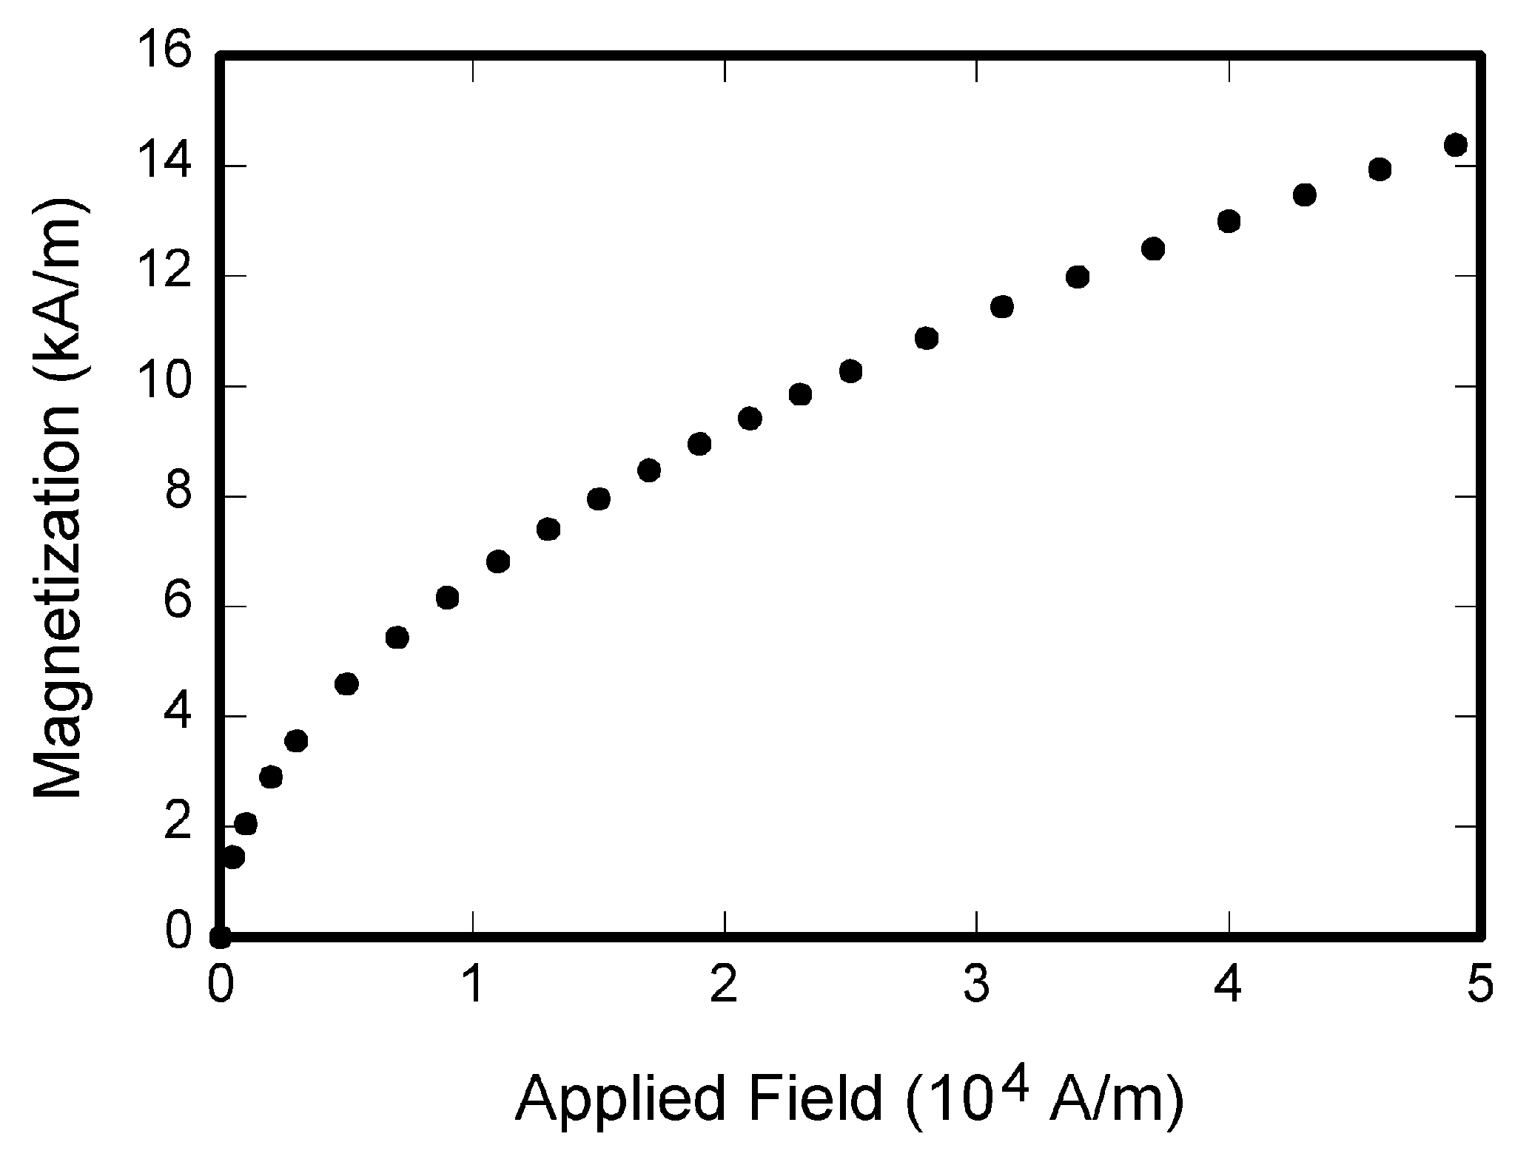
- Example of a figure caption

Conclusion
A conclusion section is not required. Although a conclusion may review the main points of the paper, do not replicate the abstract as the conclusion. A conclusion might elaborate on the importance of the work or suggest applications and extensions.

Appendix
Appendixes, if needed, appear before the acknowledgment.

ACKNOWLEDGMENT
The preferred spelling of the word “acknowledgment” in American English is without an “e” after the “g.” Use the singular heading even if you have many acknowledgments. Avoid expressions such as “One of us (S.B.A.) would like to thank ... .” Instead, write “F. A. Author thanks ... .” You could also state the sponsor and financial support acknowledgments here.

References
The template will number citations consecutively within brackets [1]. The sentence punctuation follows the bracket [2]. Refer simply to the reference number, as in [3]—do not use “Ref. [3]” or “reference [3]” except at the beginning of a sentence: “Reference [3] was the first ...”
Number footnotes separately in superscripts. Place the actual footnote at the bottom of the column in which it was cited. Do not put footnotes in the reference list. Use letters for table footnotes.
Unless there are six authors or more give all authors’ names; do not use “et al.”. Papers that have not been published, even if they have been submitted for publication, should be cited as “unpublished” [4]. Papers that have been accepted for publication should be cited as “in press” [5]. Capitalize only the first word in a paper title, except for proper nouns and element symbols.
For papers published in translation journals, please give the English citation first, followed by the original foreign-language citation [6].
- G. Eason, B. Noble, and I.N. Sneddon, “On certain integrals of Lipschitz-Hankel type involving products of Bessel functions,” Phil. Trans. Roy. Soc. London, vol. A247, pp. 529-551, April 1955. (references)
- J. Clerk Maxwell, A Treatise on Electricity and Magnetism, 3rd ed., vol. 2. Oxford: Clarendon, 1892, pp.68-73.
- I.S. Jacobs and C.P. Bean, “Fine particles, thin films and exchange anisotropy,” in Magnetism, vol. III, G.T. Rado and H. Suhl, Eds. New York: Academic, 1963, pp. 271-350.
- K. Elissa, “Title of paper if known,” unpublished.
- R. Nicole, “Title of paper with only first word capitalized,” J. Name Stand. Abbrev., in press.
- Y. Yorozu, M. Hirano, K. Oka, and Y. Tagawa, “Electron spectroscopy studies on magneto-optical media and plastic substrate interface,” IEEE Transl. J. Magn. Japan, vol. 2, pp. 740-741, August 1987 [Digests 9th Annual Conf. Magnetics Japan, p. 301, 1982].
- M. Young, The Technical Writer’s Handbook. Mill Valley, CA: University Science, 1989.

