Title of Paper
Judul Makalah
^{1,2}First Author ^{*)}, ¹Second Author and ²Third Author
¹Author’s Affiliation
²Author’s Affiliation
^{*)} corresponding email: Author’s E-mail
Abstract
Abstract contents use Franklin Gothic Book font, size 9 pt, single spacing. Spacing after is 6 pt for the paragraph after the abstract. Maximum number of words is 200. Abstract contents are 1) a short background of the research importance, 2) a research objective and/or scope,3)research novelty,4) (a short) exposition of the research method, 5) a summary of results/findings, and 6) a conclusion. The editor team will assist when having trouble writing abstracts and keywords in Bahasa Indonesia.
Keywords: Franklin Gothic Book 9 pt. , lowercase, 5 – 10 keywords.

Abstrak
Untuk isi abstrak, gunakan jenis huruf Franklin Gothic Book ukuran huruf 9pt dengan spasi single antar barisnya, untuk paragraph berikut dalam abstrak ada jarak spacing after sebesar 6 pt. Jumlah kata maksimum pada abstrak adalah 200 kata.Isi abstrak adalah 1) latar belakang singkat pentingnya penelitian, 2) tujuan dan / atau ruang lingkup penelitian, 3) Keterbaruan / novelty penelitian, 4) uraian metode (singkat) yang digunakan, 5) ringkasan hasil / finding dan 6) simpulan. Tim editor akan membantu jika penulis ada kesulitan dalam menyusun abstrak dan kata kunci berbahasa Indonesia.
Kata Kunci: Franklin Gothic Book 9 pt., huruf kecil, 5- 10 kata kunci

Paper accepted [date, month, year] – paper revised [date, month, year]– approved [date, month, year]

This paper is open access with CC BY-SA license.


Introduction (Sub Chapter)
The title uses 12 pt size, bold, font is Franklin Gothic Book; use 6 pt spacing after between title and text body, and 18 pt spacing before title. The text body uses a 10 pt font size with single line spacing. For ease of writing style, this file/writing can be used as the template. The structure of this paper is at least these sub-chapters: Introduction, Discussion, Conclusion, Acknowledgements (if any), Nomenclature (if any), and References. Subchapters are to be numbered in sequence.
Article writing may use IMRAD (Introduction, Method, Results, Discussion) discussion systematic.
Introduction is an introduction of the paper’s contents. The contents of the introduction are the background of research that includes previous research(es), problem and weakness (gap analysis), research to be done, the proposal of problem-solving, or how to overcome weakness. The paper discusses novelty/state of the art, referencing journals of the last 10 years.
Do not divide the introduction into sub-parts: background, problem exposition, and objective [1].
The research objective needs to be written explicitly in the Introduction sub-chapter, and also write statement of gap analysis or originality or novelty or significance or scientific contribution or article’s originality.

Method (Sub-Chapter)
Contents of the Method sub-chapter are how the research’s experiment is done so that other researchers can replicate or reproduce it. In the Method sub-chapter, it is sufficient to write about the main equipment or main equipment needed for analysis or characterization. Write also its type and accuracy. Write also the research location, number of respondents, and what process is done to observe results. General methods should not be written in detail; only a reference article should be shown. The experiment procedure is written as a report sentence, not an instruction sentence.
The article length is between 6 – 8 pages, including figures, tables, references, nomenclature, etc., on A4 paper size.
This document has conformed to the paper format of Jurnal Otomasi Instrumentasi dan Kontrol. Please use this document to write your paper. Styles used in this document are such :
Title of paper : title of paper in Franklin Gothic Book font, 14 pt. size, bold. Maximum of 10 words in English Language and 14 words in Bahasa Indonesia.
Author(s) : author(s) name(s) in Franklin Gothic Book font, 10 pt. size, bold.
Author(s) affiliation : author’s affiliation/workplace (university, research institution, industry/enterprise name, etc.) : Franklin Gothic Book font, 10 pt. size
Author e-mail : author’s e-mail for sending e-mail : Franklin Gothic Book font, 10 pt. size, italic.
Abstract : Franklin Gothic Book font, 9 pt. size, single spacing between lines.
Bodytext : the content of paper : Franklin Gothic Book font, 10 pt. size, single spacing between lines. Spacing sizes for paragraphs : spacing before 0 pt. and spacing after 6 pt.
Sub Chapter/Heading 1 : Franklin Gothic Book font, 12 pt. size, bold. Spacing before 18 pt. and spacing after 6 pt.
Sub-sub Chapter/Heading 2 : Franklin Gothic Book font, 12 pt. size, bold. Spacing before 12 pt. and spacing after 6 pt.
Sub-sub-sub Chapter/Heading 3 : Franklin Gothic Book font, 11 pt. size, bold. Spacing before 12 pt. and spacing after 6 pt.
Figures and graphics : formats of these are to be discussed separately in this template sub-sub chapter 2.2.
Table contents : Franklin Gothic Book font, 9 pt. size. Table contents have spacing before 3 pt. and spacing after 3 pt. Tables is to be discussed separately in sub-sub chapter 2.2.
Equations : Microsoft Equation, which is installed in Microsoft Word, may be used. Equations is to be discussed separately in sub-sub chapter 2.3.
Reference : Franklin Gothic Book font, 10 pt. size. Spacing before 0 pt. and spacing after 0 pt.
Margins : mirror margin: 0.98” (2,49 cm) inside,0.79” (2,01 cm) outside, 1” (2,54 cm) top, 1” (2,54 cm) bottom.
Footnote : use superscript format. No footnotes in abstract, please.

Sub-sub Chapter
For writing sub-sub chapters, select Heading 2 style. For writing sub-sub-sub chapters, select Heading 3 style on this template. Numbering is to appear automatically.

Figures and Tables
Data presentation should be expressed in figures and tables.
All figures and tables are center-aligned and captions for each should be numbered.
All figures/tables in the paper should be given numbers as reference (for example : “in Figure 1”, “in Table 1” etc.). Do not use location in referring (for example : in figure/table below this, in figure/table above this, in next figure/table, etc.)

Figure Format
Figure format conforms IEEE format [2], with adjustments for this template :
- Figures in vector format in PS, EPS, or PDF.
- Resolution for non-vector figures, color or grey scale is higher than 300 dpi (dot per inch), resolution for is higher than 600 dpi.
- Width of one column figure : 3,26 inches, 83 mm or 20 pica.
- Width of tow column figures : 6,49 inches, 165 mm or 39 pica
Graphics figures should not have grids, show only horizontal and vertical axes. Examples are in Figure 1 and Figure 2.
An example of a photograph is in Figure 3.
The font for the figure caption is Franklin Gothic Book, 9 pt. size in order to be read with ease.

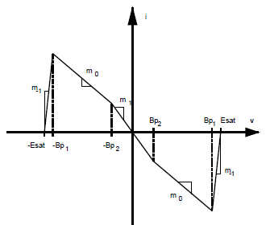
Figure 1. Caption for figure is written with Franklin Gothic Book font, 9 pt. size.
When there are two figures side-by-side, in order for neat arrangement, insert figures in one table with two columns with a separate line under the figure. See Figure 2. Figures in tables during the submit and review stage may still show column and line borders. Later, during the production stage, editors are going to hide columns and line borders.
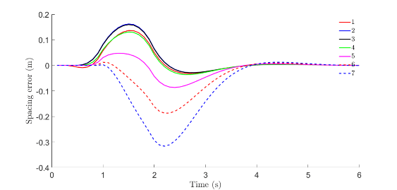 | 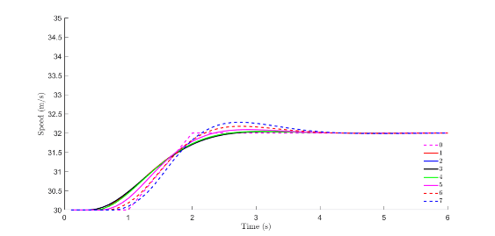
(a) | (b)
Figure 2. Example of arrangement of two side-by-side figures. Figures are taken from [3].
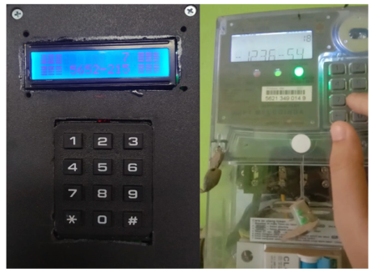
Figure 3. Example of photographed figures. Figure is taken from [4].

Table Format
Please make some effort so the whole table is within one page; do not have it continue to the next page. Vertical lines are hidden, horizontal lines are only for the top and bottom of the table, and to separate table heading and contents.
Table 1. Summary of physical parameters
No. | Segment | Length  (km) | Slope  (meter)
1 | A-B | 25 | 30
2 | B-C | 75.15 | 10
3 | C-D | 44.75 | 50
4 | D-E | 72.5 | 10

Equation Format
Equations are written with 10 pt. size font. The equation is written in the center of a column of a three-column table. The number of equations is in the right column, written with the Insert / Caption menu in Microsoft Word. Parenthesis are added on your own. During the submit and review stage, column and line borders may be shown. Later, during the production stage, editors are going to hide the column and line borders. Example of writing Equation (1): the final form of PID control algorithm, referring to a method as written by Kumar [5] :
 | $$u\left(t\right)=K_{p}e\left(t\right)+K_{i}\int_{0}^{t}{e\left(τ\right)dτ+K_{d}\frac{de(t)}{dt}}$$ | (1)

The description of symbols and notations in the equation is written as a descriptive paragraph, not in a list. For Kp, it is a proportional constant, Ki is an integrative constant, etc.

Sub-sub Chapter

Sub-sub-sub Chapter 1
Writing the title of a sub-sub-sub chapter in this template uses the Heading 3 style.

Sub-sub-sub Bab 2
Writing the title of a sub-sub-sub chapter in this template uses the Heading 3 style.

Results and Discussion (Sub Chapter)
The contents of the results and discussion sub-chapter are important discoveries during research (better presented in a concise form as figures or tables), with the possible causes and results, comparisons, and relation with previous research. Results and Discussion, at least, should have elements of :
(1) what/how: Has the presented data been processed (not raw data) and presented as tables or figures and given captions that are easy to understand? Discoveries may be written but not discussed here. (2) Why: In the discussion, the sub-chapter shows the relation between acquired results and basic concepts and/or hypotheses. (3) what else: is there a conformation or contradiction with other research?

Conclusion (Sub Chapter)
The conclusion is to answer and conform to the problem or research objective or may also create a new theory/concept based on existing facts/analysis. Implications or suggestions may also be added (not compulsory). The conclusion (and suggestion, if any) is written as paragraphs, not as an item/numbering list. Do not divide the Conclusion into the Conclusion subchapter and the Suggestion subchapter.

Acknowledgement (Sub Chapter)
Acknowledgment is intended for the grant bestower or sponsor, including the number of grant documents. If not any, an acknowledgment can be written: “This research was done autonomously without being funded by any institution."

Nomenclature (if any) (Sub-Chapter)
The nomenclature list must include all notations used with each of its meanings, ordered alphabetically. The font is Franklin Gothic Book 9 pt.
A | = | Amplitude
Cd | = | drag coefficient
fe | = | linearization coefficient
Ki | = | modification factor

Reference (Sub-Chapter)
In the text, the numbering of citations must conform to its numbering in the Reference. The order of numbers in Reference is based on their order of appearance. 15 minimum references should be from the last 10 years. References should be a minimum of 80 % from scientific journals and a maximum of 20 % from textbooks whose content is concepts and theories.
For writing references, it is suggested to use reference applications such as Mendeley, for example. Writing of references uses IEEE guide [6, 7].
These are guides for writing references from books, proceedings, journals and web.:
- Author, "Title of article in book," in Book Title, city, publisher, year. p. pages.
- Author, "Title of article in proceeding," in Name of Seminar, city, year.
- Author, "Title of article in journal," Journal Title, p. halaman, tahun.
- Author, "Title of web page," day-month-year. [Online]. Available: link.
- Author, “Title,” in Name of Conference (conference location if any), year, pp. , doi: xxx.
Example of writing a reference list (referring to IEEE Guide [6, 7]) :
- L. S. Bickley and P. G. Szilagyi, Guide to Physical Examination and History, Philadephia: Lippincot Williams & Wilkins, 2004. (example of writing a reference from a book).
- IEEE, “Resolution and size,” Create your IEEE journal article, (2025). Accessed 24 April 2025 [Online]. Available :https://journals.ieeeauthorcenter.ieee.org/create-your-ieee-journal-article/create-graphics-for-your-article/resolution-and-size/ .
- I. D. Putra, T. A. Tamba, A. Sadiyoko, “Implementasi metode kontrol model prediksi terdistribusi untuk kontrol kereta api berbasis sistem komunikasi,” Jurnal Otomasi, Kontrol dan Instrumentasi vol 13(1), 2021.https://doi.org/10.5614/joki.2021.13.1.2
- V. Firmansyah, K. Oktaviyana, H. S. Fathan, A. Muslim, D. A. Firmansyah, N. Gunawan T.W., W. Sutanto , Gianto, “Prototype of kWh meter simulator automatic button pressere for token recharge based on microprocessor and Telegram API,” Jurnal Otomasi Kontrol dan Instrumentasi vol 16(2), 2024 https://doi.org/10.5614/joki.2024.16.2.7.
- U. Kumar, "How to Insert Equation Numbering in MS Word," (20 October 2020). [Online] Available: https://earthinversion.com/utilities/how-to-insert-equation-numbering-in-MS-word/. [Accessed 23 March 2021]. (example of writing a reference from a website).
- IEEE, IEEE-Reference-Guide. (2023).Accessed 17 October 2024 [Online]. Available : https://journals.ieeeauthorcenter.ieee.org/wp-content/uploads/sites/7/IEEE_Reference_Guide.pdf (example of an online manual )
- IEEE Dataport, How to Cite References : IEEE Documentation Style. Acessed 8 May 2025 [Online]. Available : https://ieee-dataport.org/sites/default/files/analysis/27/IEEE%20Citation%20Guidelines.pdf
- J. Kramer and J. Chen, "How to write bibliographies," in Adventure Works Conference, Chicago, 2006. (example of writin a reference from a conference proceeding).
- J. Kramer and J. Chen, "How to write bibliographies," Adventure Works Monthly Journal, vol. III, no. 2, pp. 50-62, 2006. (example of writing reference from an article in a journal).
- J.L.S.Emeterio et.al., “Modeling NDT piezoelectric ultrasonic transmitters”, Ultrasonics, vol. 42, Issues 1–9, pp. 277-281, April 2004, doi: https://doi.org/10.1016/j.ultras.2004.01.021. (example of writing a reference from an online article, including the site’s doi).

When possible, avoid using footnotes.

