Specifications

Height to raise the load: H = 2m

Load: Mass = 1 ton

1.2m x 1.2m x 1.5m

Time to run: t=2m

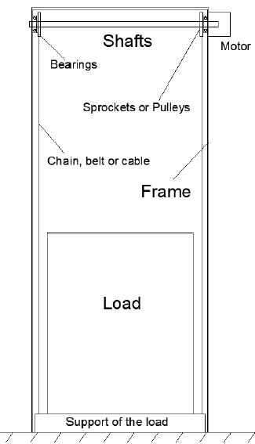

Bearings

1. **Bearings definition**

Bearing is a machine component which supports another machine element (known as journal).

It permits relative motion between the contact surfaces of the members, which carrying the load.

1. **Bearings classification**

Radial Bearing: Load acting perpendicular to the direction of motion of moving element.

1. **Bearing type**

From doc.1 we chose cylindrical roller bearings because it’s good for radial loads.

1. **Some Calculations**

After calculating the mass of the shaft = 104.472 kg , its weight is : $$P=104.472 × 9.81=1024.87032 N$$

Knowing that the force of the cable is taken ***6664.765 N***;

$$\sum{Forces on 1 bearing}= \frac{1024.87032+6664.765}{2}= \frac{14354.40032}{2}=7177.20016 N$$

1. **Bearing design**

We already know that our elevator has 3 phases: accelerating, constant and decelerating. Let’s consider the second phase that has the maximum velocity.  
Note: All calculations are the maximum values that we can use.

* Referring to *Table 11-4*, we can choose a recommended bearing life according to the type of application.
$$Life L=18 khr$$

* Referring to *Page 574*, $a = 10/3$ for cylindrical roller bearings.
* Referring to *Table 11-3 of 02-series* and having $bore = 50 mm$, we can determine the rated data below:

|  |  |
| --- | --- |
| ***Outside diameter*** | $$90 mm$$ |
| ***Width*** | $$20 mm$$ |
| ***Load Rating C10*** |  |

* Using *eq. 11-3* with 90% reliability and rating 10 million revolutions, we can find the desired speed (maximum speed) in rev/min.
$$C_{10}=F_{D}{\left(\frac{L_{D}n_{D}60}{L_{R}n_{R}60}\right)}^{\frac{1}{a}}=7177.20016{\left(\frac{18000×n_{D}60}{{10}^{6}}\right)}^{\frac{3}{10}}=45700 N$$

$$n_{D}=443.0438 RPM=46.395 \frac{rad}{s}$$

* Knowing that the desired load isn’t the manufacturer’s test load or catalog entry, we should use other formulas. Let’s consider 99% reliability and using *eq. 11-7*, $$C_{10}=a_{f}F_{D}{\left[\frac{x_{D}}{x_{0}+\left(θ-x_{0}\right){\left(1-R_{D}\right)}^{\frac{1}{b}}}\right]}^{\frac{1}{a}}=45700 N$$

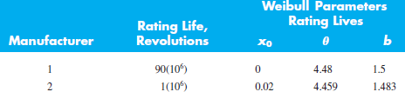  
  
In addition, referring to *Table 11-5*: $a_{f}=1.2$;



$$1.2×7177.20016{×\left[\frac{x_{D}}{0.02+\left(4.459-0.02\right){\left(1-0.99\right)}^{\frac{1}{1.483}}}\right]}^{\frac{3}{10}}=45700 N$$

${ x}_{D}=57.043$

On the other hand, $x_{D}=\frac{L_{D}}{L_{R}}=\frac{60L_{D}n_{D}}{L_{10}}=\frac{60\left(18000\right)n_{D}}{{10}^{6}}=57.043$

$n_{D}=52.81759 RPM=5.531\frac{rad}{s}$

Besides, $Velocity= n_{D}×r_{bore}=5.531×0.025=0.1382 \frac{m}{s}$

When velocity is constant, $V=\frac{d}{t}=>d=14×0.1382=1.93585 m$

**First conclusion:** (Assumption)  
Our work is safe enough because the height in question is equal to 2 meters and the maximum distance is equal to 1.93585 meters in the second phase, therefore 1.93585 will be never achieved since we have also phase 1 and 3 so we use a speed less than 0.1382 m/s.

**Second conclusion:** (Real calculation)

Consider the three phases function below,

Let :



$d_{1}:distance of phase 1 or phase 3$

$d_{2}:distance of phase 2$

From phase 2:

$V_{max} =\frac{d}{t} =\frac{d_{2}}{14} \left(constant velocity\right)$

From phase 1:



$a=\frac{V}{t}=\frac{V_{max}}{3}$

$d=\frac{1}{2}at^{2}=d_{1}=\frac{a}{2}×9$

$a=\frac{V}{t}=\frac{V_{max}}{3}=\frac{d_{2}}{14×3}=\frac{d_{2}}{42}= \frac{2d_{1}}{9}=\frac{2-d_{2}}{9}$

$$d_{2}=\frac{28}{17}m$$

$$d_{1}=\frac{2-d_{2}}{2}=\frac{3}{17}m$$

$\& V_{max} =\frac{d_{2}}{14}=\frac{28}{17×14}=\frac{2}{17}=0.1176 \frac{m}{s}$ acceptable because < $0.1382 \frac{m}{s}$

Using *eq. 11-7* again, and $x_{D}=\frac{L_{D}}{L_{R}}=\frac{60L_{D}n_{D}}{L_{10}}=\frac{60\left(18000\right)44.937}{{10}^{6}}=48.532$

$$C_{10}=1.2×7177.20016{×\left[\frac{48.532}{0.02+\left(4.459-0.02\right){\left(1-0.99\right)}^{\frac{1}{1.483}}}\right]}^{\frac{3}{10}}= 43.537 kN$$

Having the rating load $C_{10}=45.7 kN>43.537 kN$, it’s safe.

The variation of velocity during the three phases can be found in the function below,

To conclude:

|  |  |  |  |
| --- | --- | --- | --- |
|  | Phase 1 | Phase 2 | Phase 3 |
| $$n_{D}$$ | increasing | $$4.7 rad/s$$ | decreasing |
| $$Velocity$$ | increasing | $$0.1176 m/s$$ | decreasing |
| $$distance$$ | $$\frac{3}{17}m$$ | $$\frac{28}{17}m$$ | $$\frac{3}{17}m$$ |
| $$C_{10}$$ | increasing | $$43.537 kN$$ | decreasing |

Finally, we choose a cylindrical roller bearing with the properties mentioned below:

|  |  |
| --- | --- |
| ***Outside diameter*** | $$90 mm$$ |
| ***Width*** | $$20 mm$$ |
| ***Load Rating C10*** |  |