Evolutionary rescue in spatially structured landscapes
Methods and results — new simulation dataset

What this is
I’ve rerun the simulations from scratch on a corrected version of the model, with a revised parameter space. This document covers what was run and what came out.

The questions
The project has always been about how spatial structure shapes evolutionary rescue. What’s changed is how we measure rescue.
Almost all rescue work collapses the population trajectory to one number — usually the probability of rescue, sometimes a critical threshold or an endpoint density. But the trajectory has two limbs produced by different processes: a decline, governed by demographic buffering and whatever pre-adapted individuals are already nearby, and a rebound, governed by the adaptive response and subsequent growth. Orr & Unckless 2014 derived both, but for a well-mixed single-locus model, and the quantities haven’t been used since. Ulf raised this in 2021, suggesting we track the minimum relative population size and the increase after the minimum as separate quantities. That’s what we’re now doing.
The questions this dataset addresses:
- Do landscape properties — gradient slope, spatial autocorrelation and environmental variance — act differently on the two phases of rescue, and do they interact?
- How do the same parameters act on persistence alone, and is there structure that measure misses?
- Does dispersal show an intermediate optimum, as theory predicts but our earlier two-level design couldn’t test?
- Does the source of genetic variation — standing only, versus standing plus new mutation — change any of this?

Design
18,796 runs across 630 treatment combinations, 30 runs each.
Factor | Levels
Gradient slope | 0.8, 1.0, 1.2
Dispersal distance (SD) | 1.5, 3, 6
Mutational SD | 0 (standing variation only), 0.75
Perturbation magnitude | 9, 10, 11, 12, 13
Landscape heterogeneity (patch SD) | 0, 1, 2
Spatial autocorrelation | 0, 2, 4
Autocorrelation has no meaning on a flat surface, so the landscape factor is seven conditions rather than nine: flat, plus patch SD 1 and 2 each crossed with the three autocorrelation levels.
The 30 runs per combination are 10 runs on each of three independently generated landscapes. The three landscapes matter: in the earlier design each treatment used a single landscape file, so “autocorrelation 3” and “that particular terrain” were indistinguishable. Now we can check whether an effect is the treatment or the surface.
Measured lag-1 spatial correlation of the generated landscapes is 0.00, 0.74 and 0.996 for autocorrelation 0, 2 and 4. I’d suggest we report those rather than the spectral exponent — they’re verifiable straight from the deposited landscape files.

The model
Individual-based, continuous space and time, simulated with the Gillespie direct method. Each individual i has a position (x, y) on a 100 × 100 square and a heritable scalar trait u.
Locally optimal phenotype at position (x, y) at time t:
z₀(x, y, t) = S·x + Φ(x, y) + p(t)
- S is the gradient slope; the optimum increases linearly along x only. y is environmentally neutral.
- Φ(x, y) is the static heterogeneity field: a Gaussian random field with mean 0, standard deviation σ_Φ (the “patch SD” treatment), and power spectral density decaying as k^(−a) where a is the “autocorrelation” treatment. Fixed for the whole run.
- p(t) = 0 for t < 250 and p(t) = P thereafter. P is the perturbation magnitude, applied uniformly across the landscape.
Carrying capacity available to individual i:
K(u_i, x_i, y_i) = k₀ · exp( −(u_i − z₀)² / σ_K² ) k₀ = 10, σ_K = 3
σ_K is the tolerance width — the trait mismatch at which carrying capacity falls to 1/e of its maximum.
Competition experienced by i, summed over all j (including itself):
N_eff(i) = σ_c² · Σ_j exp( −r_ij ) σ_c = 1.3, r_ij = Euclidean distance
Note this is purely spatial: there is no trait-similarity term, so no frequency-dependent competition. The kernel exp(−r) has a range of about 1 spatial unit.
Rates. Birth is constant at b = 0.54 for every individual. Death is
d_i = N_eff(i) / K(u_i, x_i, y_i)
so density dependence acts entirely through mortality, and maladaptation raises the death rate by shrinking the denominator.
Reproduction is clonal. An offspring of i has
u_offspring = u_i + ε_u, ε_u ~ N(0, σ_μ²)
x_offspring = x_i + ε_x, ε_x ~ N(0, σ_d²)
y_offspring = y_i + ε_y, ε_y ~ N(0, σ_d²)
σ_μ is the mutational SD treatment (0 or 0.75); σ_d is the dispersal SD treatment (1.5, 3 or 6). Dispersal happens only at birth. The x boundary is absorbing at 0 and 99 (offspring beyond it are placed at the boundary); the y boundary is periodic.
One behaviour worth knowing. z₀ is evaluated once, when an individual is born, and never re-evaluated. So individuals alive when the perturbation fires keep their pre-shift optimum for the rest of their lives — only offspring born after t = 250 experience the shifted environment. The crash is therefore driven by recruitment failure rather than by adult mortality rising.
Initialisation. 700 individuals placed uniformly at random with u = S·x exactly, so the population starts perfectly adapted with zero trait variance. Under σ_μ = 0 all variation is generated by dispersal moving individuals away from where their trait fits.
Observation. State recorded every 10 time units from t = 10 to t = 800. At each record the simulator writes n and the first four moments of the trait, of maladaptation |S·x + Φ − u|, of nearest-neighbour distance, and of x position. Runs terminate at t = 800 or extinction.

Scale relationships
Since all the treatment levels are dimensionless numbers, here is what they mean relative to each other. σ_K = 3 sets the trait scale; the competition kernel range (~1 unit) sets the spatial scale.
Optimum turnover across the landscape (S·99 / σ_K): 26, 33 and 40 tolerance widths for S = 0.8, 1.0, 1.2. The gradient is steep in the sense that opposite ends of the landscape are tens of tolerance widths apart.
Change in optimum per dispersal step (S·σ_d / σ_K), which governs how well offspring track the gradient:
 | σ_d = 1.5 | σ_d = 3 | σ_d = 6
S = 0.8 | 0.40 | 0.80 | 1.60
S = 1.0 | 0.50 | 1.00 | 2.00
S = 1.2 | 0.60 | 1.20 | 2.40
Above 1, a typical offspring lands more than a full tolerance width from its parent’s optimum. So the top-right of that table is a migration-load regime and the bottom-left is not.
Perturbation magnitude in tolerance widths (P / σ_K): 3.0 to 4.3 for P = 9 to 13. Equivalently, the shift displaces the optimum by 3–4 tolerance widths everywhere at once.
Relocation distance — how far down the gradient an individual must move for its existing trait to match the new optimum (P / S): 7.5 to 16.2 spatial units. In dispersal steps (P / S / σ_d), at P = 11:
 | σ_d = 1.5 | σ_d = 3 | σ_d = 6
S = 0.8 | 9.2 | 4.6 | 2.3
S = 1.0 | 7.3 | 3.7 | 1.8
S = 1.2 | 6.1 | 3.1 | 1.5
Heterogeneity relative to tolerance (σ_Φ / σ_K): 0, 0.33 and 0.67.
Dispersal relative to competition range: σ_d = 1.5, 3, 6 against a kernel range of about 1, so offspring almost always land outside their parent’s immediate competitive neighbourhood.

What changed from the earlier runs
- Dispersal has three levels instead of two. Two levels can only fit a straight line, so the intermediate optimum was undetectable by construction.
- Mutational SD is 0.75 rather than 1.5. A step of 1.5 against a tolerance width of 3 is far above anything measured in real populations; a pilot showed 0.75 gives the full effect at half the magnitude.
- Patch SD is 0, 1, 2. A separate viability map (supplement) shows uncorrelated terrain becomes uninhabitable between SD 2 and 3, so 2 is the highest amplitude at which every autocorrelation level supports a population.
- Three landscape draws per condition rather than one.
- Perturbation at t = 250. Most conditions equilibrate by t = 100; the slowest (patch SD 2, autocorrelation 0) needs until roughly t = 400. The post-shift window is 650 steps throughout.

Measures
From each run’s abundance trajectory:
Baseline | median abundance across all pre-perturbation timesteps
Trough | minimum abundance after the shift
Peak | maximum abundance at or after the trough
and from those, five outcomes:
Resistance | trough / baseline — how far it fell (higher = shallower crash)
Recovery magnitude | (peak − trough) / baseline — how far it came back
Recovery vs baseline | peak / baseline — whether it regained its starting size
Recovery time | peak time − trough time
Persistence | survived to the end of the run, or not
Trough and peak are taken directly as extrema rather than fitted with a changepoint model. The crash is only two to four observations wide, which is too narrow for changepoint detection to be reliable, and direct extrema are checkable by eye against any trajectory.
Resistance and recovery correlate at only +0.32 across surviving runs, so they aren’t mechanically linked — worth knowing, because ratio-based resilience indices have been criticised for generating trade-offs by construction (Zheng et al. 2021 on Li et al. 2020).
Two estimator points. The baseline is the median across all pre-shift records rather than a single timepoint, because n fluctuates by a few percent between adjacent records and a single-point baseline inherits all of that. And the minimum of a noisy series is a downward-biased estimate of the true trough — the bias grows with series length and noise. Every run here has the same recording schedule, so the bias is close to constant across treatments and comparisons are unaffected, but absolute crash depth is slightly overstated.
Models. Linear models for the four phase outcomes, fitted on surviving runs; logistic for persistence, fitted on all runs. Same predictors throughout: slope, dispersal, mutation, severity, patch SD, autocorrelation, plus slope × severity and autocorrelation × severity.
- Every predictor enters as a factor, not a linear term, so no functional form is imposed. This matters: dispersal is non-monotonic, and a linear term would report it as weak.
- The three recovery outcomes are log-transformed (log(1+x) for the two magnitudes, log for time). The tables below report untransformed means; the models use logs.
- Standard errors are clustered by parameter cell — the 54 runs sharing a cell are not independent draws from the population of all runs.
- Autocorrelation and patch SD are fitted on patchy landscapes only (σ_Φ > 0). Including the flat runs would compare three identically-flat “autocorrelation levels”.
- Effects are tested by a joint Wald test across all levels of a factor, not coefficient by coefficient.
No time-to-extinction model. I fitted a Cox model and proportional hazards was rejected for four of five predictors, so the hazard ratios would be misleading.

Results

What a run looks like
Each panel is the same treatment combination (slope 1.0, dispersal 3, new mutation on, perturbation 11) on a different landscape, with all 30 runs drawn faintly and the median in bold.
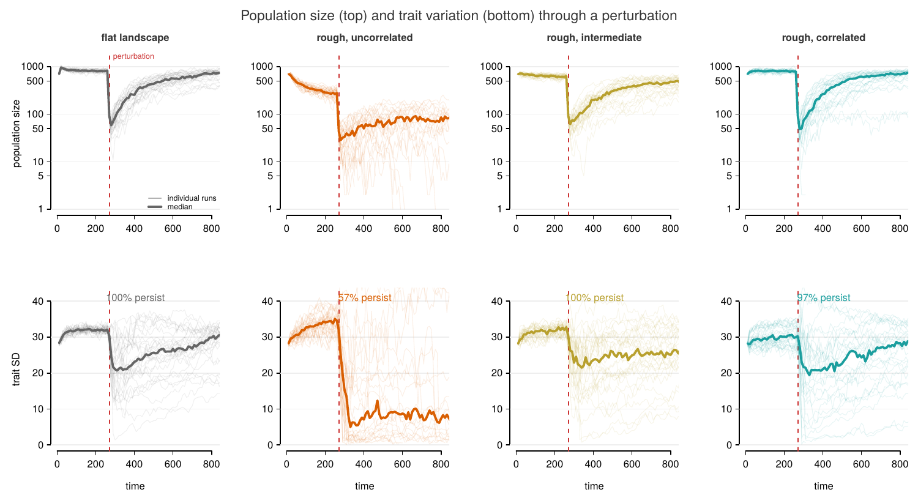
Trajectories
Figure 1. Population size (top, log scale) and trait variation (bottom) through the perturbation (dashed line). Left to right: flat landscape, then rough terrain (patch SD 2) at increasing spatial autocorrelation.
The crash is near-vertical — an order of magnitude within one or two observation intervals — and the panels differ mainly in what happens after the trough rather than in how deep it is.

Overview
Joint p-values, each parameter against each outcome. Landscape terms are fitted on patchy landscapes only. Dashes are p > 0.05.
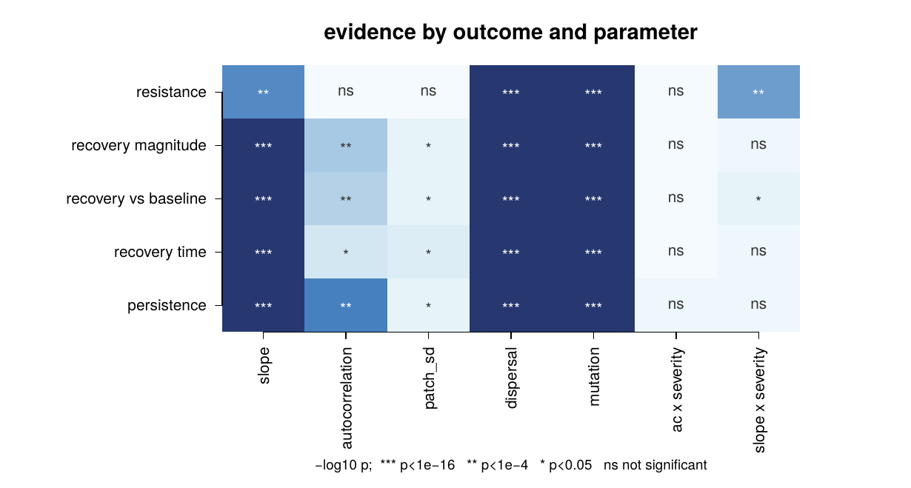
Comparison matrix
Figure 2. Strength of evidence for each parameter against each outcome. Darker is stronger; ns marks p > 0.05.
 | slope | autocorr. | patch SD | dispersal | mutation
Resistance | 2e-11 | — | — | <1e-16 | <1e-16
Recovery magnitude | <1e-16 | 8.1e-07 | 0.008 | <1e-16 | <1e-16
Recovery vs baseline | <1e-16 | 3.1e-06 | 0.012 | <1e-16 | <1e-16
Recovery time | <1e-16 | 9.6e-04 | 0.004 | <1e-16 | <1e-16
Persistence | <1e-16 | <1e-16 | 0.010 | <1e-16 | <1e-16
The only strong interaction is slope × severity on resistance (1.5e-10): the steepness penalty deepens as the shift gets more severe. Autocorrelation’s effect does not change with severity.

1. Autocorrelation acts on recovery, not resistance
Autocorrelation | 0 | 2 | 4
Resistance | 0.068 | 0.067 | 0.070
Recovery magnitude | 0.487 | 0.484 | 0.532
Persistence | 0.285 | 0.425 | 0.430
Resistance is flat (p = 0.62). Recovery and persistence both respond, and they respond differently: recovery rises mainly from AC 2 to 4, persistence mainly from AC 0 to 2.
The effect depends on heterogeneity amplitude:
 | AC 0 | AC 2 | AC 4
Recovery, patch SD 1 | 0.515 | 0.507 | 0.530
Recovery, patch SD 2 | 0.438 | 0.461 | 0.534
Persistence, patch SD 1 | 0.353 | 0.423 | 0.410
Persistence, patch SD 2 | 0.215 | 0.427 | 0.450
At low heterogeneity, autocorrelation barely matters. At patch SD 2 it doubles persistence and produces a clear recovery gradient. Spatial correlation matters when there is enough heterogeneity for it to organise.
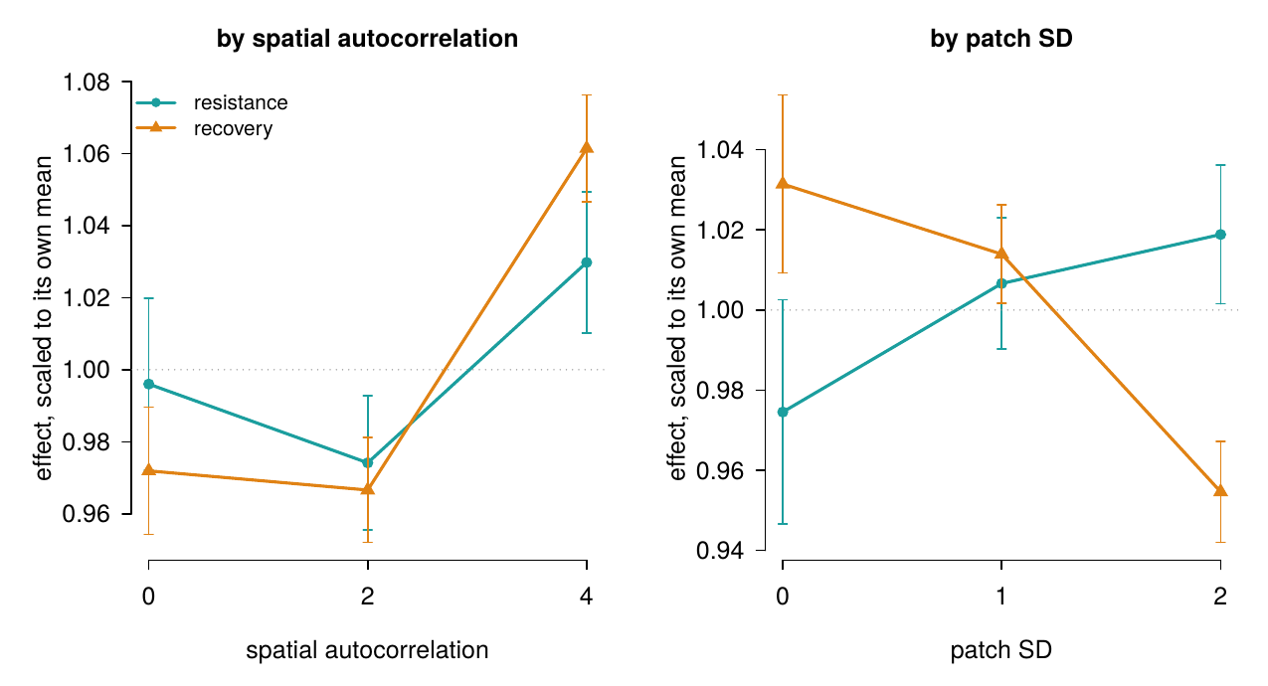
Phase signatures
Figure 3. Resistance and recovery across autocorrelation (left) and patch SD (right), each scaled to its own mean. Error bars are standard errors.
The mechanism is visible before the perturbation. Median baseline abundance:
 | AC 0 | AC 2 | AC 4
patch SD 1 | 650 | 766 | 799
patch SD 2 | 230 | 610 | 786
(Flat landscape: 817.) Rough uncorrelated terrain supports less than a third of the population that the same roughness supports when spatially correlated. Dispersal SD is 1.5–6, so on an uncorrelated surface offspring land on patch values unrelated to their parents’; on a correlated one the surface is smooth over a dispersal step.

2. Dispersal has an intermediate optimum
Dispersal SD | 1.5 | 3 | 6
Resistance | 0.024 | 0.080 | 0.098
Recovery magnitude | 0.448 | 0.551 | 0.413
Persistence | 0.311 | 0.663 | 0.160
Persistence doubles from 1.5 to 3, then collapses at 6 — the unimodal relationship Uecker et al. (2014) and Schiffers et al. (2013) predict. Resistance keeps rising across the whole range while recovery peaks in the middle: the phases disagree about which dispersal level is best.
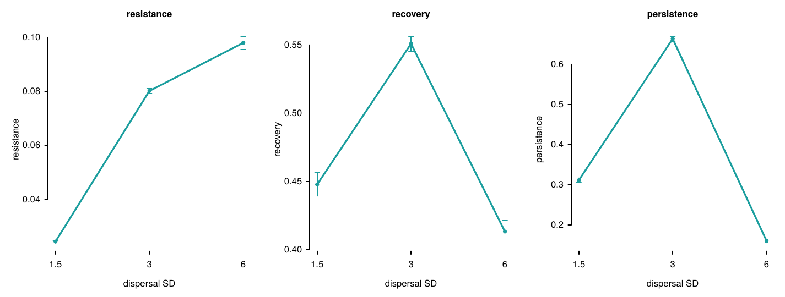
Dispersal
Figure 4. The three outcomes across dispersal distance.

3. Gradient steepness hurts both phases
Slope | 0.8 | 1.0 | 1.2
Resistance | 0.075 | 0.071 | 0.047
Recovery magnitude | 0.582 | 0.516 | 0.313
Persistence | 0.501 | 0.405 | 0.229
Steeper gradients crash deeper and recover less — same sign on both phases.
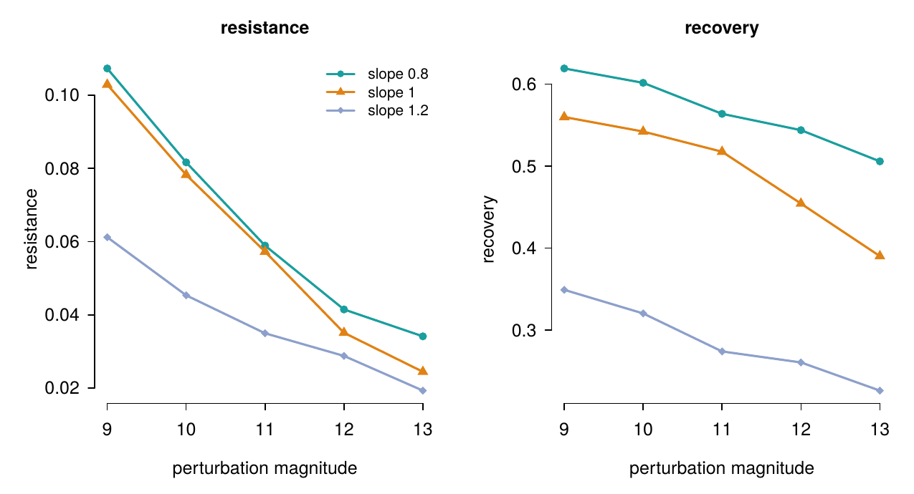
Slope and severity
Figure 5. Resistance and recovery across perturbation magnitude, by gradient slope. The steepness penalty on resistance widens with severity (the surviving interaction, p = 1.5e-10).

4. New mutation transforms recovery, barely touches resistance
Recovery magnitude is 0.240 with standing variation only against 0.703 with new mutation — nearly a tripling. Resistance moves from 0.061 to 0.074. Recovery is slower with mutation (457 vs 334 time steps), consistent with there being further to climb.

5. Heterogeneity amplitude alone is weak
With every condition viable, patch SD has modest effects throughout: persistence 0.375 / 0.395 / 0.364 across SD 0 / 1 / 2, recovery 0.526 / 0.517 / 0.487. What matters is not how rough the landscape is but whether the roughness is spatially organised — the interaction in section 1.

Robustness
Recovery by autocorrelation 0 / 2 / 4, in each landscape draw separately:
Draw 1 | 0.487 | 0.495 | 0.523
Draw 2 | 0.491 | 0.475 | 0.545
Draw 3 | 0.484 | 0.482 | 0.528
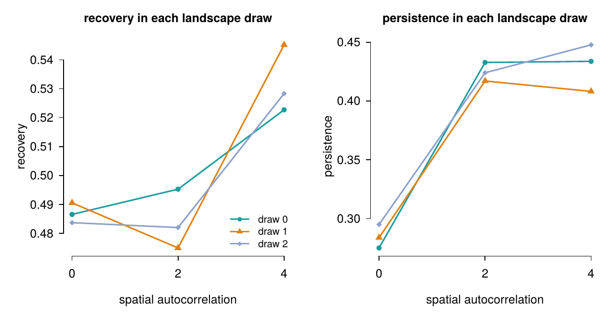
Draw robustness
Figure 6. Recovery and persistence across autocorrelation, per landscape draw.

One caveat about the design
Patch SD 2 with autocorrelation 0 equilibrates at ~230 individuals and takes until roughly t = 400 to settle fully, so it is perturbed slightly above its long-run equilibrium. Every other condition equilibrates well before t = 250. Pre-perturbation extinction is 0.6% overall.

Supplement: where landscapes stop being habitable
The main design uses patch SD 0–2 because a separate mapping experiment showed the viable range ends just above that. The map: patch SD 0.5–3 in half steps crossed with autocorrelation 0–4, three landscape draws per cell, four unperturbed runs each (slope 1.0, dispersal 3, mutation on), run to t = 800 with no perturbation at all.
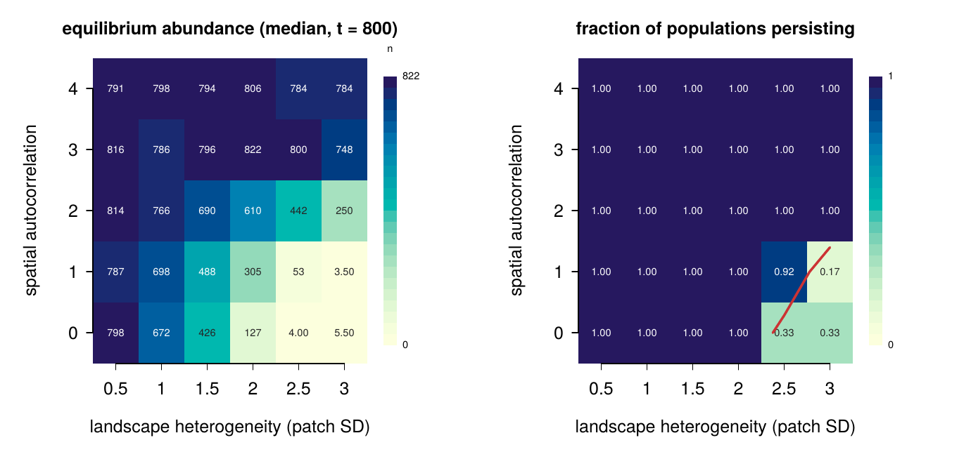
Viability map
Figure S1. Median equilibrium abundance (left) and fraction of populations persisting (right) across heterogeneity amplitude and spatial autocorrelation, with no perturbation. The red contour marks 50% survival.
Two things to read off it. First, there is a hard habitability threshold in heterogeneity: uncorrelated terrain (AC 0–1) supports populations up to patch SD 2 and essentially none at 2.5–3. Second, autocorrelation moves the threshold — at AC 2 the same SD 3 terrain that is lethal when uncorrelated supports ~250 individuals, and at AC 3–4 abundance is near the flat-landscape level across the entire range tested. The equilibrium panel shows the same effect continuously: abundance falls smoothly toward the rough-uncorrelated corner rather than switching off abruptly.
The mechanism is the same one proposed for the recovery effect: with dispersal SD 1.5–6, offspring on uncorrelated terrain land on patch values unrelated to their parents’, so local adaptation cannot accumulate; correlation makes the surface smooth at the scale of a dispersal step. Caveat: the map is one slice of the design (slope 1.0, dispersal 3), and the threshold’s position should shift with dispersal distance if that mechanism is right — a cheap and direct follow-up test.

Where this leaves us
What I think we have:
- A landscape property that acts on one phase of rescue and not the other, with the mechanism visible in the pre-perturbation state. The effect is an interaction — spatial correlation matters when heterogeneity is strong enough to organise — and it is the axis nobody has tested in an evolutionary rescue context.
- A dispersal optimum, with the phases disagreeing about where it sits: resistance favours the highest dispersal, recovery and persistence the middle.
- A demonstration that persistence alone conflates all of this — every parameter is significant for persistence, and that measure alone gives no way to tell them apart.
- A habitability threshold in heterogeneity that autocorrelation moves (supplementary viability map): uncorrelated terrain becomes uninhabitable between patch SD 2 and 3, correlated terrain does not.
To potentially discuss:
- Mechanism. The correlation-length-to-dispersal-distance ratio is the obvious candidate and the baseline abundances support it, but it hasn’t been tested directly — e.g. by varying dispersal and asking whether the autocorrelation effect shifts with it.
- The persistence/recovery split at low autocorrelation. Persistence rises sharply from AC 0 to 2 while recovery barely moves; recovery rises from AC 2 to 4. Two different things may be happening at the two ends.
- Framing. Whether this is a paper about spatial structure in rescue that needs the decomposition, or a paper about the decomposition demonstrated on spatial structure. I lean towards the first.
- What else to run. A full sweep is under a day on a laptop, so adding levels is cheap if there’s something you want.

