Evolutionary rescue in spatially structured landscapes

What this is
I've rerun the simulations from scratch on a corrected version of the model, with a revised parameter space. This document covers what was run and what came out.

Everything below comes from a single dataset of 32,632 runs, generated 28 July – 10 August 2026. Data, code and figures are in the shared Drive folder.

The questions
The project has always been about how spatial structure shapes evolutionary rescue. What's changed is how we measure rescue.
Rescue trajectories are routinely plotted, and the U-shape has been recognised since Gomulkiewicz & Holt 1995, but for analysis the trajectory is almost always collapsed to a single number — usually the probability of rescue, sometimes a critical threshold or an endpoint density. The two limbs are produced by different processes: a decline, governed by demographic buffering and whatever pre-adapted individuals are already nearby, and a rebound, governed by the adaptive response and subsequent growth. Orr & Unckless 2014 derive both limbs, but for a well-mixed single-locus model, and those quantities haven't been taken up since — least of all in a spatial setting that I know of. We therefore track the minimum relative population size and the increase after the minimum as separate quantities.
The questions this dataset addresses:
- Do the landscape parameters — gradient slope, spatial autocorrelation and environmental variance — act differently on the two phases of rescue?
- Do they interact, with each other or with the severity of the perturbation?
- How do the same parameters act on persistence alone — the conventional measure — and is there structure that measure misses?
- Does dispersal show an intermediate optimum, as theory predicts but our earlier two-level design couldn't test?
- Does the source of genetic variation — standing only, versus standing plus new mutation — change any of this?

Design
32,632 runs across 630 treatment combinations, 54 runs each.

Factor | Levels
Gradient slope | 0.8, 1.0, 1.2
Dispersal distance (SD) | 1.5, 3, 6
Mutational SD | 0 (standing variation only), 0.75
Perturbation magnitude | 9, 10, 11, 12, 13
Landscape heterogeneity (patch SD) | 0, 1, 3
Spatial autocorrelation | 0, 2, 4

Autocorrelation has no meaning on a flat surface, so the landscape factor is seven conditions rather than nine: flat, plus patch SD 1 and 3 each crossed with the three autocorrelation levels.

The 54 runs per combination are 18 runs on each of three independently generated landscapes. Note: in the earlier design each treatment used a single landscape file, so "autocorrelation 3" and "that particular terrain" were indistinguishable. Now we can check whether an effect is the treatment or the surface.

Measured lag-1 spatial correlation of the generated landscapes is 0.00, 0.74 and 0.996 for autocorrelation 0, 2 and 4. I'd suggest we report those rather than the spectral exponent — they're verifiable straight from the deposited landscape files.

The model
Individual-based, continuous space and time, simulated with the Gillespie direct method. Each individual i has a position (x, y) on a 100 × 100 square and a heritable scalar trait u.

Locally optimal phenotype at position (x, y) at time t:

z₀(x, y, t) = S·x + Φ(x, y) + p(t)

- S is the gradient slope; the optimum increases linearly along x only. y is environmentally neutral.
- Φ(x, y) is the static heterogeneity field: a Gaussian random field with mean 0, standard deviation σ_Φ (the "patch SD" treatment), and power spectral density decaying as k^(−a) where a is the "autocorrelation" treatment. Fixed for the whole run.
- p(t) = 0 for t < 150 and p(t) = P thereafter. P is the perturbation magnitude, applied uniformly across the landscape.

Carrying capacity available to individual i:

K(u_i, x_i, y_i) = k₀ · exp( −(u_i − z₀)² / σ_K² ) k₀ = 10, σ_K = 3

σ_K is the tolerance width — the trait mismatch at which carrying capacity falls to 1/e of its maximum.

Competition experienced by i, summed over all j (including itself):

N_eff(i) = σ_c² · Σ_j exp( −r_ij ) σ_c = 1.3, r_ij = Euclidean distance

Note this is purely spatial: there is no trait-similarity term, so no frequency-dependent competition. The kernel exp(−r) has a range of about 1 spatial unit.

Rates. Birth is constant at b = 0.54 for every individual. Death is

d_i = N_eff(i) / K(u_i, x_i, y_i)

so density dependence acts entirely through mortality, and maladaptation raises the death rate by shrinking the denominator.

Reproduction is clonal. An offspring of i has

u_offspring = u_i + ε_u, ε_u ~ N(0, σ_μ²)

x_offspring = x_i + ε_x, ε_x ~ N(0, σ_d²)

y_offspring = y_i + ε_y, ε_y ~ N(0, σ_d²)

σ_μ is the mutational SD treatment (0 or 0.75); σ_d is the dispersal SD treatment (1.5, 3 or 6). Dispersal happens only at birth. The x boundary is absorbing at 0 and 99 (offspring beyond it are placed at the boundary); the y boundary is periodic.

Initialisation. 700 individuals placed uniformly at random with u = S·x exactly, so the population starts perfectly adapted with zero trait variance. Under σ_μ = 0 all variation is generated by dispersal moving individuals away from where their trait fits.

Observation. State recorded every 10 time units from t = 10 to t = 800. At each record the simulator writes n and the first four moments of the trait, of maladaptation |S·x + Φ − u|, of nearest-neighbour distance, and of x position. Runs terminate at t = 800 or extinction.

Scale relationships
Since all the treatment levels are dimensionless numbers, here is what they mean relative to each other. σ_K = 3 sets the trait scale; the competition kernel range (~1 unit) sets the spatial scale.

Optimum turnover across the landscape (S·99 / σ_K): 26, 33 and 40 tolerance widths for S = 0.8, 1.0, 1.2. The gradient is steep in the sense that opposite ends of the landscape are tens of tolerance widths apart.

Change in optimum per dispersal step (S·σ_d / σ_K), which governs how well offspring track the gradient:

 | σ_d = 1.5 | σ_d = 3 | σ_d = 6
S = 0.8 | 0.40 | 0.80 | 1.60
S = 1.0 | 0.50 | 1.00 | 2.00
S = 1.2 | 0.60 | 1.20 | 2.40

Above 1, a typical offspring lands more than a full tolerance width from its parent's optimum. So the top-right of that table is a migration-load regime and the bottom-left is not.

Perturbation magnitude in tolerance widths (P / σ_K): 3.0 to 4.3 for P = 9 to 13. Equivalently, the shift displaces the optimum by 3–4 tolerance widths everywhere at once.

Relocation distance — how far down the gradient an individual must move for its existing trait to match the new optimum (P / S): 7.5 to 16.2 spatial units. In dispersal steps (P / S / σ_d), at P = 11:

 | σ_d = 1.5 | σ_d = 3 | σ_d = 6
S = 0.8 | 9.2 | 4.6 | 2.3
S = 1.0 | 7.3 | 3.7 | 1.8
S = 1.2 | 6.1 | 3.1 | 1.5

Heterogeneity relative to tolerance (σ_Φ / σ_K): 0, 0.33 and 1.0. At patch SD 3 the heterogeneity alone spans a full tolerance width, which is why that treatment is demographically severe.

Dispersal relative to competition range: σ_d = 1.5, 3, 6 against a kernel range of about 1, so offspring almost always land outside their parent's immediate competitive neighbourhood.

What changed from the earlier runs
- Dispersal has three levels instead of two. Two levels can only fit a straight line, so the intermediate optimum was undetectable by construction.
- Mutational SD is 0.75 rather than 1.5. A step of 1.5 against a tolerance width of 3 is far above anything measured in real populations; a pilot showed 0.75 gives the full effect at half the magnitude.
- Patch SD is 0, 1, 3 rather than 25, 50, 100. Against a tolerance width of 3 the old values drive carrying capacity to essentially zero. A pilot mapped the range where populations both persist and actually feel the heterogeneity.
- Three landscape draws per condition rather than one.
- Perturbation at t = 150 rather than 450. Populations reach equilibrium by about t = 60, so the earlier timing spent 300+ steps at peak population without adding information. The post-shift window is unchanged.

Because of the parameter changes, this dataset is not directly comparable to the earlier runs. It replaces them rather than extending them.

Measures
From each run's abundance trajectory:

Baseline | median abundance across all pre-perturbation timesteps
Trough | minimum abundance after the shift
Peak | maximum abundance at or after the trough

and from those, five outcomes:

Resistance | trough / baseline — how far it fell (higher = shallower crash)
Recovery magnitude | (peak − trough) / baseline — how far it came back
Recovery vs baseline | peak / baseline — whether it regained its starting size
Recovery time | peak time − trough time
Persistence | survived to the end of the run, or not

Resistance and recovery correlate at only +0.30 across surviving runs, so they aren't mechanically linked — worth knowing, because ratio-based resilience indices have been criticised for generating trade-offs by construction (Zheng et al. 2021 on Li et al. 2020).

Two estimator points. The baseline is the median across all pre-shift records rather than a single timepoint, because n fluctuates by a few percent between adjacent records and a single-point baseline inherits all of that. And the minimum of a noisy series is a downward-biased estimate of the true trough — the bias grows with series length and noise. Every run here has the same recording schedule, so the bias is close to constant across treatments and comparisons are unaffected, but absolute crash depth is slightly overstated.

Models. Linear models for the four phase outcomes, fitted on surviving runs; logistic for persistence, fitted on all runs. Same predictors throughout: slope, dispersal, mutation, severity, patch SD, autocorrelation, plus slope × severity and autocorrelation × severity.

- Every predictor enters as a factor, not a linear term. This matters: dispersal is non-monotonic and a linear term would report it as weak.
- The three recovery outcomes are log-transformed (log(1+x) for the two magnitudes, log for time). The tables below report untransformed means; the models use logs.
- Standard errors are clustered by parameter cell — the 54 runs sharing a cell are not independent draws from the population of all runs.
- Autocorrelation and patch SD are fitted on patchy landscapes only (σ_Φ > 0). Including the flat runs would compare three identically-flat "autocorrelation levels".
- Effects are tested by a joint Wald test across all levels of a factor, not coefficient by coefficient.

No time-to-extinction model. I fitted a Cox model and proportional hazards was rejected for four of five predictors, so the hazard ratios would be misleading.

Results

What a run looks like
Each panel is the same treatment combination (slope 1.0, dispersal 3, new mutation on, perturbation 11) on a different landscape, with all 54 runs drawn faintly and the median in bold.

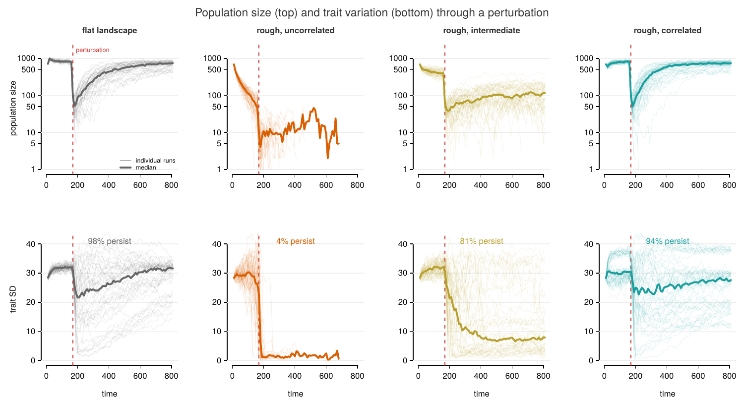

Figure 1. Population size (top, log scale) and trait variation (bottom) through the perturbation, which fires at t = 150 (dashed line). Left to right: flat landscape, then rough terrain (patch SD 3) at increasing spatial autocorrelation.

Three things are visible directly. The crash is near-vertical — an order of magnitude within one or two observation intervals — and the four panels differ almost entirely in what happens after the trough rather than in how deep it is.
The bottom row suggests why. On rough uncorrelated terrain trait variation collapses to near zero and never recovers; 4% of runs persist. At the same roughness with strong spatial correlation, variation is retained and 94% persist.

Overview
Joint p-values, each parameter against each outcome. Dashes are p > 0.05.

 | slope | autocorr. | patch SD | dispersal | mutation
Resistance | 2.9e-07 | — | — | <1e-16 | 2.5e-11
Recovery magnitude | <1e-16 | 6.1e-09 | 0.033 | <1e-16 | <1e-16
Recovery vs baseline | <1e-16 | 1.3e-08 | 0.022 | <1e-16 | <1e-16
Recovery time | 2.1e-14 | 6.9e-10 | 0.0014 | <1e-16 | <1e-16
Persistence | 3.1e-15 | 1.0e-13 | 1.3e-13 | <1e-16 | 1.4e-14

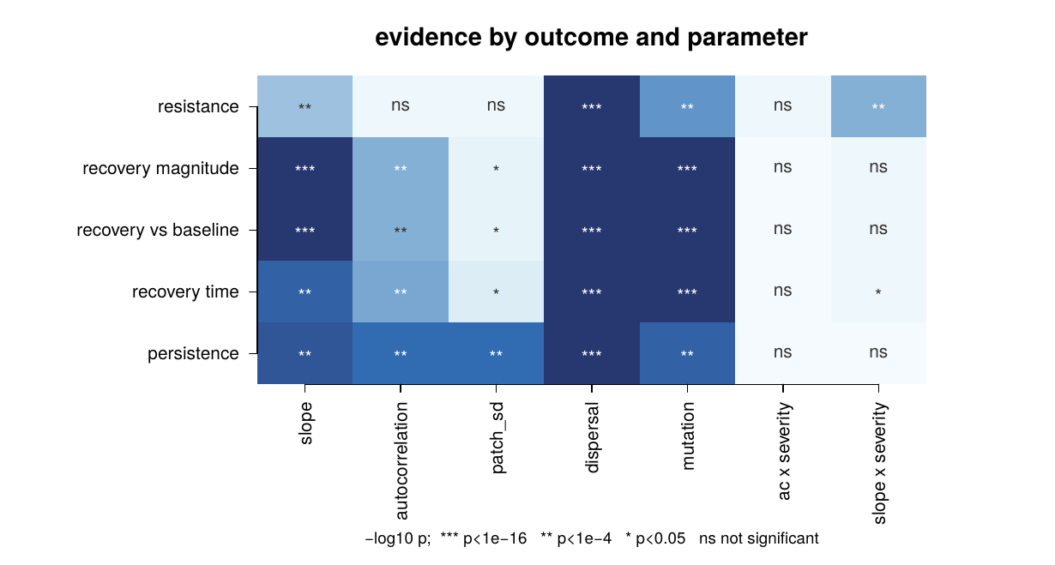
Figure 2. Strength of evidence for each parameter against each outcome. Darker is stronger evidence; ns marks p > 0.05. Persistence (bottom row) responds to every parameter, which is why it cannot distinguish them.

The only surviving interaction is slope × severity on resistance (4.3e-09). The steepness penalty deepens as the shift gets more severe. Autocorrelation's effect does not change with severity.

1. Autocorrelation acts on recovery, not resistance
This is the clearest result in the dataset.

Autocorrelation | 0 | 2 | 4
Resistance | 0.067 | 0.068 | 0.075
Recovery magnitude | 0.470 | 0.434 | 0.540
Persistence | 0.235 | 0.375 | 0.458

Autocorrelation shapes how far populations come back but leaves how far they fall untouched (p = 0.09, and no trend). Persistence, meanwhile, registers a large effect — but persistence registers a large effect for every parameter in the table, so it can't distinguish autocorrelation from anything else.

The mechanism is visible in the pre-perturbation state. Median baseline abundance at patch SD 3:

Autocorrelation | 0 | 2 | 4
Baseline abundance | 130 | 386 | 737

Rough terrain with no spatial correlation is close to uninhabitable — a 100 × 100 landscape supporting 130 individuals against 836 on flat ground. Correlated terrain at the same roughness supports 737. Dispersal SD is 1.5–6, so on an uncorrelated surface offspring land on patch values unrelated to their parents'; on a correlated one the surface is smooth over a dispersal step.

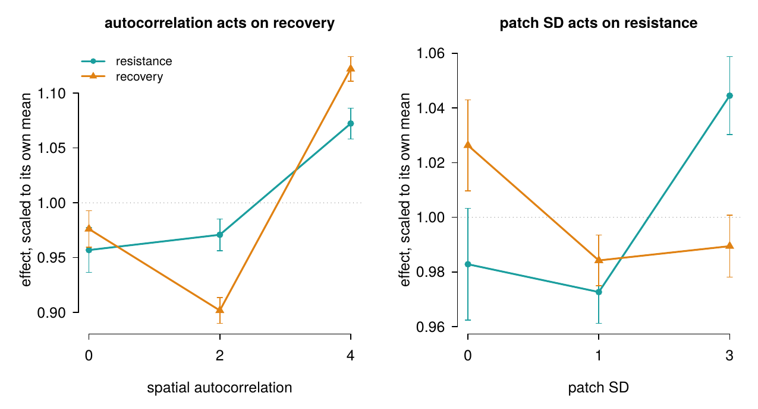

Figure 3. Resistance and recovery across autocorrelation (left) and patch SD (right), each scaled to its own mean so the two can share an axis. Autocorrelation moves recovery and leaves resistance flat. Error bars are standard errors.

2. Dispersal has an intermediate optimum
Dispersal SD | 1.5 | 3 | 6
Resistance | 0.024 | 0.081 | 0.103
Recovery magnitude | 0.454 | 0.531 | 0.405
Persistence | 0.281 | 0.606 | 0.199

Persistence triples from 1.5 to 3, then collapses at 6. This is the unimodal relationship Uecker et al. (2014) and Schiffers et al. (2013) predict, and which the earlier two-level design could not have detected. Note resistance keeps rising across the whole range while recovery peaks in the middle — the phases disagree about which dispersal level is best.

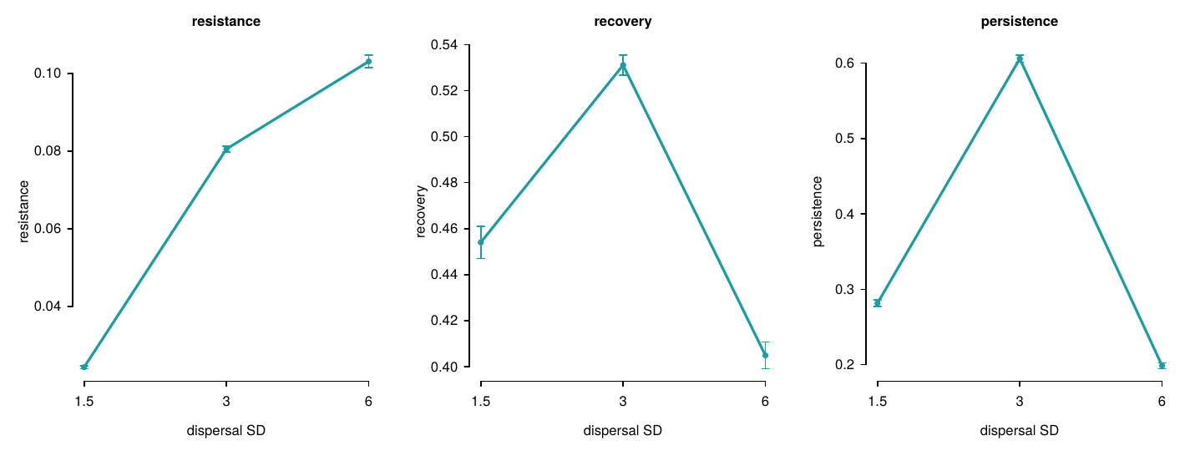

Figure 4. The three outcomes across dispersal distance. Resistance rises across the whole range while recovery and persistence peak at the middle level.

3. Gradient steepness hurts both phases
Slope | 0.8 | 1.0 | 1.2
Resistance | 0.079 | 0.071 | 0.050
Recovery magnitude | 0.558 | 0.509 | 0.312
Persistence | 0.470 | 0.381 | 0.237

Steeper gradients crash deeper and recover less. This differs from the earlier analysis, which showed steepness buffering the crash while suppressing the rebound — opposite signs on the two phases. Here the signs are the same. I don't yet know whether that reflects the corrected model, the changed parameter values, or the earlier result being an artefact.

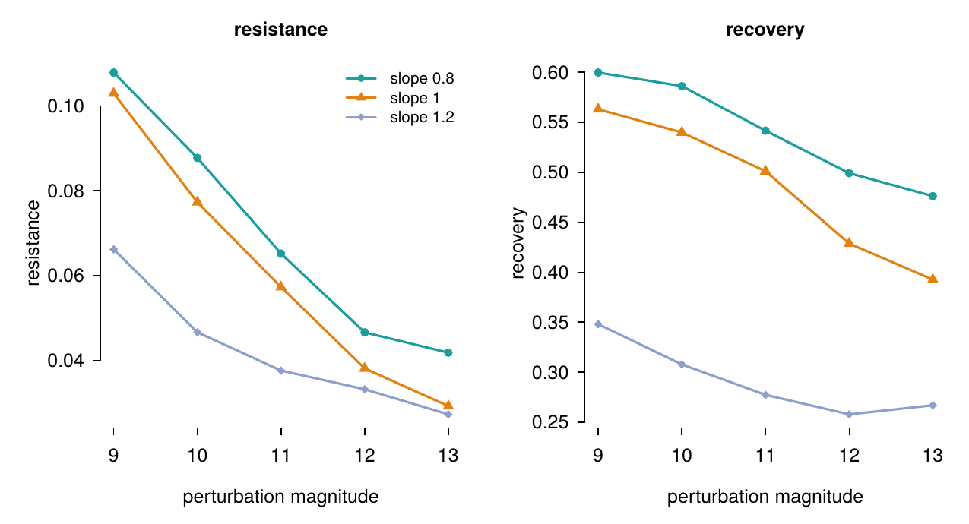
Figure 5. Resistance and recovery across perturbation magnitude, by gradient slope. The steepness penalty on resistance widens with severity (the only surviving interaction, p = 4.3e-09); on recovery the three slopes stay roughly parallel.

4. New mutation helps recovery far more than resistance
Recovery magnitude is 0.241 with standing variation only against 0.686 with new mutation — nearly a tripling. Resistance barely moves (0.065 to 0.075). Recovery is also slower with mutation (323 vs 445 time steps), which fits: there's further to climb.

5. Patch heterogeneity is weak once autocorrelation is accounted for
Patch SD affects persistence strongly (1.3e-13) but recovery only marginally (0.033, 0.022) and resistance not at all. Persistence by patch SD is 0.393, 0.412, 0.306 — non-monotonic, with heterogeneity mildly beneficial at SD 1 and costly at SD 3.

Robustness
The autocorrelation result reproduces independently across every split I've tried.

Recovery magnitude by autocorrelation 0 / 2 / 4:

Landscape draw 1 | 0.480 | 0.426 | 0.560
Landscape draw 2 | 0.474 | 0.447 | 0.534
Landscape draw 3 | 0.456 | 0.427 | 0.526
Batch 1 (n = 5,242) | 0.473 | 0.429 | 0.539
Batch 2 (n = 4,197) | 0.466 | 0.440 | 0.541

Three independently generated terrains and two independently seeded batches of runs, agreeing to the third decimal. Every treatment combination has at least 20 recorded runs, so no result depends on thin cells.

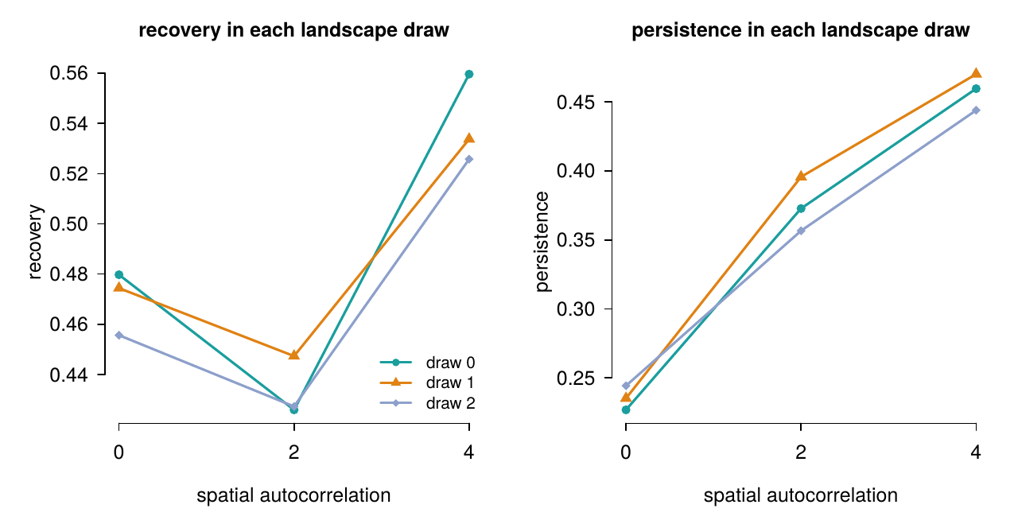

Figure 6. Recovery (left) and persistence (right) across autocorrelation, plotted separately for each of the three landscape draws. The lines are near-parallel, so the effect is a property of the autocorrelation level rather than of one particular surface.

One caveat about the design
At patch SD 3 with autocorrelation 0 — rough terrain, no spatial correlation — 25% of populations went extinct before the perturbation. Everywhere else the pre-perturbation loss rate is under 3%. Comparisons involving that corner are conditioned on the populations that survived to be perturbed. I've reported it as a result in its own right rather than tuning the parameter to avoid it, but we should decide whether that's the right call.

Where this leaves us
What I think we have:

- A landscape property that acts on one phase of rescue and not the other, with the mechanism visible in the pre-perturbation state. Autocorrelation is also the axis nobody has tested in an evolutionary rescue context, and climate models project it to increase.
- A dispersal optimum that the previous design was structurally unable to find.
- A demonstration that persistence alone conflates all of this — every parameter is significant for persistence, and that measure alone gives no way to tell them apart.

Note:
What else to run. The simulator is now fast enough that adding parameter levels is cheap — a full sweep is about 10 hours on a laptop. If there's a level or a factor you want in there, now is a good time to say.

