Draft skeleton: methods, candidate main messages, and the complete results
Anna Vinton, September 2026. In the message-focused framework. The narrative below runs homogeneous-first, per Ulf’s suggestion: start where classic rescue theory lives, add the gradient, decompose, then bring in the landscape. Eight candidate messages — the paper needs 3–5; three possible selections are at the end.

Methods

Design
The factorial. Slope (0.6, 0.8, 1.0) × dispersal SD (1.5, 3, 6) × variance infusional SD (0, 0.75) × perturbation (9–13) × seven landscape conditions (flat; environmental variation 1 and 2, each at autocorrelation 0, 2, 4). Five independently generated landscapes per condition, ten runs per landscape: 50 runs per treatment combination, 630 combinations, 31,500 runs.
The boundary block. The same factorial at slope 1.2 — retained from the earlier design and kept as a documented boundary case (see Viability below), not part of the balanced factorial. 10,500 runs.
The homogeneous block. Slope 0 on the flat landscape (no gradient, no heterogeneity — the classic non-spatial rescue setting): dispersal 3, both mutation levels, all severities, 10 runs each. 100 runs.
The control arm. Every slope × dispersal × variance infusion × landscape cell run with no perturbation to t = 1500, three landscapes × three runs: 1,512 runs certifying which cells persist on their own. This is what the viability classification below rests on.
Timing. Perturbation at t = 400; runs continue to t = 1050 (650 steps post-shift). The control-arm trajectories confirm every balanced-factorial condition is at its equilibrium by t = 400.

The model
Individual-based, continuous space and time, simulated with the Gillespie direct method. Each individual i has a position (x, y) on a 100 × 100 square and a heritable scalar trait u.
Locally optimal phenotype at position (x, y) at time t:
$$z_{0}\left(x,y,t\right)=S x+Φ\left(x,y\right)+p\left(t\right)$$
- S is the gradient slope; the optimum increases linearly along x only.
- Φ(x, y) is the static heterogeneity field: a Gaussian random field with mean 0, standard deviation σ_Φ (the “environmental variation” treatment), and power spectral density decaying as k^(−a) where a is the “autocorrelation” treatment. Fixed for the whole run. Measured lag-1 spatial correlation of the generated fields is 0.00, 0.74 and 0.996 for autocorrelation 0, 2 and 4.
- p(t) = 0 for t < 400 and p(t) = P thereafter. P is the perturbation magnitude, applied uniformly across the landscape. The shift reaches only individuals born after t = 400: adults keep their birth-time optimum (see Assumptions).
Carrying capacity available to individual i:
$$K\left(u_{i},x_{i},y_{i}\right)=k_{0}exp​\left(−\frac{{\left(u_{i}−z_{0}\right)}^{2}}{2σ_{K}^{2}}\right), k_{0}=10, σ_{K}=3/\sqrt{2}≈2.12$$
σ_K is the standard deviation of the Gaussian carrying-capacity function. We also refer to the tolerance width w = √2·σ_K = 3, the trait mismatch at which K falls to 1/e of its maximum; the code parameterises the function by w.
Competition experienced by i, summed over all j including itself:
Neffi=cj​exp​−rij22σc2, c=1.69, σc=1
A Gaussian kernel with width σ_c = 1 spatial unit (v3 change; the inherited exponential kernel was shown not to affect any result — Supplement S3). The constant c scales the whole sum; every individual contributes c to its own competition. Competition is purely spatial — no trait-similarity term. The neighbourhood is the 3 × 3 block of 10-unit grid cells around i and wraps in y.
Rates. Birth is constant at b = 0.54 for every individual. Death is
$$d_{i}=\frac{N_{eff}\left(i\right)}{K\left(u_{i},x_{i},y_{i}\right)}$$
so density dependence acts entirely through mortality, and maladaptation raises the death rate by shrinking the denominator.
Reproduction is clonal. An offspring of i has
$$u′=u_{i}+ε_{u}, x′=x_{i}+ε_{x}, y′=y_{i}+ε_{y}, ε_{u}∼N\left(0,σ_{μ}^{2}\right), ε_{x},ε_{y}∼N\left(0,σ_{d}^{2}\right)$$
σ_μ is the mutational SD treatment (0 or 0.75); σ_d is the dispersal SD treatment. Dispersal happens only at birth. The x boundary is absorbing at 0 and 99; y is periodic (period 99) for both dispersal and competition. The dispersal/mutation random stream is seeded from the run seed.
On σ_μ (per the team’s decision). The mutation treatment infuses phenotypic variance each generation and is agnostic about its source; it is not a model of the mutation process and is not to be compared with empirical mutation rates. Two levels because the question is presence versus absence of new variance, not dose.
Initialisation. 700 individuals placed uniformly at random with u = S·x + Φ(x, y): matched to their local optimum, including the heterogeneity (v3 change), so every condition starts adapted and equilibrates by relaxation rather than by initial die-off.
Observation. State recorded every 10 time units to t = 1050. At each record the simulator writes n and the first four moments of the trait, of maladaptation |S·x + Φ + p(t) − u| (includes the perturbation; v3 change), of nearest-neighbour distance, and of x position. Runs terminate at t = 1050 or extinction.
Assumptions worth knowing. Adults keep the optimum they were born under — the shift reaches only new offspring. This buffering is what makes rescue at large shifts possible in this model: if the shift reached adults, carrying capacity at P = 11 would fall to ~2×10⁻⁵ and populations would go extinct within ~10 time units (verified; transition at P ≈ 7–9). We state it as a life-history assumption — established individuals tolerate, recruitment fails — appropriate for long-lived organisms, and note that severities here are 3–4.3 tolerance widths, far beyond what any adults-exposed model survives.

Scale relationships
The ratios that govern the dynamics, for the balanced factorial:
Quantity | Range | Meaning
S·σ_d / w | 0.30 – 2.0 | Migration load: trait mismatch of a typical dispersal step, in tolerance widths (w = √2·σ_K = 3). Crosses 1 inside the design.
P / w | 3.0 – 4.3 | Magnitude of environmental change in tolerance widths (4.2 – 6.1 standard deviations σ_K).
P / S | 9 – 22 | Relocation distance: how far down-gradient the optimum moves, in spatial units. 3–7 dispersal SDs depending on the cell.
σ_Φ / w | 0, 0.33, 0.67 | Environmental variation relative to tolerance width.
correlation length / σ_d | ≪1 to ≫1 | Whether terrain is smooth over a dispersal step.
Note that P/S falls as slope falls: gentler gradients mean the optimum moves farther in space for the same trait shift. This geometry matters below.

Viability: where populations persist at all
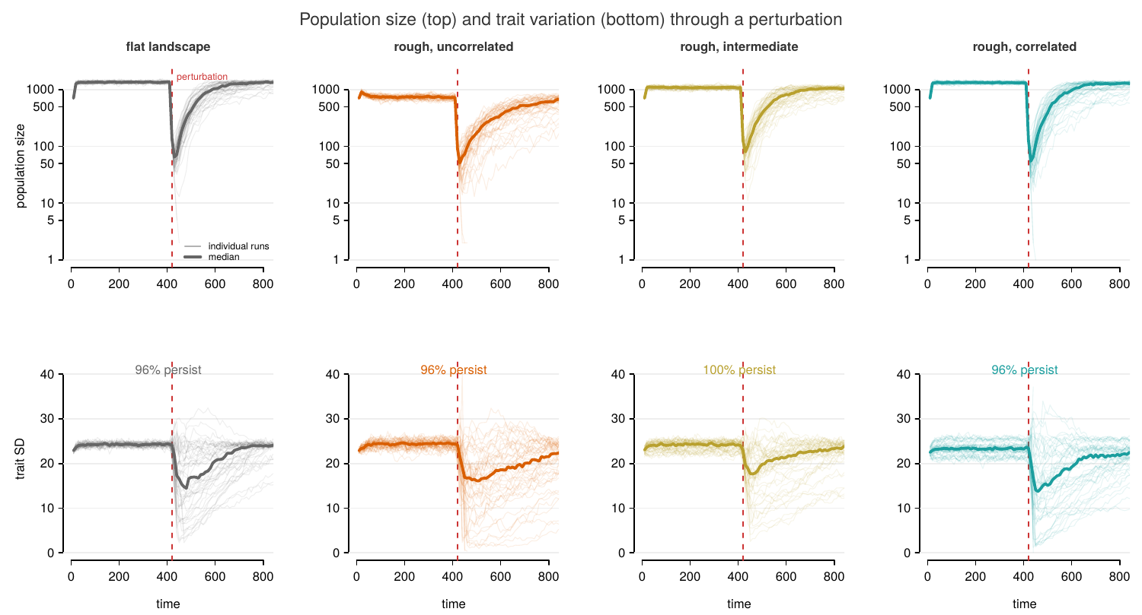
Trajectory reference. Population size (top, log scale) and trait variation (bottom) through the perturbation at the design centre (slope 0.8, dispersal 3, mutation on, magnitude of environmental change 11): flat landscape, then environmental variation 2 at autocorrelation 0, 2, 4. All 50 runs per panel, median in bold. Every condition is equilibrated at the shift; persistence 96–100% at this cell.
The control arm (no perturbation, t = 1500) certifies every cell:
Slope | viable | slowly declining | non-viable
0.6 | 41 | 1 | 0
0.8 | 34 | 8 | 0
1.0 | 32 | 6 | 4
1.2 | 16 | 15 | 11
The boundary advances with slope and consumes the uncorrelated-heterogeneity columns first: every non-viable cell at slope ≤ 1.0 is on environmental variation 2 with autocorrelation 0, and at slope 1.2 the same condition is dead at every dispersal while autocorrelation 4 still supports populations (Figure 4). Slow declines concentrate in mutation-off cells: without variance input, gradient populations erode over hundreds of time units.
Analysis rule. The balanced factorial (slopes 0.6–1.0) restricted to cells whose controls persist (unperturbed survival ≥ 0.8) is the core: 123 of 126 cells, 30,730 runs. The three excluded cells are the uncorrelated high-heterogeneity corner at slope 1.0 with dispersal at either extreme (unperturbed survival 0.11–0.33). One further cell (slope 1.0, dispersal 6, environmental variation 2, AC 2) persists in every control run but at a small equilibrium (~33); it is retained under the persistence criterion and flagged here. Slope 1.2 is reported as the boundary, not analysed for phases. Slowly-declining cells are retained — the baseline is measured at the shift (below), so slow drift does not bias the ratios.

Measures
From each run’s abundance trajectory: the baseline (median of the last five pre-shift records — the population at the moment the shift arrives), the trough (post-shift minimum), the peak (post-trough maximum), and the endpoint.
- Resistance = trough / baseline. How much of the population survives the crash.
- Recovery = (peak − trough) / baseline. How much of the lost ground is regained.
- Persistence = endpoint > 10.
Resistance and recovery correlate at +0.24 across surviving runs — related but distinct, which is the premise of the decomposition.
Estimator notes. The trough is the minimum of a noisy series and is biased low; the bias is identical across treatments (same recording schedule) so comparisons are unaffected. Median trough is ~5 against baselines of 500–1500, so resistance is a small-integer ratio with intrinsically low signal-to-noise — part of why resistance effects are weaker throughout than recovery effects.
Survivor conditioning. Phase outcomes exist only for surviving runs, and survival varies by treatment (0.24–0.76 across dispersal). Resistance and recovery are therefore estimated on a survivor subset whose composition differs by treatment; this is inherent to the decomposition, and persistence is modelled separately on all runs.
Models. For each phase outcome y (resistance untransformed; recovery log(1+x)-transformed):
$$y=β_{0}+β_{\text{slope}}+β_{\text{disp}}+β_{\text{mut}}+β_{\text{mag}}+β_{\text{var}}+β_{\text{AC}}+β_{\text{slope}×\text{mag}}+β_{\text{AC}×\text{mag}}+β_{\text{slope}×\text{disp}}+ε$$
with every β a set of factor-level contrasts. OLS on surviving runs; persistence uses the same right-hand side with a logit link on all runs. Standard errors are cluster-robust with cells (treatment × landscape draw) as clusters — clustering roughly doubles the standard errors on landscape contrasts and is essential. Each reported p-value is a joint Wald test that all contrasts for a factor equal zero. Landscape terms are fitted on patchy landscapes only. Because every term is significant at this sample size, emphasis follows variance explained (partial η²), not p-values.

Results

Measures
From each run’s abundance trajectory: the baseline (median of the last five pre-shift records — the population at the moment the shift arrives), the trough (post-shift minimum), the peak (post-trough maximum), and the endpoint.
- Resistance = trough / baseline. How much of the population survives the crash.
- Recovery = (peak − trough) / baseline. How much of the lost ground is regained.
- Persistence = endpoint > 10.
Resistance and recovery correlate at +0.24 across surviving runs — related but distinct, which is the premise of the decomposition.
Estimator notes. The trough is the minimum of a noisy series and is biased low; the bias is identical across treatments (same recording schedule) so comparisons are unaffected. Median trough is ~5 against baselines of 500–1500, so resistance is a small-integer ratio with intrinsically low signal-to-noise — part of why resistance effects are weaker throughout than recovery effects.
Survivor conditioning. Phase outcomes exist only for surviving runs, and survival varies by treatment (0.24–0.76 across dispersal). Resistance and recovery are therefore estimated on a survivor subset whose composition differs by treatment; this is inherent to the decomposition, and persistence is modelled separately on all runs.
Models. For each phase outcome y (resistance untransformed; recovery log(1+x)-transformed):
$$y=β_{0}+β_{\text{slope}}+β_{\text{disp}}+β_{\text{mut}}+β_{\text{mag}}+β_{\text{var}}+β_{\text{AC}}+β_{\text{slope}×\text{mag}}+β_{\text{AC}×\text{mag}}+β_{\text{slope}×\text{disp}}+ε$$
with every β a set of factor-level contrasts. OLS on surviving runs; persistence uses the same right-hand side with a logit link on all runs. Standard errors are cluster-robust with cells (treatment × landscape draw) as clusters — clustering roughly doubles the standard errors on landscape contrasts and is essential. Each reported p-value is a joint Wald test that all contrasts for a factor equal zero. Landscape terms are fitted on patchy landscapes only. Because every term is significant at this sample size, emphasis follows variance explained (partial η²), not p-values.

Candidate main messages
Framing. Landscape structure in this model comprises three properties, varied factorially: the slope of the environmental gradient, the magnitude of environmental variation, and the spatial autocorrelation of that variation (cf. Haller et al. 2013). Alongside these sit two population properties — dispersal and the infusion of phenotypic variance — and the magnitude of environmental change. The candidate messages treat the three landscape properties as facets of a single question: which aspects of landscape structure act on which component of rescue.
M1. Populations on homogeneous landscapes cannot be rescued from large environmental shifts; survival requires relocation along an environmental gradient.
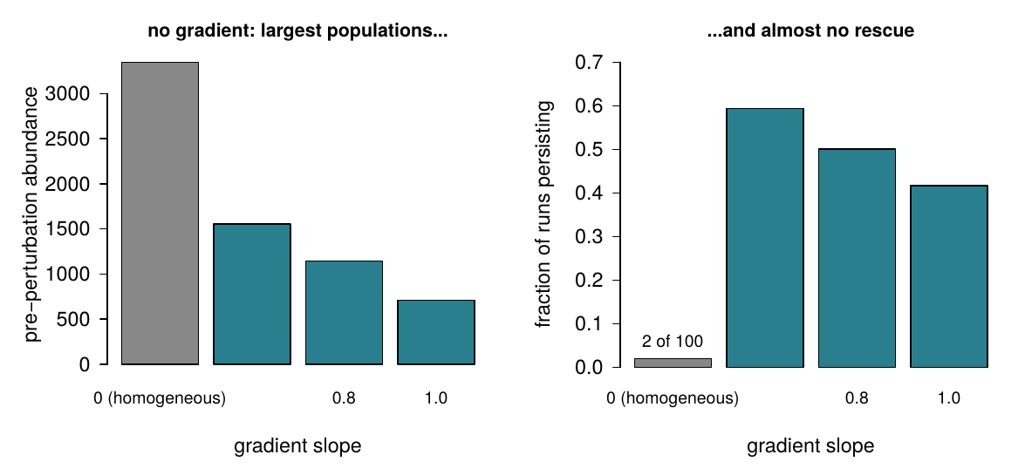
Evidence: homogeneous landscapes (slope 0) support the largest populations in the design, as they impose no migration load, yet 2 of 100 runs survived the environmental shift, and every gradient treatment performed better. Phenotypic variance alone cannot bridge a shift of 3–4 tolerance widths on this timescale; the classic non-spatial rescue setting fails precisely where the spatial settings succeed. Commits us to: foregrounding the magnitude regime and the buffered-adults assumption, both of which make relocation the operative channel.
M2. The decline and recovery of perturbed populations respond to different factors, so decomposing rescue into resistance and recovery reveals structure that persistence alone conceals.
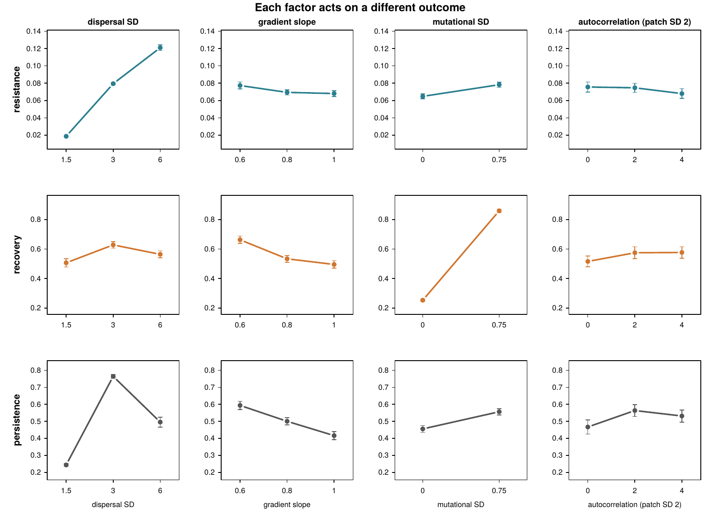
Evidence: the three outcomes have three different top drivers; no single ranking of treatments describes them all. Resistance and recovery correlate at only +0.24 across surviving runs. Commits us to: the decomposition as the paper’s framing device. The methodological message; it organises everything that follows.
M3. Populations decline less when their individuals have already spread farther along the gradient: dispersal, not adaptation, governs resistance.
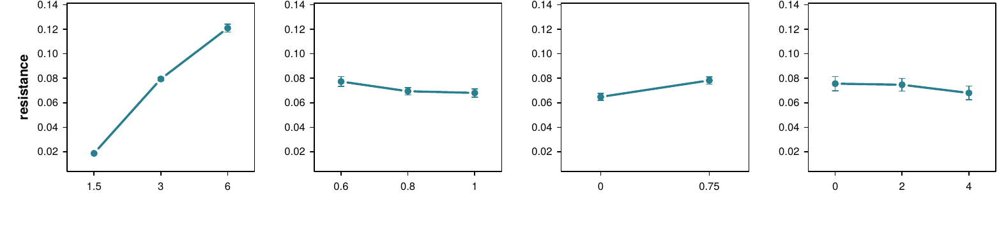
Evidence: resistance rises sixfold and monotonically across dispersal (0.019 / 0.079 / 0.121 at dispersal SD 1.5 / 3 / 6), the largest phase effect in the design, while variance infusion and autocorrelation leave resistance essentially unchanged. Processes acting through adaptation do not reach the decline phase; the individuals that persist through it are those already located near the shifted optimum. Commits us to: a spatial pre-adaptation interpretation of the decline phase.
M4. Populations rebuild through new phenotypic variance: variance infusion more than triples recovery yet does nothing to soften the decline.
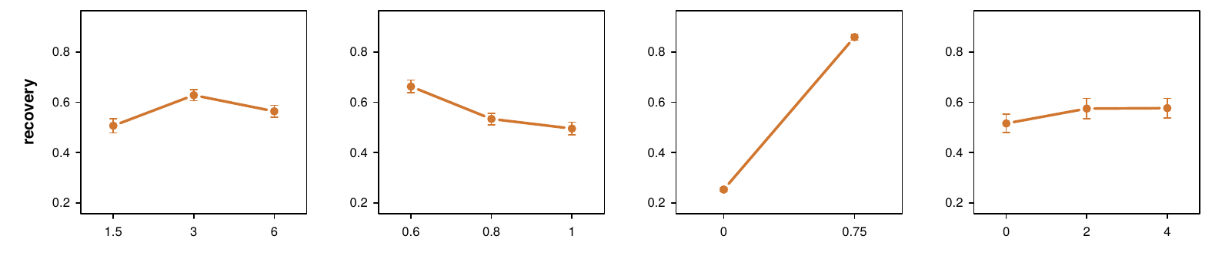
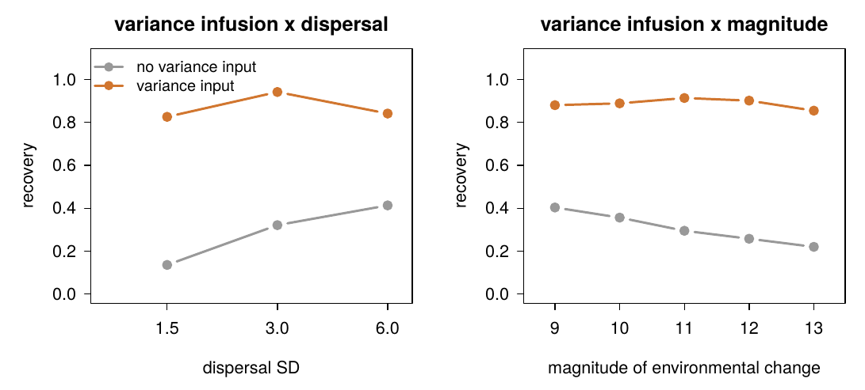
Evidence: recovery increases from 0.25 to 0.86 with variance infusion (73% of recovery variance among survivors), while resistance moves only from 0.065 to 0.078 — the largest single effect in the dataset. Without variance input, the survivors that do rebound recover more slowly and less completely. Commits us to: recovery as the adaptation-limited phase, and to describing the treatment as variance infusion agnostic to source.
M5. Populations with intermediate dispersal persist best even though populations with the longest dispersal decline least: the two phases of rescue reward different dispersal strategies.
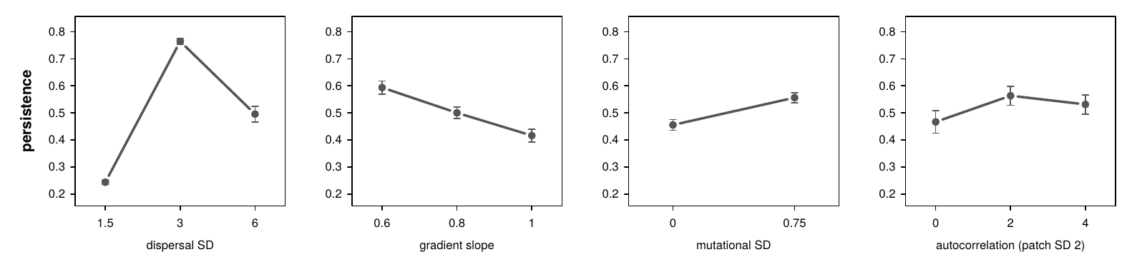
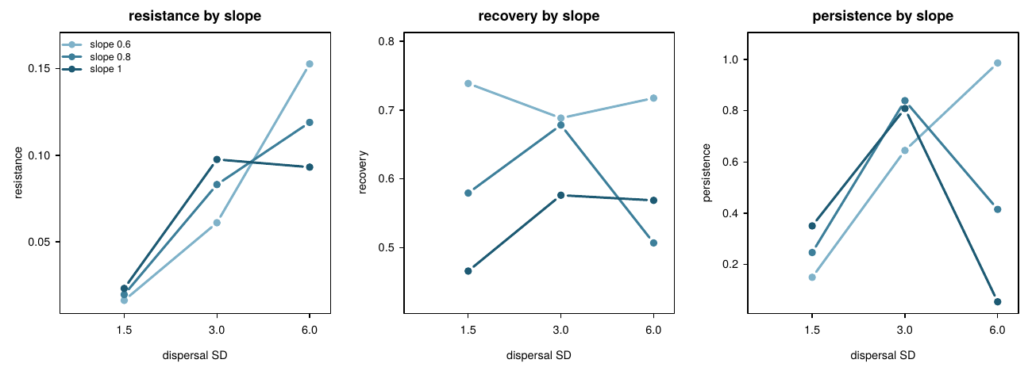
Evidence: persistence peaks at intermediate dispersal (0.24 / 0.76 / 0.50), as theory predicts, while resistance continues to rise at the highest dispersal and abundance and recovery decline there under migration load. The optimum emerges as a compromise between phases favouring opposite strategies, a mechanism the decomposition makes visible. The optimum is not fixed: on gentle gradients persistence keeps rising to the longest dispersal (0.99 at slope 0.6), while on steeper gradients the same dispersal is lethal (0.05 at slope 1.0). The optimum sits where S·σ_d crosses the migration-load boundary, which is why slope × dispersal is the dominant interaction on persistence (drop-one Δpseudo-R² = 19.1 percentage points). Commits us to: engaging the dispersal-optimum literature as explanation rather than confirmation.
M6. Populations on autocorrelated landscapes survive because they are larger when the environment shifts: landscape patchiness determines which populations persist, not how survivors recover — and on uncorrelated, highly variable landscapes, populations fail before any environmental change arrives.
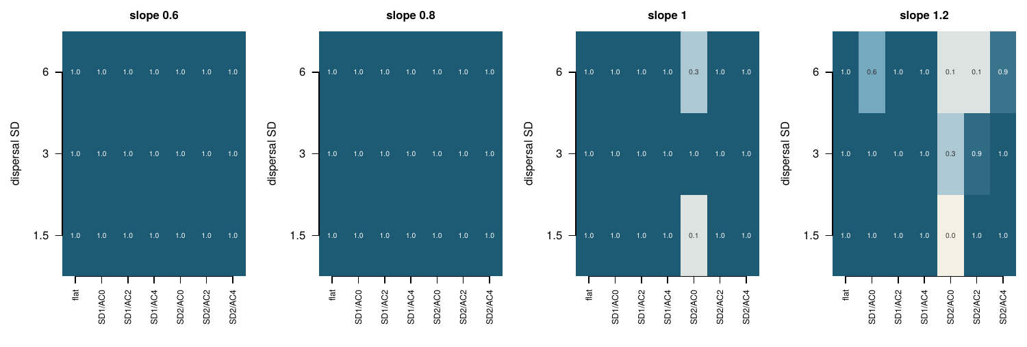
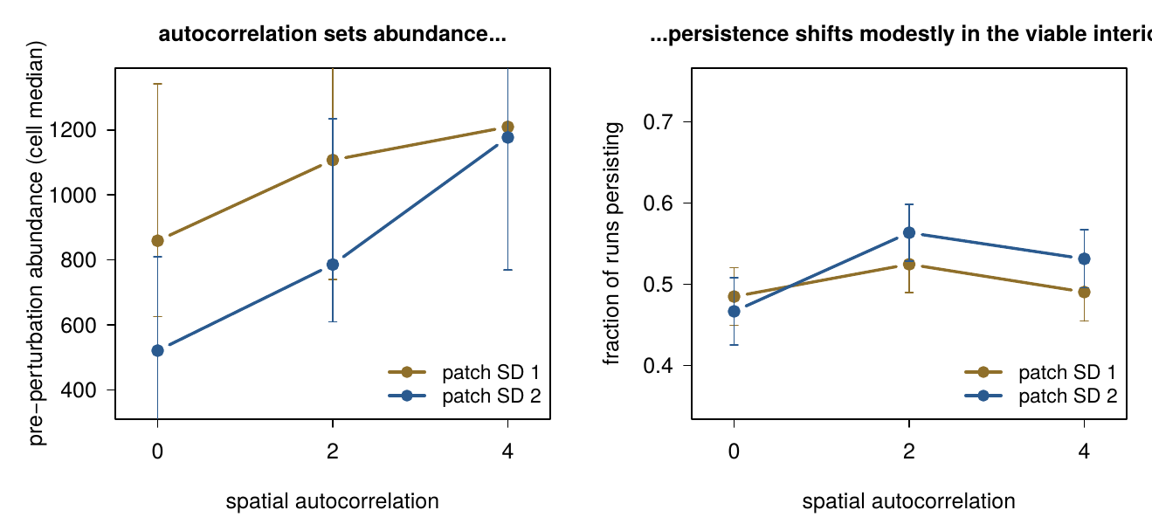
Evidence: among survivors, autocorrelation explains 0.6% of recovery variance, and its profile is flat in each of five independent landscape replicates. Its role is instead consistent with the inflationary effect (Gonzalez & Holt 2002): autocorrelated landscapes support larger populations at the same magnitude of variation (median abundance 521 to 1177 across autocorrelation levels at high variation), and once abundance is included in the model, autocorrelation explains nothing further (p = 0.62). At the viability margin this becomes a refugia effect: the non-viable region of the design is confined to uncorrelated, high-variation landscapes and expands with gradient slope, while autocorrelated landscapes of identical variation remain habitable throughout. Landscape patchiness thus determines how many individuals face the environmental change and whether a population exists at all, rather than how rescue unfolds among survivors. Commits us to: the margins framing, the inflationary-effect and refugia literature, and presenting the earlier reading of autocorrelation as resolved by mediation and viability certification.
M6b. Populations on steep gradients decline deeper and recover less, while populations on gentle gradients are larger but must relocate farther: the gradient shapes the rescue trajectory itself.
Figure: slope column of Fig 2 (for now); a dedicated two-panel with the geometry (S·σ_d load vs P/S relocation distance) if selected.
Evidence: gradient slope is second only to variance infusion in explaining recovery (13.3% as a main effect, declining monotonically on every outcome), and slope × dispersal is the largest interaction on both resistance (19.7% of variance) and persistence (drop-one Δpseudo-R² = 19.1 percentage points), reflecting the tension between gene flow and local adaptation. The mechanism is geometric as well as genetic: the product S·σ_d sets migration load, while the ratio P/S sets the distance the optimum travels in space, so gentler gradients carry larger, better-adapted populations that must nonetheless relocate farther for the same environmental shift. Together with M6 this completes the landscape account: the gradient acts on the rescue trajectory itself, while variation and its autocorrelation act on the extinction margin. Commits us to: the geometric interpretation, with the intermediate-slope expectation of adaptive-dynamics theory as the point of contact.
M7. The results are robust to landscape realisation, competition-kernel shape, baseline definition, and replication level, and every analysed cell is certified viable by unperturbed controls.
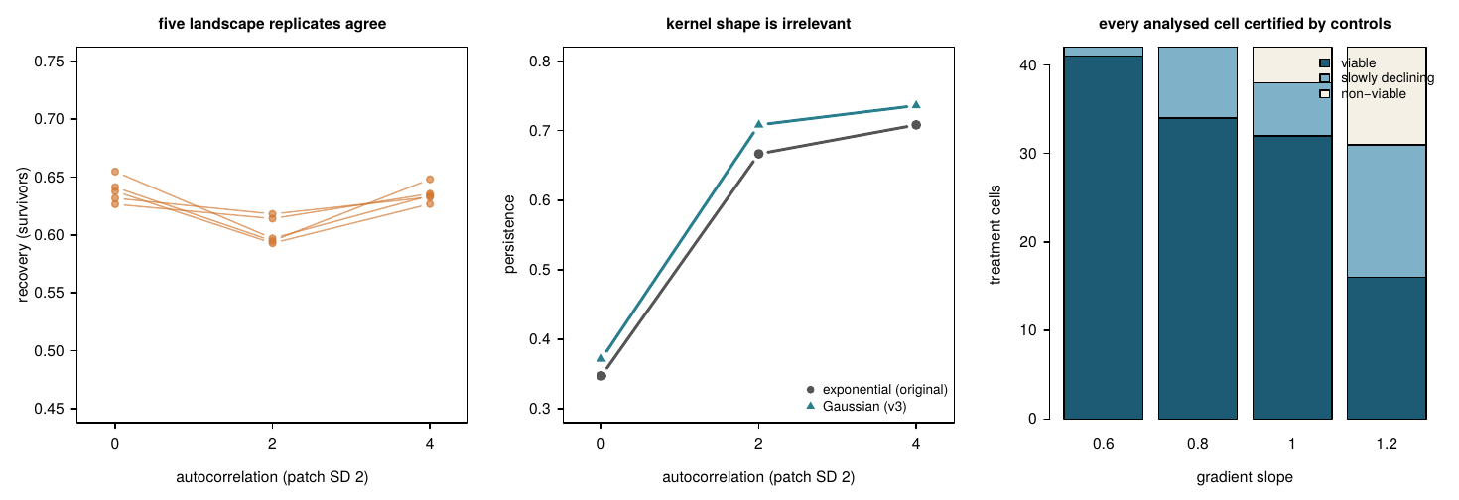
Evidence: every landscape claim reproduces in each of five independent landscape draws; an unperturbed control arm (t = 1500) certifies every analysed cell; a Gaussian-versus-exponential kernel check across eight treatment cells changes nothing; an 80%-replication experiment reproduced results to the third decimal. The closing message, per the template.

Three possible 4-message selections
- The decomposition paper: M2 leads, M3+M4 as the twin drivers, M5, M7 — homogeneous baseline (M1) folded into the introduction, landscape (M6) a Results section. Tightest story.
- The margins paper: M1, M2 (with M3+M4 compressed into it), M6+M6b (as the landscape-structure pair: the gradient shapes rescue, patchiness sets the margin), M7 — the ladder narrative: no gradient → gradient decomposed → landscape structure sorted by which margin it acts on. Keeps both novelties; the title writes itself.
- Two papers: M1–M5+M7 now (phases); M6 with a dedicated design later.
Suggested title under the margins selection: Evolutionary rescue has two phases; landscape structure decides who survives them.

Results: the complete inventory
Everything the dataset says, ranked by variance explained, so message selection can work from the full evidence. Core balanced design (123 certified cells, 30,730 runs, 14,994 survivors) unless marked. Tags: [M#] = headlined by that candidate; (supports M#) = reported inside its section; (unassigned) = no current message.

Main effects — share of variance (partial η²), survivors, patchy landscapes
Factor | Resistance | Recovery | Persistence (joint p)
Dispersal | 53.3% [M3] | 8.8% (supports M5) | 3e-266 [M5]
Magnitude of change | 48.6% (unassigned — see below) | 6.1% | 1e-147
Slope | 3.9% | 13.3% [M6b] | 2e-36
Mutation | 0.7% | 69.1% [M4] | 3e-20
Autocorrelation | 1.9% | 0.2% [M6] | 3e-10 (supports M6)
Environmental variation | 0.4% | 0.4% [M6] | 0.6
Level-by-level profiles (resistance / recovery / persistence):
- Dispersal 1.5/3/6: 0.019/0.079/0.121 | 0.51/0.63/0.56 | 0.24/0.76/0.50 [M3, M5]
- Variance infusion 0/0.75: 0.065/0.078 | 0.25/0.86 | 0.46/0.56 [M4]
- Slope 0.6/0.8/1.0: 0.077/0.069/0.068 | 0.66/0.53/0.50 | 0.59/0.50/0.42 [M6b]
- Magnitude of change 9→13: 0.132→0.044 | 0.67→0.58 | 0.74→0.29 (manipulation check: the design brackets the persistence transition; resistance responds to magnitude of environmental change far more than recovery does — worth one line in M2’s section)
- Environmental variation 0/1/2: 0.093/0.093/0.094 | 0.66/0.64/0.62 | 0.47/0.50/0.52 (supports M6: heterogeneity per se does nothing to phases)
- AC 0/2/4 at SD 2: 0.076/0.075/0.068 | 0.52/0.57/0.58 | 0.47/0.56/0.53 [M6]

All fifteen pairwise interactions
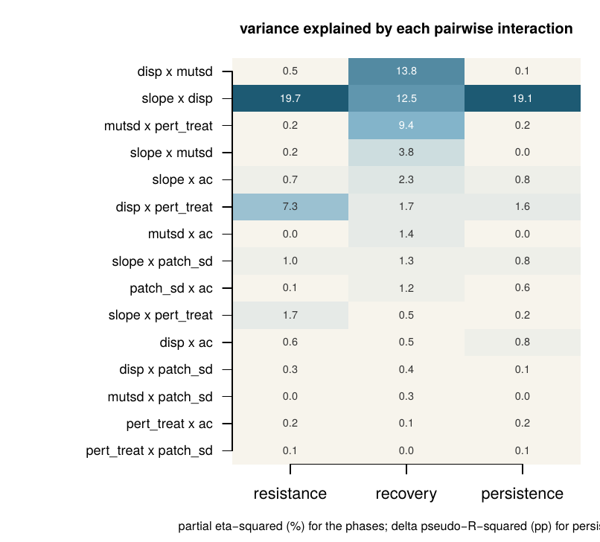
Partial η² (%) on the phase outcomes (survivors, patchy landscapes) and the drop-one change in McFadden pseudo-R² (percentage points) from the full two-way persistence model (all runs, patchy). All three columns are computed the same way: fit the model with all fifteen pairwise interactions, remove one, record the loss.
Interaction | Resistance | Recovery | Persistence (ΔR², pp) | Tag
dispersal × variance infusion | 0.5 | 13.8 | 0.11 | supports M4
slope × dispersal | 19.7 | 12.5 | 19.06 | [M6b, M5]
variance infusion × magnitude | 0.2 | 9.4 | 0.22 | supports M4
slope × variance infusion | 0.2 | 3.8 | 0.00 | supports M4/M6b
slope × autocorrelation | 0.7 | 2.3 | 0.78 | supports M6 (boundary)
dispersal × magnitude | 7.3 | 1.7 | 1.57 | supports M3/M5
variance infusion × autocorrelation | 0.0 | 1.4 | 0.00 | unassigned
slope × variation | 1.0 | 1.3 | 0.83 | unassigned
autocorrelation × variation | 0.1 | 1.2 | 0.61 | supports M6 (mediation removed it)
slope × magnitude | 1.7 | 0.5 | 0.22 | unassigned
dispersal × autocorrelation | 0.6 | 0.5 | 0.82 | supports M6
dispersal × variation | 0.3 | 0.4 | 0.07 | unassigned
variance infusion × variation | 0.0 | 0.3 | 0.00 | unassigned
magnitude × autocorrelation | 0.2 | 0.1 | 0.19 | unassigned
magnitude × variation | 0.1 | 0.0 | 0.15 | unassigned
Slope × dispersal dominates persistence as it dominates resistance: where a population sits relative to the migration-load boundary S·σ_d/w = 1 is the single most consequential combination in the design.

Interactions among the spatial parameters at the viability boundary
Within the viable interior the patchiness interactions are small (table above), but at the boundary they are the story. Compromised cells (non-viable or declining in the unperturbed controls), counted from the control arm:
- Slope × autocorrelation at variation 2 (of 6 cells each): autocorrelation 0 column runs 0 / 4 / 3 / 6 across slopes 0.6–1.2 while the autocorrelation 4 column runs 0 / 0 / 2 / 4 — the boundary advances with slope and consumes uncorrelated landscapes first [M6, Fig 4]
- Variation × autocorrelation (slopes ≥ 0.8, of 12): 13 compromised cells at variation 2 / autocorrelation 0 versus 6 at variation 2 / autocorrelation 4; variation 1 sits at 4–5 throughout — high variation is only dangerous when uncorrelated [M6]
- The three-way structure (slope × variation × autocorrelation, with dispersal extremes worst) is the viability map itself; it is presented as Figure 4 rather than as coefficients

Landscape and viability
- Baseline abundance by AC at SD 2: 521/786/1177; at SD 1: 859/1107/1209 [M6]
- Mediation: log(baseline) in the recovery model leaves AC nothing (p = 0.62, coefficient +0.045) [M6]
- Viability certification (unperturbed to t = 1500): slopes 0.6/0.8/1.0/1.2 give 41/34/32/16 viable cells; all non-viable cells at slope ≤ 1.0 are SD 2 / AC 0; slope 1.2’s failures spread from the AC 0 columns outward [M6, Fig 4]
- One retained small-equilibrium cell (slope 1.0, disp 6, SD 2, AC 2; n≈33, persists in all controls) — flagged in Methods
- Mutation-off cells decline slowly without perturbation (variance erosion); 8–15 cells per slope classed “slowly declining”, all retained (supports M4; worth a Discussion sentence)

Homogeneous block and geometry
- Slope 0: baselines 3,787 (mut off) / 2,919 (mut on) — mutation load directly visible (supports M1/M4); survival 2/100, mildest magnitude of environmental change only [M1]
- Relocation distance P/S: 9–22 spatial units (3–7 dispersal SDs) across the design; gentle slopes = less load, farther to run [M6b]

Secondary quantities
- corr(resistance, log recovery) = +0.24 across survivors [M2]
- Recovery time (trough → peak): 350 without variance input vs 456 with — slower populations that rebound farther (supports M4; interpret with care: conditioning on having a peak)
- Overall persistence 0.51 in the core; magnitude of environmental change spans 0.74 → 0.29
- Slope-1.2 boundary block (not analysed for phases): 9,844 runs available for a boundary-focused figure if M6 is selected
(unassigned items are candidates for messages we haven’t thought of — that’s what this inventory is for)

