Evolutionary rescue in spatially structured landscapes

Methods and results — final (v3) simulation dataset
Anna Vinton, September 2026

What this is
The final dataset after the full pipeline audit: every design choice tested, every treatment cell certified viable by unperturbed controls, and the slope axis balanced. This document covers what was run and what came out. Interpretation is kept to the minimum needed to read the tables — the narrative belongs to the paper draft.
Everything below comes from a single dataset of 42,100 launched runs (2–7 September 2026): the factorial sweep, a homogeneous-landscape block, and an unperturbed control arm. Data, code and figures are in the shared Drive folder.

The questions
The project has always been about how spatial structure shapes evolutionary rescue. What’s changed is how we measure rescue.
Almost all rescue work collapses the population trajectory to one number — usually the probability of rescue, sometimes a critical threshold or an endpoint density. But the trajectory has two limbs produced by different processes: a decline, governed by demographic buffering and whatever pre-adapted individuals are already nearby, and a rebound, governed by the adaptive response and subsequent growth. Orr & Unckless 2014 derived both, but for a well-mixed single-locus model, and the quantities have rarely been used since. Ulf raised this in 2021, suggesting we track the minimum relative population size and the increase after the minimum as separate quantities. That’s what we’re now doing.
The questions this dataset addresses:
- Do landscape properties — gradient slope, spatial autocorrelation and environmental variance — act differently on the two phases of rescue, and do they interact?
- How do the same parameters act on persistence alone, and is there structure that measure misses?
- Does dispersal show an intermediate optimum, as theory predicts?
- Does the source of genetic variation — standing only, versus standing plus new variance each generation — change any of this?
- Where can gradient populations persist at all, and what sets that boundary?

Design
The factorial. Slope (0.6, 0.8, 1.0) × dispersal SD (1.5, 3, 6) × mutational SD (0, 0.75) × perturbation (9–13) × seven landscape conditions (flat; patch SD 1 and 2, each at autocorrelation 0, 2, 4). Five independently generated landscapes per condition, ten runs per landscape: 50 runs per treatment combination, 630 combinations, 31,500 runs.
The boundary block. The same factorial at slope 1.2 — retained from the earlier design and kept as a documented boundary case (see Viability below), not part of the balanced factorial. 10,500 runs.
The homogeneous block. Slope 0 on the flat landscape (no gradient, no heterogeneity — the classic non-spatial rescue setting): dispersal 3, both mutation levels, all severities, 10 runs each. 100 runs.
The control arm. Every slope × dispersal × mutation × landscape cell run with no perturbation to t = 1500, three landscapes × three runs: 1,512 runs certifying which cells persist on their own. This is what the viability classification below rests on.
Timing. Perturbation at t = 400; runs continue to t = 1050 (650 steps post-shift). The control-arm trajectories confirm every balanced-factorial condition is at its equilibrium by t = 400.

The model
Individual-based, continuous space and time, simulated with the Gillespie direct method. Each individual i has a position (x, y) on a 100 × 100 square and a heritable scalar trait u.
Locally optimal phenotype at position (x, y) at time t:
z₀(x, y, t) = S·x + Φ(x, y) + p(t)
- S is the gradient slope; the optimum increases linearly along x only.
- Φ(x, y) is the static heterogeneity field: a Gaussian random field with mean 0, standard deviation σ_Φ (the “patch SD” treatment), and power spectral density decaying as k^(−a) where a is the “autocorrelation” treatment. Fixed for the whole run. Measured lag-1 spatial correlation of the generated fields is 0.00, 0.74 and 0.996 for autocorrelation 0, 2 and 4.
- p(t) = 0 for t < 400 and p(t) = P thereafter. P is the perturbation magnitude, applied uniformly across the landscape. The shift reaches only individuals born after t = 400: adults keep their birth-time optimum (see Assumptions).
Carrying capacity available to individual i:
K(u_i, x_i, y_i) = k₀ · exp( −(u_i − z₀)² / 2σ_K² ) k₀ = 10, σ_K = 3/√2 ≈ 2.12
σ_K is the standard deviation of the Gaussian carrying-capacity function. We also refer to the tolerance width w = √2·σ_K = 3, the trait mismatch at which K falls to 1/e of its maximum; the code parameterises the function by w.
Competition experienced by i, summed over all j including itself:
N_eff(i) = c · Σ_j exp( −r_ij² / 2σ_c² ) c = 1.69, σ_c = 1
A Gaussian kernel with width σ_c = 1 spatial unit (v3 change; the inherited exponential kernel was shown not to affect any result — Supplement S3). The constant c scales the whole sum; every individual contributes c to its own competition. Competition is purely spatial — no trait-similarity term. The neighbourhood is the 3 × 3 block of 10-unit grid cells around i and wraps in y.
Rates. Birth is constant at b = 0.54 for every individual. Death is
d_i = N_eff(i) / K(u_i, x_i, y_i)
so density dependence acts entirely through mortality, and maladaptation raises the death rate by shrinking the denominator.
Reproduction is clonal. An offspring of i has
u_offspring = u_i + ε_u, ε_u ~ N(0, σ_μ²)
x_offspring = x_i + ε_x, ε_x ~ N(0, σ_d²)
y_offspring = y_i + ε_y, ε_y ~ N(0, σ_d²)
σ_μ is the mutational SD treatment (0 or 0.75); σ_d is the dispersal SD treatment. Dispersal happens only at birth. The x boundary is absorbing at 0 and 99; y is periodic (period 99) for both dispersal and competition. The dispersal/mutation random stream is seeded from the run seed.
On σ_μ (per the team’s decision). The mutation treatment infuses phenotypic variance each generation and is agnostic about its source; it is not a model of the mutation process and is not to be compared with empirical mutation rates. Two levels because the question is presence versus absence of new variance, not dose.
Initialisation. 700 individuals placed uniformly at random with u = S·x + Φ(x, y): matched to their local optimum, including the heterogeneity (v3 change), so every condition starts adapted and equilibrates by relaxation rather than by initial die-off.
Observation. State recorded every 10 time units to t = 1050. At each record the simulator writes n and the first four moments of the trait, of maladaptation |S·x + Φ + p(t) − u| (includes the perturbation; v3 change), of nearest-neighbour distance, and of x position. Runs terminate at t = 1050 or extinction.
Assumptions worth knowing. Adults keep the optimum they were born under — the shift reaches only new offspring. This buffering is what makes rescue at large shifts possible in this model: if the shift reached adults, carrying capacity at P = 11 would fall to ~2×10⁻⁵ and populations would go extinct within ~10 time units (verified; transition at P ≈ 7–9). We state it as a life-history assumption — established individuals tolerate, recruitment fails — appropriate for long-lived organisms, and note that severities here are 3–4.3 tolerance widths, far beyond what any adults-exposed model survives.

Scale relationships
The ratios that govern the dynamics, for the balanced factorial:
Quantity | Range | Meaning
S·σ_d / w | 0.30 – 2.0 | Migration load: trait mismatch of a typical dispersal step, in tolerance widths (w = √2·σ_K = 3). Crosses 1 inside the design.
P / w | 3.0 – 4.3 | Magnitude of environmental change in tolerance widths (4.2 – 6.1 standard deviations σ_K).
P / S | 9 – 22 | Relocation distance: how far down-gradient the optimum moves, in spatial units. 3–7 dispersal SDs depending on the cell.
σ_Φ / w | 0, 0.33, 0.67 | Environmental variation relative to tolerance width.
correlation length / σ_d | ≪1 to ≫1 | Whether terrain is smooth over a dispersal step.
Note that P/S falls as slope falls: gentler gradients mean the optimum moves farther in space for the same trait shift. This geometry matters below.

Viability: where populations persist at all
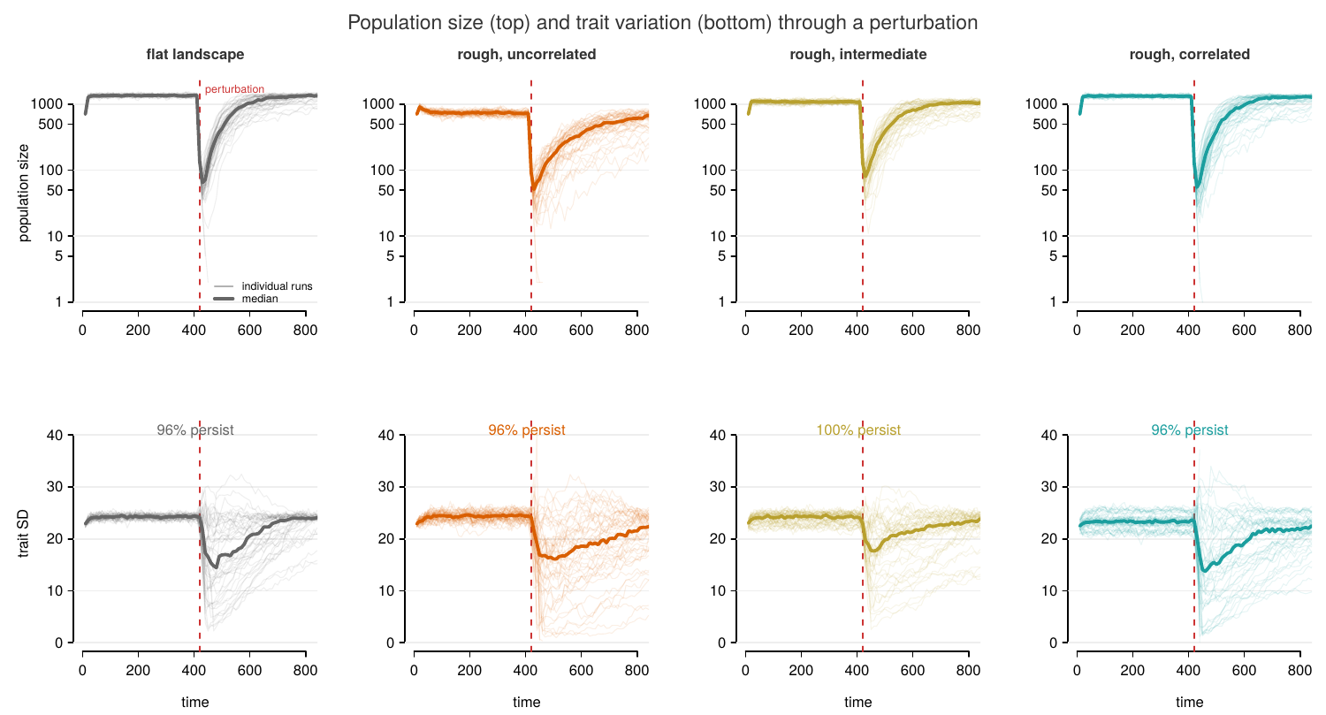
Trajectories
Figure 1. Population size (top, log scale) and trait variation (bottom) through the perturbation at the design centre (slope 0.8, dispersal 3, mutation on, severity 11): flat landscape, then patch SD 2 at autocorrelation 0, 2, 4. All 50 runs per panel, median in bold. Every condition is equilibrated at the shift; persistence 96–100% at this cell.
The control arm (no perturbation, t = 1500) certifies every cell:
Slope | viable | slowly declining | non-viable
0.6 | 41 | 1 | 0
0.8 | 34 | 8 | 0
1.0 | 32 | 6 | 4
1.2 | 16 | 15 | 11
The boundary advances with slope and consumes the uncorrelated-heterogeneity columns first: every non-viable cell at slope ≤ 1.0 is on patch SD 2 with autocorrelation 0, and at slope 1.2 the same condition is dead at every dispersal while autocorrelation 4 still supports populations (Figure 4). Slow declines concentrate in mutation-off cells: without variance input, gradient populations erode over hundreds of time units.
Analysis rule. The balanced factorial (slopes 0.6–1.0) restricted to cells whose controls persist (unperturbed survival ≥ 0.8) is the core: 123 of 126 cells, 30,730 runs. The three excluded cells are the uncorrelated high-heterogeneity corner at slope 1.0 with dispersal at either extreme (unperturbed survival 0.11–0.33). One further cell (slope 1.0, dispersal 6, patch SD 2, AC 2) persists in every control run but at a small equilibrium (~33); it is retained under the persistence criterion and flagged here. Slope 1.2 is reported as the boundary, not analysed for phases. Slowly-declining cells are retained — the baseline is measured at the shift (below), so slow drift does not bias the ratios.

Measures
From each run’s abundance trajectory: the baseline (median of the last five pre-shift records — the population at the moment the shift arrives), the trough (post-shift minimum), the peak (post-trough maximum), and the endpoint.
- Resistance = trough / baseline. How much of the population survives the crash.
- Recovery = (peak − trough) / baseline. How much of the lost ground is regained.
- Persistence = endpoint > 10.
Resistance and recovery correlate at +0.24 across surviving runs — related but distinct, which is the premise of the decomposition.
Estimator notes. The trough is the minimum of a noisy series and is biased low; the bias is identical across treatments (same recording schedule) so comparisons are unaffected. Median trough is ~5 against baselines of 500–1500, so resistance is a small-integer ratio with intrinsically low signal-to-noise — part of why resistance effects are weaker throughout than recovery effects.
Survivor conditioning. Phase outcomes exist only for surviving runs, and survival varies by treatment (0.24–0.76 across dispersal). Resistance and recovery are therefore estimated on a survivor subset whose composition differs by treatment; this is inherent to the decomposition, and persistence is modelled separately on all runs.
Models. For each phase outcome y (resistance untransformed; recovery log(1+x)-transformed):
y = β₀ + β_slope + β_disp + β_mut + β_sev + β_SD + β_AC
+ β_slope×sev + β_AC×sev + β_slope×disp + ε
with every β a set of factor-level contrasts. OLS on surviving runs; persistence uses the same right-hand side with a logit link on all runs. Standard errors are cluster-robust with cells (treatment × landscape draw) as clusters — clustering roughly doubles the standard errors on landscape contrasts and is essential. Each reported p-value is a joint Wald test that all contrasts for a factor equal zero. Landscape terms are fitted on patchy landscapes only. Because every term is significant at this sample size, emphasis follows variance explained (partial η²), not p-values.

Results

1. The three outcomes have three different top drivers
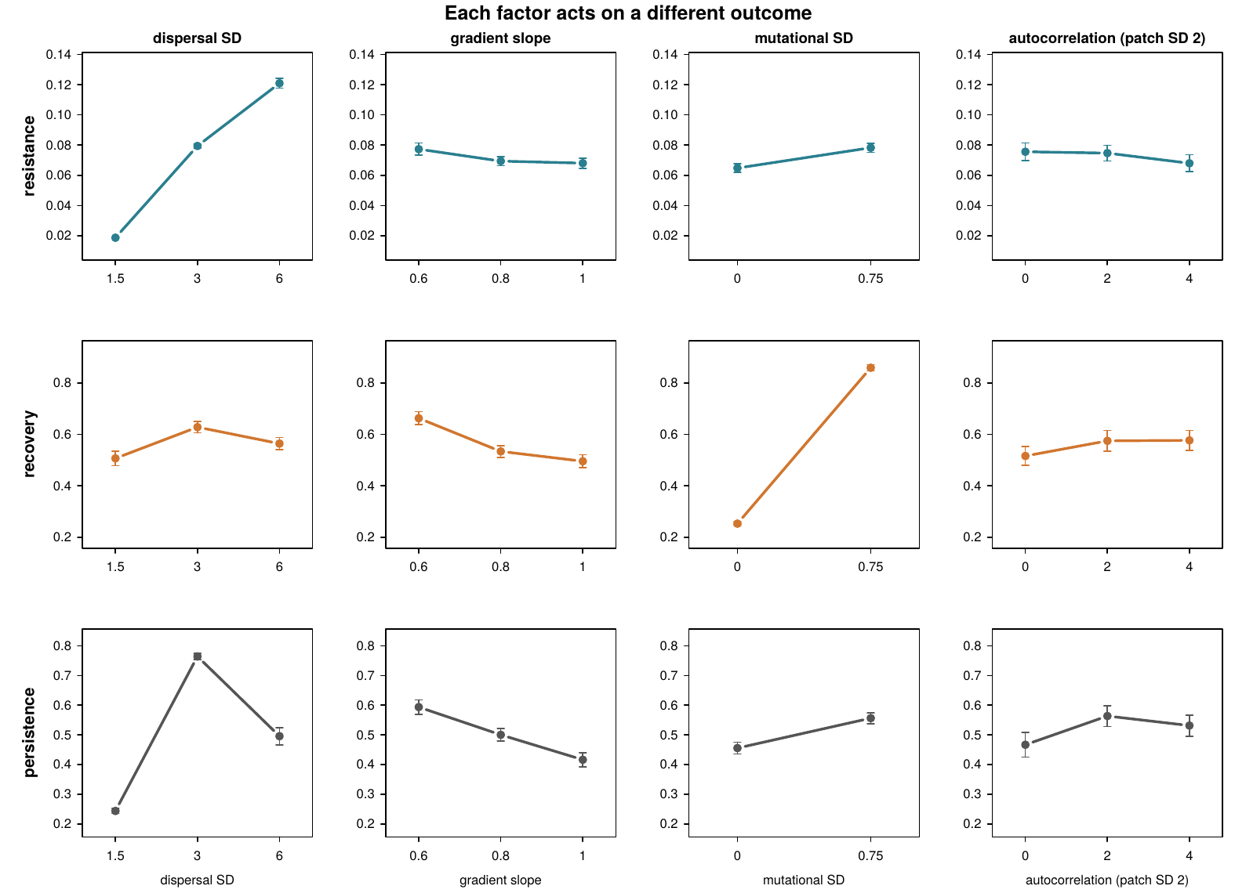
Phase profiles
Figure 2. Each factor against each outcome (cluster means ± SE, shared y-scale within rows). Read across a row: one panel dominates each outcome.
Figure 2 is the paper in one image. Survivors, balanced core; persistence over all runs:
 | Resistance | Recovery | Persistence
Dispersal 1.5 / 3 / 6 | 0.019 / 0.079 / 0.121 | 0.51 / 0.63 / 0.56 | 0.24 / 0.76 / 0.50
Mutation 0 / 0.75 | 0.065 / 0.078 | 0.25 / 0.86 | 0.46 / 0.56
Slope 0.6 / 0.8 / 1.0 | 0.077 / 0.069 / 0.068 | 0.66 / 0.53 / 0.50 | 0.59 / 0.50 / 0.42
Autocorrelation 0 / 2 / 4 (SD 2) | 0.076 / 0.075 / 0.068 | 0.52 / 0.57 / 0.58 | 0.47 / 0.56 / 0.53
- Resistance belongs to dispersal: a sixfold monotonic rise. Individuals that have already spread down-gradient are the ones whose traits fit the shifted optimum — crash depth is set by where the population already is. Mutation and autocorrelation do essentially nothing to it.
- Recovery belongs to new variance: 0.25 → 0.86, explaining 73% of recovery variance among survivors. Slope (30%) and dispersal (21%) follow. Autocorrelation: 0.6%.
- Persistence carries the dispersal optimum — 0.24 / 0.76 / 0.50, the theoretically predicted intermediate peak — and the slope penalty.
Crash depth is set by where individuals already are; the rebound by where new variance comes from; survival by whether relocation is geometrically possible. Persistence alone conflates all three.

2. The landscape acts on the extinction margin, not on the rescue curve
Among populations that survive, landscape heterogeneity and autocorrelation barely change the shape of rescue (all effects ≤ a few % of variance; the autocorrelation profile is flat in every one of the five landscape draws). What the landscape does:
- Sets pre-perturbation abundance: 521 / 786 / 1177 across autocorrelation at patch SD 2. Adding log(baseline) to the recovery model leaves nothing for autocorrelation to explain (p = 0.62).
- Moves persistence modestly in the viable interior (+6–10 points at high heterogeneity), consistent with the abundance pathway.
- Decides viability at the margin: the non-viable region is the uncorrelated high-heterogeneity corner, expanding with slope (section Viability, Figure 4). At the boundary, autocorrelation is the difference between existing and not.
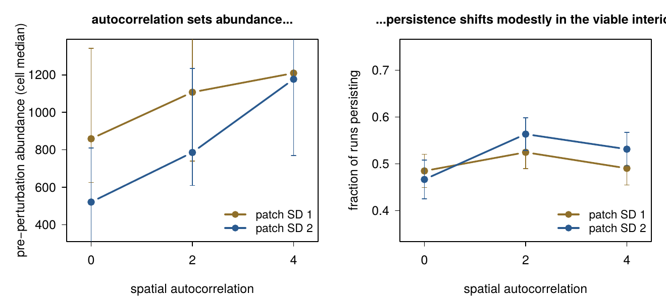
Abundance mediation
Figure 3. Autocorrelation raises pre-perturbation abundance strongly (left; median and IQR across cells); persistence in the viable interior shifts modestly (right). Adding log(abundance) to the recovery model leaves autocorrelation nothing to explain (p = 0.62).

3. The slope geometry cuts both ways
Gentler slopes carry less migration load — larger populations, better recovery, higher persistence overall. But the same trait shift moves the optimum farther in space (P/S = 18 spatial units at slope 0.6 versus 11 at 1.0), so at fixed dispersal the relocation is harder: gentle-slope cells persist slightly less well than their abundance predicts. Slope × dispersal is the dominant interaction on resistance (19.7% of variance) and second on recovery (12.5%) — migration load and relocation distance are both products of S and σ_d.
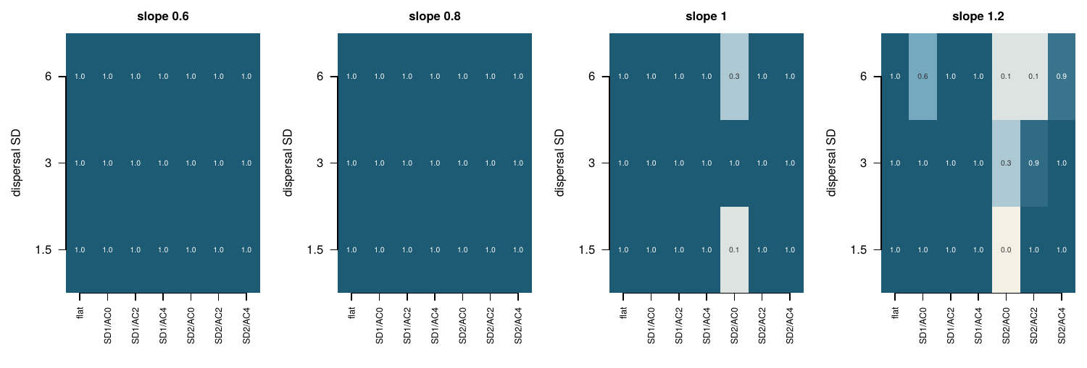
Viability map
Figure 4. Fraction of unperturbed control runs alive at t = 1500, by slope (panels), dispersal (rows) and landscape condition (columns; mutation on shown). The boundary advances with slope and consumes the uncorrelated columns first.

4. Interactions, ranked by variance explained
 | Resistance | Recovery
dispersal × mutation | 0.5% | 13.8%
slope × dispersal | 19.7% | 12.5%
mutation × severity | 0.2% | 9.4%
slope × mutation | 0.2% | 3.8%
dispersal × severity | 7.3% | 1.7%
New variance helps recovery most where dispersal is favourable (dispersal × mutation) and where the hit is hardest (mutation × severity). All other pairwise interactions are under 3% on both outcomes; the full screen is in the supplement.

5. Without a gradient there is no rescue
The homogeneous block (slope 0, flat landscape): 2 of 100 runs survived, at the mildest severity only, despite baselines of 2,900–3,800 — four times the gradient populations, because no gradient means no migration load. At these severities, relocation along the gradient is the rescue channel; new variance alone cannot bridge 3–4 tolerance widths on this timescale. (The mutation load is directly visible in the homogeneous baselines: 3,787 without new variance, 2,919 with.)

Robustness
- Five independently generated landscapes per condition; every landscape claim reproduces in each draw separately.
- Competition kernel: exponential (original) versus Gaussian at matched integral, full sensitivity check across eight treatment cells — no result changes (Supplement S3).
- Baseline definition: at-shift (last-5) versus whole-window baselines compared on the previous dataset; the at-shift definition is used throughout and is the reason slowly-relaxing cells are measured correctly.
- Replication: an earlier batch experiment (80% more runs) reproduced every result to the third decimal; factor-level estimates here rest on thousands of runs per level.
- The control arm certifies every analysed cell persists without perturbation.

Where this leaves us
What I think we have:
- A demonstration that the two phases of rescue respond to different drivers — dispersal sets the crash, new variance sets the rebound — with persistence conflating them, and each claim carried by the largest effects in the design.
- The landscape’s role located precisely: it sets abundance and the viability boundary, not the shape of the rescue curve for survivors. Spatial autocorrelation matters at the margin of existence, and its apparent effect on recovery in earlier analyses is fully accounted for by pre-perturbation abundance.
- A geometric reading of the slope × dispersal interaction: migration load and relocation distance, both products of S·σ_d.
- The homogeneous baseline showing the gradient is the rescue channel at large shifts.
- A viability boundary confirmed by direct unperturbed controls, bounded by the critical gradient and by uncorrelated heterogeneity.
To discuss:
- Framing: one paper (phases + landscape acting on different margins) or two.
- The buffered-adults assumption: stated as life history; severity table available if anyone wants the adults-exposed regime quantified.
- Whether the slope-geometry point deserves its own analysis (persistence at matched abundance across slopes) or a paragraph.
- Figure style handoff to Erik once main messages are agreed.

