**Data1: Censored(mu=0, sigma=1, lower=-3, upper=4)**

**Data2: Censored(mu=3, sigma=1, lower=-3, upper=4)**

Initialization: Data1: mu=-1; Data2: mu=4.6

Found distributions: [CensoredNorm[μ=0.03963, σ=1.031], CensoredNorm[μ=3.033, σ=0.9696]]

Weights: [ 0.51543107 0.48456893]

Log likelihood: 2414.91700879

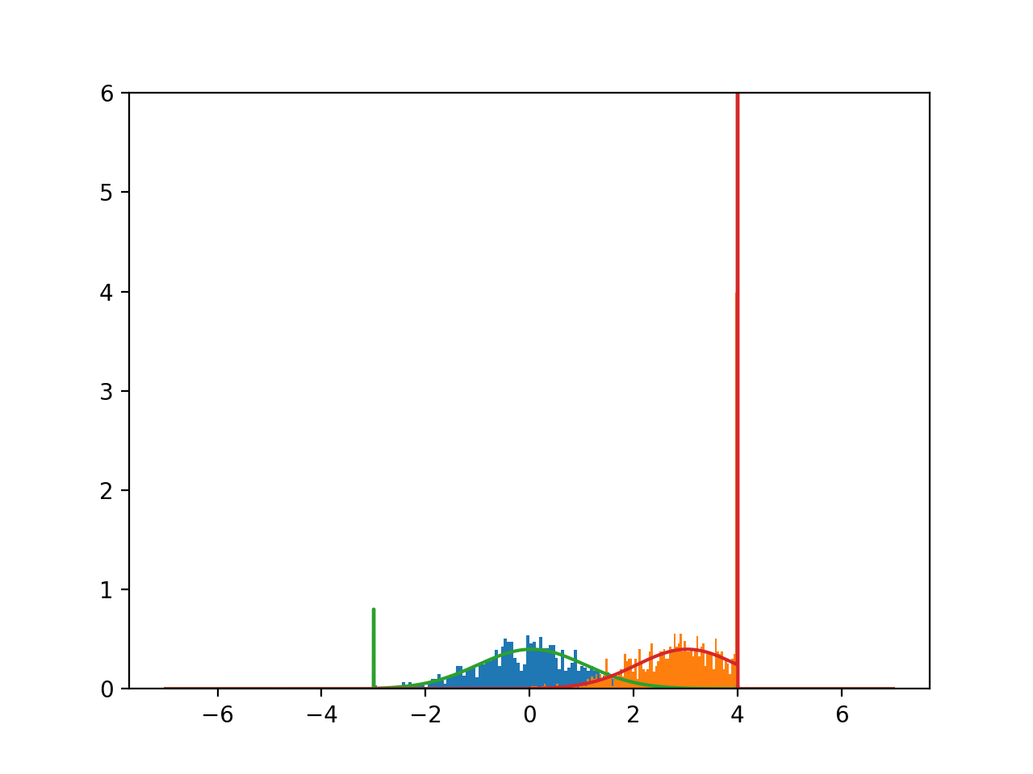

Initialization: Data1: mu=1; Data2: mu=1.5

Found distributions: [CensoredNorm[μ=1.148, σ=1.756], CensoredNorm[μ=1.711, σ=1.696]]

Weights: [ 0.55195258 0.44804742]

Log likelihood: -3485.52211243

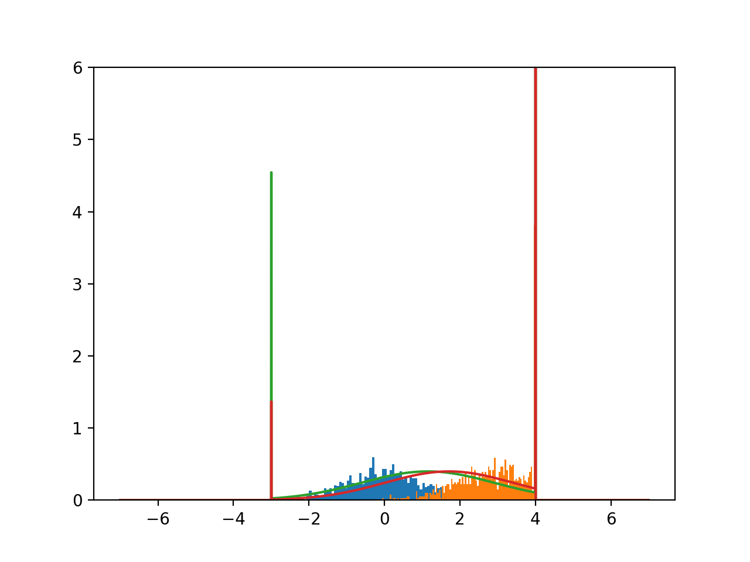

Initialization: Data1: mu=0; Data2: mu=3

Found distributions: [CensoredNorm[μ=-0.01886, σ=0.9737], CensoredNorm[μ=2.954, σ=1.028]]

Weights: [ 0.48947195 0.51052805]

Log likelihood: -1174.69731421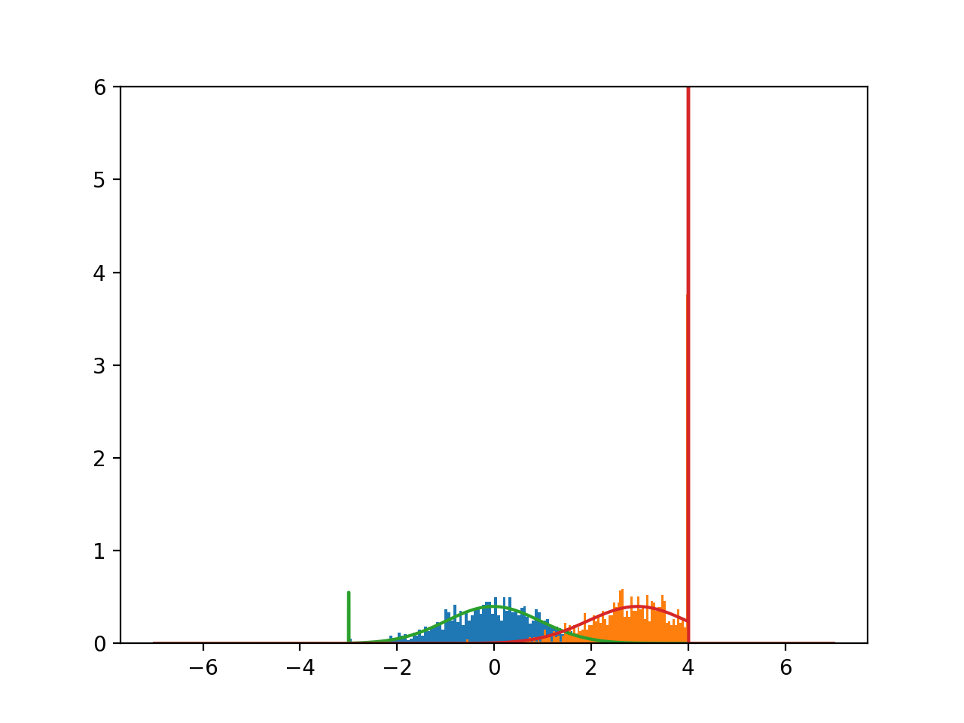

**Optimizing initialization:**

Best log likelihood: 1145.04921907

Best initial mus: (-2, 4)

Best dists: [CensoredNorm[μ=-0.116, σ=0.9371], CensoredNorm[μ=2.83, σ=1.052]]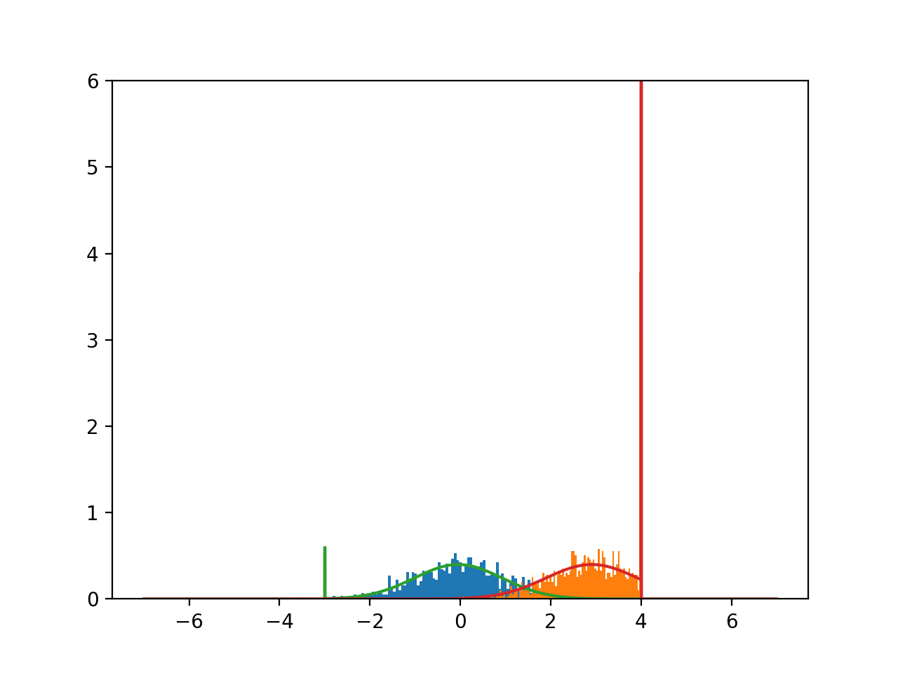

Best log likelihood: 4635.06077936

Best initial mus: (-2.5999999999999996, 4.9000000000000021)

Best dists: [CensoredNorm[μ=-0.1497, σ=0.8859], CensoredNorm[μ=2.799, σ=1.132]]