Version | Date | Author | Comments
1.0 | 15.09.2010 | Anastassia Soikonen  Anna Agafonova  Natalja Timofejeva  Olga Agen | Team meeting. Google document created and shared between team members. Tasks are assigned to team members. Use-case number 2 is added.
1.1 | 16.09.2010 | Natalia Timofejeva | Added use-case number 3 and normal scenario.
1.2 | 17.09.2010 | Olga Agen | Exercise 2 is done.
1.3 | 18.09.2010 | Anastassia Soikonen  Anna Agafonova  Natalja Timofejeva | Exercise 1 is done.  Document is created and sent to other members

Exercise 1
s
Scope:
As the concept of a ‘physical library’ can be interpreted in different ways, we feel the need to set the overall project scope before starting the analysis. This scope is by no means a substitution for the actual detailed usage analysis.
- We approach the idea of physical library as a collection of printed books, where all available books are placed on open shelves and ordered by their identification codes, whereas librarians are able to accurately determine location of a book, knowing its identification code. Books, their identification codes and their availability are listed in the library information system, which is accessible only by the librarians. Client data (loaned books and data on debts) is also stored in the information system.
- Library archives are out of the project scope.
List of actors:
Customer, librarian, library information system.

Relevance to checkout process:
- Librarian physically manipulates checkout system objects (books) and makes requests to another actors.
- Library information system is an active actor which is involved in the checkout process since it can change its states and it can trigger actions.
- Customer manipulates objects (brings and takes books), interacts with librarian and influences information system states.

Use-Case 1 | Title: Checking out a book  Description: The customer wants to take a book from the library. He finds some book from a bookshelf and brings it to the librarian. Librarian asks the customer for the library card and customer gives it to her. Librarian scans card using a card reader and looks at the customer information on the computer screen. He sees that customer is allowed to take a book from the library and doesn’t have any debts on his account. Librarian scans the book bar-code and the book is automatically marked as “taken” in the book stock and on the customer account.
Normal scenario | A customer called Egon takes a book called “Java Secrets” by John Osborn from a library shelf in the IT section, and takes the book to the librarian Maris. Egon also gives her his library card. Maris takes both and makes an enquiry from the library information system. The system shows that Egon doesn’t have any debts, so Maris scans the book bar-code and the book is marked as taken in the book stock and on the customer account. Maris gives the book and the card back to Egon, he thanks her and leaves the library
Exception scenario | Alice visits the library and finds on the shelf of new arrivals a culinary book she feels interested in. She brings it to the first vacant librarian she sees called Kate. Kate asks Alice for her library card, makes an enquiry from the library information system and the system informs her that Alice has unpaid penalty fee that exceeds the maximum of 100EEK. Kate informs Alice that she is obliged to pay a penalty fee before she can loan the book. Alice doesn’t have any money with her, so she takes back her library card and the book and heads for the reading area to write down some recipes without loaning the book. No record is made to the information system.

Use-Case 2 | Title: Lining up for a book  Description: A customer holds the information that he book he needs is currently loaned. He approaches a librarian and asks to put his name on the waiting list for the book. The librarian checks from the system that the book is really loaned, and then registers the request in the information system. The librarian informs the customer that he will be notified when the book will become available.
Normal scenario | Cathy needs the book “Social Psychology and Discourse” by Andy McKinlay and Chris McVittie for the research for her Master’s thesis in applied linguistics. She has previously questioned a librarian and has gotten the answer that the only copy of this book in the library is currently loaned. She has taken some time to think this over, and decided that it is important that she gets the book the moment it becomes available. She approaches Peter the librarian, who is currently unoccupied, and asks to add her name to the waiting list. Peter makes an enquiry from the information system and gets informed that the book in question is loaned by a customer called Michael Weber and the loan term ends in seven days. Peter asks Cathy for her library card and adds her data to the waiting list. She is the only one on the waiting list, so he tells her that she will be notified by email when the book becomes available, and that if the current holder returns it in time, that would be in seven days. He adds that she will have two days to come get the book before it is made available to other customers. Cathy thanks Peter and takes back her library card.
Exception scenario | Harry is in urgent need for a book called “Fundamentals of Algorithmics” by Brassard&Bratley. He has heard from a classmate the book is hard to get, and assumes it is because the book is constantly loaned in the library. He comes to the library and approaches librarian Jenny, asking to put his name on the waiting list. Jenny asks Harry for his library card, at the same time making a request to the information system. She realizes that all four copies of the book are for the usage only in the reading room and cannot be loaned so she returns Harry his library card and tells his that the book can be used only in the library. She then offers to tell him where the book can be found, but Harry refuses angrily and leaves the library.

Use-Case 3 | Title: Searching for a book  Description: Customer is in a library and needs to find a certain book. He approaches librarian and tells her author and/or title of the book. Librarian searches for the book in library's information system and gives customer information about it. Customer goes where librarian told him to and finds the book.
Normal scenario | Bob is in a town's library doing a research about penguins. He's a bit tired with this theme, so he decides to read some book in a completely different field. He ponders a bit and decides in favour of a book by Stephen Hawking “A brief history of time”. Bob goes to the main library hall, where a librarian Lisa is sitting. He approaches Lisa's desk. Lisa is not busy at the moment, so she can serve Bob immediately. She asks how can she help Bob. Bob tells her he wants to find a book by Stephen Hawking called “A brief history of time”. Lisa turns to her computer and starts searching for book. After few minutes she finds the book, writes down its identifying number “PS – 8934” and number of the hall “6” and gives this note to Bob. She says that “PS” is also a shelf identifier on which this book is. Lisa says that the hall he needs is on the second floor. Bob takes the note and goes to the second floor by stairs. Bob passes halls numbered 4 and 5, and sees hall number 6. He enters it and immediately finds shelf “PS”. He looks through books on this shelf and soon finds book “PS – 8934”. Bob takes the book and returns to the table, where he was writing his research. Bob is happy.
Exception scenario | James is in library. He's reading some books about chaos theory. They're all quite hard to understand. So James decides to read something more simple in this field. He recalls that there's one book that is suitable for people who don't know much about chaos theory. He approaches nearest librarian called Betty. Betty asks how can she help James. He says that he's looking for a book called “Does God play dice?” by Ian Stewart. Betty turns to her computer and starts searching for the book. After few minutes she finds the book, writes down its identifying number “PS – 7632” and gives this note to James. She informs James that this book is in the hall they're in right now; and that there's only one copy of this book left available. James thanks Betty and goes searching for the book. He finds shelf “PS” and starts looking through books on it. He can't find a book labeled “PS – 7632”. He looks through books on shelf once more. Book isn't there. Someone already took it. James is upset.

Use-case diagram
On this level of abstraction, the use-case diagram that includes all the above mentioned use-cases and actors looks like this:

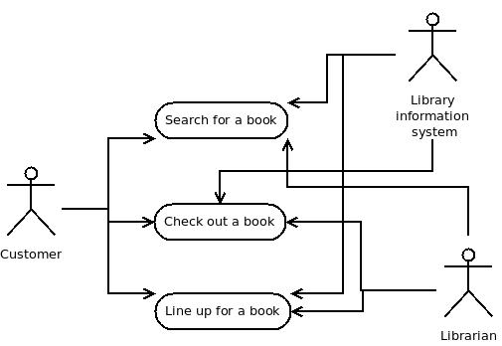

Exercise 2
pre-pre-condition:
- We have a deck of 32 cards, consisting of 4 suits (diamond, heart, spade, clubs). In each suit we have 7, 8, 9, 10, Jack, Queen, King, Ace
- We abbreviate one of these cards like
  - DA: Diamond Ace
  - S10: Spade 10
  - H7: 7 of heart
- There are three players: Eero, Ulno, and Artjom
  - Eero sits right of Ulno, Ulno right of Artjom, and Artjom right of Eero.

User-story (from the lecture slides)
Title | Eero deals one round of two cards each for Eero, Ulno, and Artjom
Pre | pre-pre-condition; Top of deck is DK, HK, HQ, HJ, DJ, DA, H10, CA, HA, H7, C7, C8 (DK is top card); Eero holds deck; Eero is dealer
Action | Eero takes the top two cards and gives them to Ulno, the next two to Artjom, the next two to himself. Each player takes the given cards on their hands.
Post | Eero has now on his hand DJ, DA, Artjom has HQ, HJ, and Ulno has DK, HK. The top of the deck shows H10, CA, HA, H7, C7, C8
Precondition diagram:

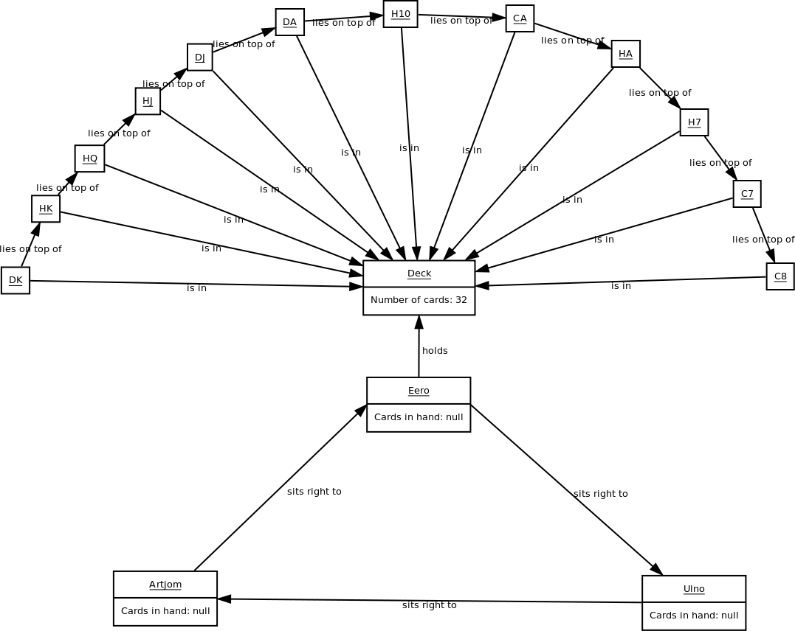

Postcondition diagram:
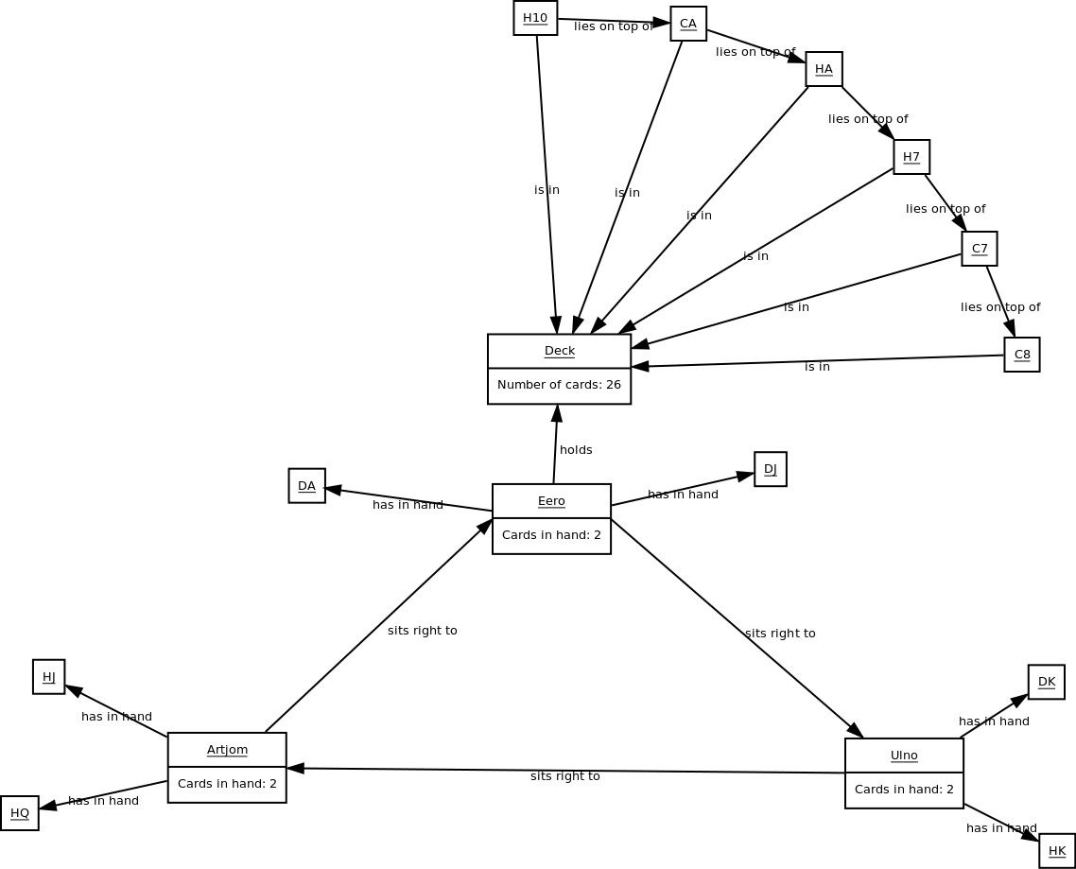

User-story
Title | The game starts with Ulno playing a seven forcing Artjom to draw
Pre-condition | Pre-pre-condition. Eero has on his hand HK, S7,C10. Artjom has CQ, CJ, and Ulno has D7, DK,H7,HQ. The last card put in play by Eero was DQ. It's Ulno's turn.
Action | Ulno looks through cards in his hands and thinks which card he should play. Since the last card put on table was DQ, he can play three cards: D7, DK and HQ. Due to deep strategical logic Ulno decides to play D7 and turn goes to Artjom. Artjom does not have an appropriate card to play, so he draws.
Post-condition | It is Eero's turn. Eero has HK, S7, C10. Artjom has CQ, CJ and H10. Ulno has DK, H7, HQ.

Precondition diagram:

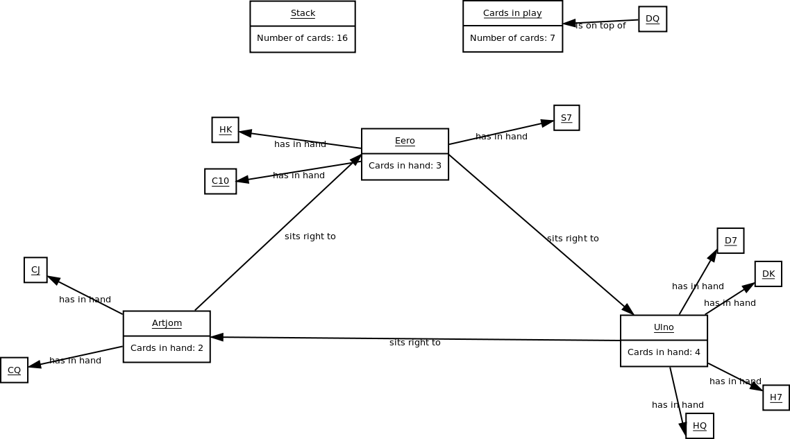

Postcondition diagram:

