Mancala Test Cases

1) Returning number of captured stones

Precondition: game situation of player Bob is as follows:

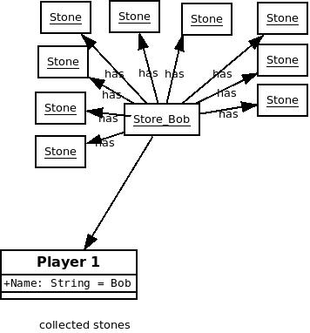
Action: Instance method Player.getStoneNumber() is called out for player Bob.

test = Bob.getStoneNumber();

Postcondition: Game situation does not change (exactly the same diagram as before). Number of captured stones is stored in the variable test.

test = 9;

2) Returning number of captured stones is case of empty mancala

Precondition: game situation of player Bob is as follows:

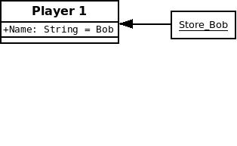

Action: Instance method Player.getStoneNumber() is called out for player Bob.
test = Bob.getStoneNumber();

Postcondition: Game situation does not change (exactly the same diagram as before). Number of captured stones is stored in the variable test. Test = 0;

3) Controlling whether the game is over

Precondition: game situation is as follows:

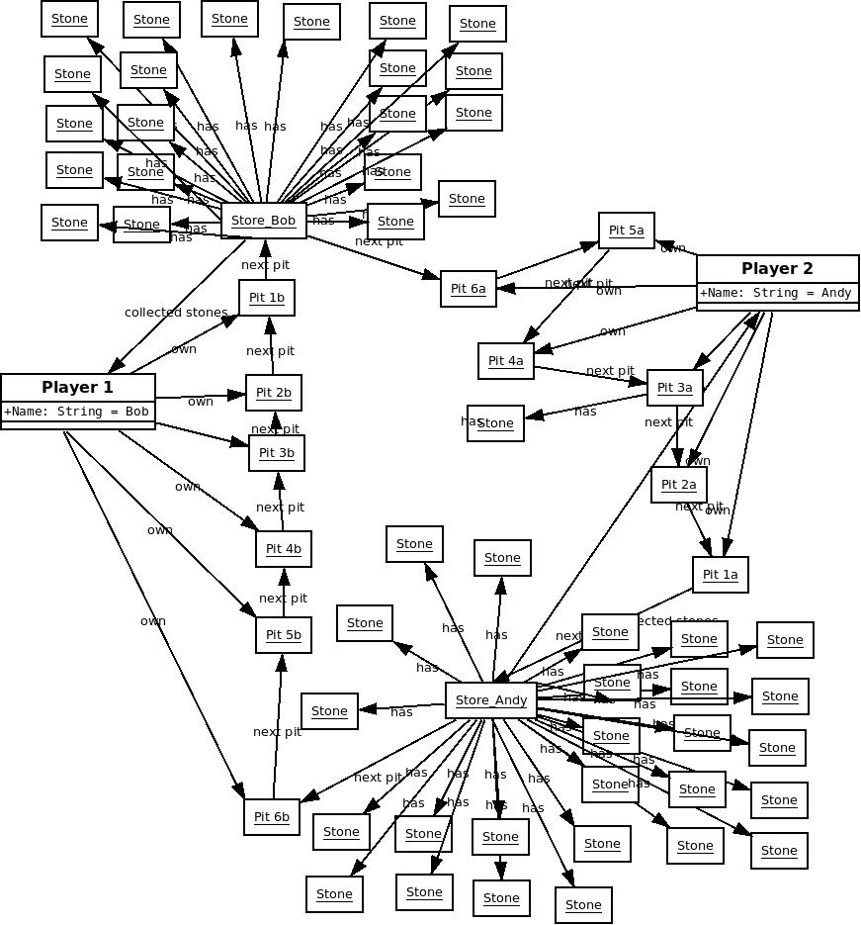

Action: method Turn.isGameOver() is called out
check = Turn.isGameOver();

Postcondition: Game situation does not change (exactly the same diagram as before). check = True;

4) Controlling whether the game is over

Precondition:
game situation is as follows:
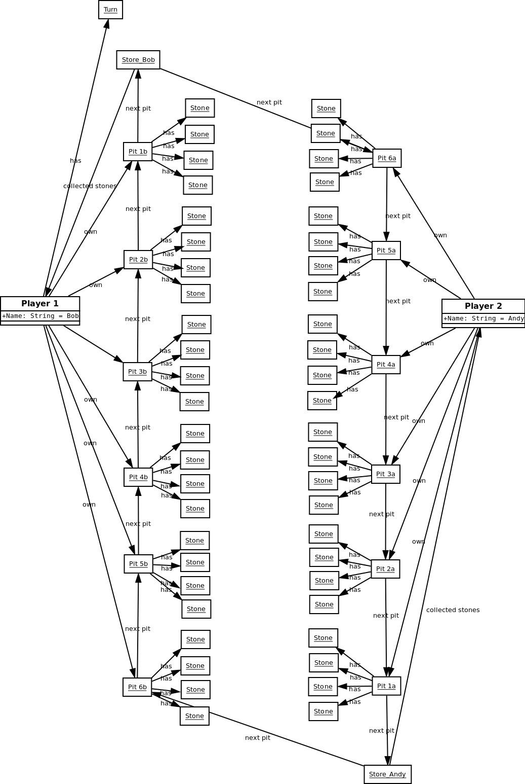
Action: method Turn.isGameOver() is called out
check = Turn.isGameOver();

Postcondition: Game situation does not change (exactly the same diagram as before).

check = False;

