Mancala Test Cases

1) Returning number of captured stones

Precondition: game situation of player Bob is as follows:
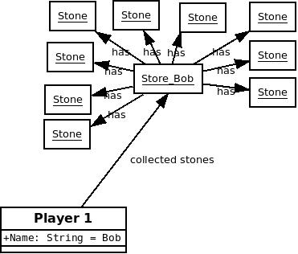

Action: Instance method Player.getStoneNumber() is called out for player Bob.

test = Bob.getStoneNumber();

Postcondition: Game situation does not change (exactly the same diagram as before). Number of captured stones is stored in the variable test.

test = 9;

2) Returning number of captured stones in case of empty mancala

Precondition: game situation of player Bob is as follows:

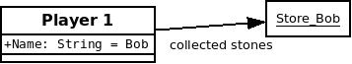

Action: Instance method Player.getStoneNumber() is called out for player Bob.
test = Bob.getStoneNumber();

Postcondition: Game situation does not change (exactly the same diagram as before). Number of captured stones is stored in the variable test. Test = 0;

3) Controlling whether the game is over

Precondition: game situation is as follows:

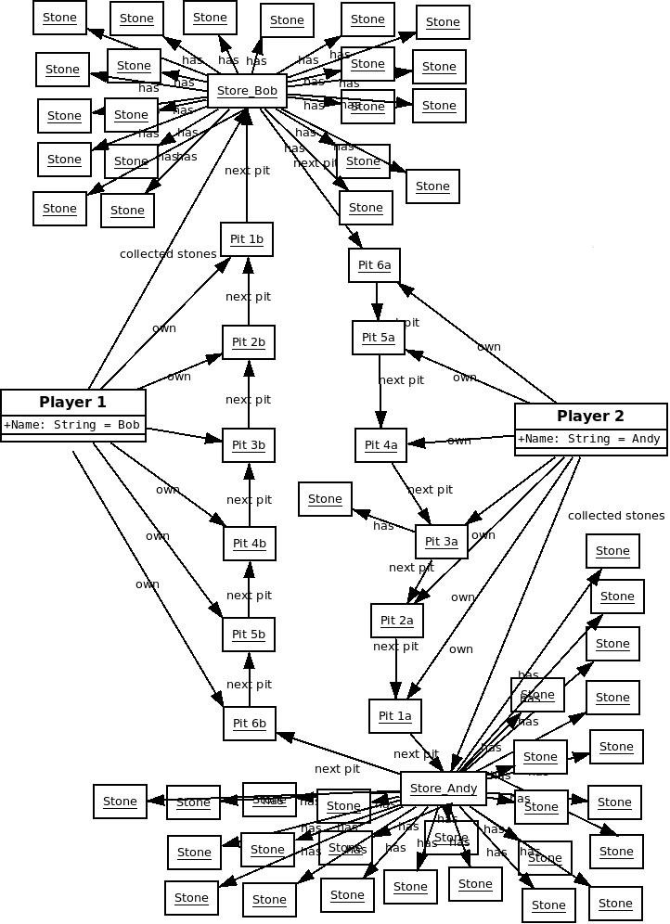

Action: method Turn.isGameOver() is called out
check = Turn.isGameOver();

Postcondition: Game situation does not change (exactly the same diagram as before). check = True;

4) Controlling whether the game is over

Precondition: game situation is as follows:
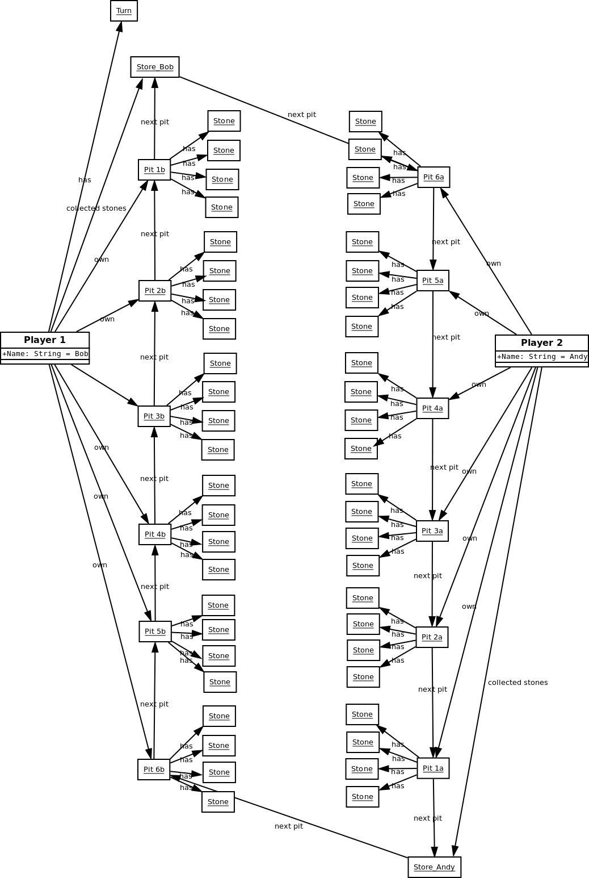

Action: method Turn.isGameOver() is called
check = Turn.isGameOver();

Postcondition: Game situation does not change (exactly the same diagram as before).
check = False;

5) Capturing opponent's stones

Precondition: game situation is as follows:

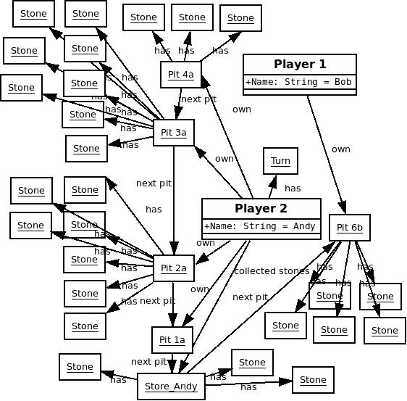

Action:
Player Andy plays pit 4. Andy.play(4);
Postcondition: game situataion is as follows. Any of the other objects didn't change.

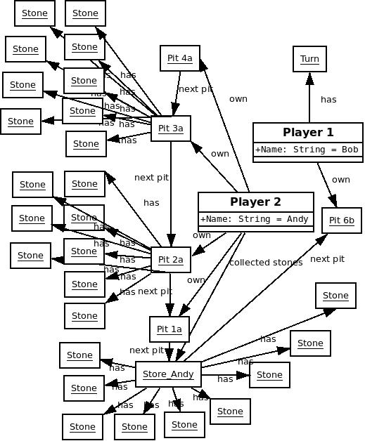

6) Getting a free turn

Precondition: game situation of player Andy:

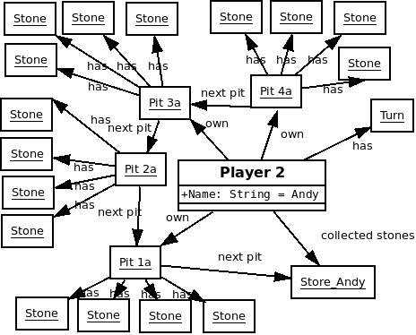

Action:
Player Andy plays pit 4. Andy.play(4);

Postcondition:
Player Andy still has turn.

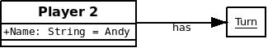

7) Player makes turn, last stone falls into his own pit

Precondition: game situation of player Andy:

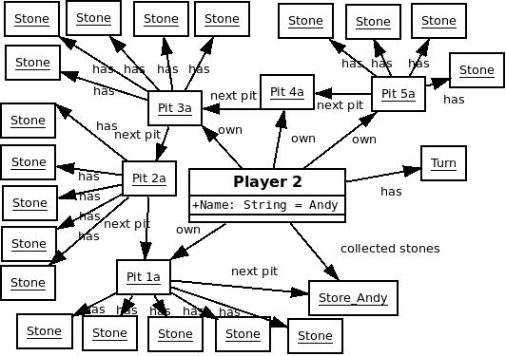

Action:
Player Andy plays pit 5. Andy.play(5);

Postcondition:
Game situation is as follows. Turn goes to player Bob.
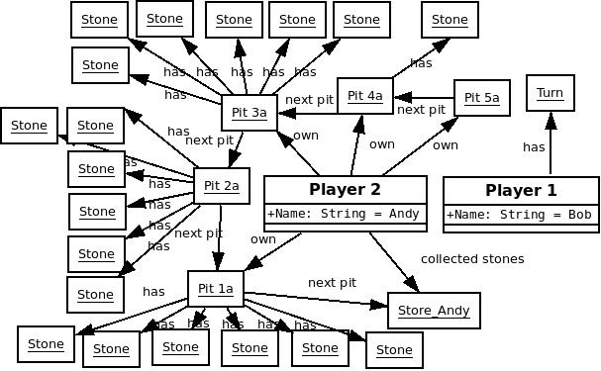
8) Player makes turn, last stone falls into opponent's pit.

Precondition: game situation is as follows:

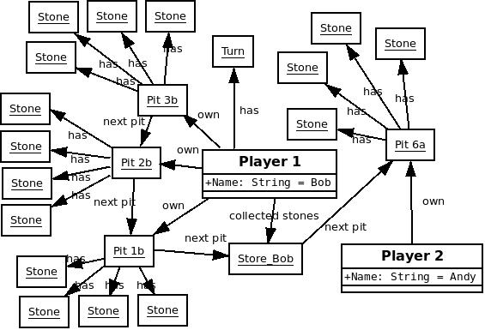

Action:
Player Bob plays pit 3. Bob.play(3);

Postcondition:
Game situation is as follows. Turn goes to player Andy.
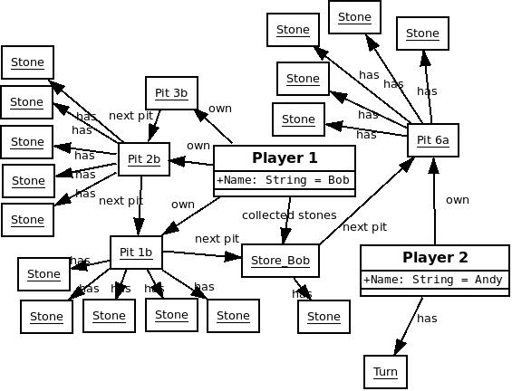

9) Player makes turn, stones cycle across the board and last stone falls into the initial player's pit.

Precondition: game situation is as follows:
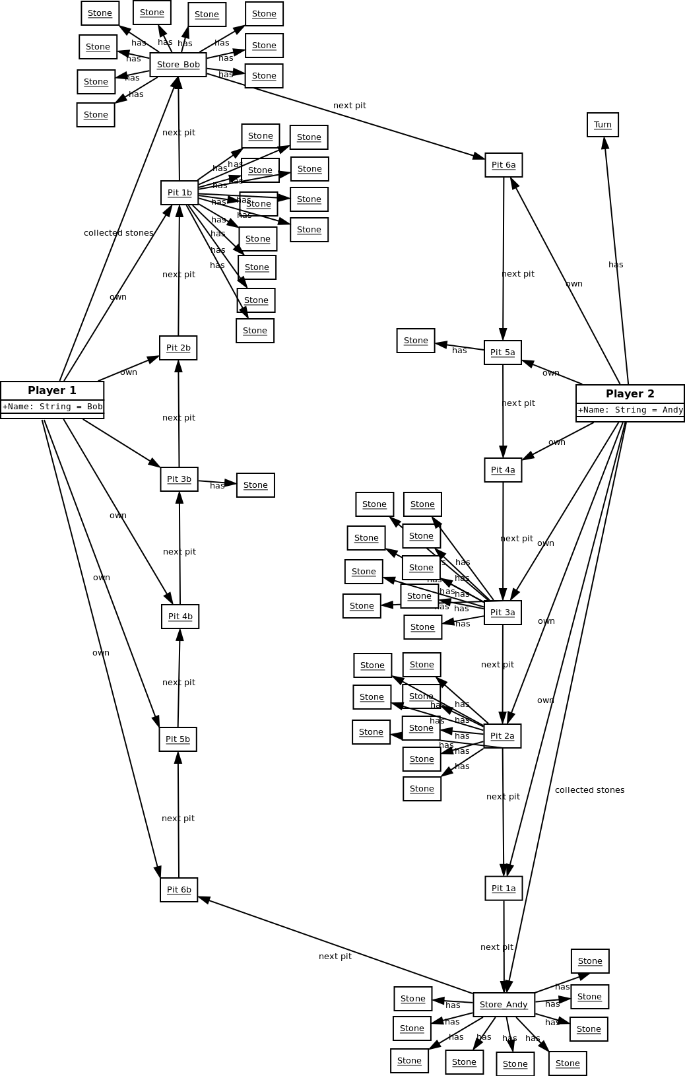

Action:
Player Bob plays pit 1. Bob.play(1);

Postcondition:
Game situation is as follows. Turn goes to player Andy.
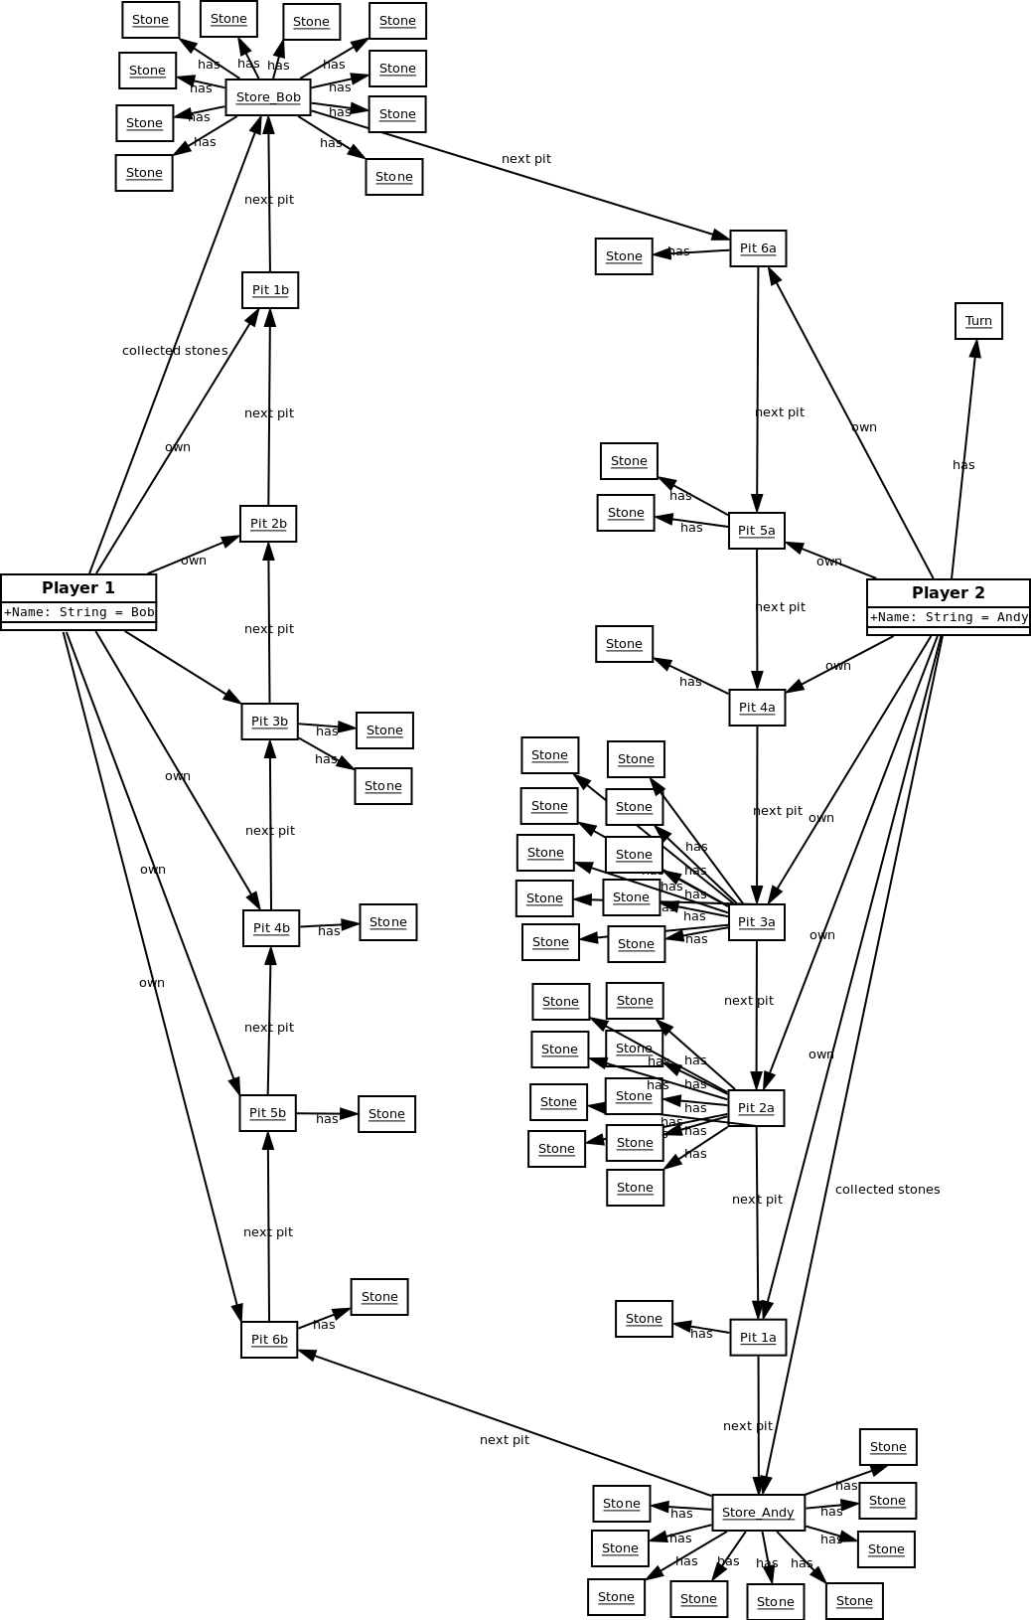

10) Controlling whether Bob has turn

Precondition: game situation of player Bob is as follows:

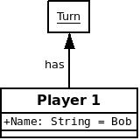

Action: method Bob.hasTurn() is called
check = Bob.hasTurn();

Postcondition: Game situation does not change (exactly the same diagram as before).
check = True;

11) Counting collected stones in a storage

Precondition: game situation of player Bob is as follows:
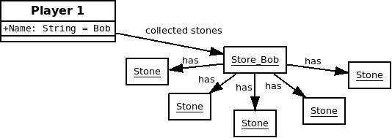

Action: method Bob.getPoints() is called
points = Bob.getPoints();

Postcondition: Game situation does not change (exactly the same diagram as before).
points = 5

12) Stone falls into an empty pit and opponent's opposite pit is empty

Precondition: game situation is as follows:
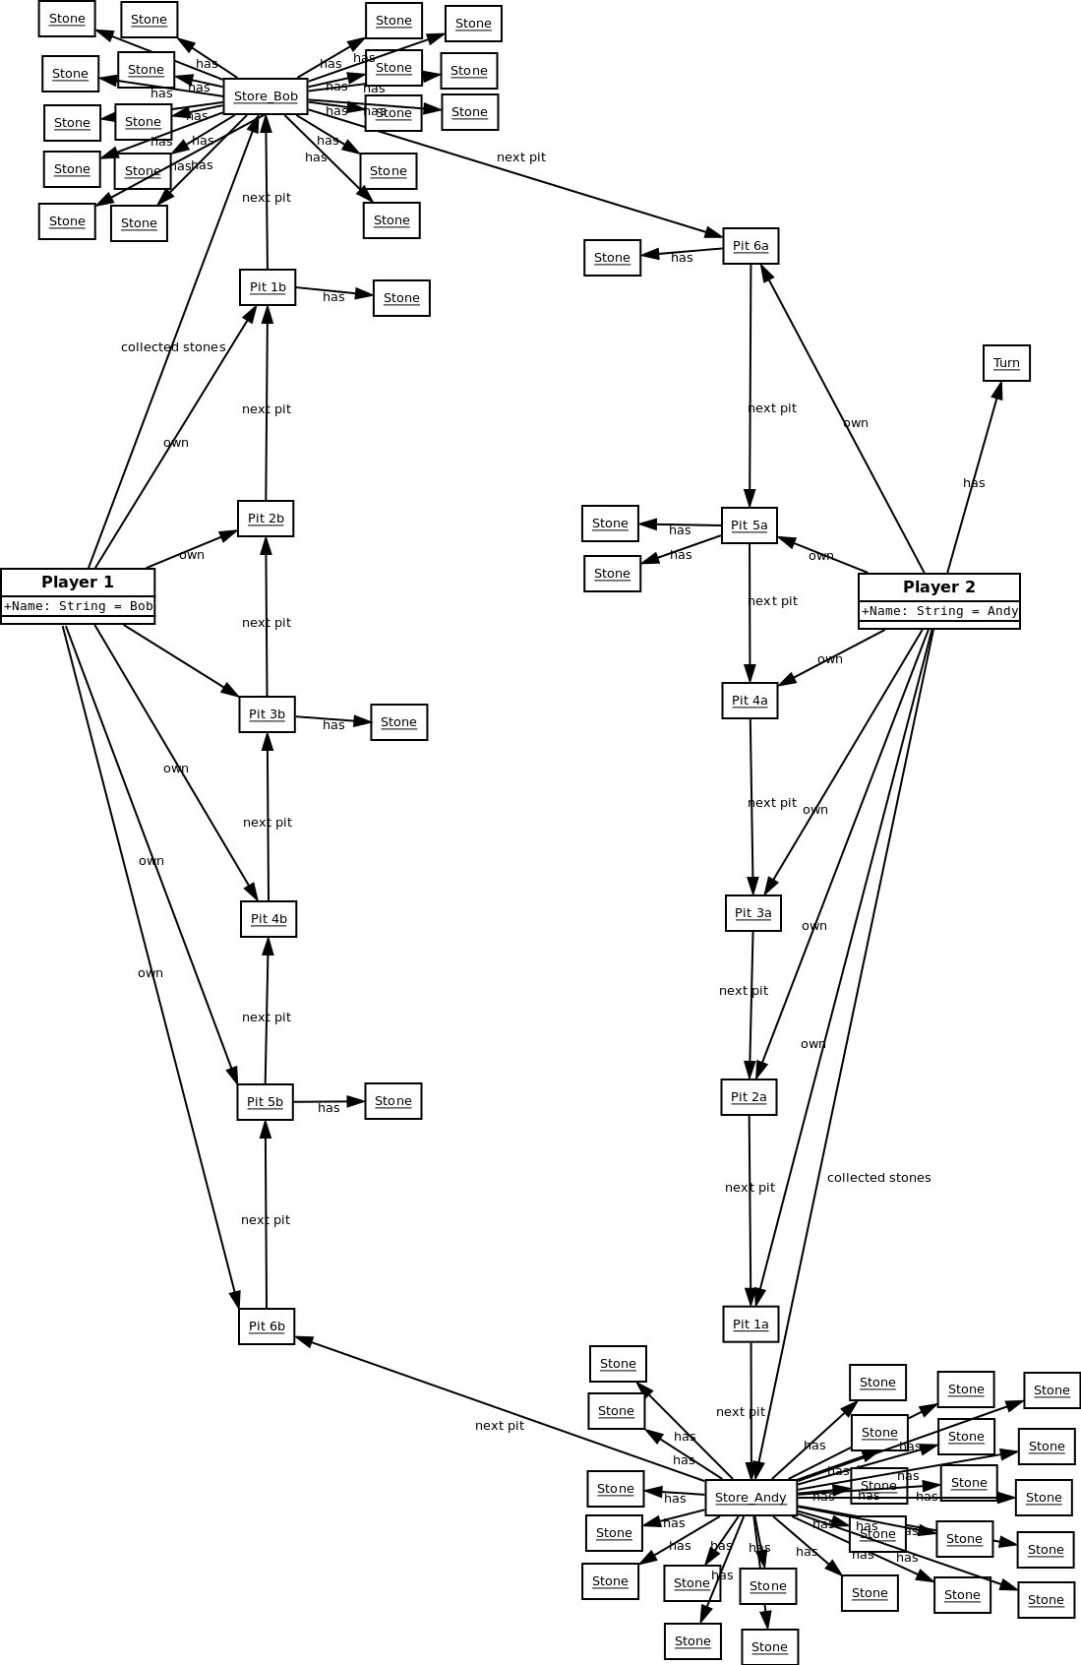

Action:
Player Andy plays pit 5. Andy.play(5);

Postcondition:
Game situation is as follows. No stones are captures. Turn goes to player Bob.
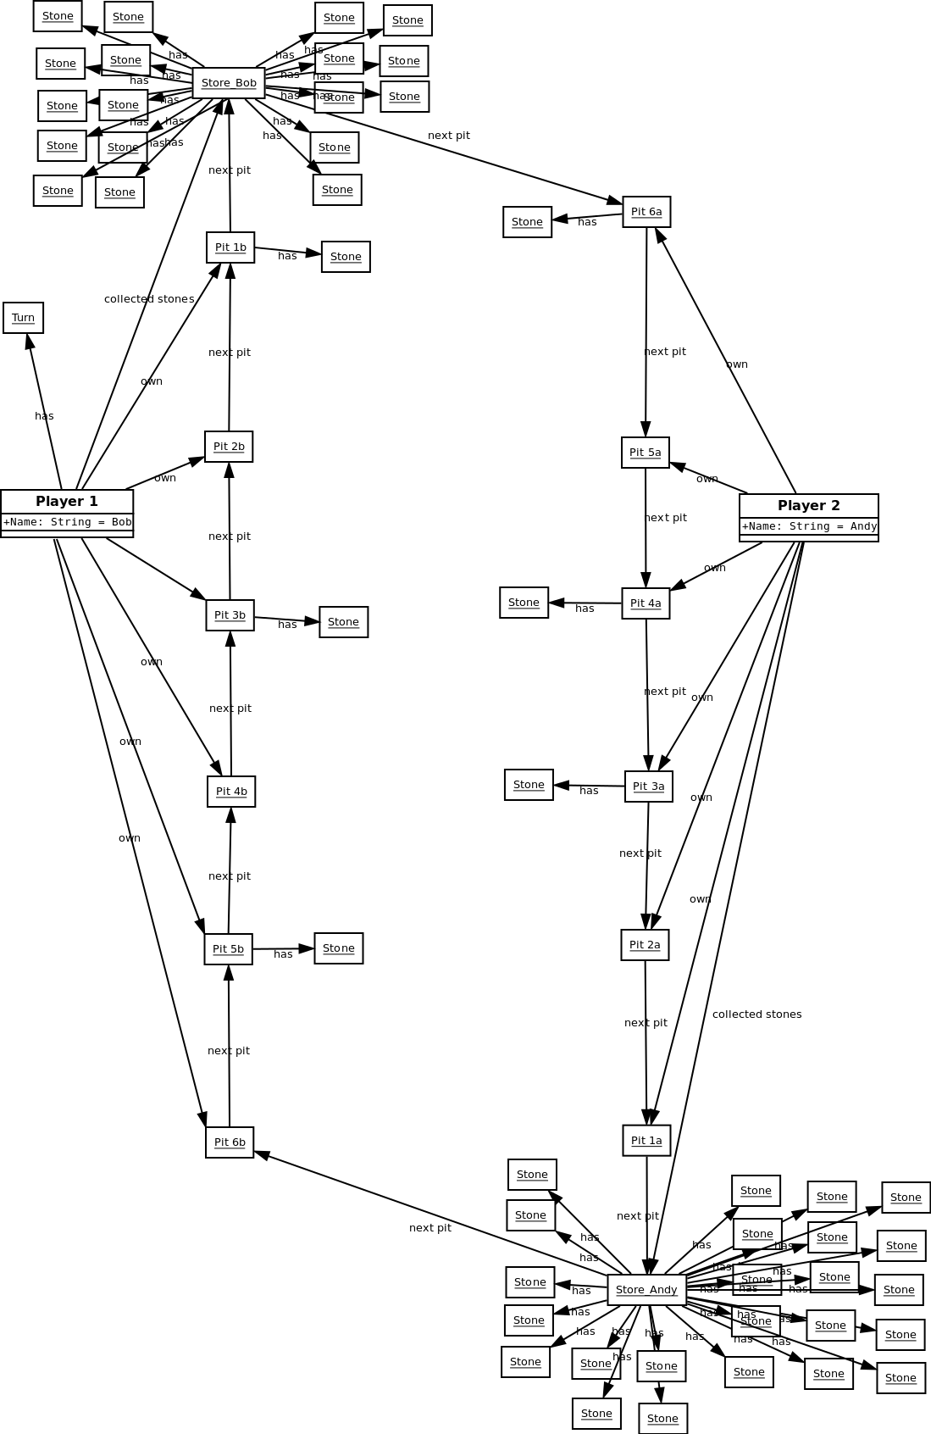

13) Checking who is the winner of the game

Precondition: game situation is as follows:

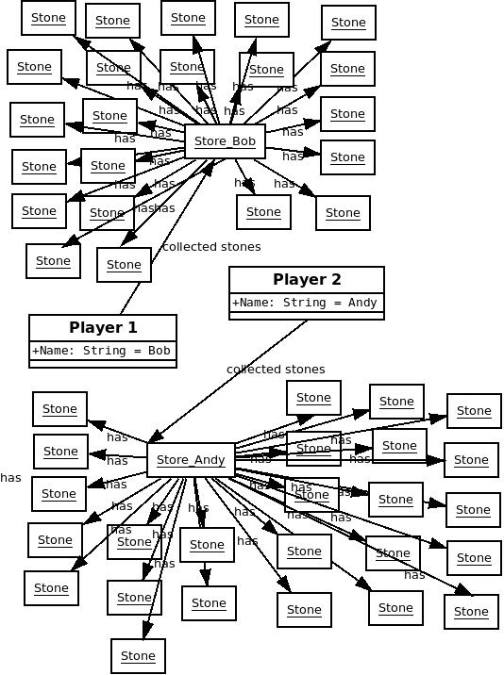

Action: method getWinner(Player, Player) is called
winner = getWinner(Bob, Andy);

Postcondition: Game situation does not change (exactly the same diagram as before).
winner = 2 (which means that Andy is the winner)

14) Checking who is the winner of the game

Precondition: game situation is as follows:

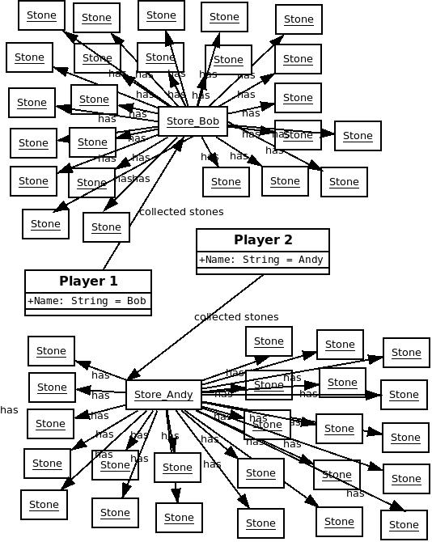

Action: method getWinner(Player, Player) is called
winner = getWinner(Bob, Andy);

Postcondition: Game situation does not change (exactly the same diagram as before).
winner = 0 (which means game ended in a draw)

