Final Project: Tic Tac Toe
Anna Gigac
CMPSC 132
03/28/26

Project Description:
In the Final Project Guidelines provided by the CMPSC 132 course curriculum, there were a multitude of options, one of which including the chosen project “Tic Tac Toe”. The project description prompted a base-line code to build a two player Tic Tac Toe game that ran on the terminal allowing two players to take turns entering moves until there was a win or the game concluded in a draw. After completing the base-line requirements for the code, I went in and implemented further advancements that allowed for more interesting and competitive game play. The requirements involved displaying a 3x3 board, allowing players to take turns, requesting player input for row and column selections, preventing invalid moves, and detecting winning/drawing conditions. On top of these requirements, I implemented two other functionalities that displayed a score and asked if the two players would like to indulge in another game, requesting a “yes” or “no” input. Displayed in Figure 1, I implemented a function that created a board: create_board(board), displayed the board before the game started and after each turn: print_board(board), requested inputs from the user of valid moves: get_valid_move(board, player), detected winnings and draws: check_winner(board, player) and is_draw(board), asked if the players would like to play again: play_again(), and printed the running score had the game not been ended: print_score(x_score, o_score, draws).
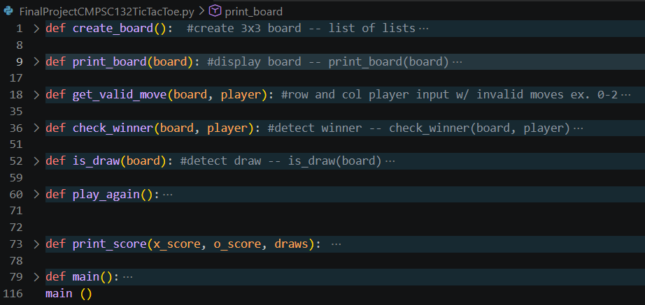
Figure 1: List of all functions – collapsed for readability
Approach:
This project was a lot to take on; there were a great deal of functions that had to be extremely fine-tuned and perfect to create a seamless and easy game playing experience for the users. I thought of the game as a “Professional League” where a ref was in plays commentators were narrating (it sounds a bit odd, but this allowed me to think of how the computer would narrate and keep track of moves and wins). The ref displays the board, the players make their marks, the commentator declares which player won and the current score of winnings and losings, the ref asks if the players wanted to play again, and the live-streaming TV as the terminal that saw and presented all of the information in a way that was easy and understandable to the viewers. I created a “flow-chart” of sorts originally on paper where I made a list of each function, I needed the game to have and the baseline requirements that would allow it to work in my favor. I then took this list that I had made and created a sort of dialogue code where instead of writing the actual code, I wrote what I wanted each line of the code to actually do. These “comments” of sorts revolved around input validation, switching turns, and score checking prior to another move being made; the fine little details that would need to be in the code to at its very least function without fault. This allowed me to break everything down into easier steps that didn’t overwhelm me and I would be able to keep track of the functionality of each line in the code rather than the code as a whole or a function. I then implemented what I wanted the code to do onto my VS Code program to create the fully functional code that I have now.

Structure:
I broke the game down to its bare functions as I would play it with my friends: seeing the empty board, choosing X or O for my moves, choosing the row/column I wanted my marker to go into, placing the move, switching turns with another player, declaring win/lose/draw, keeping score, and asking the other player if they wanted to play again. The Final Project Guidelines file was a huge help that allowed me to get general ideas of how to break all of the information down by requesting a print_board(board), check_winner(board, player), and is_draw(board) functions allowing me to fill in the gaps of what other functions were needed and the functionality of each function. I attempted to use methods and classes rather than only functions, but I knew that I always had a bit of trouble understanding methods and classes and settled on functions which would be easiest for me to perform and understand in a large deal of information and requirements. For the structure, I used my “Professional League” ideology to create a series of simple functions that were all came to a head to be performed at the def main() function. For the structure of the actual displayed games I utilized a list of lists where you could access any place on the board using row and column identification. The create_board(board) function was developed simply by creating the empty spaces out of a list of lists, where each smaller list represents a row, to allow easy access of spaces and seamless replacement of empty spaces with player markers so that none of the borders were maneuvered. The print_board(board) function seems a bit unnecessary at first, but it created the borders separately from the empty spaces of the board displaying a grid that was easy for players to recognize as the traditional game of Tic Tac Toe.

Challenges:
I expected a few major problems along the way; I was trying to get the project running in a way where I could see exactly what changes needed to be made one at a time to further break the project down into smaller and more understandable pieces for myself. Creating the grid itself posed a few challenges that took quite a bit of time to debug and get exactly what I wanted out of it. I originally tried to make a list of four separate lists where the grid was included in the empty spaces. Instead of the [“ “, “ “, “ “] that I have now, I originally tried to implement [“ |”, “ |”, “ |”] and [“---+”, “---+”, “---+”]. This worked well in theory but when I went to display the board nothing lined up as intended and worsened when I attempted to place a marker for a move. In hindsight, there are several reasons why this wouldn’t have been successful for my game that could have been foreseeable, but I wanted to perfect one thing at a time rather than all at once. I also had a bit of trouble with the is_draw(board) function that was required. I originally attempted to create a tally of how many full spots were present through a series of multiple for and if loops and return if the entire board was full, however, I soon realized that I could shorten this by created a for loop for each row and a nest for loop for each individual spot.

Improvements:
This final project does not go without the fair number of improvements that could be made. I have already made improvements by asking players if they would like to play again and keeping tally of each player’s winnings for each individual uninterrupted running of the program. I did a full run through of the game and found that at the time where there were two empty spaces left that a draw could be detected. Figure 2 displays just this: a board that is obviously a draw, but the program has yet to end the game, let the players know, and tally the score. The game could be improved by adding in a function where the draw is detected before the board is full. Many players realize that there is a draw in their game of Tic Tac Toe before the board is full, implementing a function that could detect if there was a draw prior to the board being full would prevent players wasting their time filling in pointless blanks if a win/lose/draw has already been decided. Another improvement that would heighten the overall experience of utilizing the program would be to create the grid borders out of straight seamless boarders rather than plus signs and dashes (Figure 2). It would look more professional and less like a “coding project for class”.

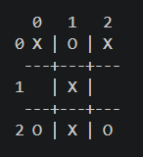
Figure 2: My Tic Tac Toe board displaying a draw

