Question 2 part 1

code run example:

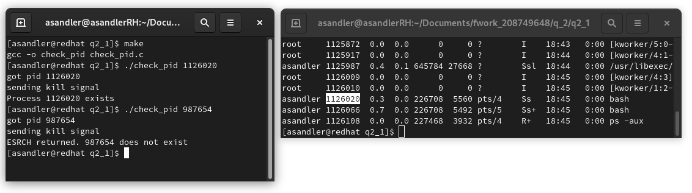

Different methods to check if a process exists:

1 – kill(<pid>,0)

pros:

cons:

2 – ps aux | grep <pid>

pros:

cons:

3 – ps -p <pid>

pros:

cons: