Unveiling Disparities
Analyzing Maternal Mortality Rates Among Women of Color

Why does a country with one of the world's highest Human Development Index scores also have the worst maternal mortality rate in the developed world — and who bears that burden?
Anna Gutierrez, Peterson Le, and Juliette Oliver
Digital Humanities 150: Data Analysis for Social Research, UCLA | Dr. Ashley Sanders

Executive Summary
The United States ranks 17th out of 189 countries on the Human Development Index (HDI), yet has the highest maternal mortality rate (MMR) of any developed nation. This report investigates why that gap exists and which populations bear its cost, using OECD country-level data and CDC race-specific data on pregnancy-related deaths in the U.S.
Three findings anchor the analysis. First, an ANOVA test confirms that race is a statistically significant factor in maternal mortality outcomes (p < .05) — this is not a pattern attributable to chance. Second, a five-number summary of 2018 OECD data places the U.S. MMR at 17.40 deaths per 100,000 live births, more than four times the comparison group's median, with the U.S. rate having risen steadily since 2000 rather than improved. Third, cause-of-death data shows Black and American Indian women die from pregnancy-related complications, many of them preventable cardiovascular conditions, at substantially higher rates than White, Hispanic, or Asian women.
Together, these results dispel the assumption that a high HDI score guarantees equitable health outcomes. The U.S. has the resources to prevent the majority of these deaths; the disparity is a matter of where those resources reach, not whether they exist.

Background & Motivation
A country ranked highly on the Human Development Index — a composite measure spanning GDP, healthcare quality, and inequality — would be expected to have correspondingly strong health outcomes. The U.S. contradicts that expectation sharply in one specific area: maternal mortality. This project set out to understand why, and specifically which population is most affected.
The topic carries direct policy relevance. As the Centers for Disease Control and Prevention (CDC) has documented, American Indian, Alaska Native, and Black women are two to three times more likely to die of pregnancy-related causes than White women — and almost two-thirds of pregnancy-related deaths are considered preventable. That combination of racial disparity and preventability is the throughline of this analysis: the U.S.'s maternal mortality crisis is not simply a resource problem, but a distribution and equity problem.

Data & Methodology
Analysis | Data Source | Purpose
ANOVA test | CDC maternal mortality rates by race (White, Black, Hispanic) | Test whether race is associated with a statistically significant difference in MMR
Contingency tables & bar charts | CDC pregnancy-related deaths, 2006–2017 | Identify leading causes of death and how they break down by race
Five-number summary | OECD country-level MMR data, 2018 | Position the U.S. against developed-country peers

Analysis was conducted in R (using ggplot2 and plotly for visualization, R Markdown for reporting), with Google Sheets used for collaborative data cleaning across the team. The final dashboard was built in Tableau.

Data Dashboard
The dashboard below summarizes the project's key statistics: overall death counts, leading causes, international comparison, the rising U.S. trend over time, and racial disparities in both overall mortality and anesthesia-related complications specifically.
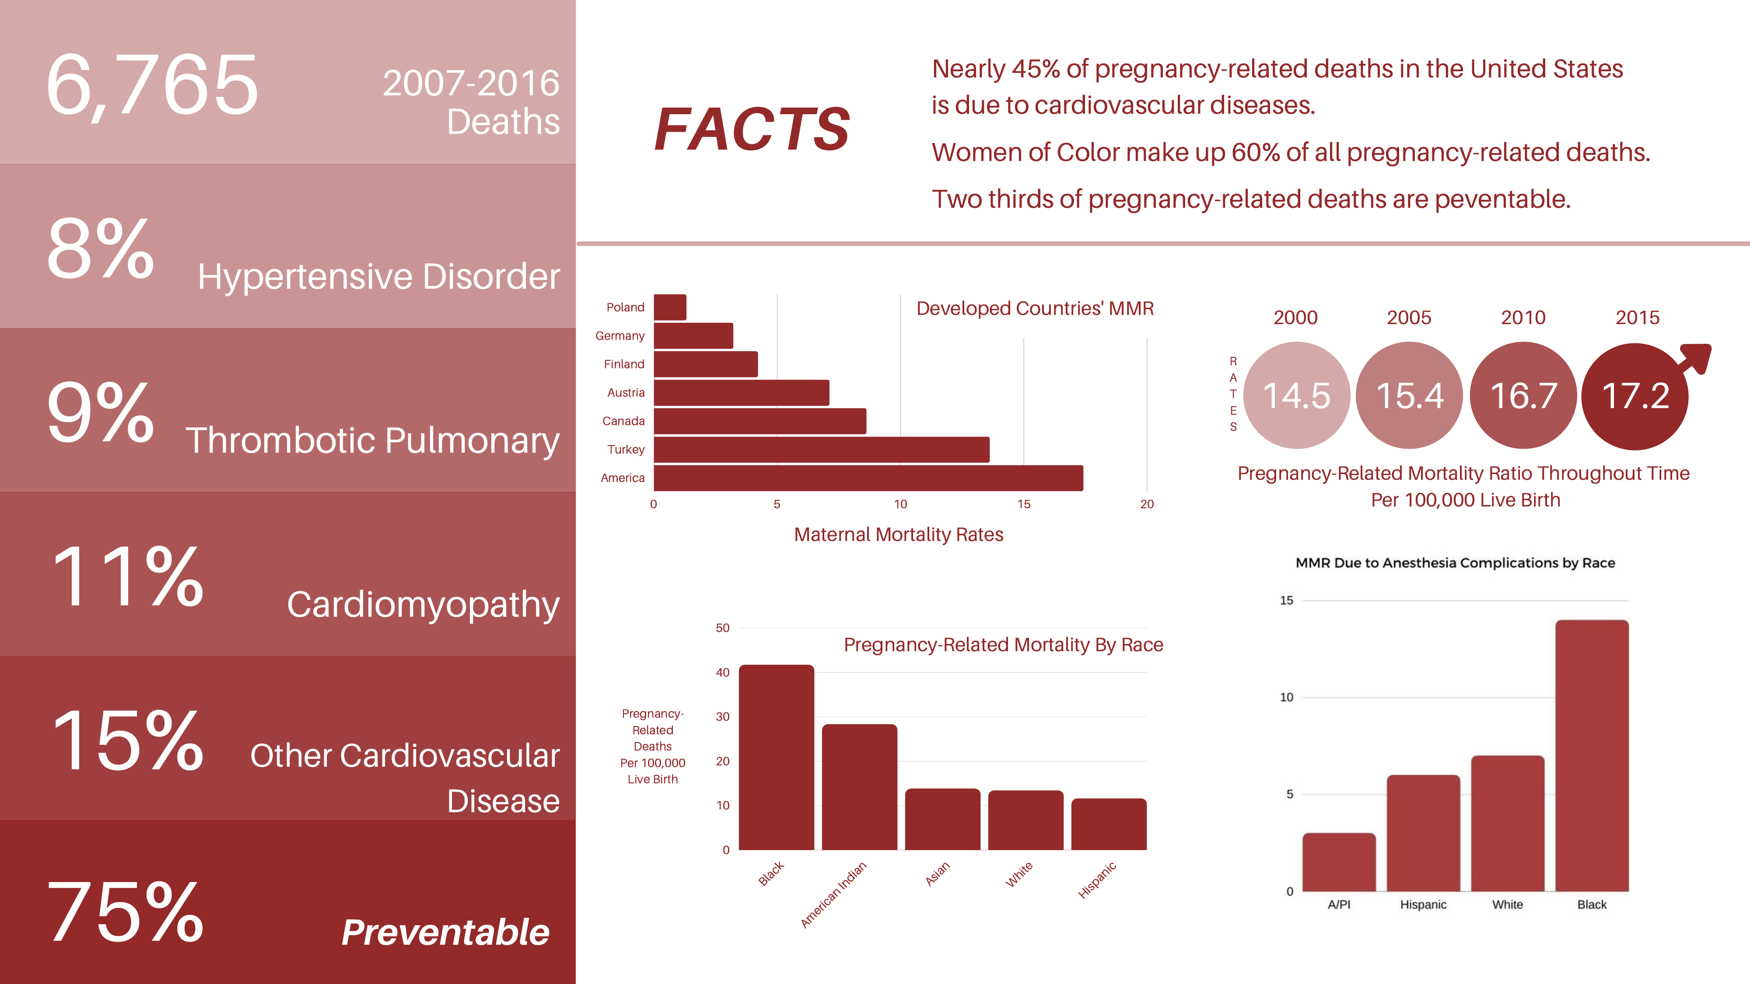
Tableau dashboard summarizing key maternal mortality statistics.

Key Findings

Race Is a Statistically Significant Factor
An ANOVA test on maternal mortality rates across White, Black, and Hispanic women returned p < .05, rejecting the null hypothesis that there is no racial difference in MMR. While the test alone doesn't identify which specific groups differ most, subsequent data in this analysis — and the wider literature — consistently show BIPOC women facing higher rates than their White counterparts.

The U.S. Is an International Outlier
The five-number summary of 2018 OECD data (restricted to countries with up-to-date reporting) placed the U.S. at 17.40 deaths per 100,000 live births:
Statistic | Value | Country
Minimum | 1.30 | Poland
Lower quartile | 3.20 | Germany
Median | 4.30 | Sweden
Upper quartile | 11.3 | South Korea
United States | 17.40 | —
Maximum (outlier) | 34.6 | Mexico

Mexico's 34.6 was treated as a distinct outlier given its markedly different HDI and GDP-per-capita profile relative to the rest of the comparison group.
The U.S. rate of 17.40 is over four times the group's median — and the trend is worsening, not improving: the national pregnancy-related mortality ratio rose from 14.5 (2000) to 17.2 (2015) per 100,000 live births, with no evidence of reversal absent structural change.

Cardiovascular Conditions Drive Preventable Deaths
Cause-of-death analysis of CDC data (2006–2017) identified cardiomyopathy, thrombotic pulmonary conditions, and hypertensive disorders as leading and largely preventable causes of pregnancy-related death — a pattern distinct from other developed nations. Statistics Canada, for comparison, identifies complications during puerperium and hemorrhage as the leading causes in Canada, pointing to differences in the U.S. that are plausibly connected to factors like food access and rates of obesity in underserved communities.

Racial Disparities Compound at Every Stage
Black and American Indian women showed substantially higher pregnancy-related mortality per 100,000 live births than Asian, White, or Hispanic women in the CDC data. The disparity persists into more specific causes: Black women showed a markedly higher rate of death from anesthesia complications than any other group — a pattern consistent with documented disparities in hospital quality across neighborhoods with different racial demographics. Research cited in this analysis estimates that relocating 1,000 BIPOC women to hospitals in predominantly White neighborhoods could reduce Black maternal mortality from 4.2% to 2.9%, underscoring that the disparity is rooted in access to quality care, not biology.

Conclusion & Implications
This analysis set out to explain a paradox: how a country with one of the world's highest Human Development Index scores can simultaneously have the worst maternal mortality outcomes among developed nations. The answer that emerges from the data is not a lack of resources, but a failure to distribute them equitably. The U.S.'s high HDI reflects real capacity — capacity that is not reaching the communities most at risk.
The combination of a statistically significant racial disparity, a worsening national trend, and a concentration of preventable cardiovascular causes points toward specific, actionable levers: expanding maternity care access in underserved neighborhoods, addressing implicit bias in clinical treatment, and investing in the hospitals that serve predominantly BIPOC communities.
This research does not, on its own, prescribe a full policy solution. But it does establish, with statistical confidence, that the story cannot be told as one of aggregate national wealth or healthcare capacity. It is a story of who that capacity reaches — and today, in the United States, it is not reaching Black and American Indian mothers at anywhere near the rate it should.

References
• Centers for Disease Control and Prevention, National Center for Health Statistics. Compressed Mortality File 1999–2016. CDC WONDER Online Database (2017).
• Government of Canada, Statistics Canada. The Daily — Deaths, 2018 (Nov. 2019).
• MacDorman, M. F., Declercq, E., & Thoma, M. E. (2017). Trends in Maternal Mortality by Sociodemographic Characteristics and Cause of Death in 27 States and the District of Columbia. Obstetrics and Gynecology, 129(5), 811–818.
• Oribhabor, Geraldine I., et al. “A Mother's Cry: A Race to Eliminate the Influence of Racial Disparities on Maternal Morbidity and Mortality Rates Among Black Women in America.” Cureus, vol. 12, no. 7 (2021).
• Tikkanen, Roosa, et al. Maternal Mortality and Maternity Care in the United States Compared to 10 Other Developed Countries. Commonwealth Fund (Nov. 2020).

