[**Helm**](https://helm.sh/)**is a package manager for Kubernetes applications**.

**Helm manages Kubernetes resource packages through Charts**.

We'll see more about charts as we create them shortly, but for now, a chart is nothing but a set of information necessary to create a Kubernetes application, given a Kubernetes cluster:

* A **chart is a collection of files** organized in a specific directory structure
* The configuration information related to a chart is managed in the configuration
* Finally, **a running instance of a chart with a specific config is called a release**
* *Chart.yaml*: This is the main file that contains the description of our chart
* *values.yaml*: this is the file that contains the default values for our chart
* *templates*: This is the directory where Kubernetes resources are defined as templates
* *charts*: This is an optional directory that may contain sub-charts
* *.helmignore*: This is where we can define patterns to ignore when packaging (similar in concept to .gitignore)

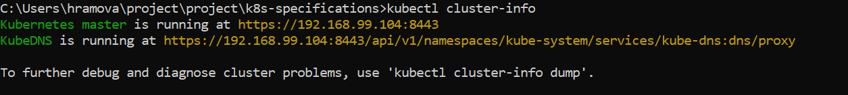

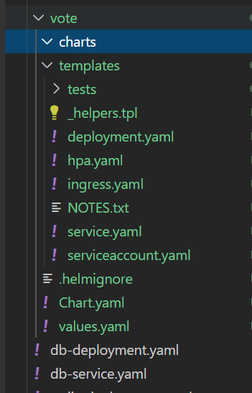

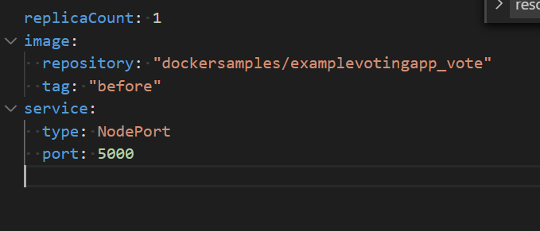

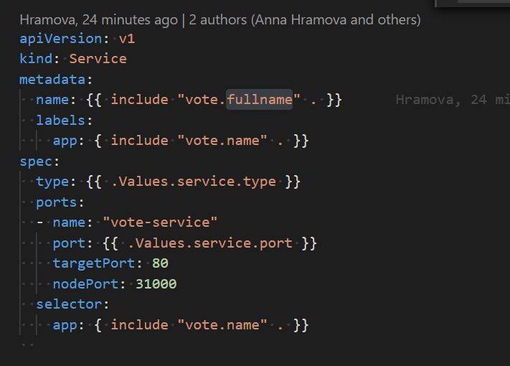

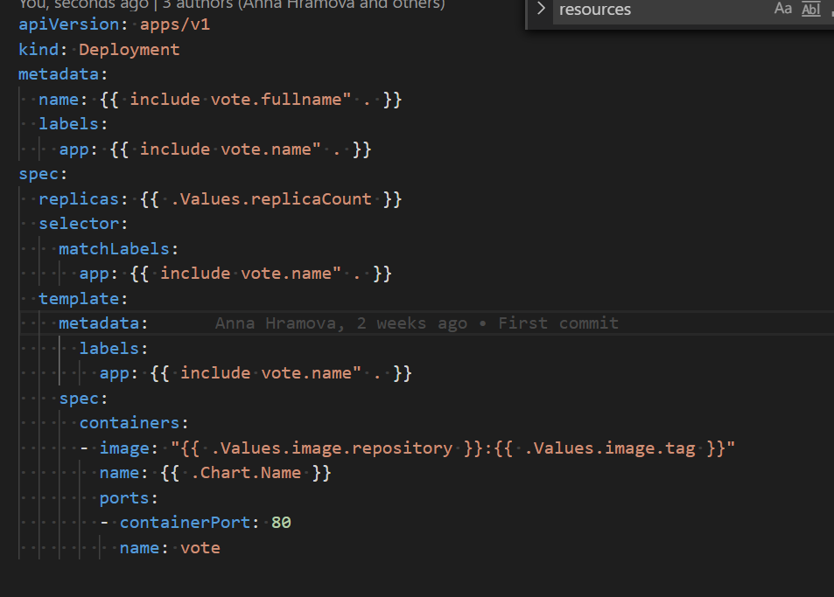



This way package vote was created and manipuated.