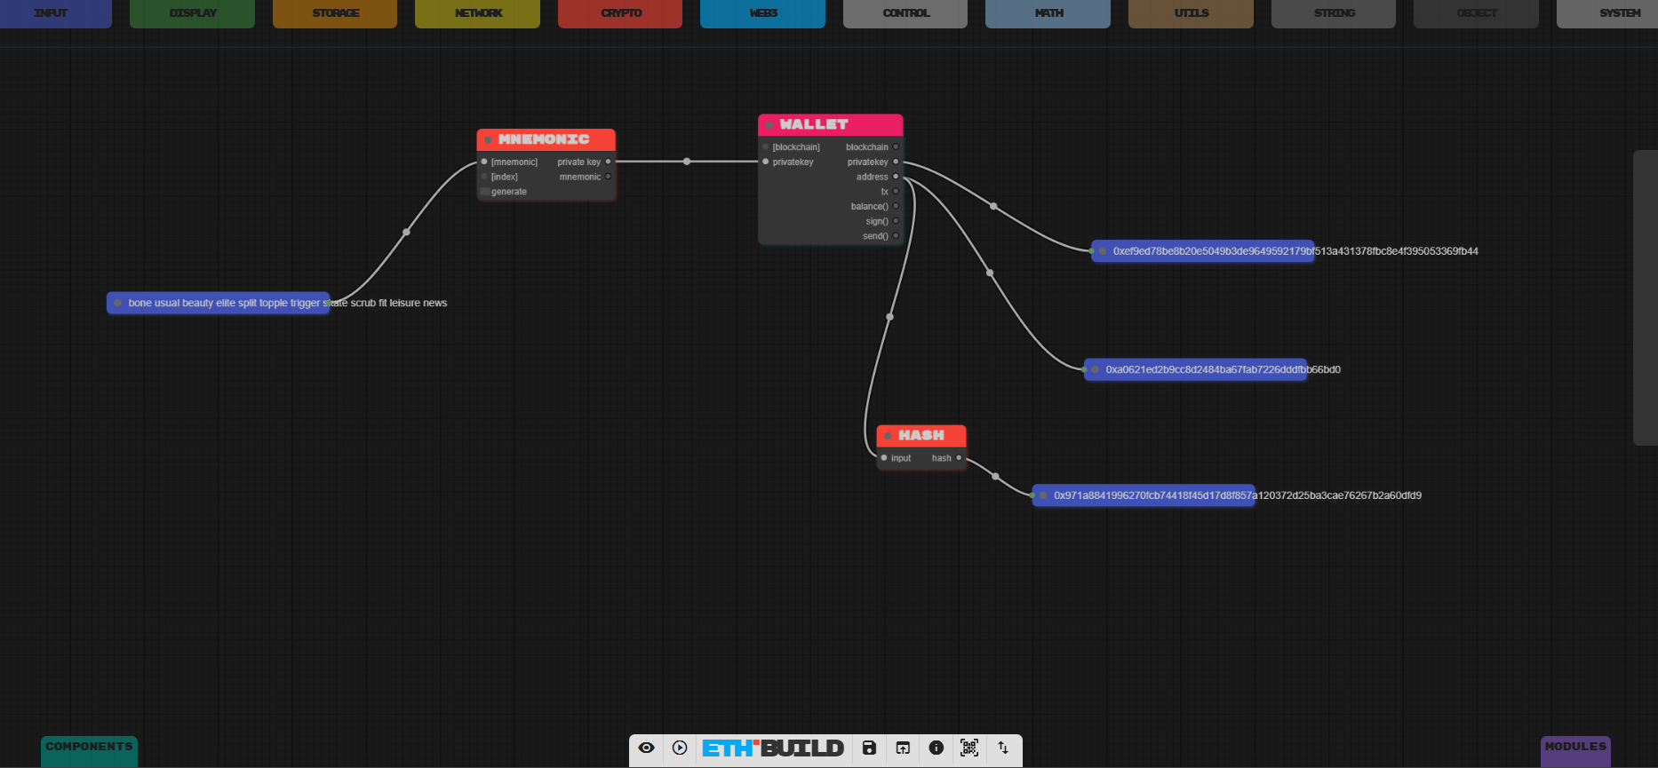
1. Wallet
Address: 0xa0621ed2b9cc8d2484ba67fab7226dddfbb66bd0
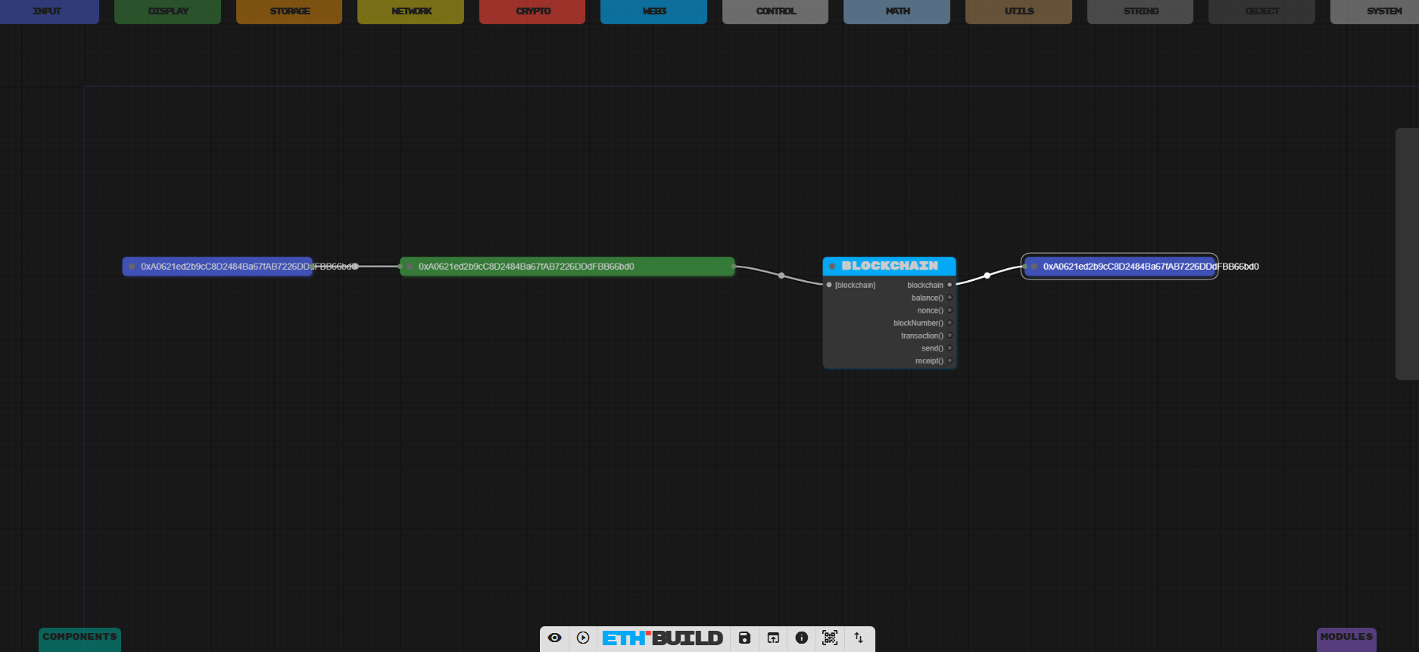
2. Chains
Incoming Transaction:
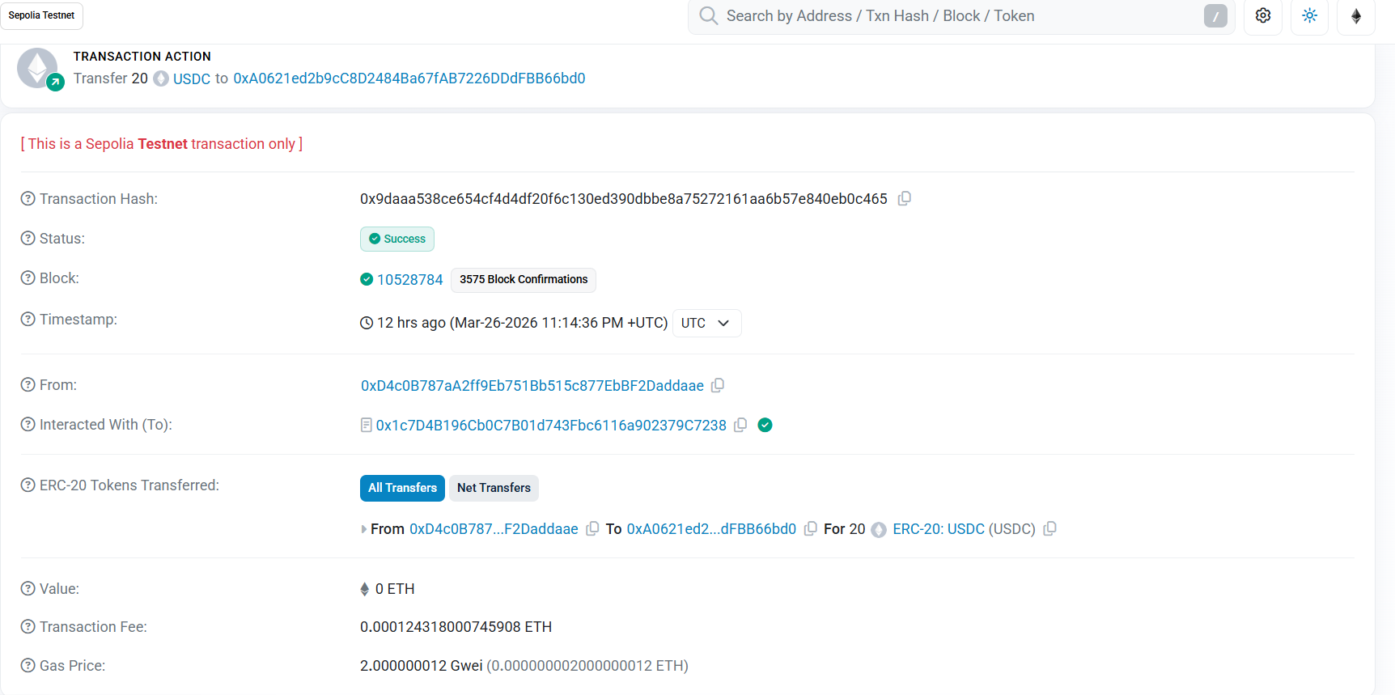
https://sepolia.etherscan.io/tx/0x9daaa538ce654cf4d4df20f6c130ed390dbbe8a75272161aa6b57e840eb0c465
3. Transactions
Address 2: 0x00a75aDb7CE82DFB024eA29688D75dF9fdf1d1d1
https://sepolia.etherscan.io/tx/0xd784446accc63b707311923390430e2c42e5916433473115f878c990b44b1683
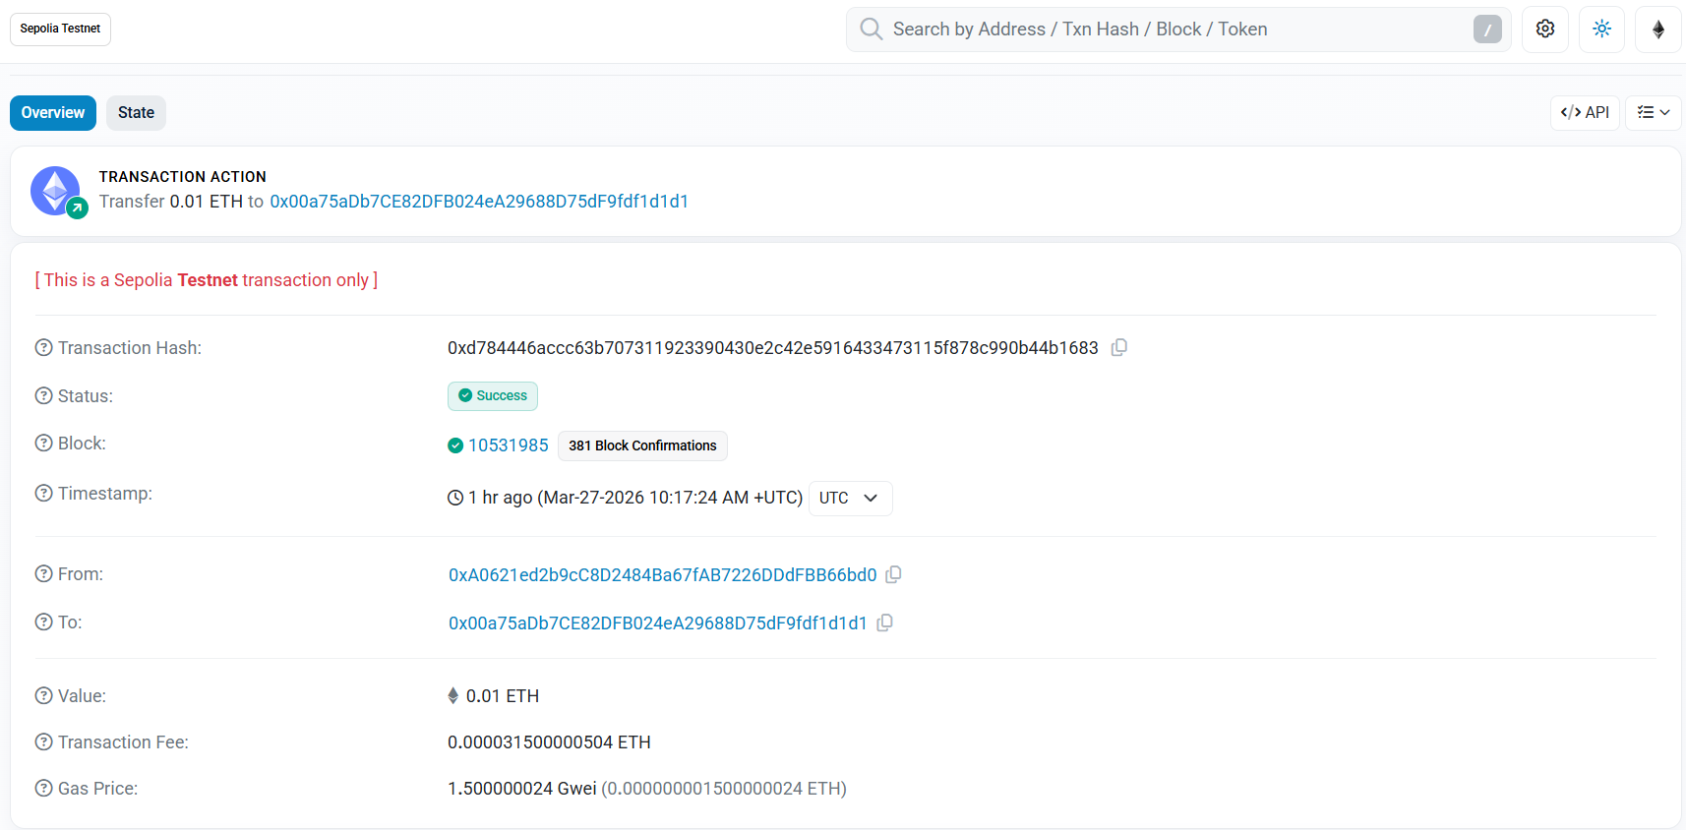
4. Gas
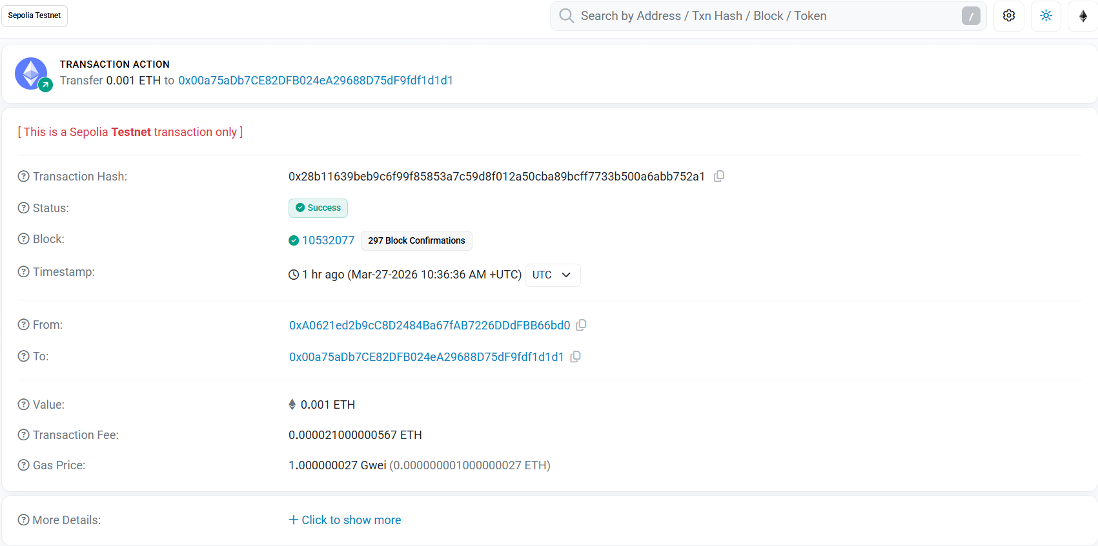
https://sepolia.etherscan.io/tx/0x28b11639beb9c6f99f85853a7c59d8f012a50cba89bcff7733b500a6abb752a1

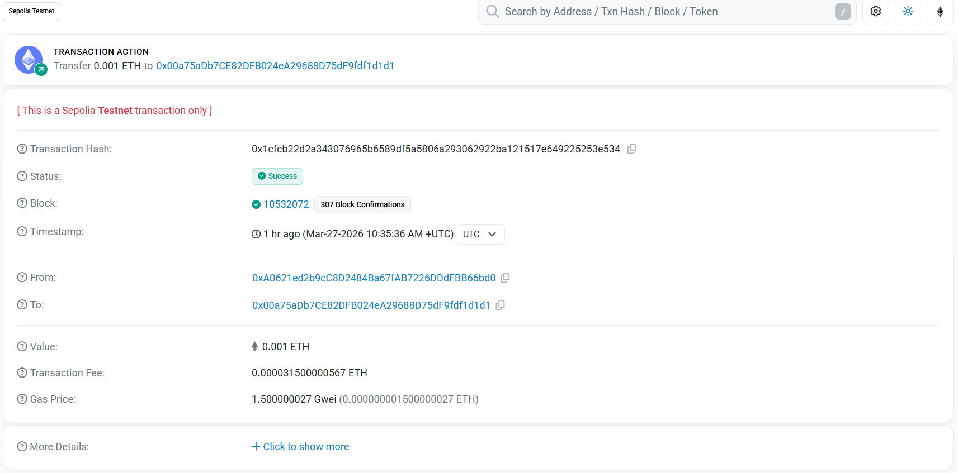
https://sepolia.etherscan.io/tx/0x1cfcb22d2a343076965b6589df5a5806a293062922ba121517e649225253e534
5. Nonce
https://sepolia.etherscan.io/tx/0x5e89e9708adec118e799c58beadcd9b4793064d2ce817b8321b6fac1ead5034f
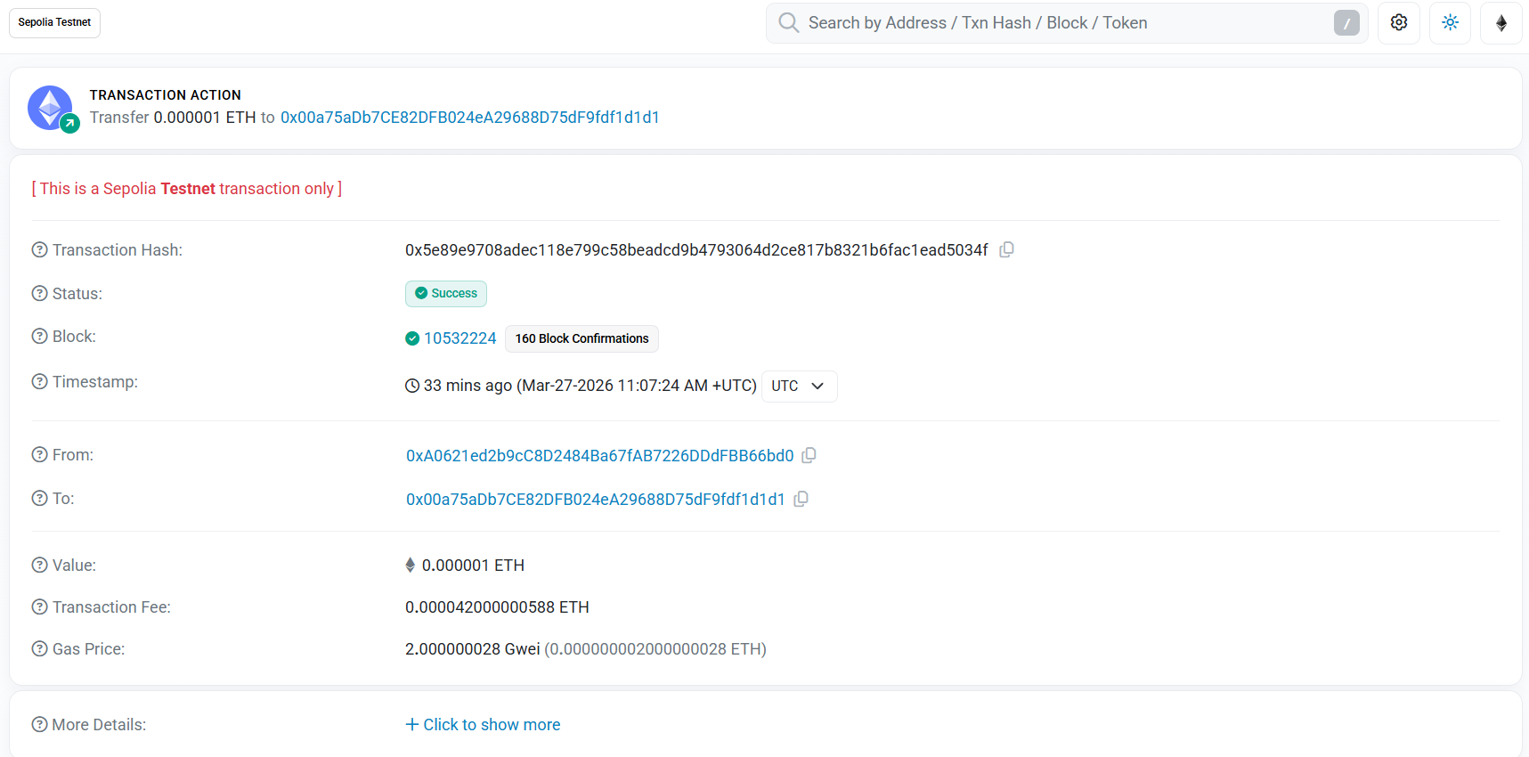
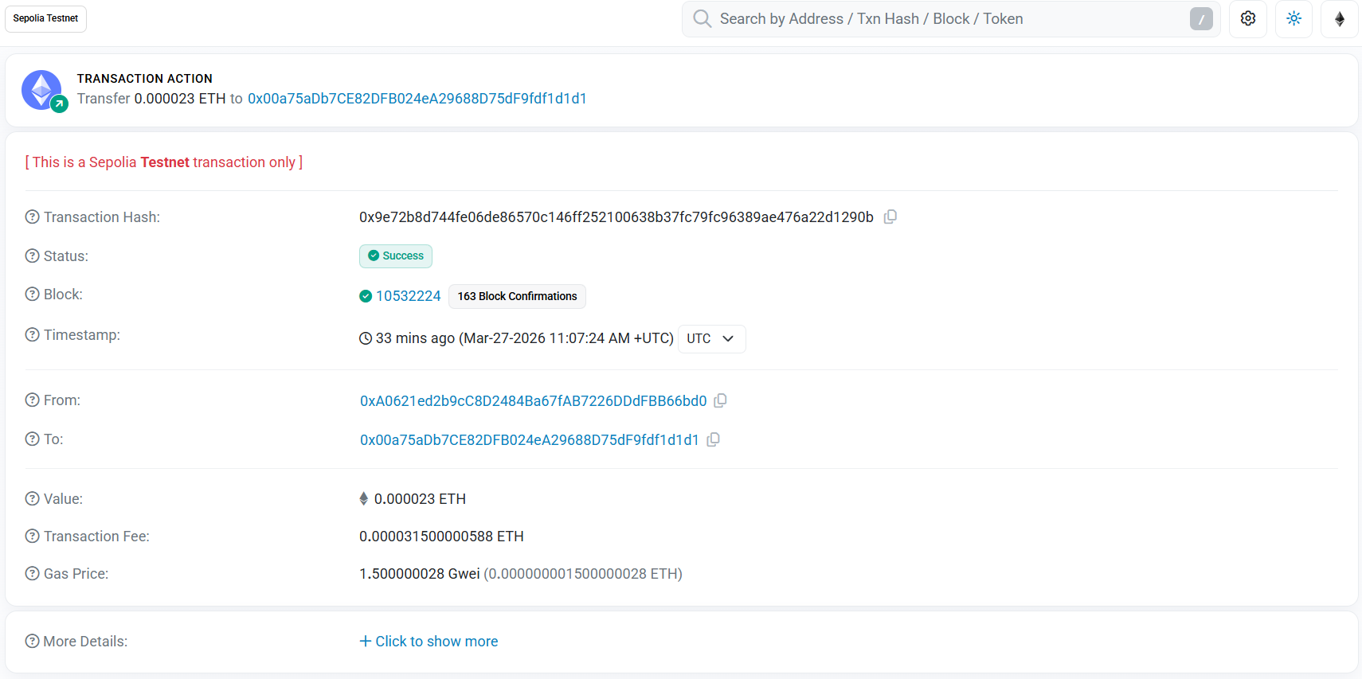
https://sepolia.etherscan.io/tx/0x9e72b8d744fe06de86570c146ff252100638b37fc79fc96389ae476a22d1290b

