**é**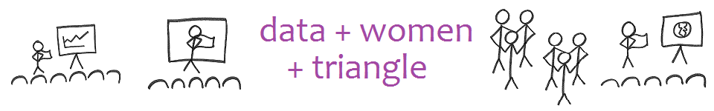

Welcome to Data+Women+Triangle. All are welcome. Please take a moment to understand our why, how, and what.

# Why are we here?

**Relationships**. So many data scientistas were schooled in subject areas and work in companies that are male-dominated. But as women, we have a right to a quilting bee, and enjoy seeing one another eye to eye. So, we aggregate to break the isolation, to make eye contact, to create an enclave to be who we are, and to engender success in one another.

**The Difference That Only Scientistas Can Make in Our World**. So, if we build actual relationships and demonstrate support, grit, leveraging, resilience, and joy, other women will be drawn to data science. Women in data science will naturally put data in the hands of women. Women with data in their hands have the capacity to make good decisions and be leaders. In enabling women leaders to emerge, we can increase the presence of women in leadership.

# How do we create relationships? Through these tools:

* **Partner presentation meetups.** Two (or more) scientistas present to the group about their common passion, purpose, history, or technique. Attendees get to learn something from a woman for once! Our backup is viewing TEDtalks given by data scientistas from around the world. Evenings, last Monday of certain months.
* **Unofficial meetups.** Scientistas meet on their own to do the projects and prepare the presentations for the rest of the group. Taking time to work with other women one normally doesn’t work with is the critical activity.
* **Book club meetups**. Scientistas discuss a recently published book in which data is essential to the discussion. Past titles were *The Signal and the Noise* and *Algorithms to Live By*. Evenings, last Monday of certain months.
* **Update sheet**. Each attendee introduces herself at each meeting with best/worst/personal/professional bullet points about the past month and the upcoming month. This disclosure is deeper than standard professionalism.
* **Moms meetup.** One power hour for moms other others who need to meet during the workday. Update sheets and TED talks. Last Monday of certain months.
* **The *Quick List.*** Attendees of meetings get added to this monthly publication that announces who is looking for a job, who has a position to offer, who is looking for a partner, who has had career progress, and who has a need.

# What are the requirements for membership?

* Have a LinkedIn profile and join the group at [**www.meetup.com/DataPlusWomenPlusTriangle/**](http://www.meetup.com/DataPlusWomenPlusTriangle/)
* Sign in at in-person meetings. FYI, There’s no money involved. You can bring food, etc., if you want.

# What is a data scientista?

Yes, data scientists. Yes, women in analytics. But also women who love algorithms in any application in life. And women who are impressed with how data visualizations influence decision makers. And women who recognize the awesome power of data. And women whose intuition tell them to be here with us. And anyone who wants to create the enclave for these women.

# And how did this group come to be?

Tableau (data visualization software) had a brainstorm in late 2015 to start Data+Women meetups. We had a kickoff on May 23, 2016. Tableau doesn’t follow up with us. As far as we can tell, we are free to create the enclave as we see fit.