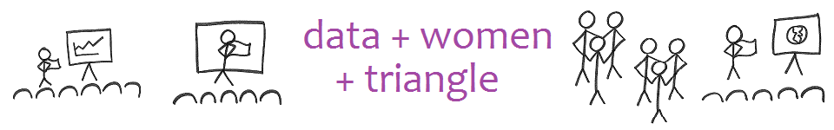

Annual Report

November 26, 2018

# Mission

## The mission of the Data Scientista Society is to build relationships among co-located women pursuing careers in data science, a.k.a data scientistas, while also practicing mutual supportiveness towards competency, success, and leadership.

# Vision

## Our vision is to create a world full of data of the women, by the women, and for the women.

# Values

|  |  |
| --- | --- |
| Gratitude Thankfulness for each other and available resources Grit according to Angela Duckworth Growth Mindset according to Carol Dweck Grip We focus on our strengths, and affirm the perspective of our background | Grapes of Empathy We are ethical and world-improving with what we do. Group We work with at least one partner Gravity We are solution-oriented. Great Women We are inspired by and rely on the examples of women who have gone before us; mentorships and partnerships |

# Data Sets Envisioned

## Meetup Sign-Up

LinkedIn Profile – Home Zip Code – Work Zip Code – Year of Bachelor’s Degree

## Meeting Sign-In, which becomes the Quick List and the Attendance Record

Meeting Date - Meeting Description – Member Name – Title - Company – Email – Various Needs – Various Intentions – Additional Group Participation

## Survey

LinkedIn Profile Sometimes – Various Descriptions – Various Career Goals

## LinkedIn Profiles

LinkedIn Profile – Member Name – Various Career Goals Attained – Company – Industry

## Essential Profiles (Does Not Exist Yet)

LinkedIn Profile – General Compentency with Rating – Tooling Competency with Rating

# Our Member Profile View

**How Buckets – General Competencies**

* Business, Accounting, Marketing
* Quality, Lean, and Six Sigma
* Statistics
* Analytics
* Decision Science
* Optimization
* Data Engineering & Visualization
* Security, Privacy, and Threats

**What Buckets – Tooling/Cert Competencies**

* SAS
* SQL
* Python
* R
* Google Analytics
* Alteryx
* Tableau
* Certified Analytics Professional

# Attendance

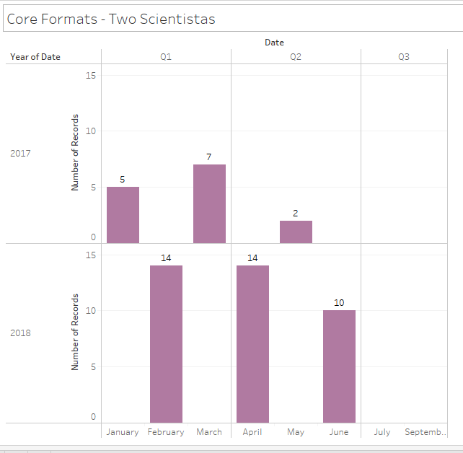

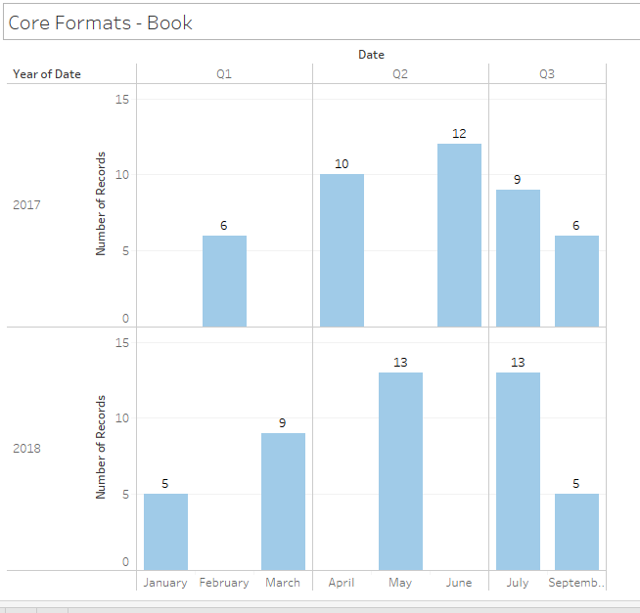

# Member Count

From 236 in 2017 to **346** in 2018

# Leadership Roles

|  |  |
| --- | --- |
| Role | Data Scientista |
| President | Anna Kirkland Smith |
| Vice President | Jaronda Ingram |
| Secretary | Janel Kinlaw |
| Treasurer | Kelly Camus |
| Brand Manager | Shannon Kreps |
| RTA Advisor | Aaron Terry |
| Book Club | Julia Kutznova |
| Secretary, Attendance |  |
| Secretary, Awards |  |
| Secretary, SAS |  |
| Secretary, SQL |  |
| Secretary, Python | Python Ladies Ginny Ghezzo and Mel Wilson |
| Secretary, R | R Ladies, Sheila Saia |
| Secretary, Google Analytics |  |
| Secretary, Alteryx |  |
| Secretary, Tableau |  |
|  |  |

# Initiatives for 2018

* 501(c)(3)
* Programs
* CAP Program
* Shoujia Project
* Awards Banquet
* Academy and College?

# Schedule

TO BE DETERMINED could be

* Heather & Shannon talk on Bitcoin
* Shoujia Project
* Elevator Pitch practice
* Headshots

|  |  |  |
| --- | --- | --- |
| Monday | Which | Meeting |
| 1/28/2019 | Last | Book Club |
| 2/4/2019 |  |  |
| 2/11/2019 | 2nd | CAP Chat: The Certified Analytics Professional Program |
| 2/18/2019 |  |  |
| 2/25/2019 | Last | **TO BE DETERMINED** |
| 3/4/2019 |  |  |
| 3/11/2019 | 2nd | CAP Chat: Business, Accounting, Marketing |
| 3/18/2019 |  |  |
| 3/25/2019 | Last | Book Club |
| 4/1/2019 |  |  |
| 4/8/2019 | 2nd | CAP Chat: Quality, Lean, and Six Sigma |
| 4/15/2019 | Odd | Board Meeting |
| 4/22/2019 |  |  |
| 4/29/2019 | Last | **TO BE DETERMINED** |
| 5/6/2019 |  |  |
| 5/13/2019 | 2nd | CAP Chat: Statistics |
| 5/20/2019 |  |  |
| 5/27/2019 | Last | Book Club |
| 6/3/2019 |  |  |
| 6/10/2019 | 2nd | CAP Chat: Analytics |
| 6/17/2019 |  |  |
| 6/24/2019 | Last | **TO BE DETERMINED** |
| 7/1/2019 |  |  |
| 7/8/2019 | 2nd | CAP Chat: Decision Science |
| 7/15/2019 | Odd | Board Meeting |
| 7/22/2019 |  |  |
| 7/29/2019 | Last | Book Club |
| 8/5/2019 |  |  |
| 8/12/2019 | 2nd | CAP Chat: Optimization |
| 8/19/2019 |  |  |
| 8/26/2019 | Last | **TO BE DETERMINED** |
| 9/2/2019 |  |  |
| 9/9/2019 | 2nd | CAP Chat: Data Engineering & Visualization |
| 9/16/2019 | Odd | Board Meeting |
| 9/23/2019 |  |  |
| 9/30/2019 | Last | Book Club |
| 10/7/2019 |  |  |
| 10/14/2019 | 2nd | CAP Chat: Security, Privacy, and Threats |
| 10/21/2019 |  |  |
| 10/28/2019 | Last | Awards Banquet |
| 11/4/2019 |  |  |
| 11/11/2019 | 2nd | Board Meeting |
| 11/18/2019 |  |  |
| 11/25/2019 | Last | Annual Co-Organizer's Meeting |