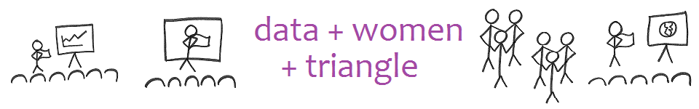

**SURVEY REFERENCE**

**1.       Please highlight one response to the panelists:**

a.       The panelists delivered messages and experiences that resonated with me.

b.      The panelists didn’t resonate with me, but other analytic women needed those messages.

c.       The panelists session was not worthwhile.

**2.       Please highlight one response to the small group discussion:**

a.       My small group members learned about one another and I’m proud of the message we delivered to the group.

b.      With some changes, the small group discussion could be more valuable.

c.       The small group session was not worthwhile.

**3.       Please highlight one response to the group pitch:**

a.       The speaker delivered messages and experiences that resonated with me.

b.      The speaker didn’t resonate with me, but other analytic women needed those messages.

c.       I don’t think data + women + triangle is right for me.

**4.       Should future meetings occur at the Wake Tech Rotunda site?**

a.       Yes, the general location and the meeting room were satisfactory.

b.      No, we should find a different general location.

c.       No, we should find a meeting room of a different format.

**5.       Please think of one location where you could comfortably act as host. This site would have public access, seating, computer, projector, speakers, and a nearby and satisfactory restaurant/bar.**

**6. Please identify an audience you could advertise Scientista meetups to, and how you would do that.**

**7.       What types of spin-offs interest you?**

a.       A Lean In circle

b.      A book club with the theme of books with data sets or books on data passion

c.       The hands-on development and administration of Data + Women + Triangle

d.      A data initiative

                                                               i.      About your favorite cause, which is :

                                                             ii.      About women

                                                            iii.      About this hypothesis you have, which is:

                                                           iv.      About something else:

e. another idea altogether which is:

8. Look at the next tab, "Came or Almost Came to Kickoff". You would find it to be an enriching experience to work with which ONE woman on a short seminar?

PLEASE DON'T CONTACT HER JUST YET. But who?